Bank Statement Agent
Provider-Agnostic ReAct Agent for FinTech
Technical Documentation
Version 0.0.3 — 2026-05-20

Changelog

v0.0.3 (current)
- Introduced a provider-agnostic ReAct agent loop. The LLM thinks, acts, observes, repeats — across Gemini, Claude, and Groq alike.
- All three providers are now genuinely agentic (previously only Claude was).
- Kept Claude's native tool_use API as an optional "native" mode for side-by-side comparison.
- New mode form field on /analyze; new mode dropdown in the UI.
- /providers endpoint now also returns the available modes.

v0.0.2
- Multi-provider support: Gemini (default, free), Claude (paid), Groq (free).
- Replaced ChromaDB with in-memory numpy similarity store.

v0.0.1
- Initial Claude-only agent with ChromaDB-backed RAG and sequential pipeline.

Table of Contents

1. Executive Summary
The Bank Statement Agent is an agentic AI application that ingests PDF bank statements and produces structured transaction data, spend categorisation, anomaly detection, and a plain-English monthly summary in under 30 seconds.
Version 0.0.3 introduces a provider-agnostic ReAct agent loop. Previously only Claude ran a true tool-use loop; Gemini and Groq executed a hard-coded Python pipeline. The ReAct loop closes that gap: one orchestrator, three providers, all genuinely agentic via prompted JSON actions.

1.1 Why this project
- Demonstrates a real agent pattern (ReAct) implemented from first principles, not via a framework.
- Multi-provider abstraction: the same loop runs against Gemini, Claude, and Groq.
- Optional native-tool-use mode for Claude gives a side-by-side comparison of approaches.
- Direct extension of FinTech document-verification work without using real client data.
- Ships to a public URL with a 30-second recruiter demo at zero API cost (Gemini free tier).

2. Product Requirements

2.1 Problem
Individuals and SME finance teams spend hours manually reviewing bank statements: extracting transactions, categorising spend, spotting anomalies, and writing summaries. This agent automates the workflow end-to-end.

2.2 Target Users
Persona | Pain Point | Value Delivered
Individual user | Tracking personal spend, tax records | Instant categorisation and summary
SME finance owner | Monthly reconciliation, accountant reports | Structured JSON + narrative
Technical recruiter | Evaluating candidate's AI engineering skill | 30-second demo at zero cost

2.3 Functional Requirements
- Accept PDF bank statement upload.
- Let user pick LLM provider (Gemini default, Claude, Groq).
- Let user pick agent mode (ReAct loop default, Claude native opt-in).
- Extract, categorise, flag anomalies, summarise.
- Return structured JSON + narrative + metadata (provider, model, mode, latency).
- Expose /evaluate endpoint with pytest accuracy metrics.

2.4 Success Metrics
Metric | Target | Notes
Extraction accuracy | ≥ 95% | Claude/Gemini meet; Groq lower
Categorisation accuracy | ≥ 90% | Provider-independent (RAG-grounded)
Anomaly precision | ≥ 80% | Low FP rate prioritised
Latency p95 (10-page PDF) | < 30 s | ReAct adds turns; still under target
Cost per run (default) | $0.00 | Gemini free tier

3. System Architecture

3.1 High-Level Diagram
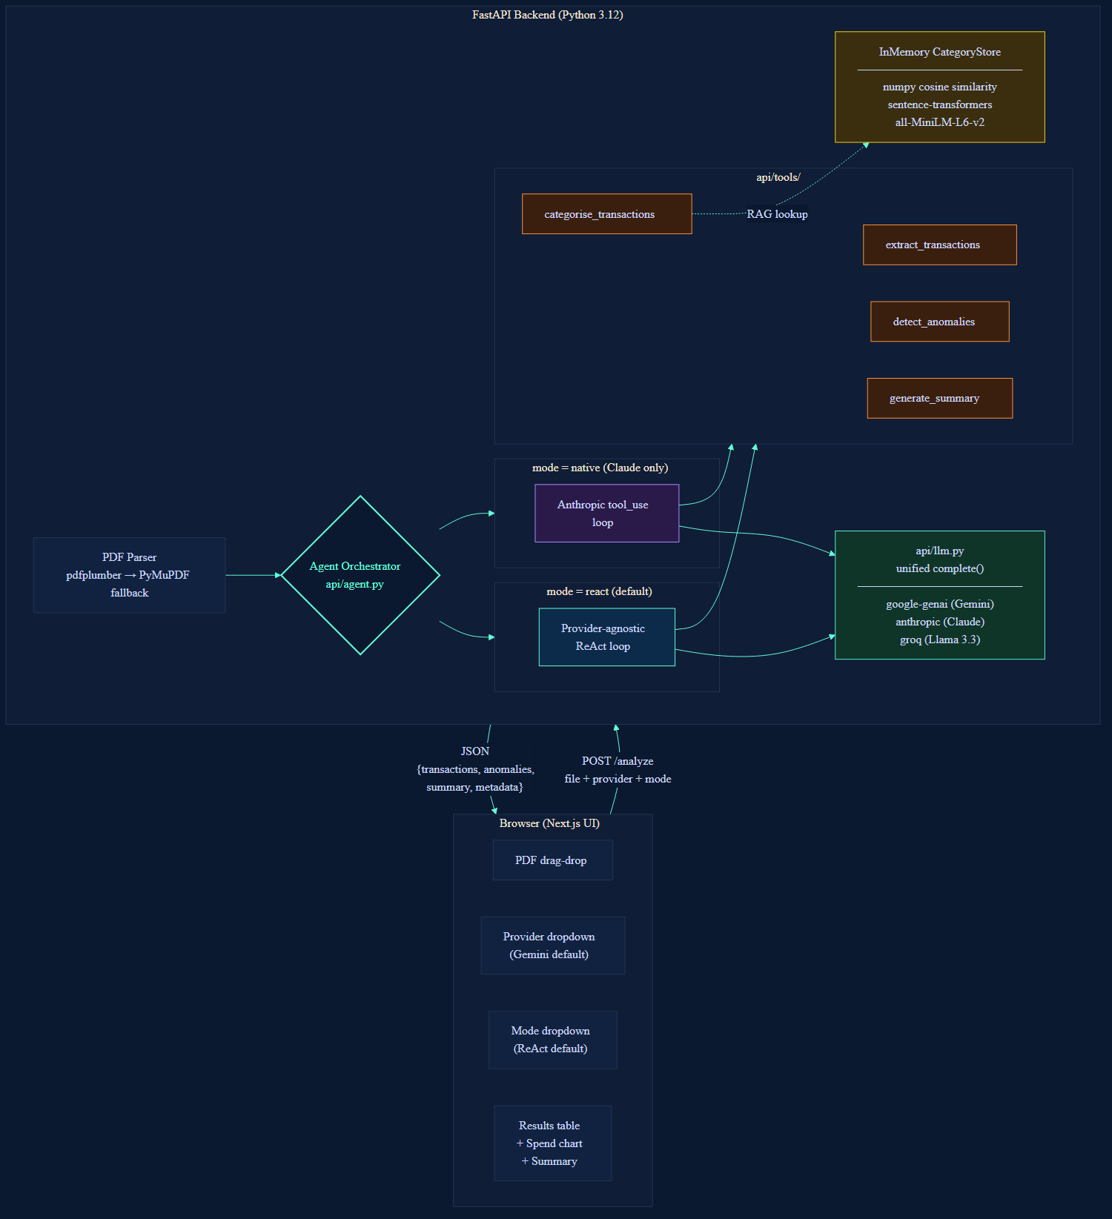
Figure 1 — High-level architecture

3.2 The ReAct Loop — what changed in v0.0.3
ReAct stands for Reasoning + Acting. On each turn the LLM produces a small JSON object containing its thought and the next action ("call_tool" or "finish"). The orchestrator parses that JSON, executes the requested tool, appends the result as an OBSERVATION, then asks the LLM again. Loop until the LLM emits {"action": "finish"} or we hit the iteration cap.

Why ReAct instead of native tool-use for every provider?
- Portability — one loop runs against Gemini, Claude, and Groq with no per-provider code.
- Transparency — every step is plain text in the prompt; you can read the agent's reasoning trail in logs.
- Honest agency — the LLM genuinely decides the next step. Errors feed back; the model can retry.
- Side-by-side comparison — keeping Claude's native tool-use as a toggle lets reviewers see both patterns.

Loop pseudocode

state = {transactions: [], anomalies: [], summary: {}, raw_text: ...}
history = []

for iteration in range(MAX_ITERATIONS):
prompt = build_prompt(raw_text, history)
response = llm.complete(prompt, system=REACT_SYSTEM, provider=provider)
action = json.loads(response)

if action == "finish":
return state

if action == "call_tool":
observation = execute_tool(action.tool, state, provider)
history.append((action, observation))

Tool inputs are implicit
The ReAct loop maintains shared state (state dict). Tools don't receive transaction lists as arguments — they read from state and write back. The LLM only needs to decide which tool to call next, not how to wire data between them. This keeps prompts compact.

Sample agent loop prompt (illustrative)

SYSTEM:
You are a bank statement analysis agent.

Available tools (call each exactly once, in order):
1. extract_transactions
2. categorise_transactions
3. detect_anomalies
4. generate_summary

On each turn, respond with EXACTLY ONE JSON object:
- To call a tool: {"action": "call_tool", "tool": "<name>", "thought": "<reasoning>"}
- To finish: {"action": "finish", "thought": "<reasoning>"}

USER:
Bank statement raw text (preview): DBS BANK SINGAPORE Account Statement...

=== Agent loop history ===
ACTION: {"action": "call_tool", "tool": "extract_transactions", "thought": "Start by parsing"}
OBSERVATION: OK. Extracted 16 transactions.
ACTION: {"action": "call_tool", "tool": "categorise_transactions", "thought": "Now categorise them"}
OBSERVATION: OK. Categorised 16 transactions.

What is your next action? Respond with one JSON object.

ASSISTANT (next):
{"action": "call_tool", "tool": "detect_anomalies", "thought": "Check for unusual transactions"}

3.3 Component Breakdown

3.3.1 LLM Abstraction (api/llm.py)
Unified complete() and complete_json() interface across three providers. Lazy SDK imports.
Provider | Model | Free? | Native tool-use?
gemini (default) | gemini-2.5-flash | Yes | Not implemented (uses ReAct)
claude | claude-sonnet-4-6 | No | Yes — optional 'native' mode
groq | llama-3.3-70b-versatile | Yes | Not implemented (uses ReAct)

3.3.2 Agent Orchestrator (api/agent.py)
Mode | Function | Providers
react (default) | _run_react_loop() | gemini, claude, groq
native | _run_claude_native_agent() | claude only (others fall back to react)

3.3.3 Tools
Tool | Purpose | Uses LLM? | Uses RAG?
extract_transactions | Parse raw text into structured rows | Yes | No
categorise_transactions | Assign spending category | Yes | Yes
detect_anomalies | Rules + LLM contextual flags | Yes (hybrid) | No
generate_summary | Aggregate + write narrative | Yes | No

3.3.4 Category Knowledge Base
In-memory numpy cosine similarity over ~50 merchant seeds embedded with sentence-transformers/all-MiniLM-L6-v2. No external DB. Same as v0.0.2.

3.3.5 Frontend
- New: ModeSelect component — dropdown for react / native. Disables 'native' unless provider is Claude.
- Provider change handler resets mode to 'react' if user switches away from Claude while 'native' is selected.
- Footer chip shows model · mode · elapsed_seconds.

4. Use Case Sequence Diagrams

4.1 ReAct Loop (Default — Any Provider)
The provider-agnostic agent loop. Same flow runs against Gemini, Claude, or Groq. Each iteration: the LLM emits a JSON action; the orchestrator executes the tool and appends an observation; loop until {"action": "finish"}.
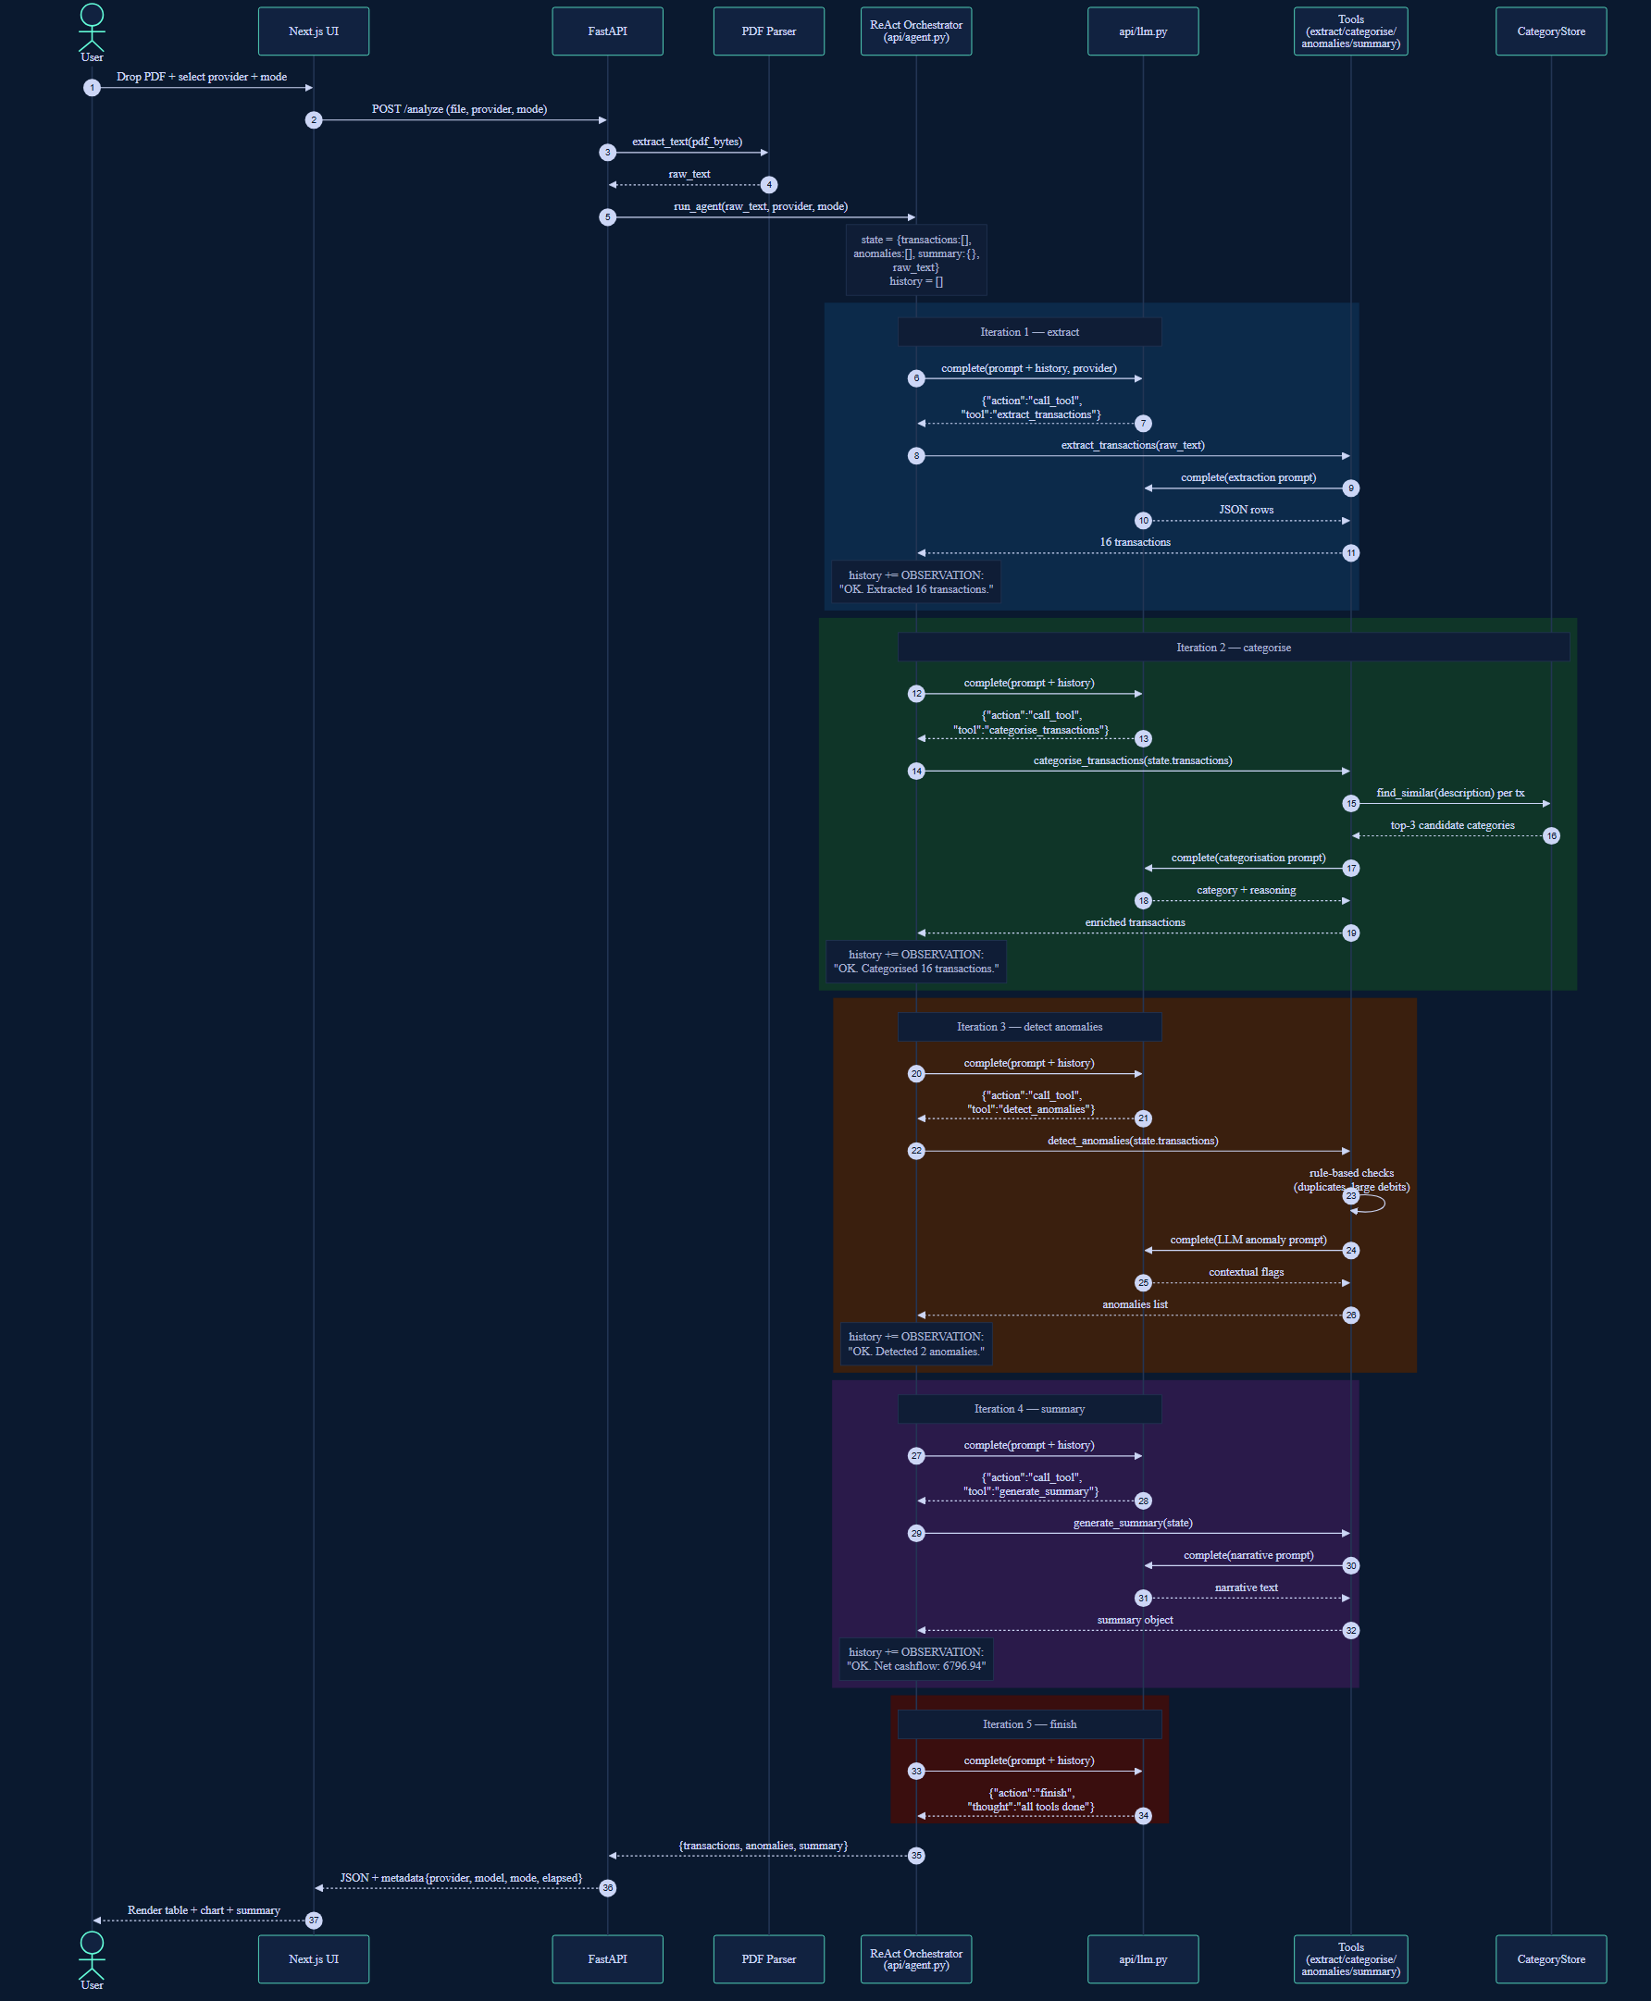
Figure 2 — ReAct loop, full agent run

4.2 Native Claude Tool-Use (Opt-In)
When the user selects 'native' mode with Claude provider, the orchestrator uses Anthropic's tool_use content blocks directly. The tools schema is re-sent on every API call (the API is stateless).
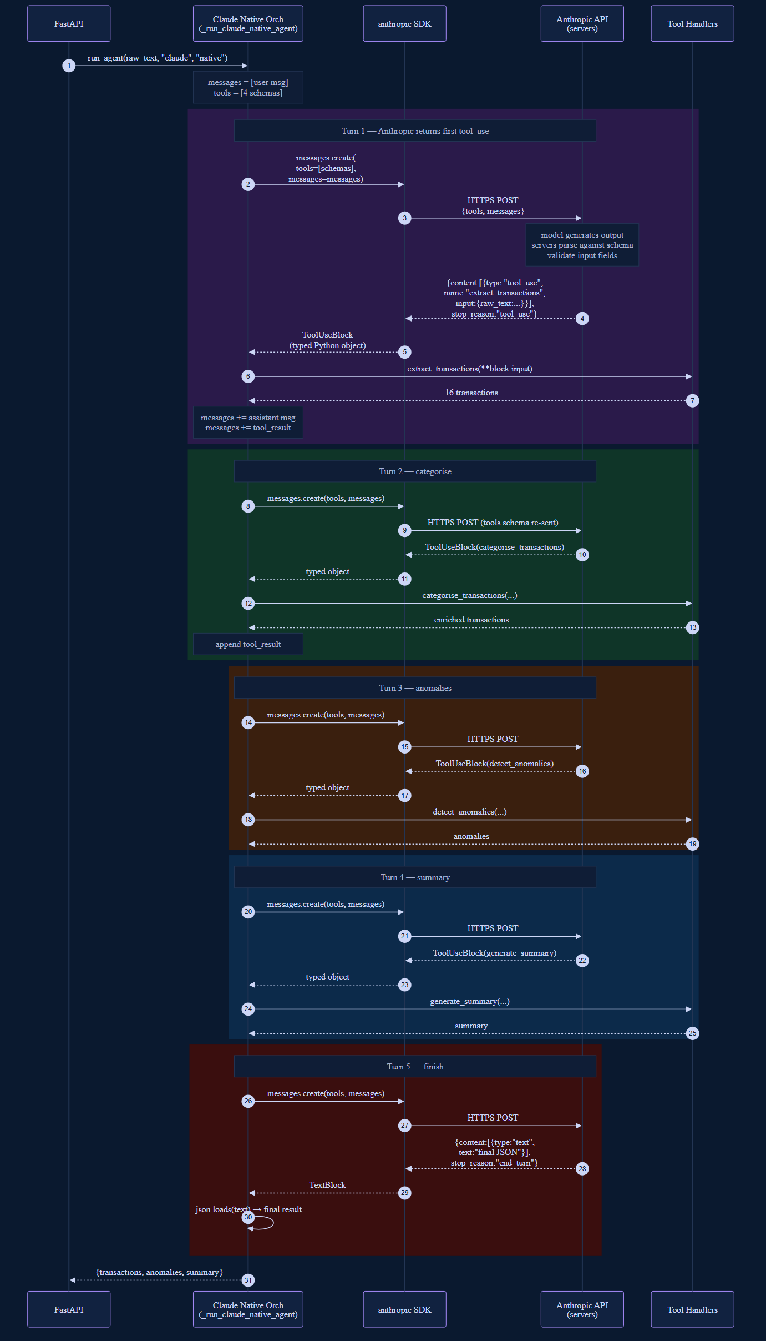
Figure 3 — Native Claude tool-use loop

4.3 Provider + Mode Switching
Three scenarios shown: default (Gemini + ReAct), switch to Claude + Native, switch to Groq (mode auto-resets to ReAct because Native is Claude-only).
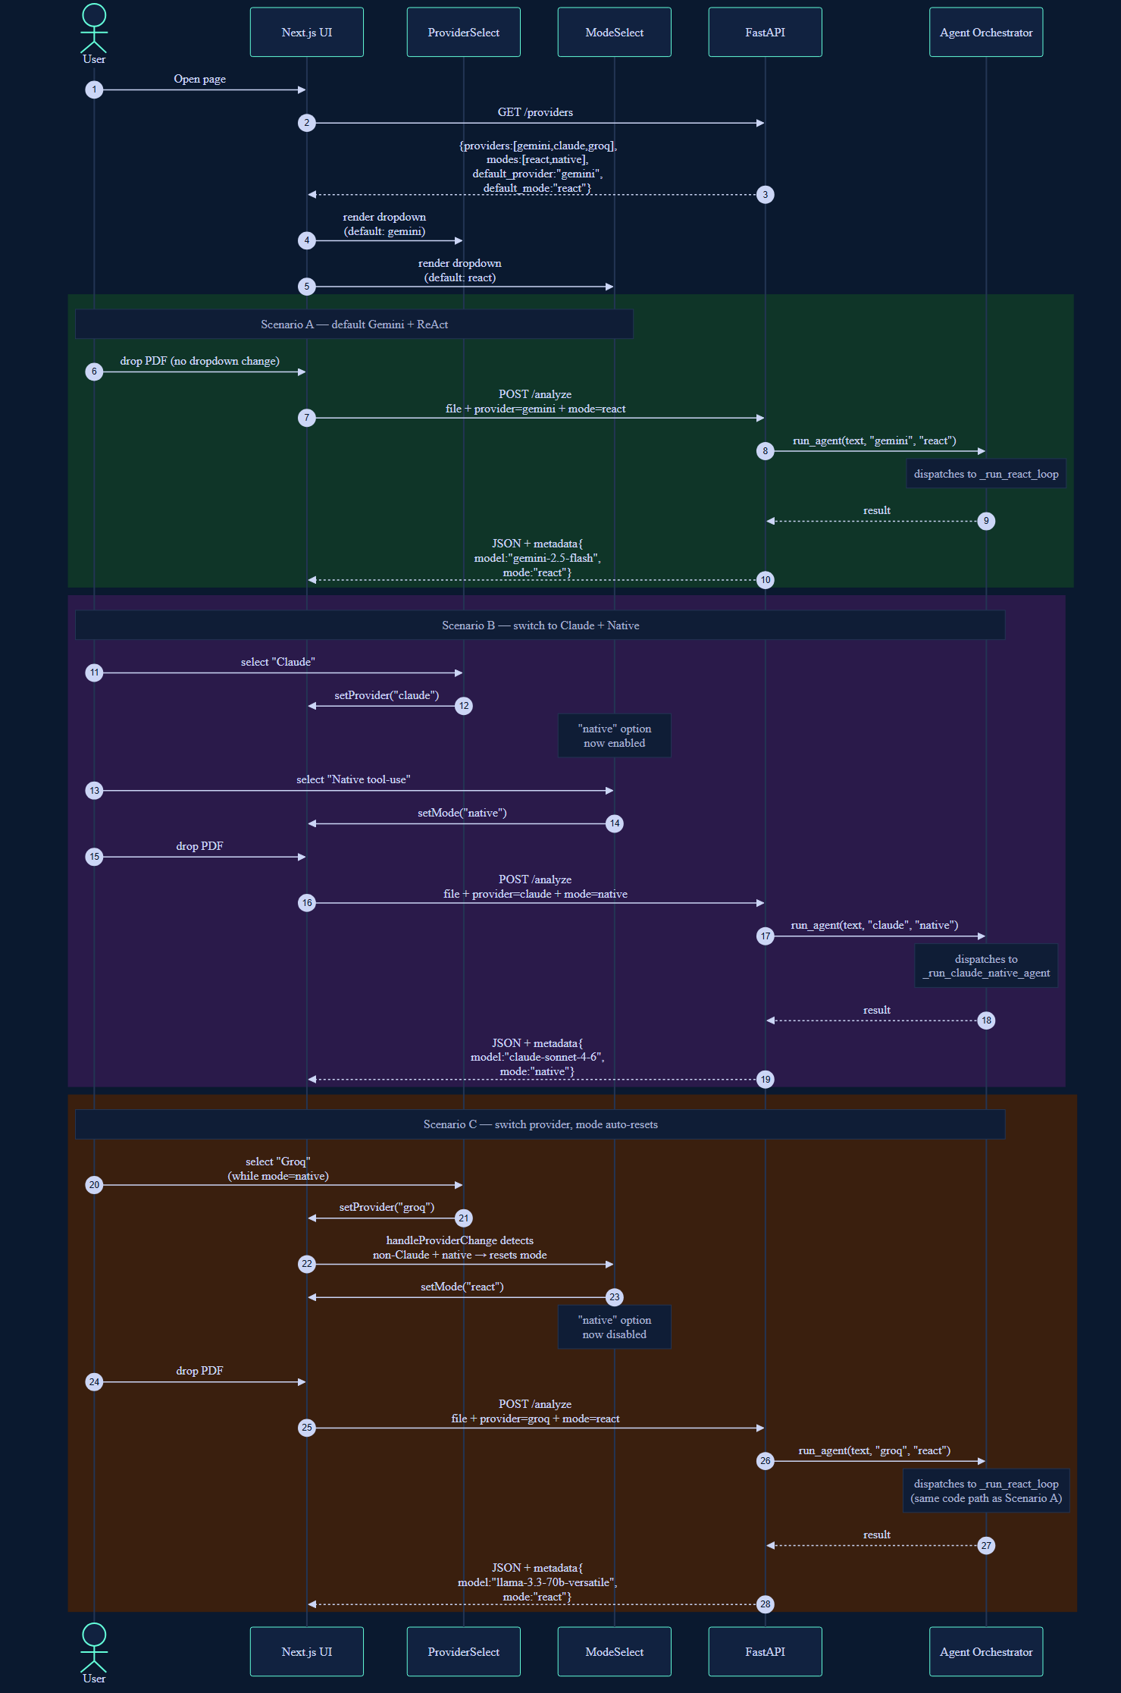
Figure 4 — Provider and mode switching flow

4.4 Native vs ReAct — Where Parsing Happens
Side-by-side: the only material difference between the two modes is who parses the LLM's tool intent. Native: Anthropic's servers parse, validate against schema, and return a typed object. ReAct: the LLM returns plain text and your code parses the JSON.
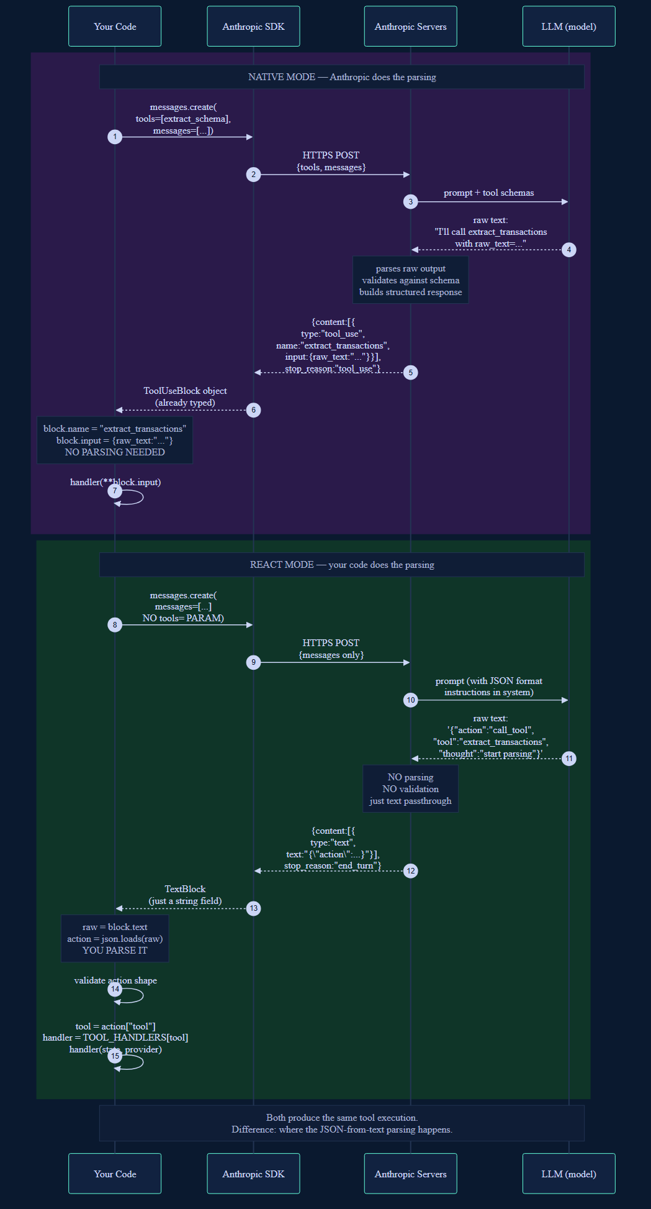
Figure 5 — Where the parsing happens in each mode

5. APIs and External Services

5.1 HTTP Endpoints
Endpoint | Method | Purpose | Added in
/health | GET | Liveness check | v0.0.1
/providers | GET | List providers and modes | v0.0.2 (modes in v0.0.3)
/analyze | POST | Upload PDF + provider + mode | v0.0.1 (mode in v0.0.3)
/evaluate | GET | Run pytest eval suite | v0.0.1

5.2 External LLM Providers
Provider | Auth Variable | Pricing | Notes
Google Gemini | GOOGLE_API_KEY | Free tier | Default; signup at aistudio.google.com
Anthropic Claude | ANTHROPIC_API_KEY | Paid | Only one with native tool_use mode here
Groq | GROQ_API_KEY | Free tier | Fastest; lower quality on extraction

5.3 MCP Servers
No MCP servers in production. Reserved for future enhancements (live bank APIs, accounting writeback, fraud-signal enrichment).

6. Technology Stack

6.1 Backend
Layer | Technology | Version
Language | Python | 3.12
Web framework | FastAPI | 0.115
LLM SDK (Gemini) | google-genai | 0.3
LLM SDK (Claude) | anthropic | 0.39
LLM SDK (Groq) | groq | 0.11
PDF (primary) | pdfplumber | 0.11
PDF (fallback) | PyMuPDF | 1.24
Embeddings | sentence-transformers | 3.1
Similarity | numpy | >=1.26
Validation | Pydantic | 2.9
Logging | structlog | 24.4

6.2 Frontend
Layer | Technology | Version
Framework | Next.js | 14.2
UI library | React | 18.3
Language | TypeScript | 5.6
Styling | Tailwind CSS | 3.4
Charts | Recharts | 2.12

7. Migration Notes — v0.0.2 → v0.0.3

7.1 Breaking Changes
- Default execution path changed from sequential pipeline (Gemini/Groq) to ReAct loop. Latency increases ~50%. Output unchanged.
- run_agent() signature: new optional mode kwarg. Existing callers default to 'react' — backward-compatible.

7.2 Non-Breaking Additions
- /analyze accepts a new 'mode' form field (defaults to 'react').
- /providers response includes a 'modes' array and 'default_mode'.
- Output metadata gains a 'mode' field.

7.3 Why latency increased
ReAct calls the LLM once per agent turn (4 tools = 4 turns + finish = 5 LLM calls). The v0.0.2 sequential pipeline called the LLM only inside each tool (4 calls). Extra turns let the agent self-correct on tool errors — a worthwhile tradeoff for portfolio signal.

8. Risks and Limitations
- ReAct adds turns and tokens. Free tiers may rate-limit on heavy demos.
- Smaller models (Groq Llama) occasionally emit invalid JSON; loop tolerates by reprompting once.
- Native tool-use mode is Claude-specific. Gemini and Groq both have native function calling APIs that could be added in v0.0.4.
- MVP supports DBS/UOB/NAB-style PDF layouts. Exotic formats may extract poorly.

Future enhancements
- Native function-calling modes for Gemini and Groq (would be 3 native modes + 3 ReAct modes).
- Streaming agent loop — push observations to the UI in real time.
- Token + cost telemetry per run.
- Cross-provider eval: same ReAct loop, three providers, compare accuracy and cost.

Appendix A: Glossary
Term | Definition
Agent | An LLM-driven system that uses tools to accomplish multi-step tasks
ReAct | Reasoning + Acting — agent loop where the LLM emits thought + action per turn
Tool use (native) | Provider SDK feature where the LLM emits typed function calls via API content blocks
Tool use (prompted) | Same idea but encoded in plain JSON via the prompt — works with any LLM
RAG | Retrieval-Augmented Generation — grounding LLM output in retrieved context
Provider | Source of LLM inference: Gemini, Claude, or Groq in this project
Mode | react = ReAct loop (any provider); native = provider's tool_use API
Observation | Brief text result of a tool execution, fed back to the LLM for next decision

Appendix B: References
- ReAct paper — Yao et al., "ReAct: Synergizing Reasoning and Acting in Language Models"
- Anthropic Claude API — https://docs.claude.com
- Google Gemini API — https://ai.google.dev/gemini-api/docs
- Groq API — https://console.groq.com/docs
- FastAPI documentation — https://fastapi.tiangolo.com
- sentence-transformers — https://www.sbert.net

