**ALGORITHM**

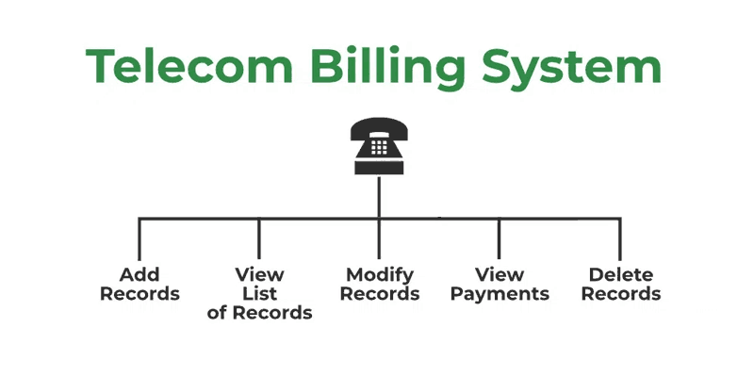

* **Add New Record:**Add new customer record.
* **View List of Records:** View all the records at a glance.
* **Modify Record:** Modification of an already existing record.
* **View Payment:** View the bill for a given customer.
* **Delete Record:** The deletion of a record from the memory.

**Prerequisites:**This project requires you to have a basic understanding of the C programming language concepts such as arrays, strings, structs, etc.

**Components of the Telecom Billing System Program**

The telecom billing system is divided into multiple components each performing a specific task.

**Necessary Libraries**

We will use the following libraries:

1. **<stdio.h>:** For Input and Output
2. **<string.h>:** For String Manipulation

Both of these are standard libraries that come bundled with the C compiler.

**Data Structure to Hold Customer Information**

* A structured **Customer**is defined as holding information about a customer.
* Array **customers[100]** of type Customer is created to store customer records. It can hold up to 100 records.
* **customerCount** is an integer variable used to keep track of the number of customers.

**addRecord(): Function to Add New Customer Record**

* The **addRecord()**is created in order to add a customer record in the memory.
* It checks if the current number of customers customerCount is less than 100 ensuring there’s space for a new record.
* The function prompts the user to enter the customer’s name, phone number, usage in minutes.
* It calculates the total bill for the customer by multiplying their usage in minutes by 0.1.
* After adding the record, customerCount is incremented by 1.

**viewRecords(): Function to Display Customer Records**

* The function named **viewRecords()** is responsible for displaying the list of customer records.
* It uses a loop to iterate through each customer record.
* Within the loop, it prints the name, phone number, usage in minutes, and total bill for each customer.

**modifyRecord(): Modifying Customer Records by Phone Number**

* The function **modifyRecord()** is responsible for modifying a customer record using their phone number.
* It takes a character array **phoneNumber** as a parameter which is used to identify the customer record to be modified.
* Using a loop, it checks if the phone number of the current customer matches the provided **phoneNumber.**
* If a matching phone number is found it prompts the user to enter the new usage in minutes for the customer and the new bill is calculated based on the updated usage.
* It displays output to the user either confirming a successful record modification or informing them if the record was not found.

**viewPayments(): Viewing Payment for a Customer by Phone Number**

* The function **viewPayment()** is responsible for displaying the total bill for a customer based on their phone number.
* It takes a char array **phoneNumber**as a parameter which is used to identify the customer.
* If a matching phone number is found it prints the total bill for the customer along with their name.
* It displays output to the user, either displaying the total bill or informing them if the record was not found.

**searchRecord(): Searching for a Customer Record by Phone Number**

* This function searchRecord responsible for searching for a customer record based on their phone number.
* It takes a char array phoneNumber as a parameter which is used to identify the customer.
* It uses a loop to iterate through each customer record.
* Within the loop it checks if the phone number of the current customer matches the provided phoneNumber.
* If a matching phone number is found it prints the information of the customer including name, phone number, usage in minutes, total bill.
* It displays output to the user either displaying the customer record or informing them if the record was not found.

**deleteRecord(): Deleting a Customer Record by Phone Number**

* This function **deleteRecord()** is responsible for deleting a customer record based on their phone number.
* It takes a char array **phoneNumber** as a parameter which is used to identify the customer record to be deleted.
* If a matching phone number is found, it shifts all records after the matched record by one position to effectively delete the record.
* After deleting the record it decrements the customerCount by 1.
* It provides feedback to the user confirming a successful record deletion or informing them the record was not found.

**Main Function**

The main function handles the primary control of the program.

* An infinite while loop is used to provide the user with a dashboard that resets after each.
* A switch case is used to process the user’s choices.