1. (2 points) There are five entities extracted from the ERD diagram of the hotel management information system as shown in the diagram. Add the following business requirements to the diagram:

Allow customers renting rooms to use the hotel's services. Each room can use multiple services, and each usage should record the date and time, as well as the number of times the service was used. The services should have a service ID, service name, and service charge. (Add to the existing diagram in the exam).

*Use the diagram below to complete question 1 (you can draw it in MS Word).*

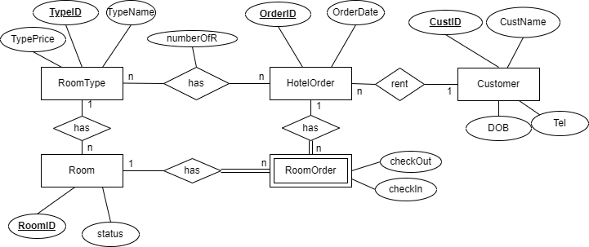

**Entities Description**  
Entity Customer: Contains personal information of the customer.

Entity RoomType: Stores information about the different types of rooms in a hotel. Entity Room: Holds information about hotel rooms.

Entity HotelOrder: Contains information about customer room reservations.

Entity RoomOrder: Contains information when a customer checks in at the hotel.

1. (2 points) From the diagram in question 1, write SQL statements to create **a table** to store detailed information about customer room reservations *(the table is created from the relationship between two entities: RoomType and HotelOrder).* The statements should include the maximum possible data constraints on the table fields. Insert 3 appropriate data rows into each newly created table. (Other tables are already available)
2. (2 points) Write a procedure to perform the addition of a new customer. Requirement: Error notification procedure if the data addition operation is not successful.
3. (2 points) Write a trigger for assigning a room to an order. If the room's status is NA, perform a rollback; otherwise, change the room's status from A (Availability) to NA (Not Availability).
4. (2 points) Create a view to display information about customers who have booked rooms at the hotel more than once. Information about customers includes customer ID, customer name, date of birth, phone number, and the number of room reservations.

End