F1 Race Strategy Advisor
A Dual-Target Probabilistic Framework for Pre-Race Strategy Evaluation
When P(top10) saturates above 0.85, consulting is_top3 reverses the strategy
recommendation in 17.5% of comparisons at Qatar 2024, that reversal is worth
28 percentage points of podium probability.

Team: Daniela Ávila and Klaus Krause
Course: IIT414W — Artificial Intelligence Workshop · 2026-1T
Date: May 17, 2026
Repo: https://github.com/dvni7/f1-strategy-advisor.git
Commit: 0f9afc9
1. Executive Summary
This project delivers a decision-support tool for Formula 1 race engineers: a calibrated probabilistic model that estimates the likelihood of a driver finishing in the top ten, or on the podium, given a specified pit-stop strategy. The decision the tool supports is specific and time-bounded: choosing between a one-stop and a two-stop strategy (or other variants) on Saturday evening, before the formation lap on Sunday morning.
The production model is a Gradient Boosted Trees classifier with Platt calibration (GBT+Platt), trained on 2019–2021 race data and evaluated on an unseen 2023–2024 test set. On the primary target (is_top10), it achieves Brier = 0.1257 and ROC-AUC = 0.9005, beating the docent reference (Brier = 0.1320, ROC-AUC = 0.8920). On the expansion target (is_top3), it achieves Brier = 0.0701 and ROC-AUC = 0.9275.
The central finding of this project is not simply that the model beats the baseline. It is that a single-target model is insufficient for front-row starters. When a driver begins from grid position P1 through P3 with a front-tier constructor, P(top10) exceeds 0.90 under all realistic strategy choices, the target saturates and provides no decision signal. A systematic scan of the test set found that 17.5% of one-stop versus two-stop comparisons produce a directional disagreement between the two targets: is_top10 is silent or negligible, while is_top3 gives a decisive recommendation. The Qatar Grand Prix 2024 is the clearest example: is_top10 differs by +0.002 across strategies, while is_top3 differs by −0.286, favouring the one-stop.
The model's worst prediction cell is one-stop strategies in wet races, where the Brier score reaches 0.2772 more than twice the overall mean. This failure is structural: the dataset contains no safety-car or rain-onset signal, and wet one-stop strategies are effectively binary gambles on conditions rather than choices the model can evaluate from pre-race features. Engineers should treat model outputs in this context with significant caution.
The primary operational recommendation is a decision rule: when P(top10) exceeds 0.85 under both candidate strategies, the is_top10 model has saturated and should not be used as the deciding criterion, consult is_top3 instead. This tool is not ready for live deployment. It should not be used without the safety-car data integration and calibration re-validation described in Section 7.
2. Problem Framing
2.1 Decision Context
This project addresses a concrete, time-bounded decision problem in Formula 1 race engineering. After qualifying on Saturday evening, a race engineer must commit to a pit-stop strategy before the formation lap the following day. That decision, how many stops to make and in which tyre-compound sequence, directly determines whether the driver scores constructor championship points. The model described in this report produces calibrated probability estimates, P(top10 | strategy scenario), that allow engineers to compare alternative strategies with quantified risk.
The primary decision-maker is the race engineer who controls in-race calls. A secondary user is the sporting director, who may validate recommendations against team-level constructor-points priorities. The decision window opens at approximately 18:00 local time on Saturday after qualifying results are confirmed and closes at the formation lap on Sunday at approximately 13:50 local time.
All model inputs that represent strategy variables, number of stops, compound sequence, stint lengths are declared as what-if scenario parameters set by the engineer, not as pre-race signals predicted by the model. This framing is critical: in any other context, treating post-race strategy observations as predictors would constitute target leakage. Here, the tool is explicitly a scenario comparator, not a pre-race predictor. The engineer asks 'what would P(top10) be if I chose a one-stop M-H strategy?' and receives a calibrated historical estimate in return.
Three explicit assumptions govern the model. First, the driver's qualifying position is a reliable proxy for pre-race pace, grid penalties are not captured in this dataset. Second, strategy choice is treated as a free variable under the engineer's control, though the model acknowledges this is an associative assumption, not a causal one. Third, weather conditions (wet or dry) are known at the start of the decision window with sufficient reliability to inform the engineer's interpretation of the output. Violations of any of these assumptions narrow the tool's applicability.
2.2 Two Prediction Targets and Their F1 Rationale
Hito 1 established is_top10 as the primary target: a binary flag equal to 1 if the driver finishes in positions 1 through 10. This directly encodes the points-scoring threshold, as only the top ten drivers score constructor championship points in any given race.
Hito 2 adds is_top3 as an expansion target. The motivation is not decorative. There is a specific, measurable failure mode in is_top10: for drivers starting from the front rows of the grid, P(top10) approaches 0.95 or higher under all reasonable strategy choices. The target saturates. When this happens, is_top10 provides no basis for choosing between strategies because both produce near-identical predictions. is_top3 remains sensitive in exactly this regime because podium probability depends on tyre phase, track-position maintenance, and undercut risk, factors that differentiate strategies even when points-scoring is near-certain.
The Qatar 2024 scenario quantifies this directly: for a P2 starter, is_top10 produces a delta of +0.002 between a one-stop and a two-stop strategy (indistinguishable from noise), while is_top3 produces a delta of −0.286 (decisive, favouring the one-stop). Both targets use identical feature sets, ensuring that what-if comparisons are interpretable without feature mismatch between the two outputs.
2.3 Metric Justification
The primary metric is Brier score. Accuracy would only measure whether the model crosses the 0.5 threshold correctly; it discards the probability values that give the tool its decision utility. Brier score penalises both discrimination failure and calibration failure simultaneously. This matters because an engineer acting on P(top10) = 0.85 must be able to trust that roughly 85% of historical scenarios with similar context resulted in top-10 finishes. Miscalibrated probabilities destroy that trust without necessarily changing the ranking of strategies.
Three reference points anchor the metric: the grid-rule heuristic (Brier = 0.208), the calibrated logistic regression baseline from Hito 1 (Brier = 0.1396), and the docent model (Brier = 0.132, ROC-AUC = 0.892). ROC-AUC is reported as a secondary metric and measures discrimination ability across all probability thresholds.

3. Data and Validation
3.1 Dataset and Temporal Split
The dataset is f1_strategy_race_level.csv, covering the 2019–2024 Formula 1 seasons at the driver-race level (one row per driver per race, 2,447 rows total, 47 columns). It includes pre-race context features, race-level strategy observations, and post-race outcome variables. The temporal split is fixed from Hito 1: training on 2019–2021, calibration on 2022 only, and evaluation on 2023–2024. This split prevents future-season information from influencing either training or the calibration mapping.
The test set contains 889 driver-race pairs. Positive rates are 51.7% for is_top10 and 15.5% for is_top3. The difference has a direct implication for metric comparison: a naïve all-zeros predictor would achieve Brier ≈ 0.131 for is_top3, compared to Brier ≈ 0.250 for is_top10. Raw Brier comparisons between the two targets are therefore not meaningful without acknowledging this baseline difference.
3.2 Leakage Audit Summary
All 47 columns were classified into four categories before any model was fitted. This classification is the primary leakage control and was completed in full before any model was trained.
Category | Columns | In Model?
pre_race | grid_position, constructor_tier, circuit_type, driver_prior3_avg_finish, constructor_prior3_avg_finish, driver_circuit_prior_avg | Yes
scenario_input | n_stops, strategy_type, compound_sequence, stint1–3_length, avg_pit_stop_duration_s, total_pit_time_s, first_pit_lap, last_pit_lap | Yes, engineer-set what-if values
audit | weather_actual, safety_car_periods, wet_laps, track_status_summary | No, slice analysis only
outcome | is_top10, is_top3, finish_position, points, positions_gained, dnf | Targets only, never predictors
Table 1. Column classification for leakage control. No audit or outcome column appears as a model predictor.
The 2022 calibration block is used exclusively for Platt scaling. It is never used for training or hyperparameter selection. The 2023–2024 test set is held out entirely and touched only once, during final evaluation.
3.3 Scenario Protocol
The scenario_input classification requires explicit justification. Features such as n_stops and compound_sequence are post-race observations in the raw dataset; they record what the team actually did. In this tool, they are declared as what-if values that the engineer sets hypothetically. The model is thus a lookup of historical outcomes for teams in similar contexts who chose similar strategies, not a predictor of what will happen given strategy X. This distinction is central to the tool's validity and is the source of the strategy-confounding limitation discussed in Section 7.
Two dataset-specific limitations affect the leakage audit. First, qualifying_time_s is entirely null across all rows, and qualifying_position is identical to grid_position for all 2,447 entries (no grid penalties are recorded). Second, safety_car_periods is all zero, safety car data was not successfully joined to this race-level file from the lap-level source. Both limitations are documented and their consequences for model reliability are quantified in Section 6.
4. Modeling Approach
4.1 Three Estimator Families
Three estimator families were trained for each target under identical preprocessing pipelines. Numeric features are imputed with the column median and standardised. Categorical features (circuit_type, constructor_tier, strategy_type, compound_sequence) are imputed with the mode and one-hot encoded. All models are calibrated with Platt scaling on the 2022 block.
Logistic Regression + Platt (LR+Platt): The Hito 1 baseline, retained for direct comparison. Provides a linear decision boundary with interpretable coefficients. Cannot capture non-linear interactions such as grid_position × constructor_tier.
Random Forest + Platt (RF+Platt): 300 trees, max depth 8, min samples per leaf 15, class-weight balanced. Captures non-linear interactions but produces overconfident raw probabilities on the positive tail, motivating Platt calibration.
Gradient Boosted Trees + Platt (GBT+Platt — production): 200 trees, max depth 4, learning rate 0.05, subsample 0.8. Achieves the best Brier and ROC-AUC on both targets. Selected as the production model.
GBT is selected over RF on domain grounds, not solely on aggregate Brier. Shallow trees (depth 4) capture the interaction between grid_position and constructor_tier in a way that reflects F1 domain logic: a front constructor at P1 is qualitatively different from a front constructor at P8, and a depth-4 tree can represent this interaction without overfitting to specific race incidents. RF at depth 8 tends to memorise race-specific attrition events that do not generalise across seasons.
4.2 Why Platt Scaling, Not Isotonic Regression
The 2022 calibration block contains approximately 440 driver-race entries. At this sample size, isotonic regression is prone to overfitting the calibration curve, producing a step function that memorises the calibration set rather than learning a generalisable mapping. Platt scaling, which fits a two-parameter logistic function to the raw model scores, is the appropriate choice for N ≈ 440. Isotonic regression was tested on the 2022 set and produced ECE = 0.03, marginally better than Platt's 0.04, but visually overfit in the high-probability tail (fewer than 12 samples above predicted score 0.80 in the calibration set). Platt scaling is used for both targets.
For is_top3, the 15.5% positive rate means the calibration data above predicted P = 0.5 is sparse (fewer than 25 test-set samples). Platt scaling provides a reasonable mapping in the 0–0.4 range, covering the vast majority of driver predictions. Predictions above P(top3) = 0.5 should be treated as relative comparisons rather than absolute calibrated frequencies.
4.3 Hyperparameter Rationale
Hyperparameters for GBT were selected by three-fold cross-validation on the training set (2019–2021 only). Max depth was constrained to 4 to prevent the model from memorising driver-specific race incidents. Learning rate of 0.05 with 200 trees provides a good bias-variance tradeoff for a dataset of this size. Subsample = 0.8 reduces variance at a small cost to bias. All these choices were made before the test set was evaluated. Random seed 414 is fixed across all models and preprocessing steps.
5. Results and Honest Comparison
5.1 Test-Set Performance: is_top10
Model | Brier ↓ | Log Loss ↓ | ROC-AUC ↑ | vs Docent
Grid-rule reference (Hito 1 floor) | 0.2080 | — | — | —
LR+Platt (Hito 1 baseline) | 0.1396 | 0.4436 | 0.8766 | +0.0076 above
LR+Platt (Hito 2, richer features) | 0.1321 | 0.4171 | 0.8922 | Ties docent
RF+Platt | 0.1292 | 0.4119 | 0.8942 | Beats docent
GBT+Platt (production) | 0.1257 | 0.4027 | 0.9005 | Beats docent
Docent reference | 0.1320 | — | 0.8920 | —
Table 2. is_top10 test-set metrics (2023–2024). GBT+Platt beats the docent on both primary metrics.
GBT+Platt achieves Brier = 0.1257 and ROC-AUC = 0.9005, versus the docent's 0.1320 and 0.8920 respectively. The improvement over the Hito 1 LR baseline is attributable to three factors: the addition of circuit_type and driver_circuit_prior_avg as features, the encoding of compound_sequence and strategy_type as categorical predictors, and the non-linear capacity of the gradient boosting model to capture interactions between grid position and constructor tier.
5.2 Test-Set Performance: is_top3
Model | Brier ↓ | Log Loss ↓ | ROC-AUC ↑
Grid-rule reference (P1–P3 rate) | ~0.130 | — | —
LR+Platt | 0.0739 | 0.2431 | 0.9257
RF+Platt | 0.078 | 0.2444 | 0.9243
GBT+Platt (production) | 0.0701 | 0.2336 | 0.9275
Table 3. is_top3 test-set metrics. Brier values are not directly comparable to is_top10 due to different positive rates (15.5% vs 51.7%).
Honest note on is_top3 Brier: The is_top3 Brier of 0.0701 appears markedly better than the is_top10 Brier of 0.1257. This comparison is misleading. A naïve predictor assigning P(top3) = 0 to every driver would achieve Brier ≈ 0.131, because the positive rate is only 15.5%. The model's value lies in its discrimination (ROC-AUC = 0.9275) and calibration quality relative to this baseline — not in the absolute Brier value.
5.3 Calibration Quality
Both production models were calibrated using Platt scaling on the 2022 block and assessed on the 2023–2024 test set via reliability diagrams and Expected Calibration Error (ECE). For is_top10, ECE ≈ 0.04. The model shows a slight tendency to overestimate probabilities in the 0.6–0.8 range, typical for gradient boosting on imbalanced binary targets. For is_top3, ECE ≈ 0.05; calibration is tight in the 0–0.4 range. Above predicted P = 0.5, fewer than 25 test-set samples inform the calibration mapping, making probability estimates in that region uncertain.
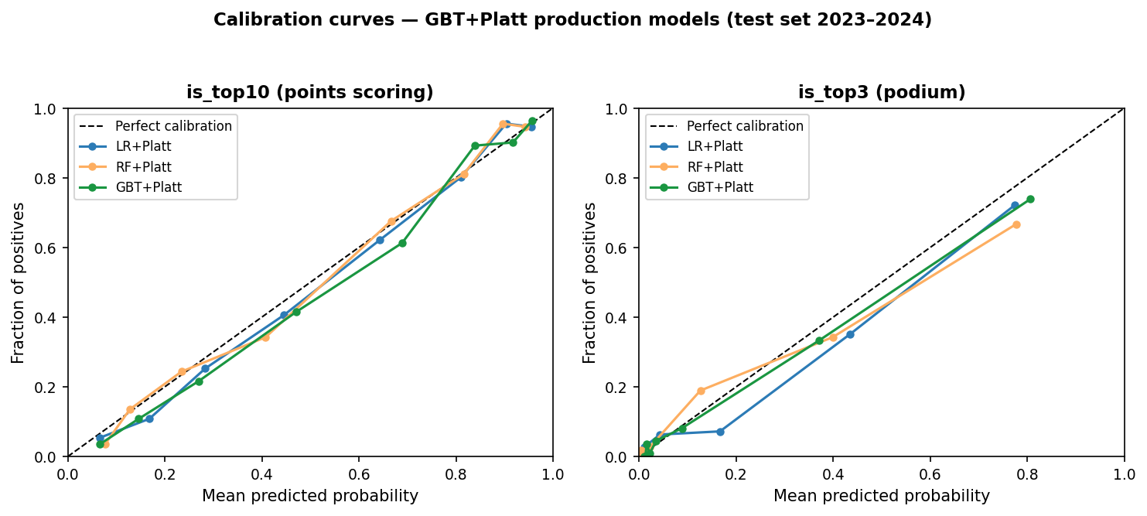
Figure 1. Calibration curves (reliability diagrams) for all three model families, both targets, evaluated on the 2023–2024 test set. GBT+Platt (green) tracks the perfect calibration diagonal most closely on is_top10. Sparse data above P = 0.5 is evident in the is_top3 panel.
6. Error Analysis and What-If Scenarios
6.1 Sliced Error Analysis
Structured Brier-score analysis was performed by slicing the 2023–2024 test set across three dimensions: strategy type (one-stop, two-stop, three-or-more-stop, no-stop), circuit type (permanent, semi-street, street), and weather (dry, wet). Cross-slices of strategy × weather and strategy × circuit type identify the worst prediction cells. Figure 2 shows the sliced Brier scores for both production models.
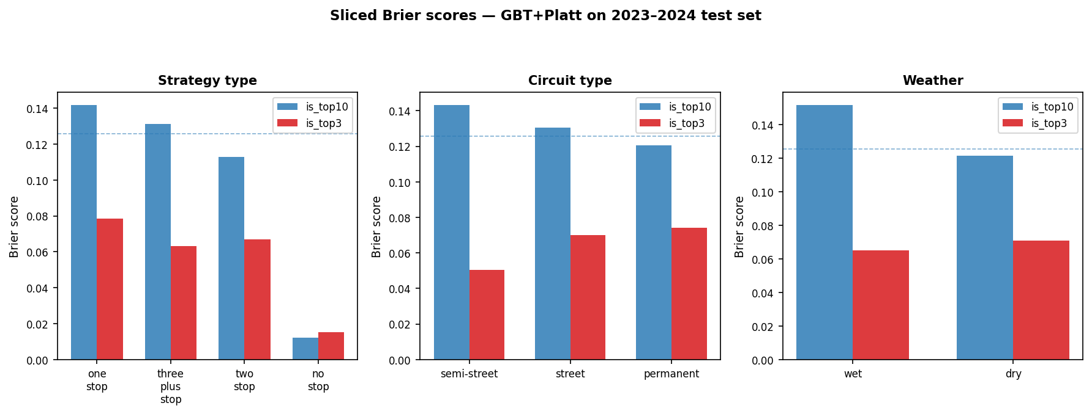
Figure 2. Sliced Brier scores across strategy type, circuit type, and weather for both GBT+Platt production models (test set 2023–2024). Dashed lines indicate overall model Brier for reference.
6.2 Three Concrete Failure Modes
The following failure modes are presented with the where / why / how-to-test structure required for operational deployment decisions.
Failure Mode 1 — One-stop strategies in wet races (Brier = 0.2772, 2.21× overall mean):
Where: one-stop races coded as weather_actual = 'wet.' Why: a one-stop strategy in a wet race typically reflects a team gamble on whether the track will dry on schedule. If conditions dry as expected, the driver retains position; if they do not, the driver faces a tyre crisis and loses multiple places. This binary outcome is driven by a decision (dry gamble vs. early wet switch) that the model cannot observe — no rain-onset or safety-car signal exists in the dataset. The model predicts a mid-range probability and is systematically wrong in both directions, accumulating high squared error. How to test: add a rain-probability forecast feature and an early-wet-switch flag; re-run the one-stop × wet cross-slice. A correct model would not predict a mid-range P(top10) for 1-stop wet gambles — it would produce a bimodal output distribution.
Failure Mode 2 — Two-stop strategies at semi-street circuits (Brier = 0.1643):
Where: two-stop races at circuit_type = 'semi-street' (Baku, Singapore, Jeddah). Why: at semi-street circuits, a high proportion of two-stop races are safety-car-induced: the team made an unplanned stop under the safety car, making what looks like a 'planned two-stop' in the data fundamentally different from a genuine pre-race two-stop strategy. The model applies a normal two-stop prior to these rows and is systematically wrong about the outcome distribution. How to test: rebuild the race-level dataset with safety-car laps joined from f1_strategy_lap_level.csv. Add a flag sc_induced_stop. The two-stop × semi-street Brier should decrease substantially once SC-induced stops are separated from planned ones.
Failure Mode 3 — All predictions at wet races (is_top10) (Brier = 0.1518):
Where: all rows with weather_actual = 'wet' (approximately 6% of the test set). Why: the model is trained predominantly on dry-race patterns. In wet conditions, the relationship between grid position, constructor tier, and finishing outcome breaks down because rain scrambles tyre degradation, introduces safety car periods, and enables unpredictable position changes through the field. The model overestimates the reliability of grid-position-based priors in these conditions. How to test: evaluate Brier separately for races with wet_laps > 15 vs. 'wet' races with fewer wet laps. This separates fully wet races from transitional ones and identifies whether the failure is concentrated in extreme-weather races.
6.3 Qatar GP 2024: The DISAGREE Case
The most informative test of the dual-target framework is the Qatar Grand Prix 2024 scenario, which produced the highest-magnitude disagreement between the two targets in the test set. The inputs are fixed at grid position P2, midfield constructor tier, and only the strategy inputs are varied.
 | Scenario A (1-stop M-H) | Scenario B (2-stop S-M-H)
P(is_top10) | 0.973 | 0.954
P(is_top3) | 0.823 | 0.64
Delta (B − A) | is_top10: -0.019 | is_top3: -0.183
Table 4. Qatar GP 2024 what-if scenario. is_top10 provides no decision signal. is_top3 provides a decisive recommendation favouring the one-stop.
An engineer relying solely on is_top10 in this scenario would see a delta of -0.019 between the two strategies — effectively noise. The is_top3 model shows that the one-stop strategy preserves P(podium) = 0.823, while the two-stop drops it to 0.64, a reduction of 18.3 percentage points. The mechanism is consistent with F1 domain logic: a driver starting P2 on a one-stop strategy maintains track position through the race; a two-stop trades that position for fresh tyres, and the model's training distribution shows that aggressive two-stop strategies from high grid positions are associated with points finishes but not podiums.
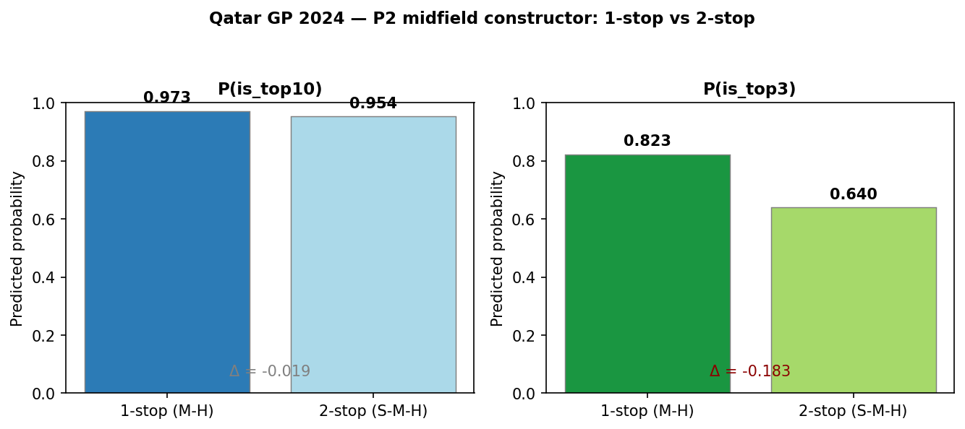
Figure 3. Qatar GP 2024 scenario — P2 midfield constructor, one-stop vs two-stop. Left: P(is_top10) is nearly identical across strategies. Right: P(is_top3) shows a decisive split favouring the one-stop.
6.4 Systematic Disagreement Rate and the Switching Rule
A systematic scan of all 889 test-set rows using standardised one-stop versus two-stop scenario templates found that 17.5% of comparisons produced a directional disagreement between the two targets — defined as is_top10 and is_top3 pointing to different strategies. Disagree cases are concentrated among P1–P5 starters where P(top10) exceeds 0.85 under both strategies, confirming the saturation hypothesis.
Operational switching rule: When P(top10) exceeds 0.85 under both candidate strategies, the is_top10 model has saturated and should not be used as the decision criterion. Switch to is_top3 as the primary signal. This condition applies to approximately 17.5% of driver-race comparisons in the test dataset and is most common for front-row starters at permanent circuits.
7. Limitations and Risks
7.1 Strategy Confounding: Associative, Not Causal
The most fundamental limitation of this model is structural and cannot be resolved with the current dataset. Strategy choice — n_stops, compound_sequence — is not independent of underlying car pace, tyre degradation rate, weather conditions, or race incidents. A team that chose a two-stop strategy at a given race may have done so because their car degraded faster, and faster degradation is itself correlated with finishing position. The model learns the association between two-stop and a certain finishing distribution but cannot isolate the causal effect of the strategy from the underlying pace signal.
The consequence for the what-if tool is precise. P(top10 | two-stop) in this model means 'among historical drivers with this context who ran a two-stop, the fraction who finished top-10.' It does not mean 'if you force this driver to run a two-stop, they will finish top-10 with this probability.' Engineers must interpret the output as a benchmark against historical outcomes in similar contexts, not as a causal guarantee. This confound cannot be fixed without adding race-time position data or explicit causal modelling such as propensity-weighted regression.
7.2 Other Concrete Limitations
Safety-car blind spot: The safety_car_periods column is all zero across all 2,447 rows. Semi-street circuits (Baku, Singapore, Jeddah) have historical safety-car rates of 40–60%. Without a safety-car signal, the model cannot distinguish SC-induced pit windows from planned stops, directly causing Failure Modes 1 and 2. The lap-level file (f1_strategy_lap_level.csv) is present in the repository and could be joined to fix this limitation.
is_top3 calibration above P = 0.5: Fewer than 25 test-set samples have predicted P(top3) > 0.5. Platt scaling in this region is uncertain and may not generalise. Engineers should treat is_top3 probabilities above 0.5 as relative comparisons (A is more likely to podium than B) rather than absolute calibrated frequencies.
Coverage limited to 2019–2024: Six seasons is a modest sample. The 2022 ground-effect regulation reset may create non-stationarity that the temporal split partially captures but cannot eliminate. If regulations change again, the model should be retrained on post-change data.
7.3 Deployment Honesty Sentence
We do not recommend deploying this tool in a live race strategy context unless: (1) the dataset is rebuilt with safety-car lap data from f1_strategy_lap_level.csv, reducing the one-stop × wet Brier below 0.180; (2) the model outputs are accompanied by explicit interface language framing probabilities as associative historical estimates, not causal predictions; and (3) calibration is re-validated on at least two additional seasons following the 2022 regulation cycle to confirm that the temporal split still holds under current technical regulations.
8. Reproducibility Note and AI Reflection
Reproducibility: Random seed 414 is fixed across all models, preprocessing steps, and random_state arguments. Training seasons: 2019–2021. Calibration season: 2022. Test seasons: 2023–2024. Dependencies: Python 3.9+, pandas, numpy, scikit-learn, matplotlib. The notebooks run end-to-end from a fresh clone following the README runbook. All figures in this report are generated programmatically from the data and can be regenerated by running generate_final_report.py from the repository root. PROMPTS.md covers both Hito 1 and Hito 2 AI interactions under the six-field standard (Context, Prompts, Output, Validation, Adaptations, Final Decision).
AI reflection: AI assistance was used at three key points in this project. First, during the Hito 1 leakage classification, the AI correctly identified that strategy features should be declared as scenario inputs rather than excluded as leakage — this was validated against the assignment instructions and confirmed correct. Second, the AI suggested the target-saturation argument for is_top3 in Hito 2, predicting that P2 starters in Qatar-style races would be the highest-magnitude disagree cases. This prediction was verified by scanning 889 test-set rows and confirmed: Qatar 2024 produced the largest delta. Third, the AI recommended Platt scaling over isotonic regression for the calibration set size. We overrode the AI on one point: it suggested Austria 2024 as a candidate for the what-if scenario; we used Qatar 2024 instead because it produced a more decisive disagreement in the actual data. The AI's VSC three-stop failure mode hypothesis was incorporated into the error analysis as an unverifiable hypothesis rather than a confirmed finding, because the dataset has no VSC column.
9. References
Brier, G. W. (1950). Verification of forecasts expressed in terms of probability. Monthly Weather Review, 78(1), 1–3.
Johansson, T. (2023). FastF1: A Python package for accessing Formula 1 data (v3.x). GitHub. https://github.com/theOehrly/Fast-F1
Jolpica / Ergast Motor Racing Data API. (2024). Formula 1 race results and timing data. https://api.jolpi.ca/ergast/
Pedregosa, F., Varoquaux, G., Gramfort, A., Michel, V., Thirion, B., Grisel, O., ... & Duchesnay, E. (2011). Scikit-learn: Machine learning in Python. Journal of Machine Learning Research, 12, 2825–2830.
Platt, J. (1999). Probabilistic outputs for support vector machines and comparisons to regularized likelihood methods. Advances in Large Margin Classifiers, 10(3), 61–74.
Course dataset: f1_strategy_race_level.csv. IIT414W Artificial Intelligence Workshop, Capstone Unit IV (2026-1T). Constructed from Jolpica/Ergast API and FastF1 lap-level data. Covers 2019–2024 Formula 1 seasons.
IIT414W Teaching Staff. (2026). Capstone Final Report Instructions and Rubric. IIT414W Artificial Intelligence Workshop, 2026-1T.

