Project Automate:

General Overview:
Project automate is a system built to automate the creation of short form content on a variety of platforms such as: YouTube shorts, Instagram reels, and TikTok. Several American accounts will be created beforehand on these platforms to serve as outlets for the short form content. The intent of this project is to create a large amount of formulaic content spanning a variety of different topics to capitalize on creator programs/funds on the given platforms.

The automation of short form content is composed of three systems: scraping, creating, and publishing. Scraping is the process of observing and collecting media from the internet. This media can include text, images, or videos. The content of the media to be scraped is up to the discretion of the account needs for content. Creation is the process of taking in scraped content and generating short form video. Videos will have a specific formula and will be predictable in their content. Finally, publishing is the process of taking videos and scheduling it’s upload it to its respective account and platform. Videos can then be easily reviewed in advance on the respective platform.
In addition to the content creation systems, there are two more components to the system: the proxy and storage. A proxy server will be used to act as a middle for the communications to the internet. Particularly, the traffic of the system needs to imitate an American ip addresses to have access to monetization on most platforms. Additionally, traffic also needs to constantly change ips to easily access websites multiple times for web scraping. Lastly, the storage system describes where all the media files flowing throughout the system will be placed. These components, in addition to the previously mentioned subsystems, make up the larger system for automated shortform content creation.

System Specifications:

Storage:
The storage component takes care of storing scraped data, rendered videos, and account credentials. A database management system, particularly MariaDB, will manage assist in properly managing and organizing the data. Data will be organized based on emails and social media account credentials. For example: dvmedia00@gmail.com is connected to a tiktok account that posts narration videos. The DBMS will contain pointers to scraped data for the specific account, rendered videos associated to the account, and account credentials for posting requests to the account. The data is to be stored in a 1 TB hdd, and can be expanded if needed.
Requirements:
- System is to have a clean file system that organizes all aspects of an independent account into a directory.
- The RDBMS MariaDB is to be deployed and ready to accept requests. Queries to handle:
  - Store account data: email, password.
  - Store location and account association of media data.
  - Pull
- Media is to NOT be stored in the database, but in an organized file system on a hdd.
- Inputting of an email account is done with a python script that runs a query on the database. (Later to be done via a user interface).
- Handle all files such as scraped media and exported data, on a specified hdd.

Networking:
The networking component takes care of interfacing with the internet. There are two points in which the entire system interfaces with the internet: For pulling data and for uploading videos. Pulling data, in some cases, requires that the ip changes multiple times. Uploading videos requires that the ip originates from one stable US location. To implement these two parts, this component will use containers of OpenVPN to connect to nordVPN. One container will constantly change it’s ip while the other will have one static ip.
Requirements:
- Component is to change the ip for web scraping traffic of whole system.
- Component is to keep a static US ip for uploading traffic of the whole system.

Scraping:
The scraping component will pull assets from websites for use in video creation. This will be developed in python3. A general scraper will be designed to take in requests. The python3 library: Beautiful Soup 4 and Requests will be used to access and pull web data. Additional methods for pulling content can be used such as using apis from websites.
Requirements:
- System is to send and receive requests to the internet from various predetermined sources and pull desired content for video automation. Timing and frequency of pulling data is to be determined while deployed.
- Use multithreading to send and receive requests as web scraping is I/O bound.
- System is to write data into central storage in designated position in file system and write to database that the new content has been pulled.

Creating:
The creator component takes the central storage’s media content pulled from the scraper and processes the media components into formulaic short form video contents. This will be developed in python3 and will mainly use the MoviePy library to edit videos.
Requirements:
- System is to pull content of designated account from central storage. Ie: I/O is to be handled in a multithreaded programing manor.
- System is to render multiple videos in a parallel processing manor using moviepy scripts.
- How media is parsed and manipulated is handled to the discretion of the account needs. Ex: Long meme compilations being chopped up will be different from how narration videos.
- Any components of videos that are shared, will be in a dedicated library file for code reuse. Ex: text subtitles will be a reusable library.
- System is to output final rendered content to central.
- System is to mark used media files in central as “used” and queed for deletion.

Publishing:
The publisher component takes rendered videos from central and preps them for upload. There are three platforms to focus on: TikTok, YT shorts, and Meta’s Instagram/Facebook. Uploading the content to these platforms by any means necessary, even if this means bypassing some of the official apis.
Requirements:
- System is to pull videos from central and queue them for uploading to their respective account onto social media.
  - Sometimes an account will be active on social media on multiple platforms concurrently at the same time.
- System is to use multithreading to handle parallel uploads.
- On a successful upload, system is to mark video in central as uploaded.

Diagram:
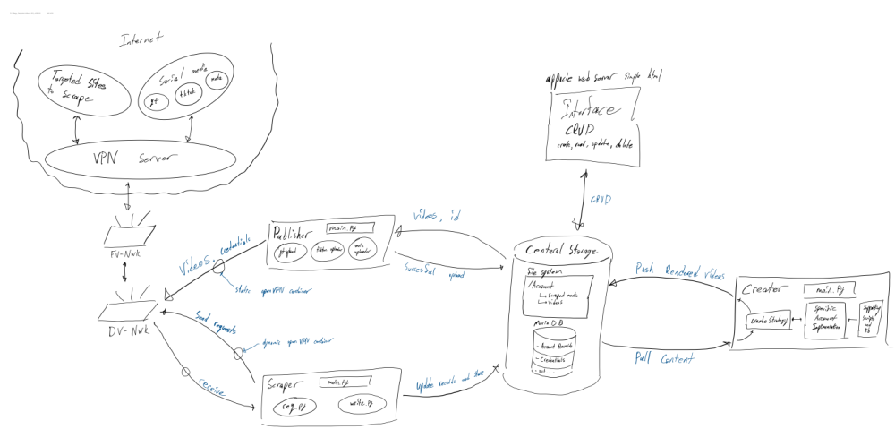

Operating Environment:

Environment

All the infrastructure is to be done on premises to avoid costs from cloud providers. The DELL PRECISION 5820 is the main server running the Scraping, Creating, Publishing, and the VPN component Networking sub systems. The Dell will run a type 1 hypervisor: Proxmox to deploy.

Constraints
The constraints are not scalable.

Ideas:
- Live stream an AI and then get the chat to make it say stupid things

