Submitting code for review

# Logging into CodeCommit

**1.1** Authenticate for AWS access <https://access.amazon.com/aws/accounts/>

**1.2** Open the CodeCommit console at <https://console.aws.amazon.com/codesuite/codecommit/home>

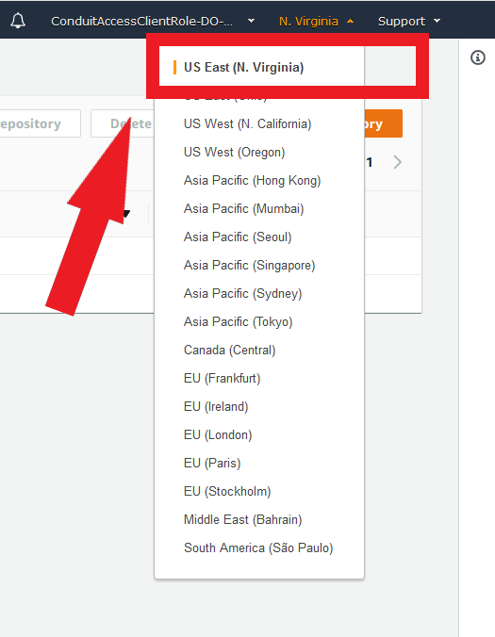**1.3** Select US East (N. Virginia) as the region

**Figure 1.1**

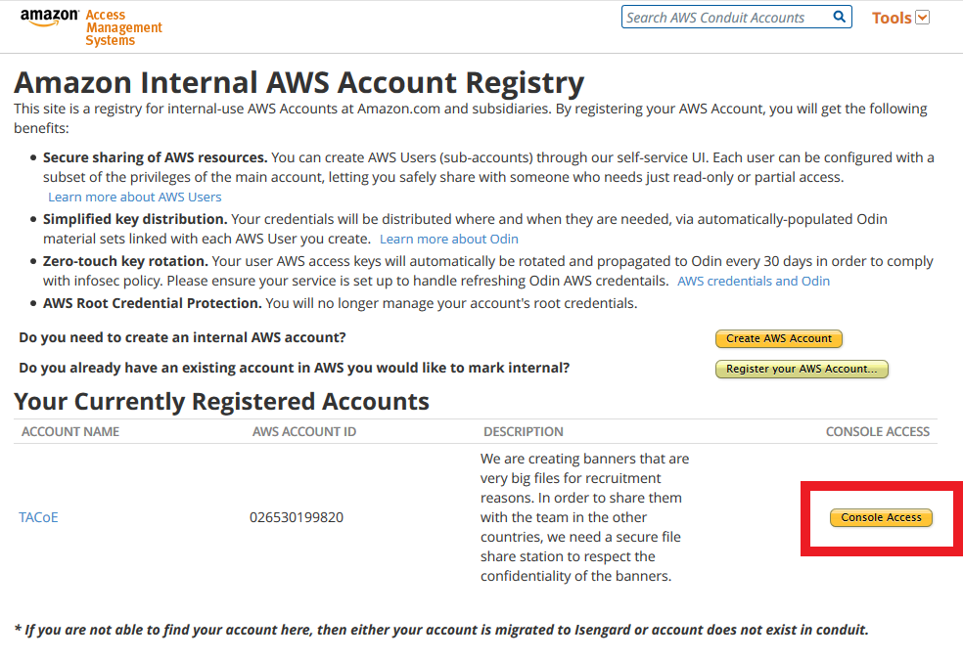

**Figure 1.3**

# Creating a repository

In order to upload code you first have to create a repository which will store all files for the particular ticket you are working on. A name and optional description are required.

* 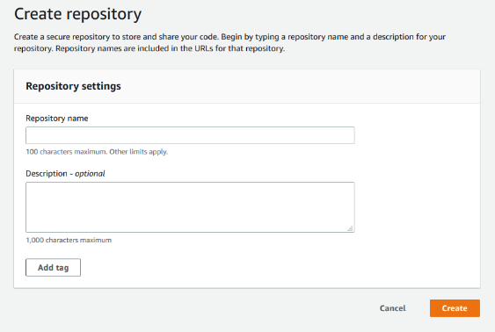Name
* Description (optional)

After you create a repository, you can connect to it and start adding code.

# Naming convention (Repository name)

The first part of the repository name should be the GATA code which can be found in the URL as well as next to the directory highlighted in grey.

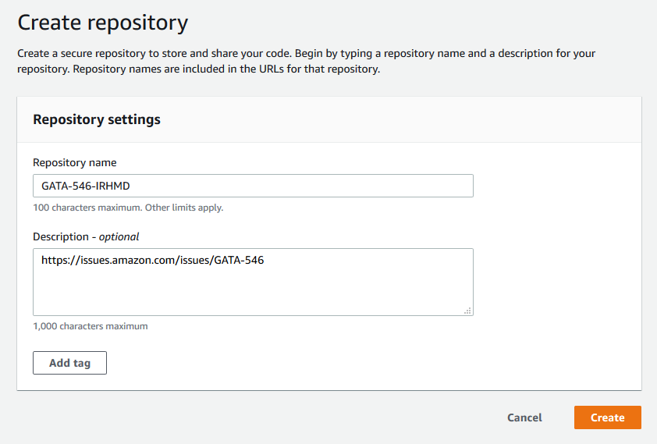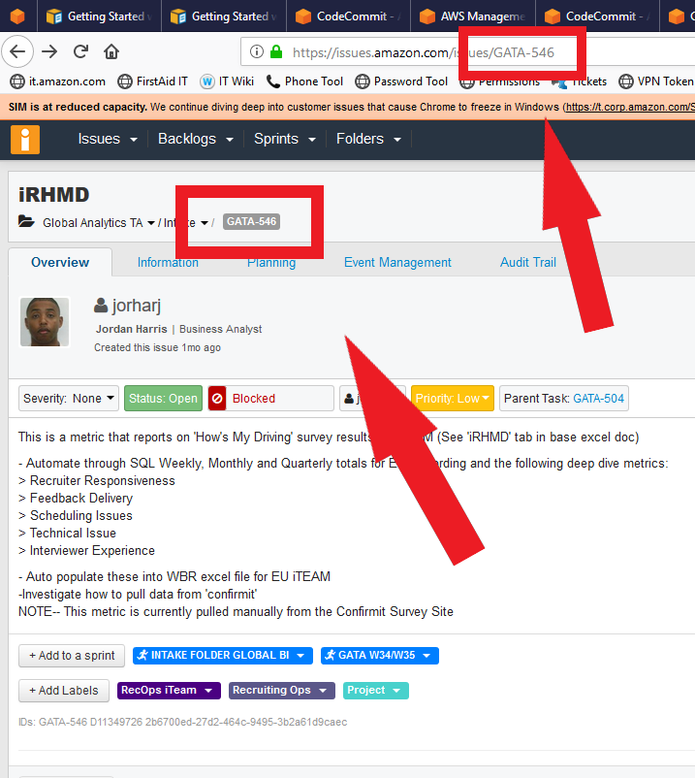

**Naming format:** **(**GATA CODE**)-(**Ticket title**)**

Link for the ticket along with any other optional information can be placed in the description.

# Uploading files to repository

After creating a repository files can be uploaded and added on the following page.

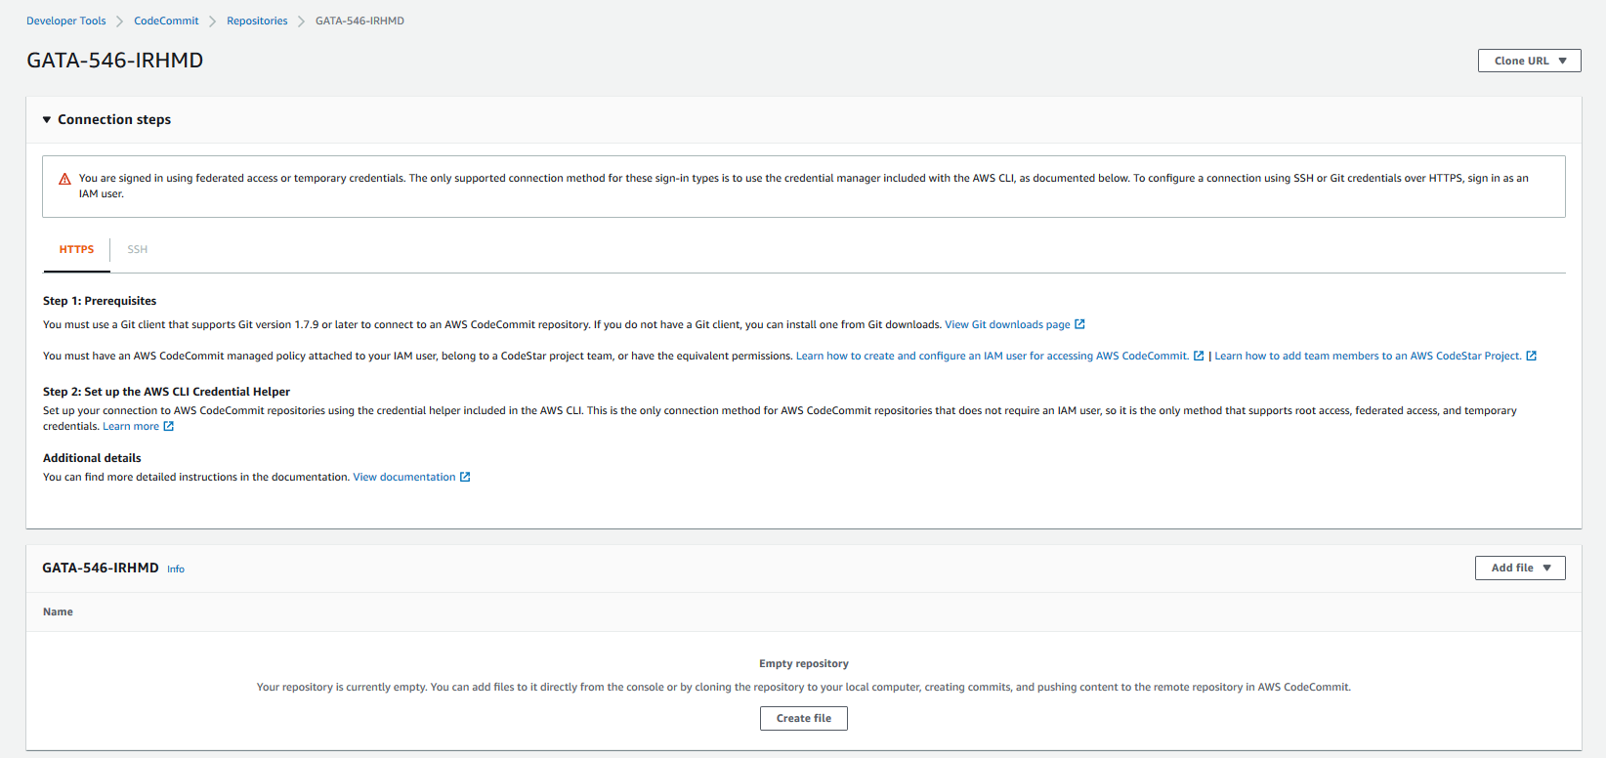

After the files have been uploaded to the repository and updated the link of the repository can be sent to the auditor for code review.

# Files in a repository

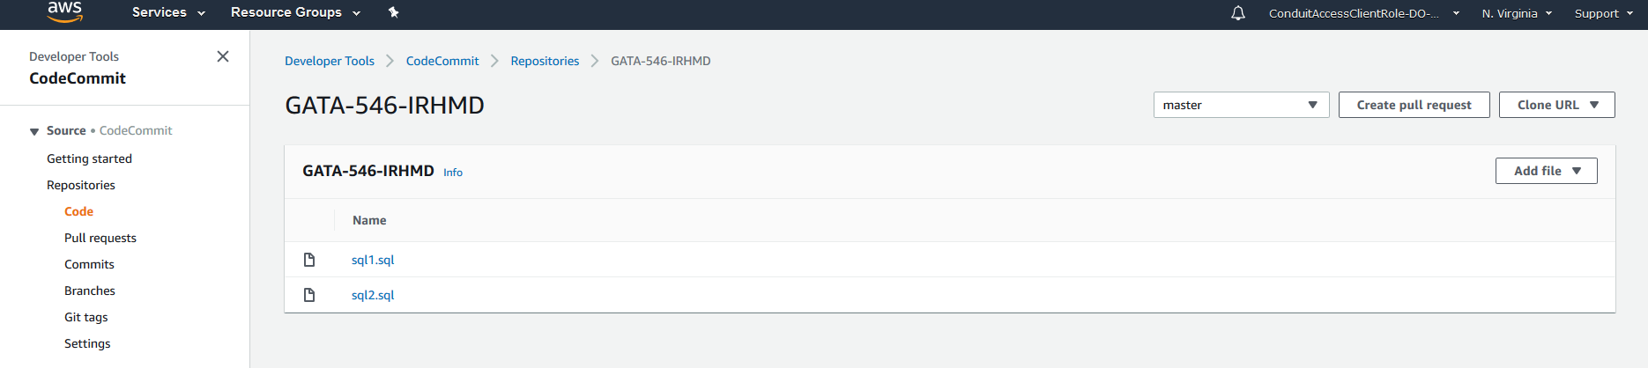

Once files have been added they can be viewed/filtered. Branches can be used to create different versions of certain files. Left sidebar shows all the different areas of CodeCommit. Files can be cloned easily and placed into a separate branch to test changes in the code.

# Additional Links

Extra information on CodeCommit and its features

**What Is AWS CodeCommit?**

<https://docs.aws.amazon.com/codecommit/latest/userguide/welcome.html>

**Working with Repositories in AWS CodeCommit**

<https://docs.aws.amazon.com/codecommit/latest/userguide/repositories.html>

**Delete a Repository**

<https://docs.aws.amazon.com/codecommit/latest/userguide/how-to-delete-repository.html>