# MPC-MAP Assignment No. 4 - Report

## **Author:** Šimon Prasek

## **Date:** 18.03.2025

## Task 1

As we already examined the uncertainty of the GNSS measurement in the first week I used these values for the matrix Q. After the first run in the update_kalman_filter the counter is used for measuring the mean values of the gnss_history data and then I kf.R is set to the desired values.

## Task 3

After tuning the R matrix and with all the conditions defined in task 3 the robot was able to get to the goal position without many problems.

Figure - Filter tuning with a known initial pose

## Task 4

In Figure 2, it can be clearly seen that the first 15 measurements appear somewhat inconsistent. However, after that, the robot begins to approach the intended trajectory and reaches the destination without significant issues.

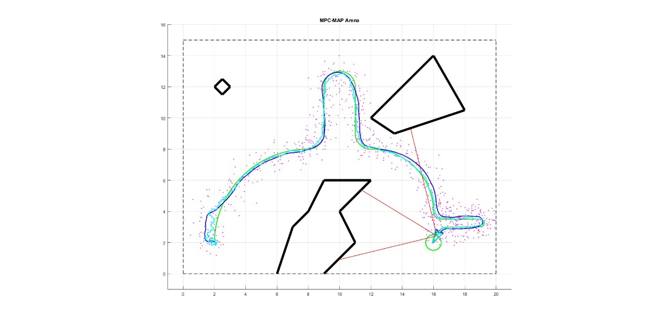

Figure - Filter tuning with a unknown initial pose