# MPC-MAP Assignment No. 5 - Report

## **Author:** Šimon Prasek

## **Date:** 25.03.2025

## Task 2

After implementing the A* algorithm for the path planning I implemented algorithm to keep a clearance from obstacles, I set the clearance to 0.3 m.

## Task 3

Using the iterative algorithm provided in the lecture I implemented the smoothing function that you can see below in figure 1. I set parameter B to 0.7 so the path is smoother than if I would set it to smaller value.

Figure - Planned path vs smooth planned path

In the figures bellow you can see some more planned paths – please note that in the indoor maps I had to set the PF to bet the main algorithm for path planning since I didn’t make the switching of the algorithms yet. For the indoor map planning I had to implement a part of code that is commented out that changes the path each X iterations of the code because of the estimated pose – sometimes the simulator crashes due to “Path not found” issue because it tries to calculate the path when the estimated pose is moving its location and it’s in the wall.

Figure - Path planning in indoor maps

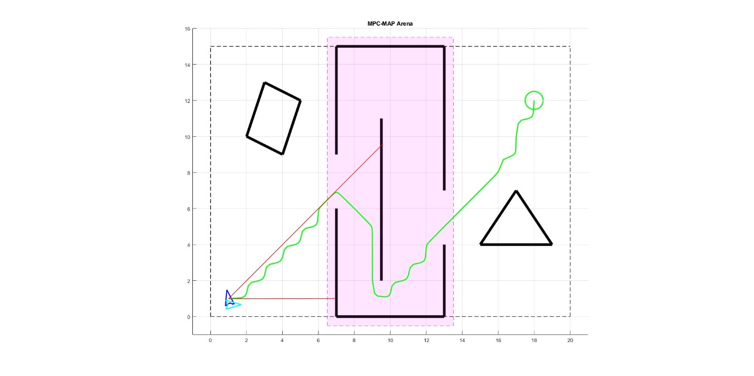

Figure - Mixed map, starting pose 1

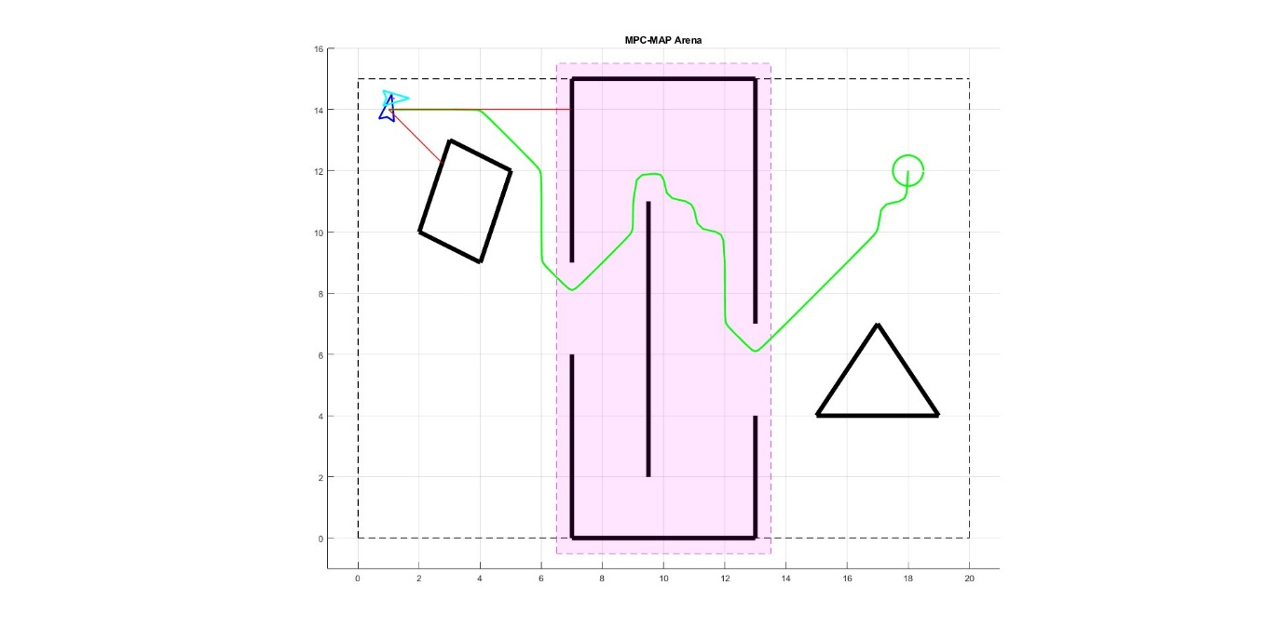

Figure - Mixed map, starting pose 2