Quantifying The Divergence Between Operation-Based Complexity Metrics And Measured Energy Consumption In Edge Inference
¹O.J. Akojede, ²E.V. Kwuelum, ³T.E. Hamzat
^{1,2}Department of Biomedical Engineering, University of Lagos.
³Department of Mechanical Engineering, University of Lagos.
daraakojede01@gmail.com, capitise90@gmail.com, hamtemilolu@gmail.com

Abstract
Floating Point Operations (FLOPs) and Multiply-Accumulate Operations (MACs) are commonly used as hardware-independent proxies for neural-network efficiency, although they describe arithmetic workload rather than the energy costs of execution and data movement. This study evaluates the reliability of these proxies using 43 frozen neural networks deployed on a Raspberry Pi 4 and an ESP32-S3. The same full-integer INT8 TensorFlow Lite artifacts and deterministic input sequences were evaluated on both platforms, while FP32 was additionally measured on the Raspberry Pi to better understand any precision relationship. Board level energy was measured using an external INA226 current module, repeated-inference windows, and adjacent-idle subtraction. The experiment produced 258 and 129 valid trials on the Raspberry Pi and ESP32-S3 respectively. In the two primary standard-depthwise pairs, energy used by the depthwise model was 49.5% and 44.8% higher that its standard convolution model on the Raspberry Pi and 82.4% and 88.9% higher on the ESP32-S3. Measured latency was more closely associated with energy than any of the selected static predictors on both platforms. These results show that MACs describe broad within-platform energy scaling but cannot reliably quantify the energy gap between structurally different models across different hardware and runtime environments.

Keywords: Energy Consumption, Edge Devices, Operation Counts, Floating Point Operations (FLOPs), Multiply-Accumulate Operations (MACs).

1. Introduction
Real-world applications of Artificial Intelligence inference is shifting from centralized cloud infrastructure to edge computing, as local processing has been proven to reduce reliance on off-site connections while optimizing energy, latency, memory, and privacy (Singh & Gill, 2023). A model’s computation and energy consumption requirements will hence determine whether it can be deployed on certain target devices, particularly in resource-constrained scenarios.
Since direct measurement of energy consumption depends on the deployment environment and choice of hardware, operation-based complexity metrics are widely used as an approximation of model efficiency by researchers and engineers. FLOPs, MACs, and parameter counts are the most popular choices due to accessibility prior to deployment, ease of computation, and platform independence. This comes with a caveat, however, as operation counts may represent arithmetic workload but do not necessarily reflect accurate data movement and computation costs.
Neural network energy consumption depends not only on computation, but also on memory access, activation lifetime, operator implementation, numerical precision, and runtime scheduling (Tu et al., 2023). Earlier work has likewise shown that equal FLOP counts do not guarantee equal execution speed because memory access and platform characteristics also matter (Ma et al., 2018), and that reductions in model size or operation count do not necessarily produce proportional energy reductions (Yang et al., 2017). Consequently, operation counts may describe broad workload scaling while still obscuring energy differences between models with different architectures.
Prior evidence already establishes that operation count is not universally equivalent to energy. Henderson et al. (2020) showed more broadly that computational reporting alone does not consistently characterize measured energy across machine-learning systems. Wess et al. (2023) found latency substantially more predictive than operation count across several edge accelerators, while Speckhard et al. (2023) observed substantial energy variation among mobile-CPU architectures with similar FLOP counts and a strong relationship between latency and energy. Lahmer et al. (2022) derived layer and board specific models for NVIDIA edge boards, and Guo et al. (2025) combined network structure and device encodings in a learned cross-device energy predictor. In contrast, operation count can remain useful inside a tightly constrained microcontroller search space (Banbury et al., 2021). Broader edge benchmarks likewise report platform and protocol dependent behaviour (Baller et al., 2021; Bartoli et al., 2025b; Tschand et al., 2025). Building on this evidence, this study tests whether the predictive value of operation counts and the model rankings they imply remain stable when the same set of model artifacts is evaluated across different hardware classes, particularly for models with different architectures but nearly equal operation counts.
This paper makes three contributions. First, it evaluates a frozen 43-model corpus containing controlled architectural variants and prespecified standard-depthwise pairs with closely matched MAC counts. Second, it applies the same board measurement principles—external current monitoring, repeated-inference windows, and adjacent-idle subtraction—to a Raspberry Pi 4 and an ESP32-S3 while holding the common INT8 artifact corpus and input sequence fixed. Third, it compares MACs with graph-derived byte proxies and primarily, measured latency to distinguish broad workload scaling from platform-dependent model ranking. The study addresses the following research questions:
- How strongly do FLOPs and MACs correlate with measured inference energy across representative edge platforms?
- Does this relationship differ between microcontroller-class and Linux-based edge systems?
- Do graph-derived memory-aware metrics or measured latency explain energy consumption more effectively than operation counts alone?
- Can structurally different models with closely matched operation counts reveal failures in operation-count-based energy estimates across hardware classes?

2. Materials and Methods
An initial controlled experiment separated a predictor phase from the measurement phase. Before energy outcomes were examined, the data partitions, model corpus, task-quality criteria, deployment artifacts, static predictors, controlled comparisons, and exclusion rules were fixed. The measurement phase deployed those frozen artifacts without retraining or graph modification and recorded latency and board-input energy under platform-specific controls for every valid trial of the study.
One fixed artifact was executed under one fixed hardware and runtime configuration. The common cross-platform condition used the same full-integer INT8 TensorFlow Lite artifact and deterministic input order on the Raspberry Pi 4 and ESP32-S3. Raspberry Pi FP32 measurements formed a within-platform precision comparison. Three repeated measurement windows quantified technical variation within each measured condition, this allowed to solidify repeatability claims. The model corpus combined application-oriented workloads with controlled probes that varied convolution type, channel width, spatial activation size, residual structure, and parameter concentration; this variation was intentionally stretched to better understand the relationship between several architectural conditions and their effect on how data moves in those conditions.

2.1 Model Corpus
The canonical sample of 43 trained neural networks comprised 4 reference-style workloads and 39 controlled architectural probes, as shown in Figure 2.1.
The four reference-style workloads were:
- ResNet-8 style CIFAR-10 image classifier (He et al., 2016; Saha et al., 2024),
- Depthwise-separable convolutional network (DS-CNN) for keyword spotting (Bartoli et al., 2025a; Zhang et al., 2017),
- Width-reduced MobileNetV2 visual-wake-word model (Datta et al., 2022; Sandler et al., 2018), and
- Fully connected ToyADMOS autoencoder for acoustic anomaly detection (Koizumi et al., 2019).
Thirty-eight of the 39 probes formed eight replicated width families while the dense keyword-spotting bottleneck was a singleton control. For family-resampled analyses, these nine probe groupings and the four reference models formed 13 architecture-family clusters.
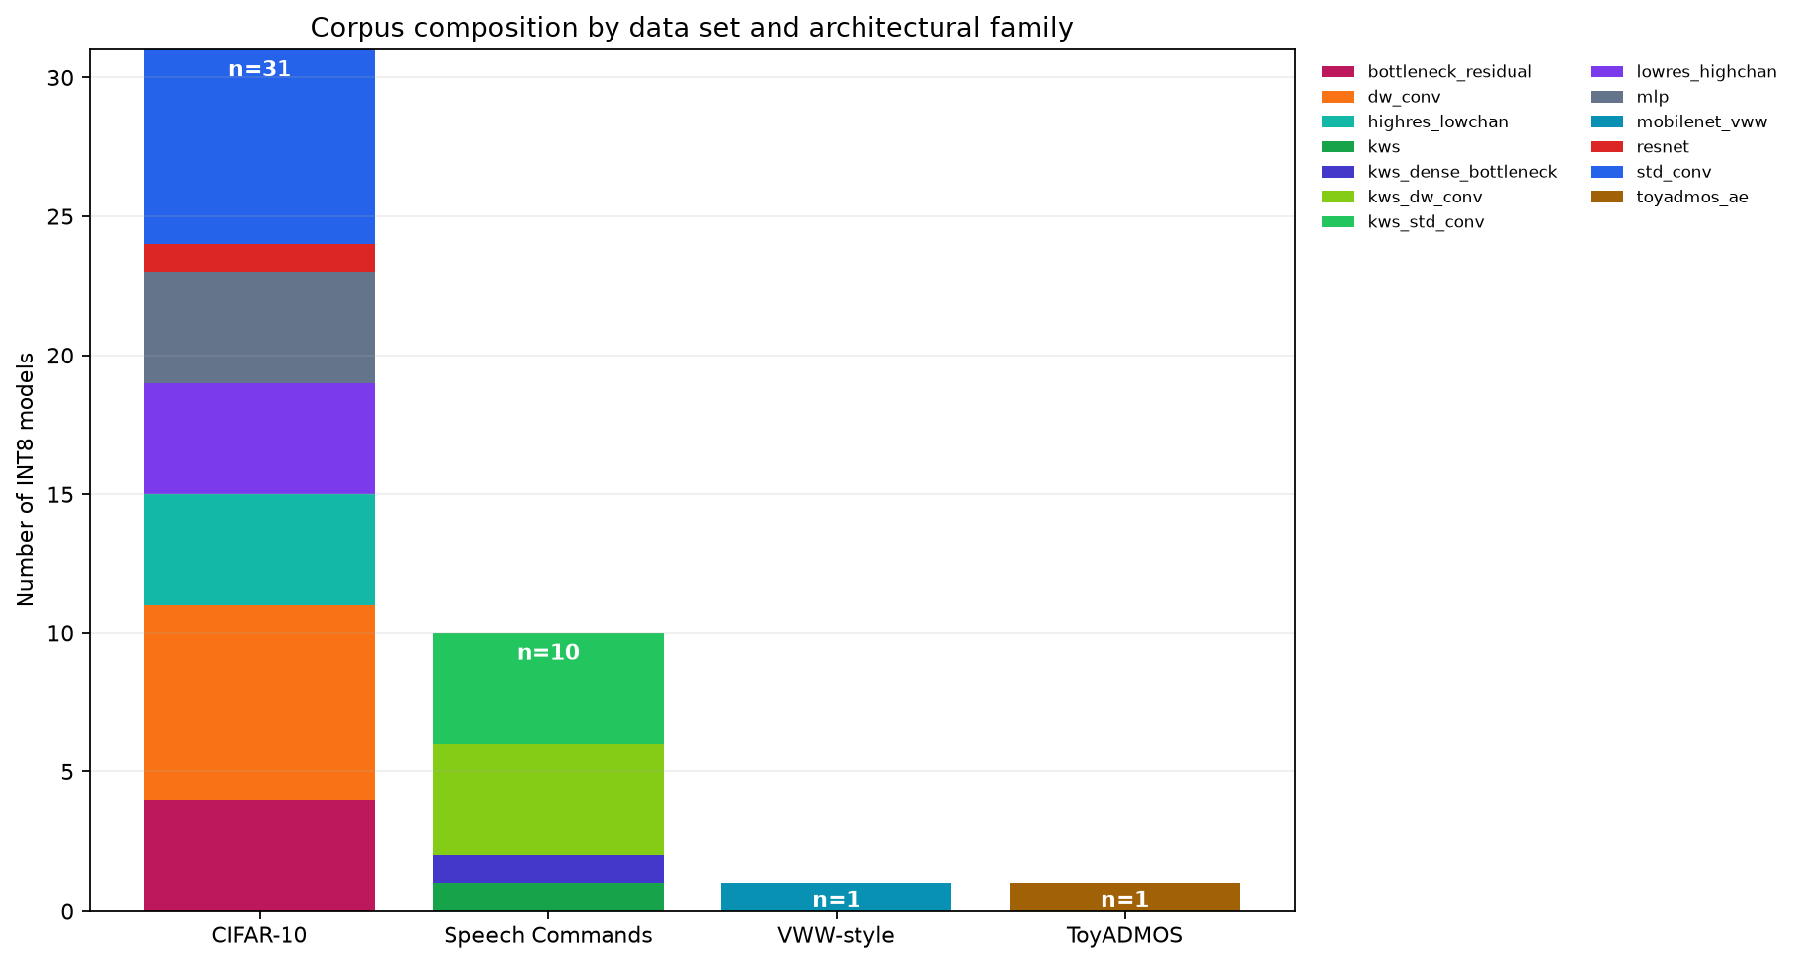
Figure 2.1. Composition of the 43-model corpus.

2.2 Datasets, Training, and Deployment of Artifacts
Four datasets were divided into fitting, validation, and held-out test sets using recorded seeds. Normalization statistics and post-training quantization representative samples were derived only from fitting data, test data was excluded from model selection, early stopping, normalization-statistic estimation, and quantization calibration.

2.2.1 CIFAR-10
The official 50,000-image training set was divided by seeded permutation into 45,000 fitting and 5,000 validation images. Images were channel-wise standardized using statistics estimated from the fitting partition. The official 10,000-image test split was retained for final evaluation, and balanced accuracy was reported (Krizhevsky, 2009).

2.2.2 Speech Commands v0.02
Speech Commands v0.02 was divided using its published validation and testing lists into 36,923 fitting, 4,443 validation, and 4,888 test examples across 12 classes. One-second, 16 kHz recordings were represented by 49 × 10 mel-frequency cepstral coefficient matrices, and balanced accuracy was reported (Warden, 2018).

2.2.3 Visual wake words
A balanced visual-wake-word-style subset was constructed from COCO 2014, with a positive label assigned when a non-crowd person occupied at least 0.5% of image area. Images were resized to 96 × 96 pixels and scaled to [0, 1]. The 16,000-image fitting subset and disjoint 2,000-image validation and test subsets preserved person-size and difficult-negative strata. Because this was a controlled subset rather than the complete official benchmark, results are described as VWW-style rather than official MLPerf Tiny scores (Chowdhery et al., 2019; Lin et al., 2014).

2.2.4 ToyADMOS
ToyCar normal training and test recordings were converted to normalized 640-element spectral vectors. The autoencoder was fitted only on normal training vectors and evaluated using reconstruction error, receiver-operating-characteristic area under the curve (AUC), and partial AUC (Koizumi et al., 2019).
Classification models were trained in TensorFlow/Keras using Adam, sparse categorical cross-entropy, an initial learning rate of 0.001, and a batch size of 128. Early stopping monitored validation accuracy with a patience of 10 epochs and restored the best weights and the learning rate was reduced when validation loss stopped improving. CIFAR-10 models used horizontal reflection and translation augmentation, and keyword-spotting convolutional models received small additive feature noise. The VWW-style condition used MobileNetV2 with width multiplier 0.35 and ImageNet initialization: its head was trained with the backbone frozen before upper layers were fine-tuned at a lower learning rate while earlier and batch-normalization layers remained frozen (Sandler et al., 2018). The ToyADMOS autoencoder used Adam and mean-squared reconstruction loss, with the best checkpoint selected by validation reconstruction loss. Task performance served as a quality check rather than the primary outcome of this study; model accuracy is reported in Appendix A.
Every selected model checkpoint was converted to an FP32 TensorFlow Lite artifact and a full-integer INT8 artifact using at most 300 deterministic fitting examples for calibration. INT8 conversion required signed INT8 input-output tensors and integer TensorFlow Lite operators, providing the common deployment representation for TensorFlow Lite Micro on the ESP32-S3 and LiteRT on the Raspberry Pi (David et al., 2021; Jacob et al., 2018). FP32 was retained only on the Raspberry Pi because its Linux LiteRT/XNNPACK runtime supports FP32 efficiently. Running FP32 on the ESP32-S3 would require a different, slower execution path, consume substantially more memory, and some models might not fit or deploy. The full-integer INT8 TensorFlow Lite Micro models are the practical deployment format optimized for the ESP32-S3.

2.3 Static Metrics and Controlled Comparison
For all 43 models, static predictors were derived before hardware energy outcomes were inspected. Table 2.1 shows the deployed-graph MAC count as the primary arithmetic predictor, while the static byte-access proxy and its component quantities represented prespecified graph-structure alternatives.

Table 2.1. Static predictors.
Static Quantity | Analytical Role | Definition | Unit | Interpretation
Deployed-graph MAC count | Primary predictor | Sum of MACs across convolutional, depthwise, and fully connected operators. | MACs/inference | Arithmetic workload
Static byte-access proxy | Primary competing predictor | Input bytes + Output bytes + 2 × Intermediate activation bytes + Parameter bytes | Bytes/inference | Idealized data access demand
Activation output bytes | Secondary predictor | Sum of intermediate operator-output tensor sizes | Bytes | Volume of intermediate activations
Parameter footprint | Secondary predictor | Unique weight and bias tensor bytes | Bytes | Stored model data required during inference
Peak live tensor estimate | Secondary predictor | Estimated maximum size of tensors simultaneously alive | Bytes | Approximate working memory pressure
TensorFlow Lite artifact size | Secondary predictor | Actual deployed .tflite file size | Bytes | Deployment storage footprint
Arithmetic intensity | Exploratory derived predictor | MACs/static byte-access proxy | MACs/byte | Graph-derived work per estimated byte
Operator composition | Exploratory structural predictor | Proportion of work assigned to convolution, depthwise convolution, fully connected, and other operators | Percentage/count | Describes the type (and not merely the amount) of computation

The static byte-access proxy was calculated using Equation 2.3:

SB = B_{i} + B_{o} + 2AB_{o} + B_{p} (2.3)

where SB is the static byte-access proxy, B_{i} and B_{o} are input and output bytes, AB_{o} is the sum of intermediate operator-output tensor sizes, and B_{p} is unique parameter bytes. The factor of two treats each intermediate output as one write followed by one later read. It is an intentionally simple graph-derived lower-bound proxy, not a measurement of cache, flash, PSRAM, or DRAM traffic. Sensitivity analysis using activation multipliers from one to four changed the coefficient sizes but the overall finding remained the same: activation-related information added explanatory value beyond MAC count, especially on the ESP32-S3.
MACs were recomputed from the deployed TensorFlow Lite operator and tensor shapes. One multiplication followed by one accumulation was counted as one MAC. Under the study's explicit convention, that computation equals two FLOPs, so FLOPs = 2 × MACs for every model; quantization changes operand width but not graph MAC count. Consequently, FLOPs and MACs have identical rankings and correlation coefficients in this corpus, and the analysis focuses on MACs to avoid presenting a constant rescaling as independent evidence. There were nine standard-depthwise pairs with less than 10% MAC count difference and they are documented in Table 2.2. While a model’s accuracy does not directly determine the energy it spends on inferencing, the quality differences of both standard and depthwise convolution models are also documented to show that they are within the same bracket.
A broader descriptive screen identified 35 standard/depthwise combinations in total with less than 50% MAC difference. Because the same models appear in multiple combinations, these overlapping pairs were not treated as independent confirmatory tests.

Table 2.2. Near-MAC standard/depthwise pairs.
Standard Model | Depthwise Model | Standard MACs | Depthwise MACs | MAC Difference | Standard Static Bytes | Depthwise Static Bytes | Static-Byte Increase (%) | Activation-Byte Increase (%) | Quality Difference
std_conv_32 | dw_conv_64 | 7,963,264 | 8,049,280 | 1.074% | 193,850 | 539,610 | 178.4% | 288.9% | 1.13 pp
std_conv_36 | dw_conv_72 | 9,954,000 | 9,829,584 | 1.258% | 225,462 | 608,394 | 169.8% | 288.9% | 0.72 pp
std_conv_40 | dw_conv_80 | 12,165,920 | 11,781,920 | 3.207% | 258,802 | 677,562 | 161.8% | 288.9% | 1.52 pp
std_conv_28 | dw_conv_56 | 6,193,712 | 6,441,008 | 3.915% | 163,966 | 471,210 | 187.4% | 288.9% | 4.40 pp
std_conv_24 | dw_conv_48 | 4,645,344 | 5,004,768 | 7.449% | 135,810 | 403,194 | 196.9% | 288.8% | 4.43 pp
kws_std_conv_32 | kws_dw_conv_64 | 3,238,464 | 3,245,056 | 0.203% | 119,030 | 262,102 | 120.2% | 297.5% | 1.17 pp
kws_std_conv_28 | kws_dw_conv_56 | 2,494,968 | 2,555,392 | 2.393% | 98,178 | 228,070 | 132.3% | 297.4% | 1.07 pp
kws_std_conv_24 | kws_dw_conv_48 | 1,848,240 | 1,946,880 | 5.198% | 79,054 | 194,422 | 145.9% | 297.4% | 0.82 pp
kws_std_conv_20 | kws_dw_conv_40 | 1,298,280 | 1,419,520 | 8.922% | 61,658 | 161,158 | 161.4% | 297.3% | 2.37 pp

2.4 Hardware Platforms and Pre-Inference Preparation
The Raspberry Pi 4 used LiteRT 2.1.6 with XNNPACK, one inference thread, CPU 3 affinity for inference, CPU 2 affinity for the logger, a fixed 1.8 GHz performance setting, and an independently powered stationary fan to keep board temperature fairly constant. The ESP32-S3 used TensorFlow Lite Micro 1.4.0 with ESP-NN pinned to exactly 1.4.1 in the component manifest and optimized kernels at 240 MHz; the models were mapped from flash memory, while input banks and the tensor arena resided in PSRAM (Espressif Systems, 2026a, 2026b; Raspberry Pi Ltd., 2024). The platforms were not forced to use identical internal execution environments because those differences are part of the research question. Both boards were measured at their supply inputs using the same INA226 module configured with the nominal 0.002-ohm shunt and a 9 ms update interval (Linux Kernel Developers, 2022; Texas Instruments, 2024).
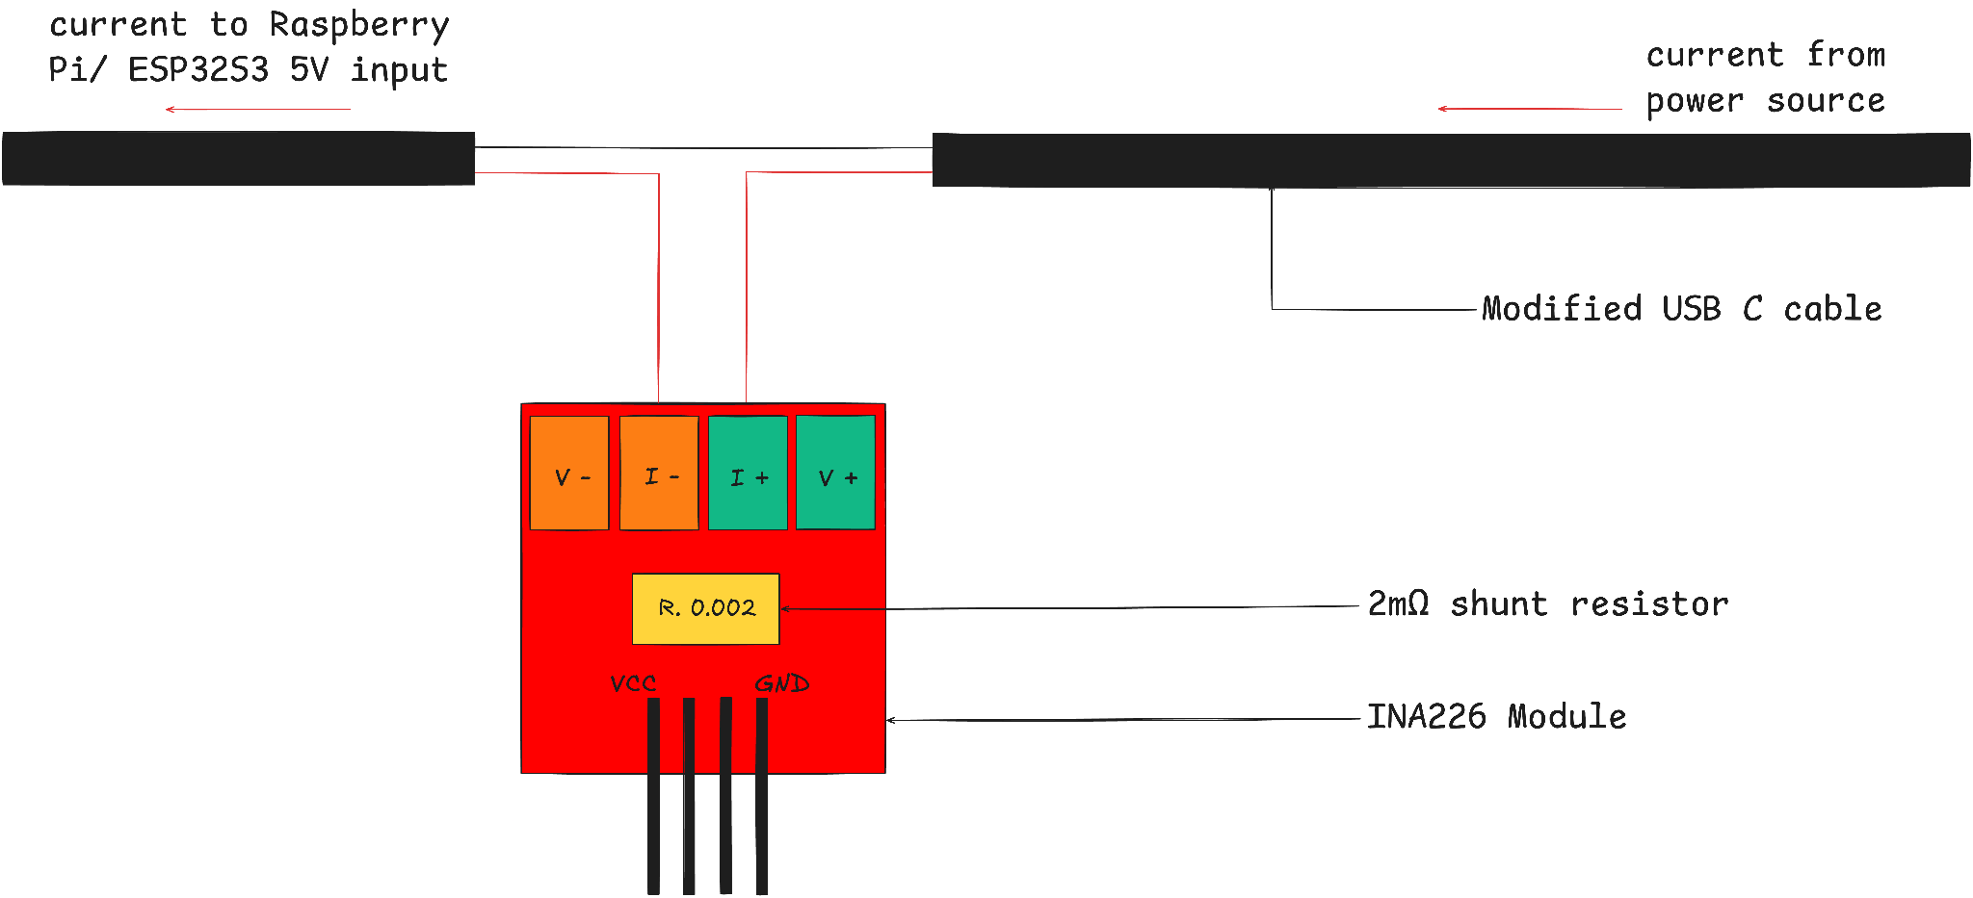
Figure 2.2. Board-input measurement path.
An electrical-zero characterization using an Arduino Nano produced a four-repeat mean apparent current of -0.070 mA. This value was not subtracted from the power readings because it is negligible relative to the observed load signal and largely cancels in adjacent active-minus-idle subtraction. The test setup is shown in Figure 2.3a and Figure 2.3b shows serial monitor logs from the test.
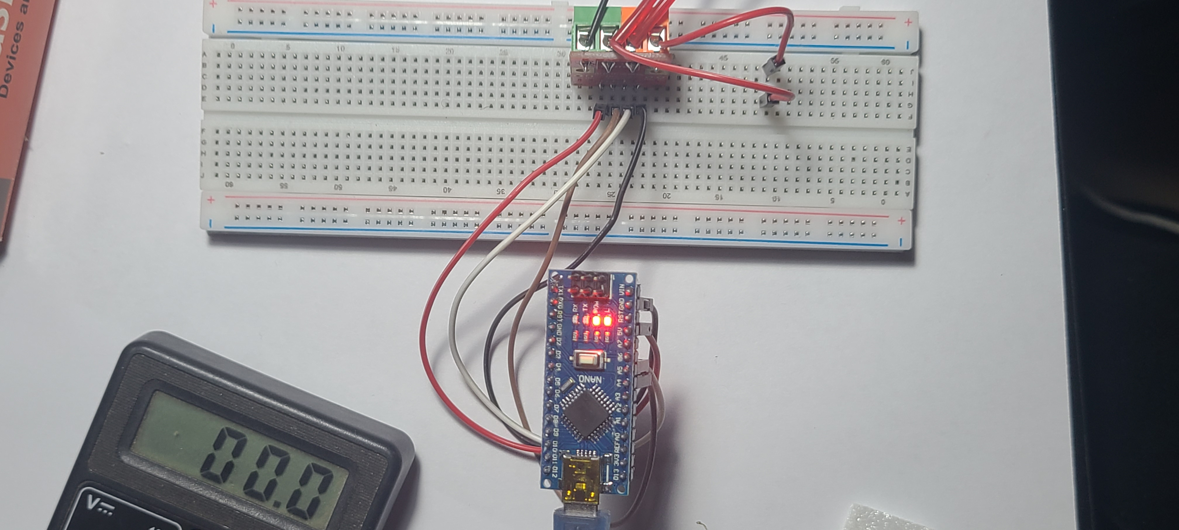
Figure 2.3a. INA226 electrical-zero test setup.
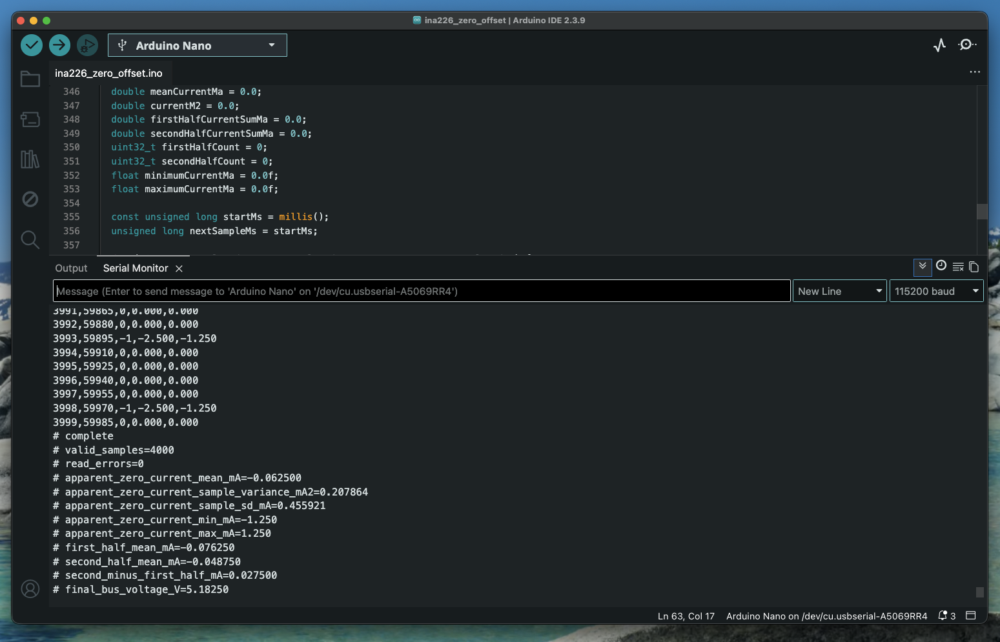
Figure 2.3b. INA226 electrical-zero test output.

Four frozen input banks—one per dataset—standardized the measurement stimuli across models and platforms. The same underlying examples and ordering were used for FP32 and INT8 conditions. All 86 Raspberry Pi artifacts and all 43 ESP32-S3 INT8 artifacts passed deployment smoke testing before formal measurement.
On the Raspberry Pi, model loading, allocation, input-bank loading, and warm-up occurred outside measurement.
On the ESP32-S3, an active window included input copying, model invocation, and output retrieval, while the reported per-invocation latency timed only the TensorFlow Lite Micro Invoke call. At the start of repeated inference, the ESP32-S3 set GPIO4 high, producing a rising edge on Raspberry Pi GPIO17; it set the pin low when inference ended, producing a falling edge. The Raspberry Pi timestamped these two edges using the same monotonic clock used for the INA226 power samples. This precisely identified which power readings belonged to the active inference window. The hardware signal was necessary because ESP32 timestamps and USB serial messages use a different clock and can experience transmission delays; using GPIO edges avoided uncertain clock synchronization and serial latency.
The ESP32 could technically communicate with the INA226, but using the same board to run inference and measure itself would weaken the experiment:
1. Reading the INA226, formatting records, and transmitting or storing them would consume ESP32 processor time and electrical energy. The measurement would then include the logger’s overhead.
2. A TensorFlow Lite Micro invocation occupies the processor for part of the trial. INA226 polling could be delayed or stopped while inference runs, causing precisely the most important power samples to be missed.
3. Running the logger on the ESP32’s second core would still increase board power and could affect memory contention, scheduling, and inference latency.
4. The ESP32 has much less memory and storage for retaining complete timestamped power logs.

2.5 Trial Ordering and Record Structure
Each repetition contained every applicable condition once in randomized order so that a model (whether INT8 or FP32) was not clustered at one temperature or time. The Raspberry Pi schedule contained 86 model–precision conditions per repetition; the ESP32-S3 schedule contained 43 INT8 conditions. Trial registers recorded condition identity, execution order, latency, inference count, power-integration outputs, voltage, temperature, timing gaps, idle drift, validity, and evidence paths. Artifact, firmware, input-bank, and evidence hashes were retained in manifests that are included in the canonical Github repository.

2.6 Formal Measurement Procedure and Statistical Analysis
Each formal trial used 25 warm up invocations, a 5-second settling interval, and adjacent 10-second pre-idle, active, and post-idle windows. During the active window, the model was invoked repeatedly until the target duration elapsed and invocation latency was timed separately for each successful Invoke call. Net energy per inference was then calculated using Equation 2.6.

N_{e} = (E_{a} − P_{m} × D_{a}) / C_{i} (2.6)

where N_{e} is net board-input energy per successful inference, E_{a} is active-window energy obtained by trapezoidal integration of INA226 power over monotonic timestamps, P_{m} is the mean of the adjacent pre and post idle mean powers, D_{a} is active duration, and C_{i} is the number of successful invocations. Thus, P_{m} × D_{a} estimates the board energy that would have been consumed during the active duration without repeated inference (energy = power × duration).
Raspberry Pi CPU frequency, affinity, temperature, bus voltage, timing gaps, idle drift, and throttling state were checked against predeclared rules. ESP32-S3 power and GPIO phase events were captured by the Raspberry Pi while a separate serial controller issued the frozen trial commands. The ESP32-S3 GPIO marker contributed a negligible consistent active-only load inside the measured ESP32 boundary.
Three randomized technical repetitions were performed per condition and the condition averages were used for corpus-level analysis. Pearson correlation measured linear association on the stated raw or log10 scale, while Spearman correlation measured rank association. Confidence intervals were calculated from 10,000 bootstrap resamples of 13 architecture families using seed 20260827, rather than treating width variants as independent architecture types. We repeated each trial to measure consistency, not to increase the number of independent models.

3. Results

3.1 Trial Completion and Quality of Measurements
All 258 Raspberry Pi and 129 ESP32-S3 accepted trials retained complete power and latency evidence. Figure 3.1 compares repeatability across the two platforms. The median ESP32-S3 repeat-level energy coefficient of variation was 0.313% and the maximum was 1.728%. All ESP32-S3 trials satisfied the declared checks: minimum bus voltage was 5.196 V, maximum device temperature was 36.2 °C, maximum absolute idle drift was 1.111%, and the largest power-poll gap was 28.488 ms, below the 50 ms limit. A secondary voltage-times-current integration reproduced the ESP32-S3 condition ordering (raw Pearson r = 0.998 relative to the primary power register).
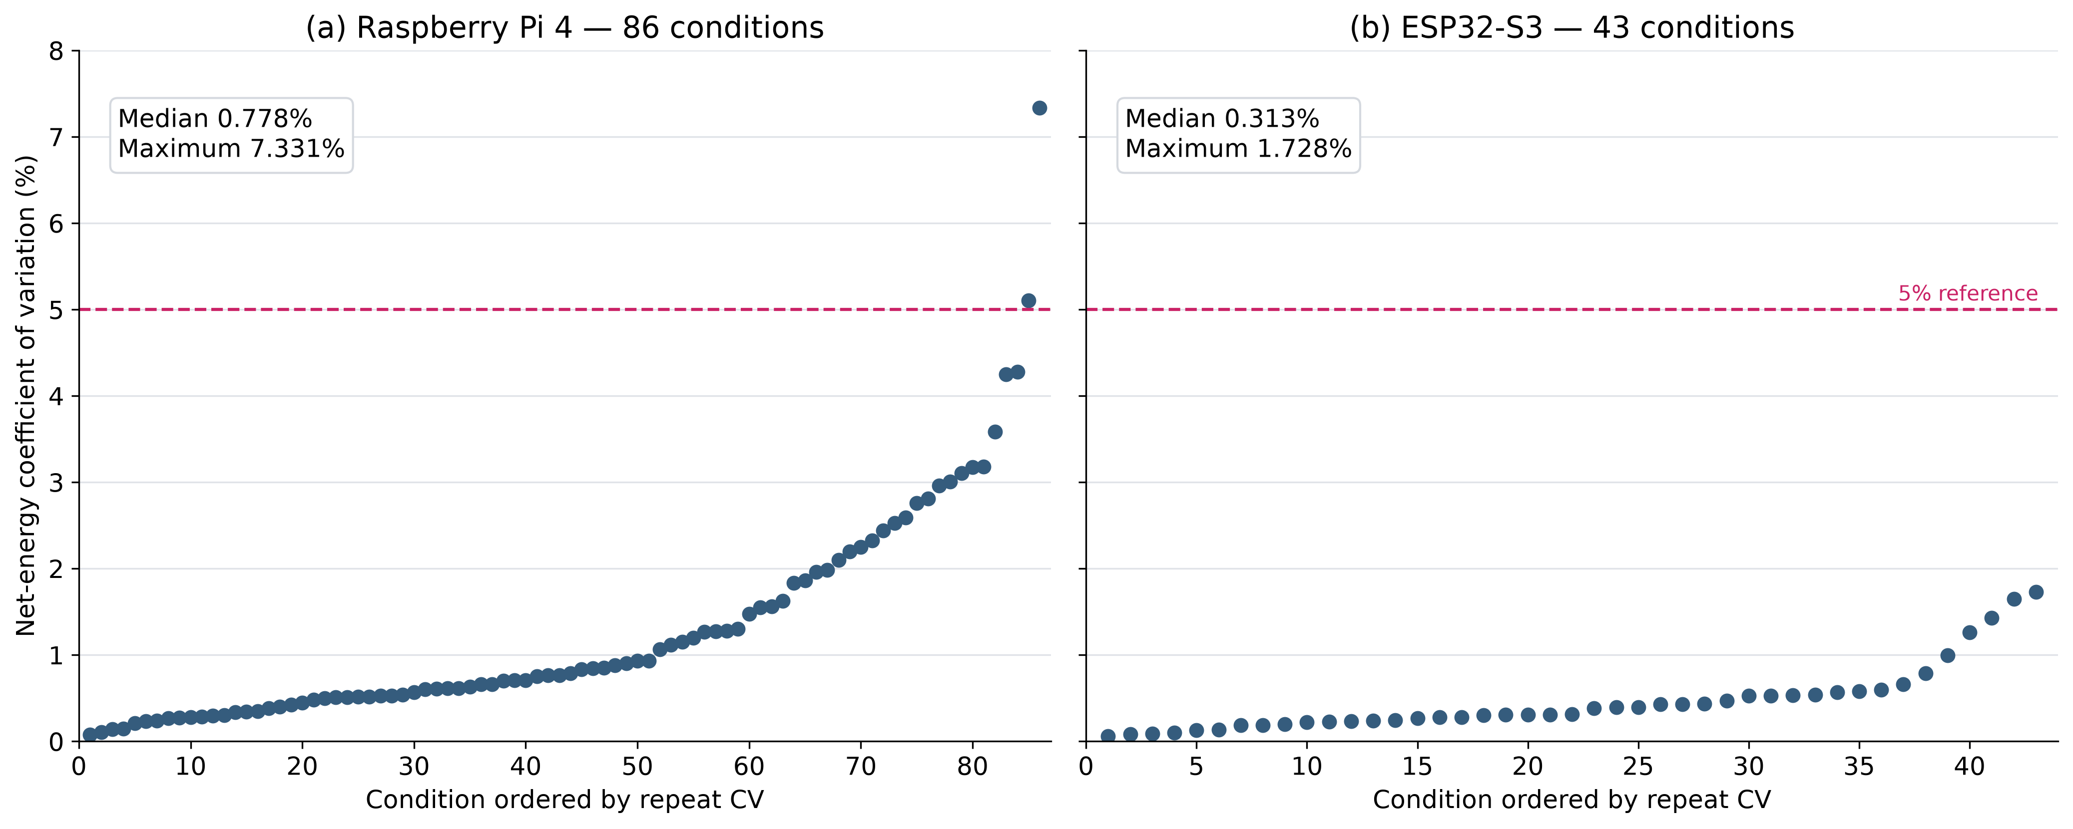
Figure 3.1. Net-energy repeatability on both platforms.

3.2 Corpus-wide Predictor Relationships
Raspberry Pi energy ranged from 31.62 to 4,795.94 µJ per inference, while ESP32-S3 energy ranged from 796.30 to 35,572.68 µJ. MAC count remained strongly associated with energy, with log-scale Pearson correlations of 0.895 for Raspberry Pi FP32, 0.973 for Raspberry Pi INT8 and 0.877 for ESP32-S3 INT8. The full-corpus INT8 value of 0.973 is above the latter range because each sensitivity run removes an entire architecture family and recalculates the association on a changed corpus. Measured latency was the strongest correlate of energy on both platforms (log-scale r = 0.995 for Raspberry Pi INT8 and 0.995 for ESP32-S3), whereas ESP32-S3 log-scale correlations were 0.602 for the static byte-access proxy, 0.718 for activation-output bytes, 0.071 for artifact size, and 0.028 for parameter bytes (Figures 3.2 and 3.3).
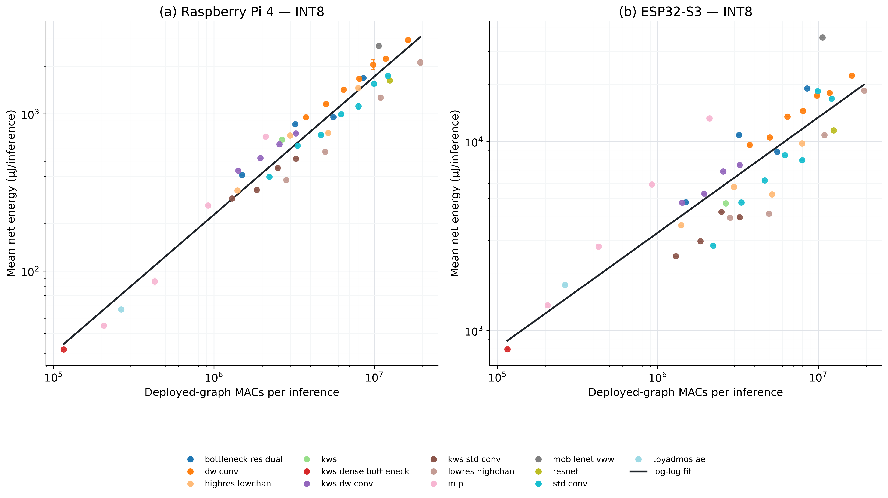
Figure 3.2. INT8 net energy versus MAC count.
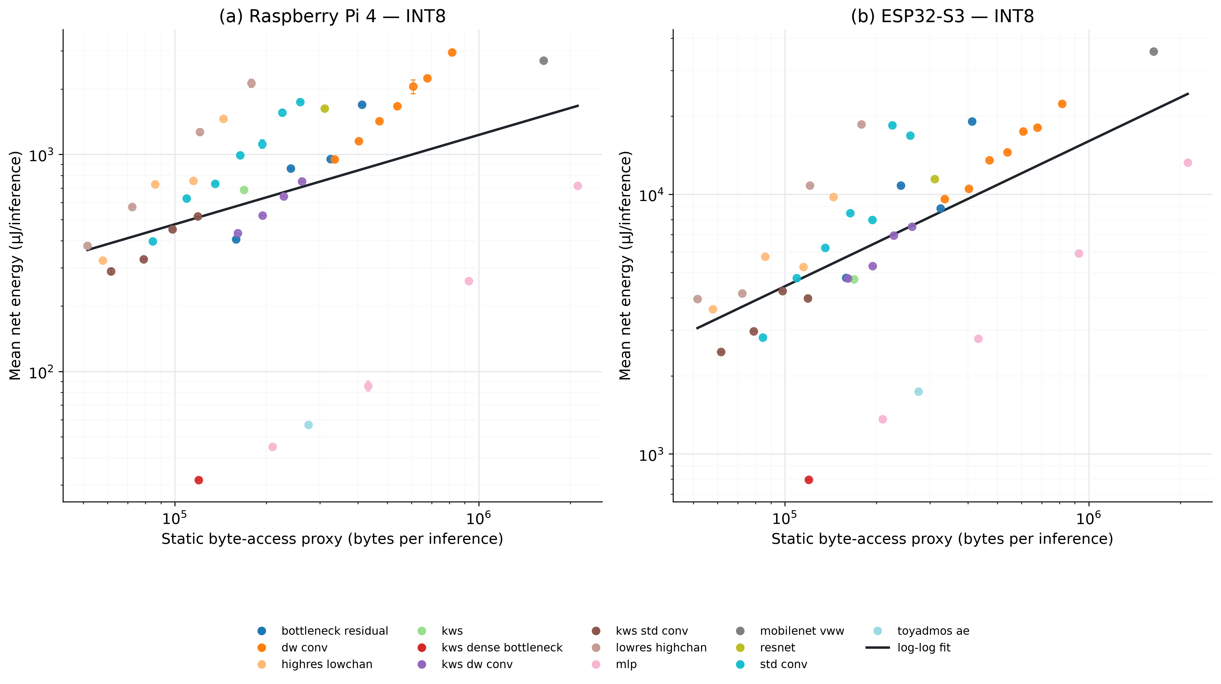
Figure 3.3. INT8 net energy versus static byte-access proxy.

3.3 Task-Adjusted and Residual Analyses
Table 3.1 reports the task-adjusted linear regressions requested for the final analysis. On the Raspberry Pi, replacing parameter bytes with the static byte-access proxy increased total R-squared from 0.947 to 0.989 for FP32 and from 0.889 to 0.911 for INT8 while reducing RMSE. On the ESP32-S3, the corresponding replacement increased R-squared from 0.849 to 0.896 and reduced RMSE from 2,694.5 to 2,232.1 microjoules. In the prespecified unadjusted log analysis, adding the static byte proxy increased explained energy variation from 76.9% to 94.4% on the ESP32-S3, but only from 94.8% to 96.4% on the Raspberry Pi. The purpose of these evaluations is to stop differences between datasets or tasks from being mistaken for effects of MAC count or memory demand. It asks:

"Among models performing the same task, how well do MACs and other predictors explain differences in energy?"

Table 3.1. Task-adjusted energy regressions.
Condition | Predictor set | MAC coefficient | Second coefficient | R-squared | RMSE (microjoules)
Raspberry Pi FP32 | MACs + parameter bytes | 1,128.9 | 353.5 | 0.947 | 277.5
Raspberry Pi FP32 | MACs + static bytes | 1,017.7 | 498.1 | 0.989 | 124.5
Raspberry Pi INT8 | MACs + parameter bytes | 626.7 | 11.3 | 0.889 | 237.2
Raspberry Pi INT8 | MACs + static bytes | 622.3 | 127.4 | 0.911 | 212.2
ESP32-S3 INT8 | MACs + parameter bytes | 4,895.6 | 1,164.1 | 0.849 | 2,694.5
ESP32-S3 INT8 | MACs + static bytes | 4,547.0 | 2,234.3 | 0.896 | 2,232.1

3.4 Near-MAC Comparisons
Figure 3.4 compares two model pairs selected because their MAC counts are almost identical. In the CIFAR-10 pair, MAC count differed by 1.074%, yet the depthwise model used 49.5% more energy on the Raspberry Pi and 82.4% more on the ESP32-S3. In the Speech Commands pair, MAC count differed by only 0.203%, yet the depthwise model used 44.8% more energy on the Raspberry Pi and 88.9% more on the ESP32-S3. The Raspberry Pi FP32 measurements showed the same pattern. In each comparison, the model that ran longer also consumed more energy, while the difference in active power remained below approximately 5%.
The broader set contained nine standard/depthwise comparisons with MAC differences below 10%. The depthwise model consumed more energy in all nine Raspberry Pi comparisons and eight of the nine ESP32-S3 comparisons. These comparisons support the conclusion that similar MAC counts can conceal substantial energy differences. However, because the paired models differ in both convolution type and channel width, the results do not prove that convolution type alone caused the differences.
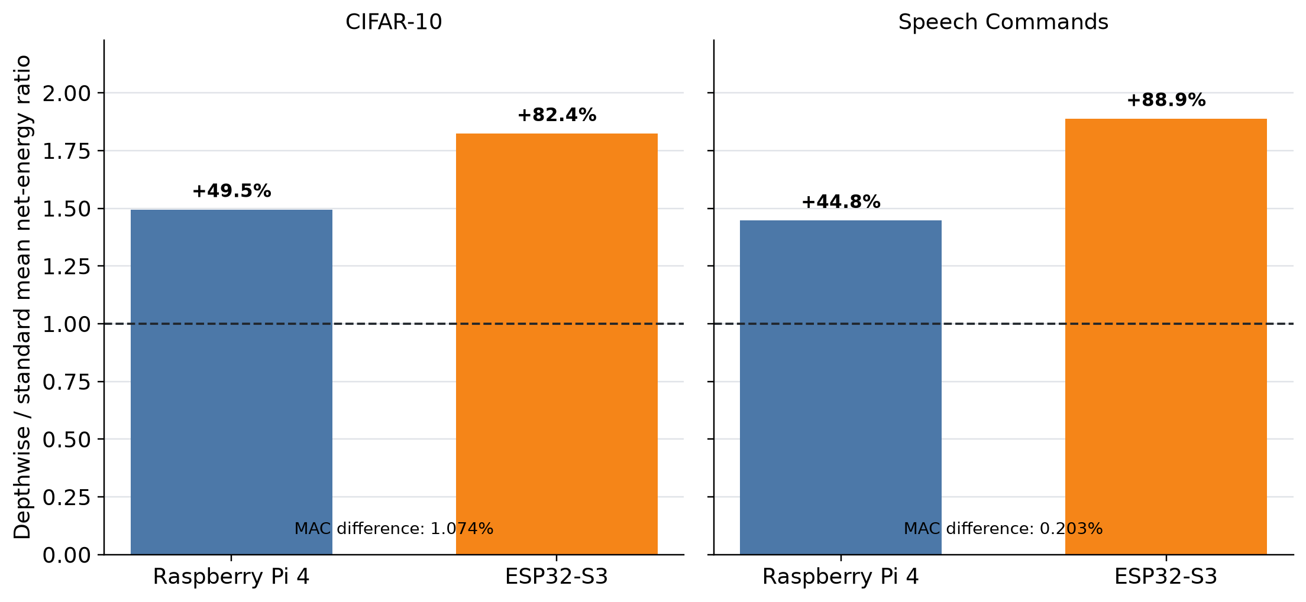

Figure 3.4. Near-MAC energy differences across platforms.

3.5 Latency, Cross-Platform Ranking, and Precision
Measured invocation latency was the strongest energy correlate on both platforms (log-scale Pearson r = 0.995 for Raspberry Pi INT8 and 0.995 for ESP32-S3), as shown in Figure 3.5. Across the 43 common INT8 models, platform energy rankings remained related but not interchangeable (Figure 3.6a). On the Raspberry Pi, INT8 reduced net energy relative to FP32 for all 43 models (median reduction 32.8%; range 7.1%–85.0%), as shown in Figure 3.6b. FP32 was not an ESP32-S3 measurement condition.
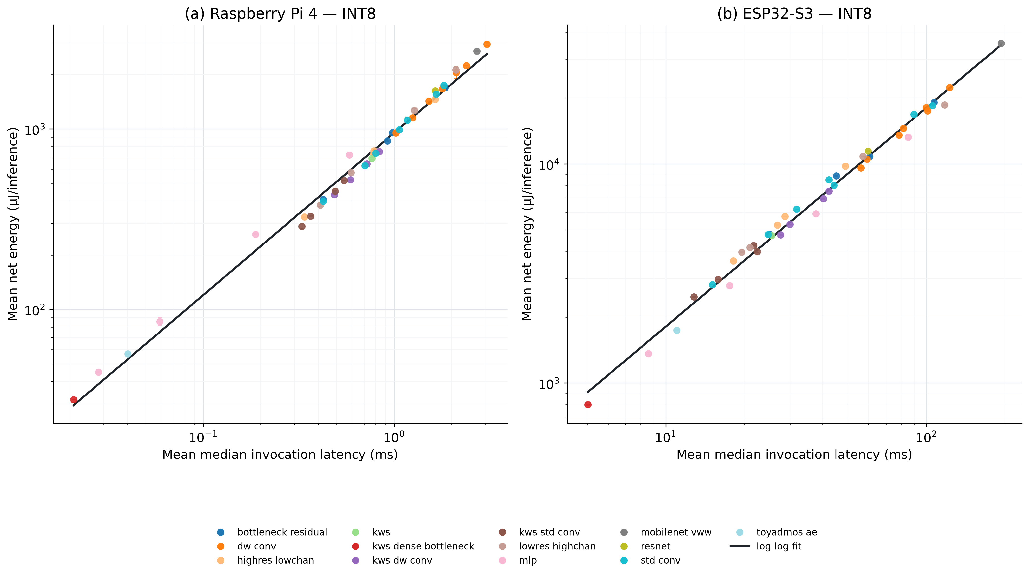
Figure 3.5. INT8 net energy versus invocation latency.
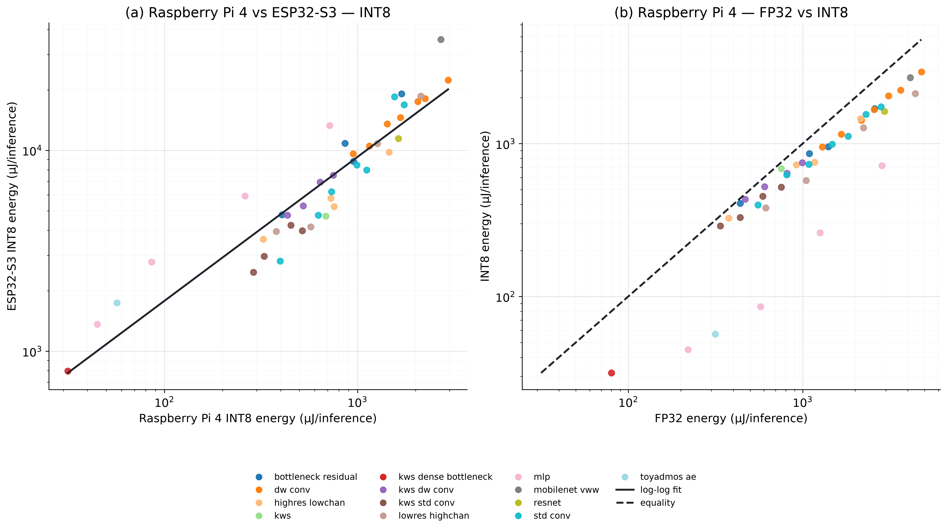
Figure 3.6. Cross-platform and Raspberry Pi precision comparisons.

4. Discussion
The completed two-platform experiment distinguishes broad prediction from local model selection. MAC count tracked the overall energy trend on both platforms, but more strongly on Raspberry Pi INT8 (log-scale r = 0.973) than on ESP32-S3 (r = 0.877). The common INT8 energy rankings were strongly related but not identical, and the primary near-MAC energy gaps were substantially larger on the ESP32-S3. MACs are therefore useful for broad workload scaling within a fixed deployment environment, but they are not reliable hardware-independent selectors between structurally different models with similar arithmetic workloads (Figures 3.2 and 3.4).
The static byte-access proxy was a weaker standalone correlate than MAC count on both platforms. It nevertheless added log-scale explanatory power after MACs, especially on ESP32-S3. That finding is appropriately limited: the proxy is a graph-derived count and the experiment did not record physical flash, PSRAM, cache, DRAM, or bus traffic. The sensitivity analysis over alternative activation multipliers showed that the qualitative complementary result was not unique to the selected factor of two, but the coefficient magnitude depended on that modelling choice.

Measured invocation latency was the strongest energy correlate on both platforms (Figure 3.5). In the primary pairs, the direction of the energy difference followed the direction of latency while incremental active power changed little. This identifies execution duration as the immediate arithmetic explanation of the measured energy gap because energy is power integrated over time. It does not identify the lower-level cause of the runtime difference, and latency remains a post-deployment, platform-specific quantity rather than a design-time replacement for MAC count.
Lower board power therefore did not imply lower energy per completed inference. Across the 43 common INT8 conditions, median active board power was 0.429 W on the ESP32-S3 and 3.423 W on the Raspberry Pi, while median incremental power above matched idle was 0.181 W and 0.913 W, respectively. However, median invocation latency was 40.240 ms on the ESP32-S3 and 0.782 ms on the Raspberry Pi. The corresponding median net energies were 6,951 and 733 microjoules per inference, and the median per-model ESP32-S3-to-Raspberry-Pi energy ratio was 9.26. The microcontroller drew less power at any instant but remained active much longer, so execution time outweighed its power advantage for this corpus and these runtime configurations. This workload-specific result shows why nominal device power class alone is insufficient for predicting energy per inference.
The archived ESP-NN 1.3.1 campaign produced the opposite primary-pair ordering: depthwise energy was 19.9% and 2.3% lower than standard convolution. Under ESP-NN 1.4.1, with the same model artifacts and input banks, depthwise energy was instead 82.4% and 88.9% higher. The standard models’ energy fell by 53.8% and 49.5% between campaigns, whereas the depthwise models changed by +5.2% and −2.3%. The source change most directly relevant to these standard models corrected and enabled ESP-NN’s optimized 3 × 3 standard-convolution path, which had been disabled because of an inline-assembly priming error and a documented performance regression (Espressif Systems, 2026c; commit 0c428a3). Because the model graphs and MAC counts did not change, this comparison directly demonstrates that MACs do not encode runtime-kernel selection. The releases contain other changes, so the comparison establishes runtime dependence but does not isolate the commit as the sole cause.
The Raspberry Pi precision comparison provides a separate result: INT8 reduced net energy for all 43 models even though graph MAC count was unchanged. This reinforces the need to treat precision, runtime, and hardware as deployment conditions rather than inferring energy from arithmetic count alone.
Together, the cross-platform and precision findings answer different parts of the study: common INT8 artifacts reveal hardware-dependent ranking, while Raspberry Pi FP32/INT8 pairs reveal the effect of precision within one platform. Neither comparison supports a universal per-MAC energy constant.

5. Limitations
Hardware evidence was obtained from one physical Raspberry Pi 4 and one physical ESP32-S3. Three randomized repetitions quantify technical repeatability within those units but not board-to-board or manufacturing variation. Family-clustered bootstrap intervals address dependence among related model widths; they do not create hardware-unit replication.
The INA226 calculations use the module's nominal 0.002-ohm shunt value and were not traceably multipoint calibrated. The recorded electrical-zero result, adjacent-idle subtraction, repeatability, and agreement between the INA226 power register and voltage-times-current sensitivity channel strengthen within-experiment comparisons but do not establish traceable absolute energy accuracy. The monitor produced about 111 physical result updates per second; faster software polling reduced the chance of missing an update but did not increase physical measurement bandwidth.
The static byte-access proxy does not measure cache misses, memory-stall cycles, tensor placement, flash traffic, PSRAM traffic, or physical data transfers. No Raspberry Pi performance-monitoring-unit counters or ESP32-S3 bus-traffic counters were retained, so lower-level mechanisms such as cache behavior, optimized-kernel choice, tensor reuse, and operator fusion cannot be isolated. Results apply to the fixed one-thread LiteRT/XNNPACK Raspberry Pi configuration and the fixed TensorFlow Lite Micro 1.4.0/ESP-NN 1.4.1 ESP32-S3 configuration. The archived ESP-NN 1.3.1 campaign demonstrates runtime-version sensitivity but does not isolate one physical mechanism.
The role-based corpus deliberately contains more CIFAR-10 probes than models from the other tasks. Family-balanced, leave-one-family-out, clustered-bootstrap, and task-adjusted analyses reduce but do not eliminate this composition effect. VWW-style and ToyADMOS conditions broaden the operator and input coverage but lack within-task architectural replication. The prespecified standard/depthwise pairs also change channel width as well as convolution type, so their energy gaps cannot be attributed causally to convolution type alone.
Only INT8 was common to both platforms; FP32 conclusions are limited to the Raspberry Pi. The ESP32-S3 conformance sweep produced one changed predicted class among 5,040 classification comparisons, so exact desktop/ESP32 numerical equivalence is not claimed, although the frozen ESP32 artifact and input bank were the objects actually measured. GPIO4 was held high only during ESP32-S3 inference to mark the active phase and contributed a small consistent active-only electrical load that was not independently metered. The study evaluates one runtime and control configuration per platform and should not be generalized to every Raspberry Pi, ESP32-S3, runtime, thread count, or frequency policy.

6. Future Work
Future work will use the completed measurements to develop a cross-hardware regression model for estimating net board-input energy when a model has not yet been physically measured on the target device. Candidate inputs will include compiled-graph MAC count, parameter and activation bytes, the static byte-access proxy, and recorded platform characteristics. A calibration-assisted variant will first run a small fixed kernel suite on a new device and use its timing and power signature as additional predictors.
Development will begin with transparent baselines: MAC-only regression, MACs combined with memory-related graph features, the existing static byte-access proxy, and device-specific operator or fused-kernel regression. Tree-based or hierarchical models will be considered only if they improve held-out performance. Evaluation will withhold complete architecture families and physical devices and will report energy-prediction error, model-ranking accuracy, prediction-interval coverage, and the error incurred when the predictor selects a supposedly efficient model. Measurements from additional physical units and hardware classes will be required before presenting the resulting equation as generally transferable.

7. Conclusion
Across 43 common INT8 models, MAC count described broad energy scaling on both platforms but with materially different strength: log-scale Pearson r was 0.973 on the Raspberry Pi 4 and 0.877 on the ESP32-S3. Cross-platform energy rankings were strongly related (Pearson r = 0.931; Spearman rho = 0.941) but not identical.
The two prespecified pairs differed by at most 1.074% in MAC count, yet depthwise energy was 44.8%–49.5% higher on Raspberry Pi INT8 and 82.4%–88.9% higher on the ESP32-S3. The ordering followed latency rather than a large change in incremental power, and the size of the gap changed materially across platforms and ESP-NN versions. The static byte-access proxy added complementary log-scale information after MAC count, particularly on the ESP32-S3, but did not measure the physical mechanism.
Operation counts are therefore useful arithmetic descriptors and broad within-platform predictors, but they are insufficient as hardware-independent energy selectors for structurally different models. Platform-aware measurement or predictors that capture realized execution are required when deployment decisions depend on fine-grained model ranking.

Data and Analysis Artifacts
The reproducibility materials contain the 258-trial Raspberry Pi register, the 129 accepted ESP-NN 1.4.1 ESP32-S3 trials, retained raw power/GPIO/latency evidence, frozen schedules, model and input manifests, analysis code, validation reports, tables, and figures. SHA-256 manifests identify source evidence and generated outputs. Family-clustered analyses use seed 20260827 and 10,000 resamples. Independent validation recomputed ESP32-S3 phase boundaries, integrated energy, latency summaries, correlations, and plotted source tables without importing the acquisition or main-analysis modules; all validation checks passed. The complete ESP-NN 1.3.1 campaign is retained separately as historical evidence. The public replication bundle will be available at: [PUBLIC REPOSITORY OR DOI URL TO BE INSERTED BEFORE FINAL SUBMISSION].

Statement of Ethics Declaration
Artificial Intelligence tools assisted with language refinement and with development and review of analysis code. The authors designed the study, selected and operated the hardware, executed the experiments, verified the retained evidence and generated outputs, interpreted the results, and take responsibility for the manuscript and its conclusions.

References
Abadi, M., Barham, P., Chen, J., Chen, Z., Davis, A., Dean, J., Devin, M., Ghemawat, S., Irving, G., Isard, M., Kudlur, M., Levenberg, J., Monga, R., Moore, S., Murray, D. G., Steiner, B., Tucker, P., Vasudevan, V., Warden, P., … Zheng, X. (2016). TensorFlow: A system for large-scale machine learning. 12th USENIX Symposium on Operating Systems Design and Implementation (OSDI 16), 265–283. https://www.usenix.org/conference/osdi16/technical-sessions/presentation/abadi
Baller, S. P., Jindal, A., Chadha, M., & Gerndt, M. (2021). DeepEdgeBench: Benchmarking deep neural networks on edge devices. 2021 IEEE International Conference on Cloud Engineering (IC2E), 20–30. https://doi.org/10.1109/IC2E52221.2021.00016
Banbury, C., Zhou, C., Fedorov, I., Matas, R., Thakker, U., Gope, D., Reddi Vijay, J., Mattina, M., & Whatmough, P. (2021). MicroNets: Neural network architectures for deploying TinyML applications on commodity microcontrollers. Proceedings of Machine Learning and Systems, 3, 517–532. https://proceedings.mlsys.org/paper_files/paper/2021/hash/c4d41d9619462c534b7b61d1f772385e-Abstract.html
Bartoli, P., Bondini, T., Veronesi, C., Giudici, A., Antonello, N., & Zappa, F. (2025a). End-to-end efficiency in keyword spotting: A system-level approach for embedded microcontrollers. 2025 IEEE Sensors, 1–4. https://doi.org/10.1109/SENSORS59705.2025.11330257
Bartoli, P., Veronesi, C., Giudici, A., Siorpaes, D., Trojaniello, D., & Zappa, F. (2025b). Benchmarking energy and latency in TinyML: A novel method for resource-constrained AI. 2025 International Joint Conference on Neural Networks (IJCNN), 1–8. https://doi.org/10.1109/IJCNN64981.2025.11228997
Chowdhery, A., Warden, P., Shlens, J., Howard, A. G., & Rhodes, R. (2019). Visual wake words dataset. ArXiv, abs/1906.05721. https://api.semanticscholar.org/CorpusID:189762389
Datta, G., Kundu, S., Yin, Z., Lakkireddy, R. T., Mathai, J., Jacob, A. P., Beerel, P. A., & Jaiswal, A. R. (2022). A processing-in-pixel-in-memory paradigm for resource-constrained TinyML applications. Scientific Reports, 12(1), 14396. https://doi.org/10.1038/s41598-022-17934-1
David, R., Duke, J., Jain, A., Reddi, V. J., Jeffries, N., Li, J., Kreeger, N., Nappier, I., Natraj, M., Wang, T., Warden, P., & Rhodes, R. (2021). TensorFlow lite micro: Embedded machine learning for TinyML systems. Conference on Machine Learning and Systems. https://api.semanticscholar.org/CorpusID:265037867
Espressif Systems. (2026a). ESP32-S3 technical reference manual (Version 1.8). https://documentation.espressif.com/esp32-s3_technical_reference_manual_en.pdf
Espressif Systems. (2026b). ESP-NN: Optimized neural-network functions for Espressif chipsets. https://github.com/espressif/esp-nn
Espressif Systems. (2026c). perf(conv/s3): enable the 3x3 im2col path [Git commit]. https://github.com/espressif/esp-nn/commit/0c428a386a9a08b8436827f54cf735c25bc58bf2
Guo, C., Wang, S., Xie, R., & Song, J. (2025). Estimating energy consumption of neural networks with joint structure–device encoding. Sustainable Computing: Informatics and Systems, 45, 101062. https://doi.org/10.1016/j.suscom.2024.101062
He, K., Zhang, X., Ren, S., & Sun, J. (2016, June). Deep residual learning for image recognition. Proceedings of the IEEE Conference on Computer Vision and Pattern Recognition (CVPR).
Henderson, P., Hu, J., Romoff, J., Brunskill, E., Jurafsky, D., & Pineau, J. (2020). Towards the systematic reporting of the energy and carbon footprints of machine learning. Journal of Machine Learning Research, 21(248), 1–43. https://www.jmlr.org/papers/v21/20-312.html
Jacob, B., Kligys, S., Chen, B., Zhu, M., Tang, M., Howard, A., Adam, H., & Kalenichenko, D. (2018, June). Quantization and training of neural networks for efficient integer-arithmetic-only inference. Proceedings of the IEEE Conference on Computer Vision and Pattern Recognition (CVPR).
Koizumi, Y., Saito, S., Uematsu, H., Harada, N., & Imoto, K. (2019). ToyADMOS: A dataset of miniature-machine operating sounds for anomalous sound detection. 2019 IEEE Workshop on Applications of Signal Processing to Audio and Acoustics (WASPAA), 313–317. https://doi.org/10.1109/WASPAA.2019.8937164
Krizhevsky, A. (2009). Learning multiple layers of features from tiny images. https://www.cs.toronto.edu/~kriz/learning-features-2009-TR.pdf
Lahmer, S., Khoshsirat, A., Rossi, M., & Zanella, A. (2022). Energy consumption of neural networks on NVIDIA edge boards: An empirical model. 2022 20th International Symposium on Modeling and Optimization in Mobile, Ad Hoc, and Wireless Networks (WiOpt), 365–371. https://doi.org/10.23919/WiOpt56218.2022.9930584
Linux Kernel Developers. (2022). Kernel driver ina2xx. Linux Kernel documentation. https://kernel.org/doc/html/v5.19/hwmon/ina2xx.html
Lin, T.-Y., Maire, M., Belongie, S., Hays, J., Perona, P., Ramanan, D., Dollár, P., & Zitnick, C. L. (2014). Microsoft COCO: Common objects in context. In D. Fleet, T. Pajdla, B. Schiele, & T. Tuytelaars (Eds.), Computer Vision—ECCV 2014 (pp. 740–755). Springer International Publishing. https://doi.org/10.1007/978-3-319-10602-1_48
Ma, N., Zhang, X., Zheng, H.-T., & Sun, J. (2018). ShuffleNet V2: Practical guidelines for efficient CNN architecture design. European Conference on Computer Vision (ECCV), 116–131.
Raspberry Pi Ltd. (2024). Raspberry Pi 4 Model B datasheet (Release 1.1). https://datasheets.raspberrypi.com/rpi4/raspberry-pi-4-datasheet.pdf
Saha, S. S., Sandha, S. S., Aggarwal, M., Wang, B., Han, L., Briseno, J. De G., & Srivastava, M. (2024). TinyNS: Platform-aware neurosymbolic auto tiny machine learning. ACM Transactions on Embedded Computing Systems, 23(3), 1–48. https://doi.org/10.1145/3603171
Sandler, M., Howard, A., Zhu, M., Zhmoginov, A., & Chen, L.-C. (2018, June). MobileNetV2: Inverted residuals and linear bottlenecks. Proceedings of the IEEE Conference on Computer Vision and Pattern Recognition (CVPR).
Singh, R., & Gill, S. S. (2023). Edge AI: A survey. Internet of Things and Cyber-Physical Systems, 3. https://doi.org/10.1016/j.iotcps.2023.02.004
Speckhard, D. T., Misiunas, K., Perel, S., Zhu, T., Carlile, S., & Slaney, M. (2023). Neural architecture search for energy-efficient always-on audio machine learning. Neural Computing and Applications, 35(16), 12133–12144. https://doi.org/10.1007/s00521-023-08345-y
Texas Instruments. (2024). INA226 36-V, 16-bit, ultra-precise I2C output current, voltage, and power monitor with alert (Rev. C). https://www.ti.com/lit/gpn/INA226
Tschand, A., Rajan, A. T. R., Idgunji, S., Ghosh, A., Holleman, J., Kiraly, C., Ambalkar, P., Borkar, R., Chukka, R., Cockrell, T., Curtis, O., Fursin, G., Hodak, M., Kassa, H., Lokhmotov, A., Miskovic, D., Pan, Y., Manmathan, M. P., Raymond, L., … Reddi, V. J. (2025). MLPerf power: Benchmarking the energy efficiency of machine learning systems from μWatts to MWatts for sustainable AI. 2025 IEEE International Symposium on High Performance Computer Architecture (HPCA), 1201–1216. https://doi.org/10.1109/hpca61900.2025.00092
Tu, X., Mallik, A., Chen, D., Han, K., Altintas, O., Wang, H., & Xie, J. (2023). Unveiling energy efficiency in deep learning: Measurement, prediction, and scoring across edge devices. Proceedings of the Eighth ACM/IEEE Symposium on Edge Computing, 80–93. https://doi.org/10.1145/3583740.3628442
Warden, P. (2018). Speech commands: A dataset for limited-vocabulary speech recognition. ArXiv, abs/1804.03209. https://api.semanticscholar.org/CorpusID:4719239
Wess, M., Dallinger, D., Schnöll, D., Bittner, M., Götzinger, M., & Jantsch, A. (2023). Energy profiling of DNN accelerators. 2023 26th Euromicro Conference on Digital System Design (DSD), 53–60. https://doi.org/10.1109/DSD60849.2023.00018
Yang, T.-J., Chen, Y.-H., & Sze, V. (2017). Designing energy-efficient convolutional neural networks using energy-aware pruning. Proceedings of the IEEE Conference on Computer Vision and Pattern Recognition, 5687–5695. https://doi.org/10.1109/CVPR.2017.643
Zhang, Y., Suda, N., Lai, L., & Chandra, V. (2017). Hello edge: Keyword spotting on microcontrollers. arXiv (Cornell University). https://doi.org/10.48550/arxiv.1711.07128

Appendix A. Frozen 43-Model Corpus
Table A.1 lists the deployed INT8 graph characteristics and held-out task score for every frozen model. Balanced accuracy is reported for classification models and area under the receiver-operating-characteristic curve (AUC) for ToyADMOS. Static bytes use Equation 2.3.
Table A.1. Frozen model corpus and task scores.
Model | Task / family | MACs | Static bytes | Held-out task score
bottleneck_residual_12 | cifar10 / bottleneck_residual | 3,207,648 | 241,038 | Bal. acc. 65.61%
bottleneck_residual_16 | cifar10 / bottleneck_residual | 5,554,816 | 325,514 | Bal. acc. 70.11%
bottleneck_residual_20 | cifar10 / bottleneck_residual | 8,540,960 | 412,582 | Bal. acc. 69.86%
bottleneck_residual_8 | cifar10 / bottleneck_residual | 1,499,456 | 159,154 | Bal. acc. 60.91%
dw_conv_40 | cifar10 / dw_conv | 3,740,560 | 335,562 | Bal. acc. 69.87%
dw_conv_48 | cifar10 / dw_conv | 5,004,768 | 403,194 | Bal. acc. 70.95%
dw_conv_56 | cifar10 / dw_conv | 6,441,008 | 471,210 | Bal. acc. 72.70%
dw_conv_64 | cifar10 / dw_conv | 8,049,280 | 539,610 | Bal. acc. 77.23%
dw_conv_72 | cifar10 / dw_conv | 9,829,584 | 608,394 | Bal. acc. 79.05%
dw_conv_80 | cifar10 / dw_conv | 11,781,920 | 677,562 | Bal. acc. 78.26%
dw_conv_96 | cifar10 / dw_conv | 16,202,688 | 817,050 | Bal. acc. 80.71%
highres_lowchan_12 | cifar10 / highres_lowchan | 2,986,104 | 86,238 | Bal. acc. 54.48%
highres_lowchan_16 | cifar10 / highres_lowchan | 5,161,120 | 115,082 | Bal. acc. 59.44%
highres_lowchan_20 | cifar10 / highres_lowchan | 7,925,960 | 144,502 | Bal. acc. 63.58%
highres_lowchan_8 | cifar10 / highres_lowchan | 1,400,912 | 57,970 | Bal. acc. 50.20%
lowres_highchan_24 | cifar10 / lowres_highchan | 2,820,336 | 51,618 | Bal. acc. 67.11%
lowres_highchan_32 | cifar10 / lowres_highchan | 4,940,096 | 72,378 | Bal. acc. 68.95%
lowres_highchan_48 | cifar10 / lowres_highchan | 10,949,088 | 120,810 | Bal. acc. 73.88%
lowres_highchan_64 | cifar10 / lowres_highchan | 19,317,376 | 178,458 | Bal. acc. 74.15%
mlp_128 | cifar10 / mlp | 427,264 | 432,730 | Bal. acc. 50.63%
mlp_256 | cifar10 / mlp | 920,064 | 927,834 | Bal. acc. 50.91%
mlp_512 | cifar10 / mlp | 2,102,272 | 2,114,650 | Bal. acc. 52.77%
mlp_64 | cifar10 / mlp | 205,440 | 209,754 | Bal. acc. 50.22%
resnet8 | cifar10 / resnet | 12,501,632 | 311,370 | Bal. acc. 82.60%
std_conv_16 | cifar10 / std_conv | 2,212,160 | 84,682 | Bal. acc. 69.47%
std_conv_20 | cifar10 / std_conv | 3,318,160 | 109,382 | Bal. acc. 74.02%
std_conv_24 | cifar10 / std_conv | 4,645,344 | 135,810 | Bal. acc. 75.38%
std_conv_28 | cifar10 / std_conv | 6,193,712 | 163,966 | Bal. acc. 77.10%
std_conv_32 | cifar10 / std_conv | 7,963,264 | 193,850 | Bal. acc. 78.36%
std_conv_36 | cifar10 / std_conv | 9,954,000 | 225,462 | Bal. acc. 78.33%
std_conv_40 | cifar10 / std_conv | 12,165,920 | 258,802 | Bal. acc. 79.78%
ds_cnn | kws / kws | 2,656,768 | 169,046 | Bal. acc. 84.53%
dense_bottleneck_kws | kws / kws_dense_bottleneck | 115,456 | 119,942 | Bal. acc. 70.77%
kws_dw_conv_40 | kws / kws_dw_conv | 1,419,520 | 161,158 | Bal. acc. 82.44%
kws_dw_conv_48 | kws / kws_dw_conv | 1,946,880 | 194,422 | Bal. acc. 83.35%
kws_dw_conv_56 | kws / kws_dw_conv | 2,555,392 | 228,070 | Bal. acc. 83.47%
kws_dw_conv_64 | kws / kws_dw_conv | 3,245,056 | 262,102 | Bal. acc. 83.41%
kws_std_conv_20 | kws / kws_std_conv | 1,298,280 | 61,658 | Bal. acc. 84.81%
kws_std_conv_24 | kws / kws_std_conv | 1,848,240 | 79,054 | Bal. acc. 84.17%
kws_std_conv_28 | kws / kws_std_conv | 2,494,968 | 98,178 | Bal. acc. 84.55%
kws_std_conv_32 | kws / kws_std_conv | 3,238,464 | 119,030 | Bal. acc. 84.58%
fc_autoencoder_toyadmos | toyadmos / toyadmos_ae | 264,192 | 275,504 | AUC 0.787
mobilenetv2_tiny_vww | vww / mobilenet_vww | 10,656,688 | 1,635,458 | Bal. acc. 79.35%

