Project-Github-Link: <https://github.com/sunnysavita10/ecomm-prod-assistant>

These are all the commands that you need to run on your command prompt

1. Write Python in your terminal
2. If you have Python, then no need to install it
3. uv --version
4. If you are not able to get the version
5. Pip install uv
6. import shutil
7. print(shutil.which("uv"))
9. 6. Uv init <my-project-name>
10. 7. uv pip list
12. 8. uv python list
13. uv venv env --python cpython-3.10.18-windows-x86_64-none
14. uv venv <your-env-namne> --python <your-python-version>
15. Note: Please use either 3.10, 3.11, or 3.12
16. **Command Prompt (CMD)** .\<your-env-nanme>\Scripts\activate.bat
17. **Git Bash ya WSL terminal, or MAC Terminal:**
    1. source <your-env-nanme>/Scripts/activate

18. If your git is asking for a login to publish the repo, execute the command below

* 1. git config --global user.name "Your Name"
  2. git config --global user.email "[your-email@example.com](mailto:your-email@example.com)"

19. UV add <package_name>

20. Uv add -r requirements.txt

21. Streamlit run <give your streamlit python filename>

22. Install the live server extension in VS Code for testing the HTML

For accessing the DataStax, here is a link: <https://accounts.datastax.com/session-service/v1/login>

Vectordb Comparison: <https://superlinked.com/vector-db-comparison>

Once you log in to the DataStax Vector page, you will get the following page

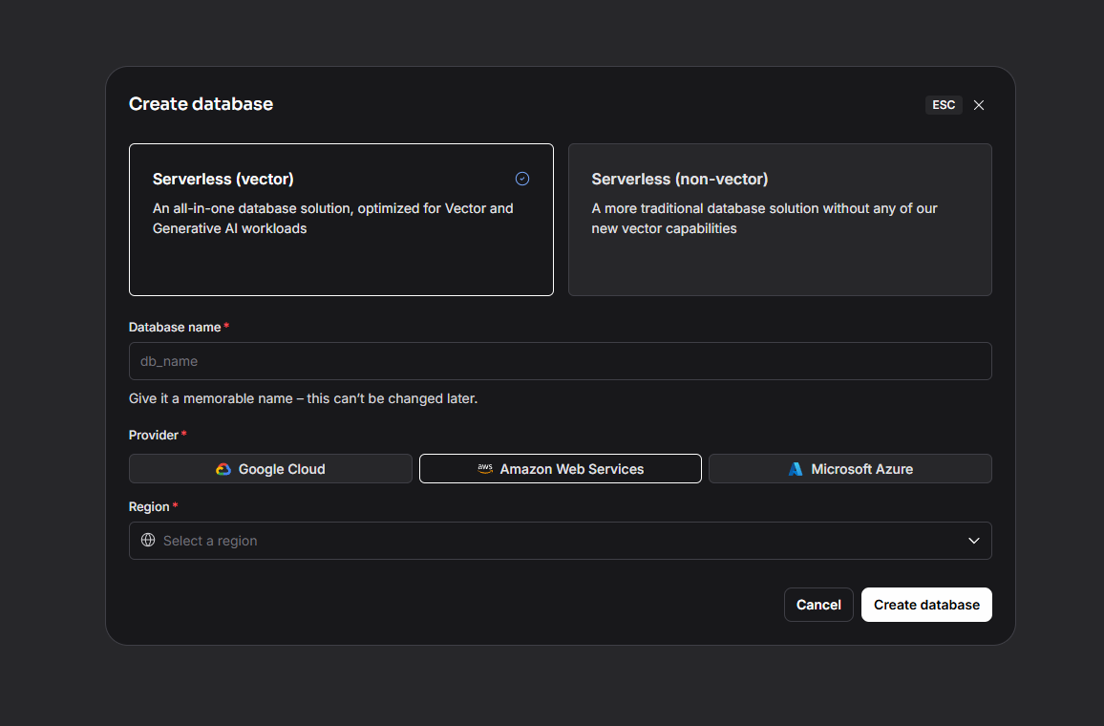

For running the streamlit UI, the command is:

streamlit run <file_path_of_streamlit_python_file>