Tests:

- defaults to short term loan (1yr)

- unique id

- doesn't allow loan amounts over $100000

Output:
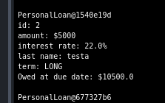
- Unique id is working
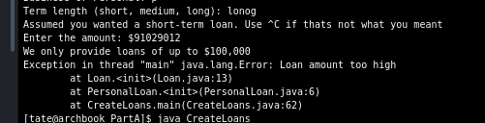

- constructor checks loan amount

- client checks loan amount

