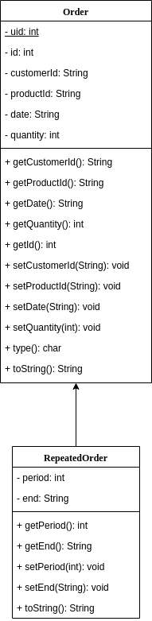

|  |  |  |
| --- | --- | --- |
| Test case | Output | Tested |
| Prints out menu and accepts selection | Menu prints to terminal | Works correctly |
| A option | Accepts order input  Prints out order that it adds | Works correctly (used option L to check) |
| D option | Accepts order id  Deletes order with given id from database  Prints out order that was deleted | Works correctly (used option L to check) |
| L option | Lists orders in increasing date order  (too big to show in one screenshot) | Works correctly |