Live AEX product — UI walkthrough
Nanoheal Live AEX · http://localhost:5176 · 2026-08-25T12:18:10 · 112 screens
Each entry is one navigable console surface or overlay with a screenshot. Coming soon / menu-disabled items are still included when the URL is reachable.

Home

Overview
Path: /home
Tenant home / control tower. Device health, compliance posture, open alerts, and recommended actions for the selected site.
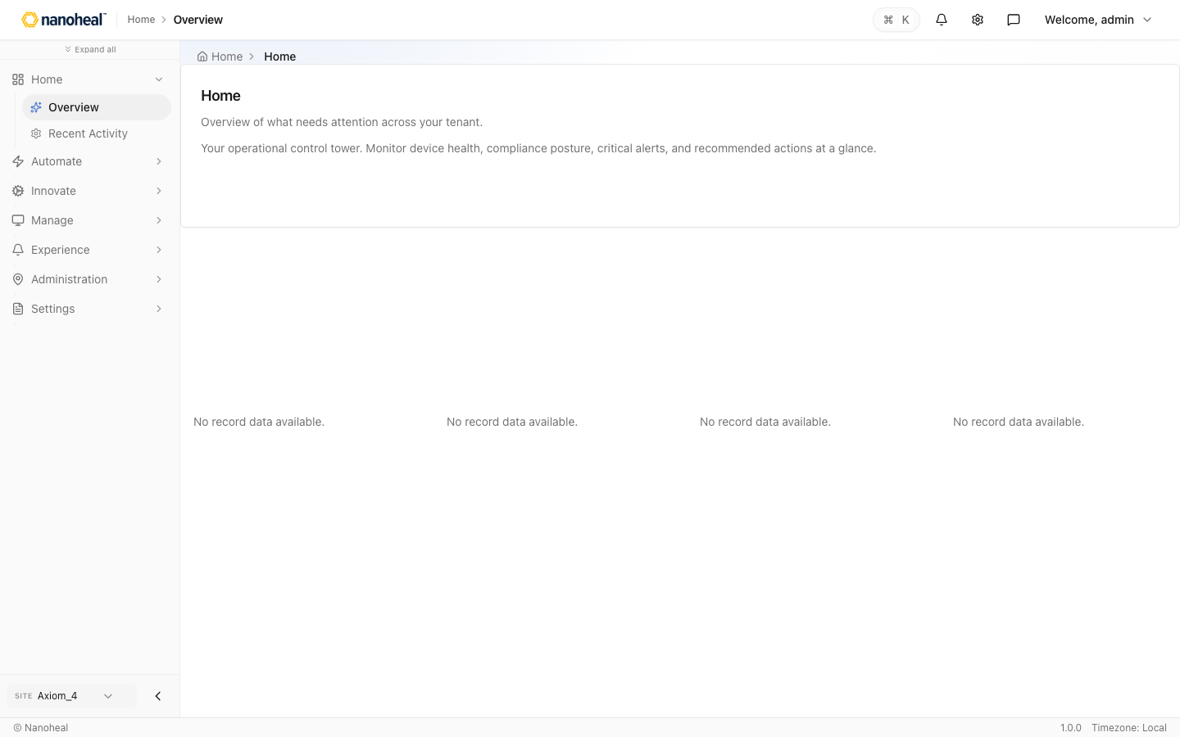
screenshots/001-home-overview.png

Recent Activity — Activity logs
Path: /settings/audit/activity-log
Operational activity log — who changed automations, published surveys, pushed software, or linked profiles.
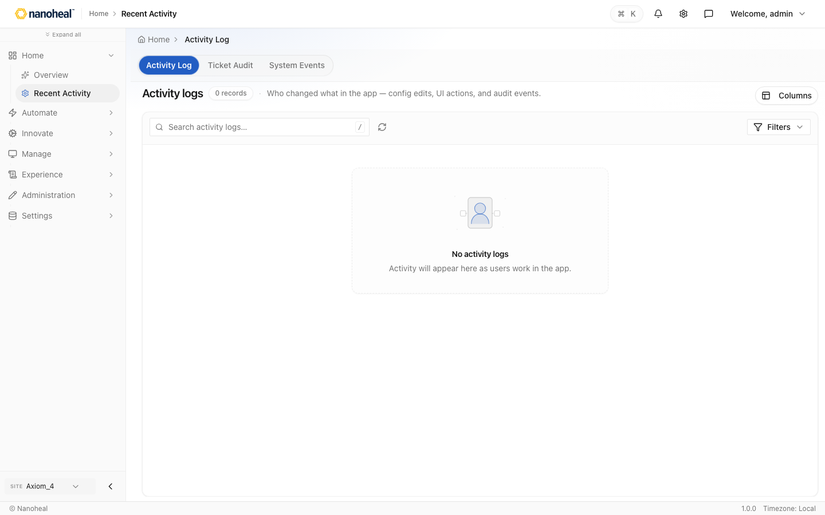
screenshots/097-home-recent-activity-seeded.png

Automate

Automation — Profiles
Path: /actions/library
Automation library of self-help, autoheal, and scheduler profiles. Browse remediations, open details, link scope to device groups.
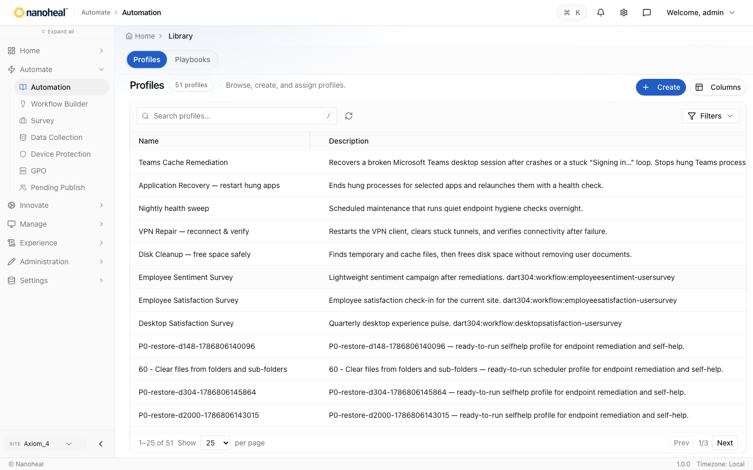
screenshots/098-automate-automation-profiles-seeded.png

Workflow Builder
Path: /actions/library/visual-builder
Workflow Builder for authoring automations visually: template or custom, actions, When triggers, Matches conditions, save, then link scope.
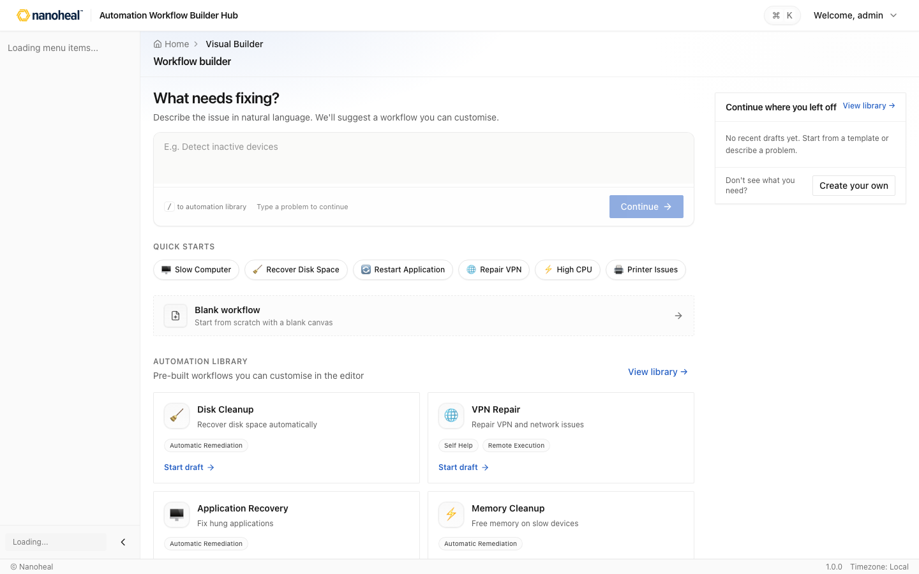
screenshots/111-workflow-builder-deep-01-hub-templates-create-custom.png

Survey — Campaigns
Path: /actions/campaigns
Survey campaigns for desktop satisfaction, employee satisfaction, and sentiment.
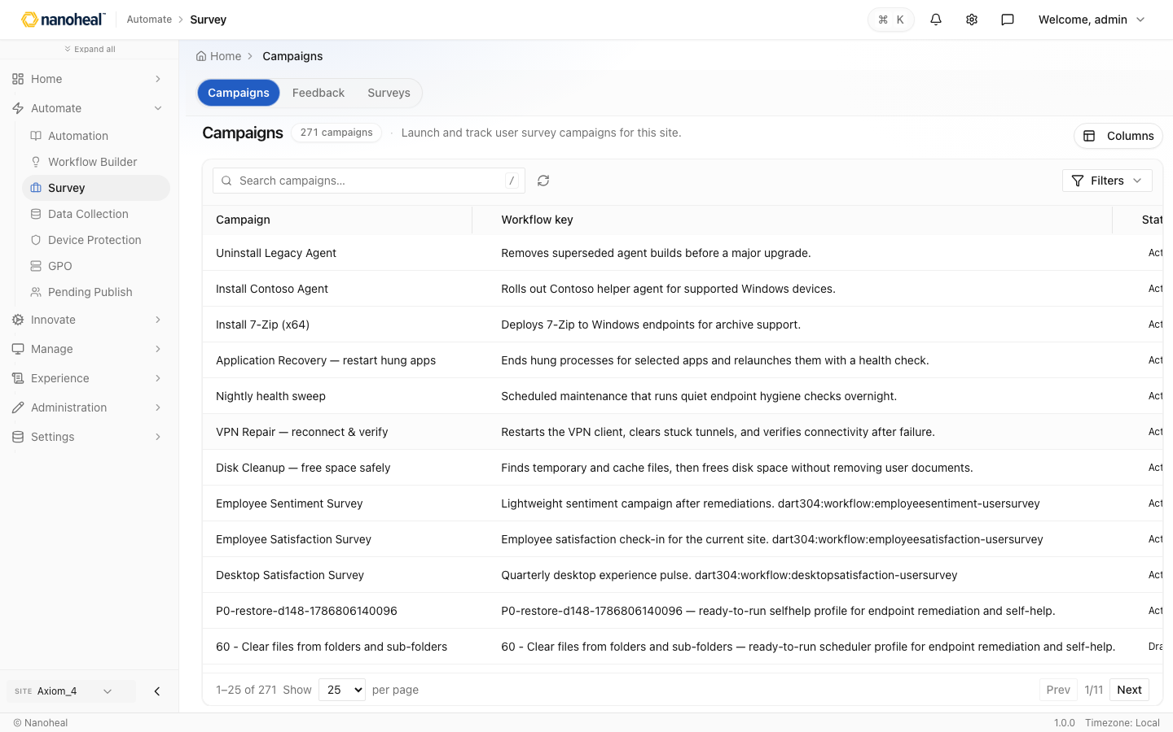
screenshots/099-automate-survey-campaigns-seeded.png

Data Collection
Path: /actions/catalogs/data-collection
Data-collection profiles (performance, storage, user activity, network) for DEX and compliance telemetry.
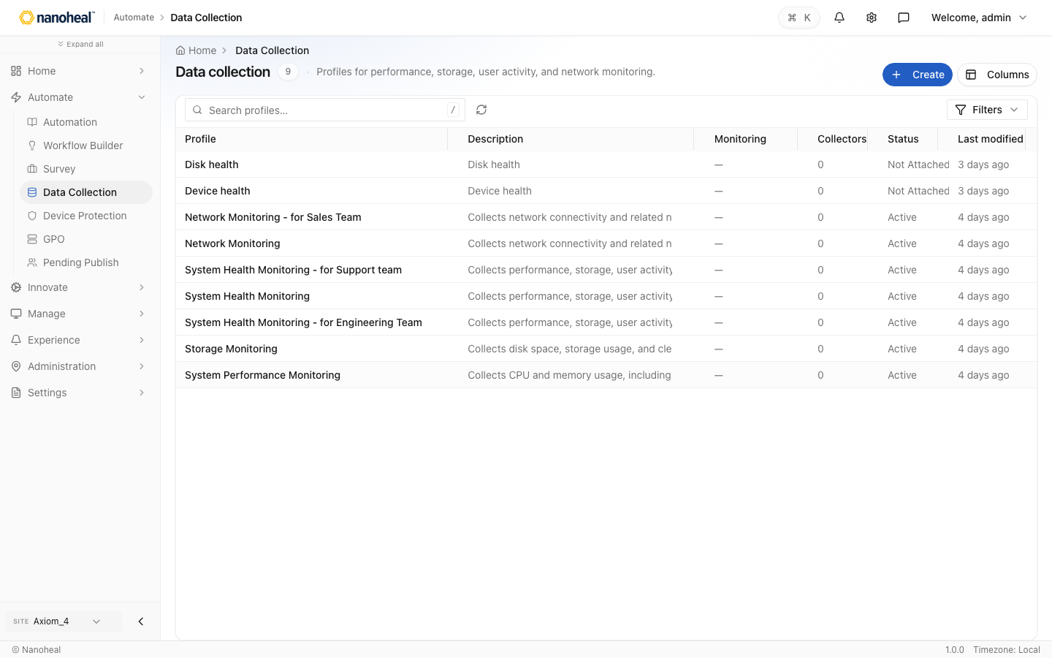
screenshots/006-automate-data-collection.png

Device Protection — Protection policies
Path: /actions/catalogs/device-protection
Device protection profiles (registry, services, application control, paths, USB).
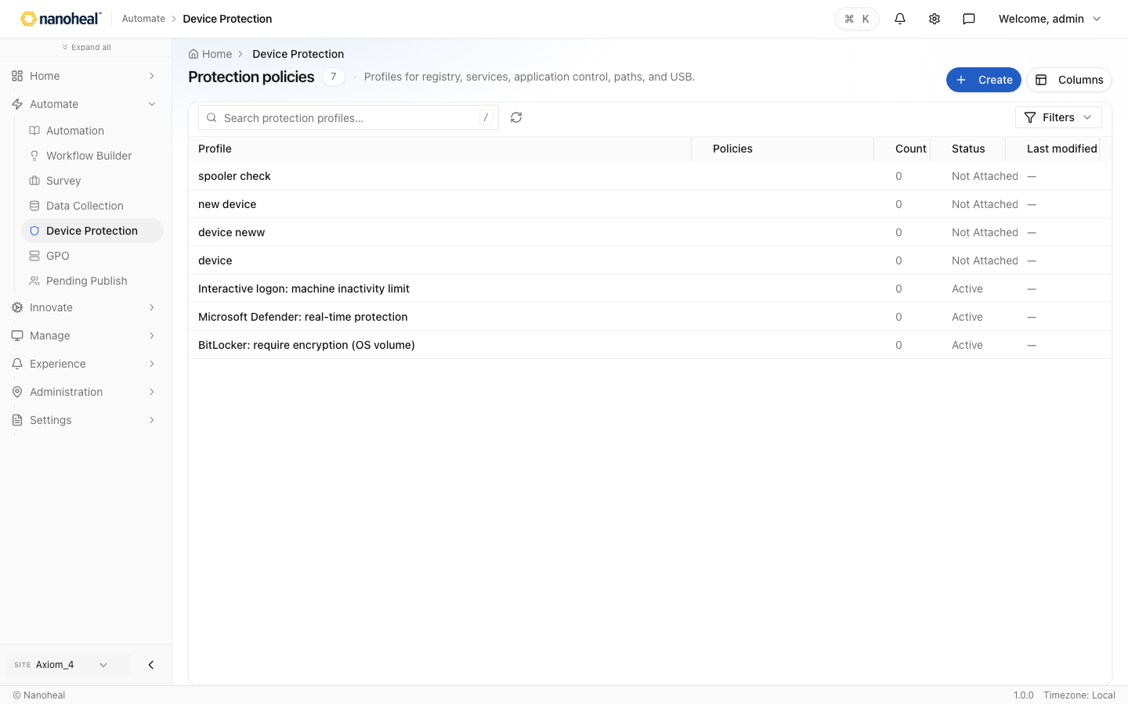
screenshots/007-automate-device-protection.png

GPO — Policy templates (ADMX)
Path: /actions/catalogs/gpo-templates
ADMX policy template browser for Windows desired-state policies.
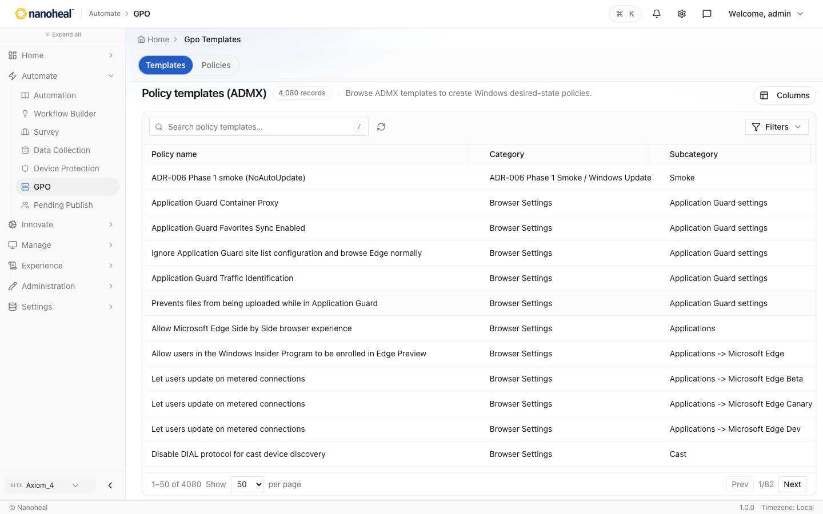
screenshots/100-automate-gpo-admx-active-only.png

Pending Publish — Pending Configuration Changes
Path: /actions/pending-publish
Pending Publish — staged configuration changes per machine group before they go live.
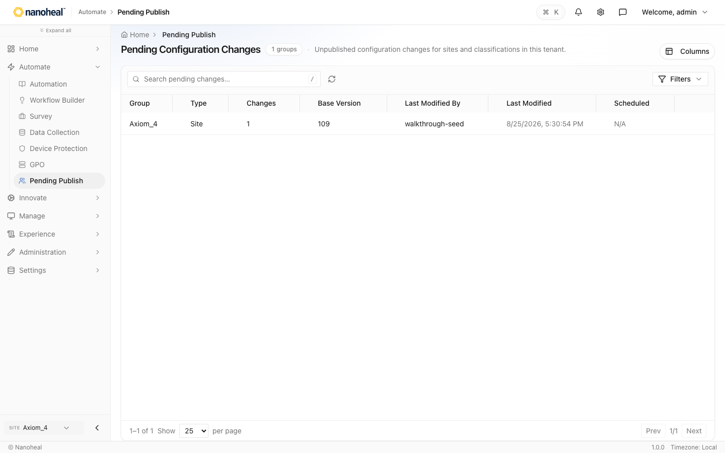
screenshots/101-automate-pending-publish-seeded.png

Innovate

AI Helpdesk
Path: /innovate/conversation
Conversational AI Helpdesk (Haya) for plain-language estate questions.
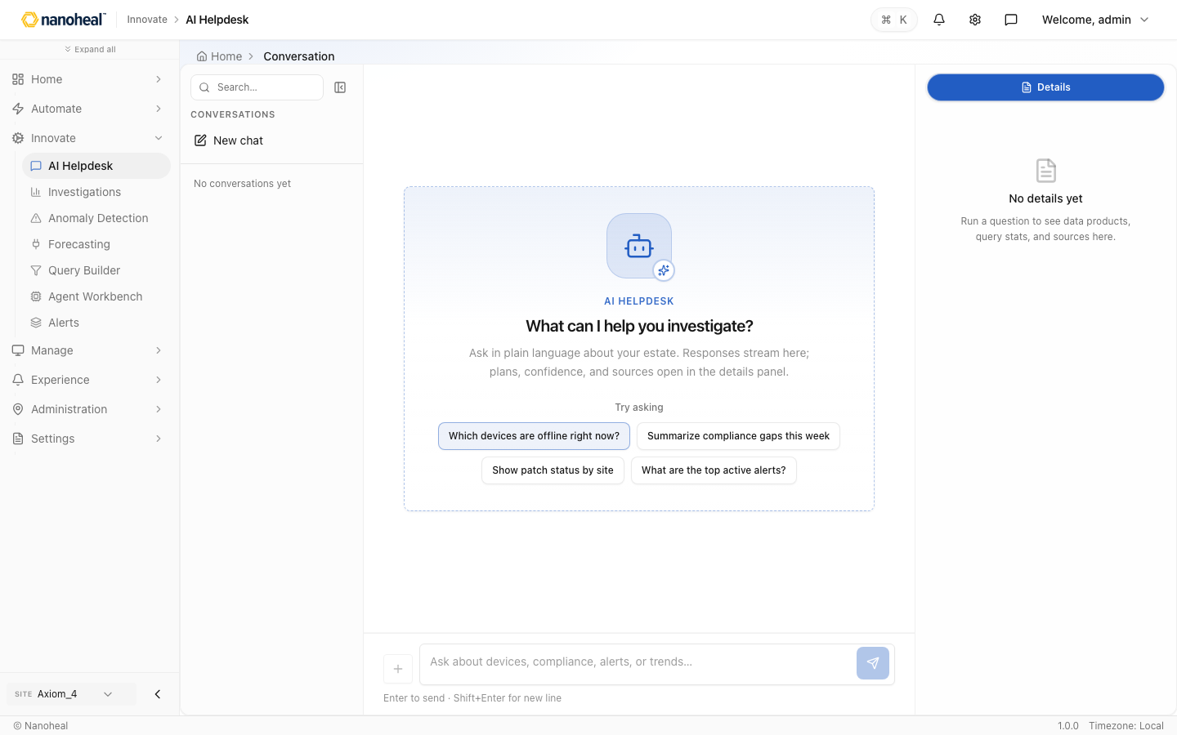
screenshots/010-innovate-ai-helpdesk.png

Investigations
Path: /innovate/haya
Investigation workspace on the Haya conversation surface.
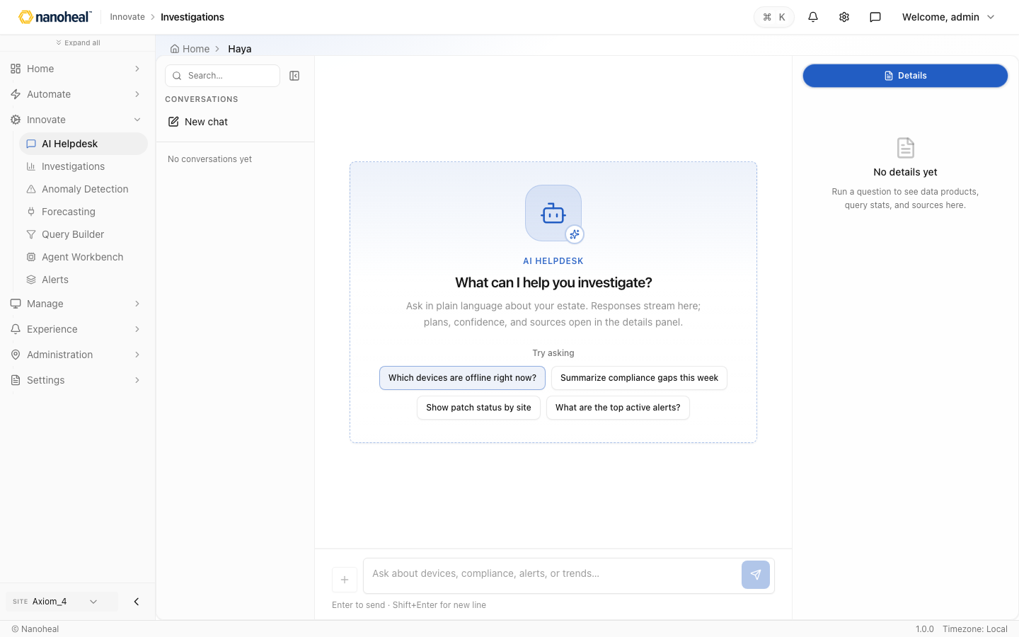
screenshots/011-innovate-investigations.png

Anomaly Detection — Clusters
Path: /innovate/clusters
Anomaly clusters for unusual device or experience patterns.
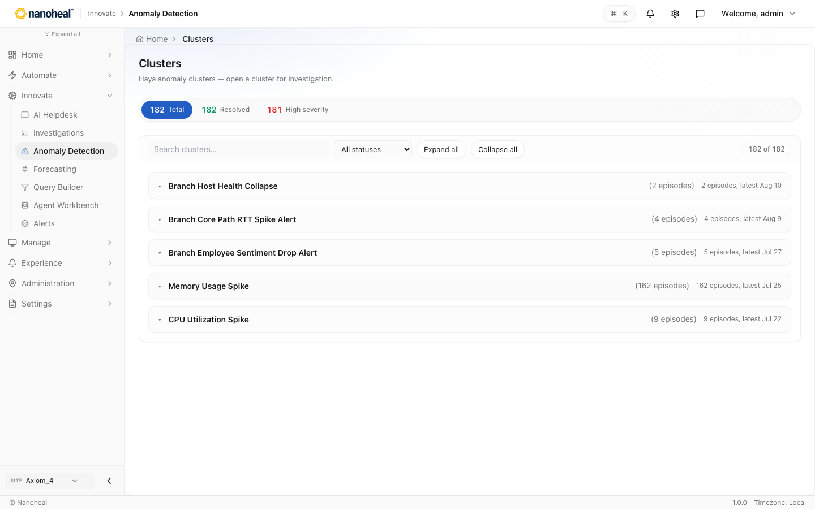
screenshots/012-innovate-anomaly-detection.png

Forecasting — Forecasts
Path: /innovate/forecasts
Forecast instances bound to Studio-published definitions.
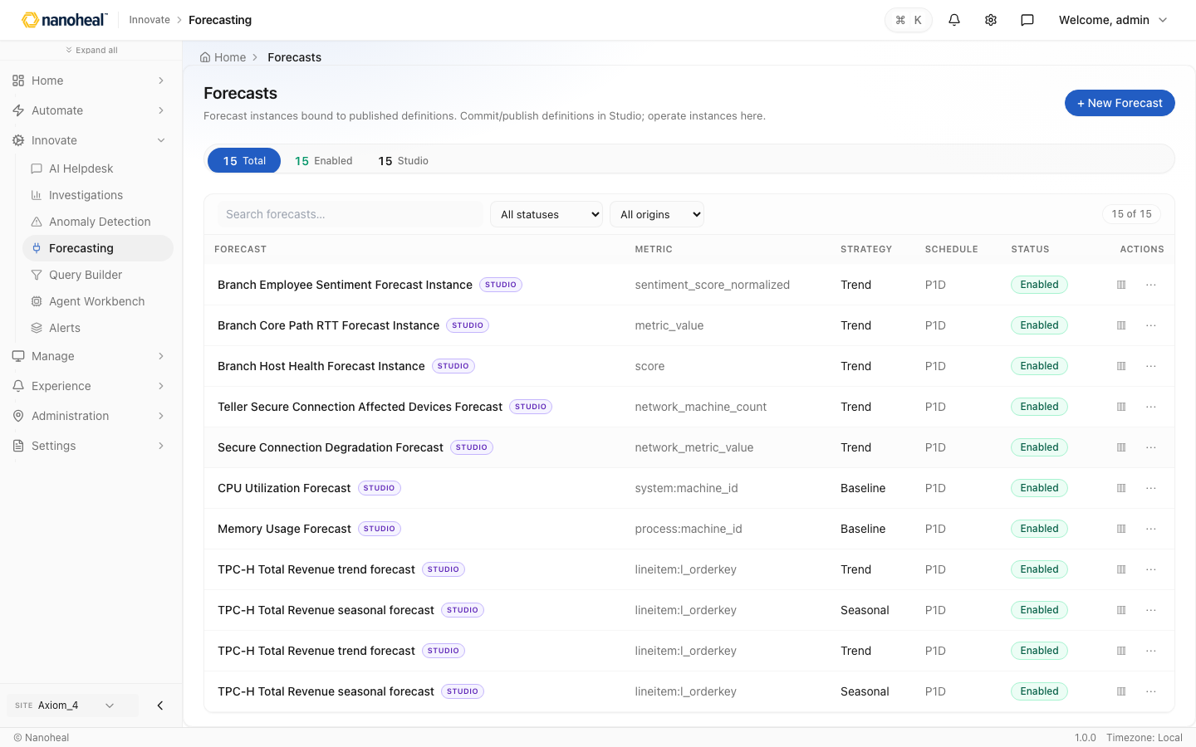
screenshots/013-innovate-forecasting.png

Query Builder
Path: /insights/exploration/query-builder
Ad-hoc analytics: dimensions, measures, JSON filters, Execute.
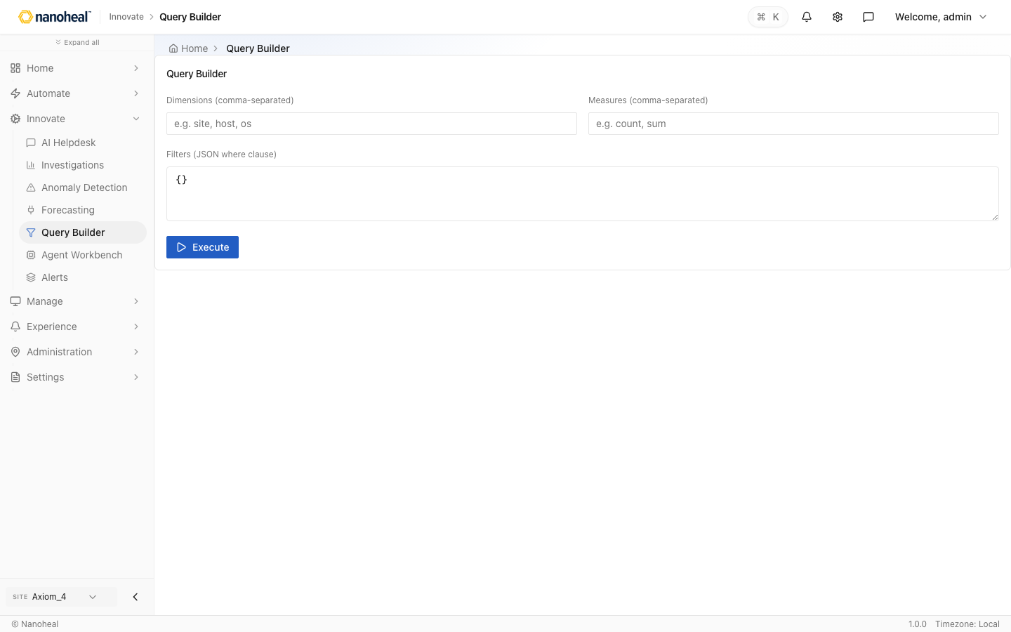
screenshots/014-innovate-query-builder.png

Agent Workbench
Path: /insights/exploration/agent-workbench
Agent chat workbench with smart recommendations from telemetry.
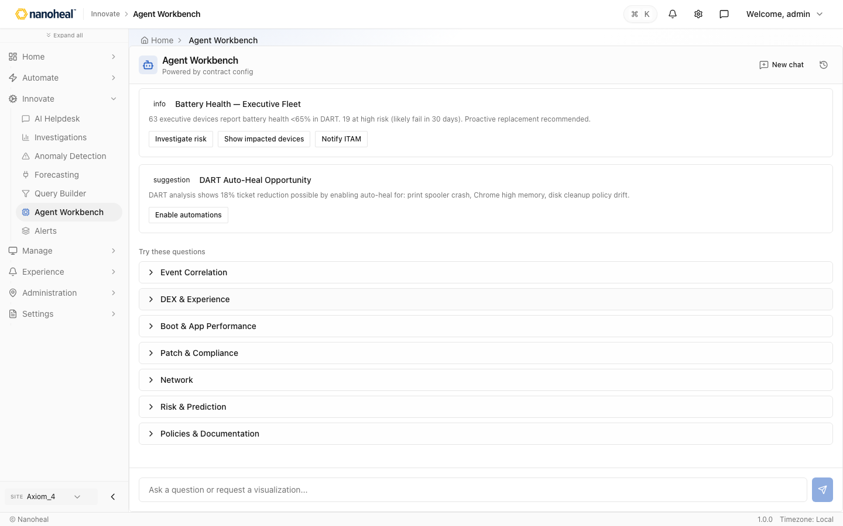
screenshots/015-innovate-agent-workbench.png

Alerts
Path: /innovate/haya?feature=alerts
Alert triage surface (Haya conversation in this build).

screenshots/016-innovate-alerts.png

Experience

Dashboards catalog — 24 DEX & Device Reports
Path: /experience/dashboards
Catalog of Digital Experience (DEX) and device reports.
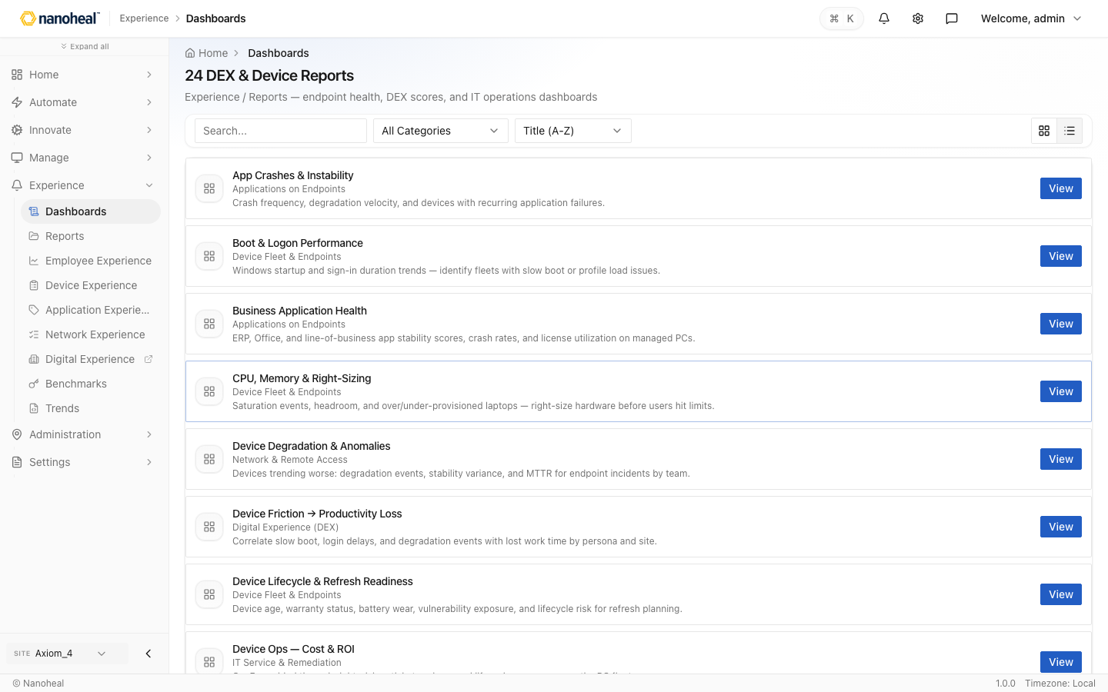
screenshots/017-experience-dashboards-catalog.png

Reports — Digital Experience Overview
Path: /experience/reports
Executive Digital Experience Overview for leadership.
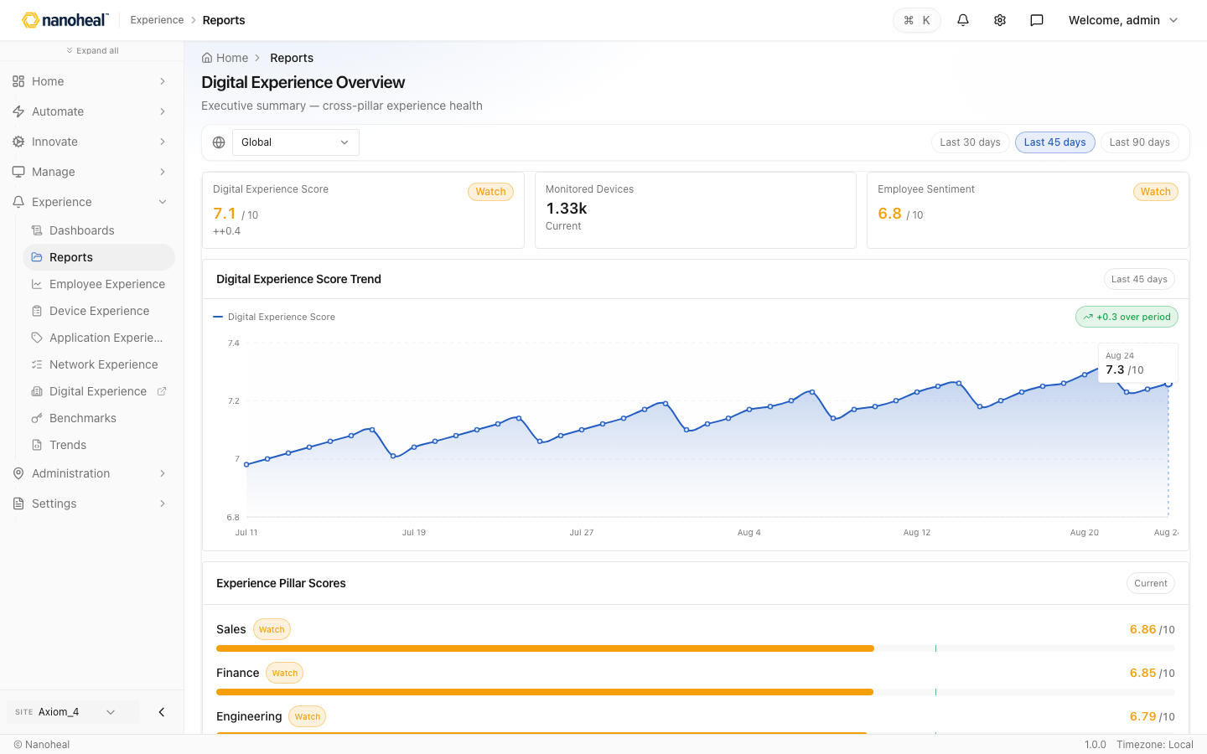
screenshots/018-experience-reports.png

Employee Experience
Path: /experience/employee
Employee Experience story: sentiment and complaint themes.
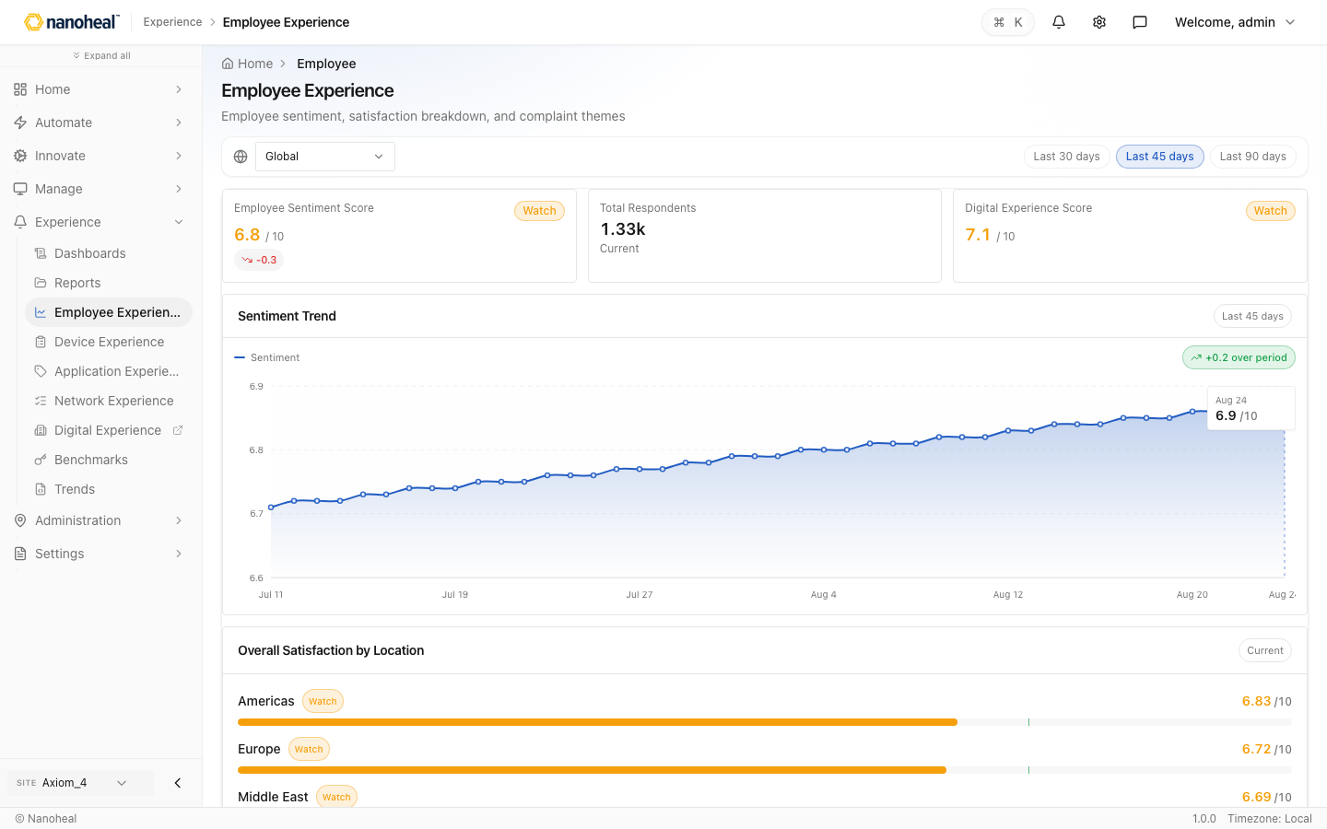
screenshots/019-experience-employee-experience.png

Device Experience
Path: /experience/device
Device Experience story: satisfaction and boot/hardware health.
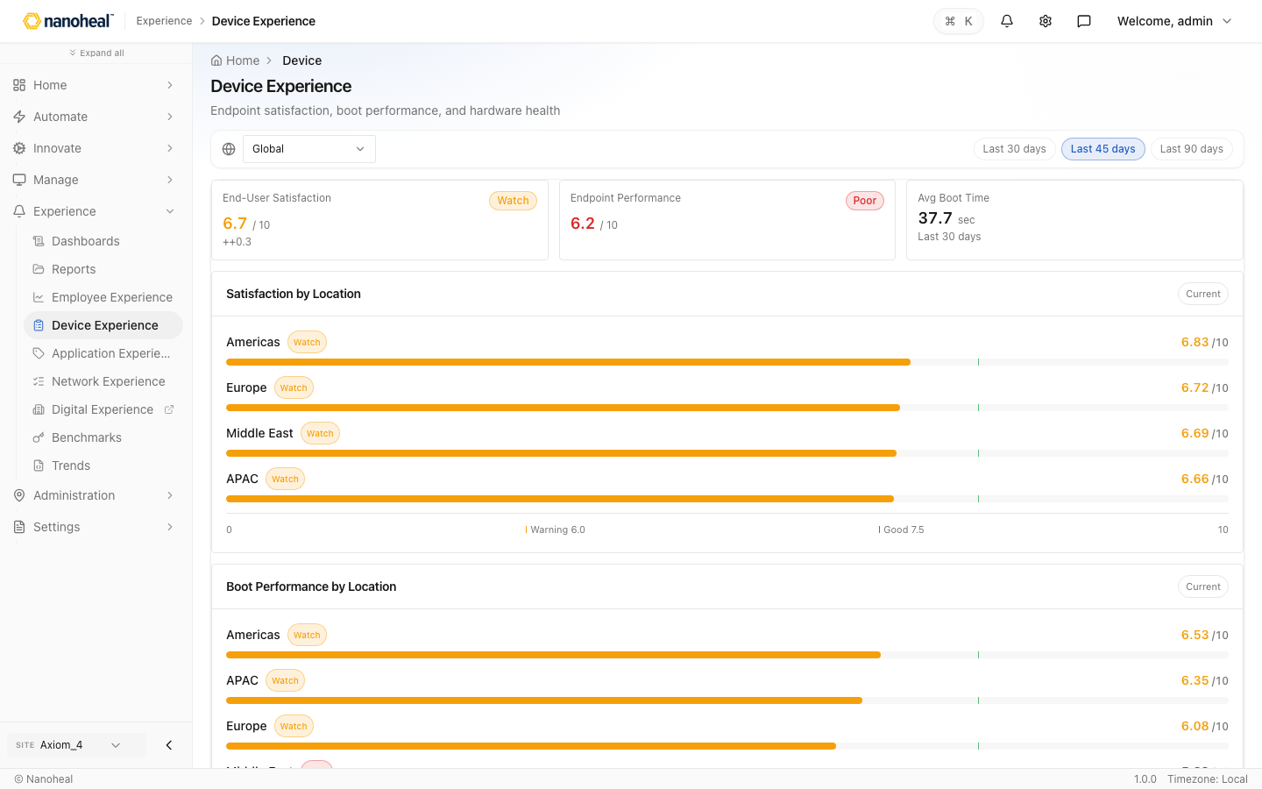
screenshots/020-experience-device-experience.png

Application Experience
Path: /experience/application
Application Experience story: business and collaboration apps.
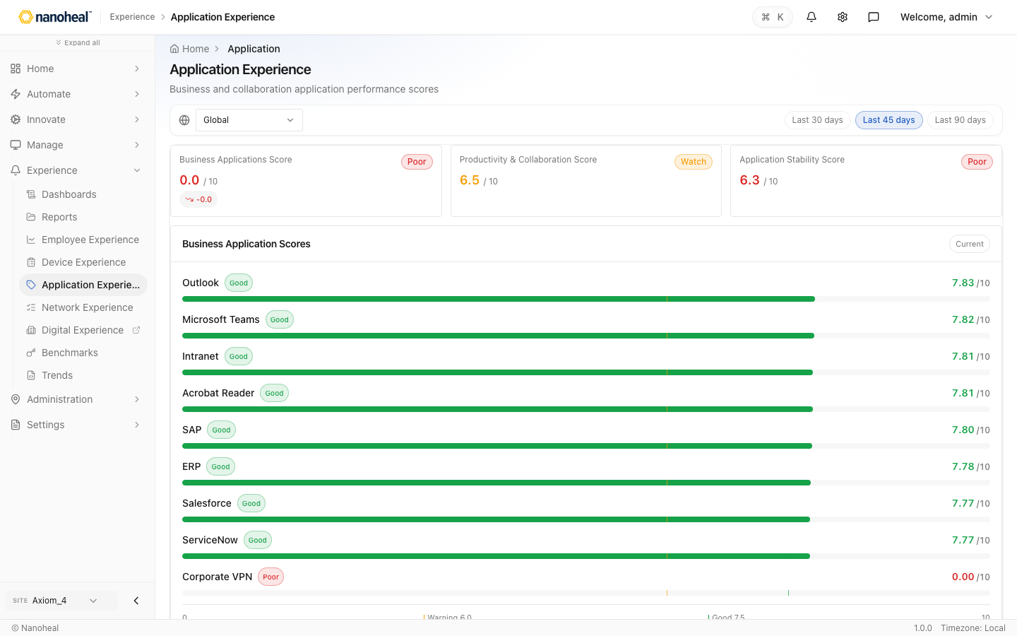
screenshots/021-experience-application-experience.png

Network Experience
Path: /experience/network
Network Experience story: latency and connectivity by site.
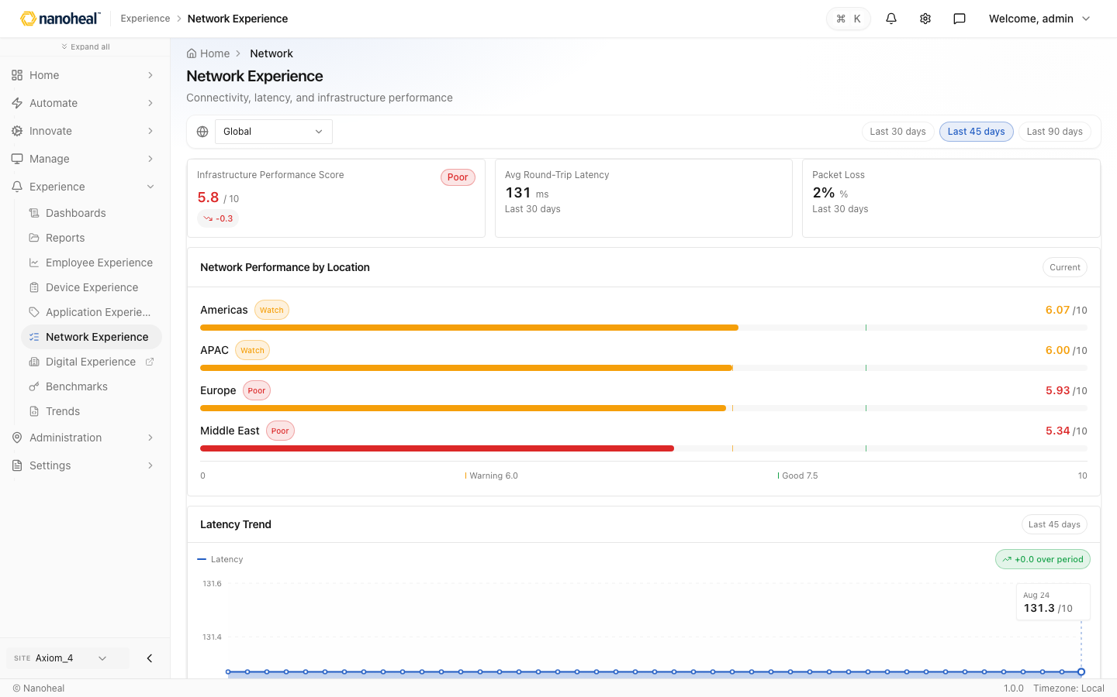
screenshots/022-experience-network-experience.png

Digital Experience — DEX Score Overview
Path: /experience/compliance-score
Digital Experience dashboard (fleet DEX score) — not an external BI login.
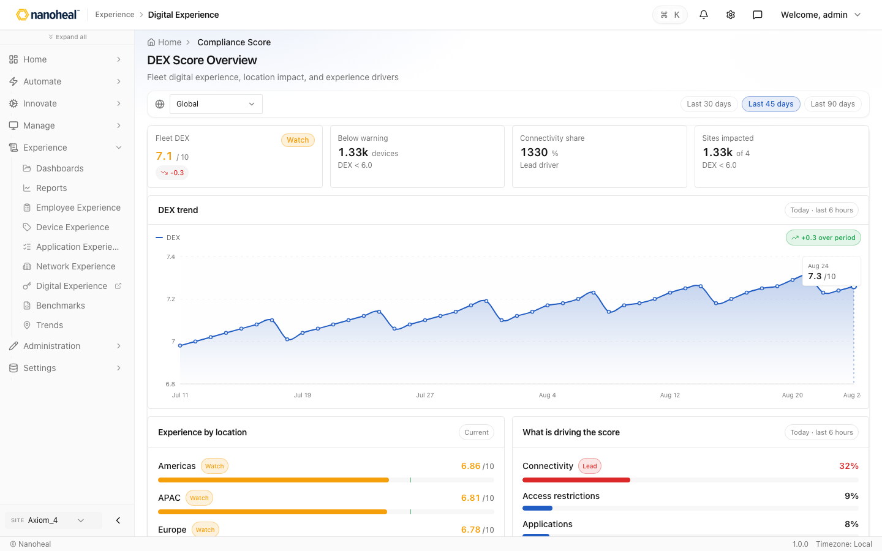
screenshots/102-experience-digital-experience-dashboard.png

Benchmarks — End-User Experience Improvement
Path: /experience/benchmarks
Benchmarks comparing satisfaction vs endpoint performance.
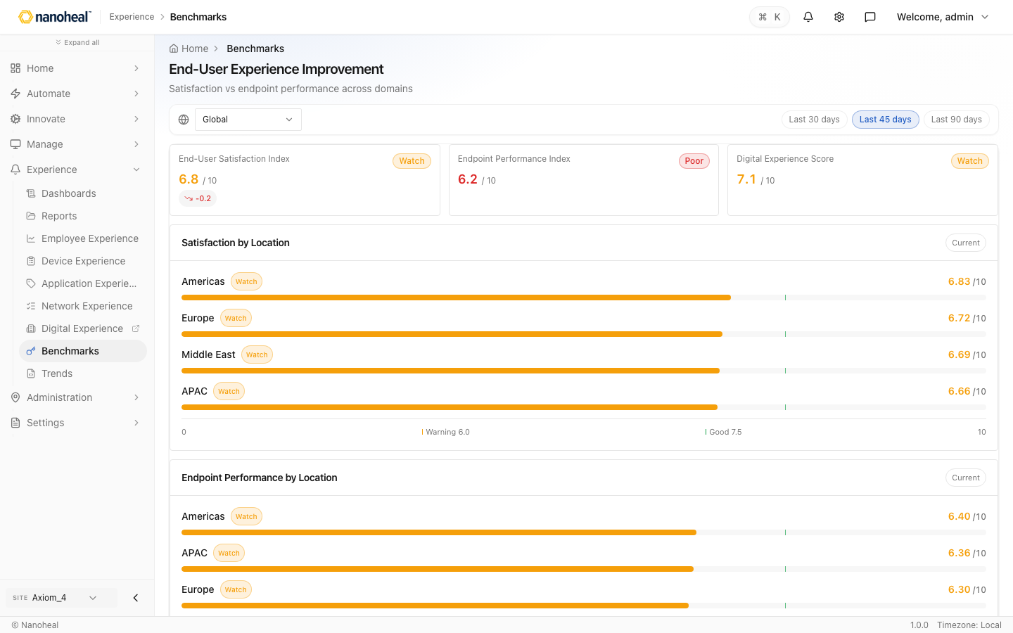
screenshots/024-experience-benchmarks.png

Trends
Path: /experience/trends · coming soon / placeholder
Trends placeholder for historical posture reporting.
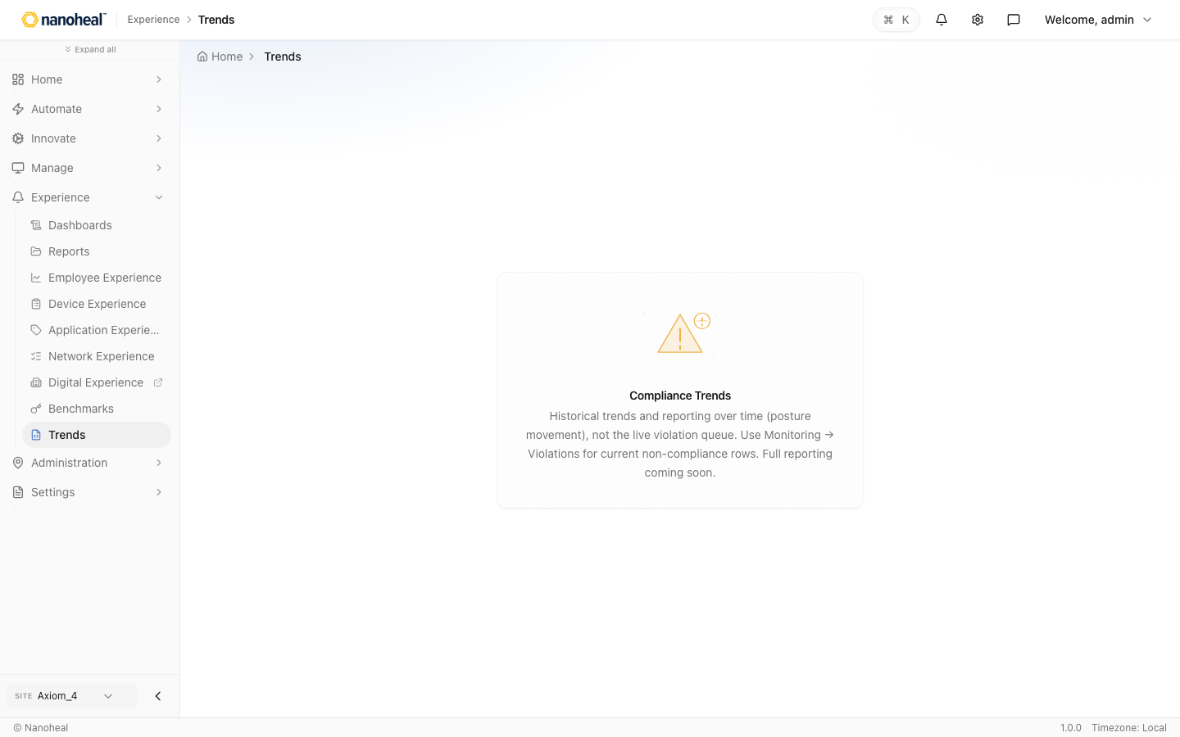
screenshots/025-experience-trends.png

Manage

Device Explorer
Path: /devices/inventory/device-explorer · coming soon / placeholder
Coming soon — device search + full profile explorer.
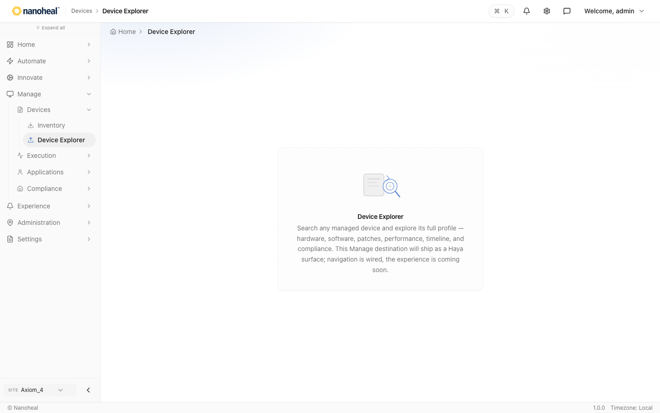
screenshots/027-manage-device-explorer.png

Remote Execution
Path: /actions/execution/remediation
Remote Execution — run a linked remediation now on site, group, or device.
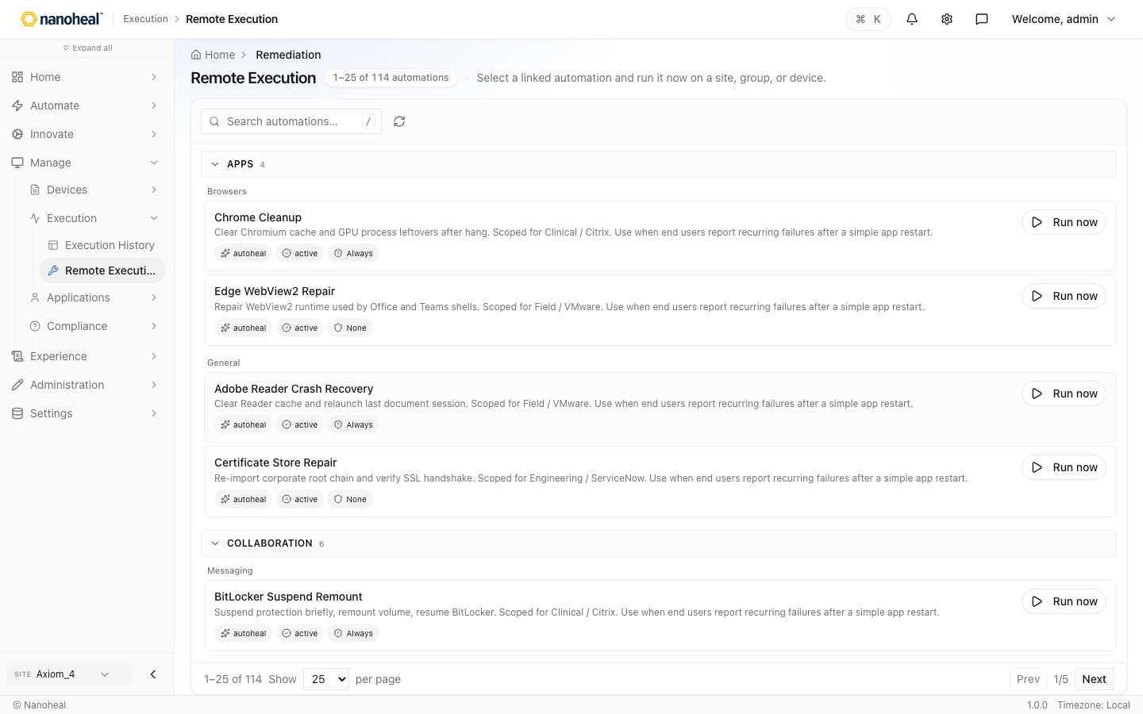
screenshots/104-manage-remote-execution.png

Software Distribution — Software install profiles
Path: /devices/software/software-distribution
Software Distribution — install/uninstall profiles and snippets.
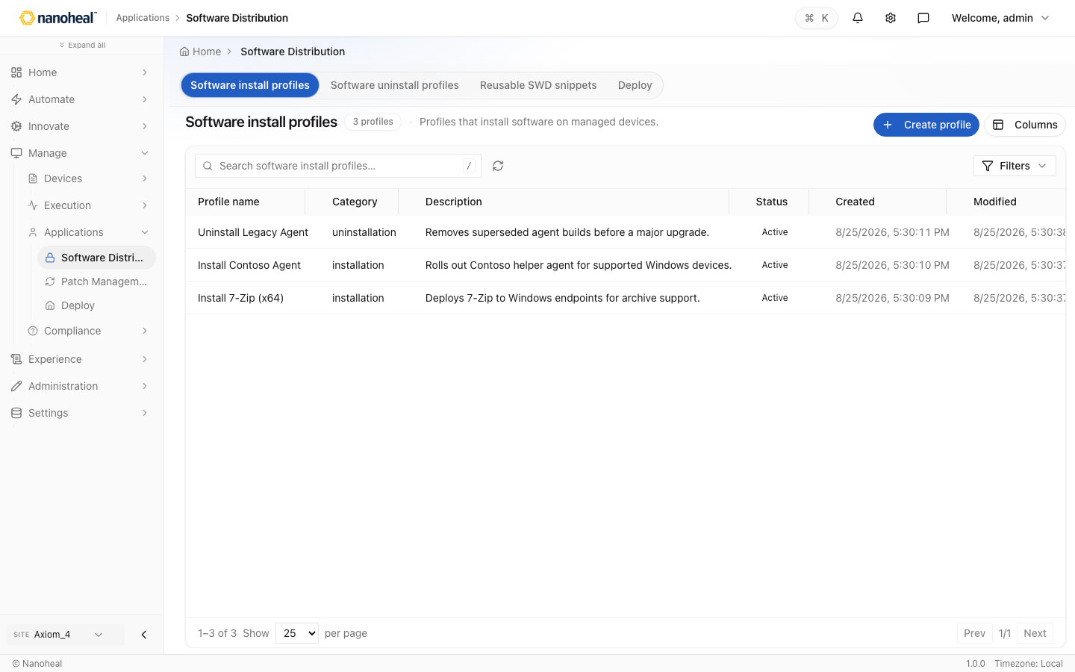
screenshots/105-manage-software-distribution-seeded.png

Patch Management
Path: /devices/software/patch-management · coming soon / placeholder
Coming soon — Windows Update / patch tracking.
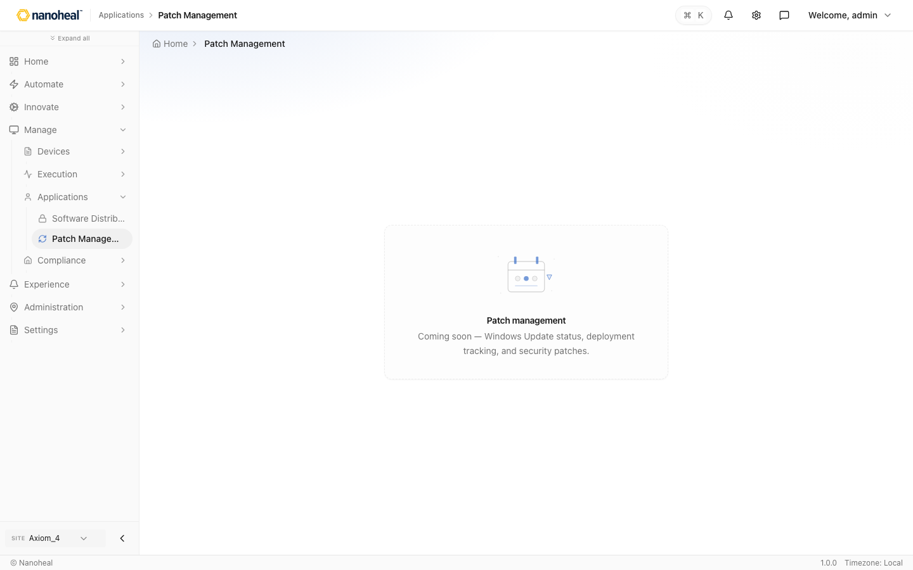
screenshots/032-manage-patch-management.png

Violations
Path: /innovate/haya?feature=violations
Violations triage (Haya conversation in this build).
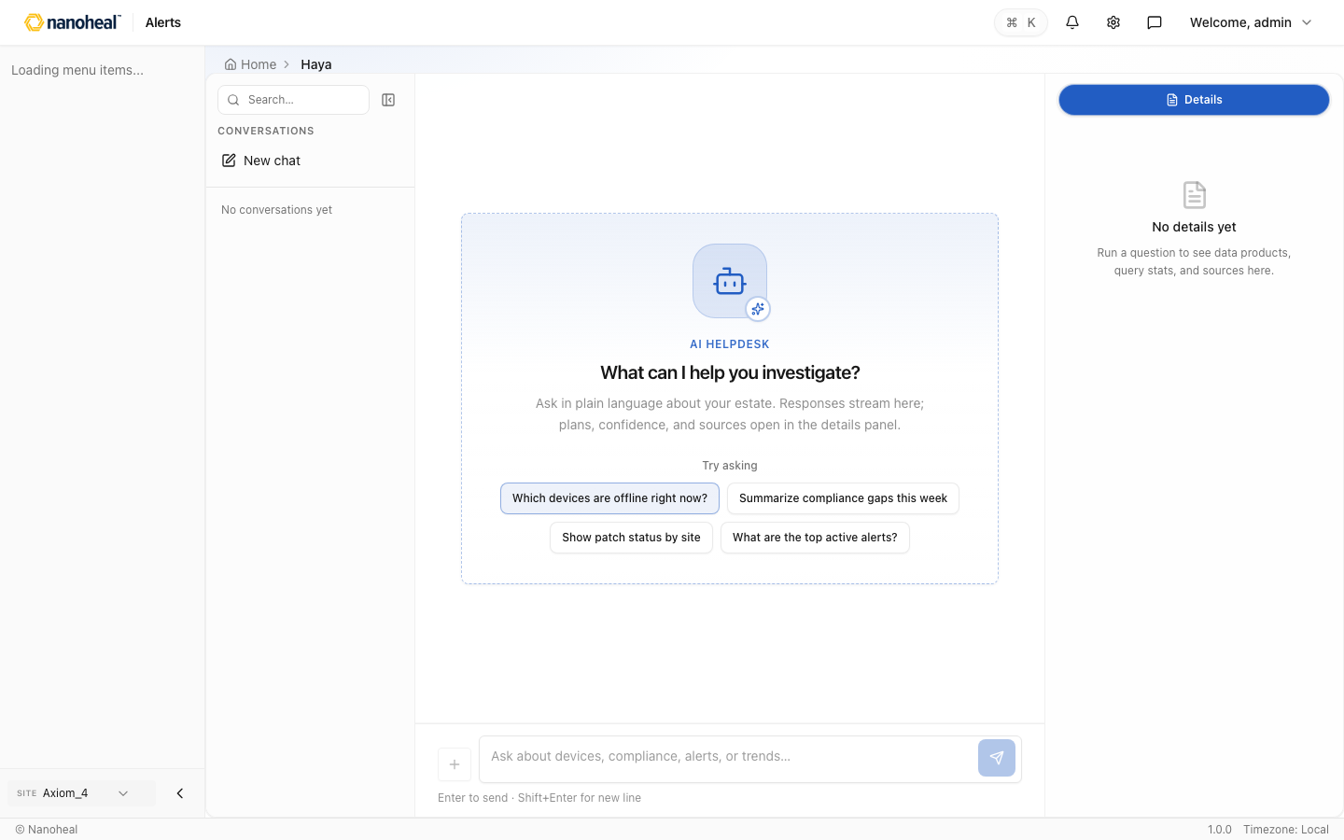
screenshots/033-manage-violations.png

Administration

Tenants
Path: /settings/organization/tenants
Organisation tenants/sites — names, org, keys, installs, license pools.
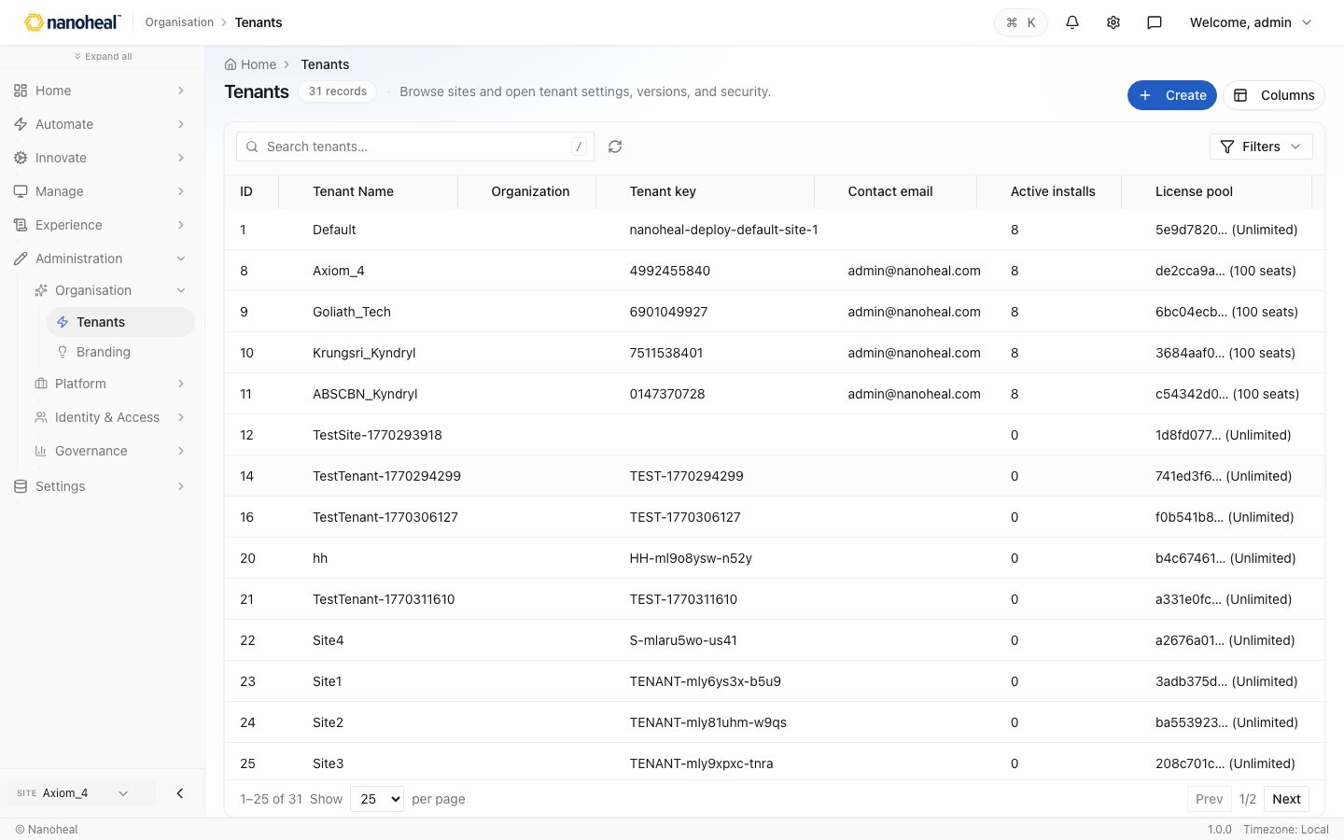
screenshots/107-administration-tenants-nanoheal-org.png

Branding
Path: /manage/organisation/branding · coming soon / placeholder
Coming soon — branding on the IA roadmap.
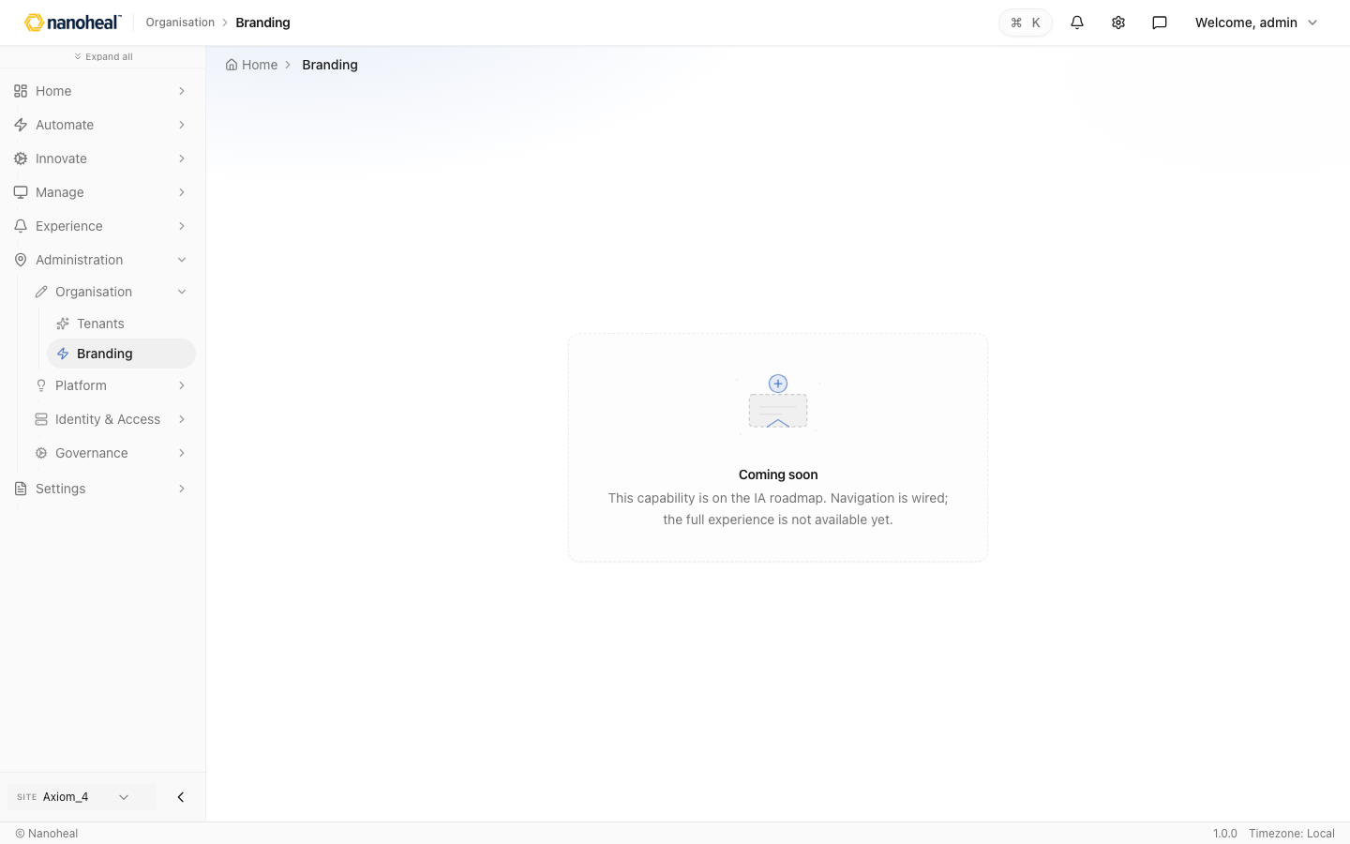
screenshots/035-administration-branding.png

Licensing
Path: /settings/licensing
License pools — entitlements and seat usage.
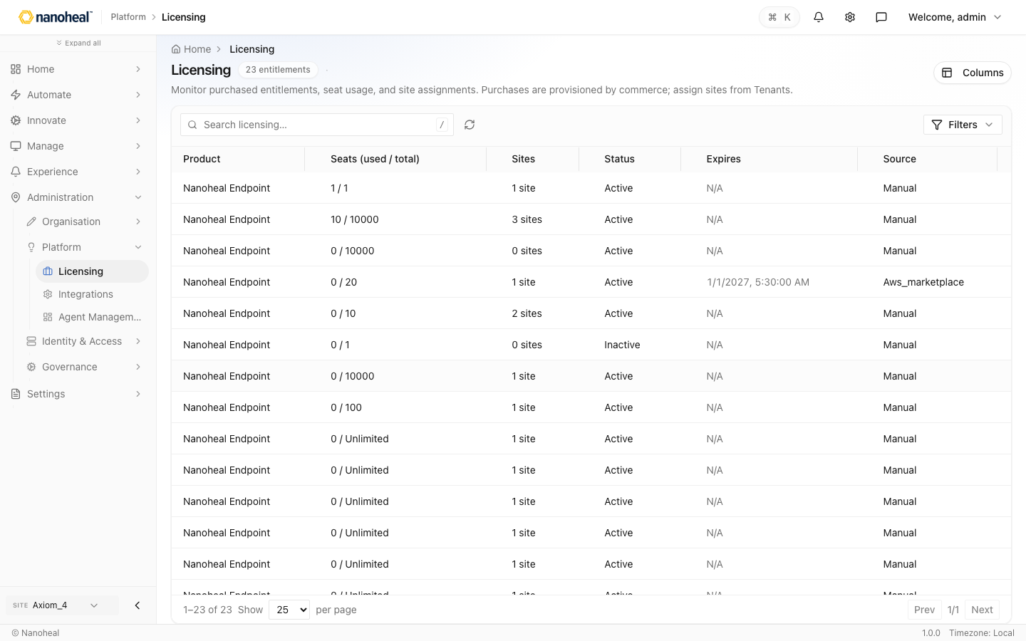
screenshots/036-administration-licensing.png

Integrations — Connectors
Path: /settings/integrations
Integrations hub: connectors, API keys, catalog, event subscriptions.
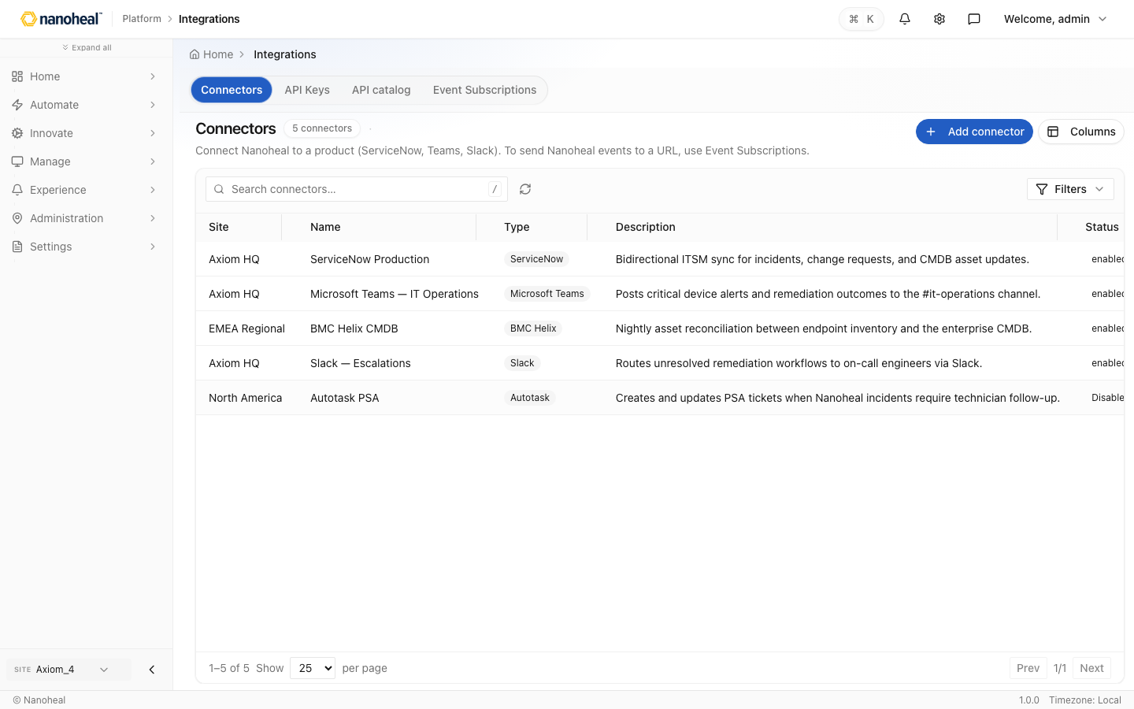
screenshots/037-administration-integrations.png

Agent Management — Versions & rings
Path: /settings/agents
Agent Management — versions & rings, updates, version catalog, uploads.
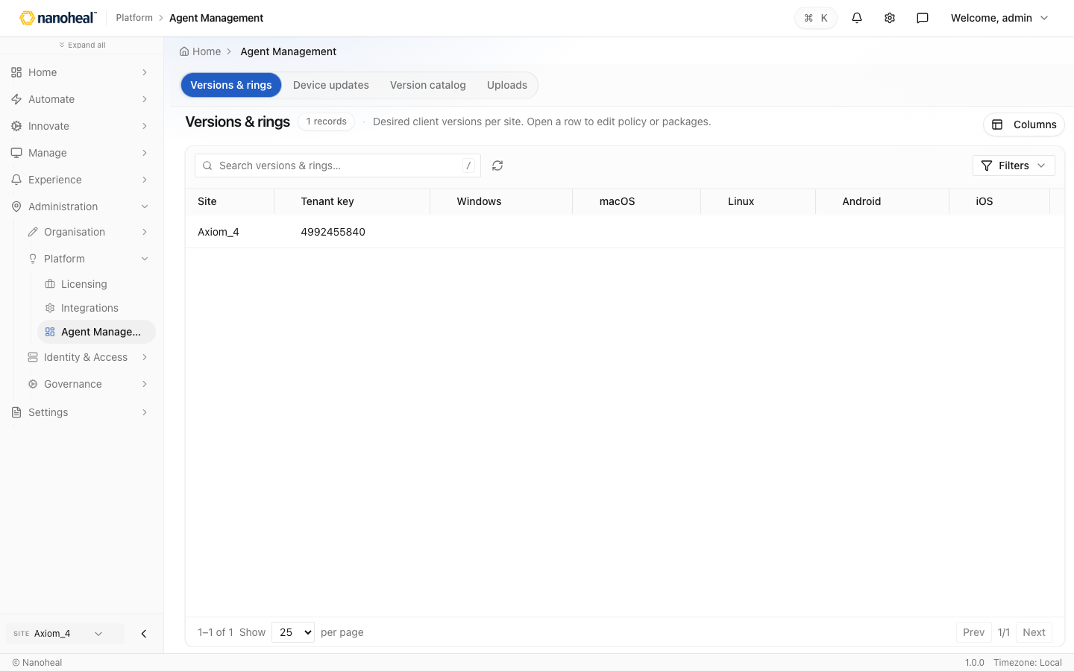
screenshots/038-administration-agent-management.png

Users & Access — User accounts
Path: /settings/users
Users & Access — accounts, RBAC, SSO, MFA.
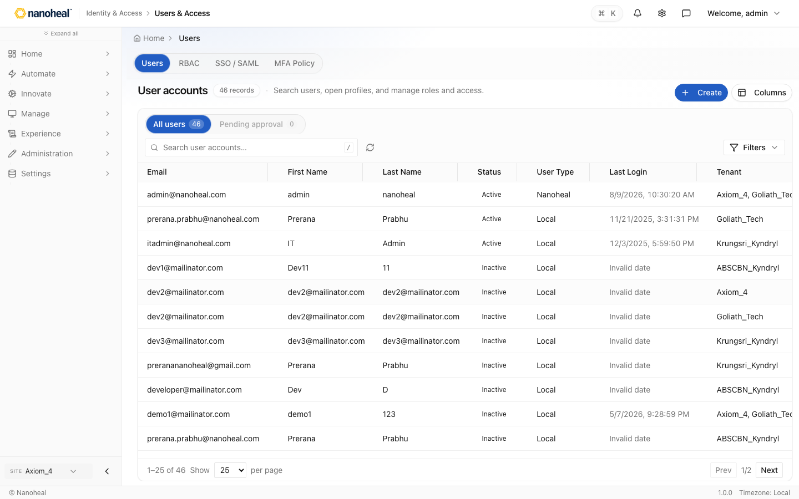
screenshots/108-administration-users-access-seeded.png

Security
Path: /settings/security · coming soon / placeholder
Coming soon — certificates/secrets and GDPR ops.
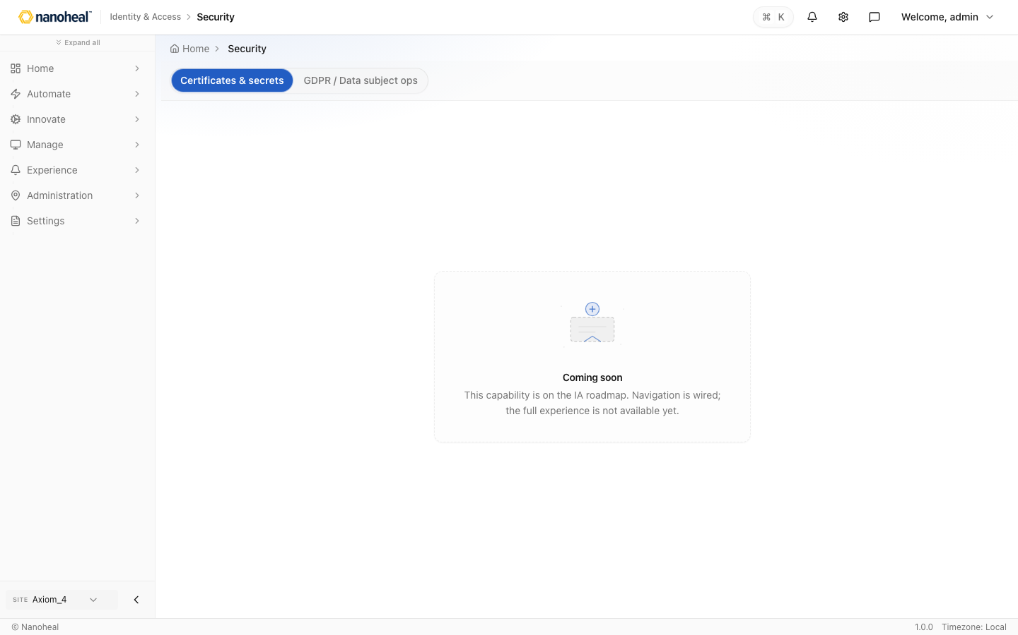
screenshots/040-administration-security.png

Classification — Device classifications
Path: /devices/organization/device-classification
Device classification groups for targeting.
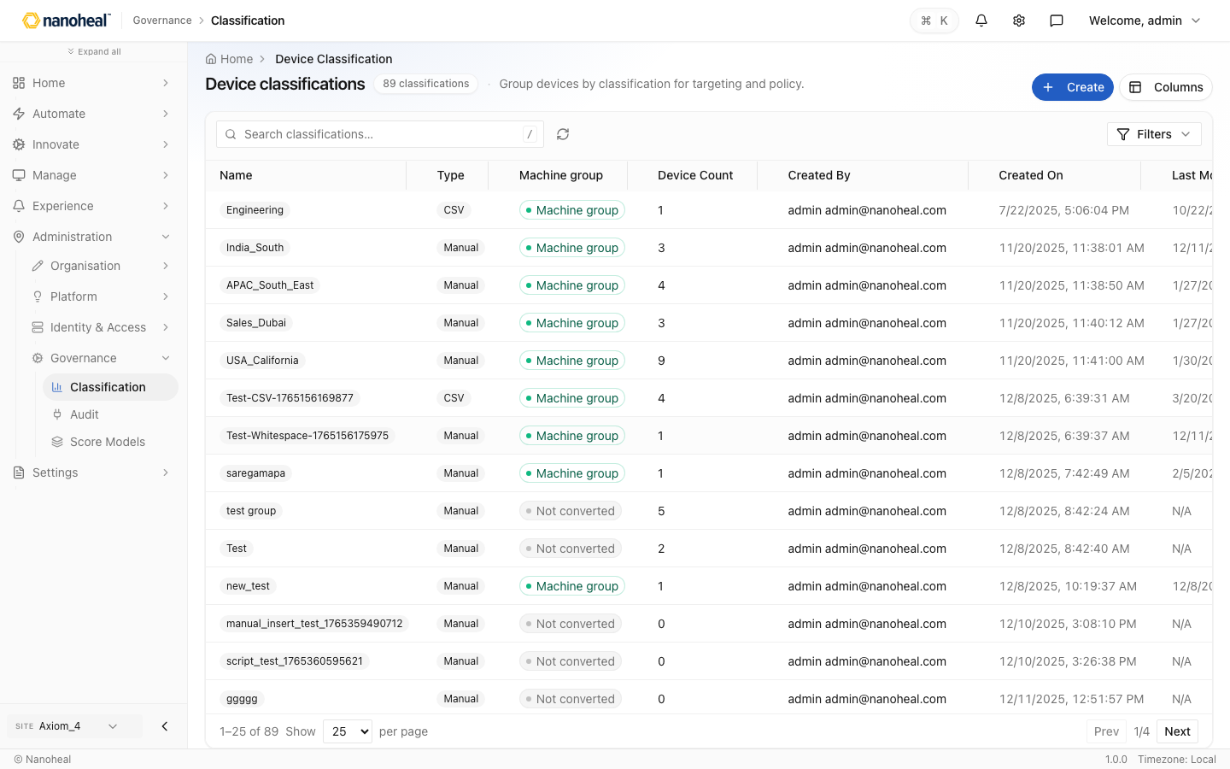
screenshots/041-administration-classification.png

Audit — Activity logs
Path: /settings/audit
Administration Audit hub — activity, ticket, and system events.
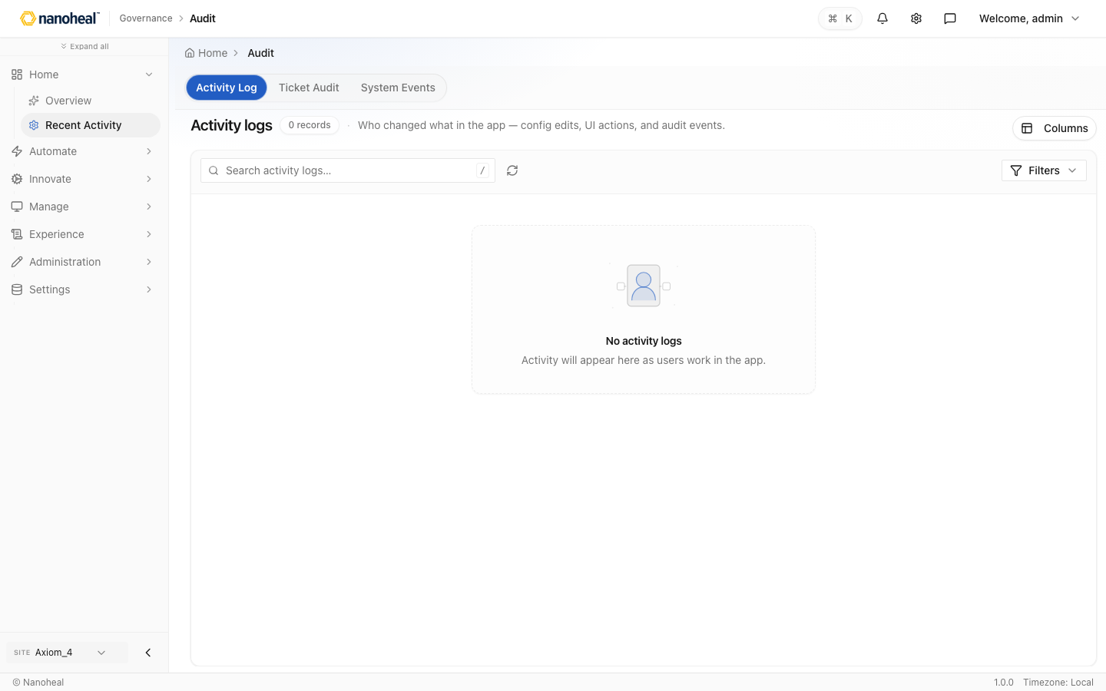
screenshots/109-administration-audit-activity-logs.png

Score Models — Scores
Path: /compliance/policy/score-models
Score Models that feed DEX and operations scoring.
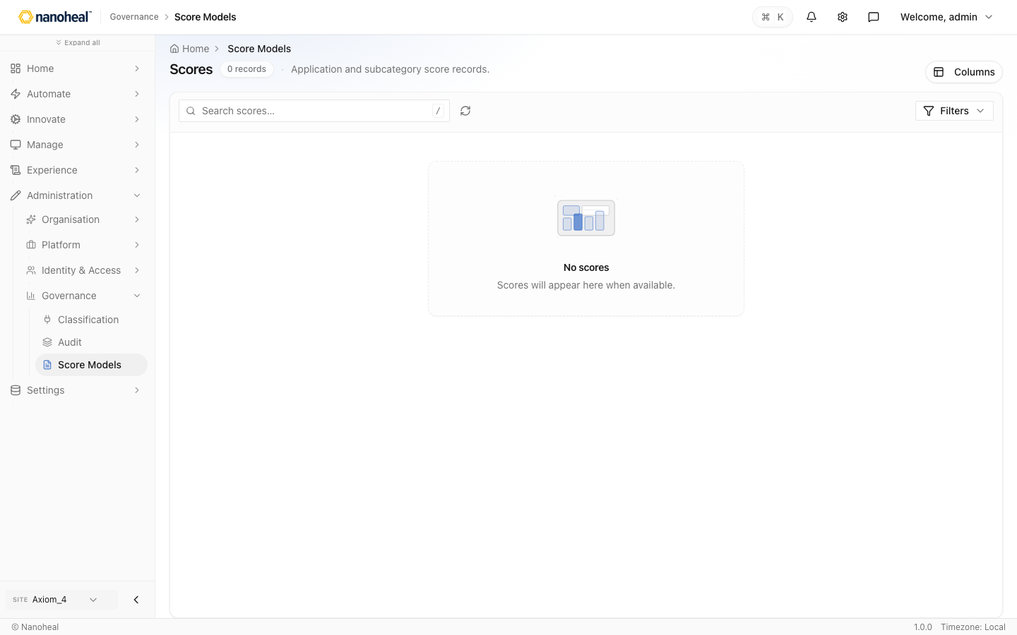
screenshots/110-administration-score-models-seeded.png

Settings

Profile
Path: /account/profile
Personal profile for the signed-in operator.
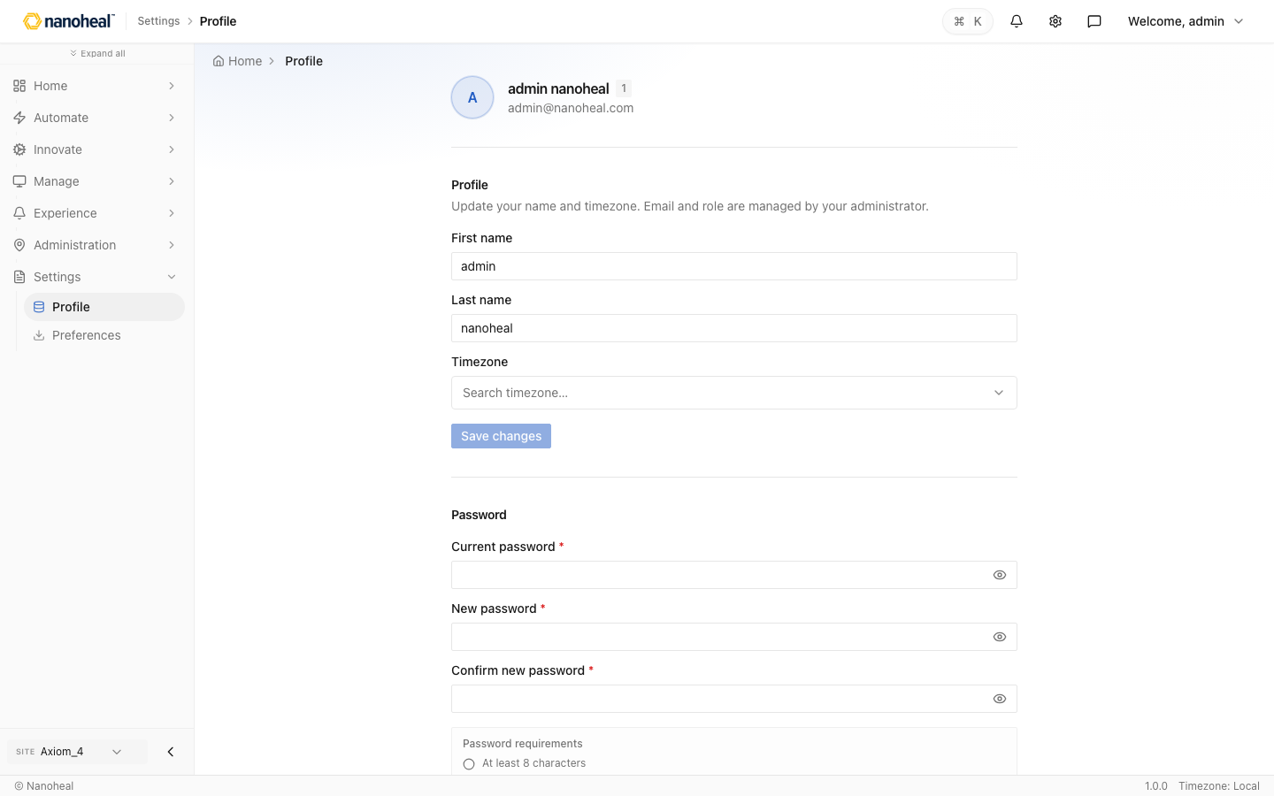
screenshots/044-settings-profile.png

Preferences
Path: /account/preferences
Theme and accent color preferences.
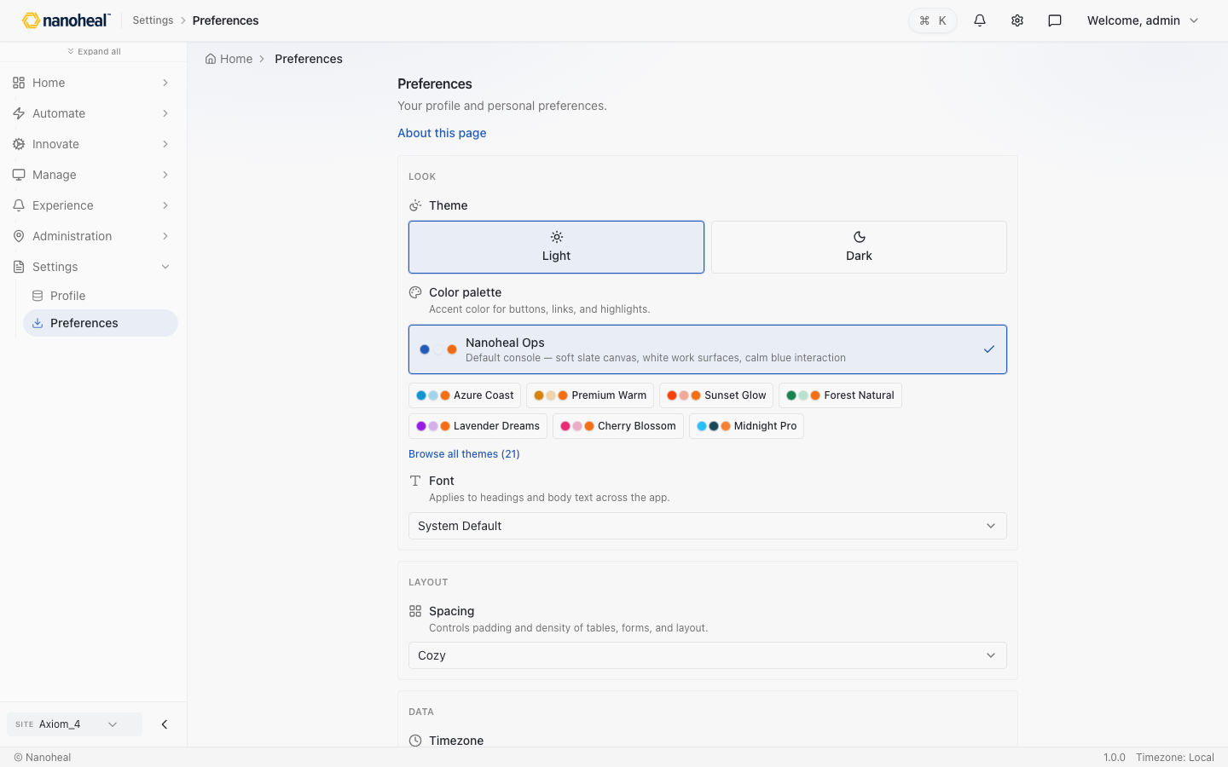
screenshots/045-settings-preferences.png

Header

Help & Feedback
Path: /experience/help
Help & Feedback from the header.
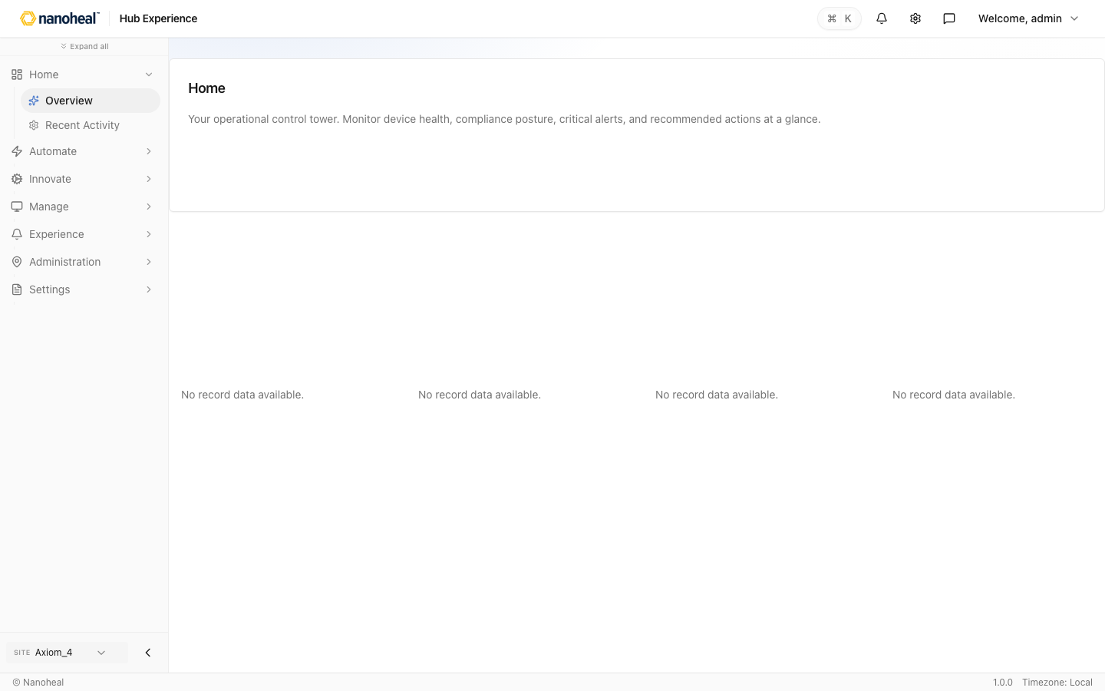
screenshots/046-header-help-feedback.png

DEX report views

DEX Score Overview
Path: /experience/dashboard/view/dex-score-overview
Fleet-wide digital experience score, location impact, and drivers across the estate.
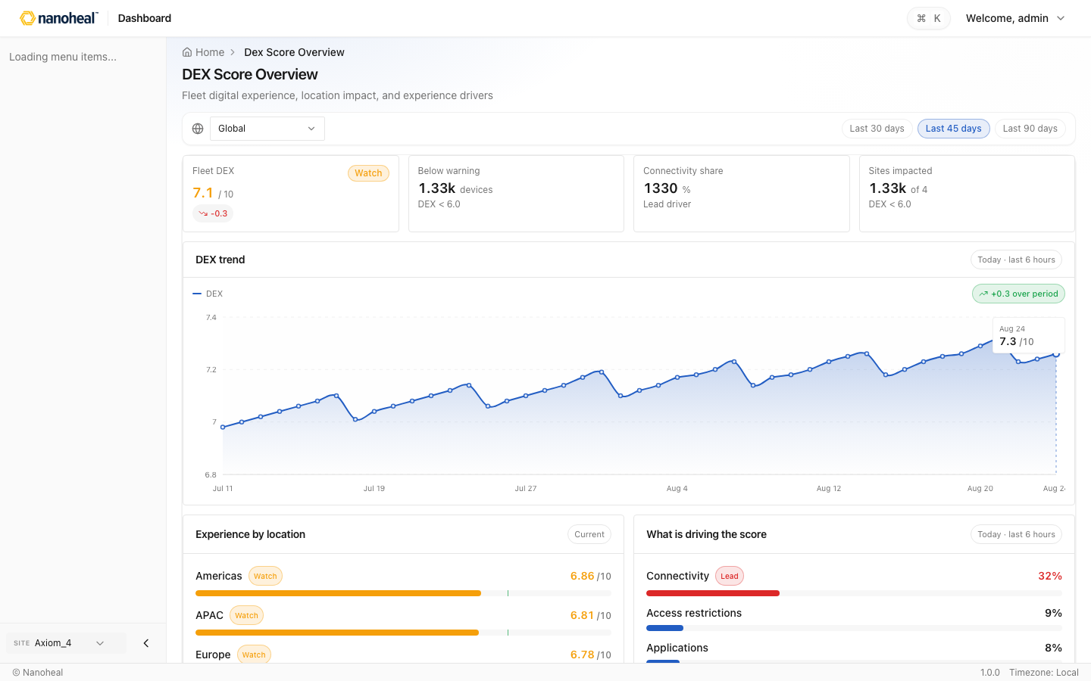
screenshots/059-dex-report-views-dex-score-overview.png

What Changed — Device & DEX Drivers — Anomaly & Degradation Intelligence
Path: /experience/dashboard/view/anomaly-degradation-intelligence
Period-over-period DEX movement driven by boot time, crashes, patch gaps, and network latency on managed devices.
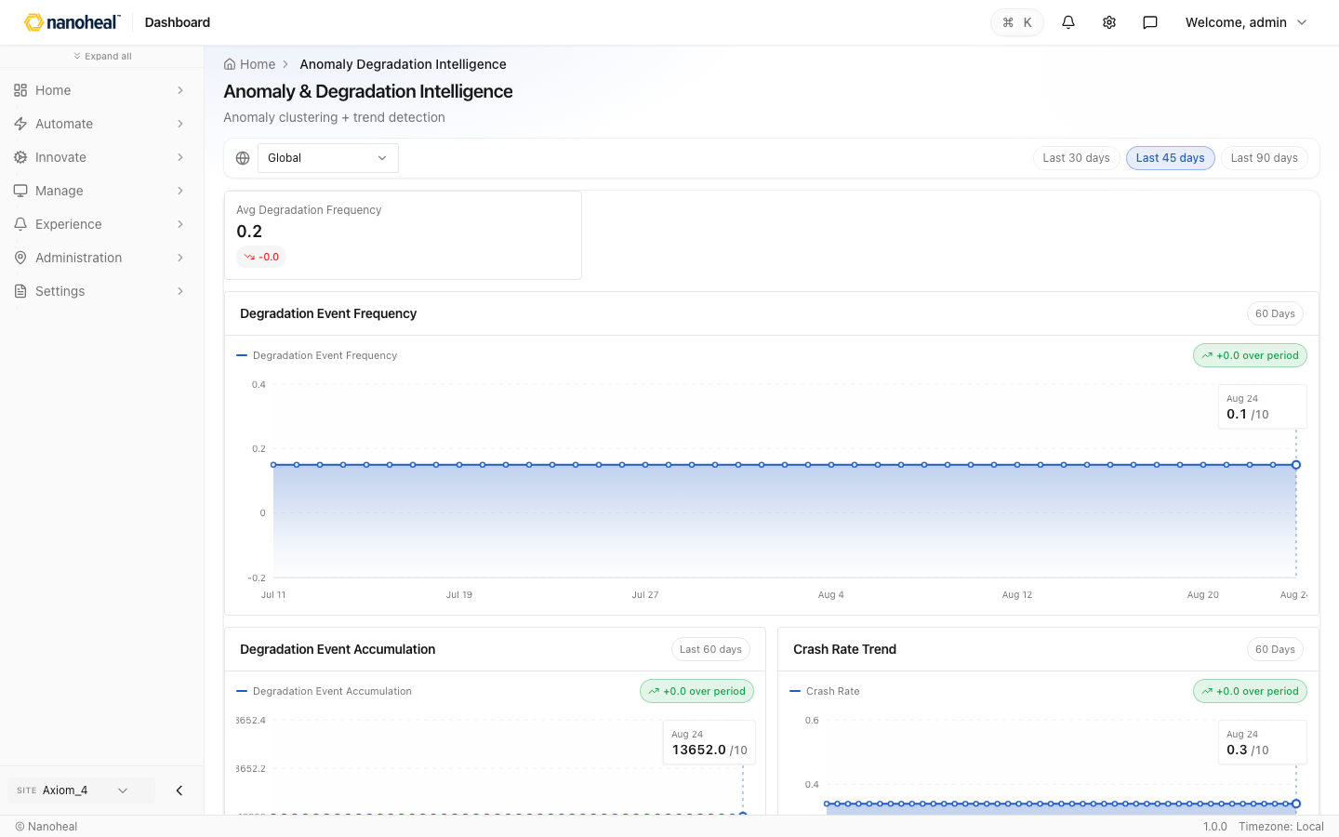
screenshots/060-dex-report-views-what-changed-device-dex-drivers.png

IT Leadership — Experience Summary — Digital Experience Overview
Path: /experience/dashboard/view/dex-executive-reports
Cross-pillar endpoint experience: device performance, application stability, sentiment, and service-desk load.
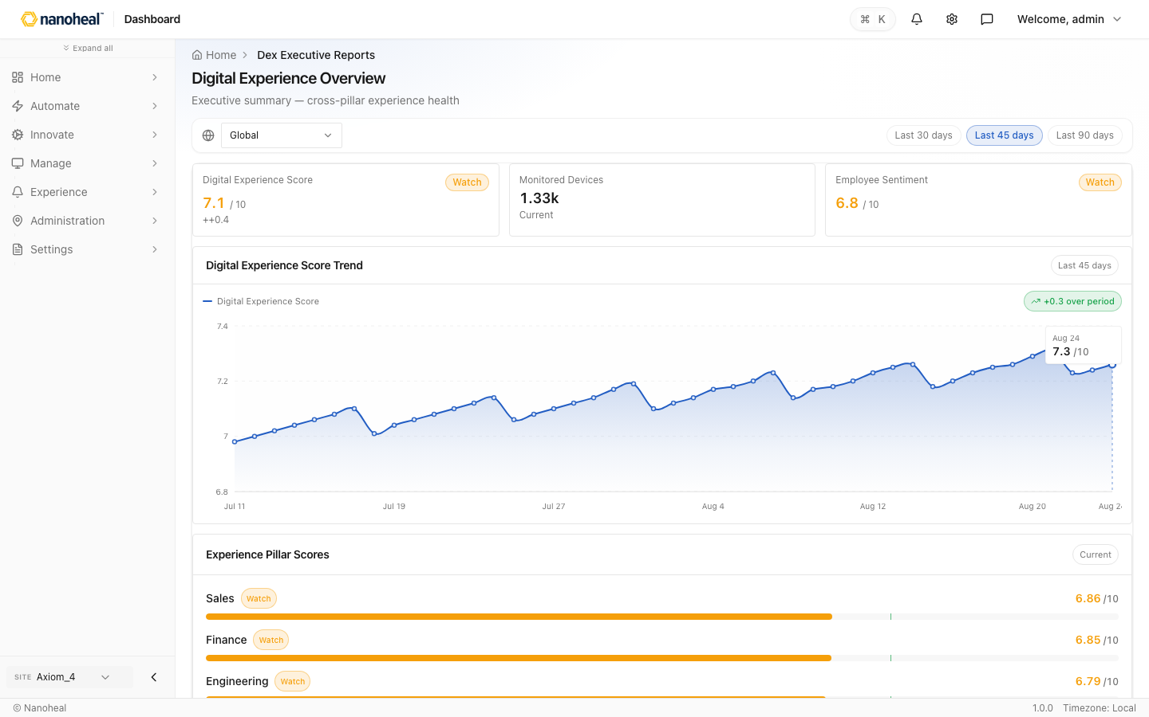
screenshots/061-dex-report-views-it-leadership-experience-summary.png

Device Friction → Productivity Loss — Experience-to-Productivity Impact
Path: /experience/dashboard/view/experience-productivity-impact
Correlate slow boot, login delays, and degradation events with lost work time by persona and site.
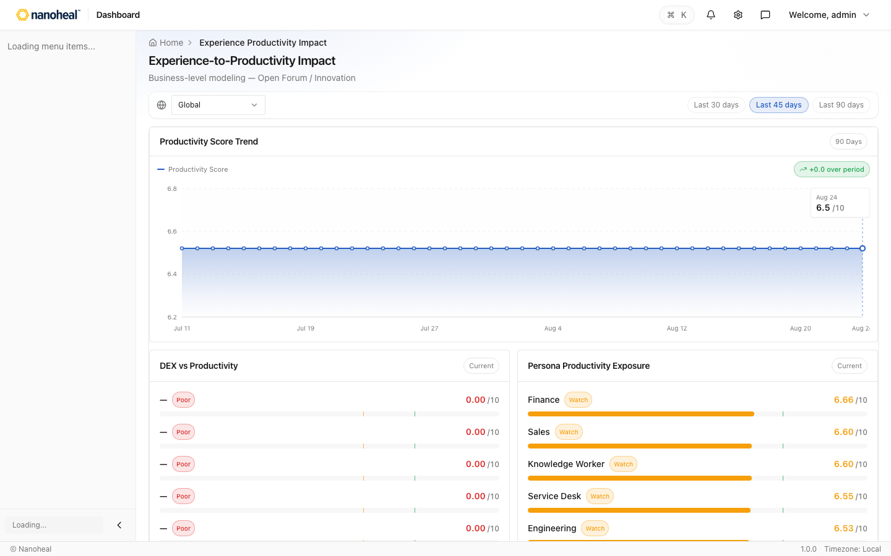
screenshots/062-dex-report-views-device-friction-productivity-loss.png

Endpoint Experience Scorecard — Device Experience
Path: /experience/dashboard/view/device-experience-report
Boot and logon times, stability, battery health, and satisfaction by device model and region.
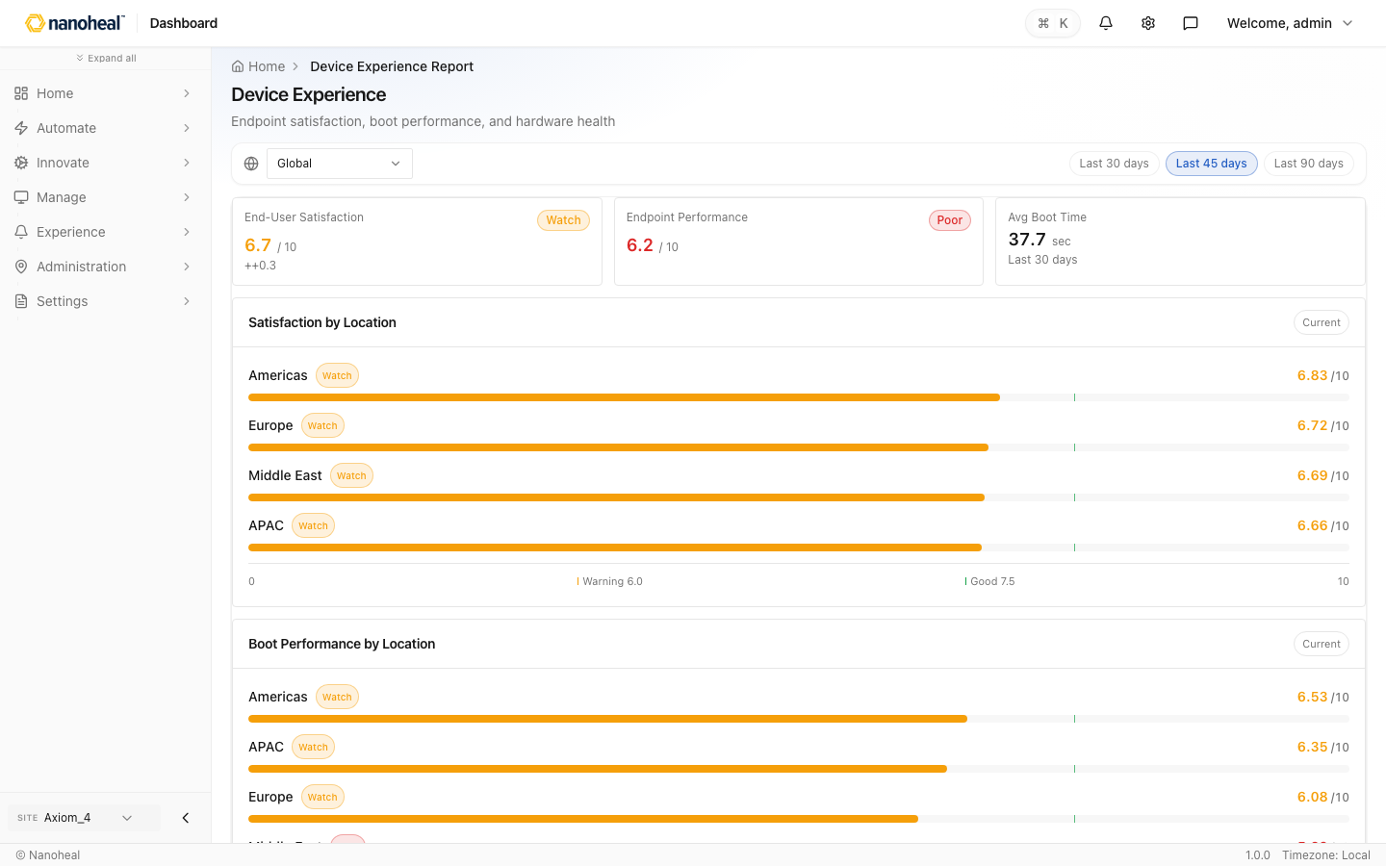
screenshots/063-dex-report-views-endpoint-experience-scorecard.png

Boot & Logon Performance — Experience Engineering Deep Dive
Path: /experience/dashboard/view/experience-engineering-deep-dive
Windows startup and sign-in duration trends — identify fleets with slow boot or profile load issues.
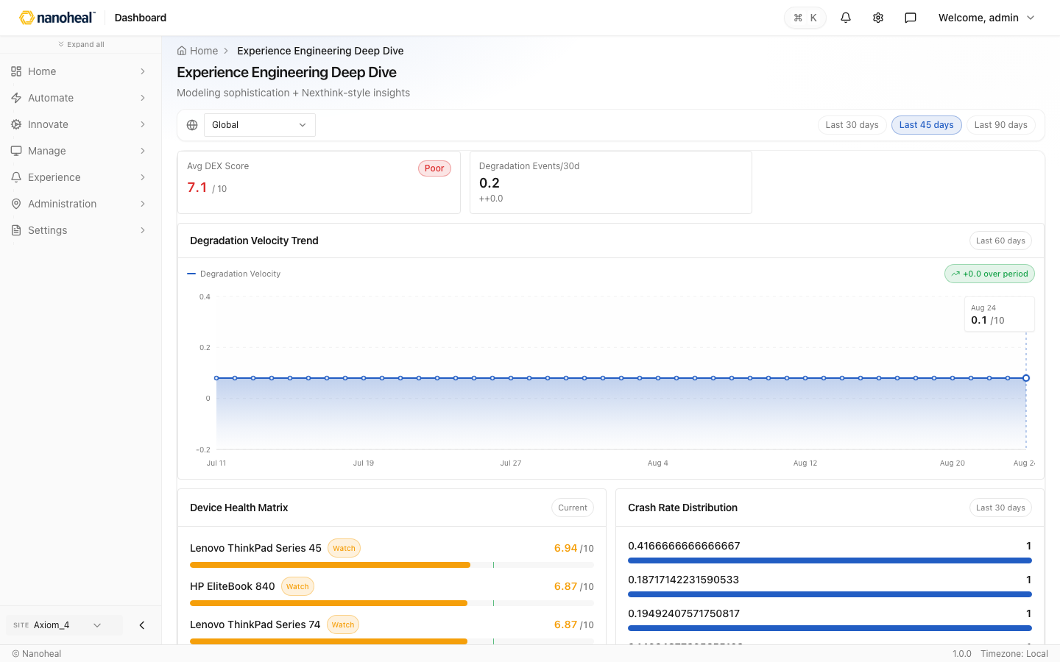
screenshots/064-dex-report-views-boot-logon-performance.png

Device Lifecycle & Refresh Readiness — Lifecycle & Device Health Intelligence
Path: /experience/dashboard/view/lifecycle-device-health
Device age, warranty status, battery wear, vulnerability exposure, and lifecycle risk for refresh planning.
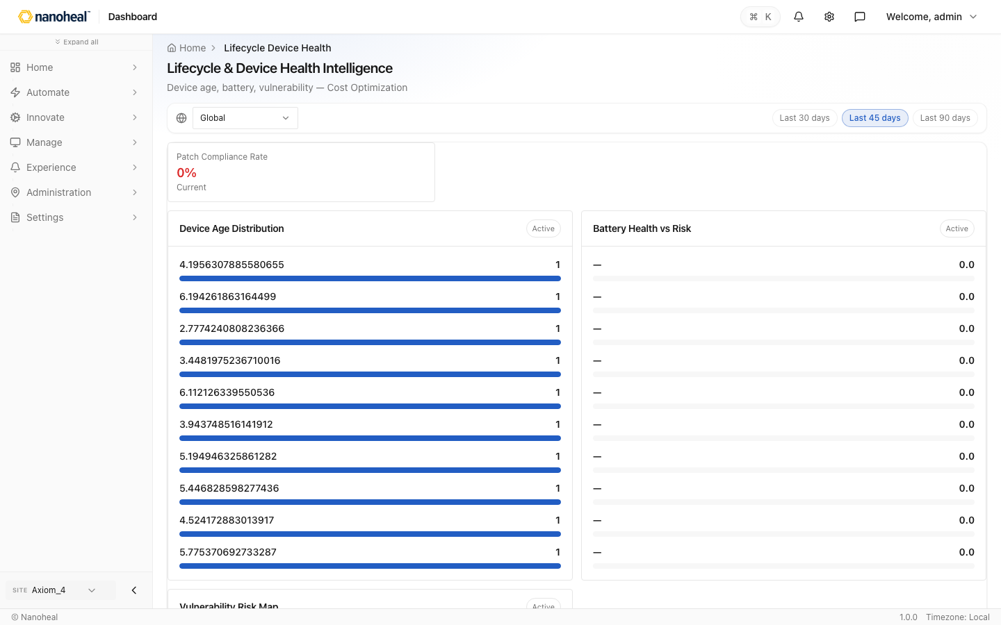
screenshots/065-dex-report-views-device-lifecycle-refresh-readiness.png

CPU, Memory & Right-Sizing — Right-Sizing & Performance Optimization
Path: /experience/dashboard/view/right-sizing-performance
Saturation events, headroom, and over/under-provisioned laptops — right-size hardware before users hit limits.
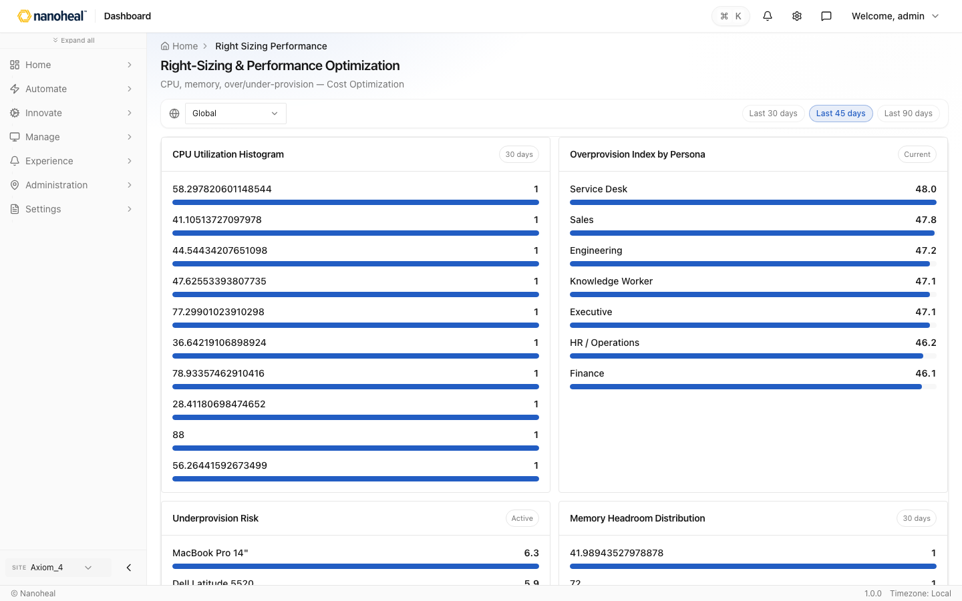
screenshots/066-dex-report-views-cpu-memory-right-sizing.png

Business Application Health — Application Experience
Path: /experience/dashboard/view/application-experience-report
ERP, Office, and line-of-business app stability scores, crash rates, and license utilization on managed PCs.
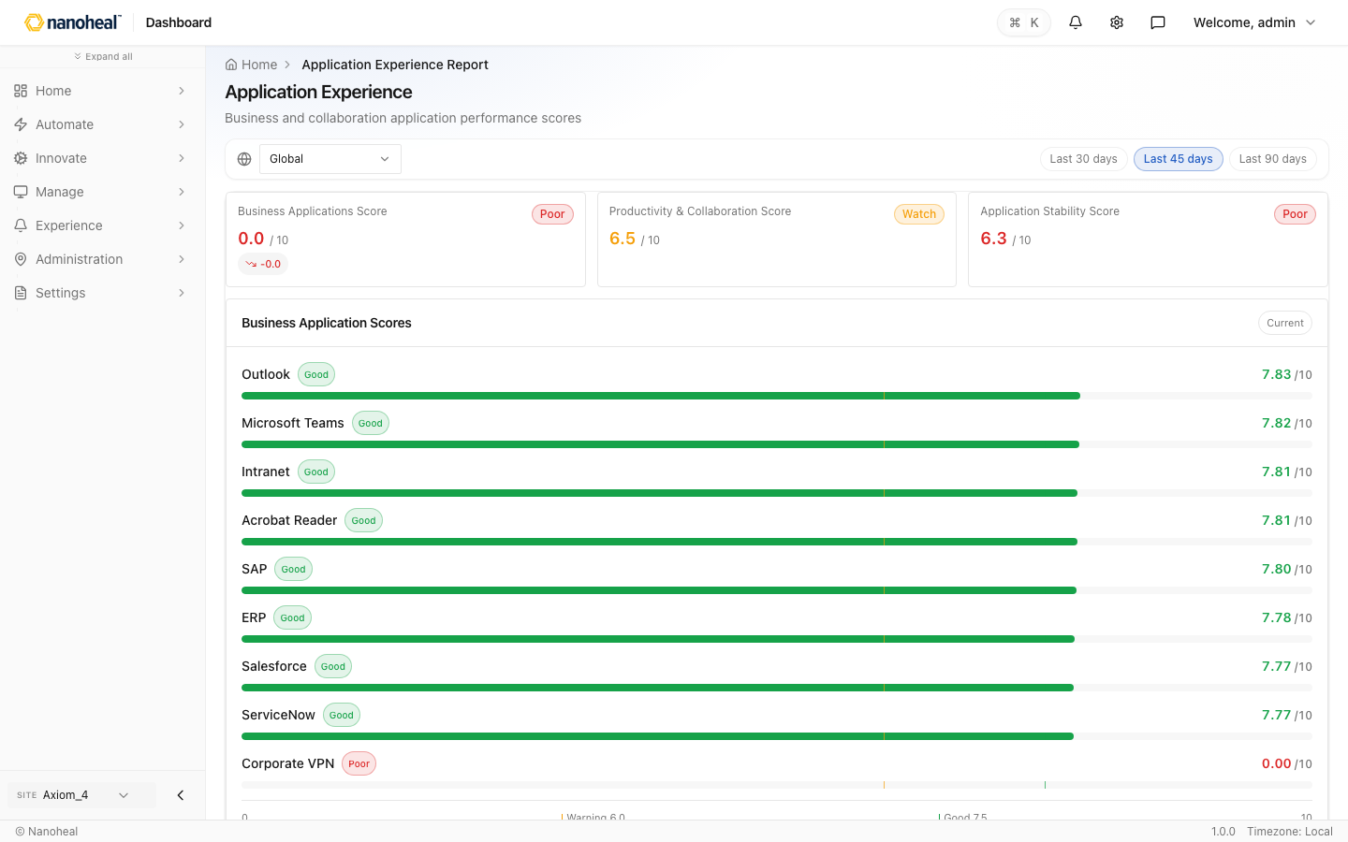
screenshots/067-dex-report-views-business-application-health.png

App Crashes & Instability — Autonomous Operations Control
Path: /experience/dashboard/view/autonomous-operations-control
Crash frequency, degradation velocity, and devices with recurring application failures.
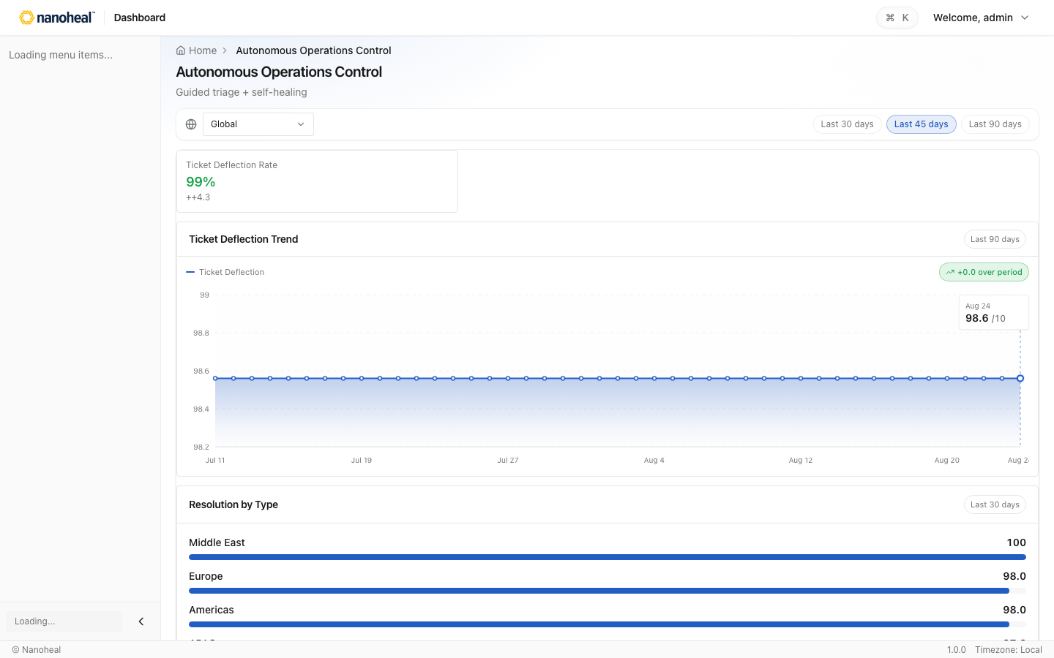
screenshots/068-dex-report-views-app-crashes-instability.png

Software Inventory & License Use — License & Software Efficiency
Path: /experience/dashboard/view/license-software-efficiency
Installed software utilization, reclaimable licenses, and unused apps across the endpoint estate.
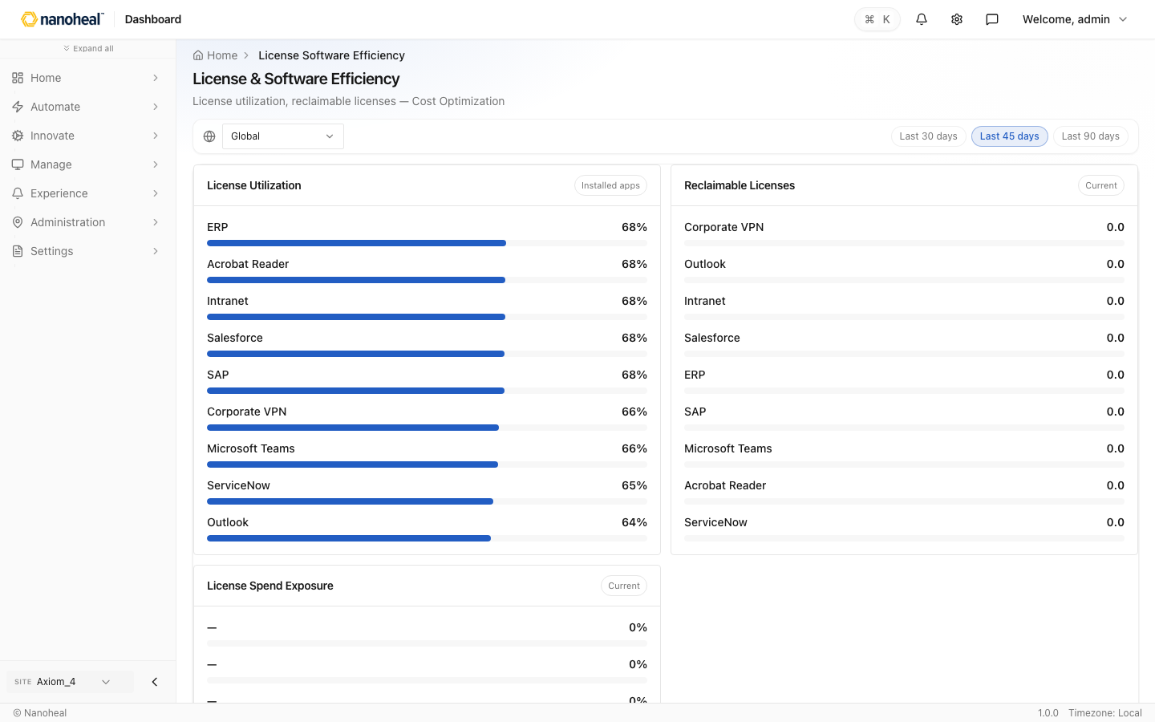
screenshots/069-dex-report-views-software-inventory-license-use.png

Teams, Outlook & Meeting Apps — Autonomous Operations Control
Path: /experience/dashboard/view/autonomous-operations-control
Collaboration tool performance on endpoints — crashes, latency impact, and auto-remediation outcomes.
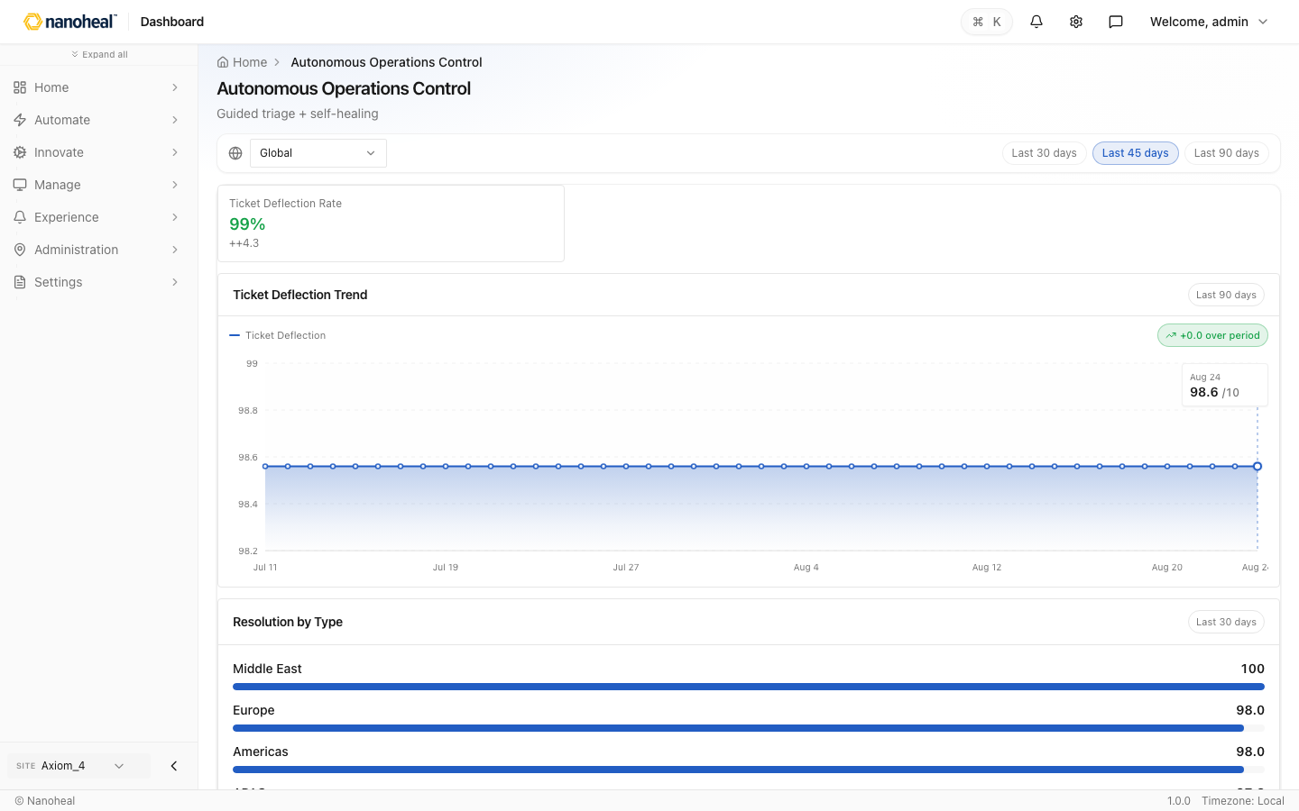
screenshots/070-dex-report-views-teams-outlook-meeting-apps.png

Network, Wi‑Fi & VPN Quality — Network Experience
Path: /experience/dashboard/view/network-experience-report
Latency, jitter, and packet loss for office and remote workers — tie network issues to DEX drops.
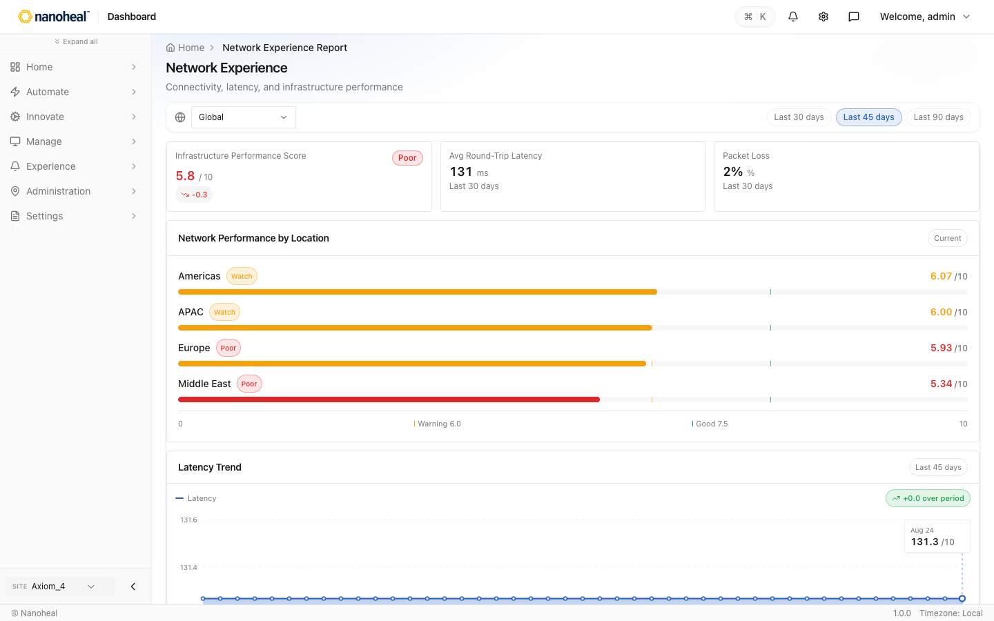
screenshots/071-dex-report-views-network-wi-fi-vpn-quality.png

Device Degradation & Anomalies — Anomaly & Degradation Intelligence
Path: /experience/dashboard/view/anomaly-degradation-intelligence
Devices trending worse: degradation events, stability variance, and MTTR for endpoint incidents by team.

screenshots/072-dex-report-views-device-degradation-anomalies.png

Employee Device Satisfaction — Employee Experience
Path: /experience/dashboard/view/employee-experience-report
End-user sentiment on devices, boot speed, and IT support — scores from DEX pulse surveys.
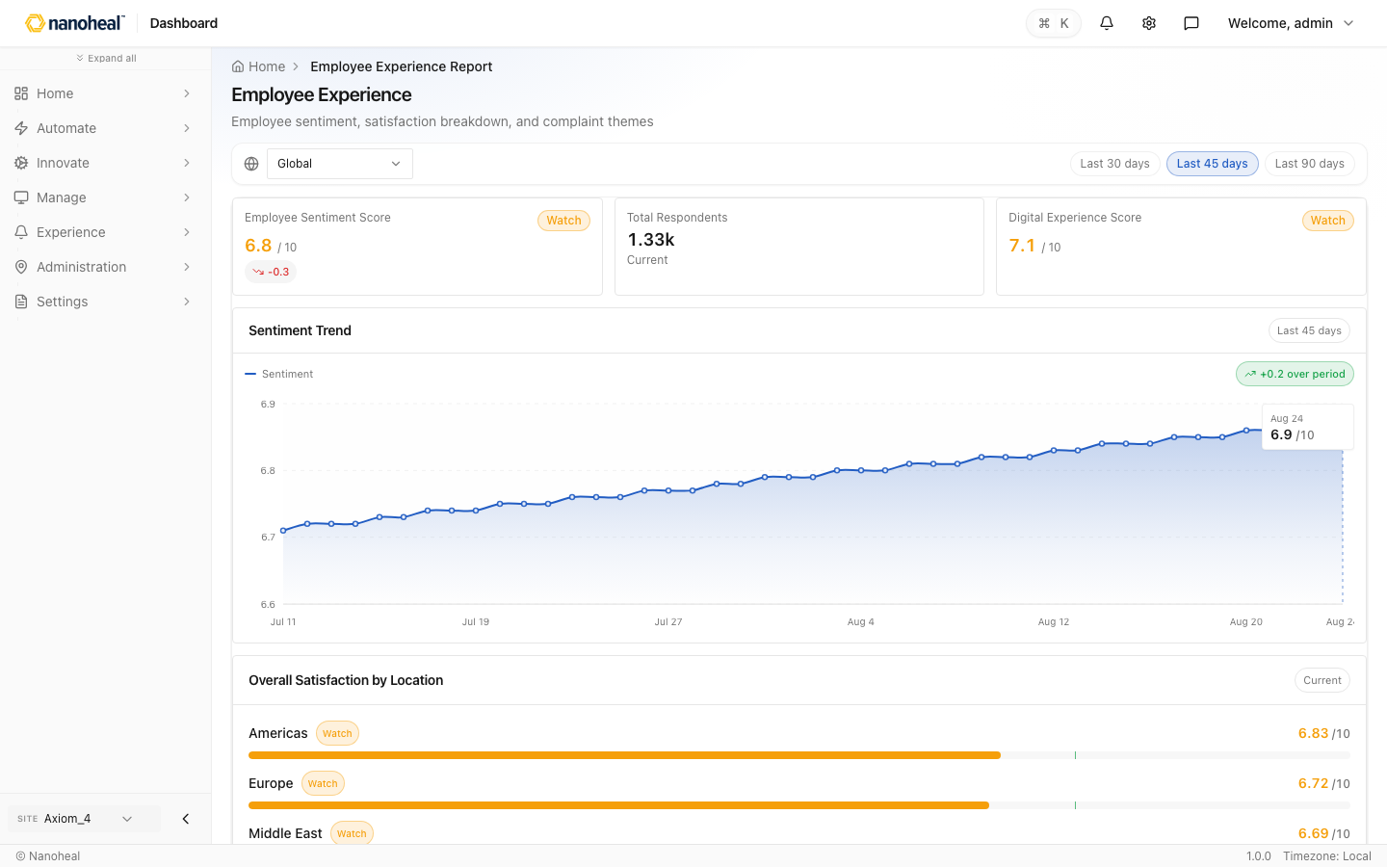
screenshots/073-dex-report-views-employee-device-satisfaction.png

Top Employee Complaints (IT) — Employee Experience
Path: /experience/dashboard/view/employee-experience-report
What users report: slow laptops, VPN, apps, printers, and meeting rooms — prioritized by volume.

screenshots/074-dex-report-views-top-employee-complaints-it.png

DEX vs Industry Benchmark — End-User Experience Improvement
Path: /experience/dashboard/view/adoption-benchmarks-report
Compare your endpoint DEX and boot/login performance against peer organizations.
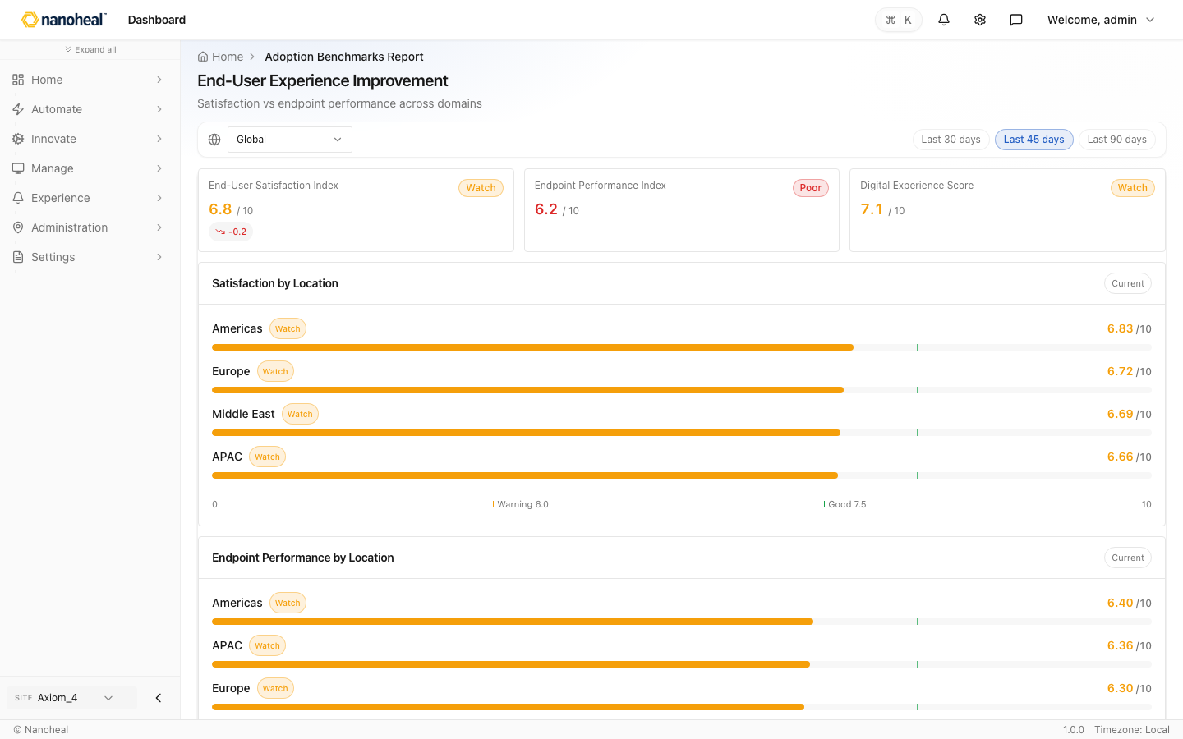
screenshots/075-dex-report-views-dex-vs-industry-benchmark.png

DEX by Site, Persona & Working Style — End-User Experience Improvement
Path: /experience/dashboard/view/adoption-benchmarks-report
Internal benchmark: office vs remote, region, and role — find where device experience lags.

screenshots/076-dex-report-views-dex-by-site-persona-working-style.png

Predictive Device Risk — Predictive & Risk Modeling
Path: /experience/dashboard/view/predictive-risk-modeling
Forecast devices at risk of failure, chronic degradation, and refresh candidates before tickets spike.
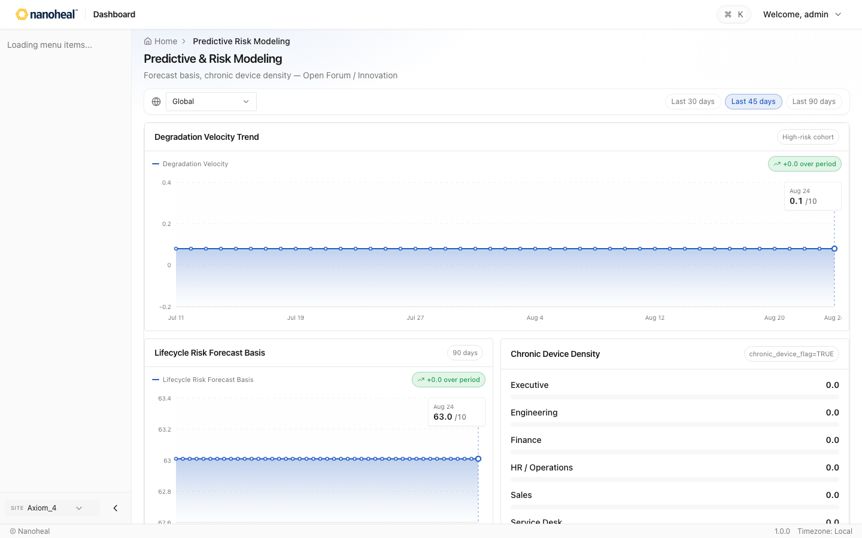
screenshots/077-dex-report-views-predictive-device-risk.png

Endpoint Auto-Remediation — Autonomous Operations Control
Path: /experience/dashboard/view/autonomous-operations-control
Self-heal success rate on devices, ticket deflection, and RCA confidence for endpoint issues.

screenshots/078-dex-report-views-endpoint-auto-remediation.png

Device-Related Ticket Volume — ITSM & Ticket Optimization
Path: /experience/dashboard/view/itsm-ticket-optimization
Help-desk tickets tied to endpoints, deflection from automation, and cost per device incident.
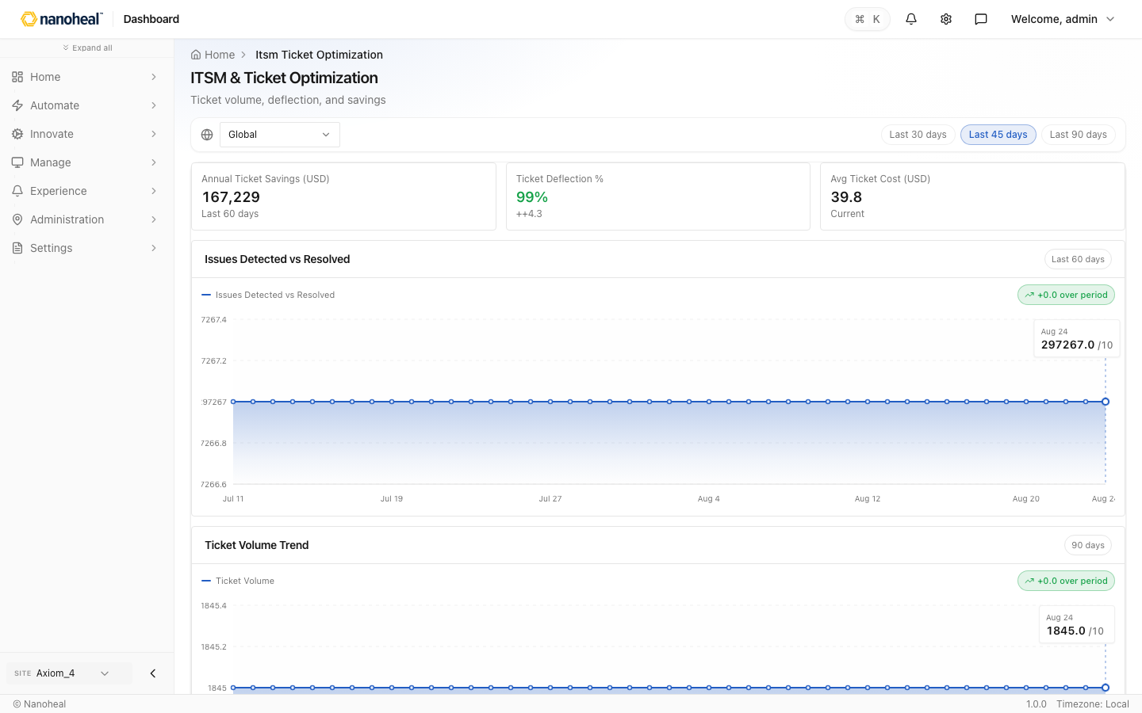
screenshots/079-dex-report-views-device-related-ticket-volume.png

Endpoint Incident MTTR — MTTR & Operational Efficiency
Path: /experience/dashboard/view/mttr-operational-efficiency
Mean time to restore device experience — resolution speed by fault domain and persona.
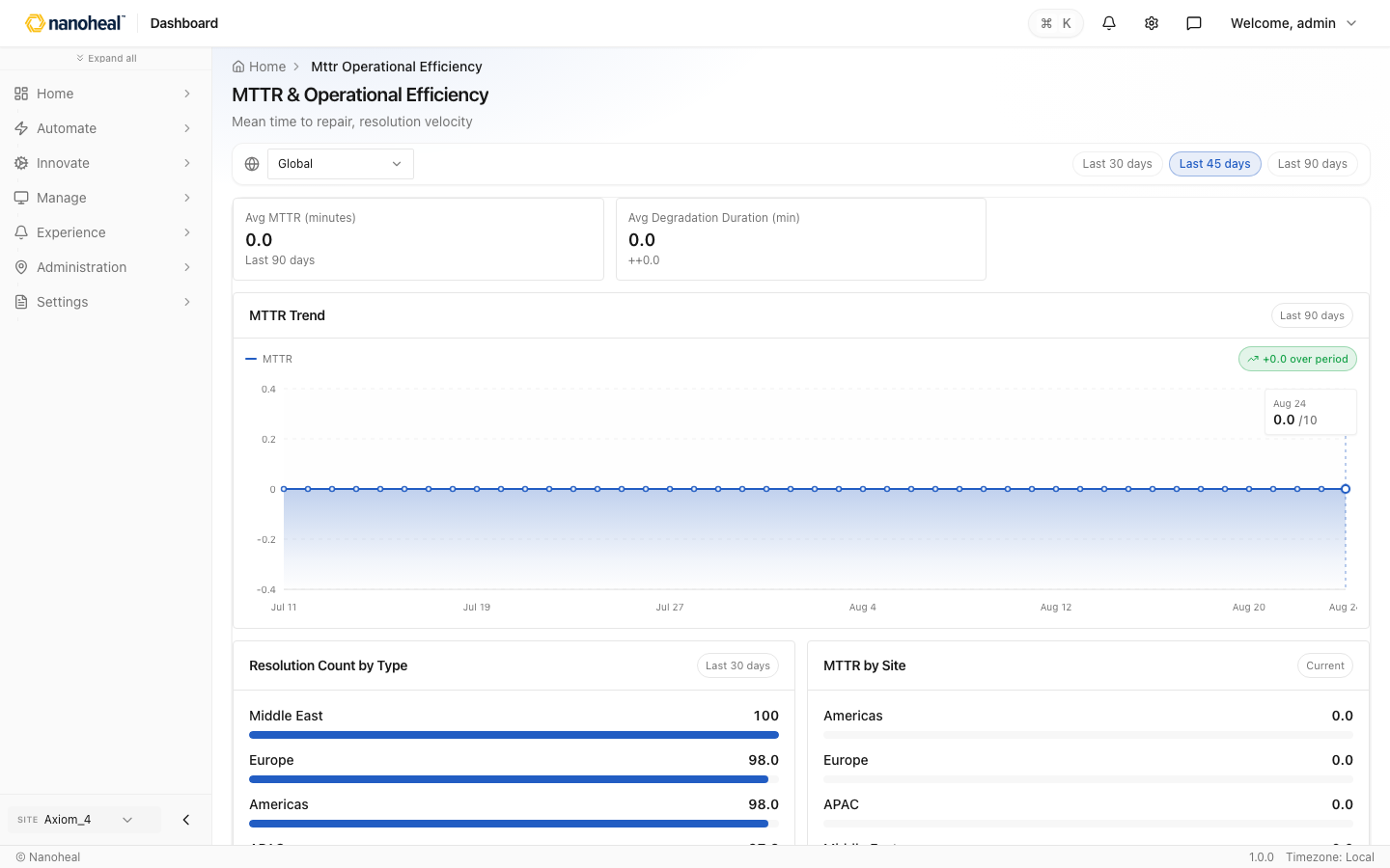
screenshots/080-dex-report-views-endpoint-incident-mttr.png

Device Ops — Cost & ROI — Financial Impact & ROI
Path: /experience/dashboard/view/financial-impact-roi
CapEx avoided through right-sizing, ticket savings, and lifecycle governance on the PC fleet.
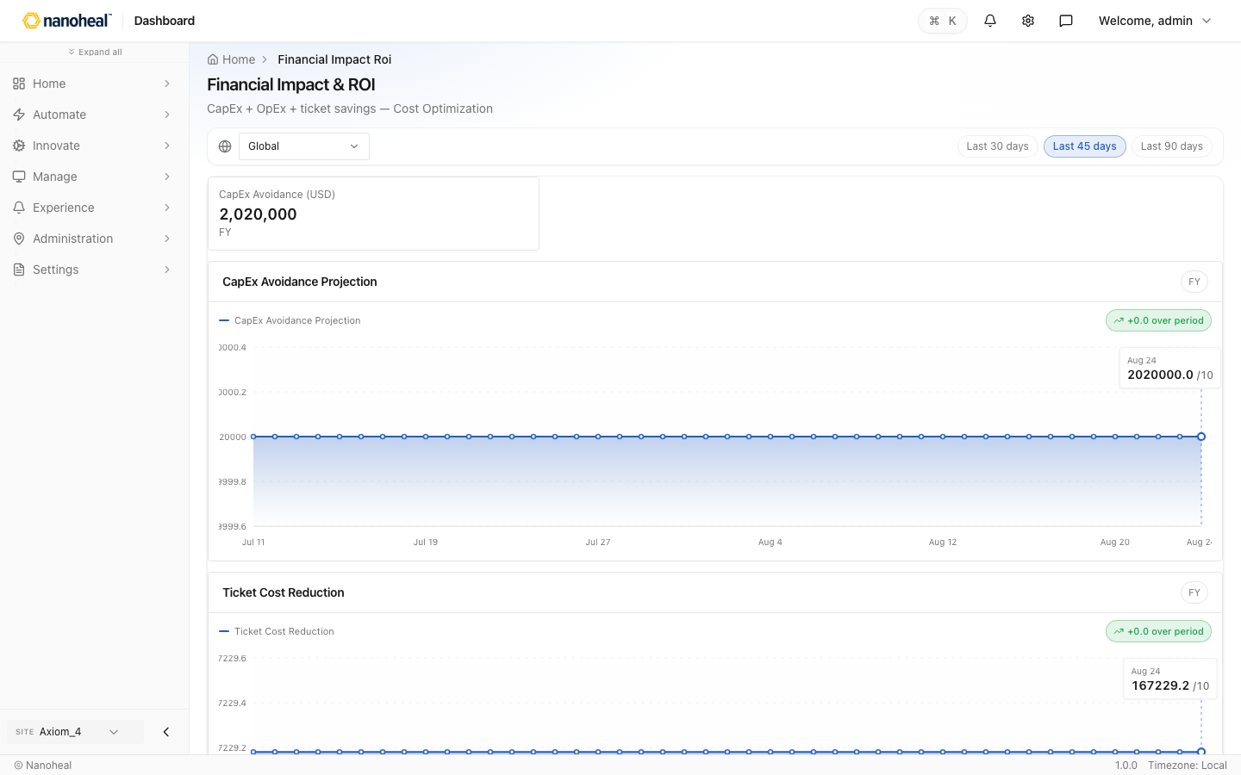
screenshots/081-dex-report-views-device-ops-cost-roi.png

Endpoint Compliance & Posture — Governance & Privilege Control
Path: /experience/dashboard/view/governance-privilege-control
Patch compliance, vulnerability exposure, and governance scores across managed devices.
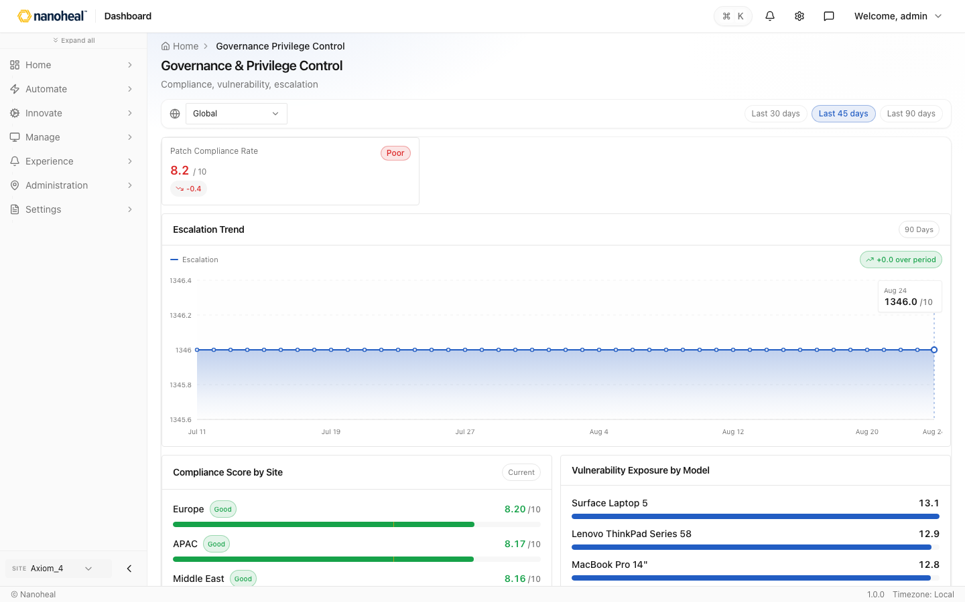
screenshots/082-dex-report-views-endpoint-compliance-posture.png

Create / edit overlays

Users — Create overlay — User accounts
Path: /settings/users
Home Users Users RBAC SSO / SAML MFA Policy User accounts 43 records · Search users, open profiles, and manage roles and access. Create Columns All users 43 Pending approval 0 / Filters Email First Name Last Name Status User Type Last Login Tenant admin@nanoheal.com admin nanohea
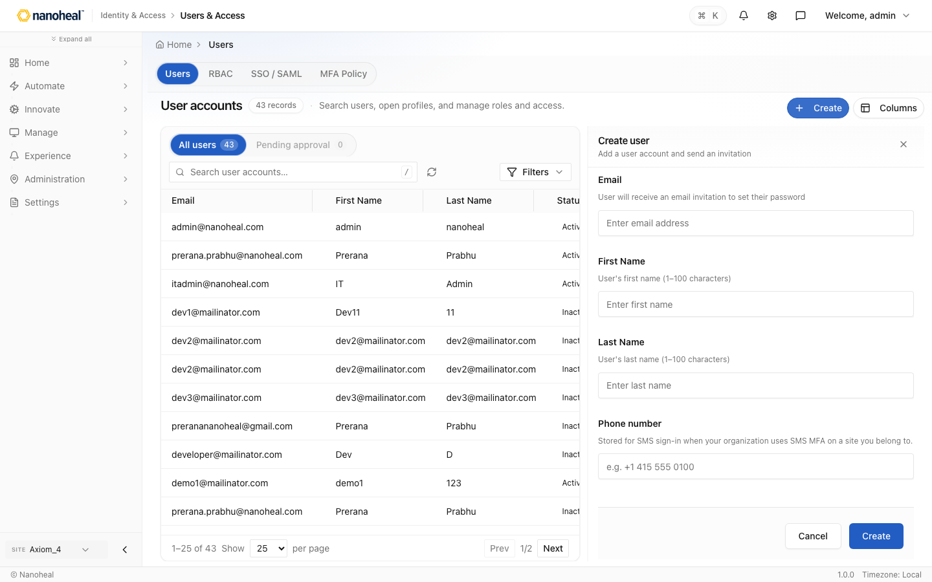
screenshots/083-create-edit-overlays-users-create-overlay.png

Classification — Create overlay — Device classifications
Path: /devices/organization/device-classification
Home Device Classification Device classifications 89 classifications · Group devices by classification for targeting and policy. Create Columns / Filters Name Type Machine group Device Count Created By Created On Last Modified Engineering CSV Machine group 1 admin admin@nanoheal.
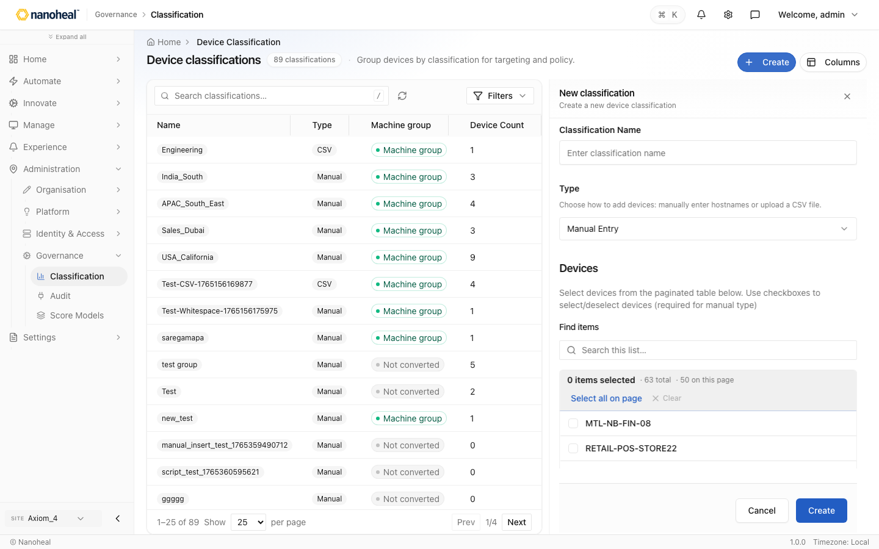
screenshots/084-create-edit-overlays-classification-create-overlay.png

Tenants — Create overlay — Tenants
Path: /settings/organization/tenants
Home Tenants Tenants 31 records · Browse sites and open tenant settings, versions, and security. Create Columns / Filters ID Tenant Name Organization Tenant key Contact email Active installs License pool 1 Default nanoheal-deploy-default-site-1 0 5e9d7820… (Unlimited) 8 Axiom_4 4
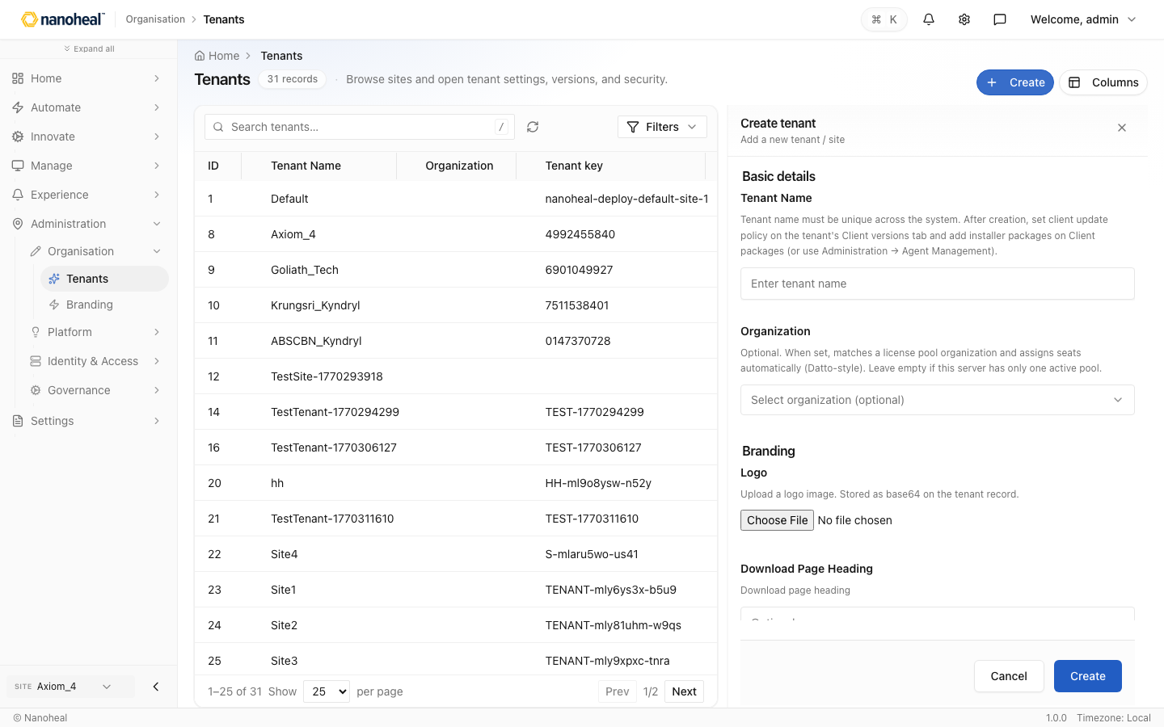
screenshots/085-create-edit-overlays-tenants-create-overlay.png

Automation — Create overlay — Workflow builder
Path: /actions/library
Home Visual Builder Workflow builder What needs fixing? Describe the issue in natural language. We'll suggest a workflow you can customise. What needs fixing? / to automation library Type a problem to continue Continue QUICK STARTS ⚡ 60 - Clear files from folders and sub-folders
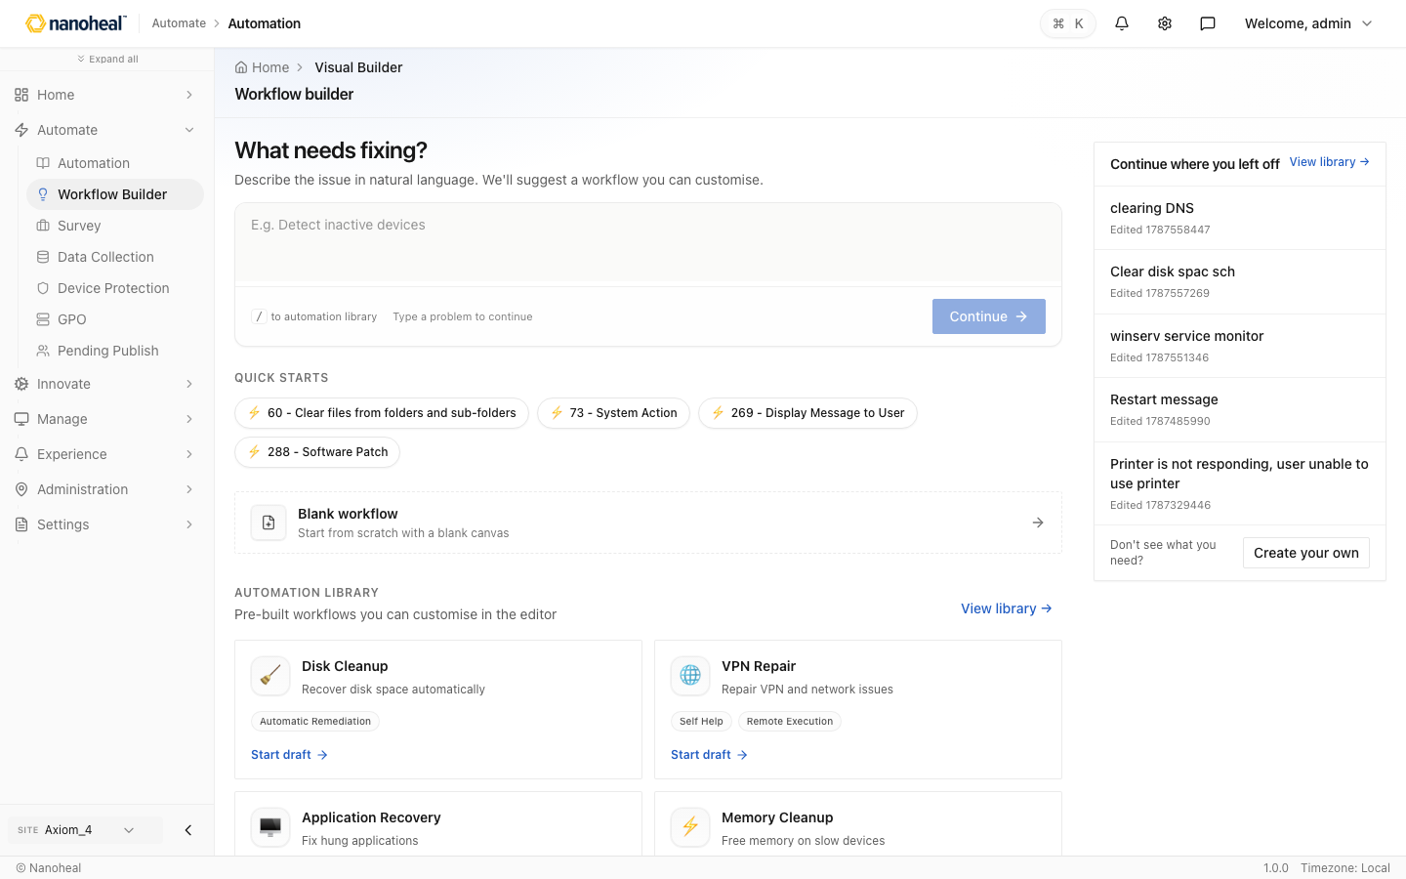
screenshots/086-create-edit-overlays-automation-create-overlay.png

Data Collection — Create overlay — Data collection
Path: /actions/catalogs/data-collection
Home Data Collection Data collection 9 · Profiles for performance, storage, user activity, and network monitoring. Create Columns / Filters Profile Description Monitoring Collectors Status Last modified Disk health Disk health — 0 Not Attached 3 days ago Device health Device heal
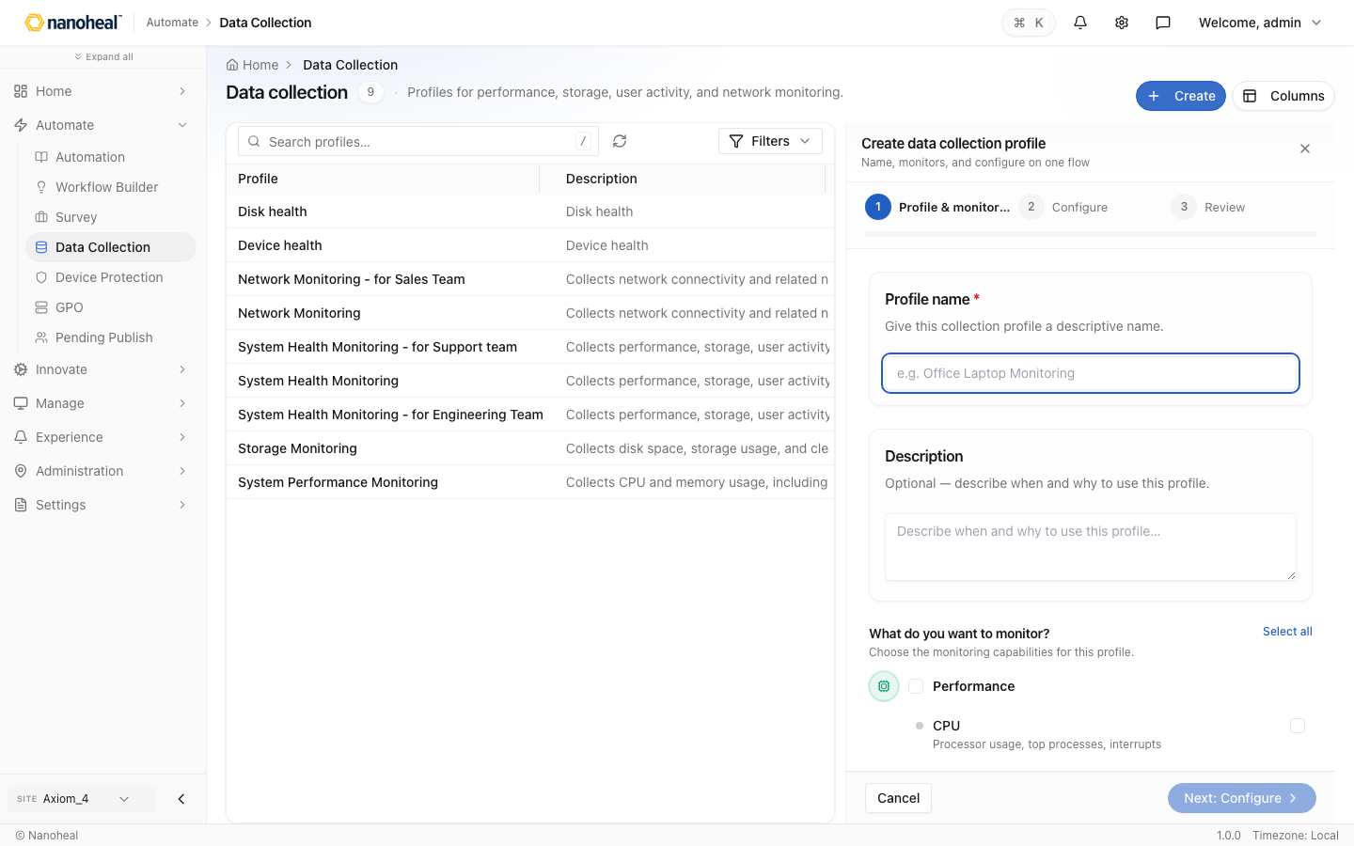
screenshots/087-create-edit-overlays-data-collection-create-overlay.png

Device Protection — Create overlay — Protection policies
Path: /actions/catalogs/device-protection
Home Device Protection Protection policies 7 · Profiles for registry, services, application control, paths, and USB. Create Columns / Filters Profile Policies Count Status Last modified spooler check 0 Not Attached — new device 0 Not Attached — device neww 0 Not Attached — device
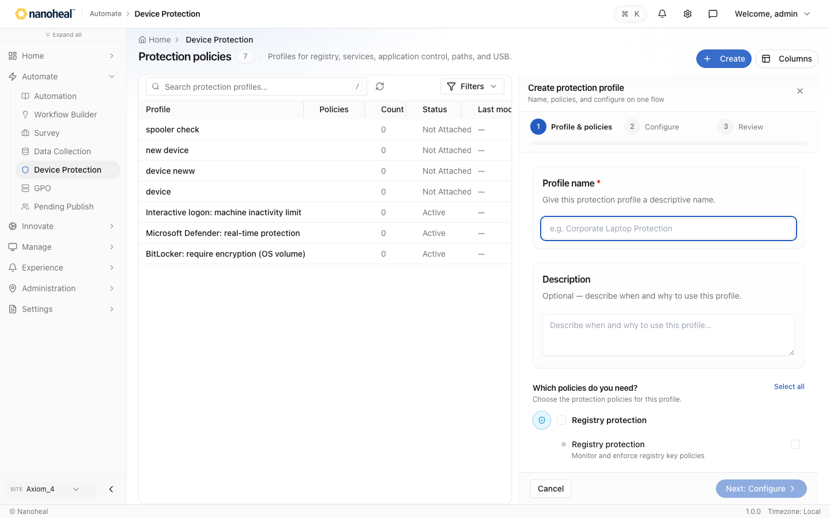
screenshots/088-create-edit-overlays-device-protection-create-overlay.png

Integrations — Add connector — Connectors
Path: /settings/integrations
Home Integrations Connectors API Keys API catalog Event Subscriptions Connectors 5 connectors · Connect Nanoheal to a product (ServiceNow, Teams, Slack). To send Nanoheal events to a URL, use Event Subscriptions. Add connector Columns / Filters Site Name Type Description Status C
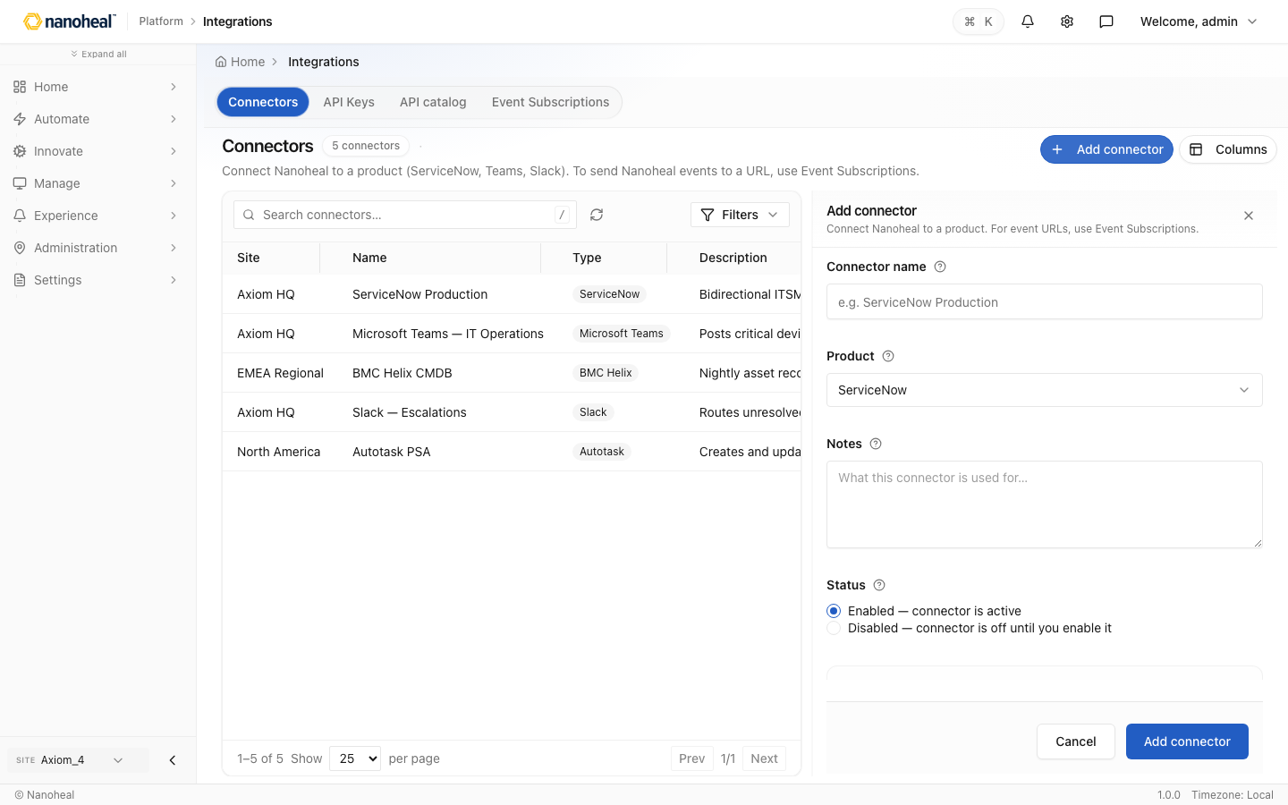
screenshots/089-create-edit-overlays-integrations-add-connector.png

Inventory — Add device — Devices
Path: /devices/inventory/census
Home Devices Inventory Devices 63 devices · Healthy 0 Pending sync 0 · Inventory, classify, and manage managed endpoints. Add device Export Columns All Devices 63 Windows 47 macOS 10 Android 0 Linux 5 Unknown / Filters Device / Endpoint Status OS Last seen Agent Installed date MT
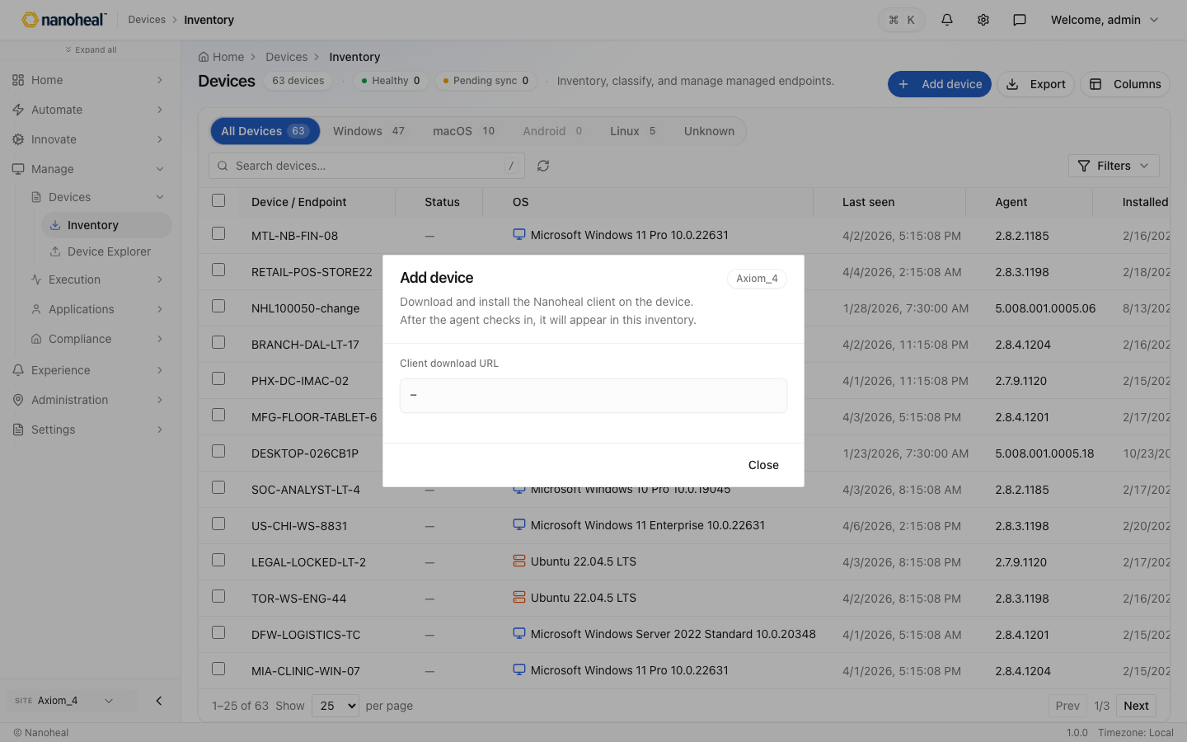
screenshots/090-create-edit-overlays-inventory-add-device.png

Score Models — Create overlay
Path: /compliance/policy/score-models · capture failed
Score Models list has no Create control in this build; list/read only.

Software Distribution — Create overlay — Profile builder
Path: /devices/software/software-distribution
Home Software Distribution Profile builder DRAFT Load 7-Zip example Design History Switch to Form View ✓ Package 2 Build 3 Options 4 Review Operating system Which OS should these patches run on? Select OS BUILD SEQUENCE 1 action — pick a type or configure below the card. 1 action
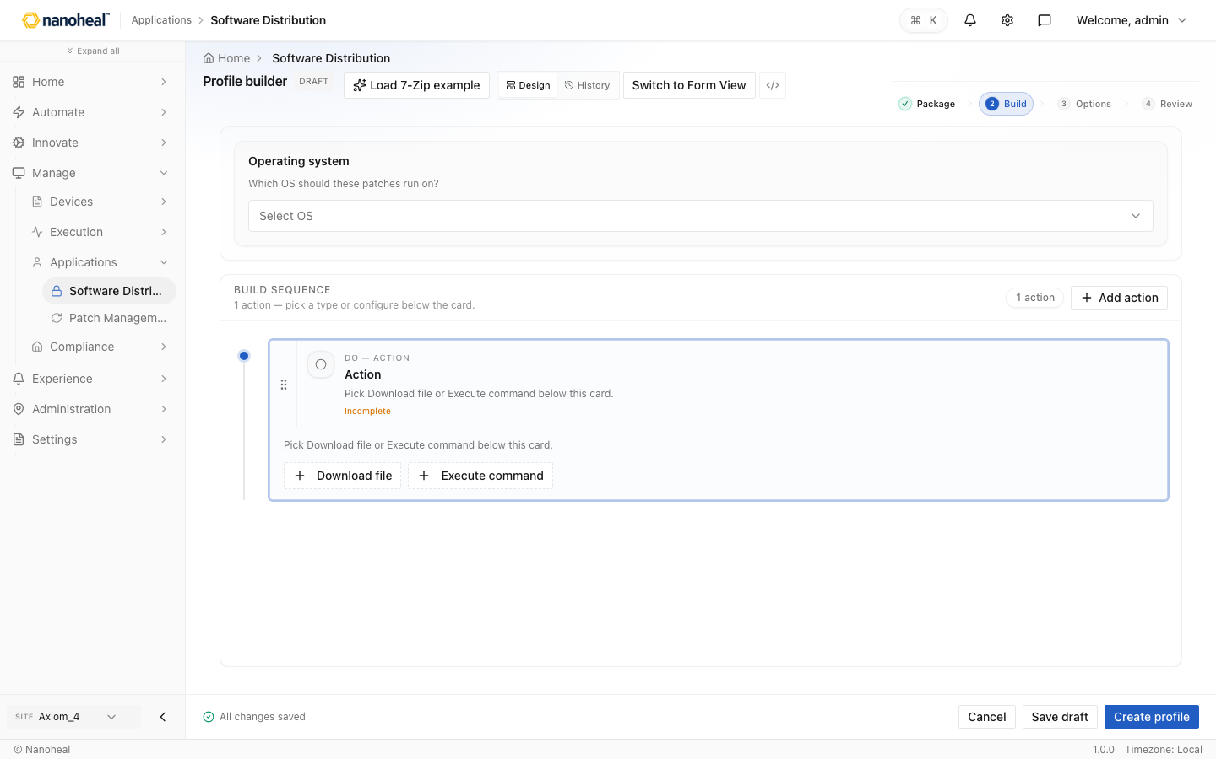
screenshots/099-create-edit-overlays-software-distribution-create-overlay.png

Workflow Builder — Blank workflow — Workflow builder
Path: /actions/library/visual-builder
Home Visual Builder Workflow builder DRAFT 1 Actions 2 Details 3 Review WORKFLOW TIMELINE Click WHEN to change the trigger, then add what should run next. 0 actions WHEN When triggered manually DO Add your first action Pick what the device should do after this trigger — from Asse
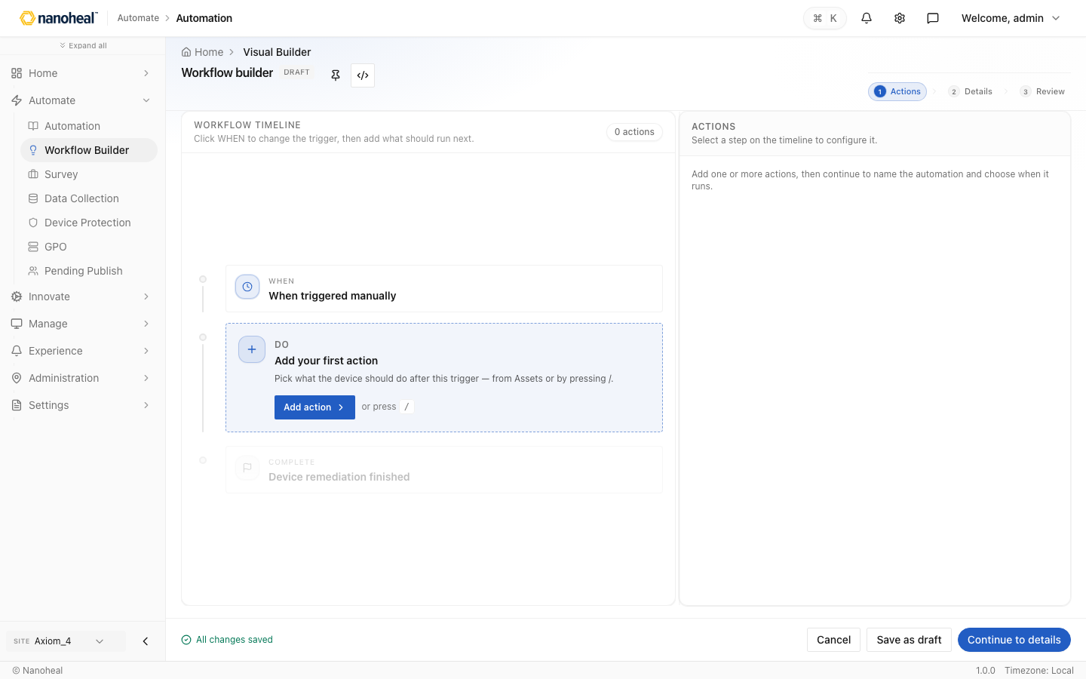
screenshots/093-create-edit-overlays-workflow-builder-blank-workflow.png

Users — Detail / edit drawer — User accounts
Path: /settings/users · drawer
Home Users Users RBAC SSO / SAML MFA Policy User accounts 43 records · Search users, open profiles, and manage roles and access. Create Columns All users 43 Pending approval 0 / Filters Email First Name Last Name Status User Type Last Login Tenant admin@nanoheal.com admin nanohea
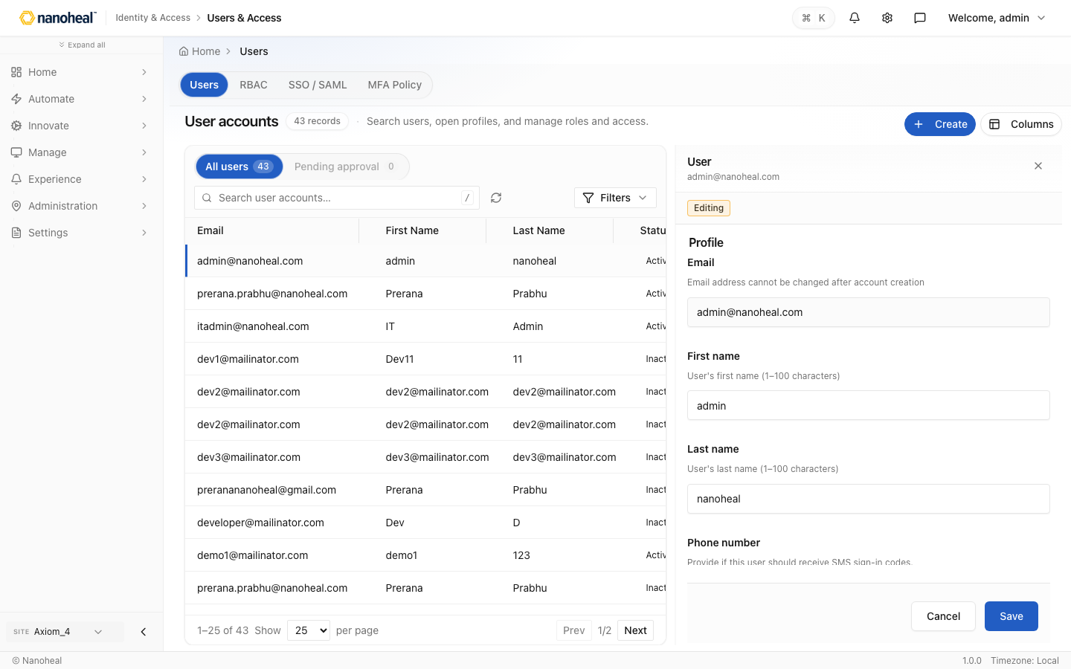
screenshots/106-create-edit-overlays-users-detail-drawer.png

Device detail

Inventory — Device detail drawer — Devices
Path: /devices/inventory/census · drawer
Home Devices Inventory Devices 63 devices · Healthy 0 Pending sync 0 · Inventory, classify, and manage managed endpoints. Add device Export Columns All Devices 63 Windows 47 macOS 10 Android 0 Linux 5 Unknown / Filters Device / Endpoint Status OS Last seen Agent Installed date MT
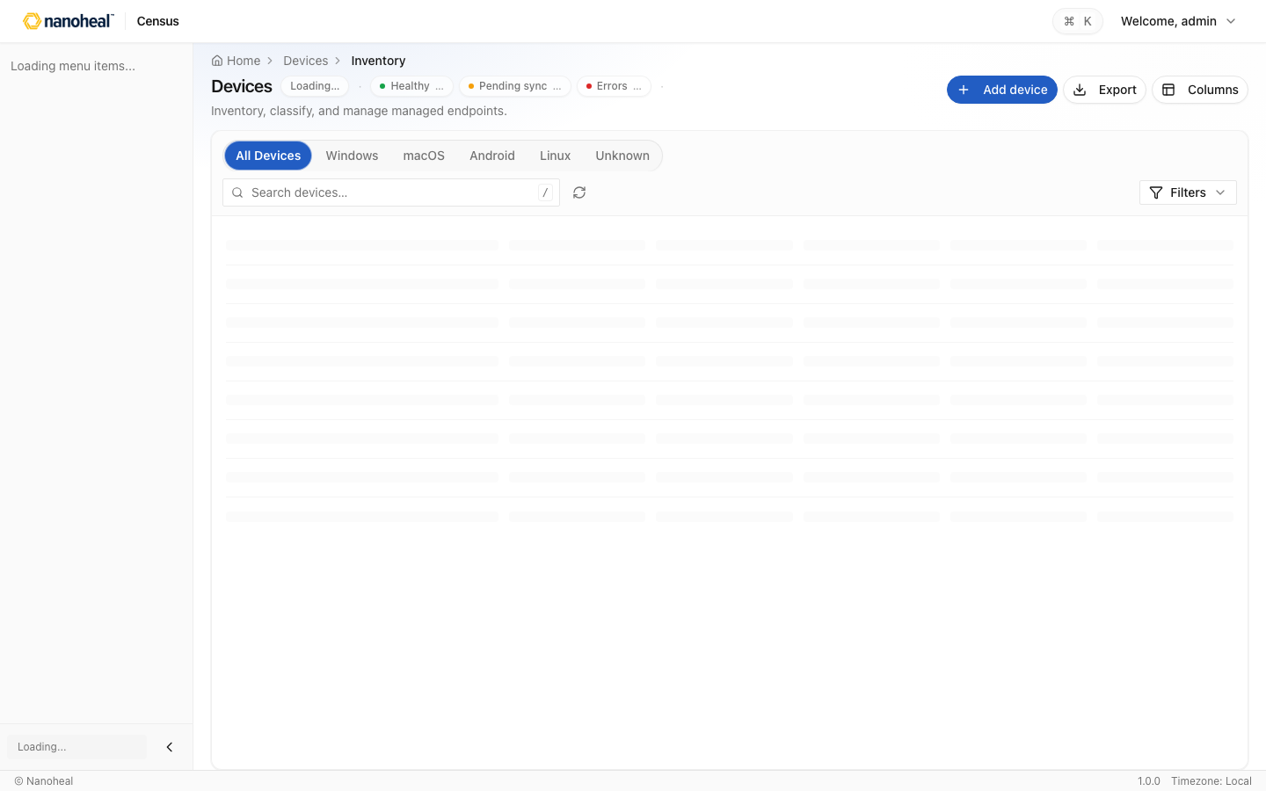
screenshots/104-device-detail-inventory-drawer.png

Device detail — full page
Path: /system-settings/census/07746bef-d0d1-2aac-2a6d-32289b3c50de
Home 07746bef D0d1 2aac 2a6d 32289b3c50de
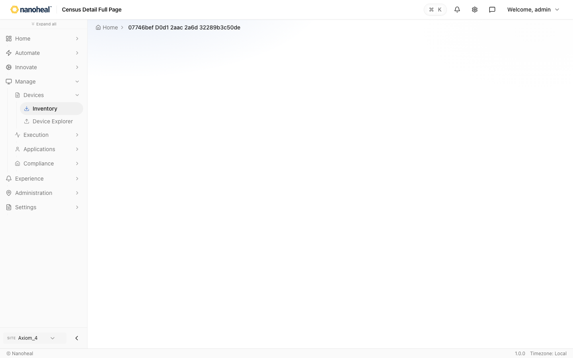
screenshots/105-device-detail-full-page.png

Disabled menu

Haya
Path: /innovate/haya · menu disabled
Home Haya Search conversations CONVERSATIONS New chat No conversations yet AI HELPDESK What can I help you investigate? Ask in plain language about your estate. Responses stream here; plans, confidence, and sources open in the details panel. Try asking Which devices are offline r
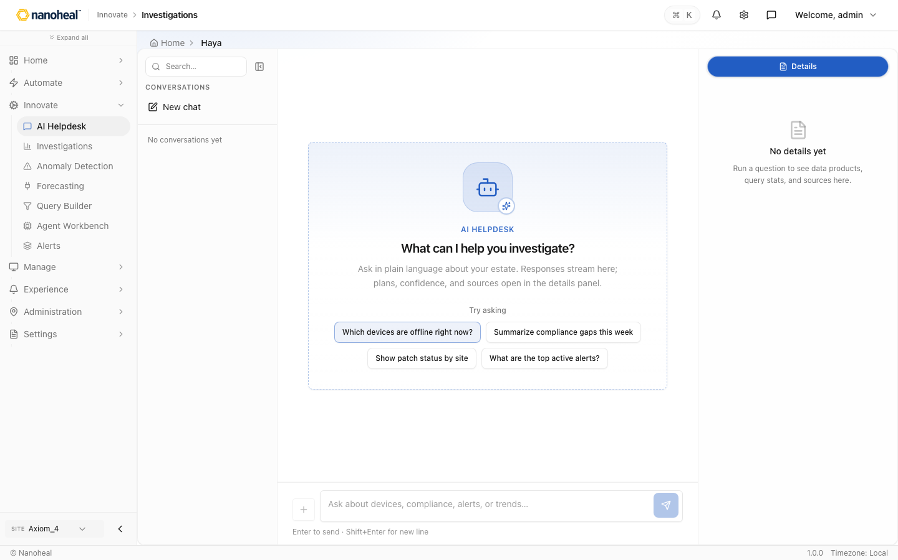
screenshots/049-disabled-menu-haya.png

Recommendations
Path: /innovate/haya?feature=recommendations · menu disabled
Home Haya Search conversations CONVERSATIONS New chat No conversations yet AI HELPDESK What can I help you investigate? Ask in plain language about your estate. Responses stream here; plans, confidence, and sources open in the details panel. Try asking Which devices are offline r

screenshots/050-disabled-menu-recommendations.png

Automation Insights
Path: /innovate/haya?feature=automation-insights · menu disabled
Home Haya Search conversations CONVERSATIONS New chat No conversations yet AI HELPDESK What can I help you investigate? Ask in plain language about your estate. Responses stream here; plans, confidence, and sources open in the details panel. Try asking Which devices are offline r

screenshots/051-disabled-menu-automation-insights.png

Knowledge
Path: /innovate/haya?feature=knowledge · menu disabled
Home Haya Search conversations CONVERSATIONS New chat No conversations yet AI HELPDESK What can I help you investigate? Ask in plain language about your estate. Responses stream here; plans, confidence, and sources open in the details panel. Try asking Which devices are offline r

screenshots/052-disabled-menu-knowledge.png

Alert rules
Path: /innovate/haya?feature=alert-rules · menu disabled
Home Haya Search conversations CONVERSATIONS New chat No conversations yet AI HELPDESK What can I help you investigate? Ask in plain language about your estate. Responses stream here; plans, confidence, and sources open in the details panel. Try asking Which devices are offline r

screenshots/053-disabled-menu-alert-rules.png

Updates — Device updates
Path: /devices/software/device-updates · menu disabled
Home Device Updates Device updates 57 records · Client update status, compliance, and attempt history. Columns All 57 Needs attention 25 / Filters Device ID Actual version Desired version Policy compliant Version gap Site OS Platform Policy status Computed at Update status Last a
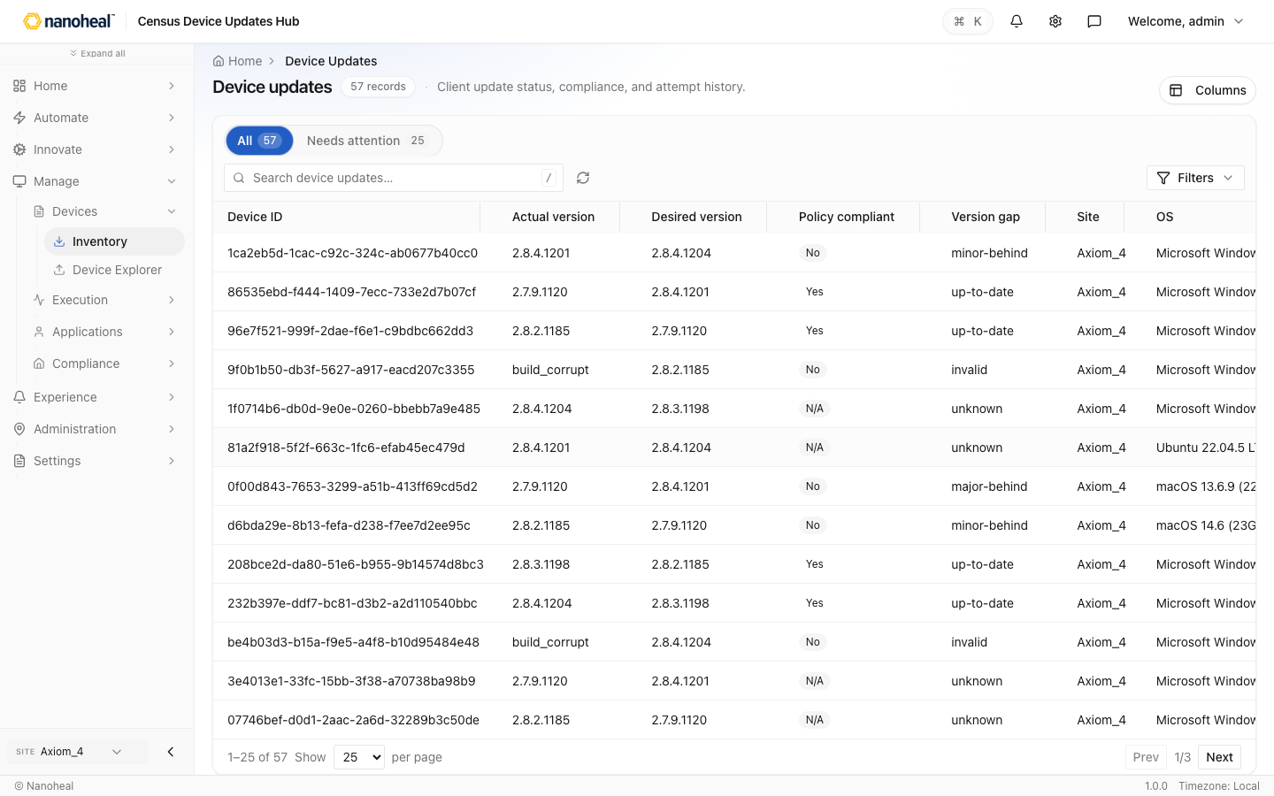
screenshots/055-disabled-menu-updates.png

Workflow Builder deep

01 Hub — templates & create custom — Workflow builder
Path: /actions/library/visual-builder
Home Visual Builder Workflow builder What needs fixing? Describe the issue in natural language. We'll suggest a workflow you can customise. What needs fixing? / to automation library Type a problem to continue Continue QUICK STARTS 🖥 Slow Computer 🧹 Recover Disk Space 🔄 Restart A

screenshots/111-workflow-builder-deep-01-hub-templates-create-custom.png

02 Actions canvas — Disk Cleanup
Path: /actions/library/visual-builder
Home Visual Builder Disk Cleanup DRAFT Workflow builder 1 Actions 2 Details 3 Review Workflow valid Complete device condition rules Live validation WORKFLOW TIMELINE Drag actions to reorder · click to configure 8 actions Add action WHEN Event: High disk usage alert DO Copy of Cop
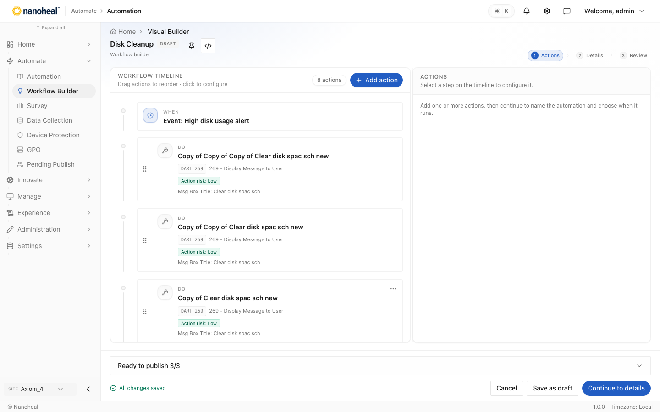
screenshots/112-workflow-builder-deep-02-actions-canvas.png

03 Details — When (On demand / Event / Schedule) — Disk Cleanup
Path: /actions/library/visual-builder
Home Visual Builder Disk Cleanup DRAFT Workflow builder ✓ Actions 2 Details 3 Review Workflow valid Complete device condition rules Live validation WORKFLOW TIMELINE Drag actions to reorder · click to configure 8 actions Add action WHEN Event: High disk usage alert DO Copy of Cop
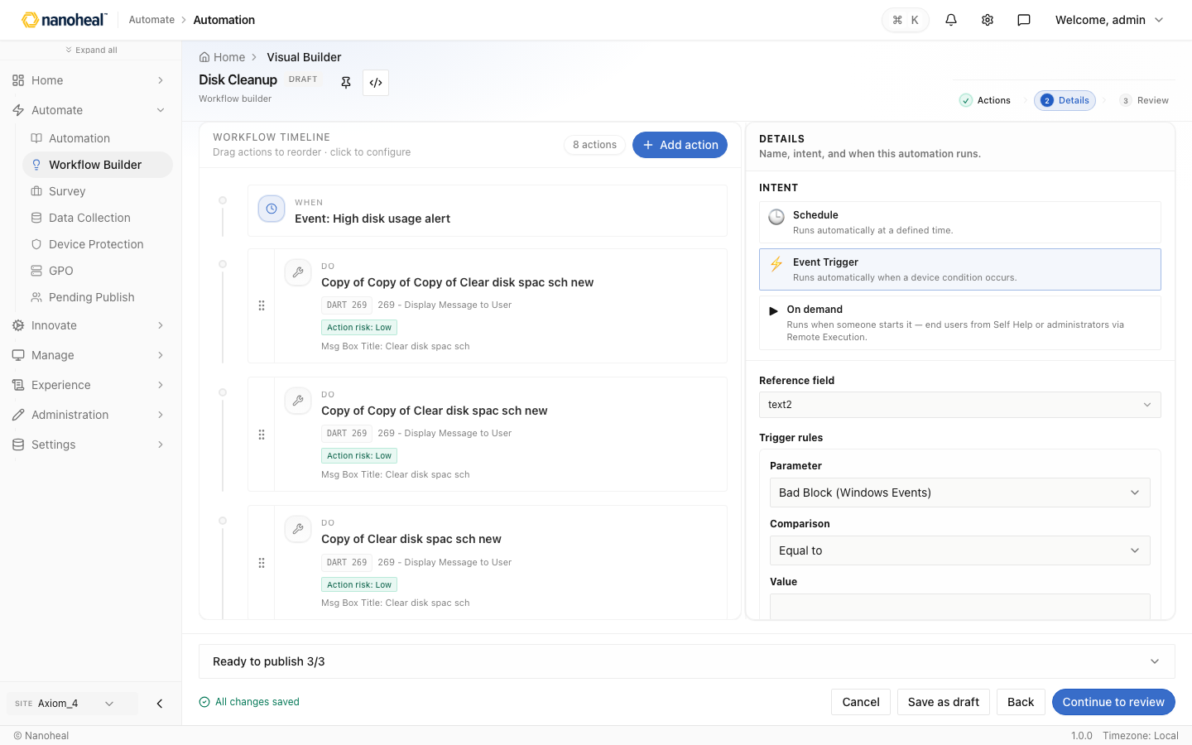
screenshots/113-workflow-builder-deep-03-details-when-on-demand-event-schedule.png

04 When — On demand (selfhelp) — Disk Cleanup
Path: /actions/library/visual-builder
Home Visual Builder Disk Cleanup DRAFT Workflow builder ✓ Actions 2 Details 3 Review Workflow valid Trigger configured Live validation WORKFLOW TIMELINE Drag actions to reorder · click to configure 8 actions Add action WHEN On demand: High disk usage alert DO Copy of Copy of Copy
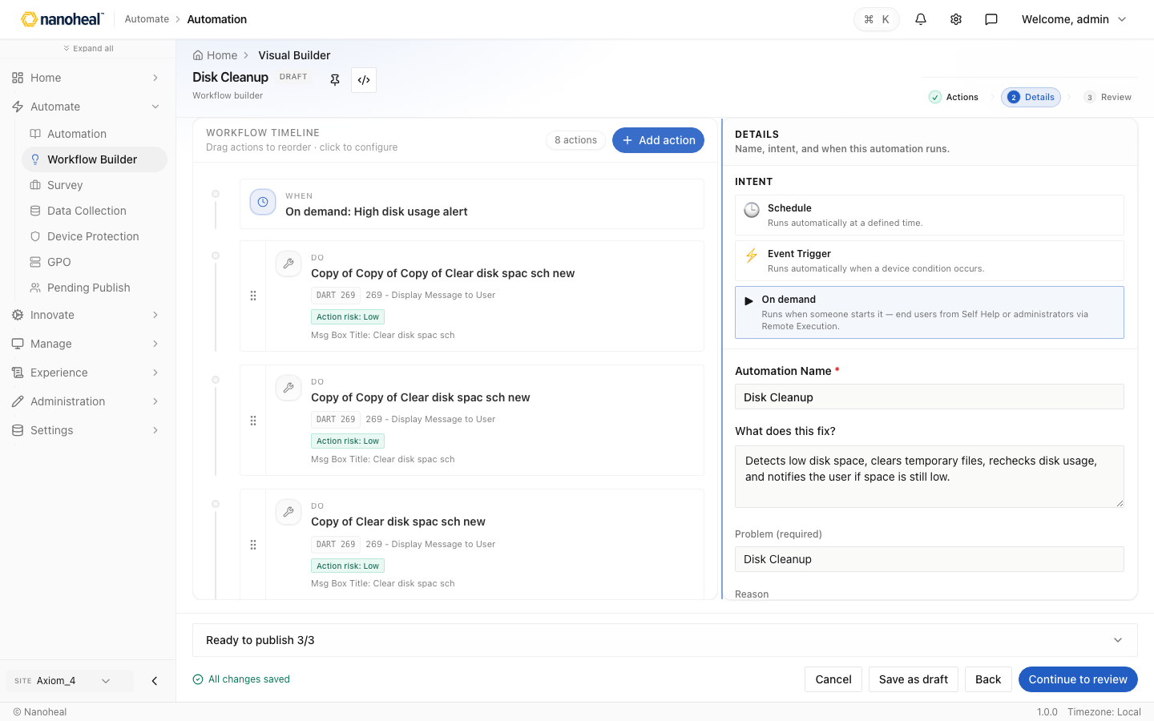
screenshots/114-workflow-builder-deep-04-when-on-demand-selfhelp.png

05 When — Event Trigger (autoheal) — Disk Cleanup
Path: /actions/library/visual-builder
Home Visual Builder Disk Cleanup DRAFT Workflow builder ✓ Actions 2 Details 3 Review Workflow valid Complete device condition rules Live validation WORKFLOW TIMELINE Drag actions to reorder · click to configure 8 actions Add action WHEN Event: High disk usage alert DO Copy of Cop
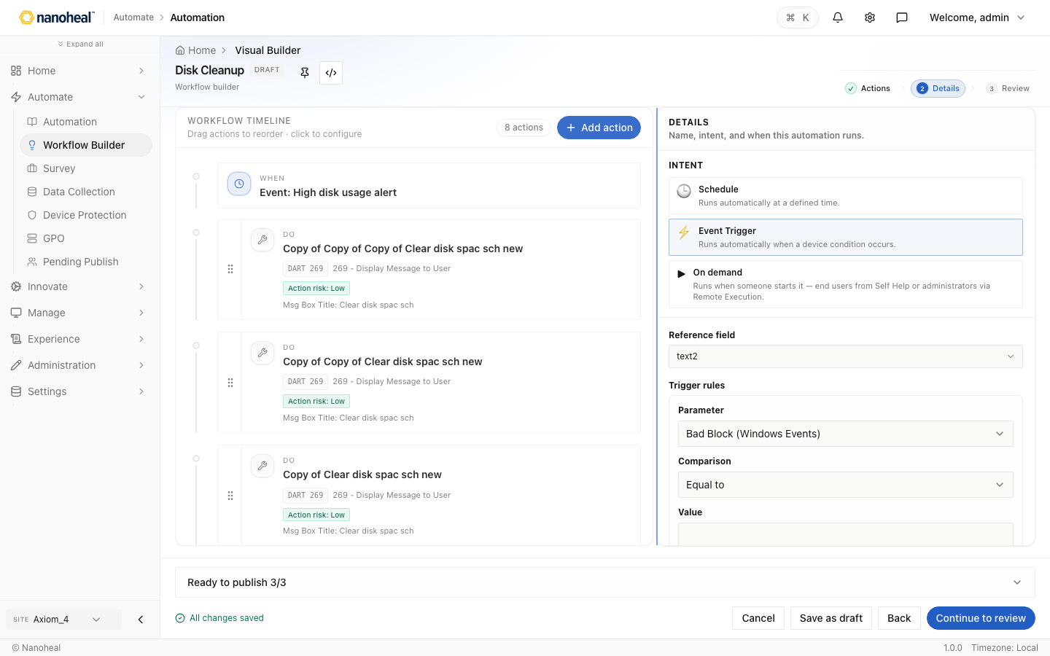
screenshots/115-workflow-builder-deep-05-when-event-trigger-autoheal.png

06 When — Schedule (scheduler) — Disk Cleanup
Path: /actions/library/visual-builder
Home Visual Builder Disk Cleanup DRAFT Workflow builder ✓ Actions 2 Details 3 Review Workflow valid Trigger configured Live validation WORKFLOW TIMELINE Drag actions to reorder · click to configure 8 actions Add action WHEN every weekday at 9:00 AM DO Copy of Copy of Copy of Clea
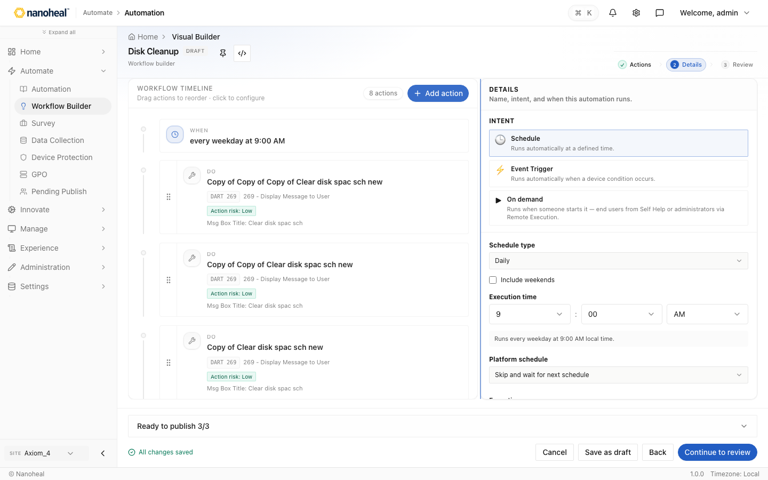
screenshots/116-workflow-builder-deep-06-when-schedule-scheduler.png

07 Conditions — Matches / Does not match — Disk Cleanup
Path: /actions/library/visual-builder
Home Visual Builder Disk Cleanup DRAFT Workflow builder ✓ Actions 2 Details 3 Review Workflow valid Trigger configured Live validation WORKFLOW TIMELINE Drag actions to reorder · click to configure 8 actions Add action WHEN every weekday at 9:00 AM DO Copy of Copy of Copy of Clea

screenshots/117-workflow-builder-deep-07-conditions-matches-does-not-match.png

08 Review before save — Disk Cleanup
Path: /actions/library/visual-builder
Home Visual Builder Disk Cleanup DRAFT Workflow builder ✓ Actions 2 Details 3 Review Workflow valid Trigger configured Live validation WORKFLOW TIMELINE Drag actions to reorder · click to configure 8 actions Add action WHEN every weekday at 9:00 AM DO Copy of Copy of Copy of Clea
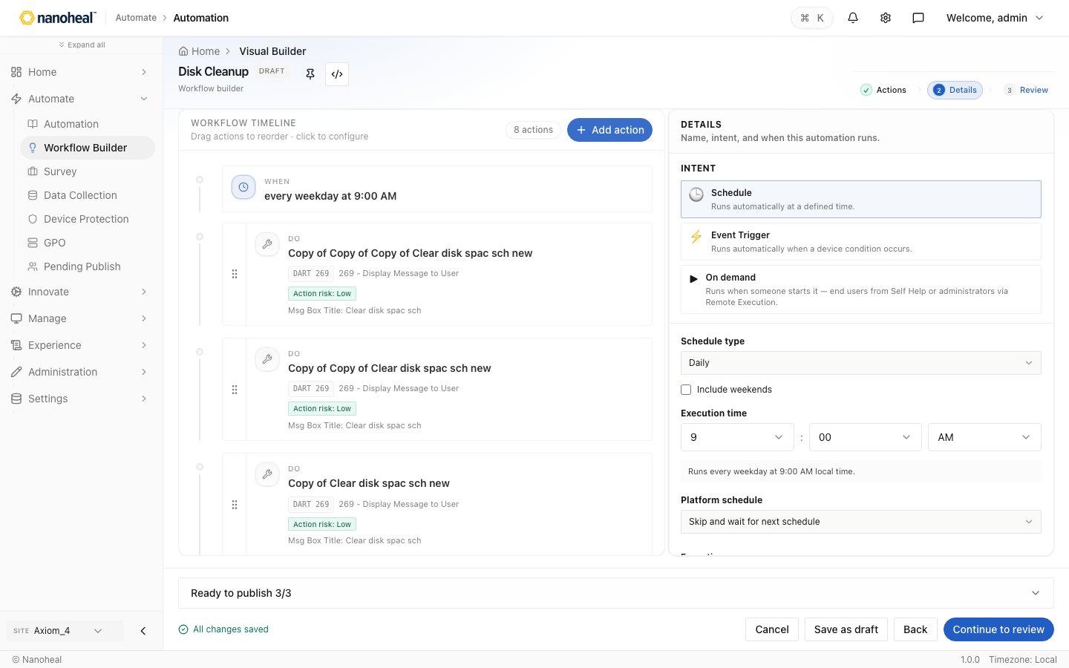
screenshots/118-workflow-builder-deep-08-review-before-save.png

09 Library inspector — edit / link — Profiles
Path: /actions/library
Home Library Profiles Playbooks Profiles 51 profiles · Browse, create, and assign profiles. Create Columns / Filters Name Description Type Status Last Modified Teams Cache Remediation Recovers a broken Microsoft Teams desktop session after crashes or a stuck “Signing in…” loop. S
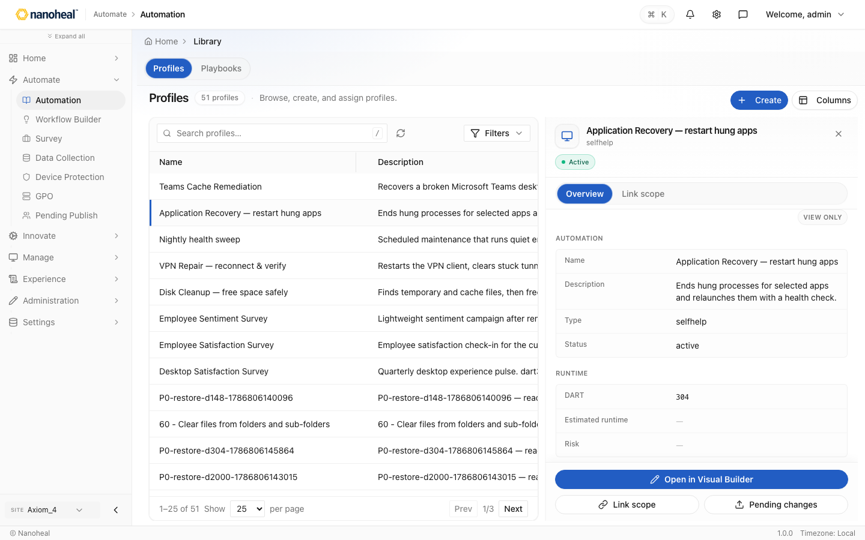
screenshots/119-workflow-builder-deep-09-library-inspector-edit-link.png

10 Link scope confirm — Profiles
Path: /actions/library
Home Library Profiles Playbooks Profiles 51 profiles · Browse, create, and assign profiles. Create Columns / Filters Name Description Type Status Last Modified Teams Cache Remediation Recovers a broken Microsoft Teams desktop session after crashes or a stuck “Signing in…” loop. S
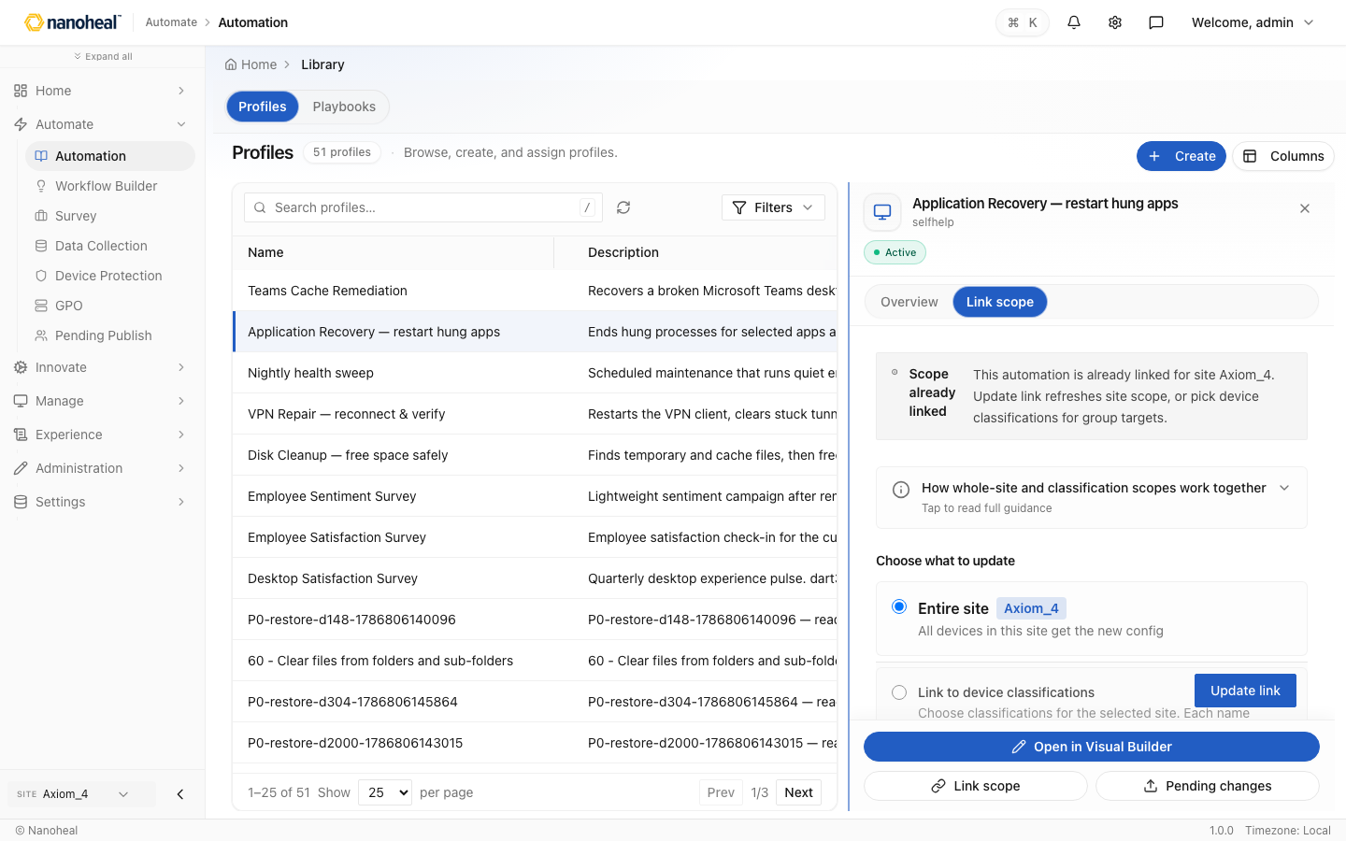
screenshots/120-workflow-builder-deep-10-link-scope-confirm.png

Software Distribution deep

01 Install profiles list — Software install profiles
Path: /devices/software/software-distribution
Home Software Distribution Software install profiles Software uninstall profiles Reusable SWD snippets Deploy Software install profiles 3 profiles · Profiles that install software on managed devices. Create profile Columns / Filters Profile name Category Description Status Create
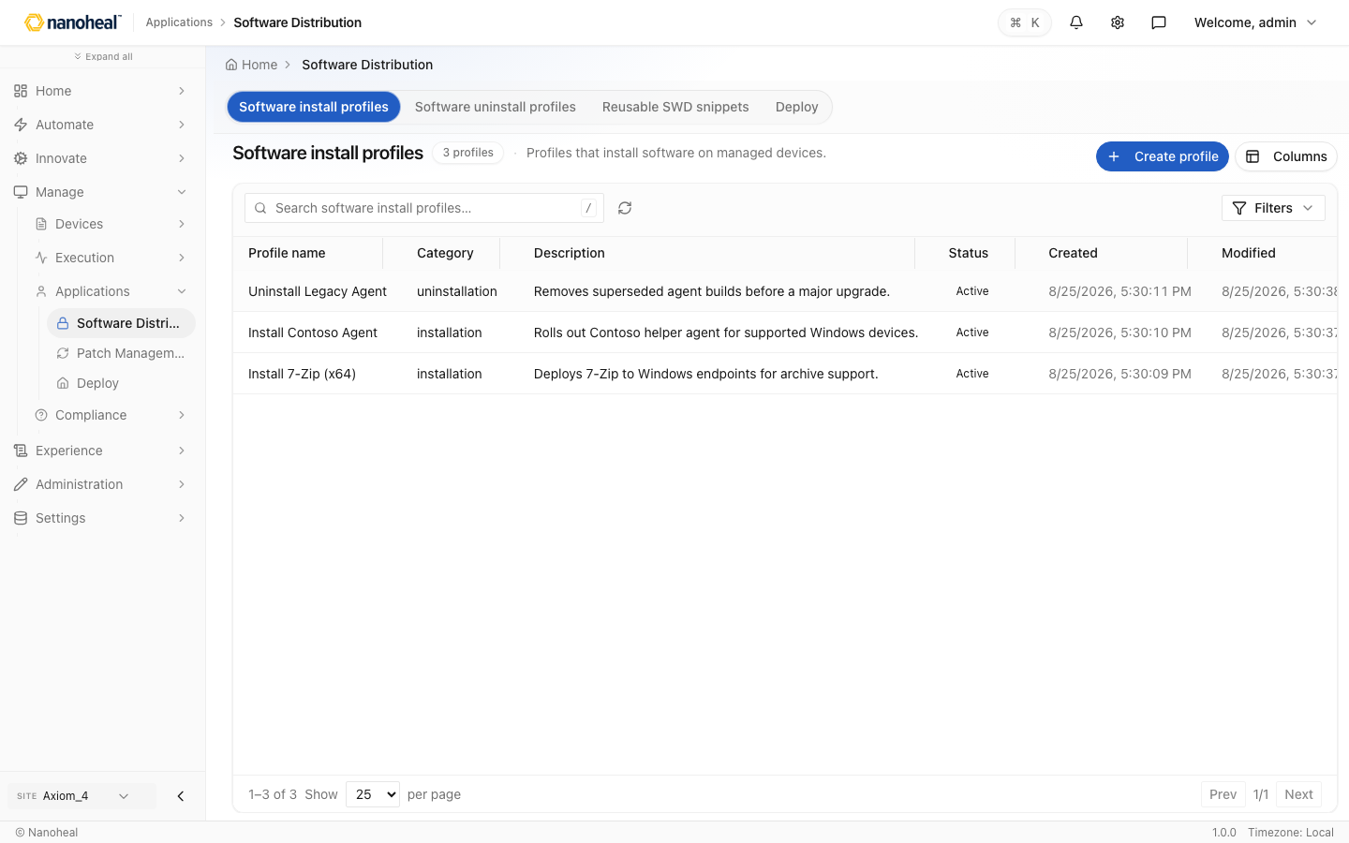
screenshots/121-software-distribution-deep-01-install-profiles-list.png

02 Create software distribution profile — Profile builder
Path: /devices/software/software-distribution
Home Software Distribution Profile builder DRAFT Load 7-Zip example Design History Switch to Form View ✓ Package 2 Build 3 Options 4 Review Operating system Which OS should these patches run on? Select OS BUILD SEQUENCE 1 action — pick a type or configure below the card. 1 action
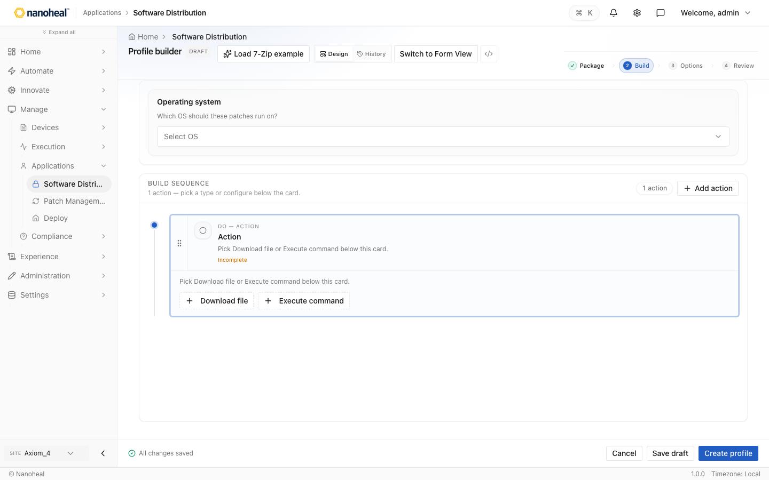
screenshots/122-software-distribution-deep-02-create-software-distribution-profile.png

05 Deploy tab — Software distribution — Deploy
Path: /devices/software/swd-push-audit
Home Swd Push Audit Software distribution — Deploy 0 rows · Deploy queue and per-device audit for software install and uninstall jobs. Columns / Filters No deploy rows Rows appear after software distribution jobs are pushed to devices.
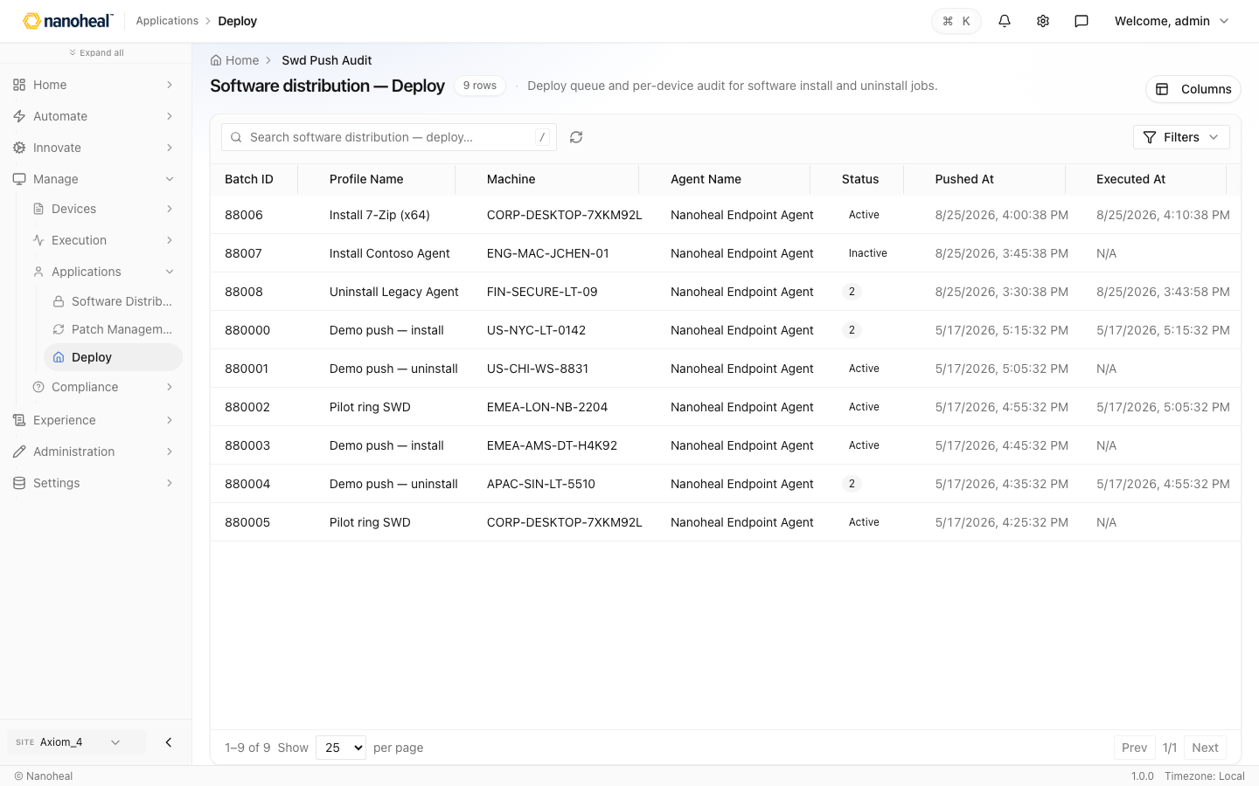
screenshots/106-manage-deploy-seeded.png

06 Deploy page (queue & audit) — Software distribution — Deploy
Path: /devices/software/swd-push-audit
Home Swd Push Audit Software distribution — Deploy 0 rows · Deploy queue and per-device audit for software install and uninstall jobs. Columns / Filters No deploy rows Rows appear after software distribution jobs are pushed to devices.

screenshots/106-manage-deploy-seeded.png

Recapture

census — Devices
Path: /devices/inventory/census
Device inventory (Census) — OS filters, search, export, health chips.

screenshots/104-device-detail-inventory-drawer.png

actions-results — Execution history
Path: /manage/execution-history
Execution History of solutions pushed to devices (success, failed, pending).
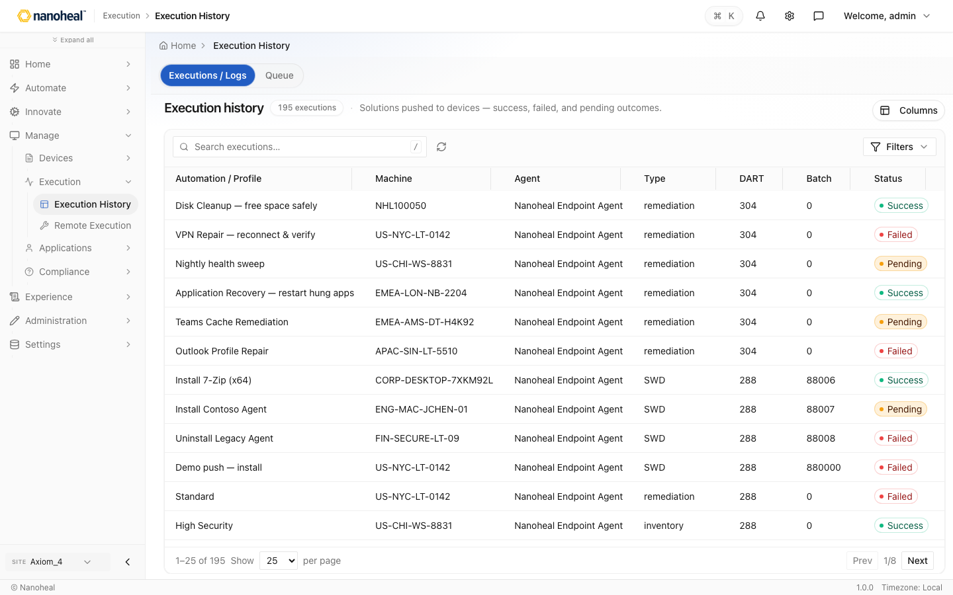
screenshots/103-manage-execution-history-seeded.png

swd-push-audit — Software distribution — Deploy
Path: /devices/software/swd-push-audit
Software distribution Deploy queue — per-device install/uninstall audit.

screenshots/106-manage-deploy-seeded.png

automate-scheduling — Schedules
Path: /actions/scheduling · menu disabled
Scheduling hub — deployed workflows on a recurring schedule.
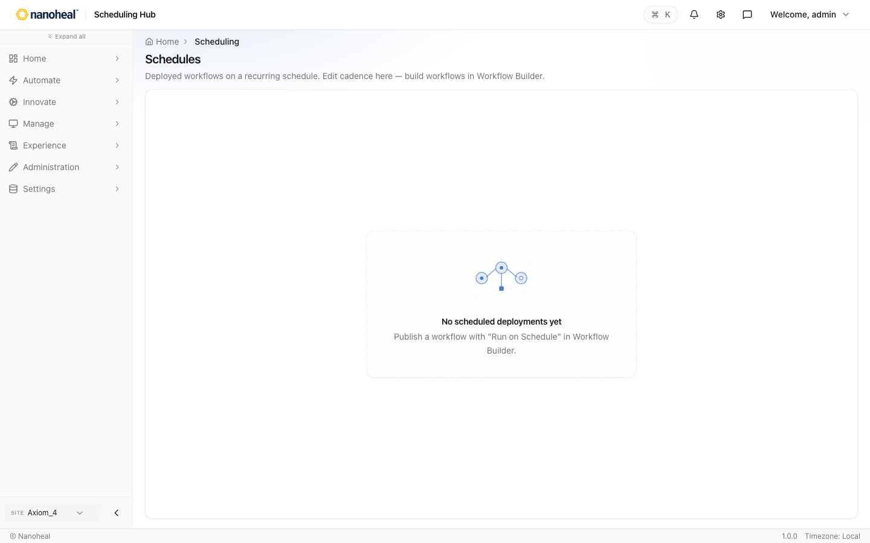
screenshots/047-disabled-menu-scheduling.png

monitoring-profiles
Path: /actions/catalogs/monitoring · menu disabled
Monitoring / Data Collection profiles hub.
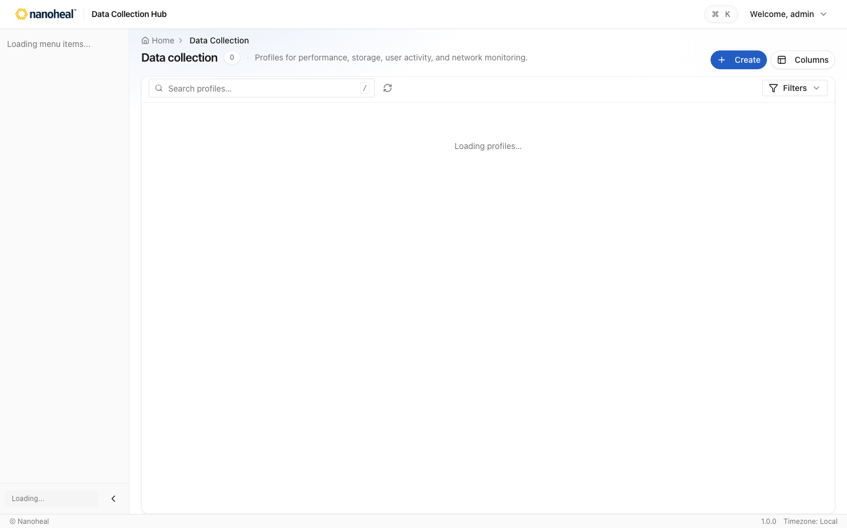
screenshots/095-disabled-menu-monitoring.png

admin-deployment
Path: /settings/deployment · menu disabled
Client enrolment packages hub (placeholder until package UI ships).
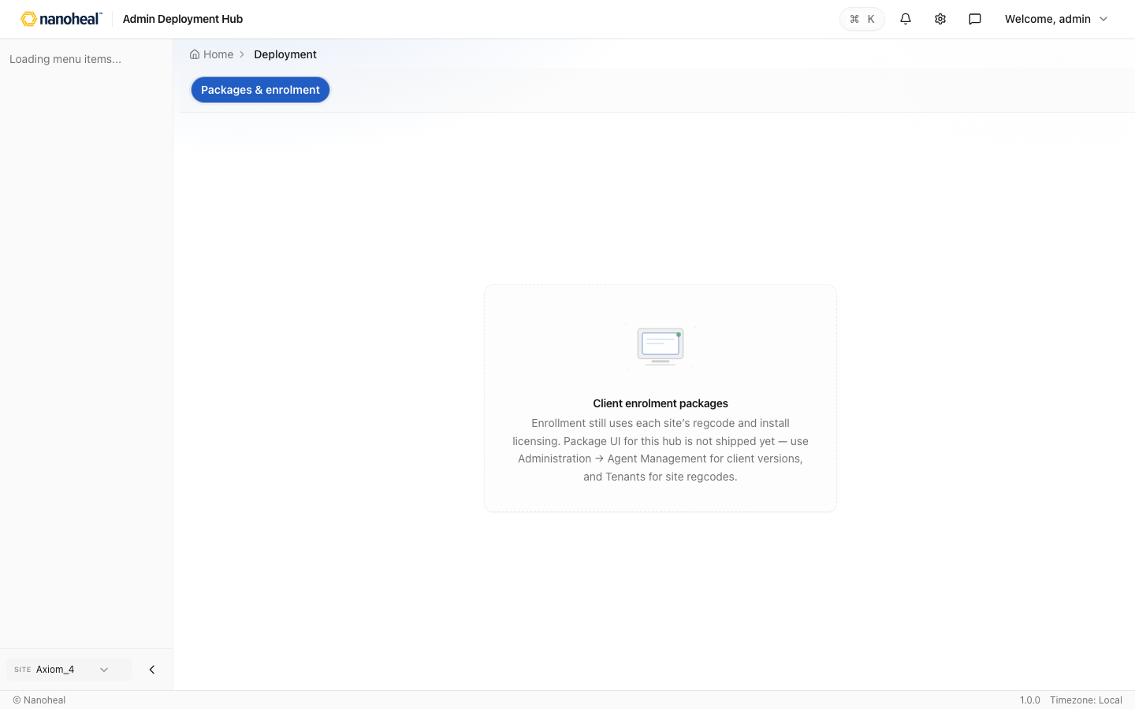
screenshots/096-disabled-menu-deployment.png

version-catalog — Version catalog
Path: /settings/agents · menu disabled
Version catalog of client packages sites can target for updates.
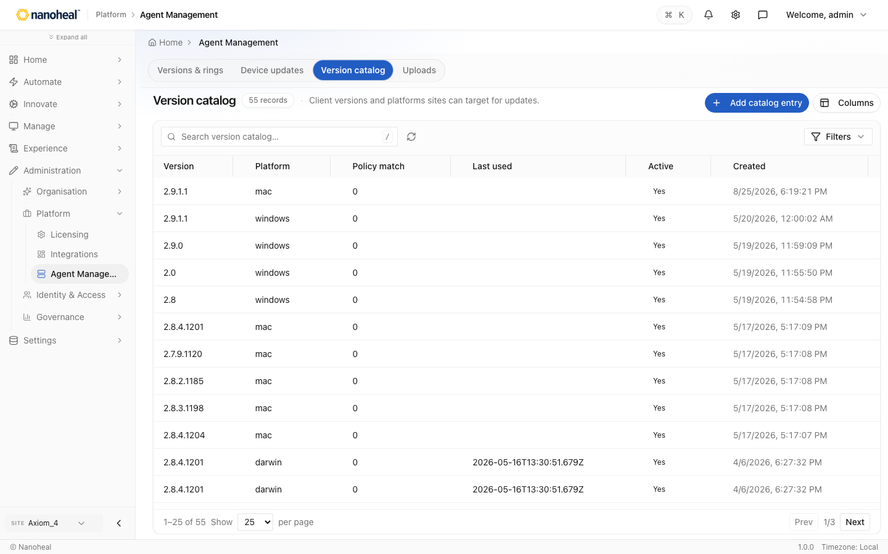
screenshots/097-disabled-menu-version-catalog.png

gpo-policies
Path: /compliance/gpo-policies · menu disabled
GPO / desired-state policy definitions list.
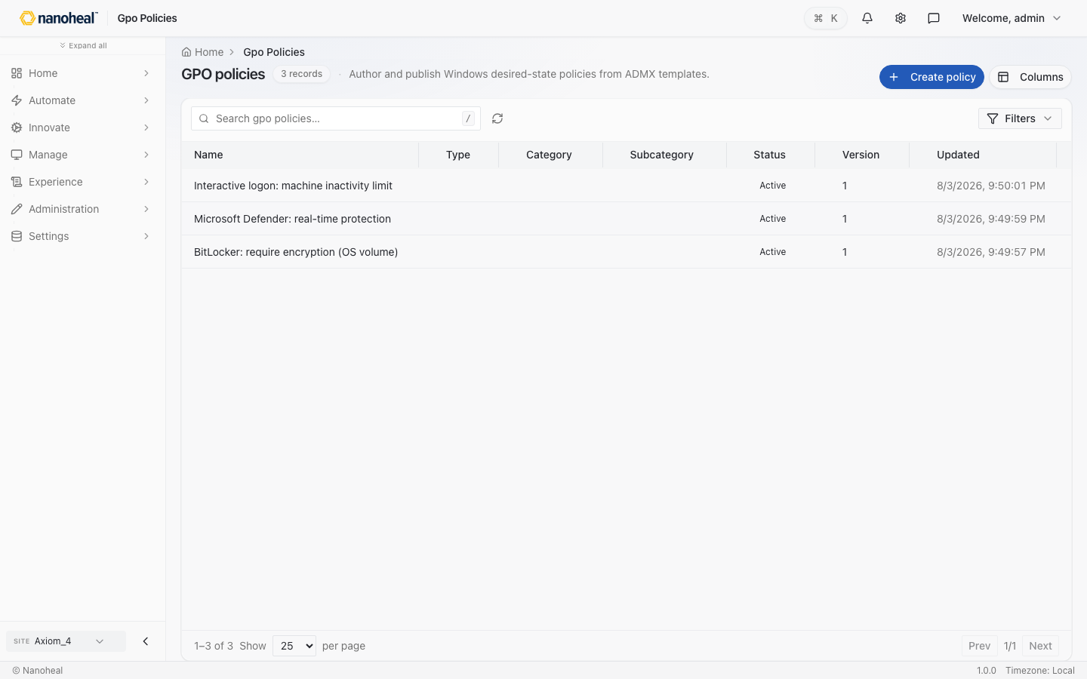
screenshots/098-disabled-menu-gpo-policies.png

compliance-policy-execution — Policy execution
Path: /compliance/policy-execution · menu disabled
Per-device policy execution status.
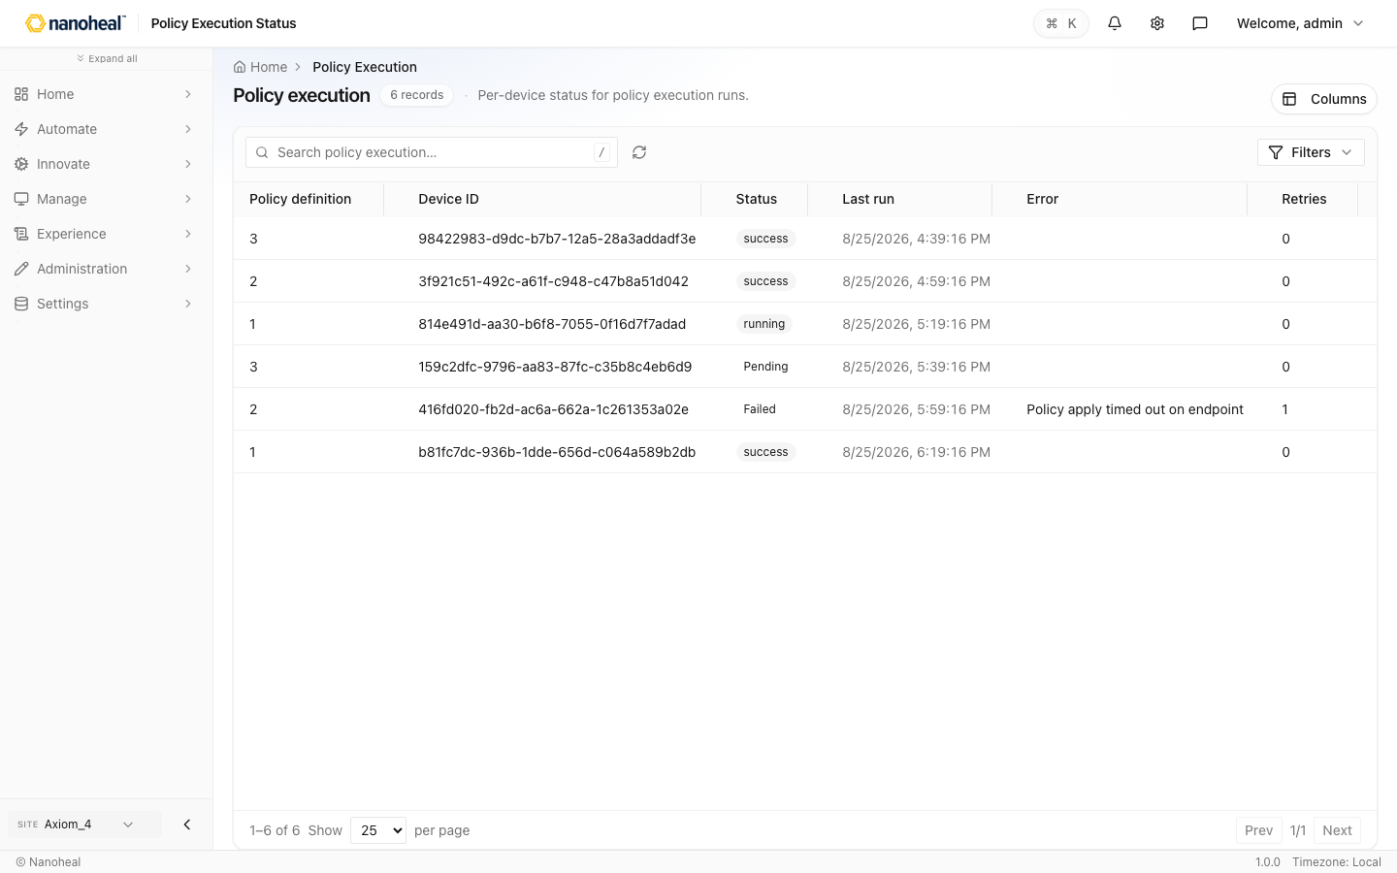
screenshots/058-disabled-menu-policy-execution.png

selfhelp-library — Profiles
Path: /actions/library
Automation library filtered toward self-help profiles.
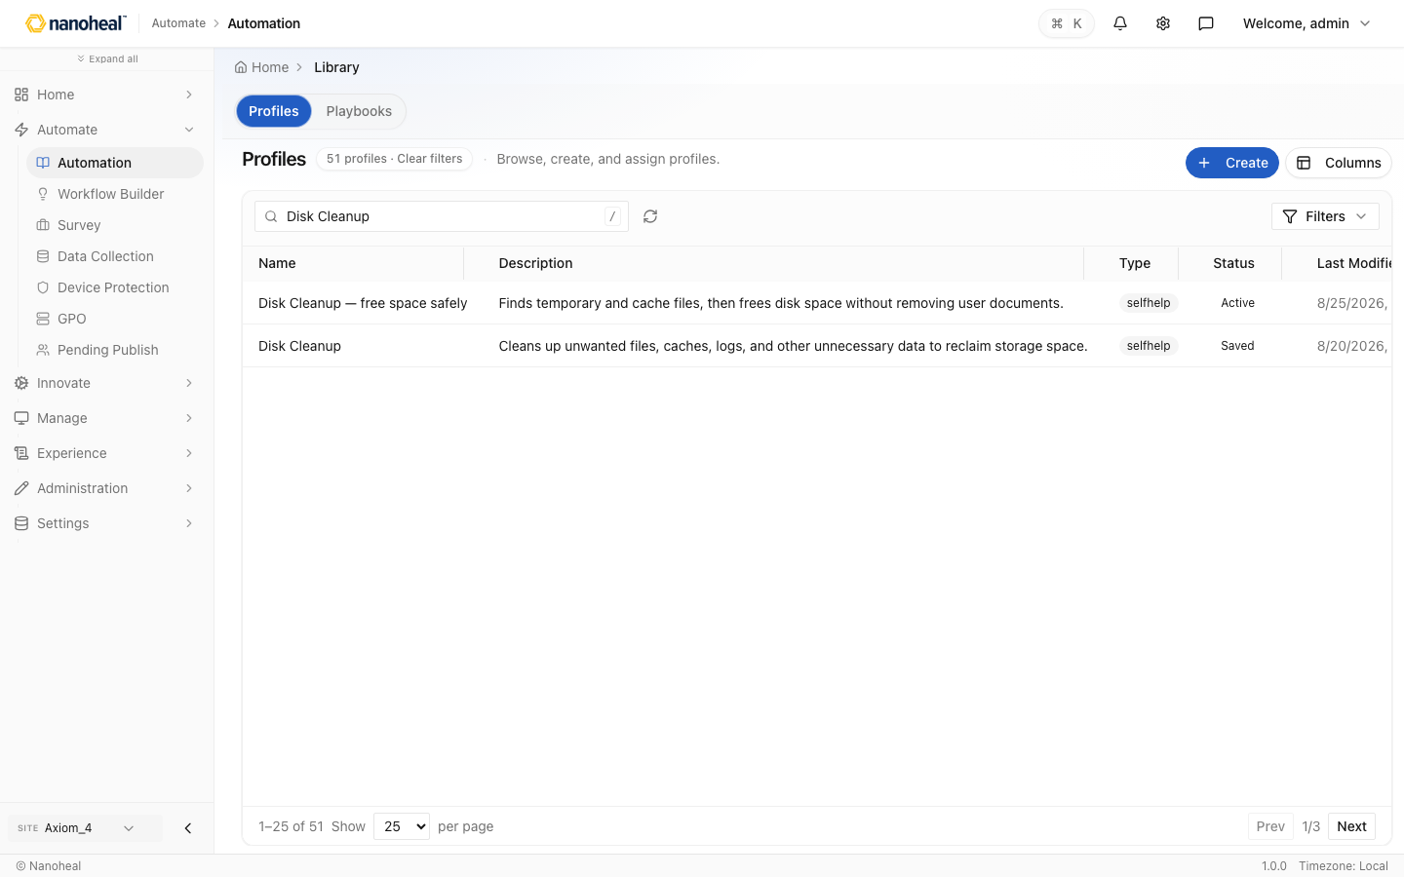
screenshots/125-automate-selfhelp-library.png

autoheal-library — Profiles
Path: /actions/library
Automation library filtered toward autoheal profiles.
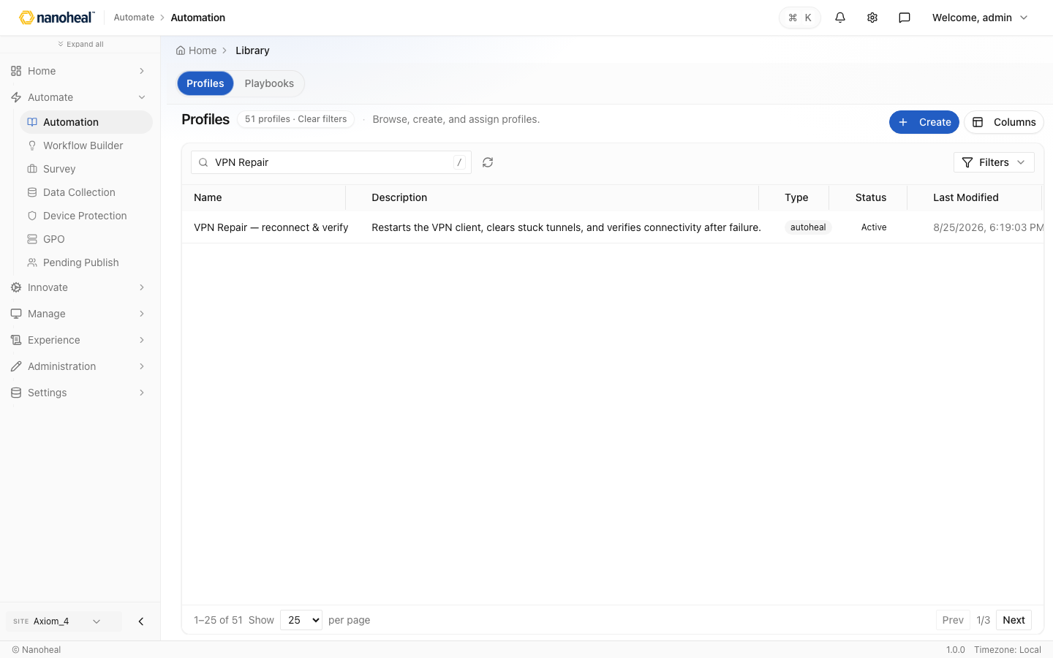
screenshots/126-automate-autoheal-library.png

