Windows Client UI — Walkthrough
UPDATED: Chat sign-in image uses Nanoheal logo (ADM removed). If Word still shows ADM, close the old file and open this new copy.

How the product works (user journey)
1. Install — device is checked, user accepts terms, client installs.
2. Home — user searches or picks a category (Browser, Disk, Microsoft, etc.).
3. Run a fix — pick a resolution → Fix now → Nanoheal runs the remediation on this PC.
4. History — see what ran and when.
5. Still stuck? — Call, Email, or Chat from Still Facing Issues? (or the floating Nanoheal chat icon).
6. Feedback — optional survey after a fix.

Installation pages

Prerequisite — System Requirements Verification
What this module is: Pre-install safety check before the agent is installed.
What the user can do: Wait for checks (proxy, drivers, OS, RAM, internet, disk, certificates). Green = passed. Change language if needed.
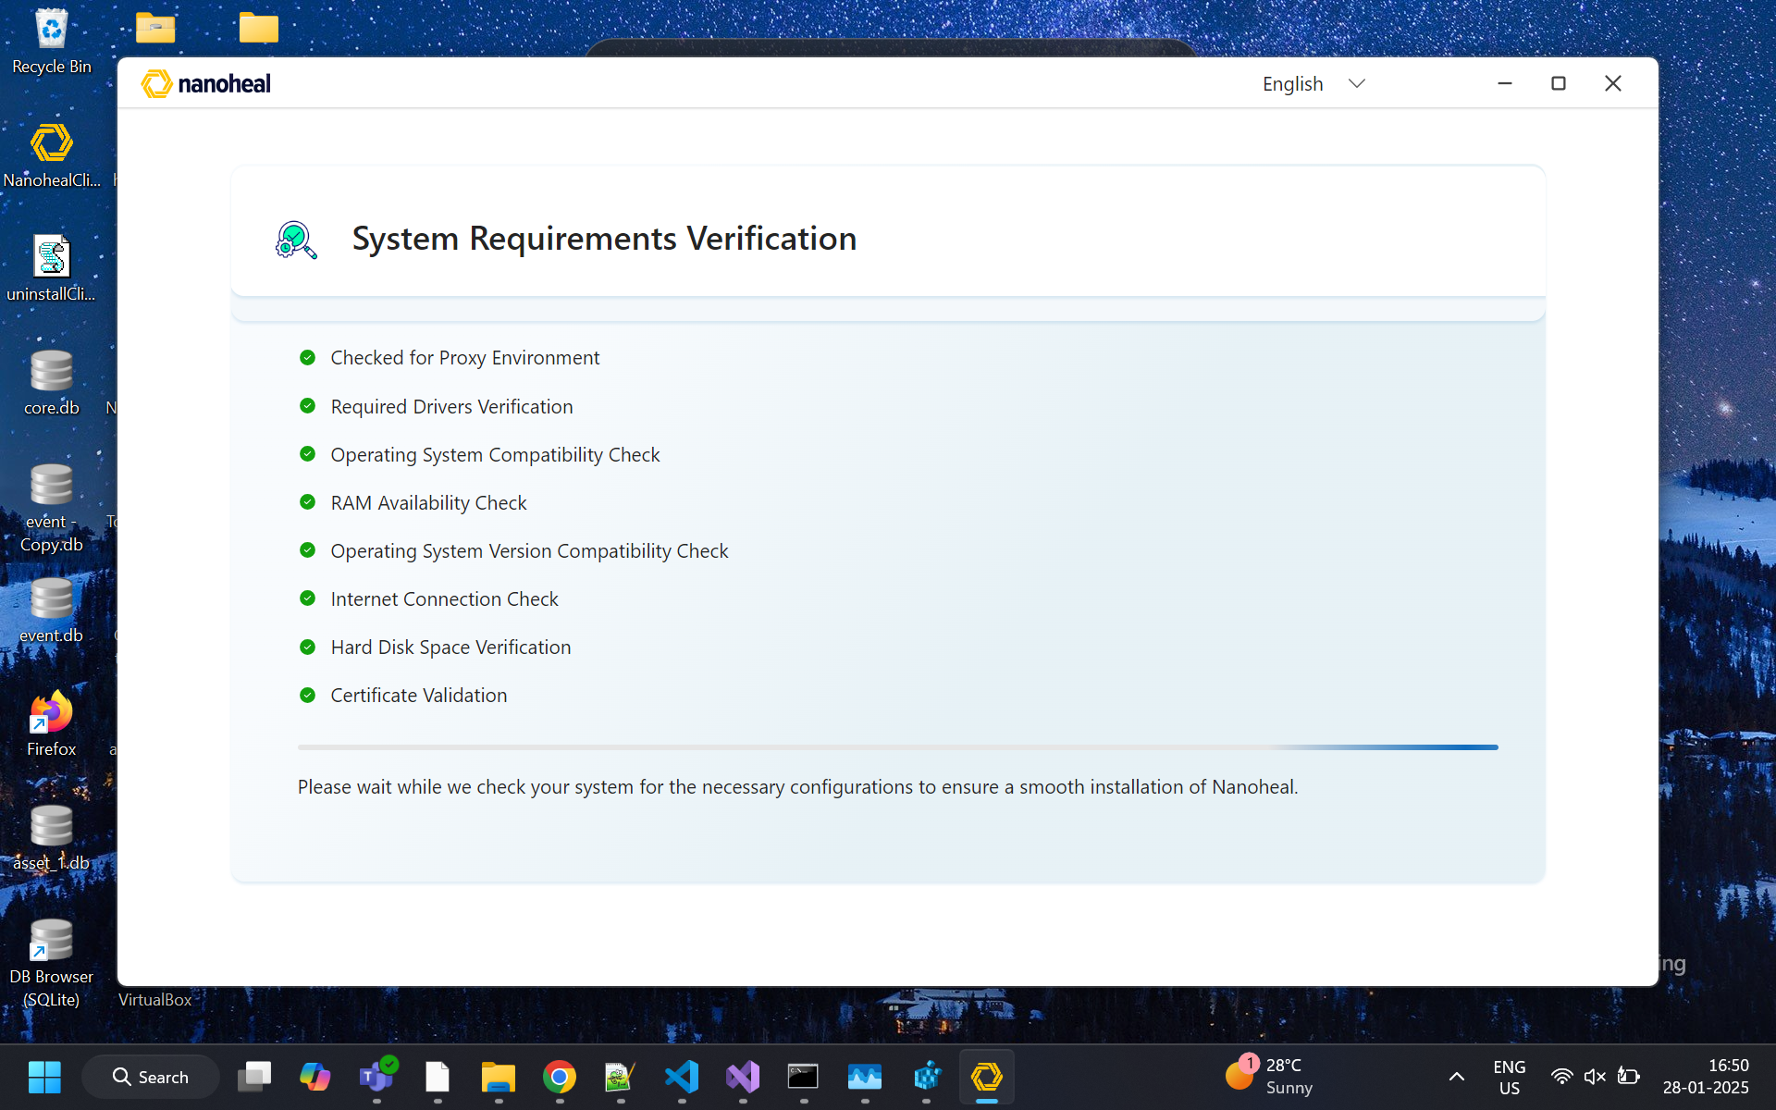
01-prerequisite.png

Acknowledgement — Terms & Install
What this module is: Legal consent before install.
What the user can do: Read terms, tick acknowledge, click Install or Cancel.
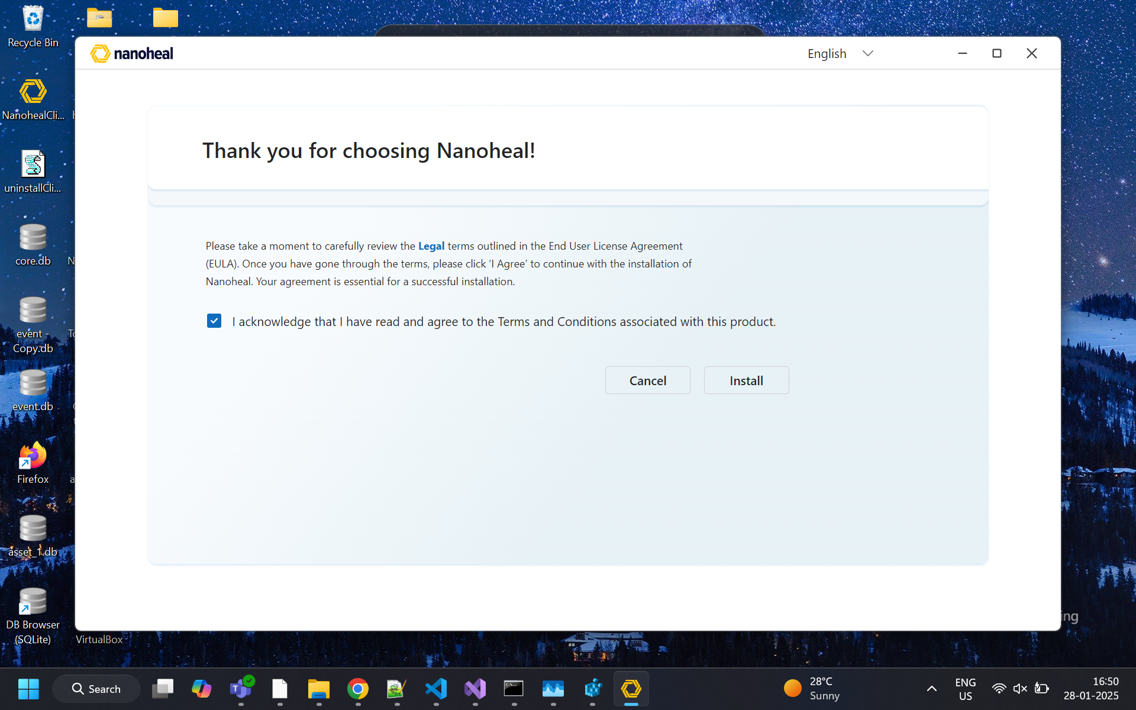
02-acknowledgement.png

Please Wait — Installation
What this module is: Progress while Nanoheal installs.
What the user can do: Wait; do not close the window until finished.
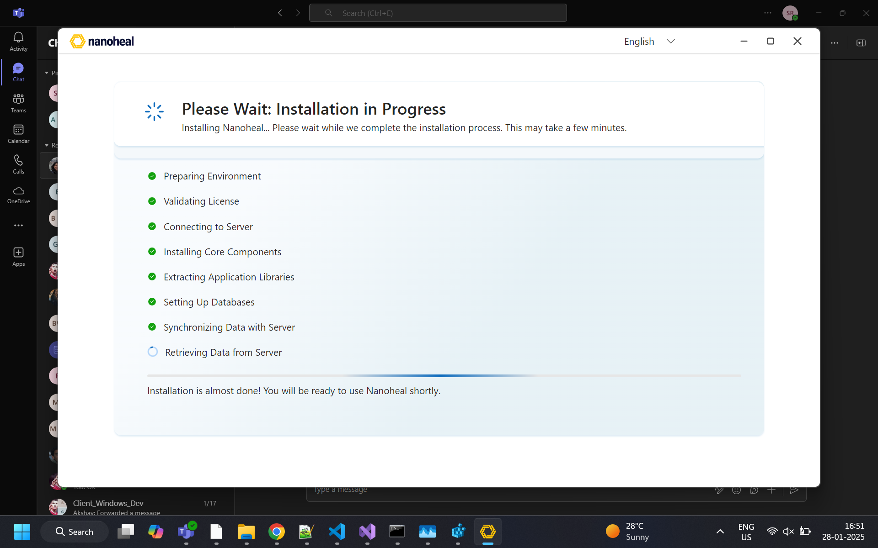
03-please-wait-install.png
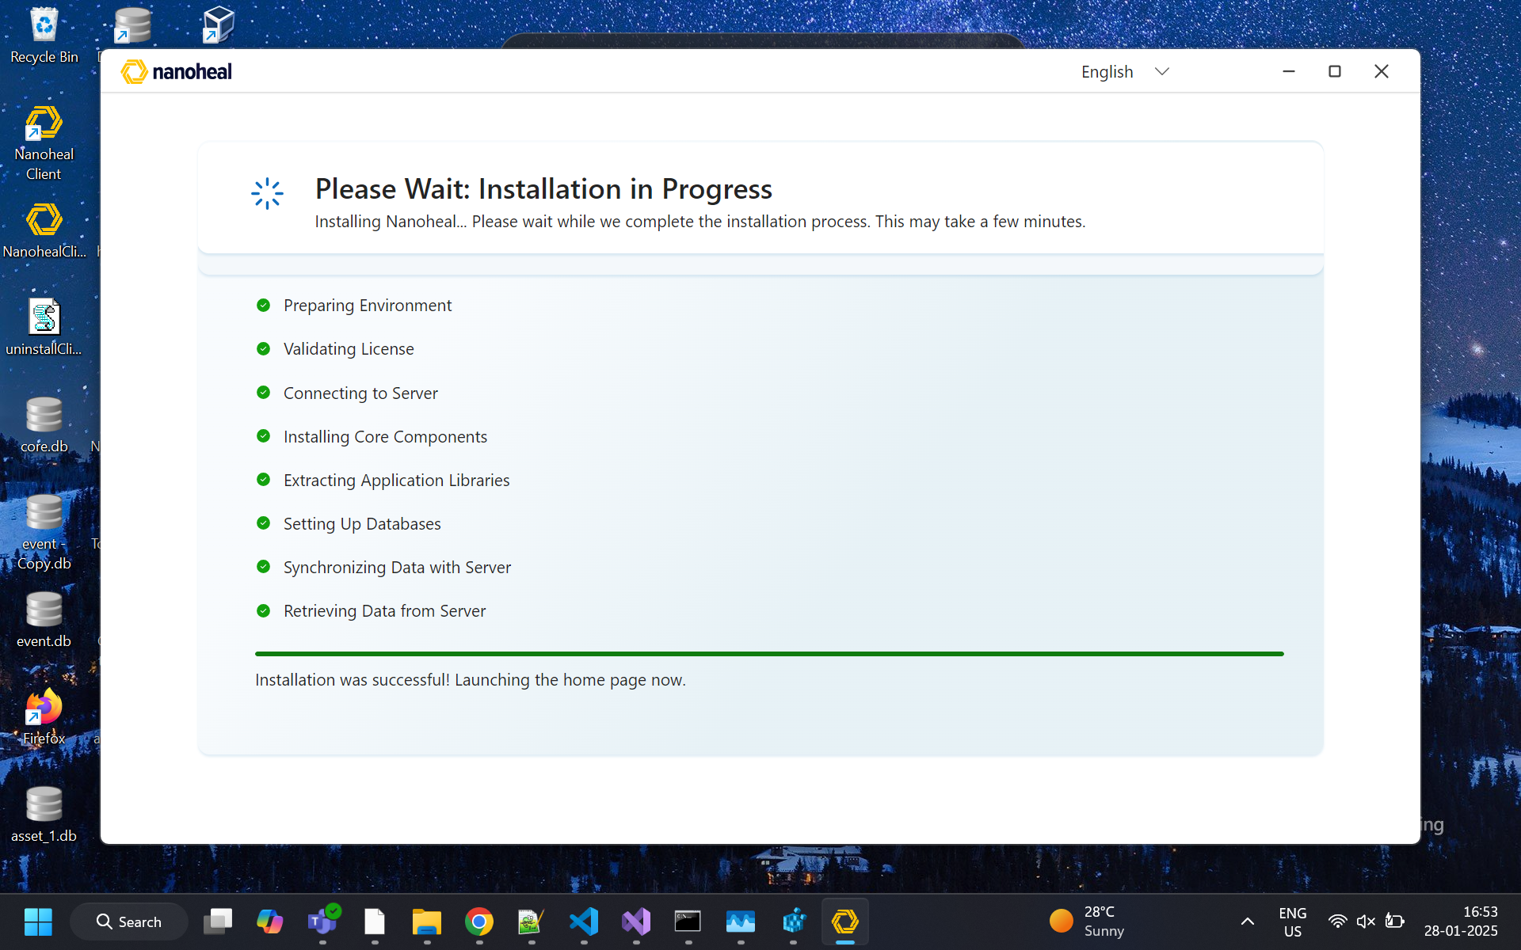
04-please-wait-install-alt.png

Post-installation — home & device

Landing Page (Home)
What this module is: Main self-service hub.
What the user can do: Search for resolutions; open category tiles (Microsoft, Browser, Disk, Sound, Display, etc.); use Frequently used resolutions; open Device Details or Service History; Sync Now; escalate via Still Facing Issues? or the Nanoheal chat icon.
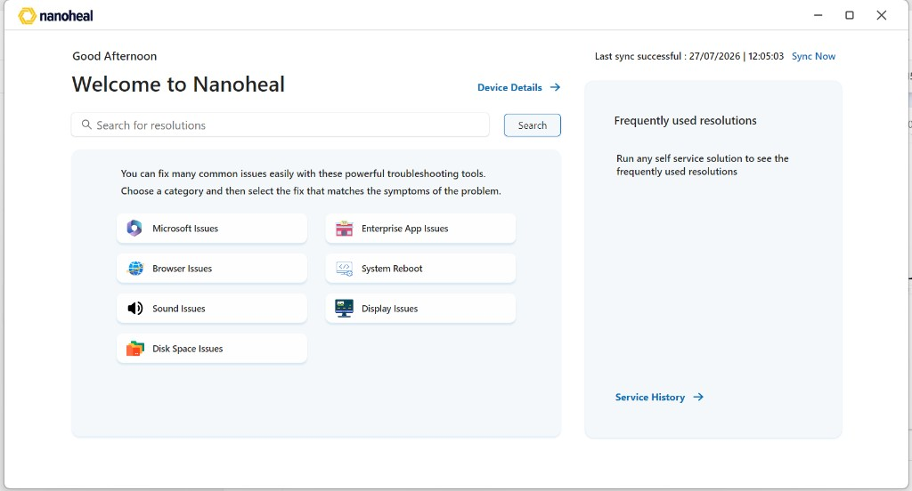
05-landing.png

Device Details
What this module is: Profile of this PC for support context.
What the user can do: View device/hardware facts; go Back to Home.
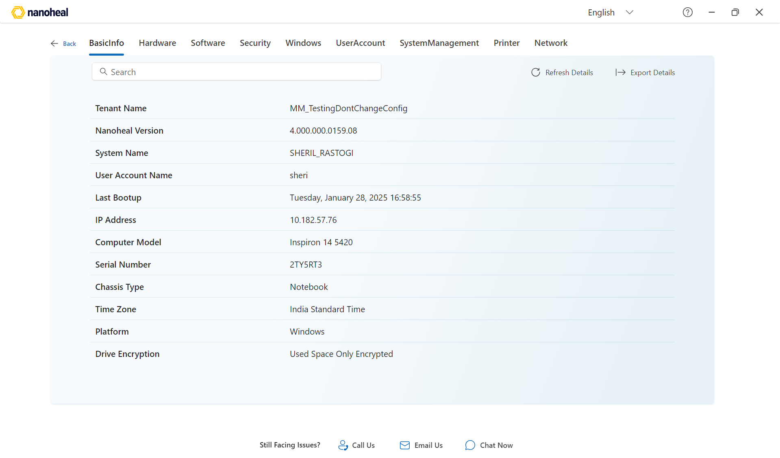
06-device-details.png
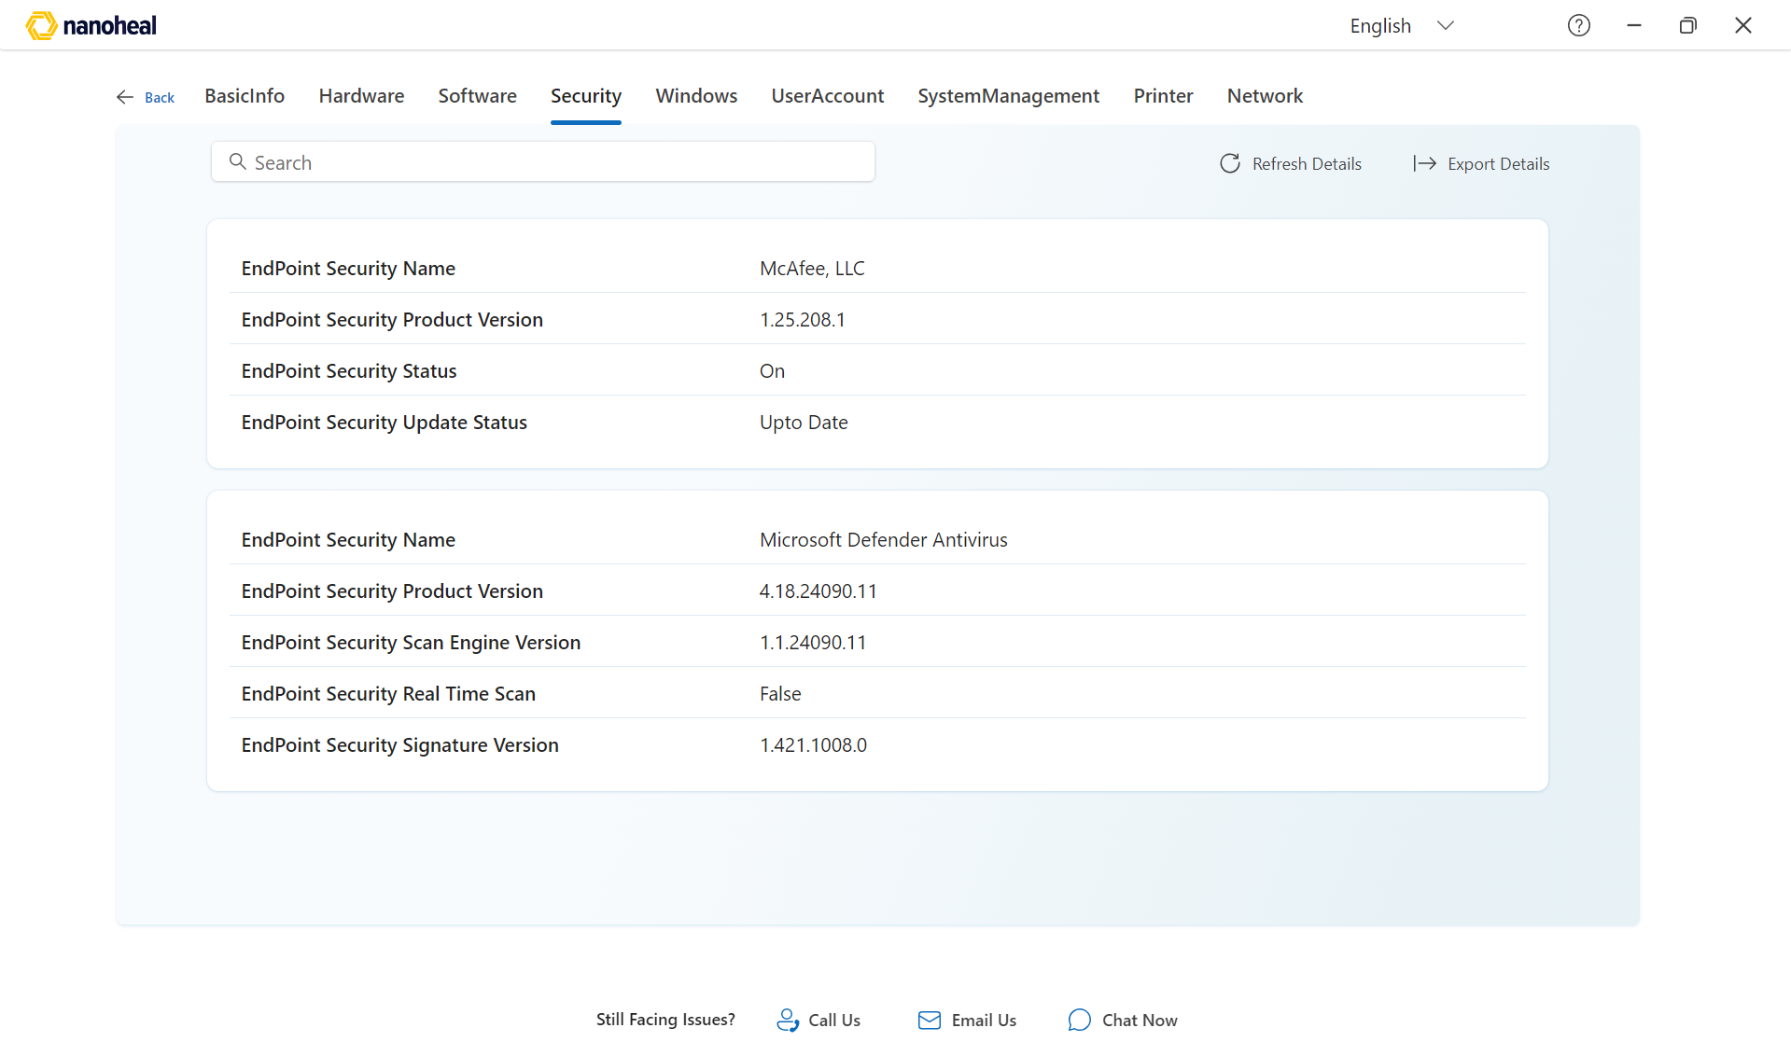
07-device-details-alt.png

Service History
What this module is: Audit of what Nanoheal ran on this device.
What the user can do: Filter tabs (HistoryDetails / Autoheal / Selfhelp / Proactive / Schedule); search, refresh, export.
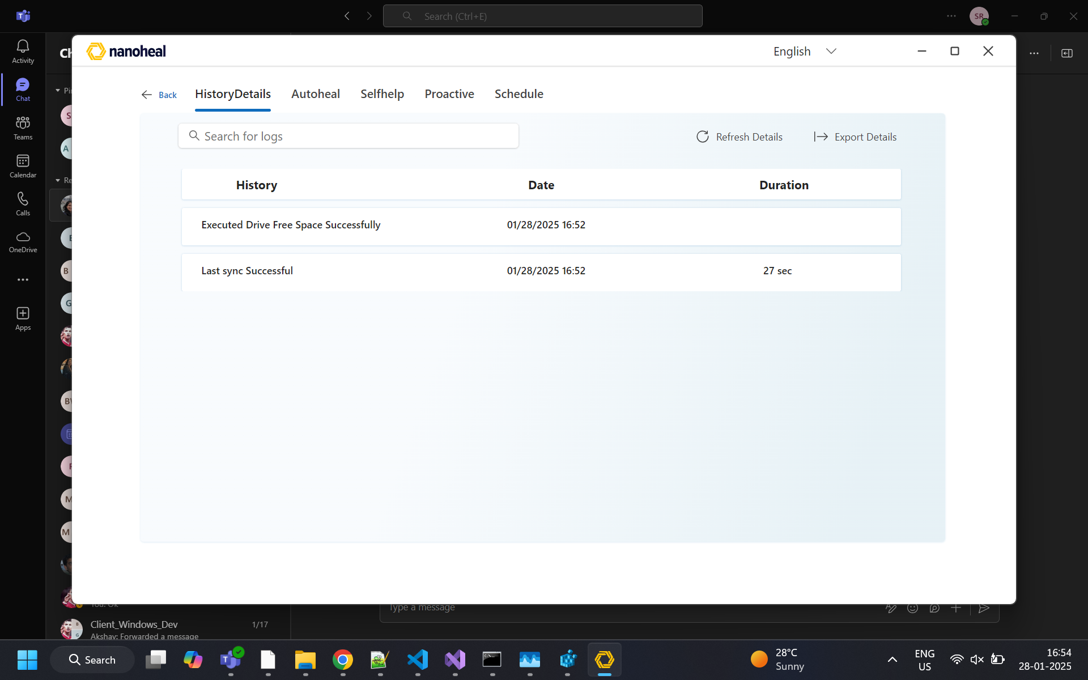
08-service-history.png

Search results
What this module is: Matching fixes from search.
What the user can do: Open a result card to run that fix; refine search; go Back.
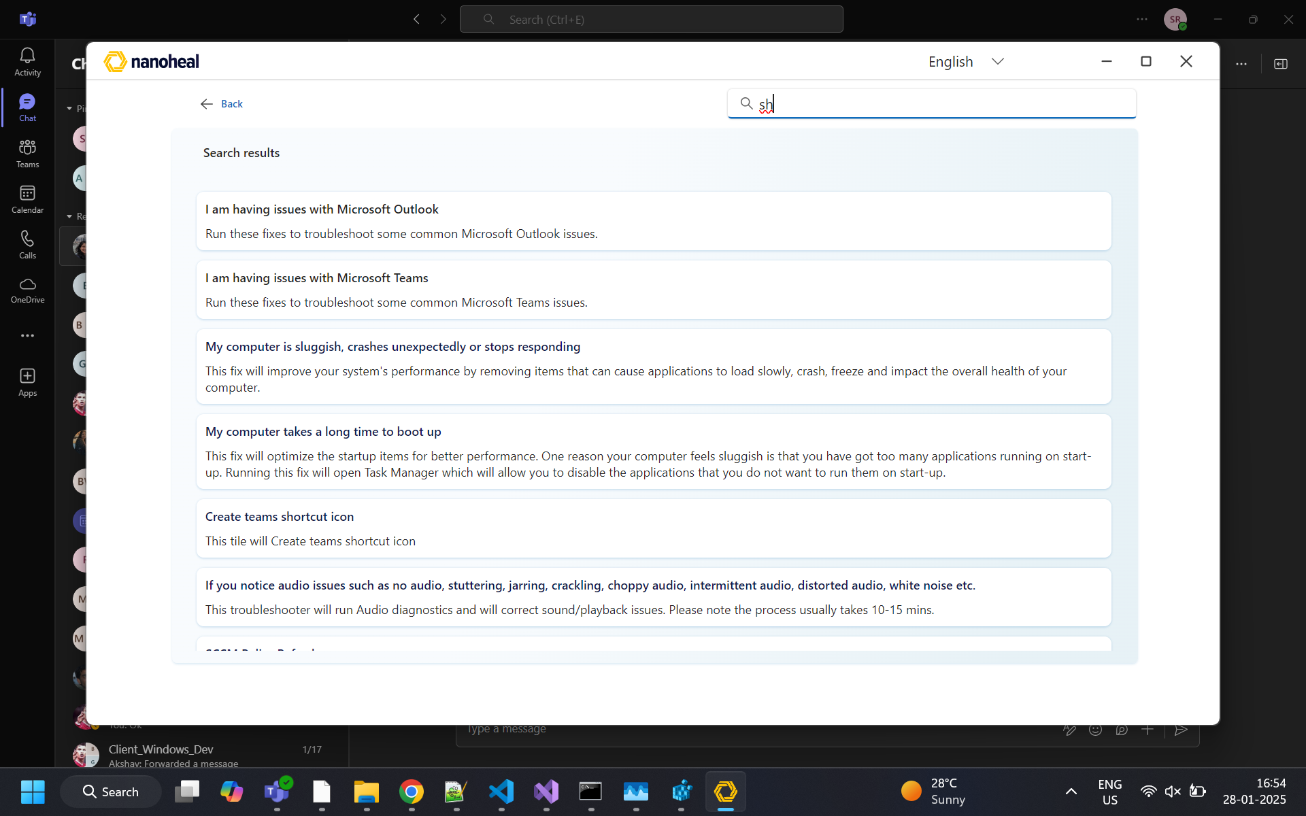
09-search.png

Solution catalog

L2 Tile — category
What this module is: Pick a product/sub-area (e.g. Chrome vs Firefox).
What the user can do: Select item → View Solutions; Update Now; Back / Home.
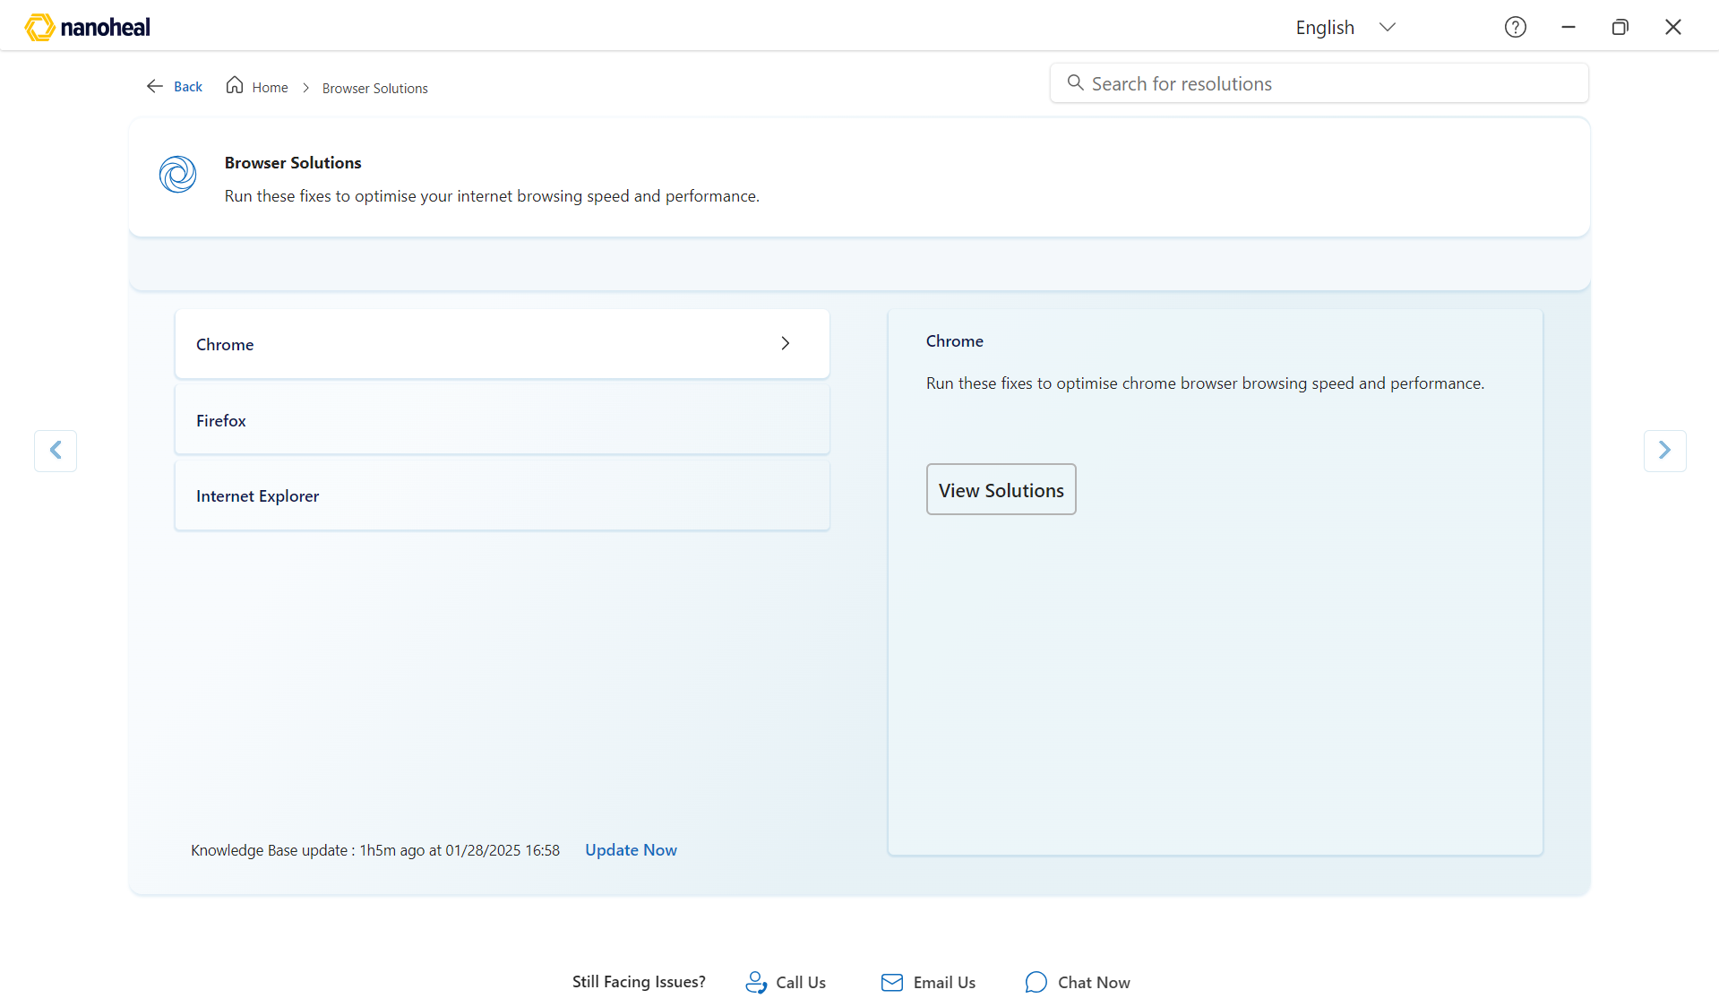
11-l2-tile.png

L3 Tile — fix detail
What this module is: Runnable fix screen.
What the user can do: Select a fix, read description, click Fix now; escalate if needed.
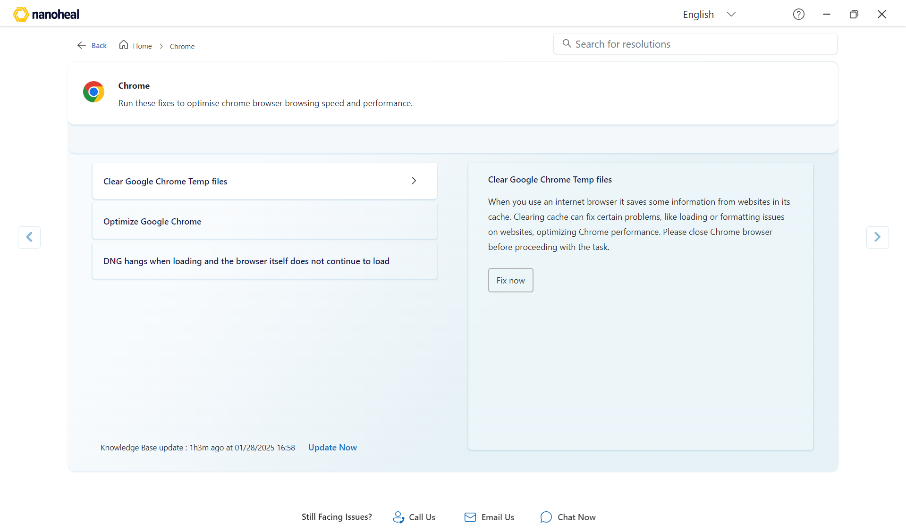
10-l3-tile.png

Support footer (Still Facing Issues?)

Call Us
What the user can do: Open Call Us; pick region; dial during published hours.
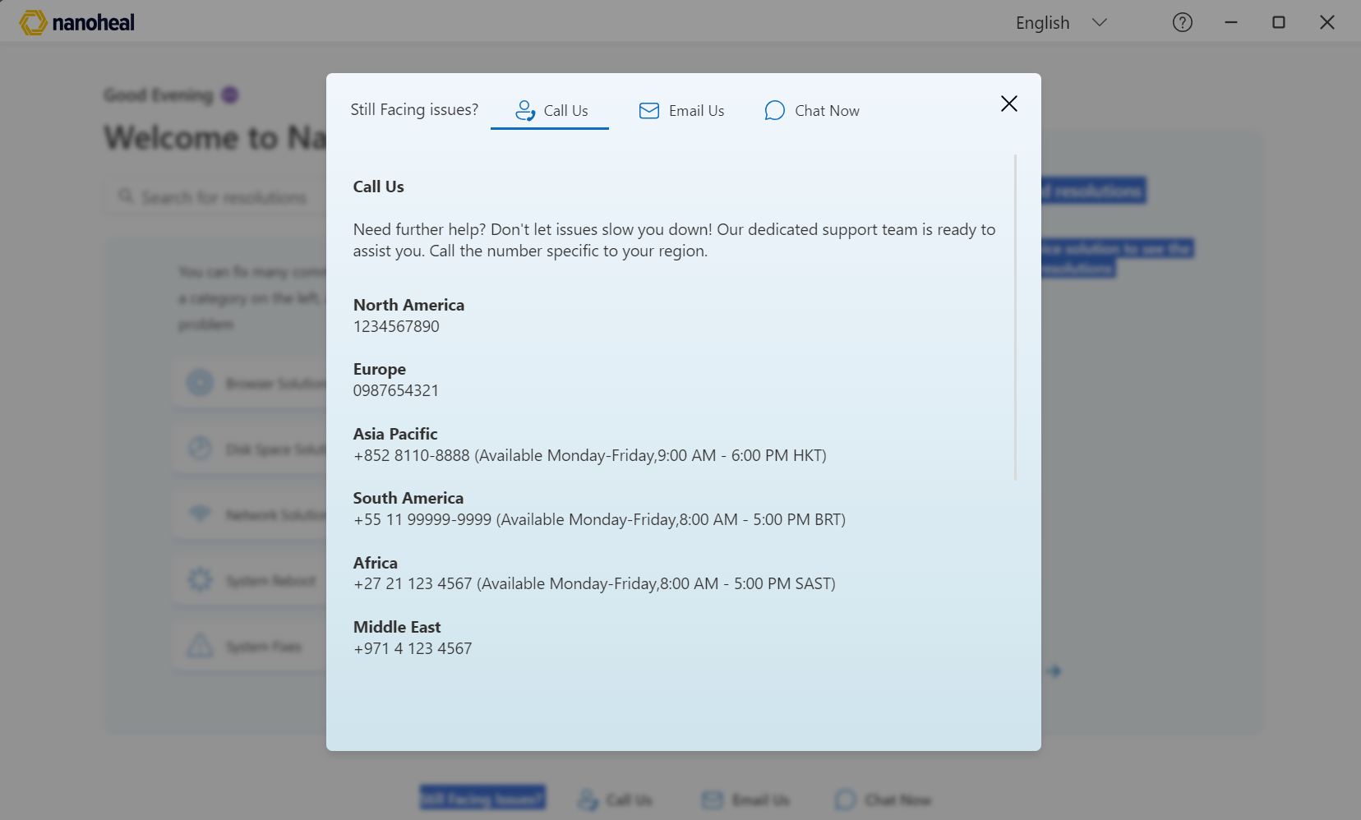
12-footer-chat-phone.png

Email Us
What the user can do: Open Email Us; contact the configured support address.
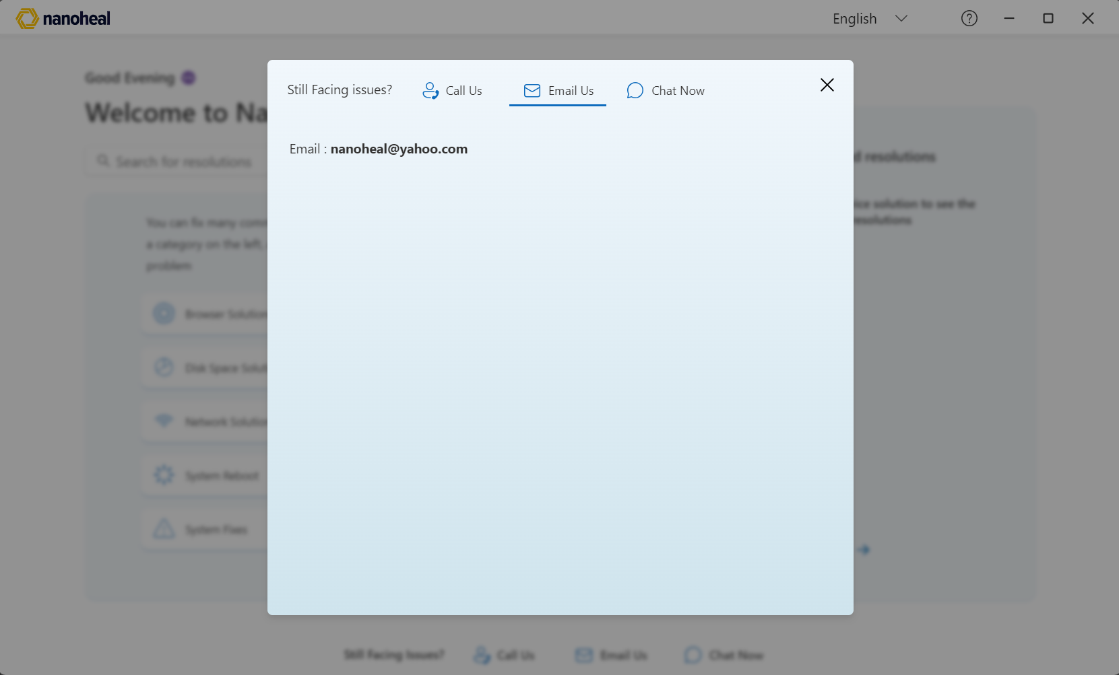
13-footer-email.png

Chat Now — Sign in (Nanoheal logo — ADM removed)
What this module is: After Chat Now / Chat, Microsoft sign-in opens. ADM branding replaced with Nanoheal logo.
What the user can do: Enter work email, continue SSO, or use Can’t access your account?; then continue into chat.
THIS IMAGE IS THE UPDATED NANOHEAL VERSION (not ADM).
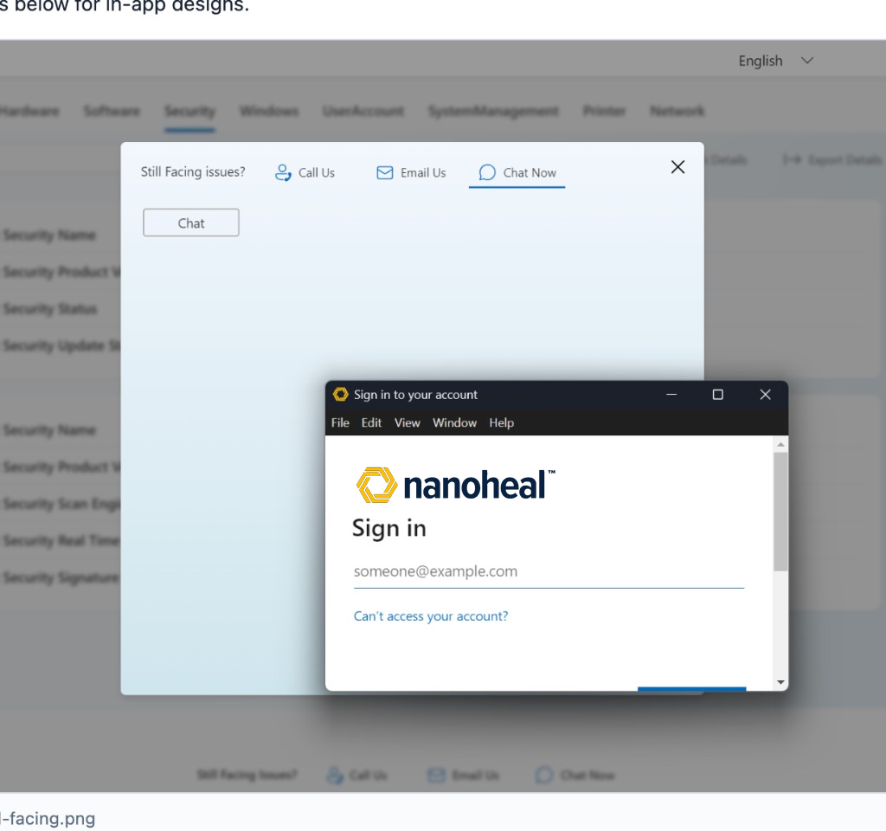
14-footer-still-facing.png

Chat Now — Sign in (same updated image)
Same Nanoheal-branded sign-in screenshot for the walkthrough gallery.

18-chat-signin-nanoheal.png

Survey & chat widget

User Survey
What the user can do: Rate the fix, pick outcome, optional note, Submit / Skip / Back.
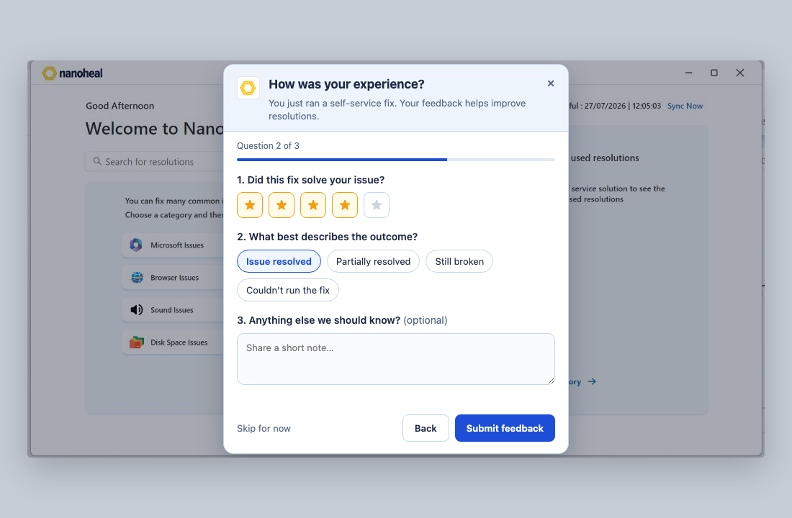
15-user-survey.png

Chatbot — open
What the user can do: Chat from bottom-right panel; greeting Hi; quick chips; Open fix / Talk to support. Nanoheal icon FAB (no blue circle).
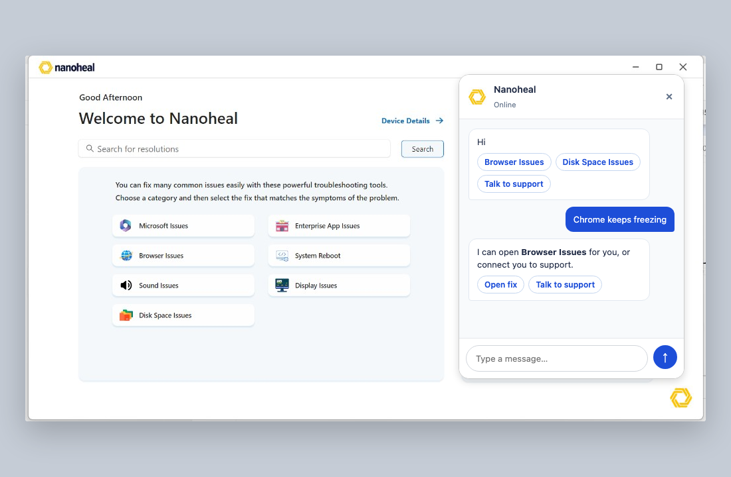
16-chatbot-panel.png

Chatbot — FAB closed
What the user can do: Click Nanoheal hexagon (bottom-right) to open chat.
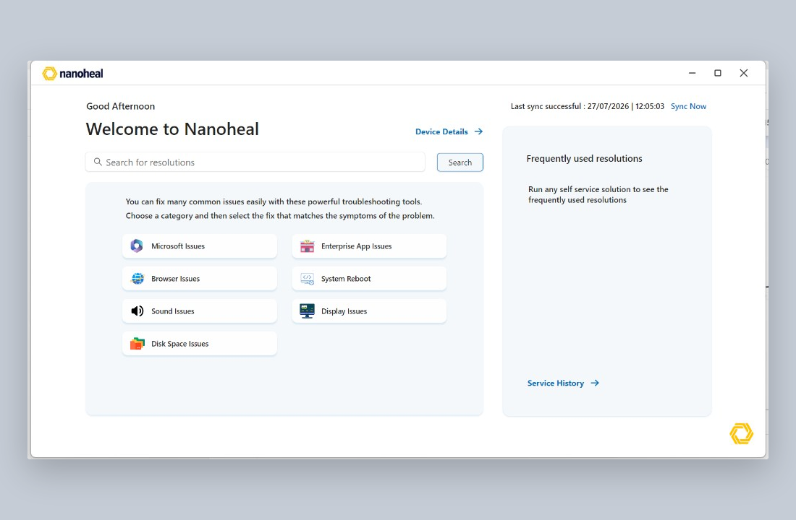
17-chatbot-widget.png

