Windows Client UI Walkthrough
Nanoheal Agent — install + post-install screens
Chat entry aligned to AEX demo nanoheal-agent-chat (AI Assist)
Source demo: AEX/aex-V1.2/demo/nanoheal-agent-chat — AI Assist beside Search opens a right-side chat overlay. Landing UI underneath is unchanged.

Installation pages

Prerequisite — System Requirements Verification
Pre-install gate. Runs system checks. Progress bar shows verification state; all green means ready to install.
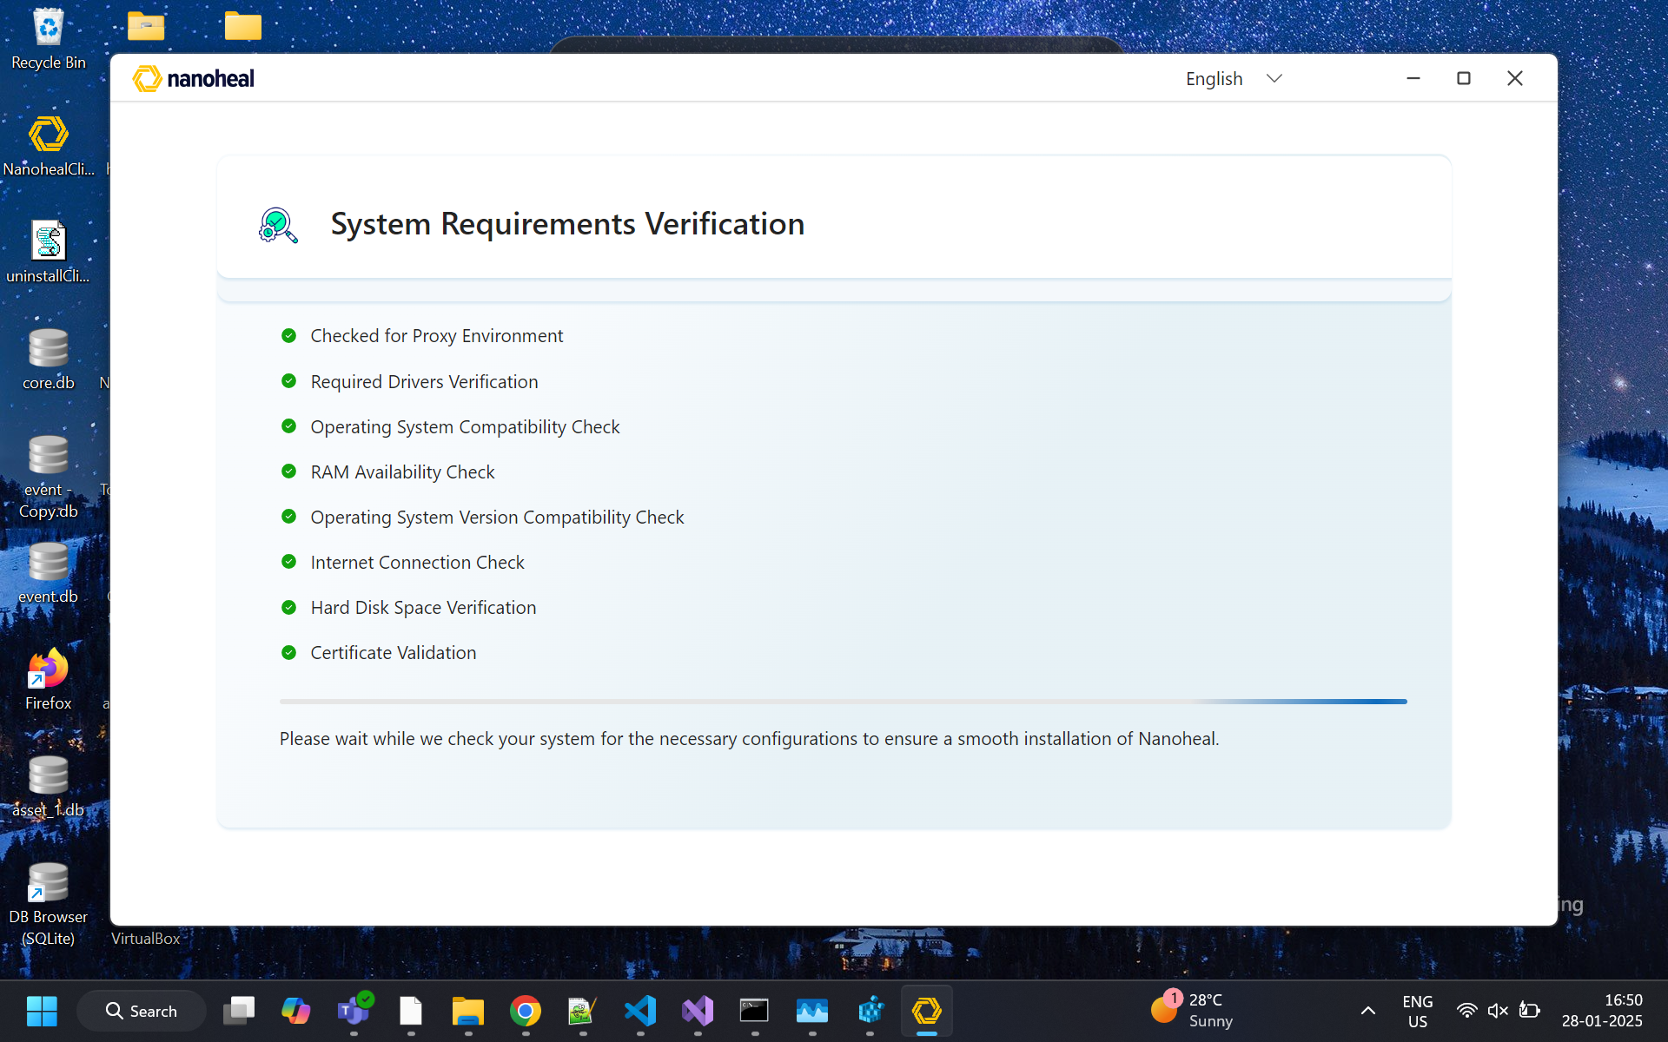
01-prerequisite.png

Acknowledgement — Terms & Install
Legal consent before install. Acknowledge Terms, then Install (or Cancel).
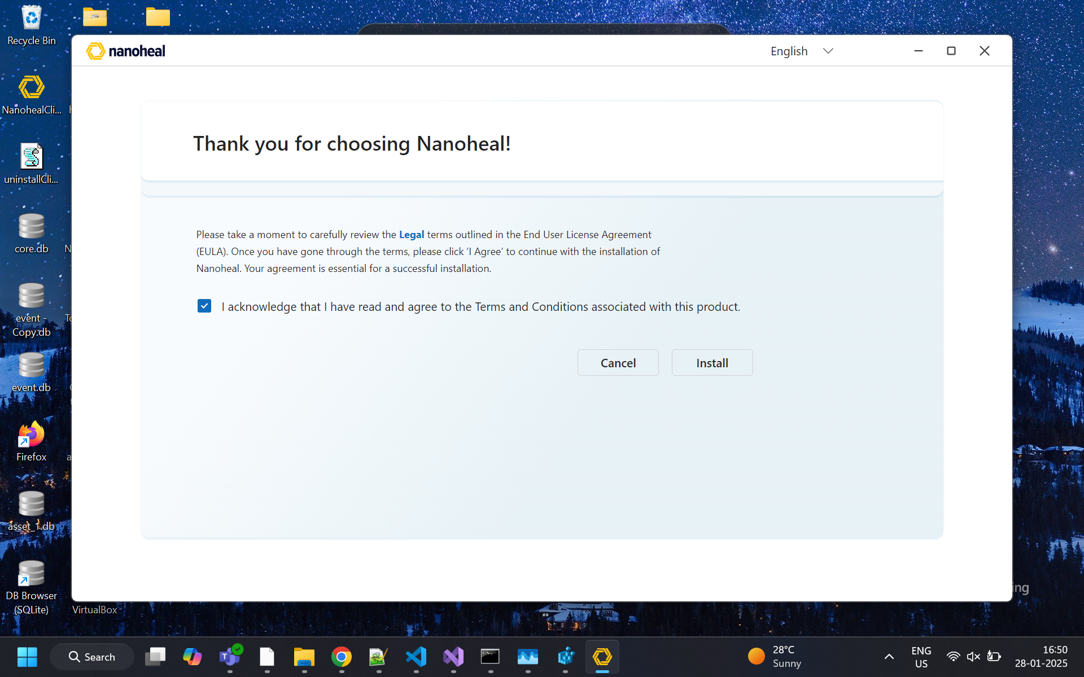
02-acknowledgement.png

Please Wait — Installing
Install progress while packages and services are set up.
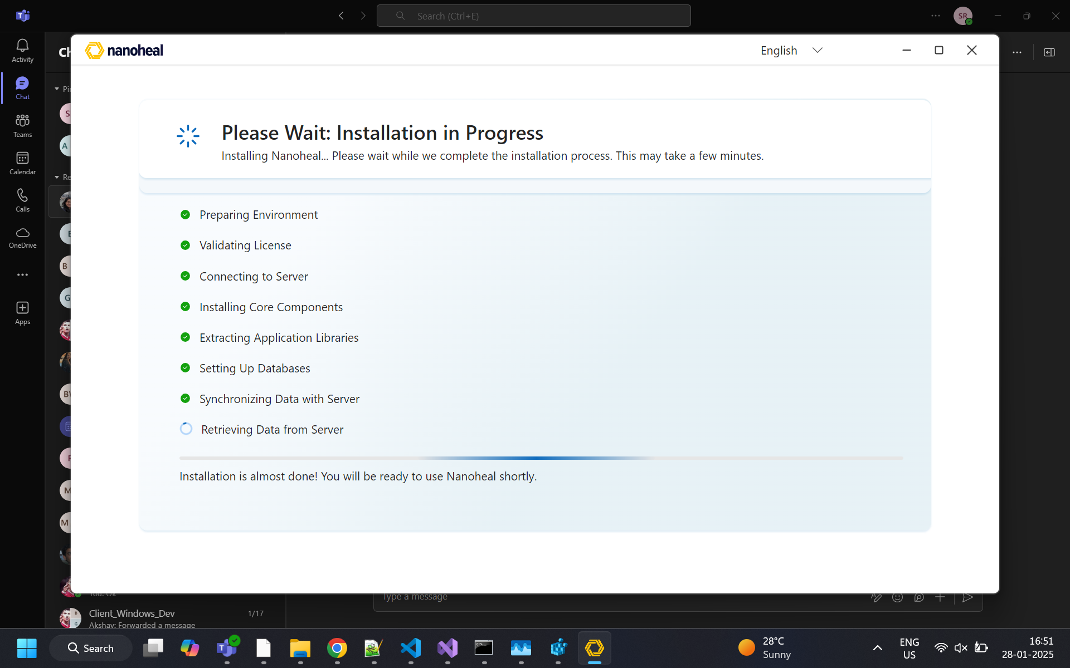
03-please-wait-install.png
[missing: 04-please-wait-install-2.png]

Post-install pages

Landing / Home
Main self-service home: search, category tiles, frequently used resolutions, Device Details, Service History, Sync.
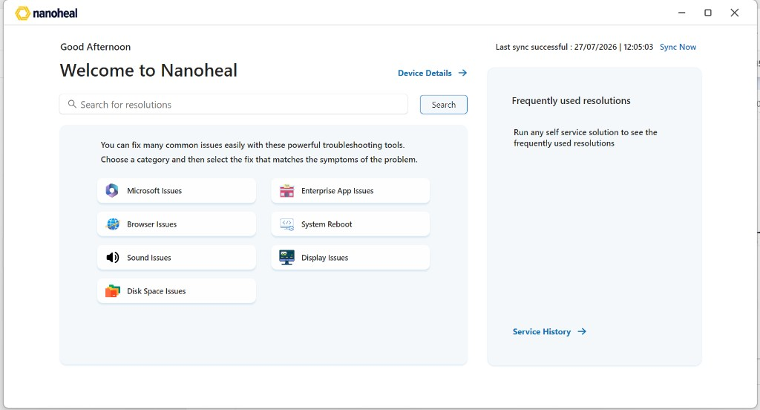
05-landing.png

Device Details
Machine identity and health snapshot for the current device.
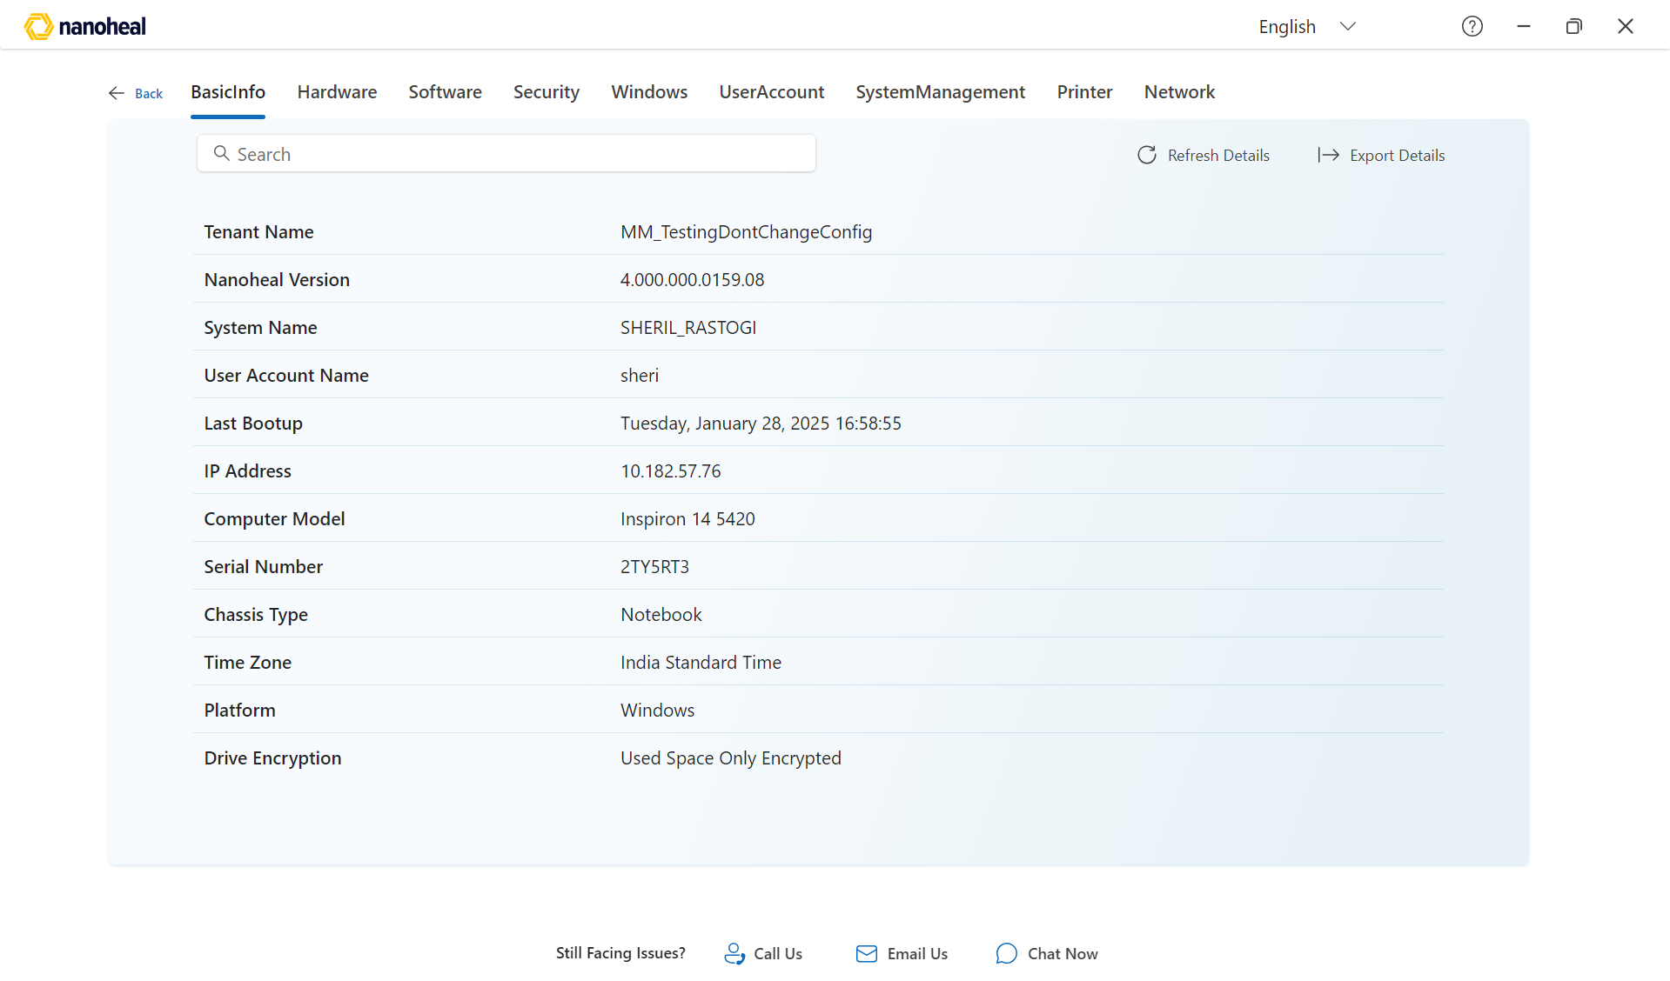
06-device-details.png
[missing: 07-device-details-2.png]

Service History
Past self-service runs and outcomes on this device.
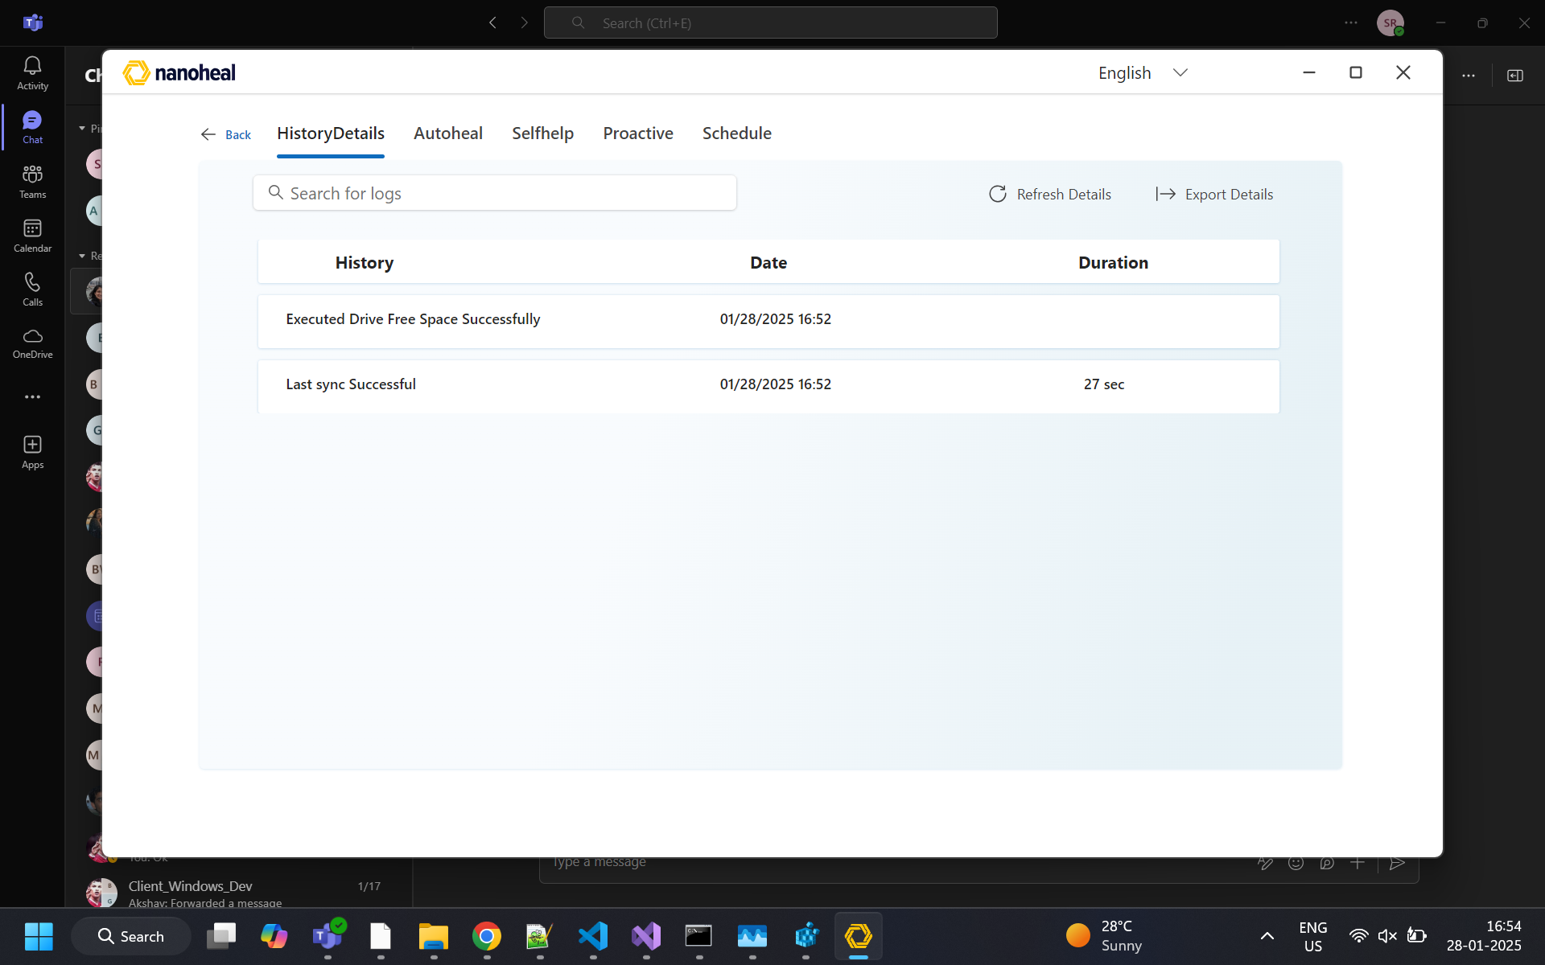
08-service-history.png

Search
Find resolutions by keyword across the catalog.
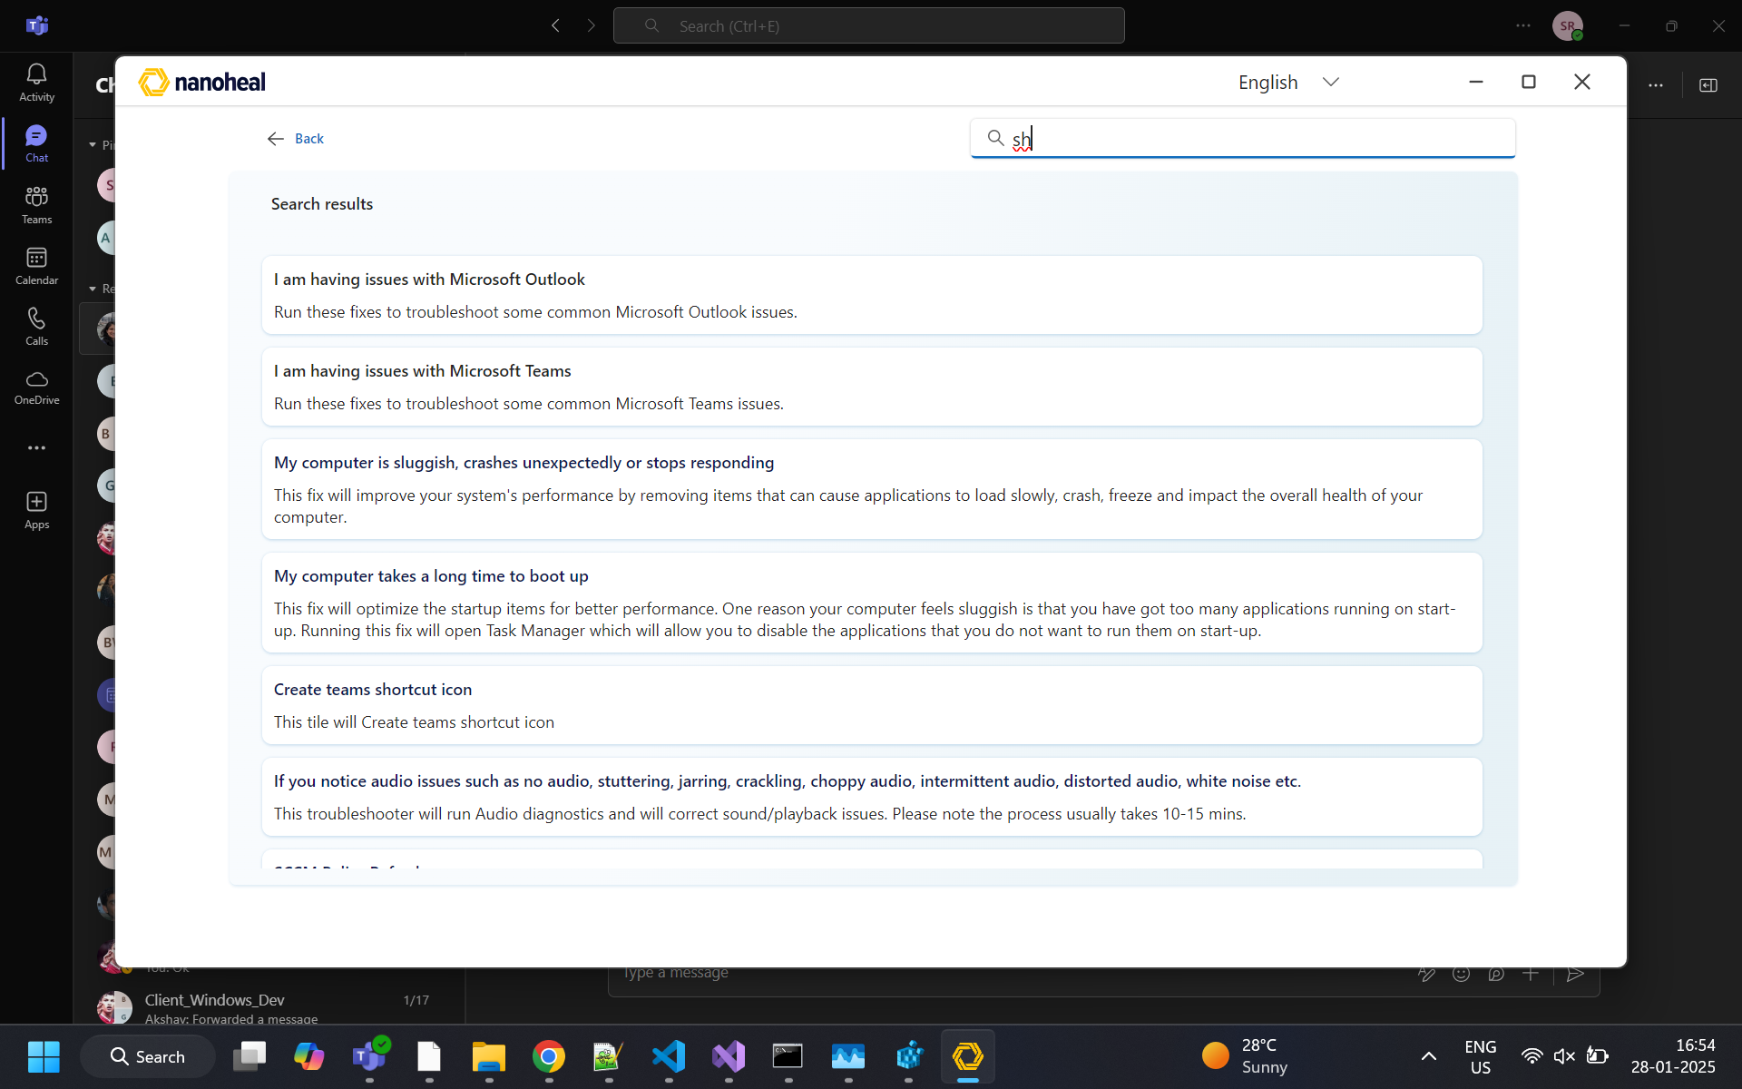
09-search.png

L3 tile — fix detail
Run a specific fix with description and action.
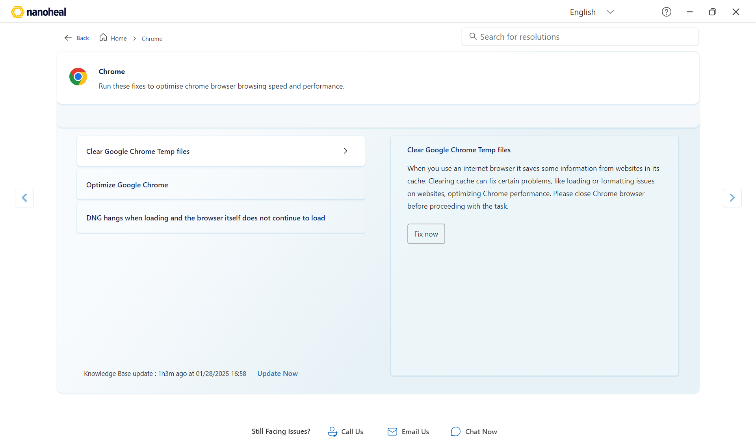
10-l3-tile.png

L2 tile — category
Browse fixes inside a category.
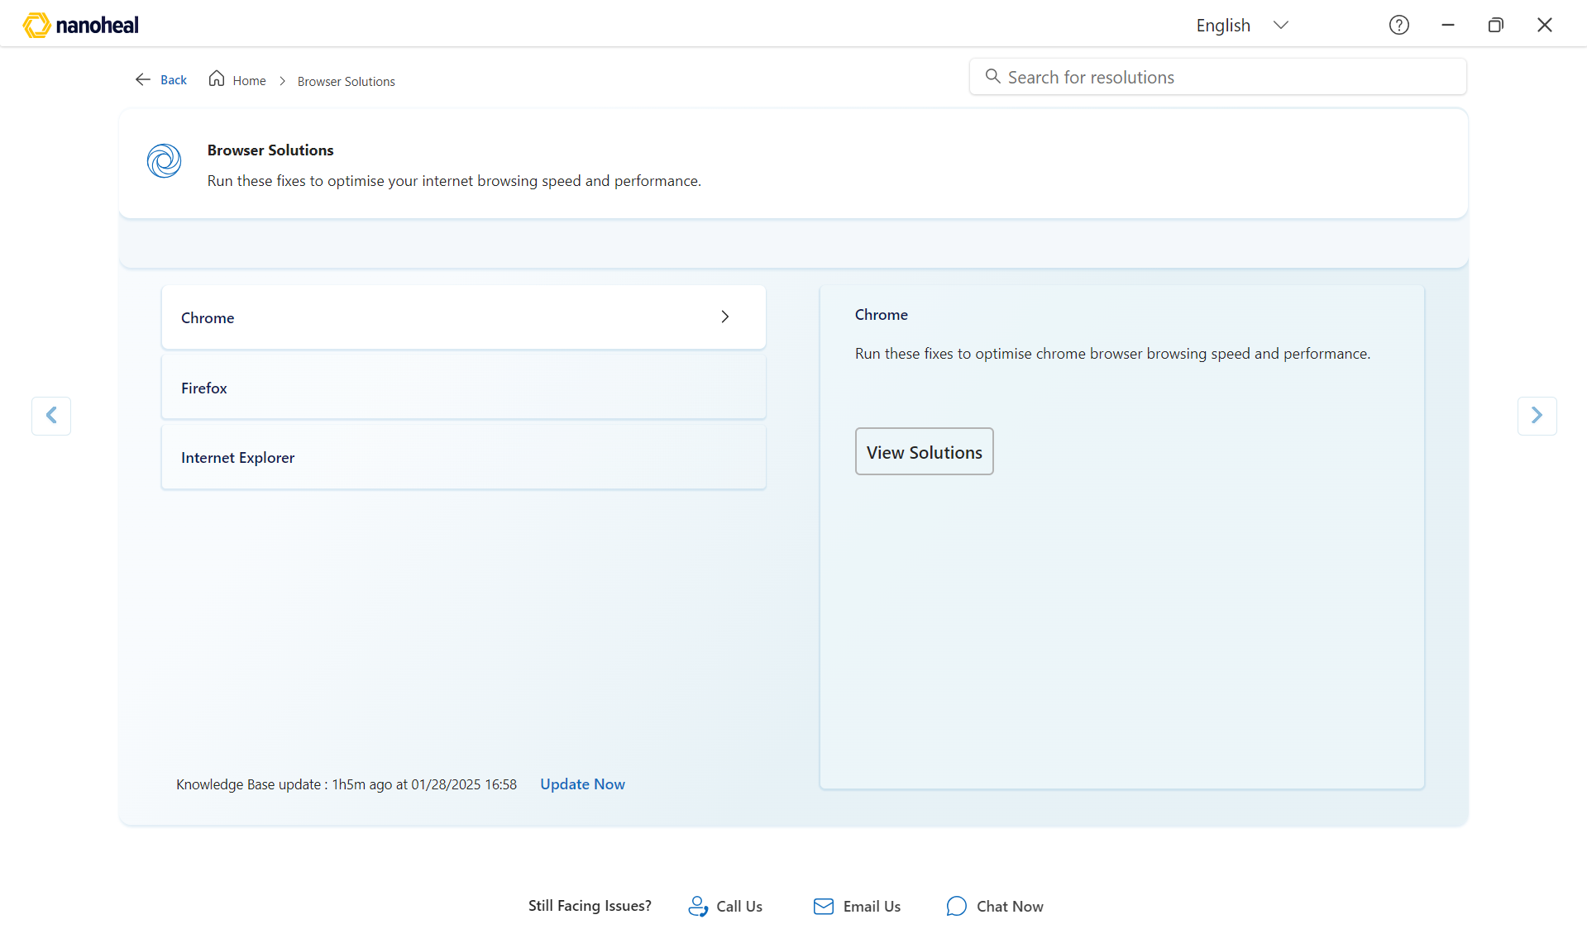
11-l2-tile.png

Support — Call / Email / Chat Now
Footer support entries. Chat Now opens external chat (SSO).
[missing: 12-footer-call.png]
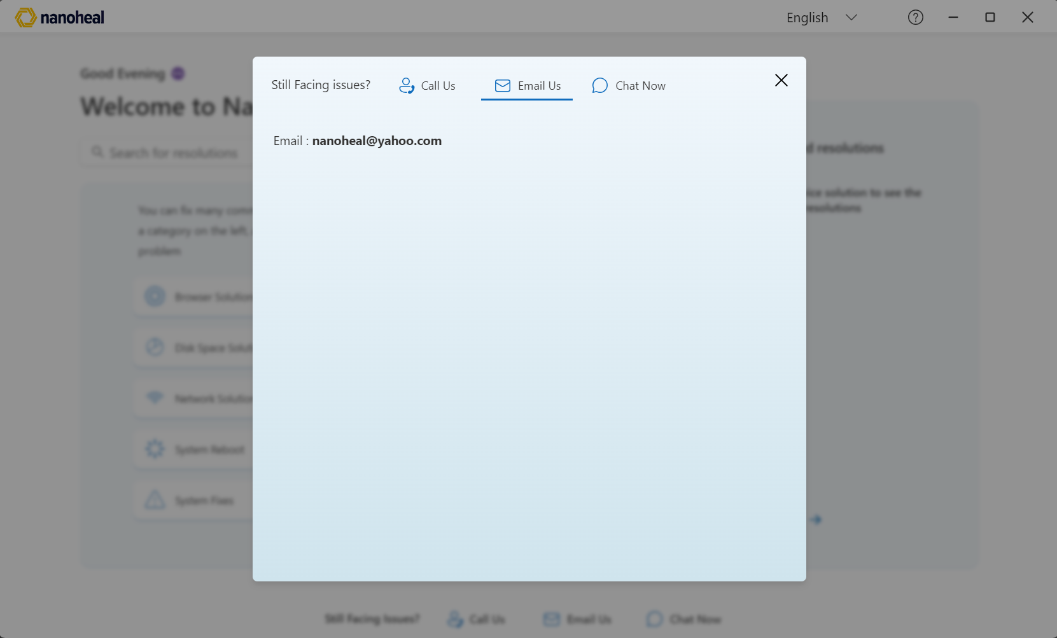
13-footer-email.png
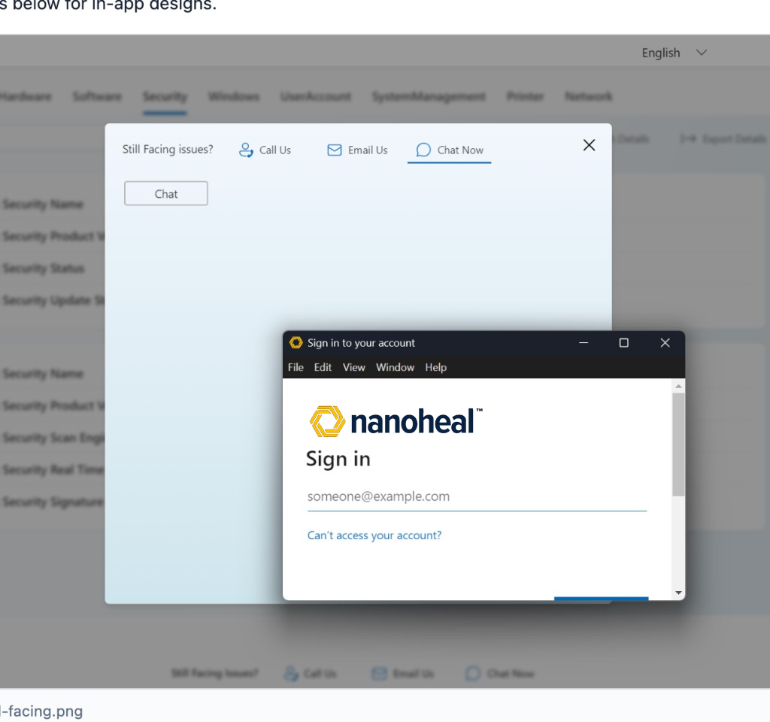
14-footer-still-facing.png

User Survey
Post-fix feedback: stars, outcome chips, optional note.
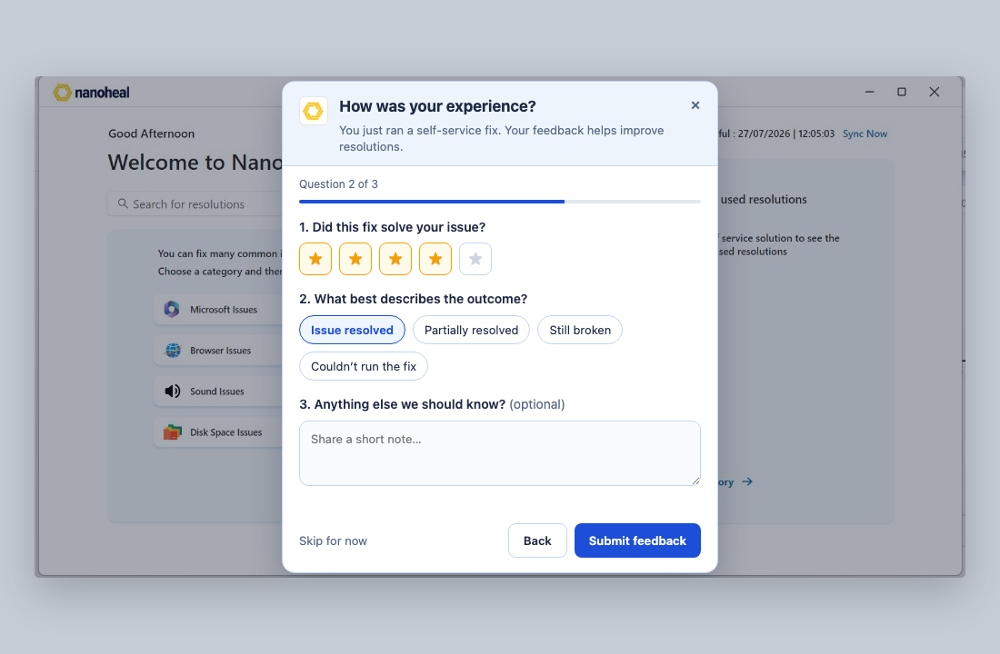
15-user-survey.png

Chat — AI Assist open (AEX demo)
Demo pattern from aex-V1.2/demo/nanoheal-agent-chat: right-side overlay, Nanoheal logo header, greeting Hi. Opens from AI Assist beside Search — not a floating FAB.
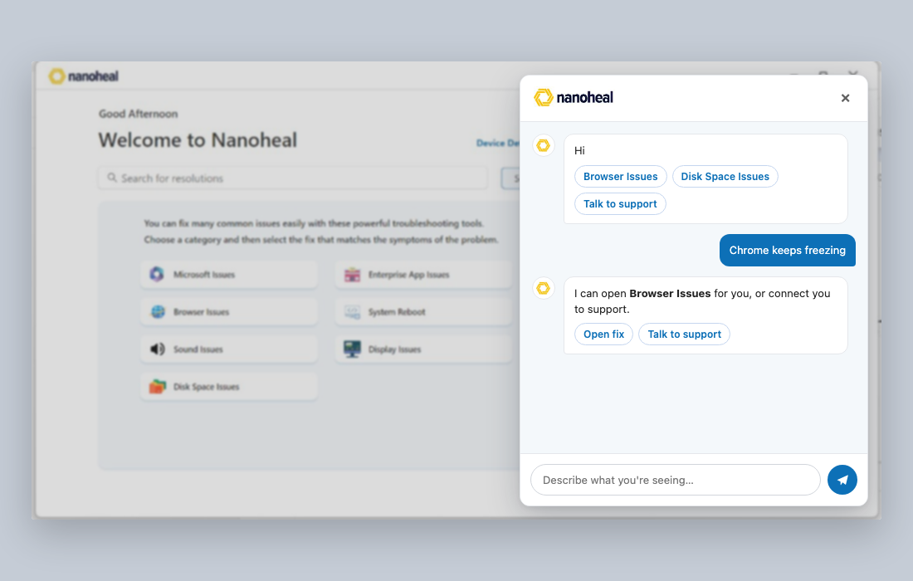
16-chatbot-panel.png

Chat — AI Assist closed (AEX demo)
Closed entry matching the AEX demo: AI Assist outline button next to Search (.nh-ask-ai). Click to open the chat overlay.
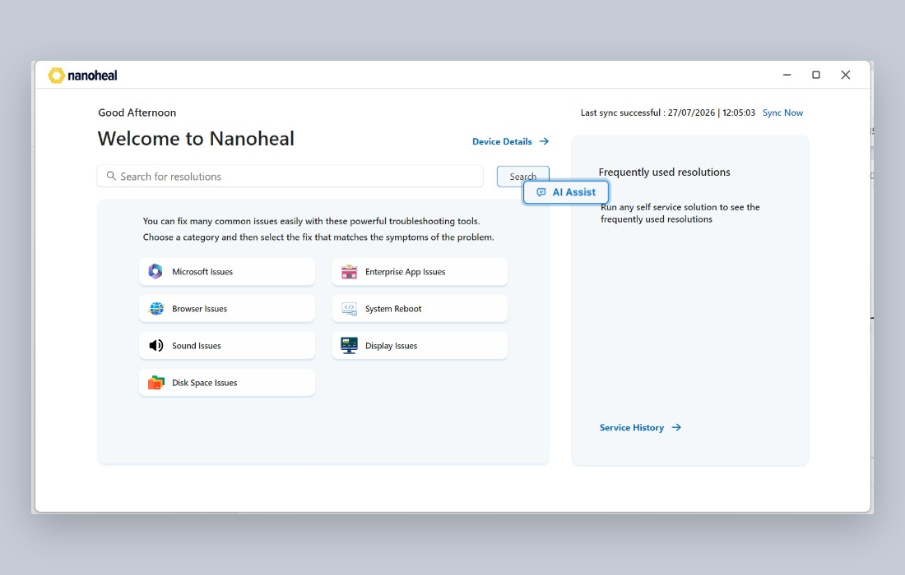
17-chatbot-widget.png

Chat Now — Sign in (Nanoheal)
Microsoft sign-in after Chat Now, shown with Nanoheal logo (ADM removed). Production branding is Entra ID company branding.

18-chat-signin-nanoheal.png

