Windows Client UI — Walkthrough
Survey + chatbot in FAB widget style (same as 1732). Landing unchanged. Greeting: Hi. Nanoheal only.

How the product works (user journey)
1. Install — Prerequisite checks → Acknowledgement → Please Wait.
2. Home — Search or open a category tile; run a fix.
3. Device / History — Device Details and Service History when needed.
4. Still stuck? — Call, Email, or Chat from Still Facing Issues? (or the floating Nanoheal chat icon).
5. Feedback — optional survey after a fix.

Installation pages

Prerequisite — System Requirements Verification
What this module is: Pre-install gate for system readiness.
What the user can do: Wait for checks; proceed when green.
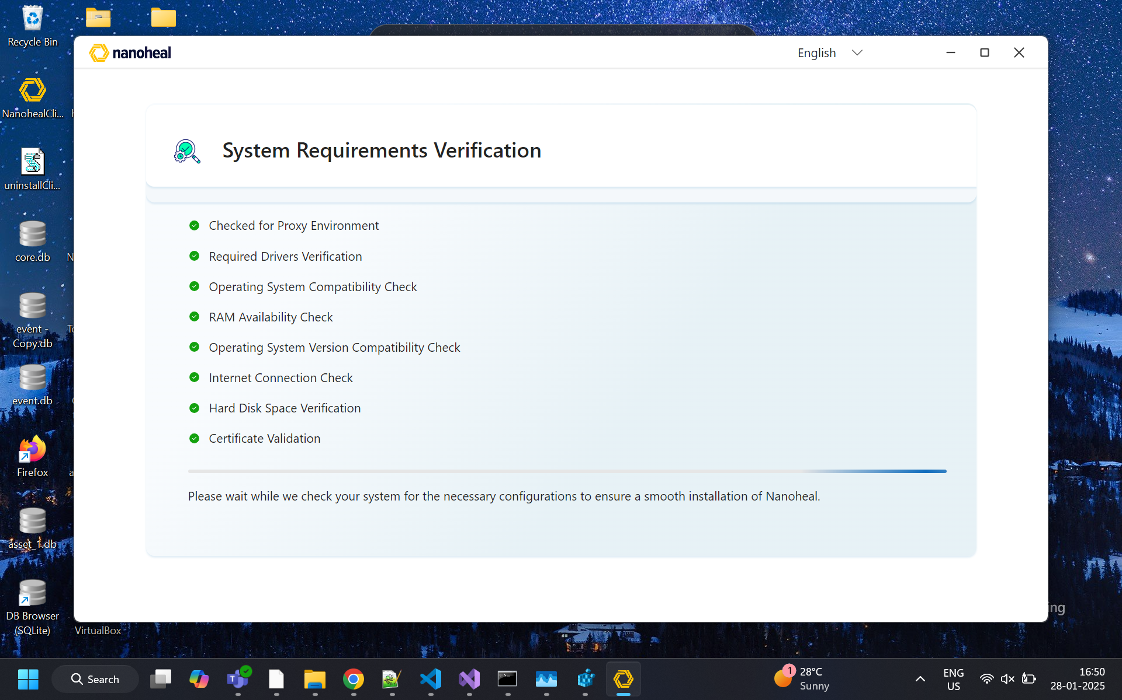
01-prerequisite.png

Acknowledgement — Terms & Install
What this module is: Legal consent before install.
What the user can do: Accept Terms, Install or Cancel.
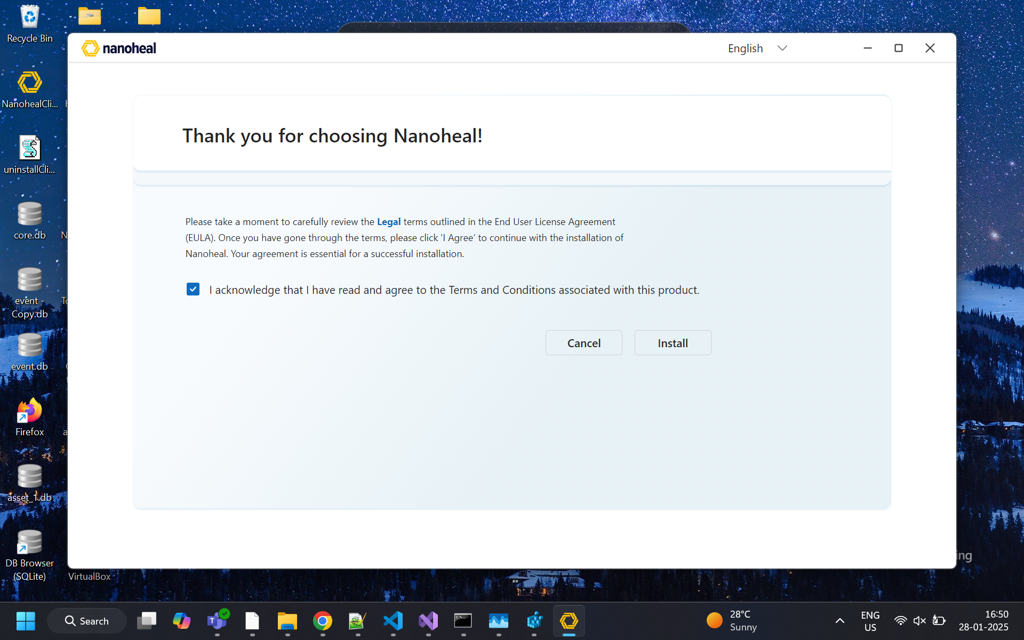
02-acknowledgement.png

Please Wait — Installing
What this module is: Install progress.
What the user can do: Wait until setup finishes.
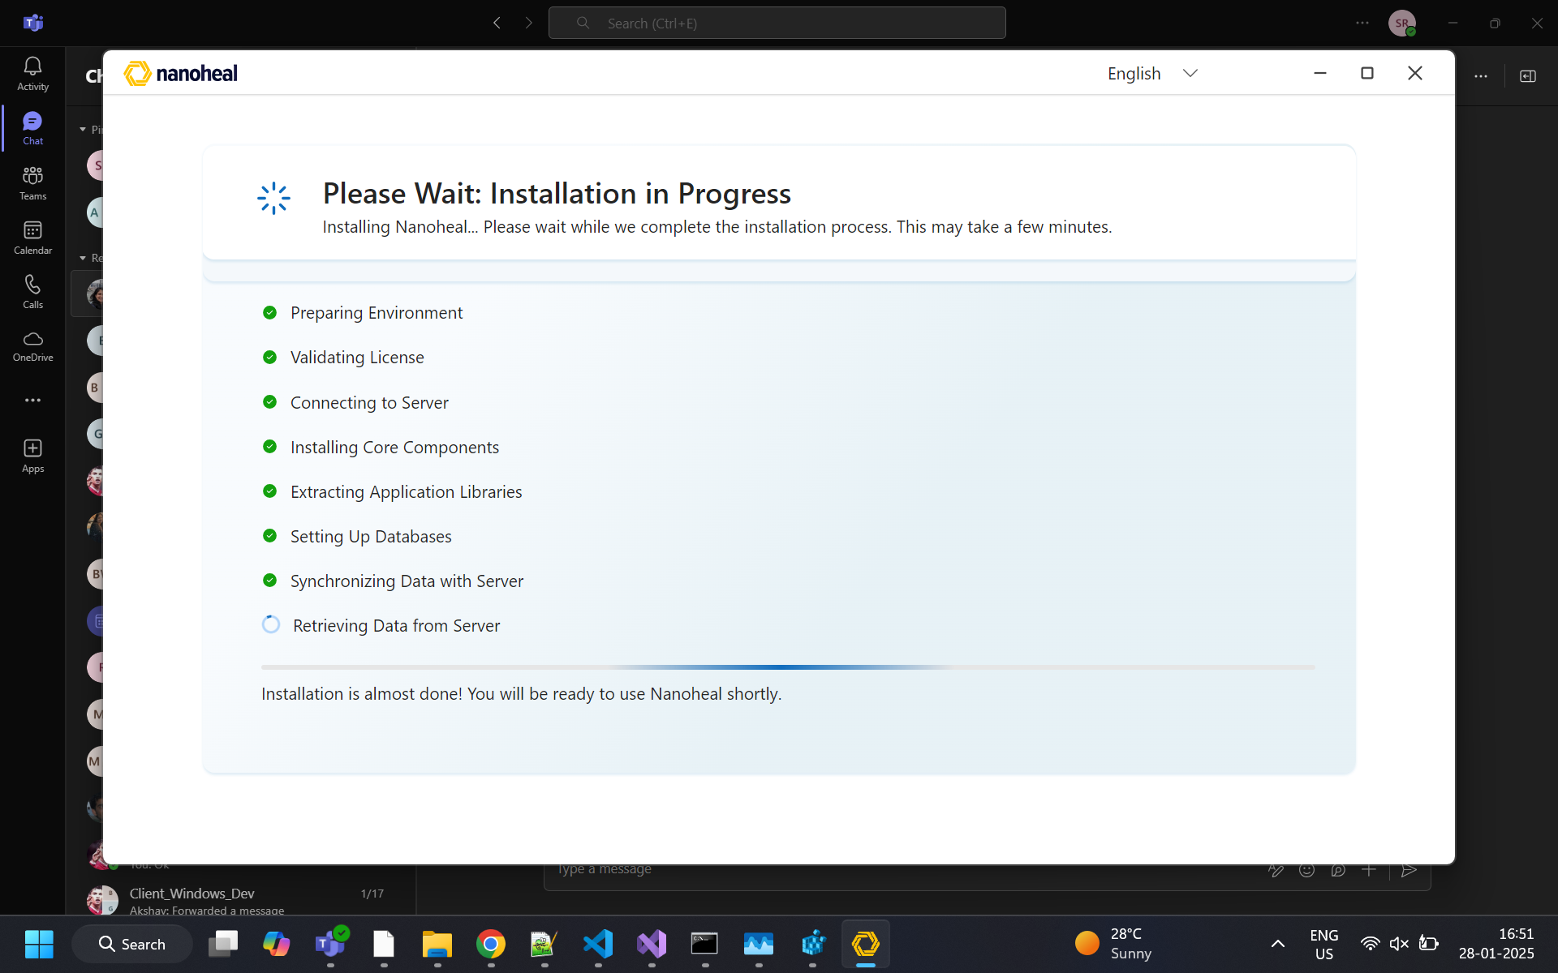
03-please-wait-install.png
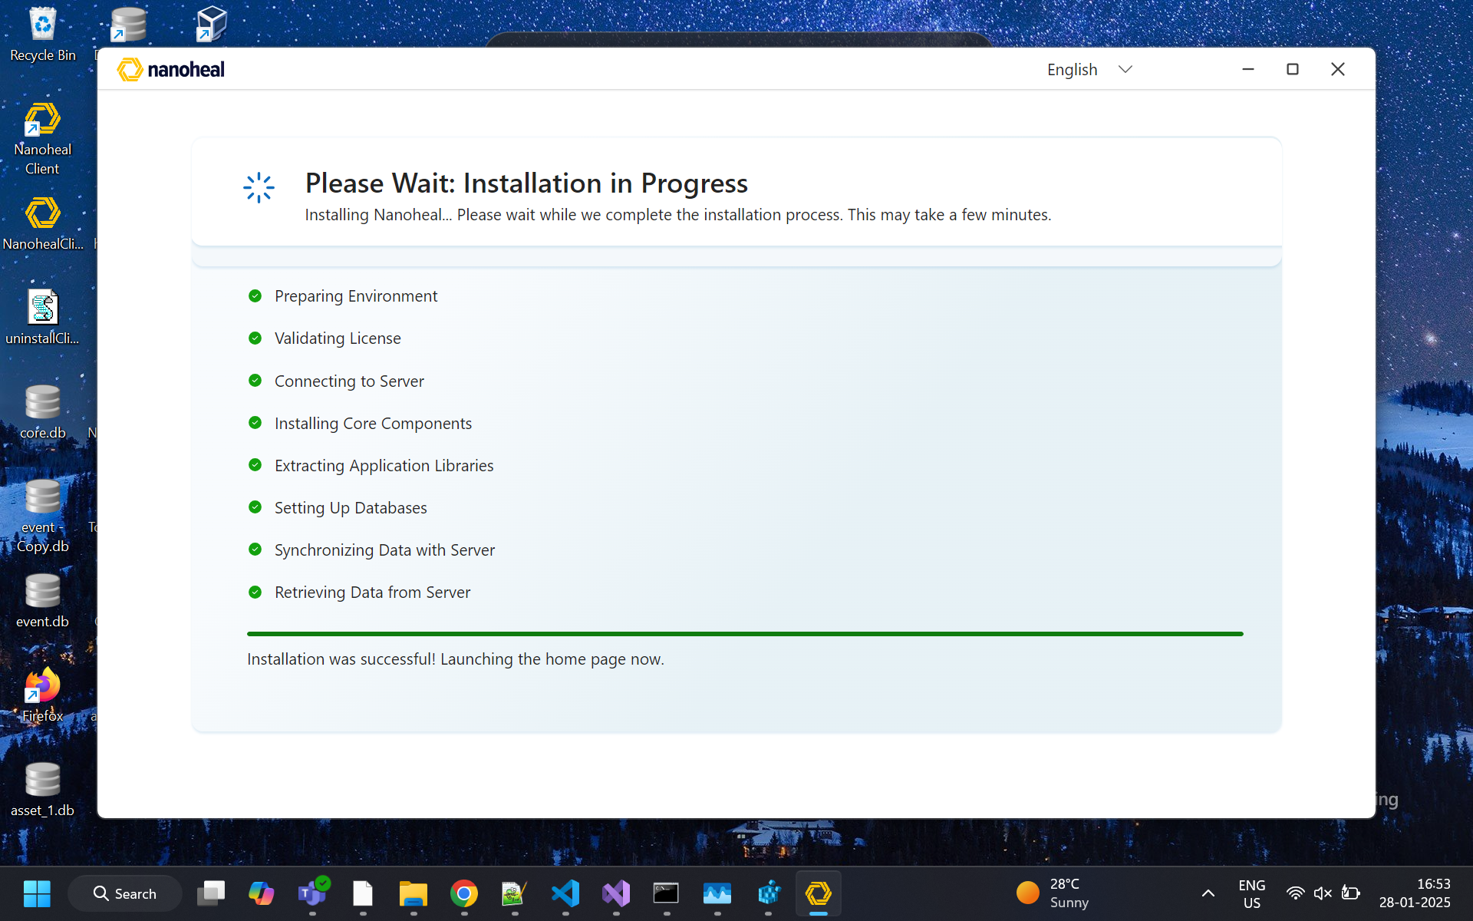
04-please-wait-install-alt.png

Post-install pages

Landing / Home
What this module is: Main self-service hub.
What the user can do: Search; open category tiles; Device Details; Service History; Sync.
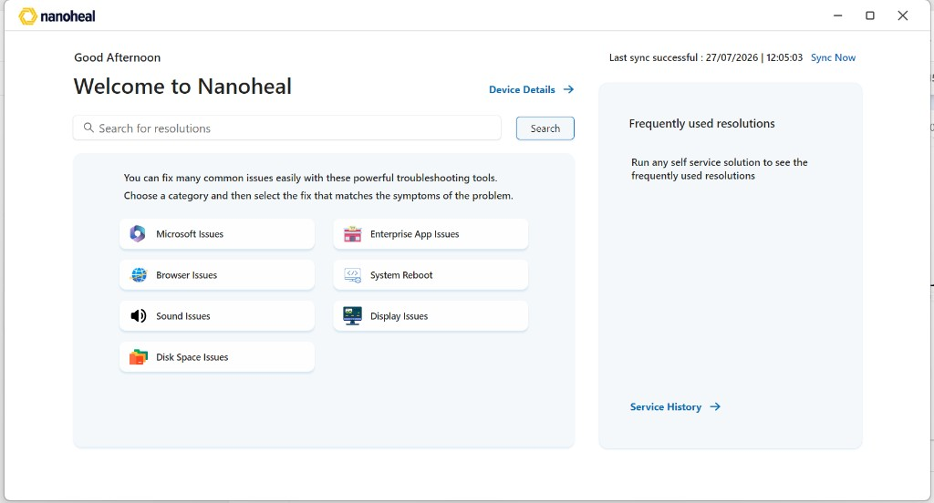
05-landing.png

Device Details
What this module is: Machine identity and health snapshot.
What the user can do: Review device fields; return Home.
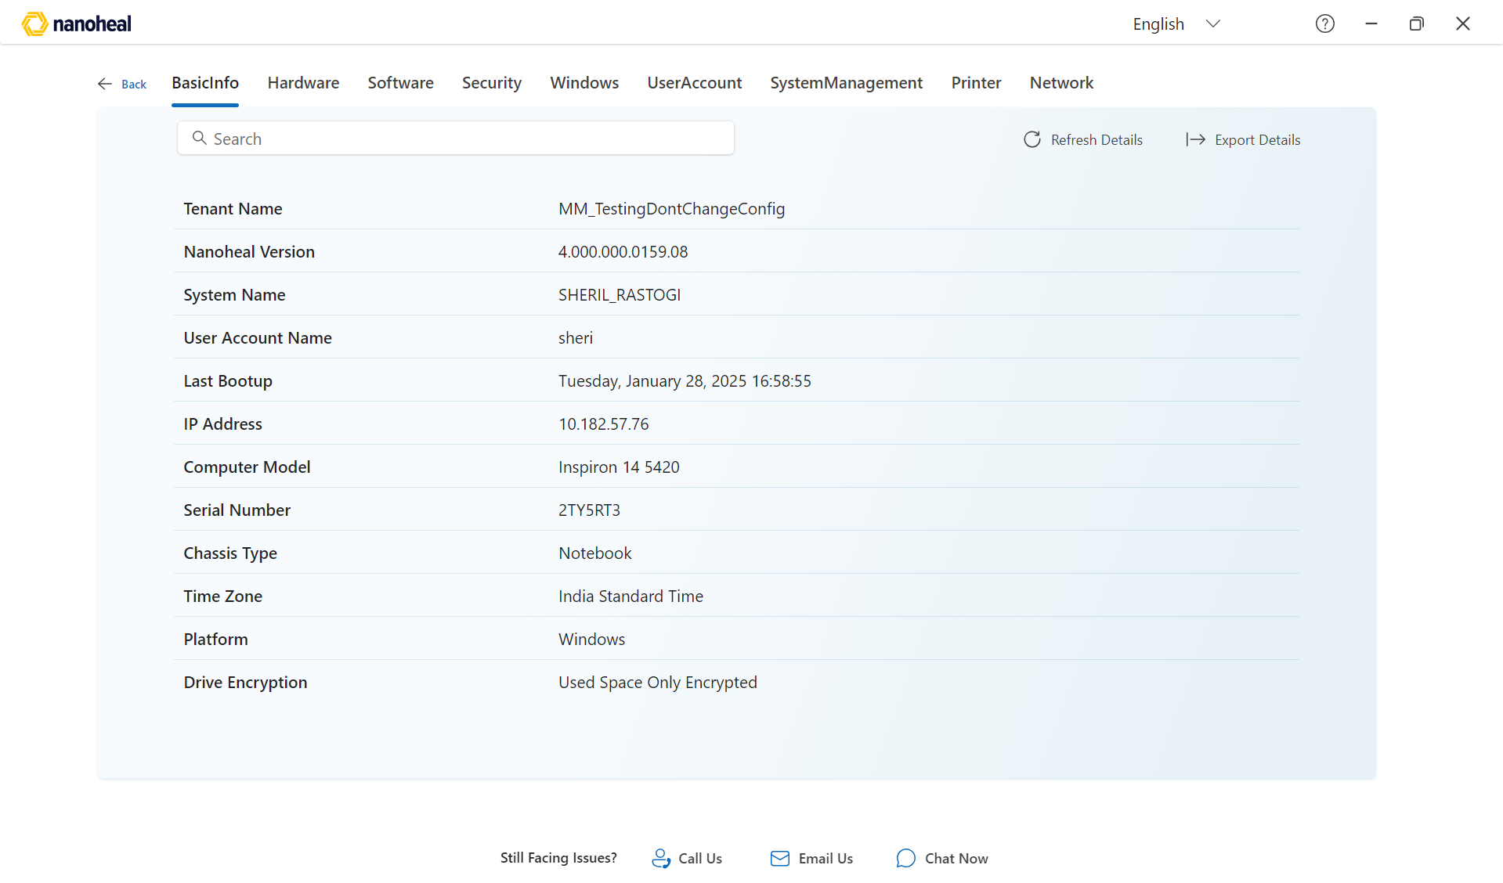
06-device-details.png
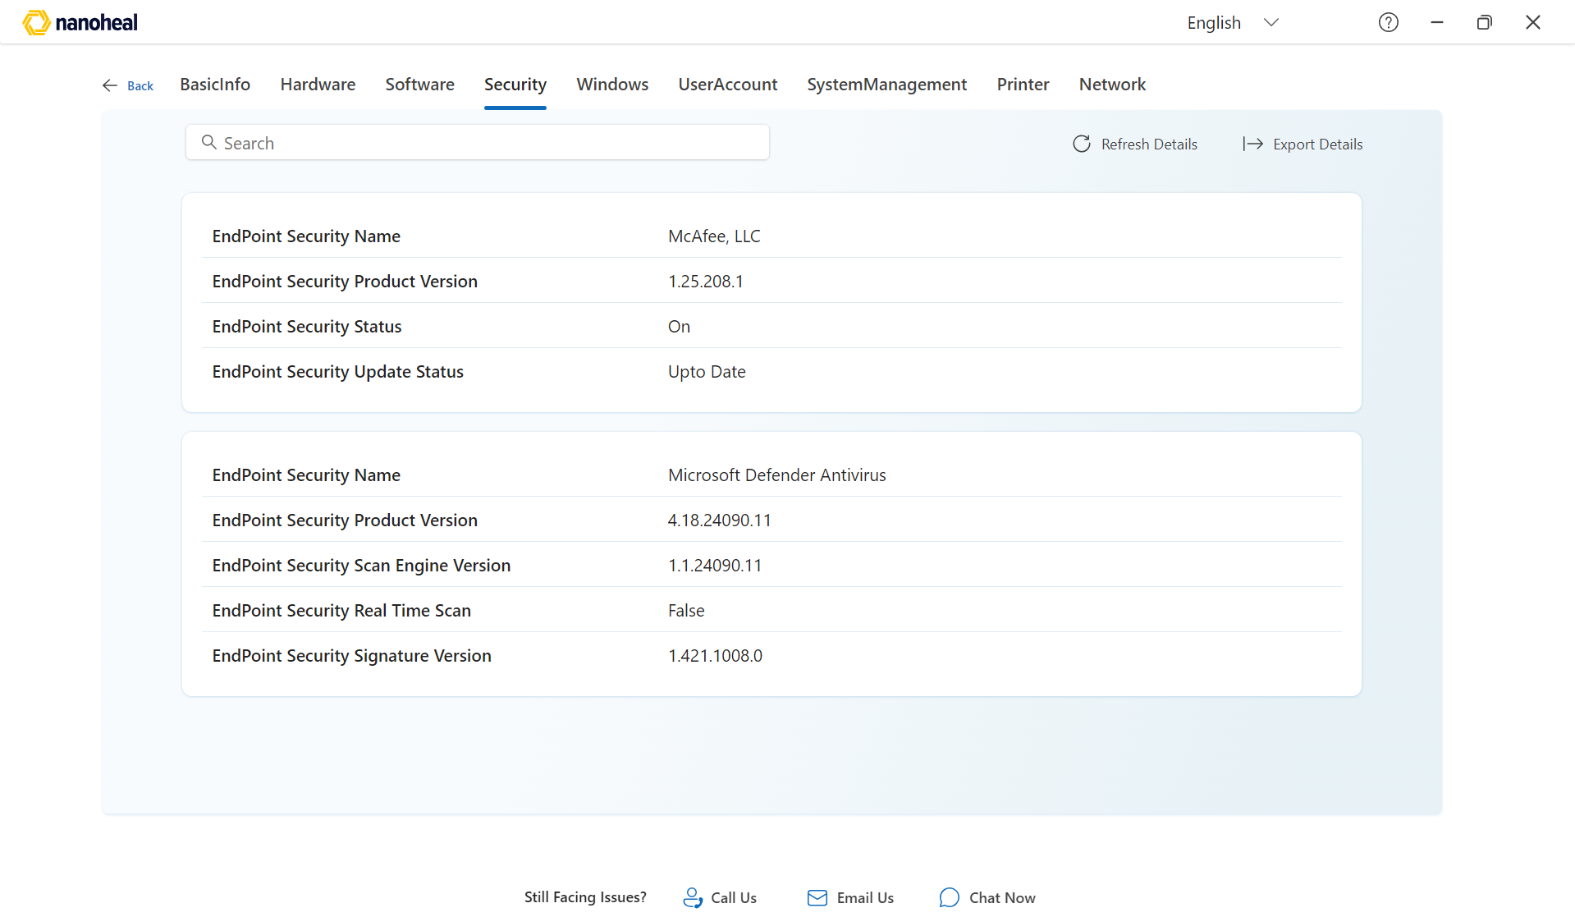
07-device-details-alt.png

Service History
What this module is: Past self-service runs on this device.
What the user can do: Browse history; reopen a past fix if available.
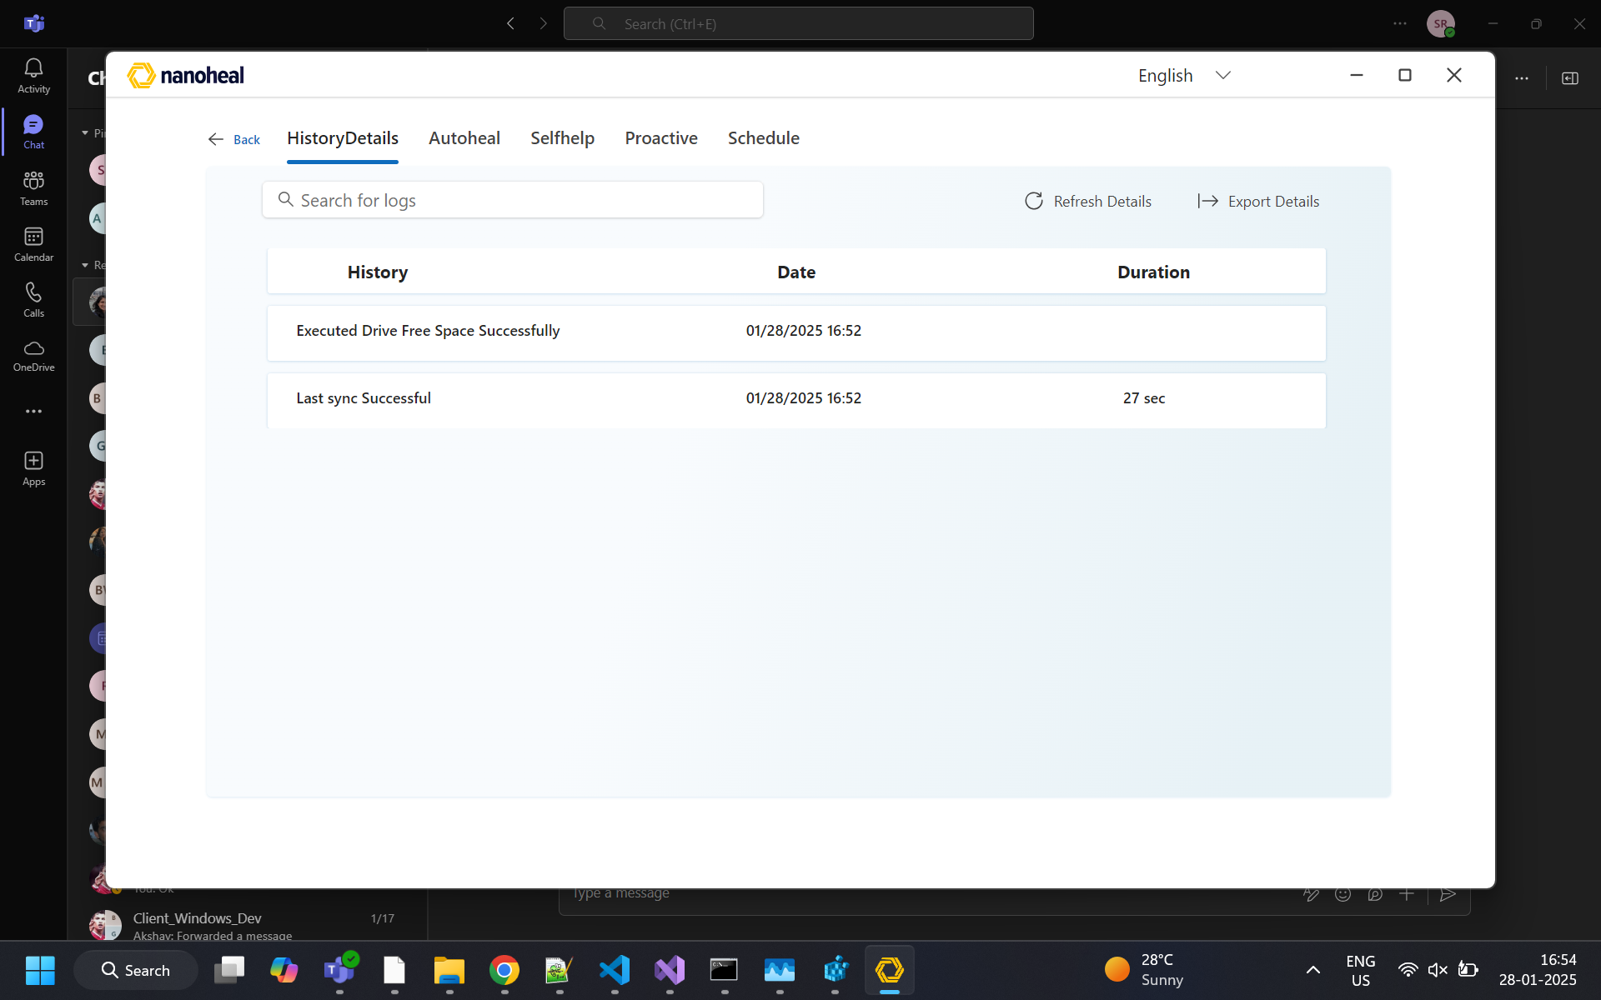
08-service-history.png

Search
What this module is: Keyword search across resolutions.
What the user can do: Type a query; open a result.
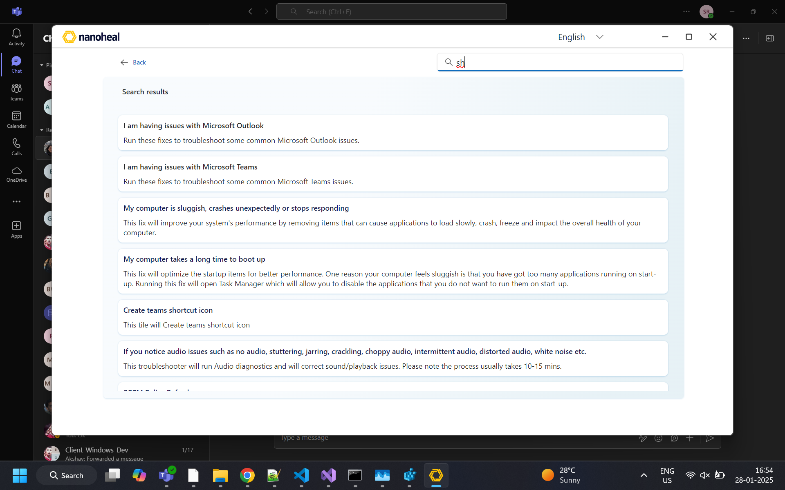
09-search.png

L3 tile — fix detail
What this module is: Specific fix with run action.
What the user can do: Read description; run the fix.
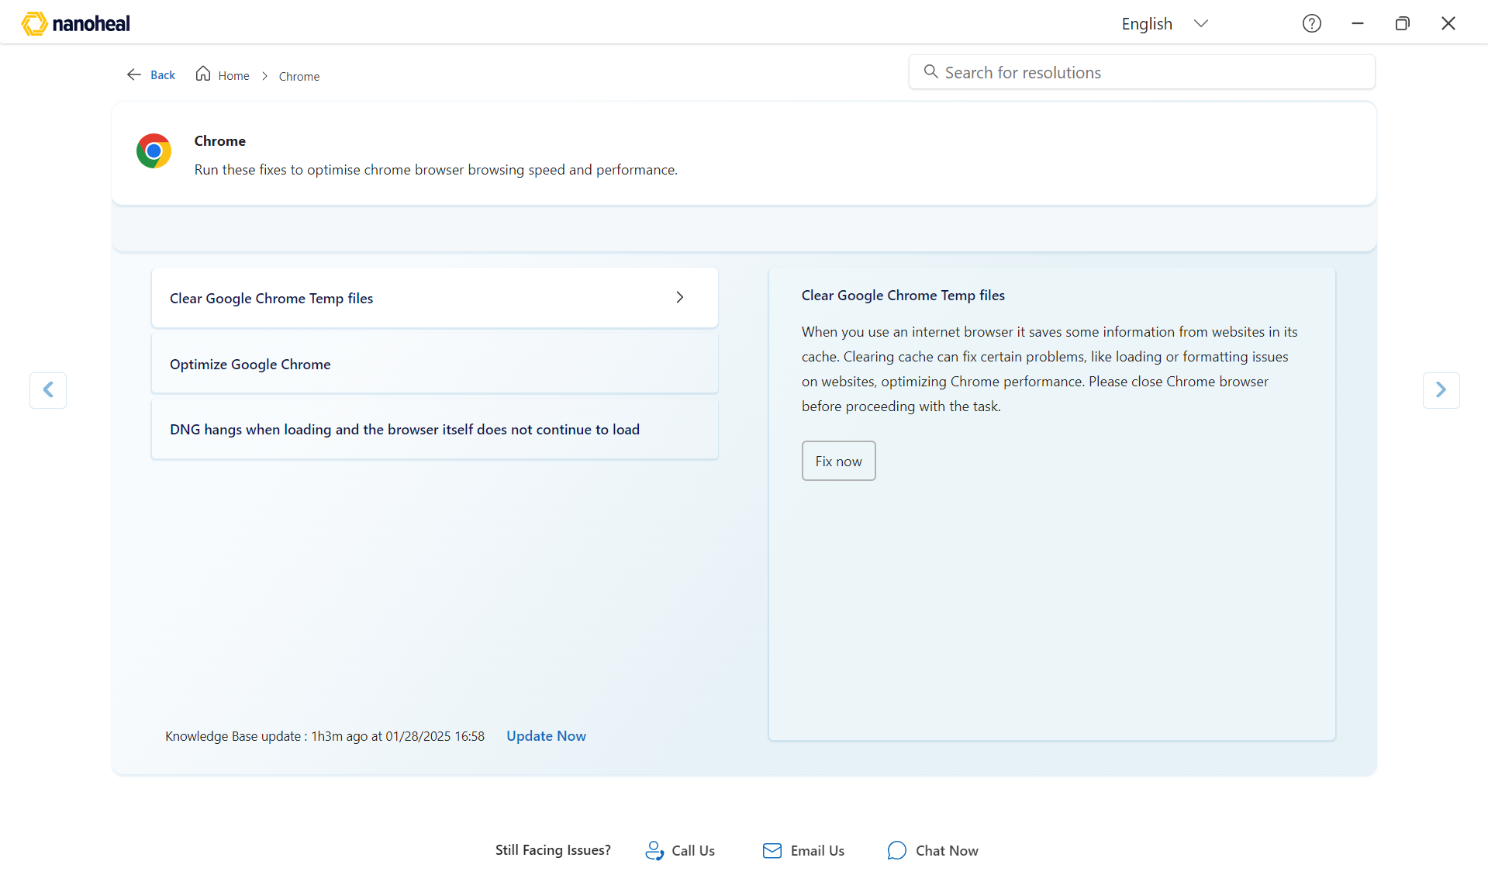
10-l3-tile.png

L2 tile — category
What this module is: Category browse of related fixes.
What the user can do: Pick a fix inside the category.
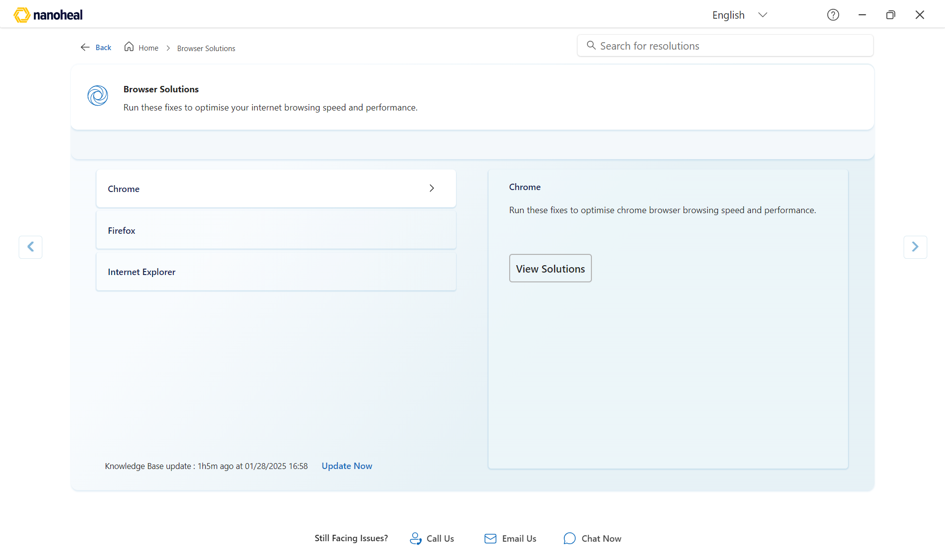
11-l2-tile.png

Support footer

Call Us
What this module is: Phone support entry.
What the user can do: Open Call Us; pick region; dial.
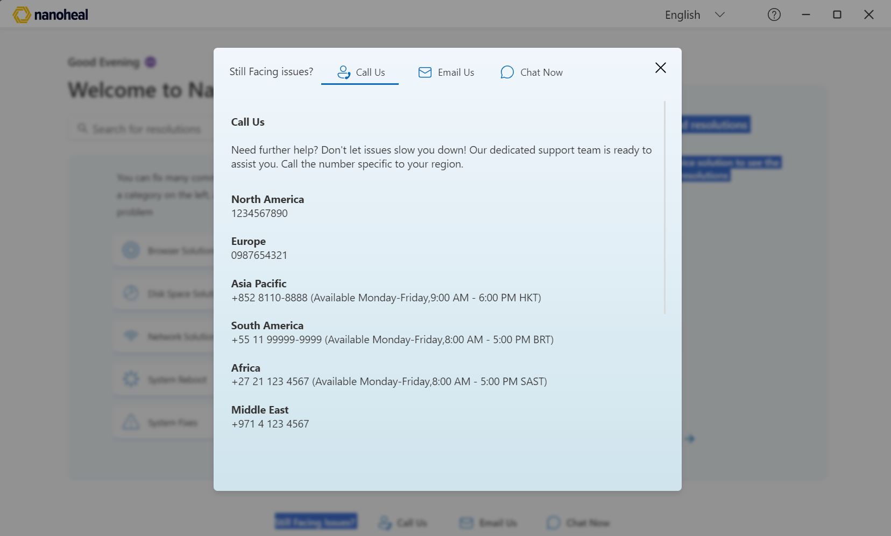
12-footer-chat-phone.png

Email Us
What this module is: Email support entry.
What the user can do: Open Email Us; contact support.
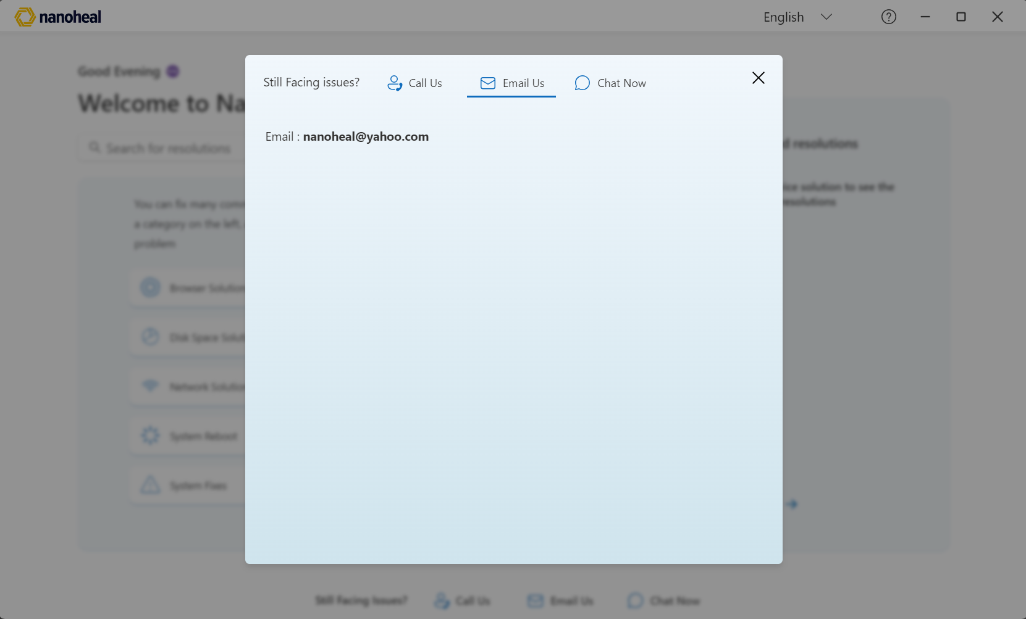
13-footer-email.png

Chat Now — Sign in (Nanoheal logo — ADM removed)
What this module is: After Chat Now, Microsoft sign-in. ADM replaced with Nanoheal.
What the user can do: Enter work email; continue SSO.
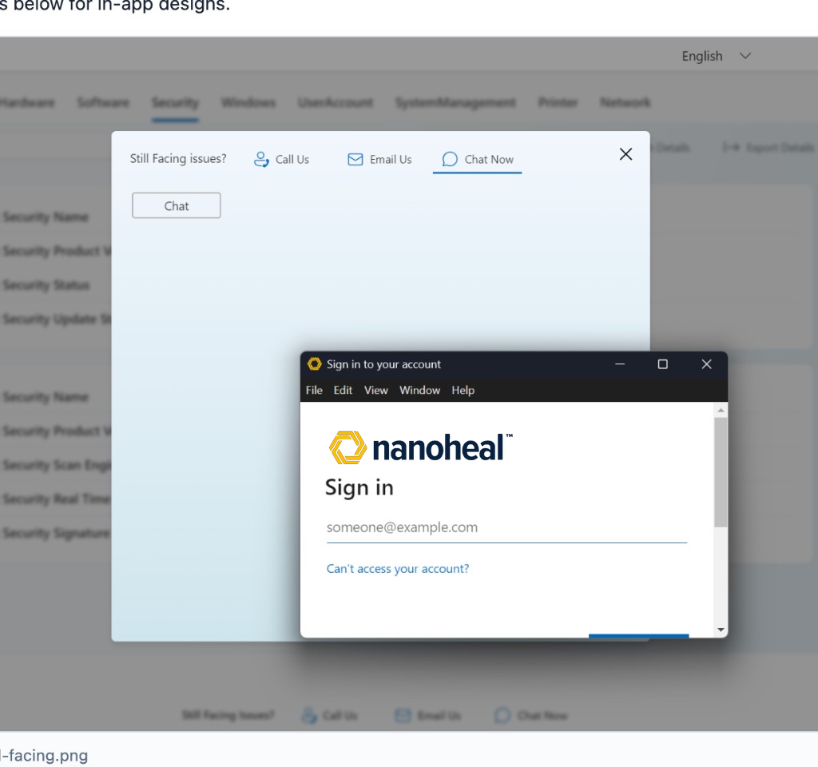
14-footer-still-facing.png

18-chat-signin-nanoheal.png

Survey & chat widget

User Survey
What this module is: Post-fix feedback modal over Home (landing unchanged). Same chrome as chat (Nanoheal icon, brand blue).
What the user can do: Rate the fix, pick outcome, optional note, Submit / Skip / Back.
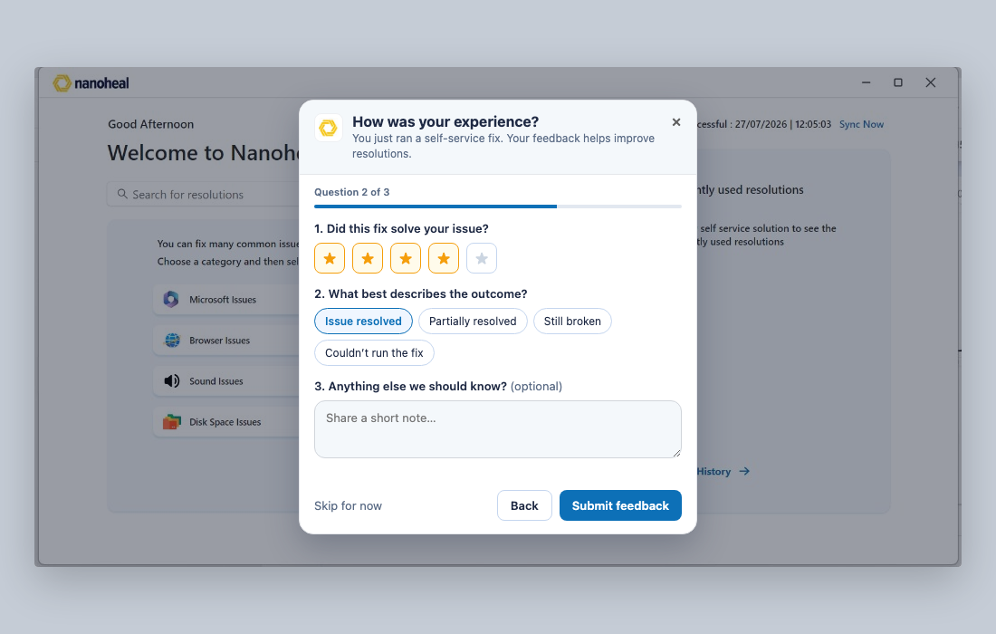
15-user-survey.png

Chatbot — open
What this module is: Bottom-right WidgetIframe panel (340×80vh). Nanoheal + Online. Greeting Hi.
What the user can do: Chat from bottom-right panel; quick chips; Open fix / Talk to support. Nanoheal icon FAB (no blue circle).
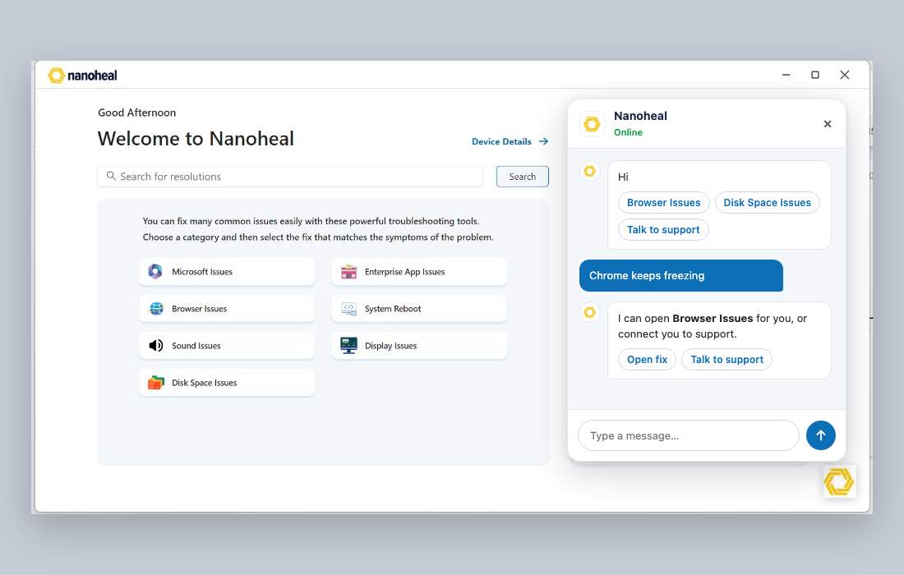
16-chatbot-panel.png

Chatbot — FAB closed
What this module is: Closed launcher — Nanoheal hexagon bottom-right only.
What the user can do: Click Nanoheal hexagon (bottom-right) to open chat.
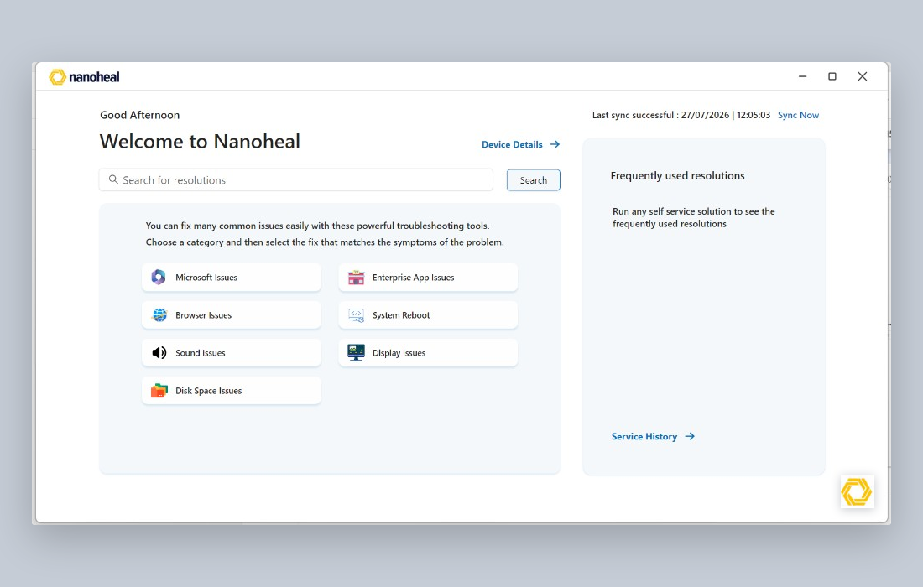
17-chatbot-widget.png

