Data-driven journalism on social media

**a content analysis by Kira Schacht, DW Data**

Many newsrooms have, in recent years, understood that social media platforms offer more than just a place to paste links to. They can be an opportunity for new and different ways of storytelling that reaches audiences where they already spend their time. Our team at DW Data has received a grant this year to explore specifically how data-driven stories can be conveyed on social media.

In the course of this project, we analyzed the social media channels of six media organizations and individual journalists to understand how other media organizations already present their data-driven work. We’ll use these findings to build a concept of what works for us, and what might work for others in the future.

# **1 Methodology and scope of the analysis**

We analyzed two weeks’ worth of posts on the Facebook, Twitter, Instagram and Youtube channels of the following accounts:

* [BBC](https://www.bbc.com/), since they are the biggest competitor of DW.
* [Buzzfeed News US](https://www.buzzfeednews.com/), because they cater to a younger audience.
* [Axios](https://www.axios.com/), a newer outlet that focuses on brevity.
* [Vox](https://www.vox.com/), who focus on background stories that often have a data component.

We also included two accounts by individual journalists to see what we can learn from how individuals tell data-driven stories:

* [Jon Schwabisch](https://policyviz.com/), a data visualization specialist.
* [Mona Chalabi](https://monachalabi.com/), who heads the Guardian US data team.

## 1.1 Sample size

We scraped at least two weeks’ worth of posts per account and platform, making sure that at least 20 posts from each account were analyzed. The frequency of posts varies greatly across pages and platforms. These are the sample sizes and time frames we ended up with:

|  |  |  |  |  |
| --- | --- | --- | --- | --- |
| platform | page | nr of posts | start date | end date |
| Facebook | [Axios](https://www.facebook.com/axiosnews/) | 377 | 09.09.19 | 22.09.19 |
| [BBC News](https://www.facebook.com/bbcnews/) | 421 | 01.03.19 | 16.03.19 |
| [BuzzFeed News](https://www.facebook.com/BuzzFeedNews/) | 267 | 09.09.19 | 22.09.19 |
| [Vox](https://www.facebook.com/Vox/) | 482 | 09.09.19 | 22.09.19 |
| Twitter | [axios](https://twitter.com/axios) | 774 | 16.07.19 | 30.07.19 |
| [BBCWorld](https://twitter.com/BBCWorld) | 427 | 16.07.19 | 30.07.19 |
| [BuzzFeed News](https://twitter.com/BuzzFeedNews) | 830 | 16.07.19 | 30.07.19 |
| [jschwabish](https://twitter.com/jschwabish) | 66 | 17.07.19 | 30.07.19 |
| [MonaChalabi](https://twitter.com/MonaChalabi) | 20 | 17.07.19 | 30.07.19 |
| [voxdotcom](https://twitter.com/voxdotcom) | 721 | 16.07.19 | 30.07.19 |
| Instagram | [axios](https://www.instagram.com/axios/) | 20 | 28.06.19 | 29.07.19 |
| [bbcnews](https://www.instagram.com/bbcnews/) | 63 | 16.07.19 | 29.07.19 |
| [buzzfeednews](https://www.instagram.com/buzzfeednews/) | 81 | 16.07.19 | 29.07.19 |
| [monachalabi](https://www.instagram.com/monachalabi/) | 21 | 08.04.19 | 26.07.19 |
| [voxdotcom](https://www.instagram.com/voxdotcom/) | 20 | 02.07.19 | 29.07.19 |
| YouTube | [Axios](https://www.youtube.com/channel/UCfU4-ArXuSX0tpyApyklMAg) | 20 | 09.02.19 | 24.06.19 |
| [BBC News](https://www.youtube.com/user/bbcnews) | 67 | 16.07.19 | 29.07.19 |
| [BuzzFeed](https://www.youtube.com/user/BuzzFeed) | 20 | 12.06.19 | 28.07.19 |
| [Vox](https://www.youtube.com/user/voxdotcom) | 20 | 20.06.19 | 29.07.19 |

## 1.2 Codebook

While we scraped the post metadata (link, timestamps, text and some performance indicators like likes/retweets/views etc.), the actual content analysis was done by hand. This is the codebook that we used to classify the presentation of the posts.

|  |  |  |  |  |
| --- | --- | --- | --- | --- |
| Nr | Variable | Code | Explanation | Notes |
| 1 | Provider | 1 | Media organization |  |
| 2 | Private individual |  |
| 2 | Content type | 1 | Journalism with numbers | Contains 1 or more numbers that are important to the story and/or make up the hook for the story, but no further analysis was conducted. **Indicator:** e.g. Number in title/teaser. **Example:** Number of the day, records, reporting on a study/statistic |
| 2 | Data-driven journalism | Data constitutes the core of the story and a custom analysis or visualization has been created. **Indicator:** Multiple graphics, various data set in context. Story would not work without the data.  **Example:** Analysis of most common XY by area / development over time / evaluation of own survey. |
| 99 | Not data-related | None of the above. If 99 then don’t code other variables |
| 3 | Post type | 1 | Teaser | Meant to advertise content on another platform and refers there for website/article |
| 2 | Stand-alone content | Can be understood on its own and contains no referral to other platforms |
| 3 | Stand-alone with references | Can be understood on its own, but also provides link to further info.  e.g. Twitter thread with links to different sources, Youtube video with link to further info in description, Instagram-Post referring to link in bio for further info |
| 4 | Media type | 1 | Video |  |
| 2 | GIF |  |
| 3 | Static image |  |
| 4 | Image gallery |  |
| 5 | Link | Links with automatic preview images still count as links, not as static images |
| 6 | Poll |  |
| 7 | Multiple | More than one of the above |
| 99 | Other/none | e.g. just Text |
| 5 | Visualization type | 1 | Illustration | Symbols, possibly with numbers |
| 2 | Chart | Data visualization |
| 3 | Both | In case of multiple elements: Charts as well as illustrations, e.g. in video / image gallery |
| 99 | Other/none | e.g. just Text, preview image without chart or illustration |
| 6 | Topic | 1 | Current events |  |
| 2 | Politics |  |
| 3 | Business |  |
| 4 | Culture |  |
| 5 | Society |  |
| 6 | Sports |  |
| 7 | Human interest |  |
| 8 | Science & technology |  |
| 9 | Environment & Nature |  |
| 99 | Other |  |

# 1.3 Defining data-driven journalism

One main challenge in this analysis was identifying the posts we considered to be about data-driven stories. This depends on a very clear definition of data-driven journalism itself, which, as many data journalists know, isn’t easy to put together. We arrived at the definition presented in the codebook above based on these criteria we found in relevant literature:

Data journalism is a special...

… form of research

… form of analyzing findings

… form of presentation

that uses methods from statistics and computer science to tell journalistic stories.

**Adapted from:** Weinacht & Spiller, Datenjournalismus in Deutschland, 2014

* It usually builds on (large) sets of (digital) quantitative **data as ‘raw material’** that is subjected to **some form of (statistical) analysis** in order to identify and tell;
* Its results ‘often need **visualization**’, that is, they are presented in the form of maps, bar charts and other

**From:** Data-driven reporting: An on-going (r)evolution? An analysis of projects nominated for the Data Journalism Awards 2013–2016

We added in the dimension of “journalism with numbers” as a kind of in-between stage. Many journalists who aren’t acquainted with the field of data-driven journalism often confuse the two, so they might also be similarly presented on social media. Because of the focus on brevity and “snackability” on social media, we also expected to find more instances of “journalism with numbers” than instances of data-driven journalism. Including that category was, for that reason, a way to boost our sample sizes and hopefully gain more insight into the way data is presented on these channels.

# 2 Results

There are some findings that are characteristic for certain accounts, and some that are specific to the platform the accounts post to. We’re going to explore both, starting with a comparison of how often data-driven work appears on different pages.

# 2.1 Prevalence of data-driven and numbers-based journalism

Media organizations tend to post quite a lot on Twitter and Facebook: Of the four media outlets, three post more than 200 posts per week on Twitter, and all post around 150 times per week on Facebook. Youtube and Instagram updates come much less frequently in comparison, presumably because they require the production of stand-alone content, which involves a lot more work than a simple teaser post.

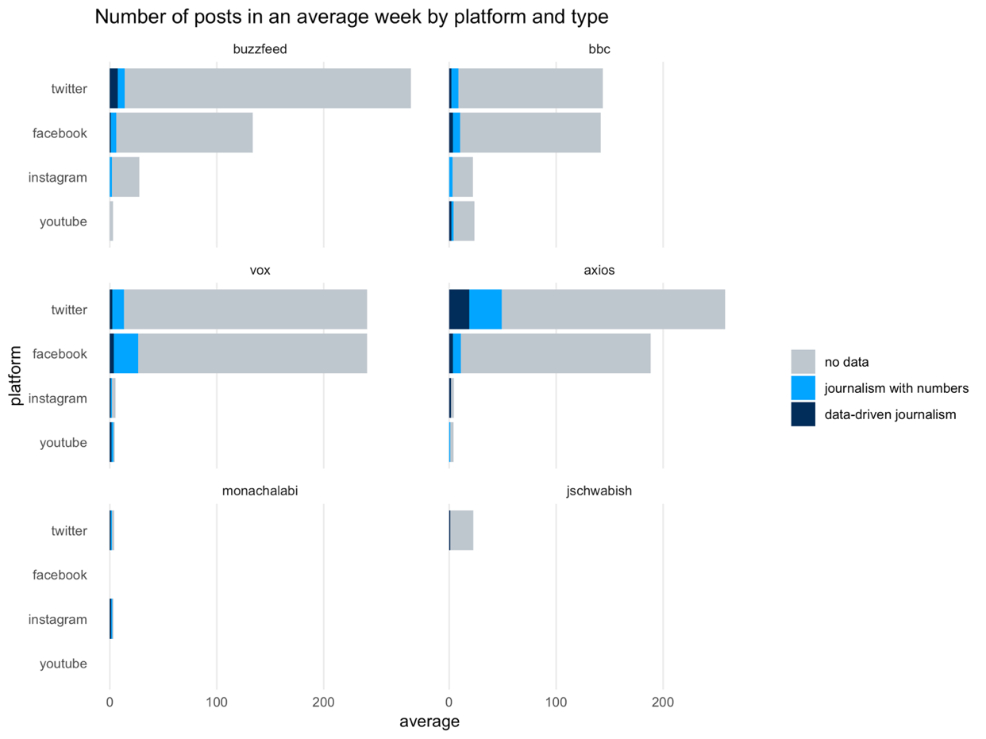

There is not much difference between the accounts when it comes to how they distribute their posts across platforms. There is, however, a big difference when it comes to the share of posts that concern data-driven content.

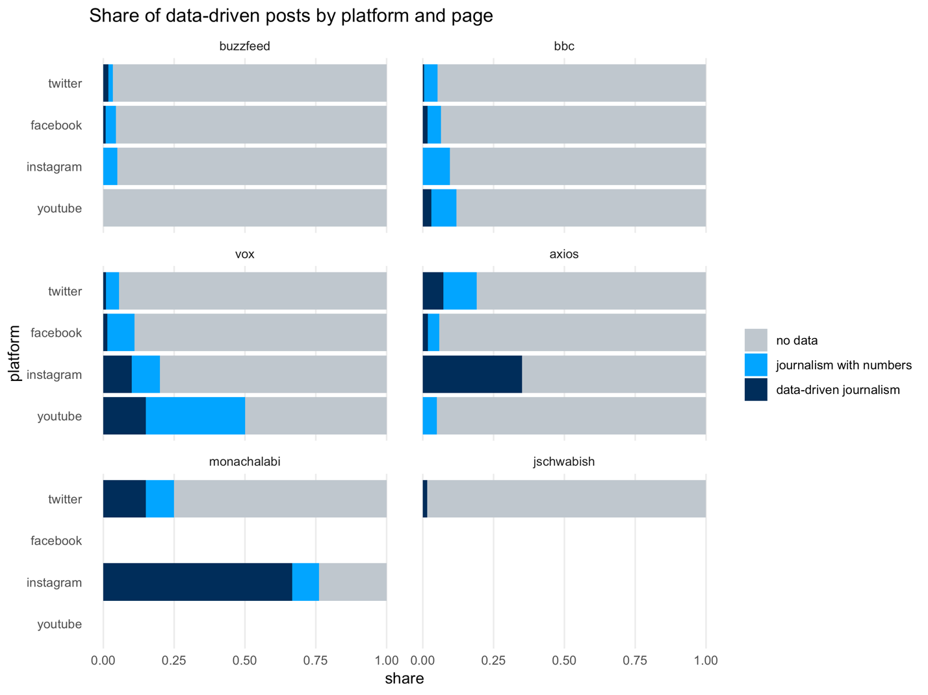

What we can see is an inverse effect to the post frequency: The platforms that are less frequently posted to often have a higher percentage of data- and numbers-based content. We assume that this is for the same reason described above: Instagram and YouTube require the production of standalone content. Since data-driven pieces tend to be the product of more complex research, they might more often warrant a special presentation on social media. They often already involve data visualizations as well, which can be adapted, for example, for Instagram posts.

# 2.2 Different newsrooms, different styles

From these charts, we can also see that the analyzed platforms prioritize data very differently. Buzzfeed and the BBC both aim to cover all daily news – albeit in a very different style. Generally, less than 10% of their posts feature anything related to numbers or data. On Twitter and Facebook, it’s less than 5%, which adds up to around 1-2 posts a day. On the BBC News Youtube channel, journalism with numbers makes up around 9% of all videos, another 3% is data-driven content.

Vox has similarly low shares on Twitter and even Facebook but prioritizes data more on Instagram (10% data-driven posts, additional 10% journalism with numbers) and especially YouTube. More than half of their content on YouTube is somehow numbers-related, around 15% of it is specifically data-driven. This was sometimes hard to classify, since Vox pieces regularly use data-driven research even to support stories that are not in themselves data-driven.

Axios is an interesting case: They use their YouTube channel almost exclusively for interview recordings, and have pretty average shares on Facebook, but their Instagram channel specifically is heavily focused on data: Around a third of posts are classified as data-driven. Axios focuses on business news, and often illustrates recent developments with charts. Many of their pieces toe the line between journalism with numbers and data-driven journalism: Their focus on brevity sometimes makes it hard to discern how much of thes analysis behind a story was done by Axios, and they illustrate numbers-based pieces with graphics significantly more often than other media. That might also be part of the reason that we counted so many of their Instagram posts as “data-driven”, even though the underlying articles might not have been (see above, “challenges in defining data-driven journalism”).

And finally, the accounts by Mona Chalabi and John Schwabish show how differently individuals use social media to present data-driven stories. Mona Chalabi uses her Instagram account almost exclusively to present her signature data-driven illustrations, save for some personal announcements. Many of these illustrations are ones she originally produced for Guardian pieces, but on Instagram, she uses the image description to provide background information on the topic right there on the platform, often not referring back to Guardian pieces (via a “link in bio” note) at all. Her Twitter feed contains more personal announcements and shared articles, but still often features her illustrations again. John Schwabish on the other hand uses his Twitter account for meta-communication about data visualization, mainly with other people in the field. These posts have not been classified as data-driven content.

# 2.3 Different platforms, different styles

## 2.3.1 Twitter

*TL;DR: 10% of tweets analyzed were data-related. Newsrooms mostly use Twitter to post links to their data-related articles, not much more. If it’s a data-driven article, the preview image will feature a chart. Other types of representation were not found. Performance-wise, ddj content does not perform significantly better than regular content.*

News organizations post a lot on twitter: We analyzed 2838 posts from the two weeks we looked at. Some organizations average at more than 200 tweets per week, or 30 per day. Of all posts, 159 were categorized as journalism with numbers and 84 were data-driven. That leaves 2595 posts (90%) that were not data-related in any way.

All major media outlets usually tweet articles out multiple times, which partly explains the frequency of posts. One subjective assessment is that data-driven pieces are usually not shared as often as other non-data stories. This finding needs verification, though, since we didn’t specifically analyze how often which linked article was shared.

### Presentation on Twitter

The share of data-related posts is quite low in general. At 15%, Mona Chalabi has the highest share of data-driven Tweets. Like on Instagram, she often posts her graphics for The Guardian separately on Twitter. Vox, BBC World and Buzzfeed all average at less than 5% numbers- or data-driven journalism (1-2 Posts a day).

Twitter Posts overwhelmingly (89%) serve as a teaser for a story on the media home page. We did not find any content on Twitter that did not contain a link: The remaining 11% was made up of stand-alone content that still contained a link to an article with further information.

These posts mainly come in the form of a short text with a link: 77% of all Twitter posts didn’t contain any media beyond the link preview image. The rest are mostly made up of tweets with a static image (18%). Data-driven content is mostly recognizable by the fact that the post features some type of data visualization chart (71%). 13% of data-driven posts contain an illustration, another 13% contain neither an illustration nor a chart. The rest contain both.

### Performance on Twitter

To see how successful data-driven posts are compared to the median number of likes for each page, we added together the number of likes and retweets each post had at the time we scraped it for analysis. This graphic shows how the posts stack up.

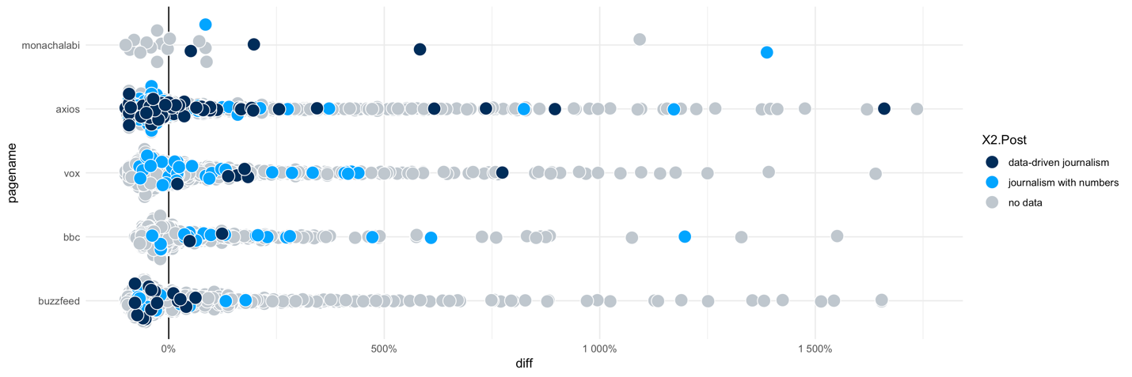

On Mona Chalabi’s and Vox’ accounts, data journalism posts are almost three times as successful, on average, as the page median. Data-driven posts on Vox, for example, get an average of 138 likes and retweets, the page average is 50. For the BBC the two data-driven posts we found in our analysis timeframe were it’s almost twice as successful on average (586 notes vs. 315) as the median. On axios, data-driven posts are pretty average, and on Buzzfeed, they’re less successful (22 notes vs 37) than the median. An interesting finding is that link posts usually get more notes, compared to the page average, than ones that feature static images.

Here are some examples we put together to explore what might make one data-driven post more successful than the other. We can’t draw any conclusive findings from this sample, though, especially since the posts are, overall, quite similar in concept.

### Twitter Examples

The most successful data-driven post we found on the Vox Twitter channel is [this one](https://twitter.com/voxdotcom/status/1152253796661248000), a teaser for their visual interactive story about warming US cities.

The post is near 100 times as successful as the page median (which is at 50 reactions), and the most successful data-driven Twitter post we found across all channels. This is particularly interesting because the tweet doesn’t have an unusual style: It’s a link preview with a short teaser text. But: The text is concise, the preview contains a custom illustration and the preview text hints at an interactive piece that lets users explore the data for their own city. And, of course, the topic of climate change is hotly debated right now. Still: The post can’t compete with [this](https://twitter.com/voxdotcom/status/1154101474894520320) Tweet about K-pop at the VMAs by a long shot: Its 317 times as successful as the average.

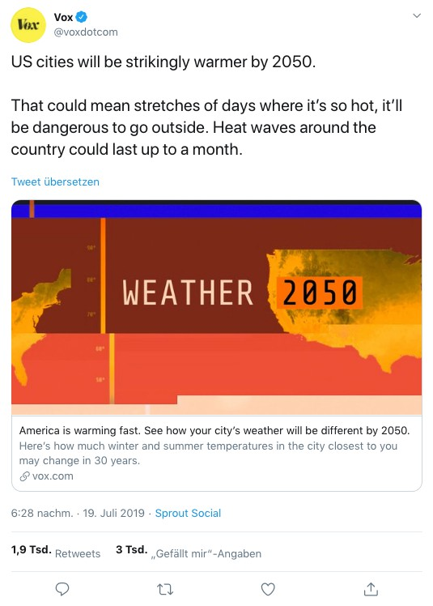

On the other hand, [two](https://twitter.com/buzzfeednews/status/1152633014813282304) [projects with similar topics](https://twitter.com/buzzfeednews/status/1155081145953898496) by Buzzfeed only got below-average notes. They contain a link with a map in the preview image as well, deal with climate change and present the findings of own research. One of them is even an interactive piece on warming cities as well. We can only speculate as to why they perform worse. It might be that the underlying article isn’t as interesting or as visually appealing as the Vox piece, or it might be about the nature of the medium: Data-driven articles on Buzzfeed often get average amounts of notes, while ones on Vox tend to be more successful. So one reason might be that Vox followers pay more attention to data-driven pieces in general, as opposed to a problem with the pieces themselves.

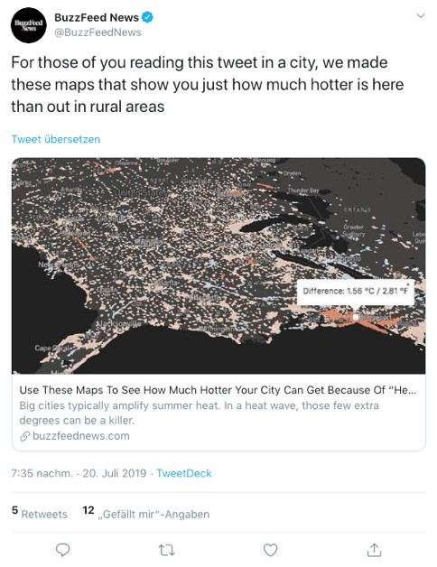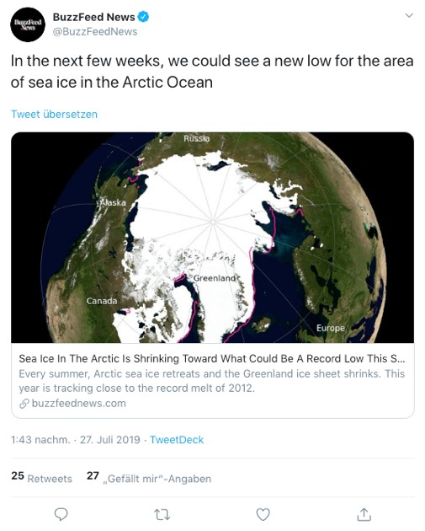

This post by Axios was unusually successful on Twitter as well as Instagram. On Twitter, it reached 16 times the usual amount of notes for Axios. It deals with immigration, a heavily-discussed topic in general, the finding is surprising and clearly communicated. Still, they only use a link preview that shows a cut-off version of the graphic from the article. All reposts of the story were unusually successful as well. Interestingly, the version that used a static image instead of a link preview, showing the graphic in its entirety, was the least successful, though it still got 3 times the usual amount of notes.

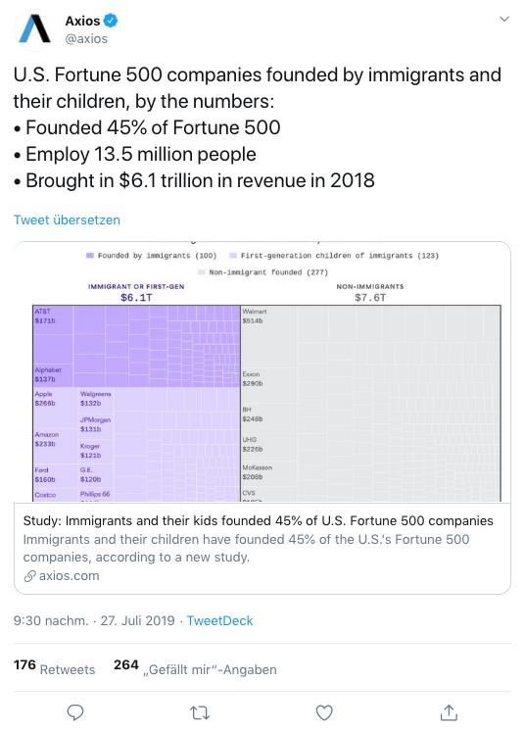

Topic alone is not a good predictor of performance, though: There are successful and unsuccessful posts in each topic we analyzed, and there’s no clear trend for any topic.

## 2.3.3 Facebook

*TL;DR: 7% of analyzed posts were data-related. More than half (58%) of data- related content was shared as links. For most pages, data-related content performed less successful compared to the median performance of a page’s content in the same time.*

### Presentation on Facebook

Of 1,546 posts we found on Facebook in our two-week analysis timeframe, 91 were categorized as journalism with numbers and 23 were data-driven. That leaves 1,432 (93%) that were not data-related.

Three quarters (76%) of all data-related posts were classified as teasers to make the user click on to the actual report on a website, rather than have users stay on the platform itself. Only 19% of data-related posts were designed to work as stand-alone content.

In terms of media variety, 58% of the data-related posts were link preview posts, 22% were videos and 9% static images. The type of visualization formats used varies: While Vox and Axios used charts in the majority (57%) of cases, the BBC predominantly (86%) used photos to catch attention for their data-related stores.

### Performance on Facebook

As a measure of performance on Facebook we looked at the total number of reactions. This results in a very mixed picture, where many data-related posts for each of the four media companies performs worse than the median performance of all posts in that timeframe. Only few data-related posts perform better than that median.

An exception is Vox, where roughly half of the data-related posts perform better than the median.

Comparison to page median:

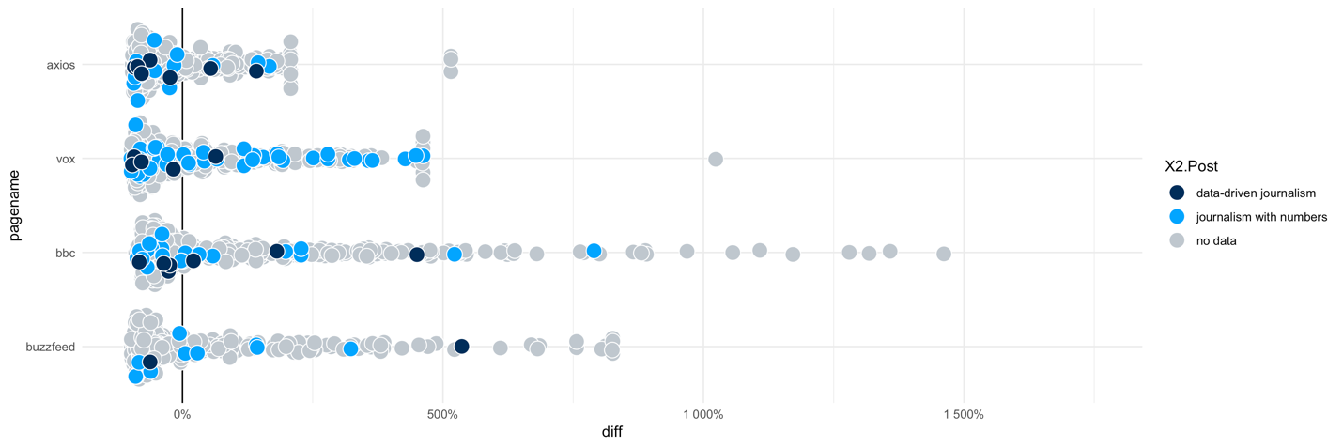

## 2.3.3 Instagram

*TL;DR: 18% of posts analyzed were data-related. The majority of content on Instagram is standalone content that does not tease the user to visit a website, which is likely due to how the platform overall works. Data-related posts perform only slightly better than the median performance of that account.*

Of 205 posts we found on Instagram in our two-week analysis timeframe, 14 were categorized as journalism with numbers and 23 were data-driven. That leaves 168 (82%) that were not data-related. Buzzfeed and the BBC post more than 20 Posts per week on average, which is more than the other accounts. They don’t feature data-driven stories at all, though.

There are a few numbers-related posts, but they’re mostly about a new record, a report on a study or they use a number as the hook to a non-data-related story. By contrast, the majority of Mona Chalabi's posts are data-driven. Axios and Vox also have quite a strong focus on data for news outlets that aim to cover all important topics of daily news.

### Presentation on Instagram

The main difference to Twitter and Facebook is that, on Instagram, it’s not possible to post link previews, so the content is naturally mostly stand-alone. 60% of posts don’t refer to external content at all. And even of the 40% that contain a “link in bio” note, a majority of the posts is designed so that the audience gets the full picture within the post itself.

This also means that, to make the data sources transparent, the outlets would have to include them either in the picture itself or in the image description. The pages handle this quite differently: Mona Chalabi always cites her sources in the image description, Vox only does it for data-driven posts, but not for journalism with numbers. Axios only names their sources on the website once you follow the “link in bio” if it exists, and Buzzfeed and the BBC don’t name sources at all.

The media types featured in the Instagram posts is quite typical for the platform: We found 13 static images (60%), as well as seven image galleries and two videos. Across all media types, data-driven content on Instagram is illustrated with charts on the Vox and Axios channels. Mona Chalabi is the only one that uses Illustration-style graphics for data-driven content.

### Performance on Instagram

For the purpose of this analysis, we’re going to use the number of likes on a post as a measure of success. We’ll exclude bbc and buzzfeednews, since they don’t have any data-driven content on their Instagram channels. The following chart shows how the likes for each post compare to the median number of likes for the page.

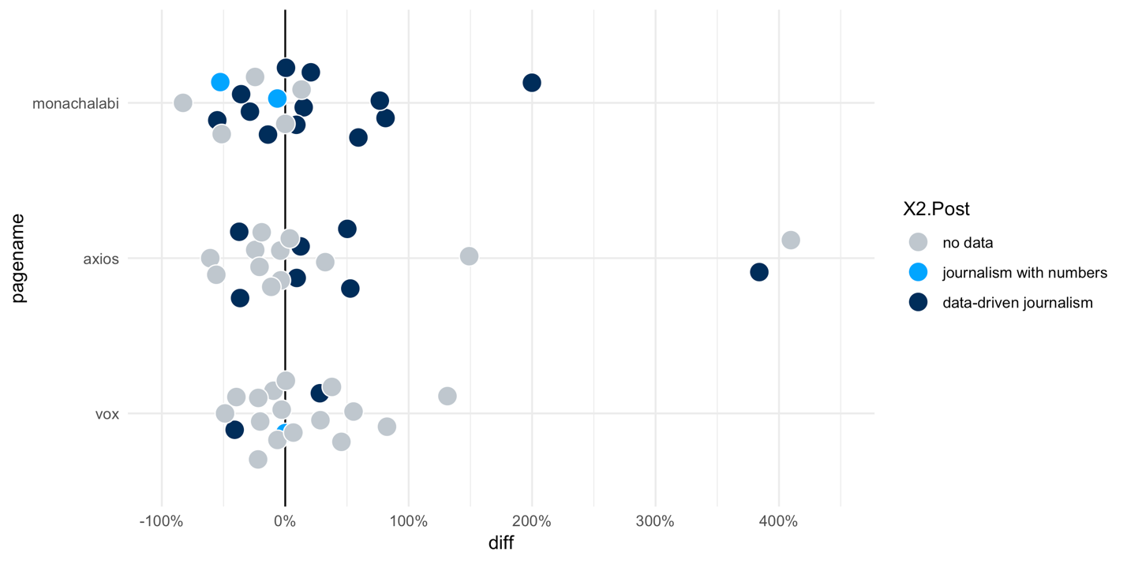

On Mona Chalabi’s and Axios’ account, data journalism posts get slightly more median likes than the overall page (monachalabi: 12%, n=12, axios: 17%, n=7). On Vox, we only found 2 posts classified as data-driven, of which one performed worse, one better than the median.

Since our sample numbers are so small, a qualitative look at the numbers may be more rewarding to explore what these channels have tried on Instagram, and how the different versions performed.

### Instagram Examples

**Vox:** We found two data-driven posts in our sample from the Vox Instagram page. One was more, one less successful than their median of 4016 likes. These are the posts:

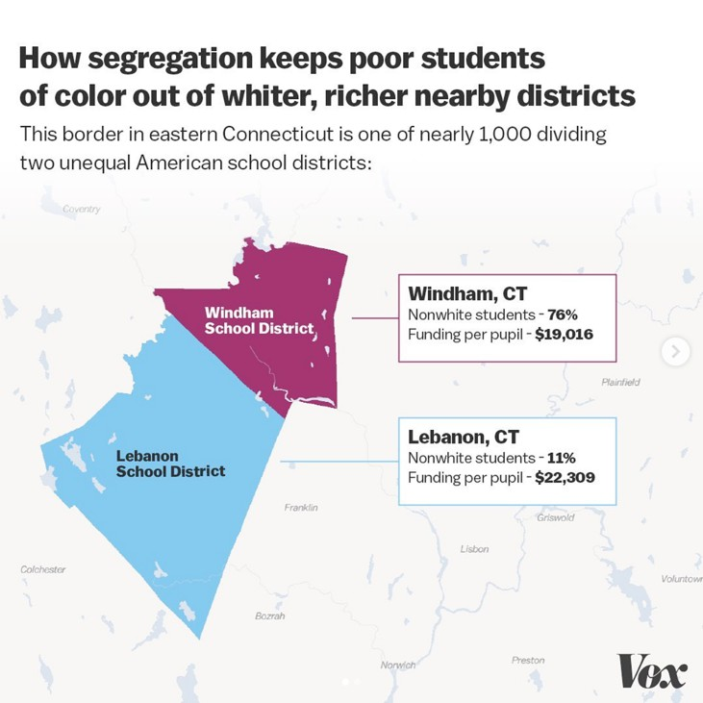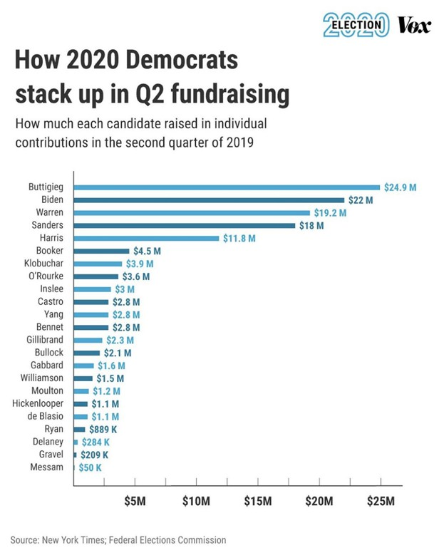

The left post, which performed worse, is much more complex, which might make it harder to read. The finding might have to be stated more clearly than it was, and with fewer technical terms. And overall, fundraising statistics of the second quarter of 2019 might just not be as interesting to audiences. Additionally, the chart is not adapted to the typical square format of Instagram, which means it might appear cropped in some views.

Link: <https://www.instagram.com/p/B0ZJgQug9ln/> 26.07.2019 20:12  
**5.142 Likes**

Link: <https://www.instagram.com/p/B0CEQMzgjPd/>   
17.07.2019 21:04  
**2.370 Likes**

The right image, by comparison, has a much clearer message and, arguably, a more compelling visual style. The topic in itself might be closer to Vox audiences’ heart. They also chose to use a gallery of two images here, the first one being the map, which serves as a concrete example to illustrate the problem. The second slide gives further information on the development over time. If the user wants even more information, they can read the description of the post and follow the link in the bio if they want the complete picture. The right posts uses some more of the features Instagram has to offer to effectively tell its story.

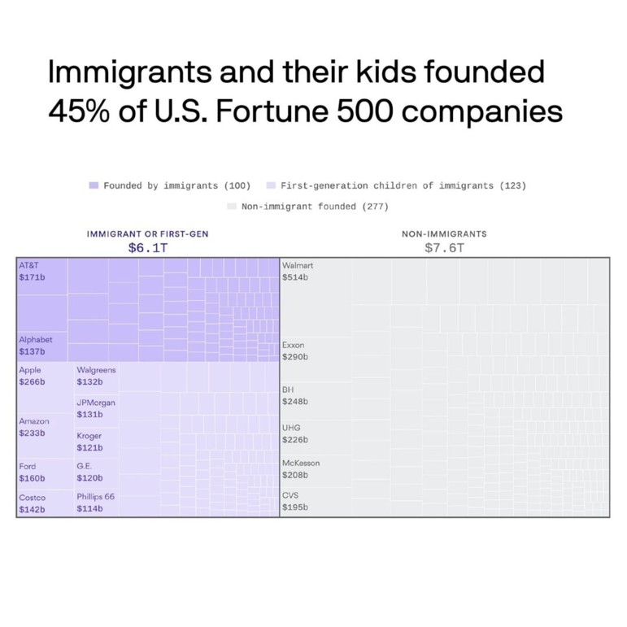

**Axios**: This post is very successful by Axios’ standards. It had 1382 likes at the time of analysis, five times as much as the page median (275). This is especially remarkable because the visualization is quite busy, with small type and a lot of details to be explored. Still, the main finding is stated clearly in the headline and is easily understandable.  
The finding itself might also be what draws people to the content: It’s new, it’s unexpected and it ties into a current discussion.

Link: <https://www.instagram.com/p/B0OlXodBBbD/> 22.07.2019 17:44:39  
**1.382 Likes**

Still, we can’t rule out the role that chance might play in the success of one post over another. For example, someone influential might have shared a post, leading new audiences to the content of the page. Our analysis cannot reflect these kinds of circumstances.

**Mona Chalabi**: This post had 22.735 likes at the time of analysis, three times as much as her median (7582). Interestingly, is also doesn’t use the typical square format of Intsagram, but still performs well. A positive note here is that the usual bar chart format has been broken up to lead the audience through the post with writing, combining type and chart effectively.

Link: <https://www.instagram.com/p/Bxh9qWhHk4E/>  
16.05.2019 16:48:18  
**22.735 Likes**

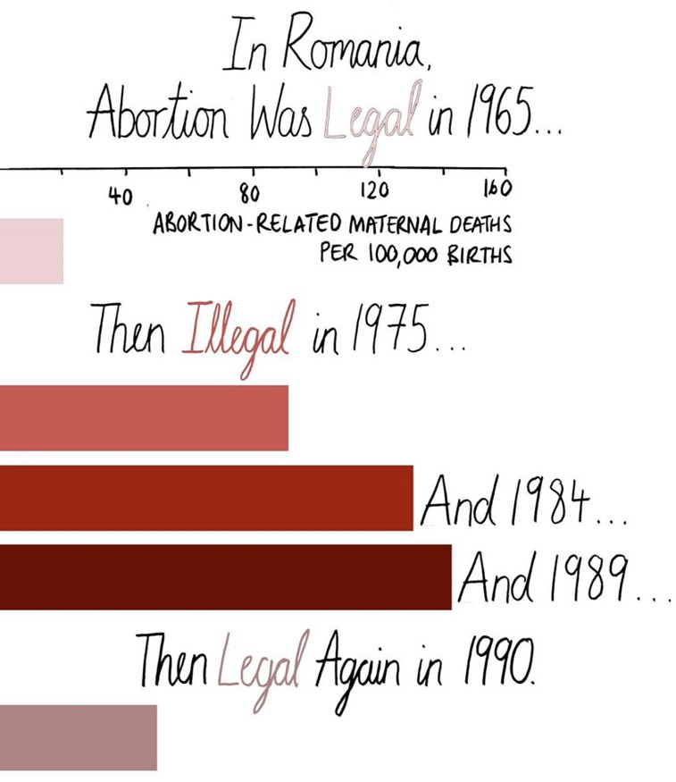

More interesting examples from her channel include: [this post](https://www.instagram.com/p/Br5h5mXnic3/), where she uses an image galleries to create one long visualization. It also illustrates how she uses illustrations to humanize the data she presents.

# 2.3.4 Youtube

*TL;DR: 15% of all video posts analyzed were data-related. At least for some platforms, data-related content performs slightly better than regular content.*

Of 127 posts analyzed, 14 were categorized as journalism with numbers and only 5 were data-driven. That leaves 108 (85%) that were not data-related at all.

* BBC posts a lot on Youtube with around 24 videos per week on average.
* BBC and Vox are the only ones with ddj content, each with around two per week

Compared to their output, Vox has the highest share of numbers-related and data-driven videos on their Youtube channel.

More than half of their content is somehow numbers-related, around 15% is data-driven. This was sometimes hard to classify: Vox regularly uses data-driven research on the newsroom, even to support stories that are not in themselves data-driven. Since they focus on explainers and background analyses, their pieces are often longer and dive deep into a topic. Because of this, some videos might contain data-driven elements and still be classified as journalism with numbers or even as not being data-related at all.

On the BBC News channel, journalism with numbers makes up around 9% of all videos, another 3% is data-driven content. Axios, who relies on data-driven content heavily (for a news site) on Instagram, mostly just uses their Youtube channel to publish interview recordings.

**Post type**

On Youtube, videos naturally mostly stand by themselves. All of the analyzed numbers-related videos are stand-alone content, 26% of those still contein a link to an article for further information in the description.

**Media type:** Video (duh)

**Visualization type:** Only one video by the BBC contains. The rest contain neither illustrations nor data visualization. Vox, on the other hand, uses some form of graphics in virtually every video. More than half contain illustrations as well as charts.

**Topic**: We didn’t collect it for the non-ddj posts, so can’t compare.

**Success:**

On Vox, videos that are numbers-related get more views than the page median. On the BBC News channel, though, neither the “journalism with numbers” nor the data-driven videos seem to be very successful.

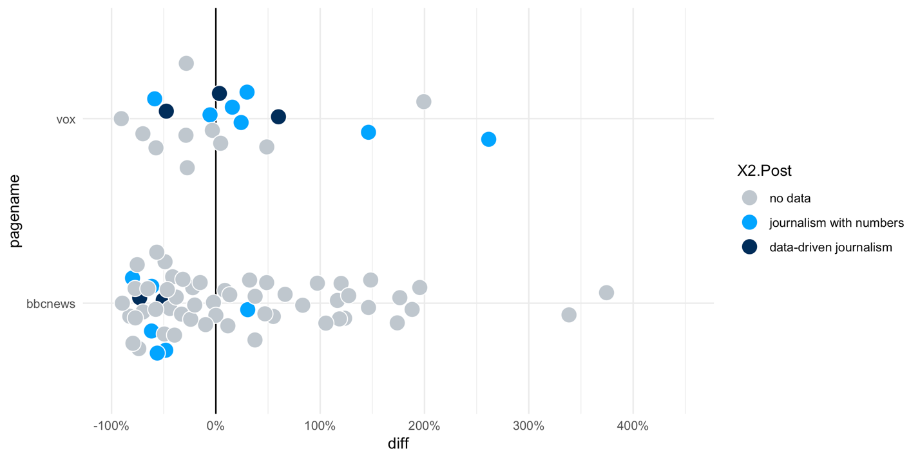

**Examples**

Let’s take a closer look at some examples to get a sense of what works for these channels.

<https://www.youtube.com/watch?v=R2RZsYFv_vM> BBC data-driven explainer (Views: 28,214, only half of the median: 56,961)

City where drought is visible from space- BBC News: <https://www.youtube.com/watch?v=ayrNyaVMvvg>

<https://www.youtube.com/watch?v=WjVVwMGJ9S8> explaining, visualizing and humanizing distributions. Classic explainer by Vox that uses data to answer the “what?” and illustrations based on other research to explain the “why”()

Tour de France: 1.399.724 views, more than median, highest of ddj posts

Hong Kong Protests: <https://www.youtube.com/watch?v=6_RdnVtfZPY> 3.6 times as many views as the page median (3,162,730, median: 874,780), highest of journalism with numbers

# 3. Interviews with data teams

## 3.1 Axios

**Interview with: Lazaro Gamio, Deputy Managing Editor for Visuals**

Axios, a young online news platform founded in 2017, approaches news coverage according to their principle of “smart brevity”. They have had a Visuals team from the very beginning. That gave the team members the opportunity to build understanding for their work in the newsroom and prevent bad visualization habits early, says Lazaro Gamio. The team, he says, has a good relationship with the rest of the newsroom: Most reporters inform them about projects early and develop ideas collaboratively.

The Visuals team is divided into a data visualization branch, which also serves as the general data expertise of the newsroom, and the editorial design, whose main job it is to produce illustrations for Axios articles. Both branches are deeply integrated into the newsroom infrastructure: Axios produces data visualizations and title illustrations for a large share of their articles, including daily news, while other outlets reserve them for bigger stories. This means that the data visualization team is mostly occupied with producing ordered graphics for reporters. Occasionally though, they also collaborate with reporters on stories and help them realize ideas for data-driven articles.

There is not a lot of time to think about social media specifically due to the high speed of production, says Lazaro Gamio. The social team does see data as an integral part of the daily coverage, though, so they use data visualizations produced by the Visual team without special prompting. For bigger projects, and newsrooms where data teams and social teams communicate less naturally, he recommends involving social media colleagues early in the process.

Axios’ goal on social media is mainly to broadcast their work, not necessarily to generate clicks to the website immediately. That gives them more freedom to experiment with different formats.

On Twitter, the Axios Visuals team has [their own account](https://twitter.com/axiosvisuals). Often, they will tweet out a story from their account first, then ask Axio’s main account to retweet or cross-post it. If the project features animations, the Visuals team will often create a GIF showcasing the animations and add that to the tweet.

On Instagram, the social team makes the editorial calls on which story to feature and how to present it. To achieve “smart brevity” on Instagram, the social team focuses, on large headlines, powerful images and distinctive colors in their posts. Especially for data-driven content and more complex visualizations, one strategy they use is a “narrative title card”: An image gallery where the first image will be an illustration introducing the topic and featuring a call to action (“Slide to see more”). The second image will feature a data visualization that gives users more information.

## 3.2 BuzzFeed

**Interview with Jeremy Singer-Vine, data editor, Buzzfeed News**

BuzzFeed News doesn’t have a particular approach to conveying data-journalism stories on social media, says Jeremy Singer-Vine. The "curation team" at BuzzFeed News is responsible for helping the newsroom promote and share their work on social media. They don’t seem to have a specific workflow for data stories, though: On bigger projects of any type, they discuss promotion strategy and language before publishing. For smaller stories, the curation team decides which ones to promote.

## 3.3 Vox

**Interview with Ryan Mark, data editor, Vox**

Vox’ data and graphics teams have shrunk over the past years. At the moment, Ryan Mark is the only data editor at Vox, as well as the only person who can write code. He mostly supports other reporters instead of developing his own projects. Collaboration with the other departments is very mixed: some reporters understand data journalism very well, some don’t. Reporter Alvin Chang is the only person in the Vox newsroom who develops data-driven stories start to finish. Apart from the website, he also works for the Vox Video team, which is organized separately from the main Vox newsroom.

Ryan Mark usually doesn’t produce custom graphics for social media, but the Vox social team employs graphic designers who produce content specifically for social media. That’s why, on bigger projects, colleagues from the social media department will be involved from the beginning. It’s usually the job of engagement director Nisha Chittal to decide how to promote a story on social media. This partnership works well, since the social media team at Vox is generally open for collaboration. One problem is that they, like many departments, are understaffed, which can lead to time shortages.

Generally, Vox doesn’t have fixed templates for data visualizations on social media since visualizations for a data-driven story are custom-fit to the specific story. Vox also takes care to hone graphics to each respective social media platform, which seems to have worked well for them so far.

**4 Feedback from EDJnet members**

In a meeting with EDJnet partners end of September 2019 we shared out findings. The discussion can be condensed into the following questions that will be considered during work package 2:

* How might we improve the conversion from social media to the website?
* Do hashtags like #ddj or the tagging of influencers have an impact on the performance of tweets?
* Do images perform better than link previews?
* How might we support high engagement AND good conversion to website traffic at the same time?

We also discussed the capabilities of EDJnet members to rehash their ddj stories for social media platforms. The majority of EDJnet members do only have little time to invest in producing ddj content for social media. In addition, not every member has the capabilities to produce animated videos, as motion designers with respective skills are not a given.

**5 Conclusion**

On Facebook and Twitter the analysis of two weeks time worth of posts shows how data- related content is often posted in a low-key fashion as link post without much extra effort to make it stand out. The most common way how a user could tell that this content is different from other content is by utilizing a chart to illustrate the data aspect of a story.

Also with regards to performance, data-related posts do not really stand out.

Taken together, we believe these findings speak to a lot of potential we can explore, for example by trying different formats of how to present data-driven stories other than with a link-preview.

On Instagram, other media outlets already use a variety of different formats to present their data-driven stories (charts, galleries, videos). Given the versatility of the platform in terms of media types, we believe it has a lot of potential to explore the full bandwidth of options and also compare how audiences on Instagram react differently to certain media type content compared to a Facebook audience, for example. We did not include Instagram stories in this analysis, but definitely consider integrating them in our work package 2 (outreach strategy) and 3 (content production).

For YouTube, particularly Vox’ channel shows how users seem to perceive data-related content as an added benefit as they receive more views than non-data-related content. At the same time, producing standalone video content is very resource-intensive (time, cost) and it might be difficult to extrapolate from one channel’s audience to another. As outlined in the next steps, we hope that an exchange on a qualitative level with the content producers will provide addition insights and starting points for format ideas.

Conducting additional interviews with members of the data teams revealed that the teams themselves usually don’t develop particular strategies. They rely on their social teams to find the ideal way of sharing ddj content on social media. How well this works depends primarily on how integrated data teams as well as social teams are into their respective newsrooms. Most of the colleagues we spoke to expressed interested in our endeavor and acknowledged it makes sense to get more involved in the process if time allowed. They stressed the idea to involve social media colleagues early on and to hone content to the separate platforms – supporting our overall idea for WP 2 and 3.

Based on the feedback from EDJnet partners we adjust our work packages 2 and 3 to reflect the different capabilities of partners. When developing for templates/ideas how to tell ddj stories on specific platforms, we also aim at providing both a “low-key” suggestion as well as a “high end” production suggestion.