Analysis of Epigenetic Gestational Age Acceleration Relative to Chronological Age

G Bhatti

9/13/2024

### Calculate,compare, and plot epigenetic gestational age acceleration

groups <- c("pretermPE","PPROM","PTL","termSGA","termPE","Controls")

## Compare eGA acceleration Using different clocks

rpc_results <- analyze_eGA_acceleration(ano, "ga_rpc", "Del_GA_Calc",  
 groups=groups,  
 title="Robust Placental Clock")  
rpc_results

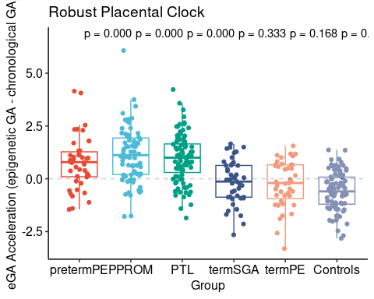

cpc_results <- analyze_eGA_acceleration(ano, "ga_cpc", "Del_GA_Calc",  
 groups=groups,  
 title="Control Placental Clock")  
cpc_results

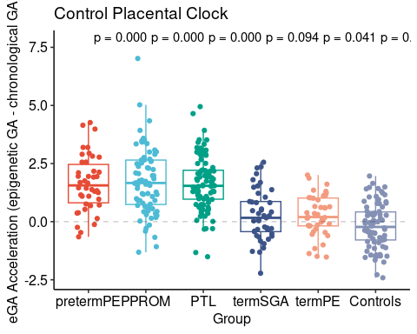

rrpc_results <- analyze_eGA_acceleration(ano, "ga_rrpc", "Del_GA_Calc",  
 groups=groups,  
 title="Refined Robust Placental Clock")  
rrpc_results

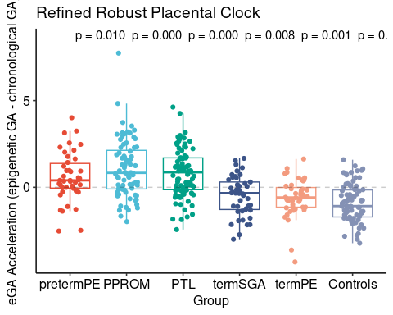

top_teams <- test_ranking |>   
 group_by(submitterid) |>   
 slice_min(Test_rmse, n = 1, with_ties = FALSE) |>   
 ungroup() |>   
 slice_min(Test_rmse, n = 3, with_ties = FALSE) |>   
 mutate(stamp = paste("ga", submitterid, evaluationid, sep = "_")) |>   
 pull(stamp)  
  
top_team_results_1 <- analyze_eGA_acceleration(ano, top_teams[1],"Del_GA_Calc",  
 groups=groups,  
 title="Top Performer #1")  
top_team_results_1

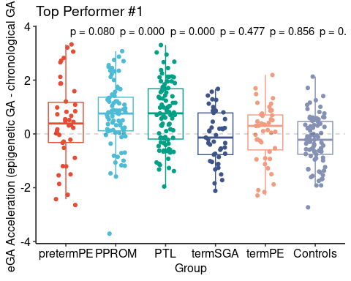

top_team_results_2 <- analyze_eGA_acceleration(ano, top_teams[2],"Del_GA_Calc",  
 groups=groups,  
 title="Top Performer #2")  
top_team_results_2

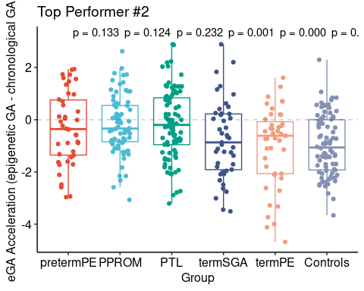

top_team_results_3 <- analyze_eGA_acceleration(ano, top_teams[3],"Del_GA_Calc",  
 groups=groups,  
 title="Top Performer #3")  
top_team_results_3

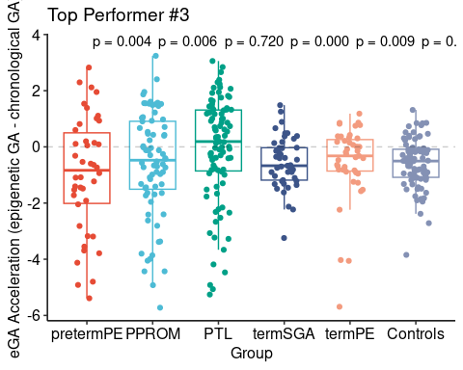

woc_results <- analyze_eGA_acceleration(ano, "ga_woc","Del_GA_Calc",  
 groups=groups,  
 title="Wisdom of Crowd")  
woc_results

