Epigenetic gestational age acceleration across pregnancy complications

G Bhatti

9/13/2024

### Calculate,compare, and plot epigenetic gestational age acceleration

## Define the comparisons

my_comparisons <- list(c("termPE", "control"),  
 c("termSGA", "control"),  
 c("PTL", "PPROM"),  
 c("PTL", "pretermPE"),  
 c("PTL", "control"),  
 c("PPROM", "control"),  
 c("pretermPE", "control"))

## Compare eGA acceleration Using RPC

rpc_results

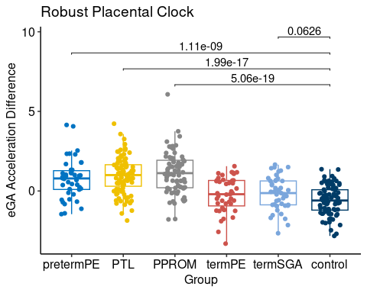

## Compare eGA acceleration using the top Solution

top_team_results

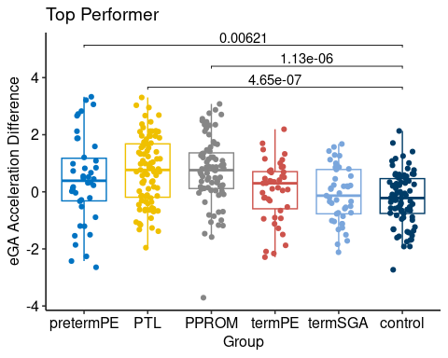

## Compare eGA Acceleration Using WOC Solution

woc_results

