CST336

Miguel Lara

Daniel Wilson

Iason Myttas

Kieran Burke

4/10/17

Team Project

Movie Rental System

Project Management

Trello: <https://trello.com/b/WamKFXXn/csumb-cst336-p1>

Git: <https://github.com/dw1lson/cst336_storefront>

Database Schema- ER diagram

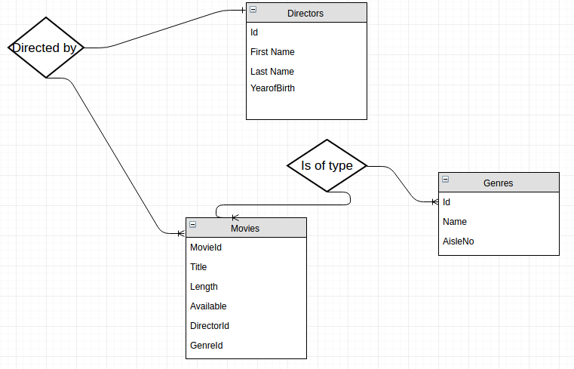

User Story

Users will be able to view our database of movies, defaultly organized alphabetically. The user is able to filter through the results of our database to narrow down the movies that are displayed. The filters available are title, genre, director(first or last name), and availability. With or without a filter the user can select how the movies are sorted by title or by length.

If the user wants more information on a movie they are able to click on the movie title. Upon clicking a popup window will appear with additional information on the movie including director, genre, and length.

If the user likes a movie in the database they are able to add it to their “Viewing Cart” by clicking “Add to viewing cart”. The user is able to go to the viewing cart link in the menu to view the contents of the cart on another page. The cart can also be emptied by clicking the Clear Viewing Cart on the bottom of the viewing cart page. This will delete all the contents of the viewing cart.

Mock-up