Project 2

Black Jack

Daniel J. Wallander

CIS-5

Summer 2023

45428

GitHub: <https://github.com/dw2737908/23SUM-CIS-5-45428>

Rules of the game

The goal of Black Jack is to get 21 points without going over.

The game is played with a standard 52 card deck, excluding the two joker cards. The numbered cards are with there numbers (E.G. 4 = 4). Jacks, Queens, and Kings are worth 10 points. Aces are worth both 11 points or 1 point depending on what the player needs.

When the game starts, each player receives two cards. During a players turn, they can choose to “hit” or “stand”. “Hit” allows them to draw a card while “stand” ends there turn. Whoever has the highest number that is 21 or lower wins.

Rules of my game

When the user starts the program, it will ask them how many players are playing. The dealer will draw two cards. If the dealer has less then 17 points, he will keep drawing cards till it is above 17 points. After he is done, Player1 will be given two cards. The player will be given the option to hit or stand. Hit will draw a card while stand will end there turn. Once all players have had there turn, it will compare the points and determine the winner.

The code techniques I used.

* An external file that holds ASCII card art.
* A map function that opens the file, locates a specific card, assigns the card to a variable, and closes the file
* Asked the user how many players are playing and stored the number in a variable.
* Assigned each 52 cards a number and a random number generator that chooses a random card.
* A for statement for the dealer that keeps looping till there total points is over 17.
* Gave each player two cards and the option to draw more.

Proof my code works

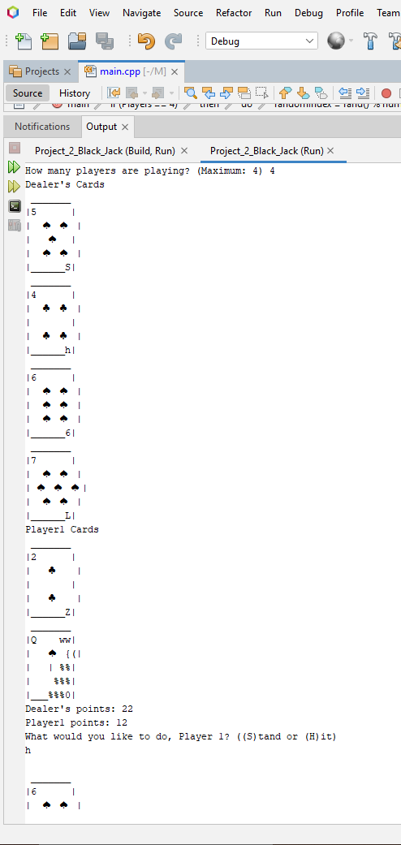

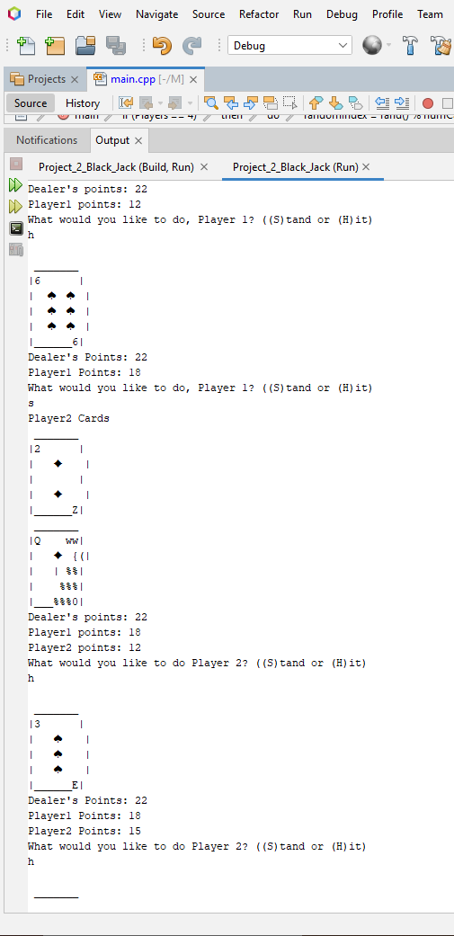

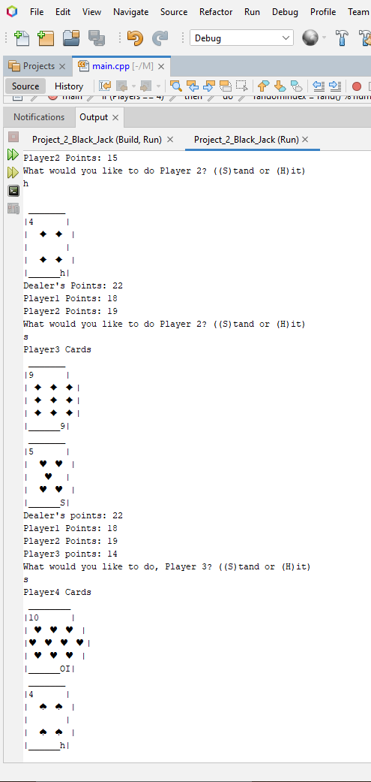

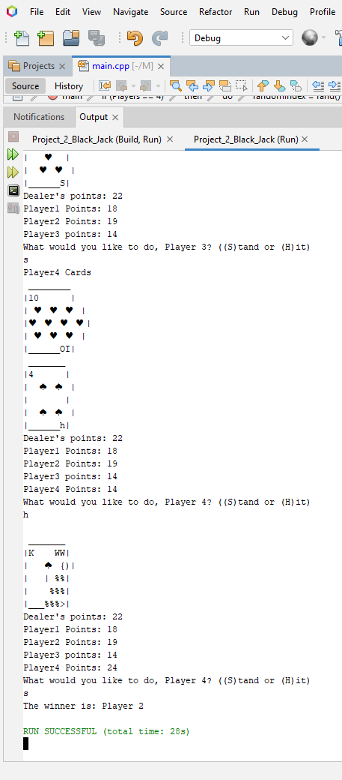

References

* “Starting Out with C++: From Control Structures through Objects” Gaddis.
* Dr. Lehr’s online lectures.
* <https://www.w3schools.com/>