Final Project: Player Analytics for an Online Game
Group: E & D Group | Group Members: Ethan Oxley, Daniel Warren
Arizona State University
IFT 530: Advanced Database Management Systems
Ashish Gulati
October 27, 2026

Final Project: Player Analytics for an Online Game
What This Project Is
This is the database behind a live, free-to-play online game — not the game, the system the business runs it from. Ten tables: six dimensions describing the customer from different angles, three fact tables recording what happened, and one audit table holding the change history of the plan lookup.
The design question behind it is that a game like this earns nothing at the moment somebody installs it. It earns weeks later, from a fraction of players who decide it is worth paying for, and it only reaches those players by buying their attention first. So the questions worth asking span areas usually kept apart: who the customer is, what they did, what they pay, and whether the payment should be trusted. The schema is built to make the joins between those areas cheap and unambiguous.
Everything is in one script, IFT530_EDGroup_FinalProject.sql, submitted as a .txt as the announcement requires. It creates the database, drops and rebuilds every object, loads the data, creates three views, a trigger, a function, a procedure and a cursor, and finishes with a block of tests that report PASS or FAIL. It is re-runnable: running it three times in a row produces the same objects, the same row counts and the same results.
Environment
SQL Server has no native macOS build, so the server here is Microsoft's official Linux container running under Docker — SQL Server 2025 Developer Edition, the full product, not a reduced one. The assignment asks for screenshots from SSMS or Azure Data Studio. SSMS is Windows only and Microsoft retired Azure Data Studio in February 2026, so the work was done with sqlcmd and the VS Code MSSQL extension, which is the same codebase Azure Data Studio was built from. The entity relationship diagram is drawn by tools/erd_html.py from the schema the script creates, and it is checked back against the live catalog views before it goes in, so the relationships it shows are the real foreign key constraints rather than something drawn by hand.
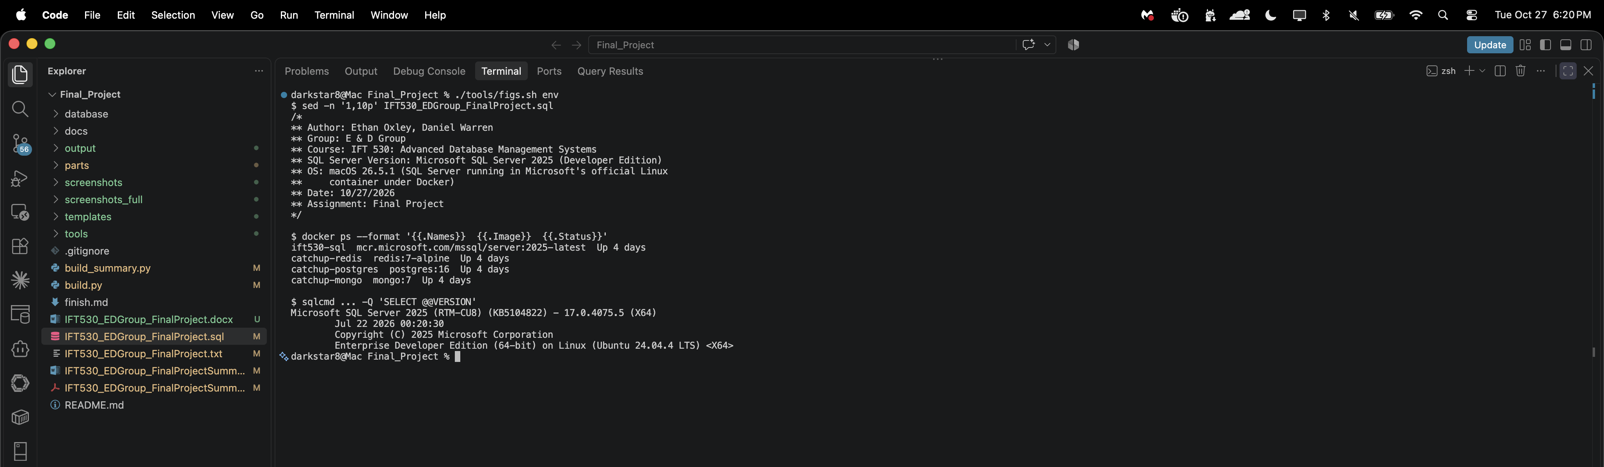
Figure 1. The environment the script was run against: the SQL Server 2025 container running under Docker, and the server version it reports. The header block required on every submitted file is shown above the output.
Requirement 1: Create the Tables (40 marks)
Ten tables, created parent-first so every foreign key points at a table that already exists. The four tables with no foreign keys of their own come first, then DimUser, then DimAccount, then the three fact tables. There are no circular references, which also means the drop order in section 2 of the script is simply this order reversed.
Two decisions are worth drawing out before the listings. The first is DimGeography, which is a role-playing dimension: five columns across four tables point at it. A user has a registered location and a last known one, an account has a billing location, and every event and every payment records where it came from. Because all five are the same table, any two of them can be compared directly — and that comparison is the whole basis of the suspicious transaction view in requirement 4.
The second is that DimUser and DimAccount are separate. A person can close an account and open another, and plan, billing status and billing address belong to the account rather than to them. Keeping them apart is what lets the data show two users holding a second account and two users holding none at all, both of which are real states a single combined table could not represent.
DimGeography
CREATE TABLE dbo.DimGeography (
GeoID INT NOT NULL,
CountryCode CHAR(2) NOT NULL,
CountryName VARCHAR(60) NOT NULL,
Region VARCHAR(40) NOT NULL,
City VARCHAR(60) NOT NULL,
Latitude DECIMAL(9,6) NOT NULL,
Longitude DECIMAL(9,6) NOT NULL,
RiskTier VARCHAR(10) NOT NULL,
CONSTRAINT PK_Geography PRIMARY KEY (GeoID),
CONSTRAINT CK_Geo_Region CHECK
(Region IN ('North America', 'EMEA', 'APAC', 'LATAM')),
CONSTRAINT CK_Geo_Latitude CHECK (Latitude BETWEEN -90 AND 90),
CONSTRAINT CK_Geo_Longitude CHECK (Longitude BETWEEN -180 AND 180),
CONSTRAINT CK_Geo_RiskTier CHECK
(RiskTier IN ('Low', 'Medium', 'High'))
);

DimPlan
CREATE TABLE dbo.DimPlan (
PlanID INT NOT NULL,
PlanName VARCHAR(30) NOT NULL,
PriceUSD DECIMAL(6,2) NOT NULL,
BillingPeriod VARCHAR(10) NOT NULL,
IsPaid BIT NOT NULL CONSTRAINT DF_Plan_IsPaid DEFAULT 0,
TrialDays INT NOT NULL,
AdsEnabled BIT NOT NULL CONSTRAINT DF_Plan_Ads DEFAULT 1,
EffectiveDate DATE NOT NULL,
CONSTRAINT PK_Plan PRIMARY KEY (PlanID),
CONSTRAINT UQ_Plan_Name UNIQUE (PlanName),
CONSTRAINT CK_Plan_Price CHECK (PriceUSD >= 0),
CONSTRAINT CK_Plan_Trial CHECK (TrialDays >= 0),
CONSTRAINT CK_Plan_Period CHECK
(BillingPeriod IN ('Monthly', 'Annual', 'None'))
);

DimProduct
CREATE TABLE dbo.DimProduct (
ProductID INT NOT NULL,
ProductName VARCHAR(60) NOT NULL,
ProductCategory VARCHAR(20) NOT NULL,
ListPriceUSD DECIMAL(6,2) NOT NULL,
IsActive BIT NOT NULL
CONSTRAINT DF_Product_Active DEFAULT 1,
ReleaseDate DATE NOT NULL,
CONSTRAINT PK_Product PRIMARY KEY (ProductID),
CONSTRAINT CK_Product_Price CHECK (ListPriceUSD > 0),
CONSTRAINT CK_Product_Category CHECK
(ProductCategory IN ('Currency', 'Cosmetic', 'BattlePass',
'Subscription'))
);

DimCampaign
CREATE TABLE dbo.DimCampaign (
CampaignID INT NOT NULL,
CampaignName VARCHAR(60) NOT NULL,
Channel VARCHAR(30) NOT NULL,
CostModel VARCHAR(10) NOT NULL,
StartDate DATE NOT NULL,
EndDate DATE NULL,
BudgetUSD DECIMAL(10,2) NOT NULL,
CONSTRAINT PK_Campaign PRIMARY KEY (CampaignID),
CONSTRAINT CK_Campaign_Budget CHECK (BudgetUSD >= 0),
CONSTRAINT CK_Campaign_Channel CHECK
(Channel IN ('Paid Search', 'Social', 'Influencer', 'Email',
'Organic')),
CONSTRAINT CK_Campaign_CostModel CHECK
(CostModel IN ('CPC', 'CPM', 'CPI')),
/* NULL EndDate means still running, so the check has to allow it. */
CONSTRAINT CK_Campaign_Dates CHECK
(EndDate IS NULL OR EndDate >= StartDate)
);

DimUser
CREATE TABLE dbo.DimUser (
UserID INT NOT NULL,
Username VARCHAR(30) NOT NULL,
Email VARCHAR(100) NOT NULL,
SignupDate DATE NOT NULL,
RegisteredGeoID INT NOT NULL,
LastSeenGeoID INT NULL,
LastSeenAt DATETIME2 NULL,
AgeBand VARCHAR(10) NOT NULL,
PreferredDevice VARCHAR(20) NOT NULL,
LifecycleStage VARCHAR(12) NOT NULL,
AcqCampaignID INT NULL,
AcqCostUSD DECIMAL(8,2) NULL,
CONSTRAINT PK_User PRIMARY KEY (UserID),
CONSTRAINT UQ_User_Username UNIQUE (Username),
CONSTRAINT FK_User_RegGeo FOREIGN KEY (RegisteredGeoID)
REFERENCES dbo.DimGeography (GeoID),
CONSTRAINT FK_User_LastGeo FOREIGN KEY (LastSeenGeoID)
REFERENCES dbo.DimGeography (GeoID),
CONSTRAINT FK_User_Campaign FOREIGN KEY (AcqCampaignID)
REFERENCES dbo.DimCampaign (CampaignID),
CONSTRAINT CK_User_AcqCost CHECK (AcqCostUSD >= 0),
CONSTRAINT CK_User_AgeBand CHECK
(AgeBand IN ('13-17', '18-24', '25-34', '35-49', '50+')),
CONSTRAINT CK_User_Device CHECK
(PreferredDevice IN ('iOS', 'Android', 'PC', 'Console')),
CONSTRAINT CK_User_Lifecycle CHECK
(LifecycleStage IN ('New', 'Active', 'AtRisk', 'Churned',
'Banned'))
);

DimAccount
CREATE TABLE dbo.DimAccount (
AccountID INT NOT NULL,
UserID INT NOT NULL,
AccountNumber VARCHAR(20) NOT NULL,
PlanID INT NOT NULL,
AccountStatus VARCHAR(12) NOT NULL,
OpenedDate DATE NOT NULL,
ClosedDate DATE NULL,
IsAutoRenew BIT NOT NULL
CONSTRAINT DF_Account_Renew DEFAULT 1,
BillingGeoID INT NOT NULL,
CONSTRAINT PK_Account PRIMARY KEY (AccountID),
CONSTRAINT UQ_Account_Number UNIQUE (AccountNumber),
CONSTRAINT FK_Account_User FOREIGN KEY (UserID)
REFERENCES dbo.DimUser (UserID),
CONSTRAINT FK_Account_Plan FOREIGN KEY (PlanID)
REFERENCES dbo.DimPlan (PlanID),
CONSTRAINT FK_Account_BillGeo FOREIGN KEY (BillingGeoID)
REFERENCES dbo.DimGeography (GeoID),
CONSTRAINT CK_Account_Dates CHECK
(ClosedDate IS NULL OR ClosedDate >= OpenedDate),
CONSTRAINT CK_Account_Status CHECK
(AccountStatus IN ('Trial', 'Active', 'PastDue', 'Cancelled',
'Suspended'))
);

FactUserEvent
CREATE TABLE dbo.FactUserEvent (
EventID INT IDENTITY(1,1) NOT NULL,
UserID INT NOT NULL,
SessionID INT NOT NULL,
GeoID INT NOT NULL,
EventType VARCHAR(20) NOT NULL,
EventTS DATETIME2 NOT NULL,
LevelNumber INT NULL,
Outcome VARCHAR(10) NULL,
DeviceType VARCHAR(20) NOT NULL,
SourceSystem VARCHAR(30) NOT NULL,
CONSTRAINT PK_UserEvent PRIMARY KEY (EventID),
CONSTRAINT FK_Event_User FOREIGN KEY (UserID)
REFERENCES dbo.DimUser (UserID),
CONSTRAINT FK_Event_Geo FOREIGN KEY (GeoID)
REFERENCES dbo.DimGeography (GeoID),
CONSTRAINT CK_Event_Level CHECK (LevelNumber BETWEEN 1 AND 10),
CONSTRAINT CK_Event_Type CHECK
(EventType IN ('SessionStart', 'SessionEnd', 'LevelStart',
'LevelComplete', 'LevelFail', 'ItemUsed',
'AdWatched')),
CONSTRAINT CK_Event_Outcome CHECK
(Outcome IN ('Win', 'Loss', 'Abandon')),
CONSTRAINT CK_Event_Device CHECK
(DeviceType IN ('iOS', 'Android', 'PC', 'Console')),
CONSTRAINT CK_Event_Source CHECK
(SourceSystem IN ('GameClient', 'MobileSDK', 'WebClient'))
);

FactPayment
CREATE TABLE dbo.FactPayment (
PaymentID INT IDENTITY(1,1) NOT NULL,
AccountID INT NOT NULL,
ProductID INT NULL,
CampaignID INT NULL,
GeoID INT NOT NULL,
PaymentTS DATETIME2 NOT NULL,
AmountUSD DECIMAL(8,2) NOT NULL,
PaymentType VARCHAR(12) NOT NULL,
PaymentMethod VARCHAR(20) NOT NULL,
IsFlagged BIT NOT NULL
CONSTRAINT DF_Payment_Flag DEFAULT 0,
SourceSystem VARCHAR(30) NOT NULL,
CONSTRAINT PK_Payment PRIMARY KEY (PaymentID),
CONSTRAINT FK_Payment_Account FOREIGN KEY (AccountID)
REFERENCES dbo.DimAccount (AccountID),
CONSTRAINT FK_Payment_Product FOREIGN KEY (ProductID)
REFERENCES dbo.DimProduct (ProductID),
CONSTRAINT FK_Payment_Campaign FOREIGN KEY (CampaignID)
REFERENCES dbo.DimCampaign (CampaignID),
CONSTRAINT FK_Payment_Geo FOREIGN KEY (GeoID)
REFERENCES dbo.DimGeography (GeoID),
CONSTRAINT CK_Payment_Amount CHECK (AmountUSD > 0),
CONSTRAINT CK_Payment_Type CHECK
(PaymentType IN ('OneTime', 'Subscription', 'Refund')),
CONSTRAINT CK_Payment_Method CHECK
(PaymentMethod IN ('Card', 'PayPal', 'AppStore', 'GooglePlay')),
CONSTRAINT CK_Payment_Source CHECK
(SourceSystem IN ('BillingAPI', 'AppStore', 'PlayStore'))
);

FactSubscription
CREATE TABLE dbo.FactSubscription (
SubEventID INT IDENTITY(1,1) NOT NULL,
AccountID INT NOT NULL,
PlanID INT NOT NULL,
PrevPlanID INT NULL,
EventType VARCHAR(12) NOT NULL,
EventDate DATE NOT NULL,
MRRDeltaUSD DECIMAL(8,2) NOT NULL,
TermMonths INT NULL,
CancelReason VARCHAR(40) NULL,
SourceSystem VARCHAR(30) NOT NULL,
CONSTRAINT PK_Subscription PRIMARY KEY (SubEventID),
CONSTRAINT FK_Sub_Account FOREIGN KEY (AccountID)
REFERENCES dbo.DimAccount (AccountID),
CONSTRAINT FK_Sub_Plan FOREIGN KEY (PlanID)
REFERENCES dbo.DimPlan (PlanID),
CONSTRAINT FK_Sub_PrevPlan FOREIGN KEY (PrevPlanID)
REFERENCES dbo.DimPlan (PlanID),
CONSTRAINT CK_Sub_Term CHECK (TermMonths > 0),
CONSTRAINT CK_Sub_EventType CHECK
(EventType IN ('Start', 'Renew', 'Upgrade', 'Downgrade',
'Cancel', 'Expire')),
CONSTRAINT CK_Sub_Source CHECK
(SourceSystem IN ('BillingAPI', 'AppStore', 'PlayStore'))
);

DimPlanAudit
CREATE TABLE dbo.DimPlanAudit (
AuditID INT IDENTITY(1,1) NOT NULL,
PlanID INT NOT NULL,
ChangeType VARCHAR(6) NOT NULL,
OldPlanName VARCHAR(30) NULL,
NewPlanName VARCHAR(30) NULL,
OldPriceUSD DECIMAL(6,2) NULL,
NewPriceUSD DECIMAL(6,2) NULL,
OldIsPaid BIT NULL,
NewIsPaid BIT NULL,
ChangedBy VARCHAR(128) NOT NULL
CONSTRAINT DF_Audit_By DEFAULT SUSER_SNAME(),
ChangedAt DATETIME2 NOT NULL
CONSTRAINT DF_Audit_At DEFAULT SYSDATETIME(),
CONSTRAINT PK_PlanAudit PRIMARY KEY (AuditID),
CONSTRAINT CK_Audit_ChangeType CHECK
(ChangeType IN ('INSERT', 'UPDATE', 'DELETE'))
);

Indexes
The primary keys give a clustered index each and the foreign keys give none, so these six cover the columns the later sections actually filter and join on. At ten users the optimizer will ignore them and scan the table every time; they are here because the schema is designed for a hundred thousand, where the two timestamp columns are what every time-series query ranges over.
CREATE INDEX IX_Event_TS ON dbo.FactUserEvent (EventTS);
CREATE INDEX IX_Event_User ON dbo.FactUserEvent (UserID);
CREATE INDEX IX_Payment_TS ON dbo.FactPayment (PaymentTS);
CREATE INDEX IX_Payment_Acct ON dbo.FactPayment (AccountID);
CREATE INDEX IX_Sub_Account ON dbo.FactSubscription (AccountID);
CREATE INDEX IX_User_Lifecyc ON dbo.DimUser (LifecycleStage);

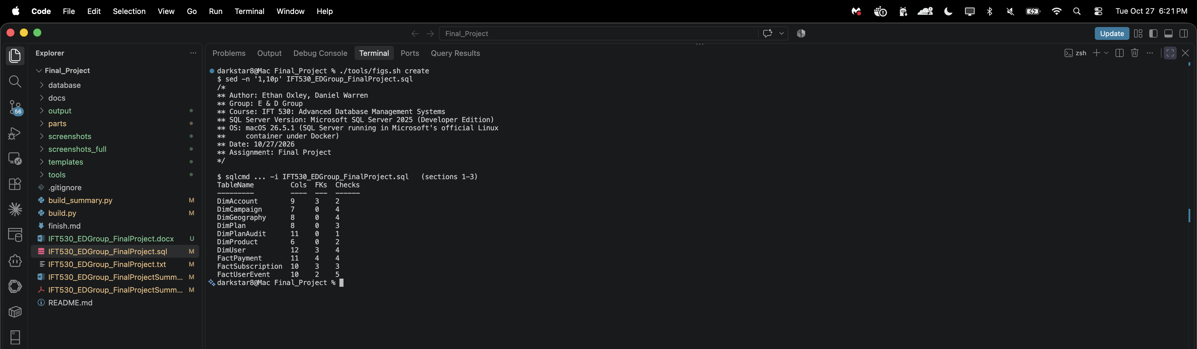
Figure 2. The ten tables after the script created them, read back out of sys.tables with their column, foreign key and check constraint counts. Fifteen foreign keys and thirty-two check constraints across the ten tables.
Requirement 2: Entity Relationship Diagram (5 marks)
The diagram below is rendered by tools/erd_html.py from the schema in section 3 of the script, and every table, column, type, nullability and key in it was compared against sys.tables, sys.columns and sys.foreign_keys on the live database before it was captured. All ten tables and all fifteen foreign keys agree, so every line in it is a constraint the server actually holds, not one drawn by hand.
The shape to look for is the two hubs. DimGeography is the first: the five lines converging on it are the registered and last-seen locations on DimUser, the billing location on DimAccount, and the transaction locations on FactUserEvent and FactPayment. DimPlan is the second, with three: the account's current plan, and both the new and previous plan on FactSubscription, which is what makes an upgrade and a downgrade distinguishable. Everything else flows left to right from the dimensions into the facts, and nothing flows back, which is how the diagram shows there are no circular references.
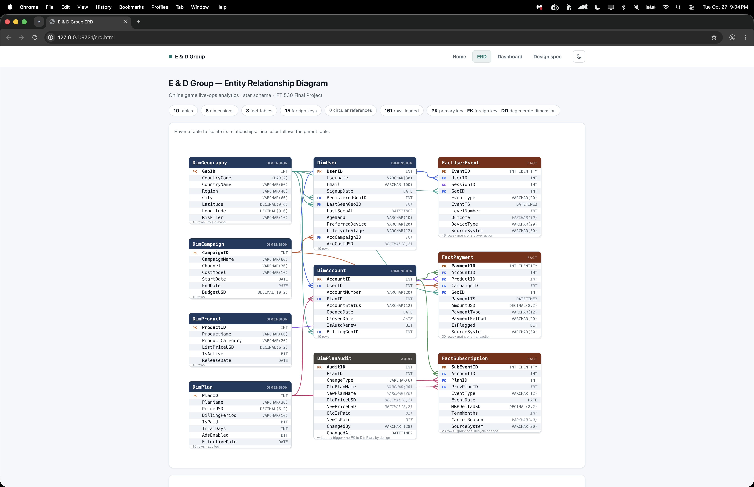
Figure 3. Entity relationship diagram for the E_D_Group database, checked against the live catalog, showing all ten tables and the fifteen foreign key relationships between them.
Requirement 3: Populate the Tables (20 marks)
Every dimension holds exactly ten rows. The three fact tables hold 48, 30 and 23 rows, all inside the 20 to 50 the assignment asks for. DimPlanAudit is not loaded here at all: it is written only by the trigger in section 6, so it starts empty.
Ten players over a short window will not demonstrate a reporting database by accident, so the rows were laid out deliberately rather than drawn at random. The window is 30 days and crosses a month boundary, so the monthly procedure returns two rows rather than one. The twelve sessions sit on nine days, and three of those days carry more than one player, so daily active users moves between one and three instead of being flat. Nine accounts are open and they cover both a free and a paid plan. Level five is lost three times out of four. Three payments happen in countries the account holder was nowhere near minutes earlier.
Each of those is a property that a view, the procedure or the cursor depends on, and at this size a random draw can miss all of them at once. The generator asserts every one of them before it writes an INSERT, so a change that would quietly empty a result set fails when the data is built instead of being noticed by whoever reads the report.
The rows are literal INSERT statements, so the script is self-contained. They were produced by a generator with a fixed seed, which is why the data is reproducible and why the numbers quoted throughout this document are stable. A short extract is shown below.
INSERT INTO dbo.DimGeography
(GeoID, CountryCode, CountryName, Region, City,
Latitude, Longitude, RiskTier)
VALUES
(1,'US','United States','North America','Phoenix',33.448377,-112.074037,'Low'),
(2,'US','United States','North America','Seattle',47.606209,-122.332071,'Low'),
(3,'CA','Canada','North America','Toronto',43.653226,-79.383184,'Low'),
(4,'GB','United Kingdom','EMEA','London',51.507351,-0.127758,'Low'),
(5,'DE','Germany','EMEA','Berlin',52.520007,13.404954,'Low'),
(6,'BR','Brazil','LATAM','Sao Paulo',-23.55052,-46.633309,'Medium'),
(7,'IN','India','APAC','Mumbai',19.075984,72.877656,'Medium'),
(8,'PH','Philippines','APAC','Manila',14.599512,120.984219,'Medium'),
(9,'NG','Nigeria','EMEA','Lagos',6.524379,3.379206,'High'),
(10,'RU','Russia','EMEA','Moscow',55.755826,37.6173,'High');

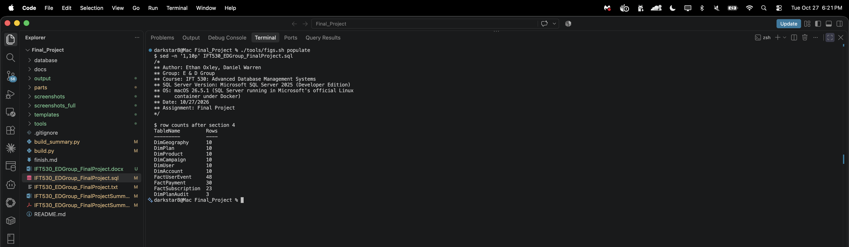
Figure 4. Row counts in all ten tables after the populate section ran, counted back out of the tables themselves.
Requirement 4: Three Queries Converted Into Views (30 marks)
All three join more than one table and all three restrict with a WHERE clause. The three restrictions are deliberately different in kind: the first throws out rows before grouping, the second restricts to open accounts, and the third is a restriction that only exists because two copies of one dimension are being compared against each other.
None of the three has an ORDER BY inside it. SQL Server does not allow one in a view definition without TOP or OFFSET, because a view is a table expression and a table has no order; the ordering belongs to whoever reads the view. None uses WITH SCHEMABINDING either, because binding a view to the columns it reads would block the DROP TABLE statements that make the script re-runnable.
View 1: vwDailyActiveUsers
Why this is useful: daily actives is the number this business is run on, but on its own it only says how busy yesterday was. Divided by the rolling thirty-day count it becomes stickiness — what share of the people who played this month played today — which is the difference between a game people return to and one they tried once. Splitting it free against paid in the same view shows whether paying players are the ones coming back.
The rolling count is a CROSS APPLY rather than a window function because SQL Server has no COUNT(DISTINCT) OVER (). A correlated subquery per day is the way to get a distinct count over a moving window. Only SessionStart rows are counted, so a long session does not make somebody more active than a short one.
CREATE VIEW dbo.vwDailyActiveUsers
AS
SELECT d.ActivityDate,
d.DAU,
d.PaidDAU,
d.FreeDAU,
m.Rolling30DayMAU,
CAST(100.0 * d.DAU / NULLIF(m.Rolling30DayMAU, 0)
AS DECIMAL(5,2)) AS StickinessPct
FROM (
SELECT CAST(e.EventTS AS date) AS ActivityDate,
COUNT(DISTINCT e.UserID) AS DAU,
COUNT(DISTINCT CASE WHEN p.IsPaid = 1
THEN e.UserID END) AS PaidDAU,
COUNT(DISTINCT CASE WHEN p.IsPaid = 0
THEN e.UserID END) AS FreeDAU
FROM dbo.FactUserEvent AS e
JOIN dbo.DimUser AS u ON u.UserID = e.UserID
LEFT JOIN dbo.DimAccount AS a
ON a.UserID = u.UserID
AND a.ClosedDate IS NULL
LEFT JOIN dbo.DimPlan AS p ON p.PlanID = a.PlanID
WHERE e.EventType = 'SessionStart'
AND u.LifecycleStage <> 'Banned'
GROUP BY CAST(e.EventTS AS date)
) AS d
CROSS APPLY (
SELECT COUNT(DISTINCT e2.UserID) AS Rolling30DayMAU
FROM dbo.FactUserEvent AS e2
JOIN dbo.DimUser AS u2 ON u2.UserID = e2.UserID
WHERE e2.EventType = 'SessionStart'
AND u2.LifecycleStage <> 'Banned'
AND e2.EventTS >= DATEADD(day, -29,
CAST(d.ActivityDate AS datetime2))
AND e2.EventTS < DATEADD(day, 1,
CAST(d.ActivityDate AS datetime2))
) AS m;

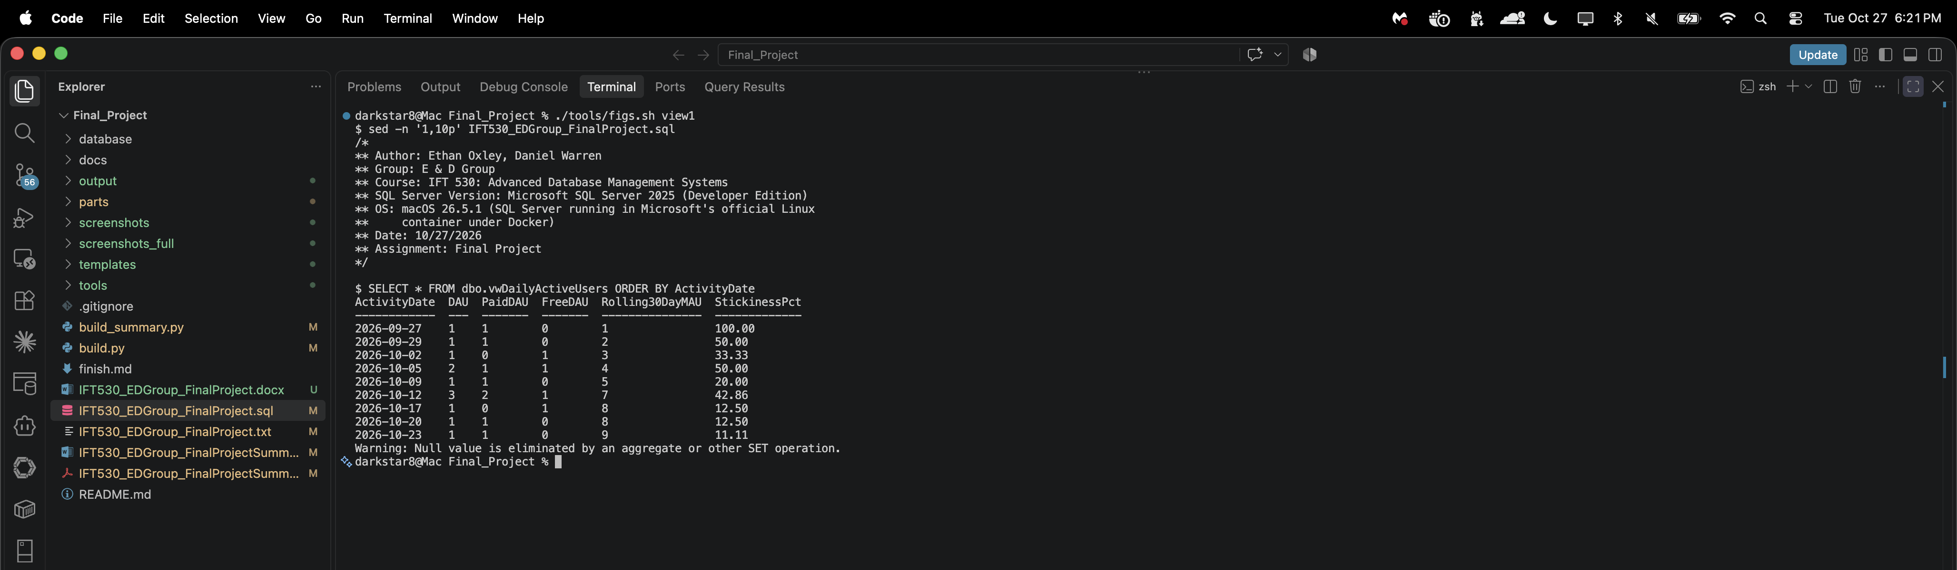
Figure 5. Every active day in vwDailyActiveUsers: daily active users split free against paid, the rolling thirty-day count, and the stickiness ratio between them. Days nobody played do not appear, which is why there are nine rows and not thirty.
View 2: vwFreeVsPaidValue
Why this is useful: it answers the question every pricing argument turns on, which is whether paying players genuinely play more or simply pay. It also surfaces something the plan table alone would hide — the free tier produces more total revenue than any single paid plan, because free players buy one-time store items. That is the real free-to-play dynamic, and it is an argument against judging the free tier as a cost.
Engagement and revenue sit in different fact tables at different grains, so they are aggregated separately through OUTER APPLY and only then brought together. Joining both fact tables directly would multiply sessions by payments and overstate both. Refunds are subtracted rather than ignored, so the revenue column is net.
CREATE VIEW dbo.vwFreeVsPaidValue
AS
SELECT pl.IsPaid,
pl.PlanName,
pl.PriceUSD,
COUNT(DISTINCT a.AccountID) AS Accounts,
SUM(ev.Sessions) AS Sessions,
SUM(ev.Events) AS Events,
CAST(AVG(CAST(ev.Sessions AS DECIMAL(9,2)))
AS DECIMAL(9,2)) AS AvgSessionsPerAccount,
CAST(SUM(pay.NetRevenue) AS DECIMAL(10,2)) AS NetRevenueUSD,
CAST(SUM(pay.NetRevenue) /
NULLIF(COUNT(DISTINCT a.AccountID), 0)
AS DECIMAL(10,2)) AS RevenuePerAccountUSD
FROM dbo.DimAccount AS a
JOIN dbo.DimPlan AS pl ON pl.PlanID = a.PlanID
JOIN dbo.DimUser AS u ON u.UserID = a.UserID
OUTER APPLY (
SELECT COUNT(DISTINCT e.SessionID) AS Sessions,
COUNT(*) AS Events
FROM dbo.FactUserEvent AS e
WHERE e.UserID = u.UserID
) AS ev
OUTER APPLY (
SELECT ISNULL(SUM(CASE WHEN f.PaymentType = 'Refund'
THEN -f.AmountUSD
ELSE f.AmountUSD END), 0) AS NetRevenue
FROM dbo.FactPayment AS f
WHERE f.AccountID = a.AccountID
) AS pay
WHERE a.ClosedDate IS NULL
GROUP BY pl.IsPaid, pl.PlanName, pl.PriceUSD;

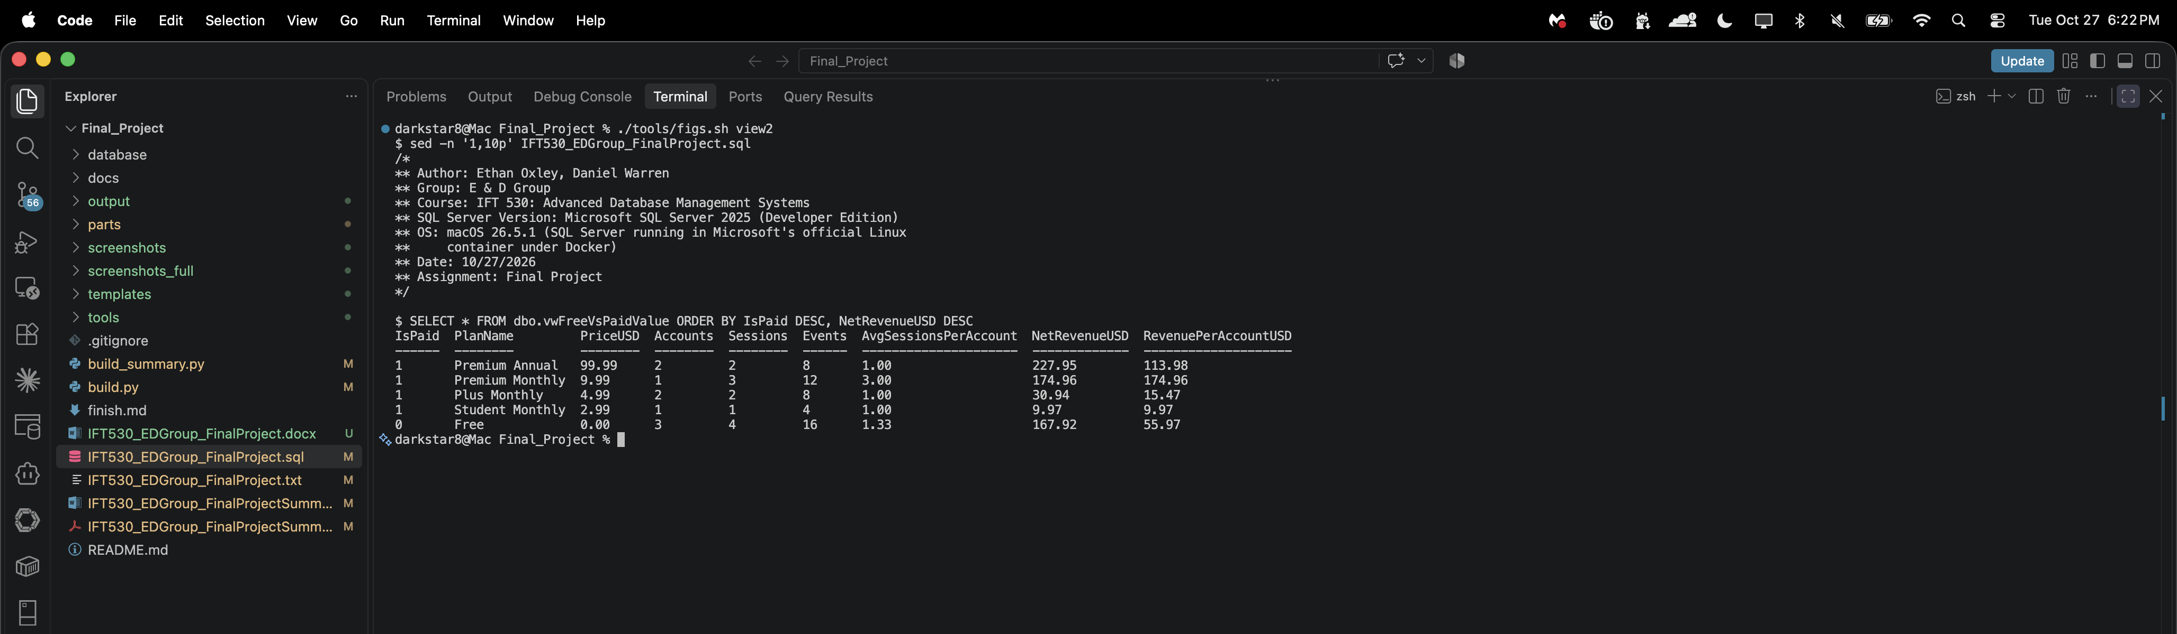
Figure 6. vwFreeVsPaidValue: engagement and net revenue per plan, paid plans first. The free tier's total revenue comes entirely from one-time store purchases.
View 3: vwSuspiciousTransactions
Why this is useful: this is the query the whole geography design was built for. DimGeography is joined three times against the same payment — once as where the money moved, once as where the account was registered, once as where the person was last seen — and the suspicion is entirely in the disagreement between those three.
There are three rules. A payment from a country the person never registered in. A payment from a place the dimension marks as high risk. And an implied speed between the last session and the payment of over 900 km/h, which is faster than a commercial flight. That last one is where the distance function earns its place: distance alone says nothing, because people travel, but distance divided by the minutes since they were last seen says whether a human body could have made the trip.
One limitation is worth stating rather than hiding. LastSeenAt is the person's most recent session, full stop, not the last one before this particular payment. That is the right comparison for a screen running against live traffic, where the payment being checked is the newest thing that has happened; run over history it is backwards for any payment older than that session. Those rows show NULL for the elapsed minutes rather than a negative number, and the travel rule cannot fire on them.
CREATE VIEW dbo.vwSuspiciousTransactions
AS
SELECT f.PaymentID,
u.Username,
a.AccountNumber,
f.PaymentTS,
f.AmountUSD,
f.PaymentMethod,
rg.CountryCode AS RegisteredCountry,
pg.CountryCode AS PaymentCountry,
pg.RiskTier AS PaymentRiskTier,
lg.CountryCode AS LastSeenCountry,
CASE WHEN f.PaymentTS >= u.LastSeenAt
THEN DATEDIFF(minute, u.LastSeenAt, f.PaymentTS)
END AS MinsSinceLastSeen,
dbo.fnGeoDistanceKm(u.LastSeenGeoID, f.GeoID) AS KmFromLastSeen,
CASE
WHEN u.LastSeenAt IS NOT NULL
AND DATEDIFF(minute, u.LastSeenAt, f.PaymentTS) BETWEEN 1 AND 600
AND dbo.fnGeoDistanceKm(u.LastSeenGeoID, f.GeoID) /
(DATEDIFF(minute, u.LastSeenAt, f.PaymentTS) / 60.0) > 900
THEN 'Impossible travel'
WHEN pg.RiskTier = 'High'
THEN 'High risk location'
ELSE 'Country mismatch'
END AS Reason
FROM dbo.FactPayment AS f
JOIN dbo.DimAccount AS a ON a.AccountID = f.AccountID
JOIN dbo.DimUser AS u ON u.UserID = a.UserID
JOIN dbo.DimGeography AS pg ON pg.GeoID = f.GeoID
JOIN dbo.DimGeography AS rg ON rg.GeoID = u.RegisteredGeoID
LEFT JOIN dbo.DimGeography AS lg ON lg.GeoID = u.LastSeenGeoID
WHERE f.PaymentType <> 'Refund'
AND (pg.CountryCode <> rg.CountryCode OR pg.RiskTier = 'High');

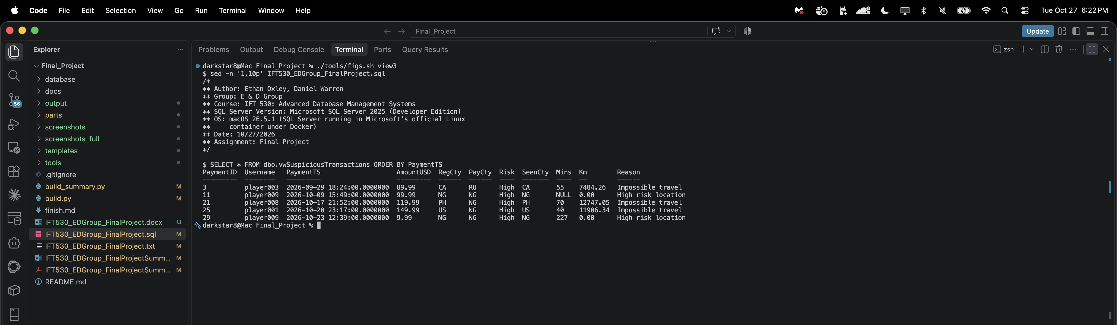
Figure 7. vwSuspiciousTransactions: five payments of 30 flagged. The three impossible-travel rows show the distance and the elapsed minutes that triggered them, including one payment 12,747 km from the last session seventy minutes earlier. The other two are flagged because the account holder is registered in a high-risk country, which is a different test and the view says so.
Requirement 5: Audit Table (20 marks)
DimPlan is the lookup table being audited. It is the right choice because its rows are the ones that genuinely change: a price rise, a plan being made free, a plan being retired. Every one of those is a change somebody will later have to account for, and none of them leaves a trace in the table itself.
DimPlanAudit records the old and new value of the three columns worth watching, who made the change, and the datetime it happened, which is the column the assignment specifically asks for. It deliberately has no foreign key back to DimPlan: a DELETE audit row has to outlive the row it describes, and a foreign key would either block the delete or cascade the history away.
One trigger covers all three operations. SQL Server gives a trigger two pseudo-tables, inserted and deleted, and which of them has rows is what the operation is — rows in inserted only is an INSERT, rows in both is an UPDATE, rows in deleted only is a DELETE. So the three cases are three statements against those tables rather than three separate triggers. The trigger is set-based, which means it handles a statement that changes ten rows as correctly as one that changes one.
CREATE TRIGGER dbo.TR_DimPlan_Audit
ON dbo.DimPlan
AFTER INSERT, UPDATE, DELETE
AS
BEGIN
SET NOCOUNT ON;

/* UPDATE: a row on both sides, keyed on PlanID. */
INSERT INTO dbo.DimPlanAudit
(PlanID, ChangeType, OldPlanName, NewPlanName,
OldPriceUSD, NewPriceUSD, OldIsPaid, NewIsPaid)
SELECT i.PlanID, 'UPDATE',
d.PlanName, i.PlanName,
d.PriceUSD, i.PriceUSD,
d.IsPaid, i.IsPaid
FROM inserted AS i
JOIN deleted AS d ON d.PlanID = i.PlanID;

/* INSERT: in inserted, with no matching row in deleted. */
INSERT INTO dbo.DimPlanAudit
(PlanID, ChangeType, OldPlanName, NewPlanName,
OldPriceUSD, NewPriceUSD, OldIsPaid, NewIsPaid)
SELECT i.PlanID, 'INSERT',
NULL, i.PlanName,
NULL, i.PriceUSD,
NULL, i.IsPaid
FROM inserted AS i
WHERE NOT EXISTS (SELECT 1 FROM deleted AS d
WHERE d.PlanID = i.PlanID);

/* DELETE: in deleted, with no matching row in inserted. */
INSERT INTO dbo.DimPlanAudit
(PlanID, ChangeType, OldPlanName, NewPlanName,
OldPriceUSD, NewPriceUSD, OldIsPaid, NewIsPaid)
SELECT d.PlanID, 'DELETE',
d.PlanName, NULL,
d.PriceUSD, NULL,
d.IsPaid, NULL
FROM deleted AS d
WHERE NOT EXISTS (SELECT 1 FROM inserted AS i
WHERE i.PlanID = d.PlanID);
END;

The test of all three operations
The script inserts a test plan, updates its price, deletes it, and then reads the audit table. PlanID 99 is used throughout and removed at the end, so DimPlan is left exactly as it was found and the script stays re-runnable. The three audit rows are deliberately not cleaned up: they are the evidence the trigger fired.
/* 1 of 3 - INSERT a new plan. */
PRINT '== Audit test 1: INSERT plan 99';
INSERT INTO dbo.DimPlan
(PlanID, PlanName, PriceUSD, BillingPeriod, IsPaid,
TrialDays, AdsEnabled, EffectiveDate)
VALUES
(99, 'Audit Test Plan', 7.99, 'Monthly', 1, 7, 0, '2026-10-26');
GO

/* 2 of 3 - UPDATE it: a price rise and the ad flag turned back on,
which is the kind of change this audit table exists to capture. */
PRINT '== Audit test 2: UPDATE the price of plan 99';
UPDATE dbo.DimPlan
SET PriceUSD = 9.99,
AdsEnabled = 1
WHERE PlanID = 99;
GO

/* 3 of 3 - DELETE it. */
PRINT '== Audit test 3: DELETE plan 99';
DELETE FROM dbo.DimPlan
WHERE PlanID = 99;
GO

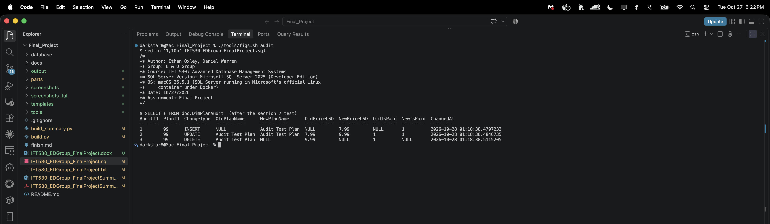
Figure 8. The audit table after the insert, update and delete test. Each row carries the operation, the before and after values, and the datetime the change was made.
Requirement 6: Stored Procedure and Function (20 marks)
fnGeoDistanceKm
A scalar function returning the great-circle distance in kilometers between two places, using the haversine formula. It exists because "the payment came from a different country" is a weak signal on its own — plenty of people travel — while "the payment came from 11,000 km away, forty minutes after they were last seen" is not something a traveler can do. View 3 divides this by the elapsed time to get an implied speed, and that is what separates a holiday from a stolen card. It returns NULL rather than zero when either location is unknown, because a user who has never played has no last-seen location and that is not a distance of nothing.
CREATE FUNCTION dbo.fnGeoDistanceKm
(
@GeoID1 INT,
@GeoID2 INT
)
RETURNS DECIMAL(10,2)
AS
BEGIN
DECLARE @lat1 FLOAT, @lon1 FLOAT,
@lat2 FLOAT, @lon2 FLOAT;

SELECT @lat1 = Latitude, @lon1 = Longitude
FROM dbo.DimGeography
WHERE GeoID = @GeoID1;

SELECT @lat2 = Latitude, @lon2 = Longitude
FROM dbo.DimGeography
WHERE GeoID = @GeoID2;

/* Either side unknown means no answer, not a distance of zero.
A NULL LastSeenGeoID is a user who has never played. */
IF @lat1 IS NULL OR @lat2 IS NULL
RETURN NULL;

DECLARE @R FLOAT = 6371.0; -- mean earth radius, km
DECLARE @dLat FLOAT = RADIANS(@lat2 - @lat1);
DECLARE @dLon FLOAT = RADIANS(@lon2 - @lon1);

DECLARE @a FLOAT =
SIN(@dLat / 2) * SIN(@dLat / 2) +
COS(RADIANS(@lat1)) * COS(RADIANS(@lat2)) *
SIN(@dLon / 2) * SIN(@dLon / 2);

RETURN CAST(@R * 2 * ATN2(SQRT(@a), SQRT(1 - @a)) AS DECIMAL(10,2));
END;

spMonthlyActiveUsers
Monthly active users, split into new and returning, with the revenue that went with them and the average per user. @Year is required; @Month defaults to NULL, which reports every month of that year rather than forcing a caller who wants the whole year to run it twelve times. Both parameters are validated and raise a numbered error rather than returning an empty set, because an empty result and a bad argument look identical to whoever called it.
CREATE PROCEDURE dbo.spMonthlyActiveUsers
@Year INT,
@Month INT = NULL
AS
BEGIN
SET NOCOUNT ON;

IF @Year IS NULL OR @Year < 2020 OR @Year > 2100
THROW 50001, 'Year must be between 2020 and 2100.', 1;

IF @Month IS NOT NULL AND (@Month < 1 OR @Month > 12)
THROW 50002, 'Month must be between 1 and 12.', 1;

/* This procedure prints "Null value is eliminated by an aggregate"
when it runs. That is expected and is not a fault. The new and
returning counts below are COUNT(DISTINCT CASE WHEN ... END),
where the CASE returns NULL for every row outside the group
being counted, and COUNT skipping those NULLs is exactly the
mechanism that makes a conditional distinct count work. */
;WITH Activity AS (
SELECT YEAR(e.EventTS) AS ActivityYear,
MONTH(e.EventTS) AS ActivityMonth,
e.UserID,
u.SignupDate
FROM dbo.FactUserEvent AS e
JOIN dbo.DimUser AS u ON u.UserID = e.UserID
WHERE YEAR(e.EventTS) = @Year
AND (@Month IS NULL OR MONTH(e.EventTS) = @Month)
),
Revenue AS (
SELECT YEAR(f.PaymentTS) AS ActivityYear,
MONTH(f.PaymentTS) AS ActivityMonth,
SUM(CASE WHEN f.PaymentType = 'Refund'
THEN -f.AmountUSD ELSE f.AmountUSD END) AS Net
FROM dbo.FactPayment AS f
WHERE YEAR(f.PaymentTS) = @Year
AND (@Month IS NULL OR MONTH(f.PaymentTS) = @Month)
GROUP BY YEAR(f.PaymentTS), MONTH(f.PaymentTS)
)
SELECT a.ActivityYear,
a.ActivityMonth,
COUNT(DISTINCT a.UserID) AS MAU,
COUNT(DISTINCT CASE
WHEN a.SignupDate >= DATEFROMPARTS(a.ActivityYear,
a.ActivityMonth, 1)
THEN a.UserID END) AS NewUsers,
COUNT(DISTINCT CASE
WHEN a.SignupDate < DATEFROMPARTS(a.ActivityYear,
a.ActivityMonth, 1)
THEN a.UserID END) AS ReturningUsers,
ISNULL(r.Net, 0) AS NetRevenueUSD,
CAST(ISNULL(r.Net, 0) /
NULLIF(COUNT(DISTINCT a.UserID), 0)
AS DECIMAL(10,2)) AS ArpuUSD
FROM Activity AS a
LEFT JOIN Revenue AS r
ON r.ActivityYear = a.ActivityYear
AND r.ActivityMonth = a.ActivityMonth
GROUP BY a.ActivityYear, a.ActivityMonth, r.Net
ORDER BY a.ActivityYear, a.ActivityMonth;
END;

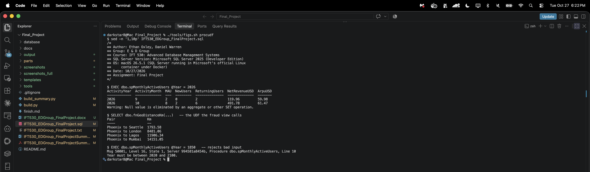
Figure 9. The procedure reporting both months of active users and revenue, the function returning distances from Phoenix, and the procedure rejecting an out-of-range year with error 50001 rather than returning nothing.
Requirement 7: Cursor (10 marks)
The cursor walks the levels in play order and prints a difficulty line for each one, comparing the difficulty the designers assigned against the failure rate the event data actually shows, and flagging any level players lose more often than they win.
A cursor is worth defending here, because set-based SQL is almost always the right answer. The output is a printed report, one PRINT per level with running commentary and a flag, and PRINT is not something a set-based statement can do per row. A result set would be the better choice for anything a program consumes; this is for a person reading a log.
On the create and drop scripts the assignment asks for: a cursor has no CREATE or DROP in T-SQL, only DECLARE and DEALLOCATE. Declaring it GLOBAL makes those two genuinely separate statements against a named object that outlives its batch, which is as close to create and drop as a cursor gets, and it means the DEALLOCATE is a real drop rather than a formality. The CURSOR_STATUS guard before it clears the name if a previous run died between OPEN and DEALLOCATE, which is what keeps this section re-runnable.
IF CURSOR_STATUS('global', 'curLevelDifficulty') >= -1
BEGIN
CLOSE curLevelDifficulty;
DEALLOCATE curLevelDifficulty;
END;

DECLARE curLevelDifficulty CURSOR GLOBAL
FOR
SELECT e.LevelNumber,
COUNT(*) AS Attempts,
SUM(CASE WHEN e.Outcome = 'Win' THEN 1 ELSE 0 END) AS Wins,
SUM(CASE WHEN e.Outcome = 'Loss' THEN 1 ELSE 0 END) AS Losses,
SUM(CASE WHEN e.Outcome = 'Abandon'
THEN 1 ELSE 0 END) AS Abandons
FROM dbo.FactUserEvent AS e
WHERE e.LevelNumber IS NOT NULL
AND e.Outcome IS NOT NULL
GROUP BY e.LevelNumber
ORDER BY e.LevelNumber;

OPEN curLevelDifficulty;

DECLARE @Level INT,
@Attempts INT,
@Wins INT,
@Losses INT,
@Abandons INT,
@WinPct DECIMAL(5,2),
@Line VARCHAR(200),
@Flagged INT = 0;

PRINT '== Level difficulty report';
PRINT 'Level Attempts Wins Losses Aband Win% Verdict';
PRINT '----- -------- ----- ------ ----- ----- -------';

FETCH NEXT FROM curLevelDifficulty
INTO @Level, @Attempts, @Wins, @Losses, @Abandons;

WHILE @@FETCH_STATUS = 0
BEGIN
SET @WinPct = CAST(100.0 * @Wins / NULLIF(@Attempts, 0)
AS DECIMAL(5,2));

SET @Line =
RIGHT(SPACE(12) + CAST(@Level AS VARCHAR(12)), 5) +
RIGHT(SPACE(12) + CAST(@Attempts AS VARCHAR(12)), 10) +
RIGHT(SPACE(12) + CAST(@Wins AS VARCHAR(12)), 7) +
RIGHT(SPACE(12) + CAST(@Losses AS VARCHAR(12)), 8) +
RIGHT(SPACE(12) + CAST(@Abandons AS VARCHAR(12)), 7) +
RIGHT(SPACE(12) + CAST(@WinPct AS VARCHAR(12)), 7) +
' ' +
CASE WHEN @WinPct < 50.0 THEN 'CHURN RISK - lost more than won'
WHEN @WinPct < 60.0 THEN 'hard'
ELSE 'ok' END;

PRINT @Line;

IF @WinPct < 50.0
SET @Flagged = @Flagged + 1;

FETCH NEXT FROM curLevelDifficulty
INTO @Level, @Attempts, @Wins, @Losses, @Abandons;
END;

PRINT '----- -------- ----- ------ ----- ----- -------';
PRINT 'Levels flagged as churn risks: ' + CAST(@Flagged AS VARCHAR(5));

/* ---- drop the cursor ----------------------------------------------- */
CLOSE curLevelDifficulty;
DEALLOCATE curLevelDifficulty;

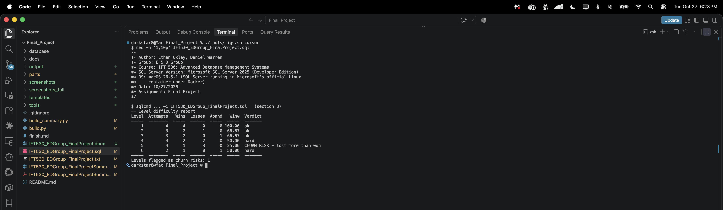
Figure 10. The level difficulty report the cursor prints. Level 5 is flagged as a churn risk: one win in four attempts. Only the levels that were actually played appear, which is six of the ten.
Requirement 8: Tests
The submission announcement asks that the script also carry the queries that test the code. Thirteen tests run at the end of the script and each reports PASS or FAIL in a column called Result, so a run can be checked by reading one column rather than by comparing numbers by eye.
What they check matters more than that they pass. Three confirm the objects exist by reading the catalog views rather than inferring it from the absence of an error message. One checks row counts. One checks that no foreign key has an orphan row. Three check the views — and for the third the test is not that it returns rows but that it returns fewer than the unrestricted table, which is what proves the WHERE clause is doing work. One checks the trigger caught all three operations. One checks the function against a distance that can be verified independently. And two check the procedure, one that it returns the months it should and one that it rejects an argument it cannot answer with error 50001 instead of coming back empty.
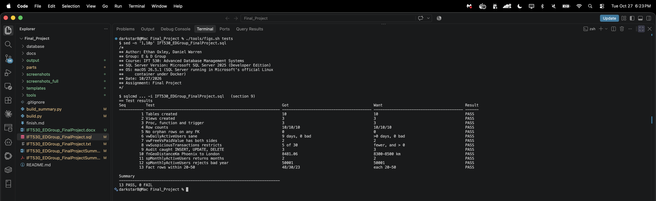
Figure 11. All thirteen tests reporting PASS, with the summary line the figure is checked against.
Running It More Than Once
Re-runnability is the requirement most likely to fail silently, so it was tested the only way that means anything, by running the file three times in a row and checking what was left behind. Every run completes with no errors and thirteen passes, and the object counts afterwards are the same ten tables, three views, one procedure, one function and one trigger the first run created.
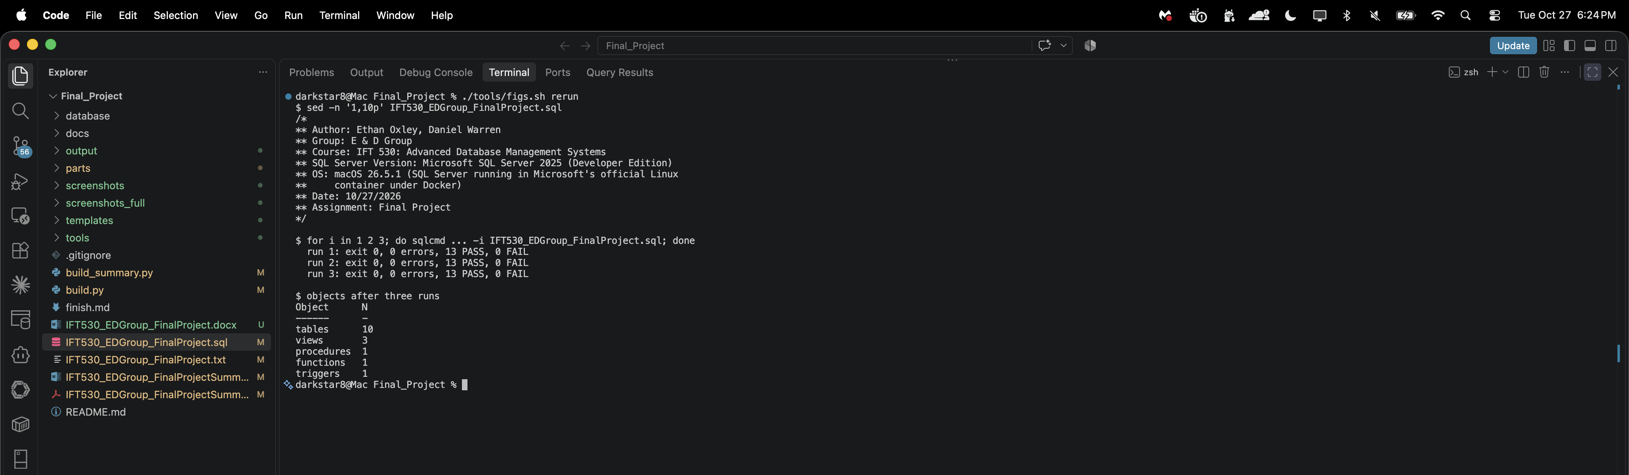
Figure 12. Three consecutive runs of the submitted script, each completing with no errors and thirteen passes, and the object counts read back out of the catalog afterwards.
Documentation Standards
The required header block is at the top of the submitted file and is visible in all eleven terminal screenshots in this document, which is what the announcement asks for. Below it, a file banner states what the script does, lists the sections in the order they run, and explains the mechanism that makes it re-runnable.
Inside the script, each of the nine sections opens with a banner carrying the requirement it satisfies and the reasoning behind the approach, each table and each object has a block comment explaining why it is shaped the way it is, and individual lines are commented only where they are not obvious. Every hand-written line stays at or under 78 characters so it reproduces as a Courier New 9 pt listing without wrapping; the generated data rows run to 86, which is what still fits in a 6.5 inch column at that size.

