Assignment 2.1: Data-Ink & Chartjunk
Daniel Warren
Arizona State University
IFT 533: Data Visualization & Reporting for IT (Fall 2026)
Asmaa Elbadrawy
August 30, 2026

Assignment 2.1: Data-Ink & Chartjunk
Problem 1: Redesigning the College-Enrollment Chart
The chart Tufte gives us here, the “Age Structure of College Enrollment” one, is a 3-D mess, and it earns all the criticism it gets. Four things are wrong with it. It uses three dimensions when there are really only two variables, the y-axis is broken twice so the scale ends up dishonest, the whole thing communicates a grand total of five numbers, and the top band is flipped upside down for no reason, so bigger ends up reading as smaller.
The thing that really gives it away is that it’s only five numbers. The two groups, under 25 and 25 and over, are complementary, they add up to 100% every single year (Table 1). So the “25 and over” numbers aren’t even their own information, they’re just 100 minus the other ones. Once you notice that, all the 3-D scaffolding and the color fills look even more pointless than they already did.
Table 1
The whole dataset — five numbers, and the two shares add up to 100%.
Year | 1972 | 1973 | 1974 | 1975 | 1976
% Under 25 | 72.0 | 70.8 | 67.2 | 66.4 | 67.0
% 25 and over | 28.0 | 29.2 | 32.8 | 33.6 | 33.0
Sum | 100.0 | 100.0 | 100.0 | 100.0 | 100.0

The fix is boring, which is kind of the point. I’d just drop it down to a plain 2-D line chart of percent of enrollment across the five years. Every change strips out ink that wasn’t doing anything. Kill the third dimension, since it encodes nothing. Use one continuous, unbroken y-axis so both breaks go away and the top band isn’t inverted anymore. Throw out the solid fills, the background, and the heavy borders. And label the lines and points right on the chart so there’s no need for a legend or a grid.
Two versions work here. Figure 1 keeps both groups on one honest axis, so it stays faithful to the original and fixes all four problems at once. Figure 2 is the one I’d actually turn in if I’m going for max data-ink, because the two shares add up to 100%, so a single line for “percent under 25” already tells you everything and drawing the second line is just redundant. Either way the story reads instantly — the under-25 share slides from 72% in 1972 down to the high-60s by 1975–76 — and it does it with a tiny fraction of the ink the original used.
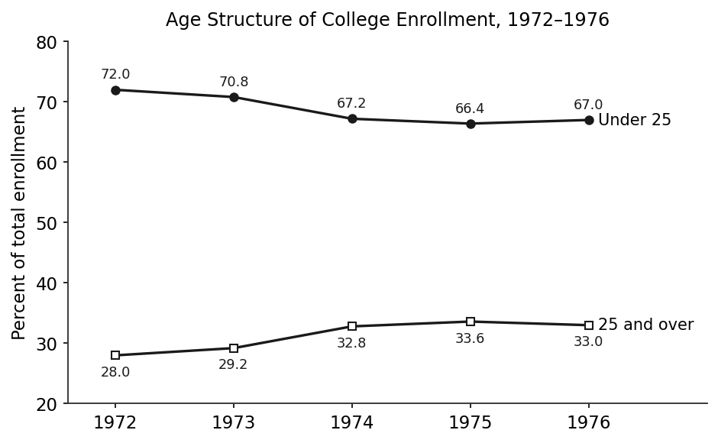
Figure 1. Both groups on one continuous axis — flat 2-D, no fills, no gridlines, directly labeled.
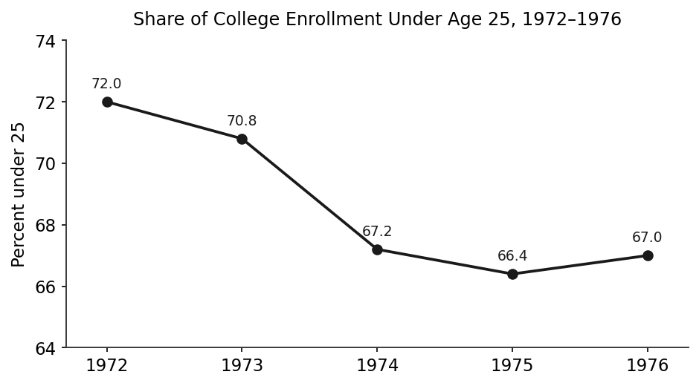
Figure 2. Max data-ink: one line for the under-25 share; “25 and over” = 100 − value, so it doesn’t need to be drawn. A hand sketch of the same line on plain axes would work just as well.
Problem 2: Activities on Chartjunk
Both of the graphics on the Activities page come from Chapter 5 of Tufte’s The Visual Display of Quantitative Information. Quick definitions first, since that’s the yardstick I’m using. Data ink is the ink that actually represents the numbers. The data-ink ratio is how much of a graphic’s total ink is data ink (data-ink divided by total ink, and higher is better). And chartjunk is everything else — the decoration, the 3-D effects, the heavy grids, the moiré patterns, all the stuff that doesn’t carry any information and usually just gets in the way.
Example 1 — The 3-D Echocardiographic “Mountains”
This one plots severity of regurgitation for 31 patients across nine time buckets after surgery, from under a month out to 43–48 months, and it draws every single reading as a little peak receding back into a 3-D box. Here’s what’s wrong with it.
First, the third dimension is pure decoration — the depth doesn’t encode anything, it just tilts everything and makes it harder to read. Second, the perspective means the front rows of peaks physically block the ones behind them, so a good chunk of the data is literally hidden from you. Third, even for the peaks you can see, trying to read a value off a tilted axis is basically guessing, and putting the y-axis on both the left and the right is just redundant ink. Fourth, the grid box around the whole thing is a cage of vibrating non-data lines. Add it all up and you’ve got a mountain of ink — hundreds of strokes for the cones plus the entire 3-D grid — spent on what’s actually a pretty small, sparse dataset. The data-ink ratio is terrible.
To fix it I’d flatten it to 2-D and just plot severity against months. Since the interesting part is the spread and the trend, a median line with a shaded range band around it does the job (Figure 3), the box drops down to two light axes, and everything gets labeled right on the chart. If the individual patients actually matter, faint sparklines or a small-multiples grid with one little panel per patient still beats the 3-D pile. Either way the takeaway — regurgitation stays mild and doesn’t really creep up over four years — reads in about a second.
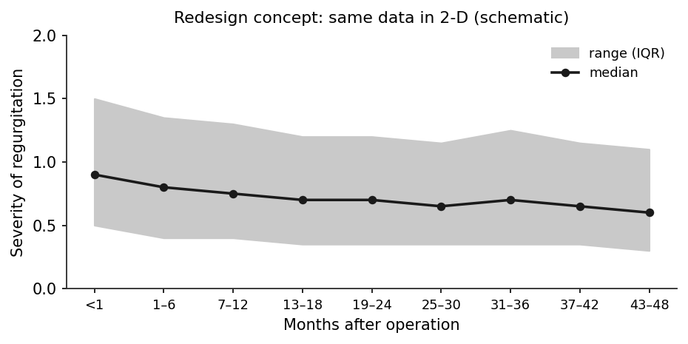
Figure 3. Redesign of Example 1 — severity over time in 2-D, median plus a range band. The values are schematic, just there to show the layout; the point is the form, not the numbers.
Example 2 — The 1927 Brazilian Cotton-Textiles Poster
The “Tecidos de Algodão” plate is actually packed with data — production, consumption, factories, looms, spindles, capital, imports, taxes — but it buries all of it under decoration. Here’s what’s wrong.
Almost every bar and wedge is filled in with heavy hatching, cross-hatching, or checkerboard, and that sets off moiré vibration, which is Tufte’s classic chartjunk sin. It’s tiring to look at and it adds exactly zero information. Then there’s ornament all over the place — a decorative border, the Rio seal, the fancy “1927” cartouche, the bilingual Portuguese/French typography — and none of that is data ink. And because the layout mixes a bunch of different chart types and fill patterns at different scales, you can’t really compare one panel to another; the donut in the middle especially, since judging arcs and angles is harder than just comparing bar lengths. So you end up with a huge amount of ink for the number of values it’s actually showing, which is a very low data-ink ratio, even though the underlying data is good.
To fix it I’d swap all the hatching and checkerboards for plain light fills or simple outlines to get rid of the moiré, then pick one honest chart type (simple bars or lines), put everything on a shared scale, and lay it out as consistent small multiples — one panel per measure, same axes, same orientation (Figure 4). Strip out the border, the seal, and the decorative type, swap the middle donut for a plain bar chart, label everything directly, and go light on the gridlines or drop them. Same data, way less ink, and now you can actually compare the panels.
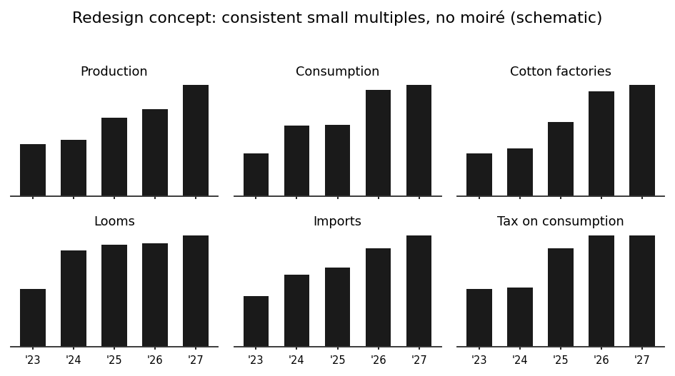
Figure 4. Redesign of Example 2 — one honest chart type on a shared scale as small multiples, no moiré fills or ornament. Schematic values, just showing the layout.
Both of my sketches try to practice what they’re preaching — one ink color, no fills, no boxes, labels right on the chart. Whatever ink is left is ink that’s actually doing something.

