# CSCE 567 Final Visualization Project Proposal

Name: Dallas Wade  
  
NOTE: Format is:  
  
Original

Feedback

Improved

Reasons

Project Purpose:

*Inform*

*For the final product, phrase your project purpose as a concise, but complete sentence. For example, fill in the blanks: "inform _____ of _____"  
  
The purpose of this project is to inform interested individuals about the correlation between poverty, gun ownership, and violent crime.*

*Changed to fit the intended form*

I. Introduction / Background

*The goal of this project is to inform readers about the correlation between poverty, gun ownership, and violent crime. Gun violence is a bigger problem in America than in any other 1st world country. Poverty is a known precursor to higher levels of violent crime. Gun ownership is also higher in the US than any other country in the world. Today, many argue that the solution to reducing gun violence will reduce gun crime. Others argue there are other solutions, ranging from mental health efforts to public programs. This project is not in support of either side, but rather simply an attempt to visualize data that could be useful in the discussion.*

*I'm not sure what you mean by "Today, many argue that the solution to reducing gun violence will reduce gun crime" Did you possibly mean ownership instead of violence?  
  
The goal of this project is to inform readers about the correlation between poverty, gun ownership, and violent crime. Gun violence is a bigger problem in America than in any other 1st world country. Poverty is a known precursor to higher levels of violent crime. Gun ownership is also higher in the US than any other country in the world. Today, many argue that the solution to reducing gun violence is reducing gun ownership. Others argue there are other solutions, ranging from mental health efforts to public programs. This project is not in support of either side, but rather simply an attempt to visualize data that could be useful in the discussion.*

*Typo, corrected*

II. Audience

*The target audience is the general public, specifically those interested in the correlation between gun ownership and violent crime.*

III. Dataset(s)

*https://dataverse.harvard.edu/file.xhtml?fileId=7107466&version=1.0*

*3500< Records, 18 Attributes*

*I do not see any issues with the data yet*

You've identified an interesting dataset. However, I don't see fields in the dataset that directly relate to gun ownership. Am I missing something? Or are you planning to get gun ownership data from another source?  
  
*For gun homicides: https://dataverse.harvard.edu/file.xhtml?fileId=7107466&version=1.0*

*3500< Records, 18 Attributes*

*For Poverty levels: https://www.census.gov/data/tables/time-series/demo/income-poverty/historical-poverty-people.html*

*For gun ownership:* [*https://www.rand.org/pubs/tools/TL354.html*](https://www.rand.org/pubs/tools/TL354.html) *1800< Records, 20 Attributes*

*I do not see any issues with the data yet*

Forgot to add the data, mistake

IV. Proposed Visualizations

*2 Line charts side by side showing the total national violent crime(1) and gun ownership(2) from selectable years, hovering over peaks will show month, year, and exact rate, can filter by state*

[*https://en.wikipedia.org/wiki/Line_chart*](https://en.wikipedia.org/wiki/Line_chart)

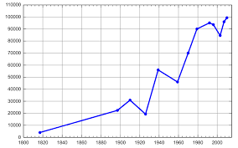

*1 Colored map, increasingly red for more violence, highlighting for Gun ownership rate, year selectable*

[*https://en.wikipedia.org/wiki/Choropleth_map*](https://en.wikipedia.org/wiki/Choropleth_map)

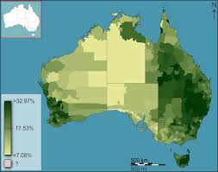

*1 Scatter plot, showing points that represent poverty levels and gun violence, selectable year*

*https://www.atlassian.com/data/charts/what-is-a-scatter-plot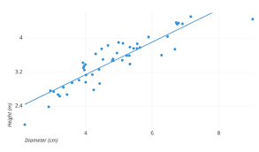*

*2 Heatmaps showing violence and poverty levels*

<https://docs.holistics.io/guides/map/create-heatmap>

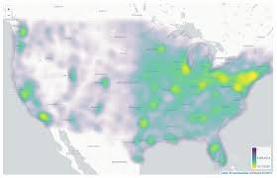

The proposed visualizations are a good start. I'm sure as you begin working with the data, you'll have ideas for additional charts to include. More visualizations will be needed to achieve your stated project goals and meet the final project expectations for the course.

1 Dashboard, with 2 line graphs on top of each other, one showing poverty and the other homicide rate

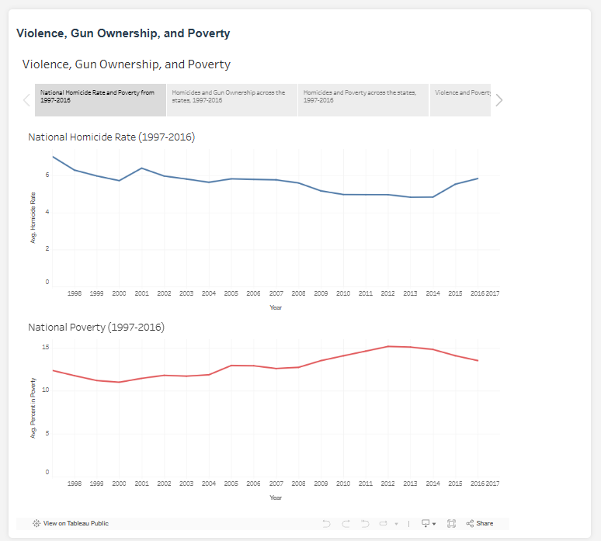

Map on top, with selectable year. Showing Homicide rate. Used as a filter for side by side line graphs below showing homicide rate and poverty

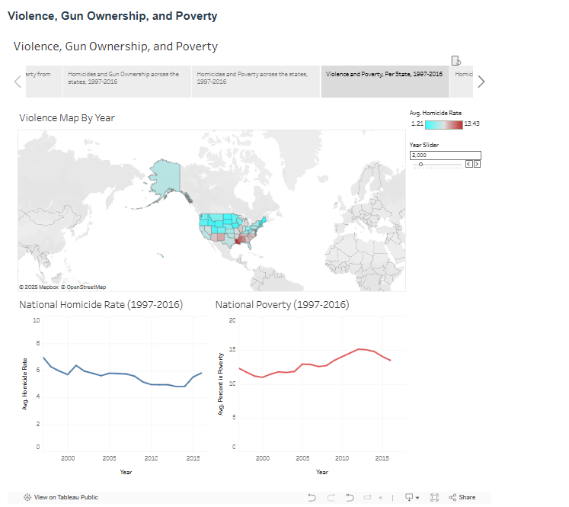

2 maps, selectable year, showing poverty and violence

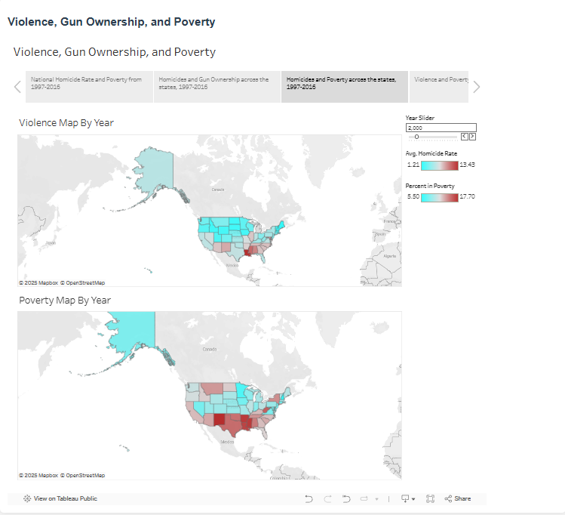

Map on top, selectable year. Shows violence. Can select state to look at firearm ownership and homicide by type at that state

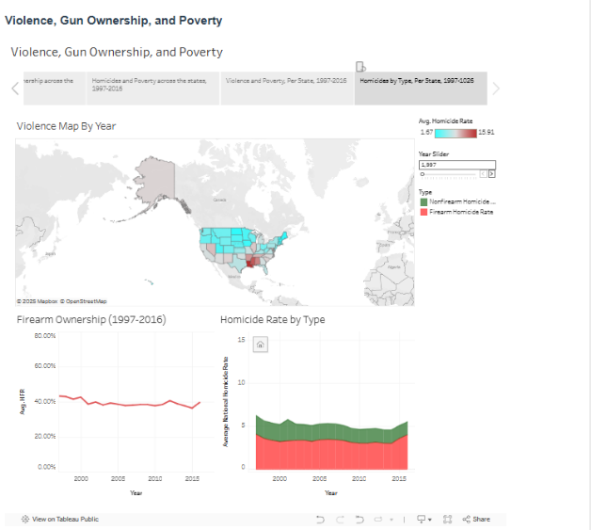

2 maps, top shows homicide rate, bottom shows firearm ownership. Selectable year.

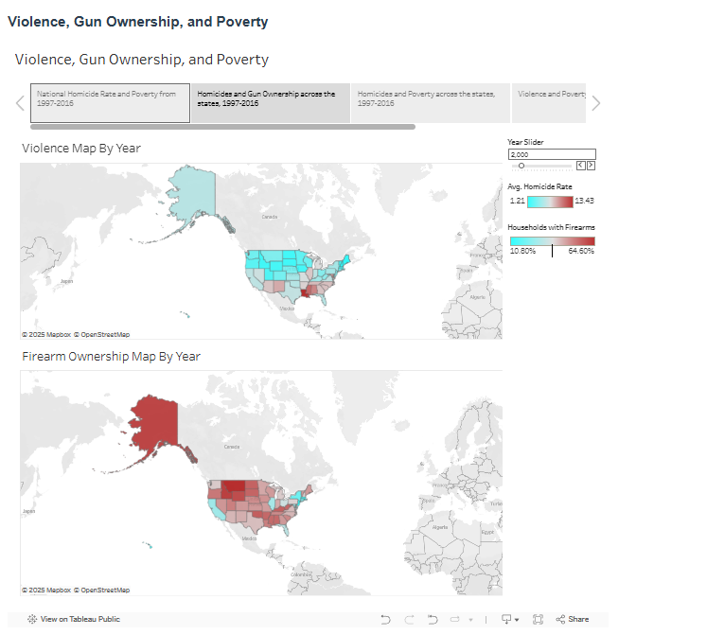

*As feedback stated, I had more ideas while working with data.*

V. Plan

*Tableau will be used to generate a story including the above visulizations. The story will be hosted on Tableau Public, and potentially posted to a website*

*Plan B could be to show the visualizations in a static slideshow.*

*The project will need to be interactive and publicly accessible in order to meet your stated goals and reach the audience you've identified. Your current plan B does not meet this minimum threshhold.*

*Tableau will be used to generate a story including the above visulizations. The story will be hosted on Tableau Public, and posted to a website*

*Plan B could be to show the visualizations on tableau live only.   
  
 Updated so plan B follows criteria*