# CSCE 567 Final Visualization Project Proposal

Name: Dallas Wade

Project Purpose:

*The purpose of this project is to inform interested individuals about the correlation between poverty, gun ownership, and violent crime.*

I. Introduction / Background

*The goal of this project is to inform readers about the correlation between poverty, gun ownership, and violent crime. Gun violence is a bigger problem in America than in any other 1st world country. Poverty is a known precursor to higher levels of violent crime. Gun ownership is also higher in the US than any other country in the world. Today, many argue that the solution to reducing gun violence is reducing gun ownership. Others argue there are other solutions, ranging from mental health efforts to public programs. This project is not in support of either side, but rather simply an attempt to visualize data that could be useful in the discussion.*

II. Audience

*The target audience is the public, specifically those interested in the correlation between gun ownership and violent crime.*

III. Dataset(s)

*For gun homicides: https://dataverse.harvard.edu/file.xhtml?fileId=7107466&version=1.0*

*3500< Records, 18 Attributes*

*For Poverty levels: https://www.census.gov/data/tables/time-series/demo/income-poverty/historical-poverty-people.html*

*For gun ownership:* [*https://www.rand.org/pubs/tools/TL354.html*](https://www.rand.org/pubs/tools/TL354.html) *1800< Records, 20 Attributes*

*I do not see any issues with the data yet*

IV. Proposed Visualizations

*2 Line charts side by side showing the total national violent crime(1) and gun ownership(2) from selectable years, hovering over peaks will show month, year, and exact rate, can filter by state*

[*https://en.wikipedia.org/wiki/Line_chart*](https://en.wikipedia.org/wiki/Line_chart)

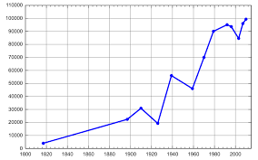

*1 Colored map, increasingly red for more violence, highlighting for Gun ownership rate, year selectable*

[*https://en.wikipedia.org/wiki/Choropleth_map*](https://en.wikipedia.org/wiki/Choropleth_map)

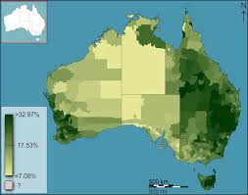

*1 Scatter plot, showing points that represent poverty levels and gun violence, selectable year*

*https://www.atlassian.com/data/charts/what-is-a-scatter-plot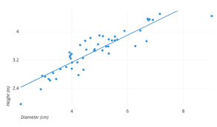*

*2 Heatmaps showing violence and poverty levels*

<https://docs.holistics.io/guides/map/create-heatmap>

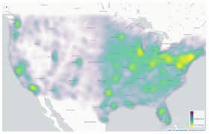

V. Plan

*Tableau will be used to generate a story including the above visulizations. The story will be hosted on Tableau Public, and potentially posted to a website*

*Plan B could be to show the visualizations in a static slideshow.*