Introduction to the Exokernel

The concept of an exokernel Operating System was originally developed by MIT [Kaashoek, 96][Engler, 98] with similar ideas being developed at the University of Glasgow and Microsoft Research in their Nemesis project [Leslie, 96]. The basic concept is to eliminate the role of a traditional kernel and allow applications (sometimes referred to as library operating systems) to directly interact with the hardware. This low-level hardware access allows the programmer to implement custom abstractions, and omit unnecessary ones, most commonly to improve a program performance.
The implementation of XDK (Exokernel Development Kit) is not a true exokernel according to the strict MIT definition, but it does provide an exokernel-like capability on top of the Linux Operating System. It allows the developers to write applications that directly interact with the hardware and bypass the Linux kernel altogether primarily as a means to improve performance and avoid building new functionality in the kernel which could be easily implemented in user space. The XDK implementation includes a dynamically loadable kernel module (known as the parasitic kernel) which provides services to XDK applications so that they can access HW (e.g., interrupts) and manage physical memory directly. The Linux UIO framework (https://www.kernel.org/doc/htmldocs/uio-howto/about.html) and the Intel DPDK (http://dpdk.org/) architectures are comparable to the XDK. The main differentiation is that XDK is unified into a single kernel module and also provides resource access control across multiple applications.

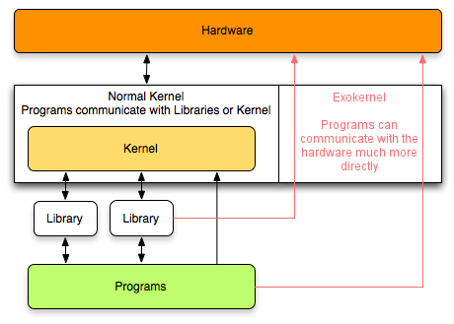
[Kaashoek, 96] Kaashoek, M. Frans (1996). "Exterminate All Operating System Abstractions" (POSTSCRIPT). MIT. Retrieved 2006-09-22.
[Engler, 98] Engler, Dawson R (1998). "The Exokernel Operating System Architecture"
[Leslie, 96] The Design and Implementation of an Operating System to Support Distributed Multimedia Applications, Ian Leslie, Derek McAuley, Richard Black, Timothy Roscoe, Paul Barham, David Evers, Robin Fairbairns, and Eoin Hyden

