Problem Statement
Objectives
- Introducing threads concepts and POSIX threads library.
- Implementing popular algorithms as multi-threaded ones.
It is required to implement two popular algorithms as multi-threaded ones
- Matrix Multiplication - It is required to implement two variations of this algorithm:.
- Merge Sort - An O (n log n) comparison-based sorting algorithm. It is a divide and conquer algorithm.

Features

Some of the features present
- Command-line arguments.
- I/O from text files.
- Descriptive error and warning messages.
- Bash files for easy execution.
- Time elapsed display after the termination of each algorithm.

Overall Description

How pthread is used
We can crate a thread t that executes a method m given list of arguments a using the call
pthread_create(&t, &attr, m, (void*) a)
and to finish the execution of a thread use
pthread_exit(&s)
and s is the returned value. If we want to wait till the execution of t finishes we use
pthread_join(t, &s)

Multipliction
The algorithm for the first method
for (int y = 0; y < h; ++y)
for (int x = 0; x < w; ++x)
create a thread for calculating cell x,y
for (int y = 0; y < h; ++y)
for (int x = 0; x < w; ++x)
join thread x,y
The algorithm for the second method
for (int y = 0; y < h; ++y)
create a thread for calculating row y
for (int y = 0; y < h; ++y)
join thread y
Sort
The algorithm for the merge sort
SORT(A)
if A.size() < 2
exit current thread
pthread_t thread[2];
a0 = A[0, A.size() / 2]
create a thread for sorting a0
a1 = A[A.size() / 2, A.size()]
create a thread for sorting a1
join both threads
merge a0,a1 to A
size_t i = 0, j = 0;
exit current thread

Help

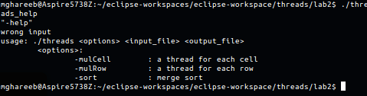

Multiplication

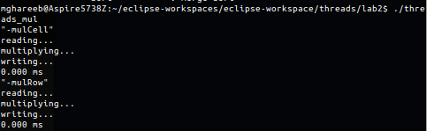

Sorting

