**Origami Face Mask Design by Jiangmei Wu**

**Design © foldedlightart 2020**

Materials:

* [Fold a Face Mask template](https://research.impact.iu.edu/coronavirus/origami-face-mask-pattern.html)
* Scissors and stapler
* 1x Twist Tie 4”
* 2x Elastic Strips 7”
* 1 HEPA filter (designs vary) *Note: Vacuum bags made from PTFE (aka Teflon®) or polyester felt will be more suitable for this DIY face mask project. You can try this design on other suitable materials too.*

1. Lay out filter so it is flat and even. May need to adjust according to design of filter. Remove cardboard tab from filter.
2. Align and trace the template on the filter. **Note**: The template is a mirrored half of the whole pattern using the straight edge as the axis. Make sure you align the straight edge in the template with one of the seams of the vacuum bag. You might want to try to align the template in a way to allow you to make maximum number of face masks from one bag. The outside of the vacuum bag will be the outside of your face mask.

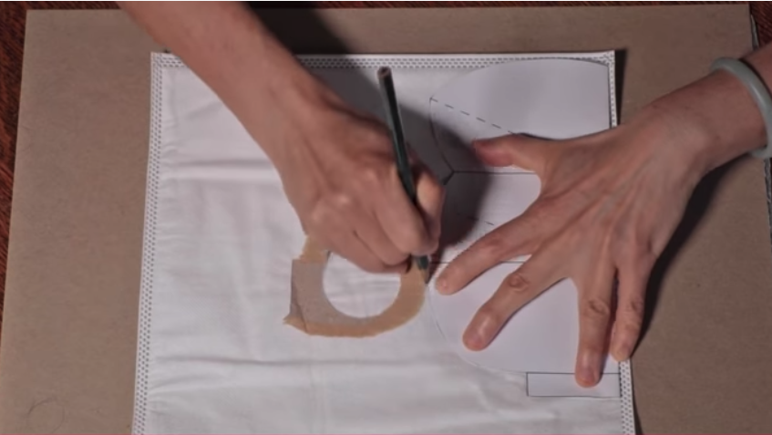

1. Cut outside the traced lines. (Optional, cut off excess fold.)

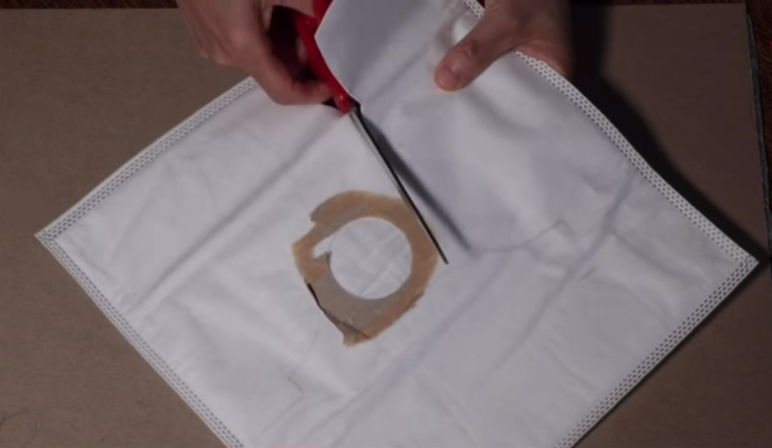

1. Open cut shape, align template over it, and mark pleating points.

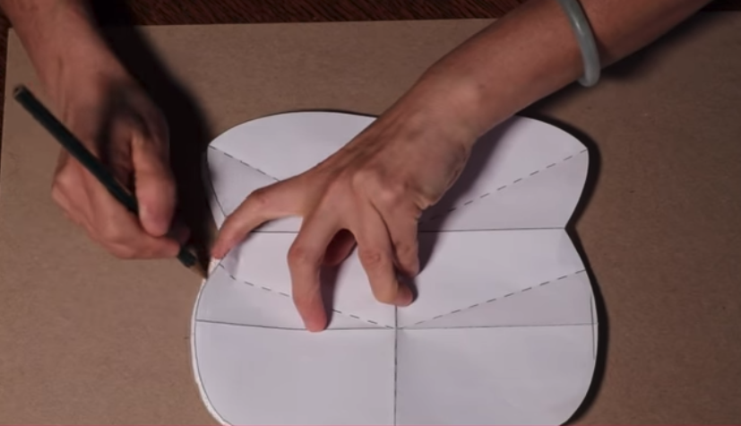

1. Place twist tie in the top tab and fold tab over it.

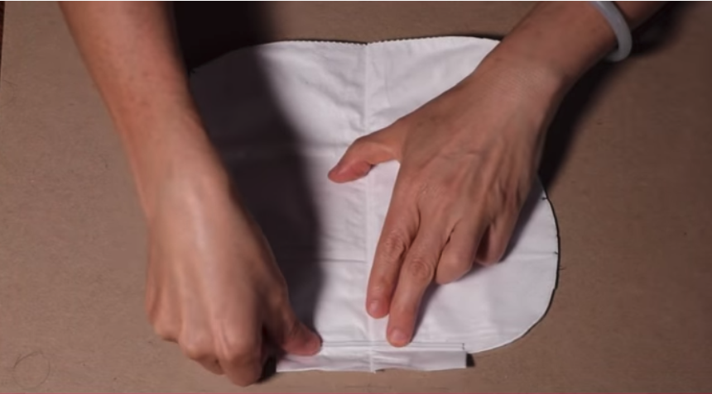

1. Staple tab shut over twist tie.

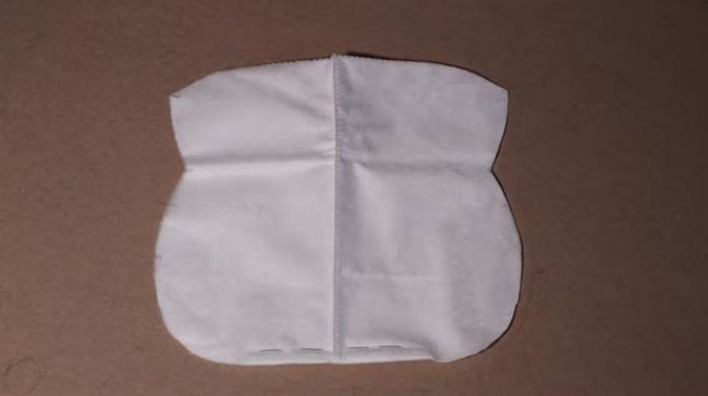

1. Flip mask over and fold in half. Pinch the first pleat point and fold. (Note the second mark is the bottom of your first pleat fold.)

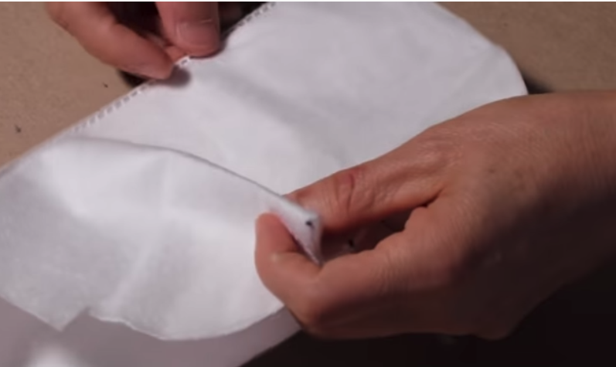

1. Crease second pleat line and fold. Bring first fold and second fold together.

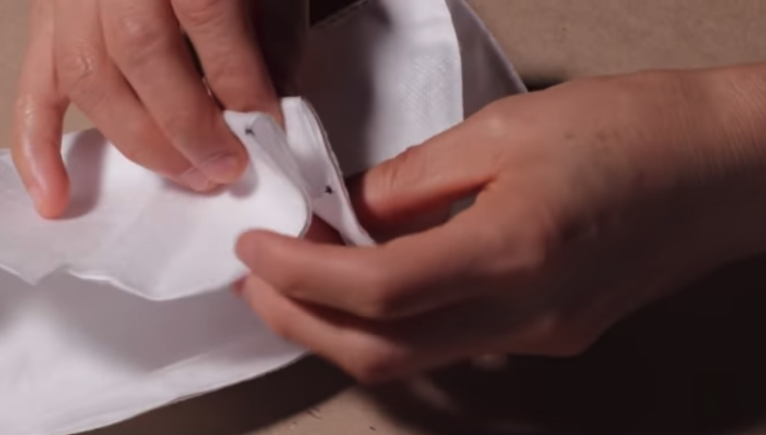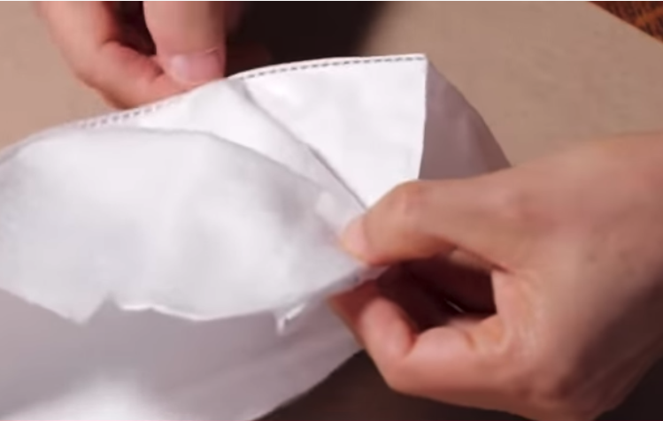

1. Staple folds together and repeat on opposite side. Add more staples around edges to secure mask. If staples on the inside of the mask are uncomfortable, flip the direction of the stapling.

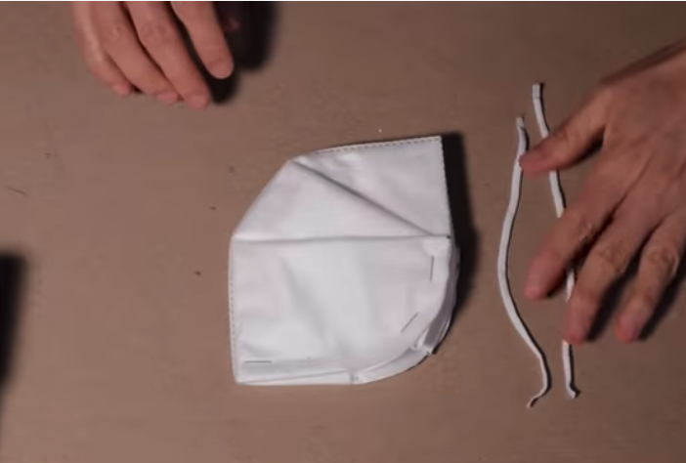

1. Staple elastic bands to the mask. (Mark both sides of mask for easy stapling.)

