David Wakazuru

March 5, 2020

Assignment 07

Foundations of programming, Python

# Pickle an Exceptions

# Introduction

In assignment 07 we will introduce pickling and exception handling. This will also be the first significant script without a starter file.

Writing the Code

This was a short script, in comparison to the last two assignments, since I couldn’t get the two items to interact. That is, I couldn’t integrate the pickling with the exception handling.

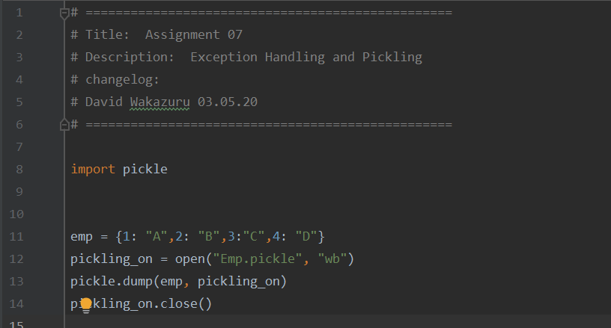

***Image 1. Header and first part of pickle program.***

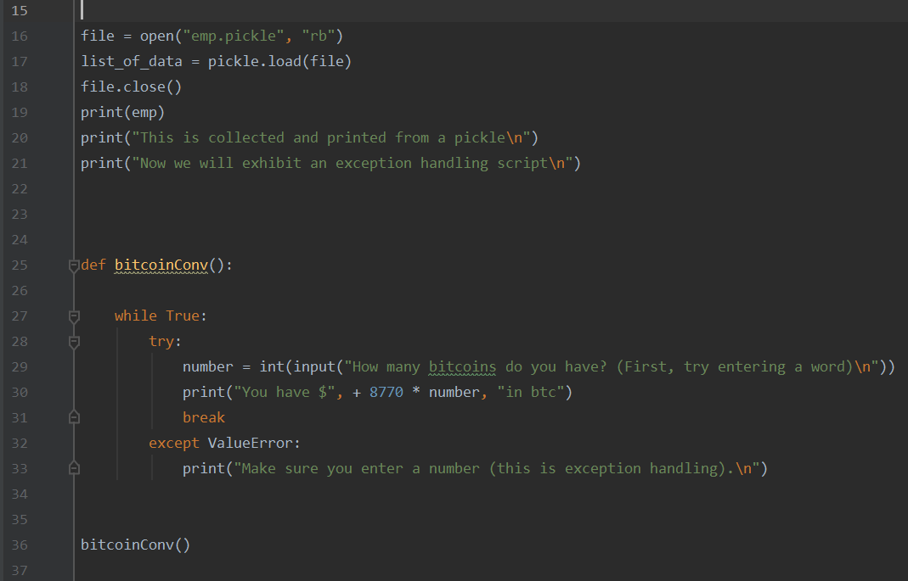

***Image 2. The second half of the pickling script and the exception handling.***

Running the Script

The first part of the script runs the pickling part in its entirety. Collecting, storing and then returning that data for the user. The opening question is the start of my exception handling script.

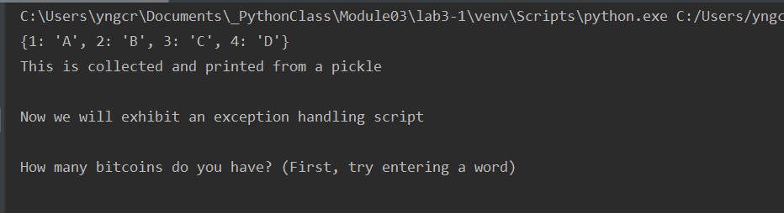

***Image 3. Pickled data is displayed at the top, followed by the exception handling.***

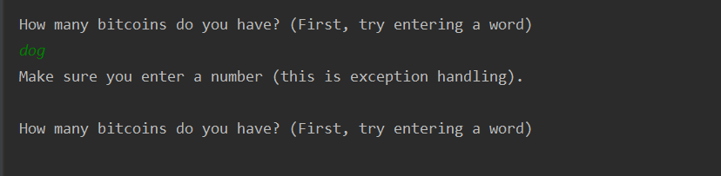

***Image 4. Entering a word, dog, triggers the exception handling message.***

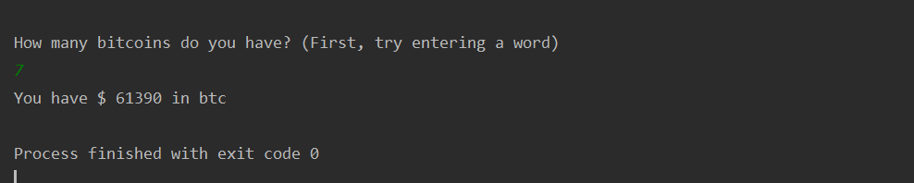

***Image 5. Entering a number returns a dollar amount in bitcoin I have.***

The pickle was stored in a binary file and is shown as follows.

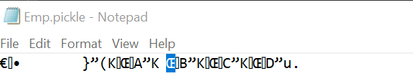

***Image 6. The pickled data, obscured.***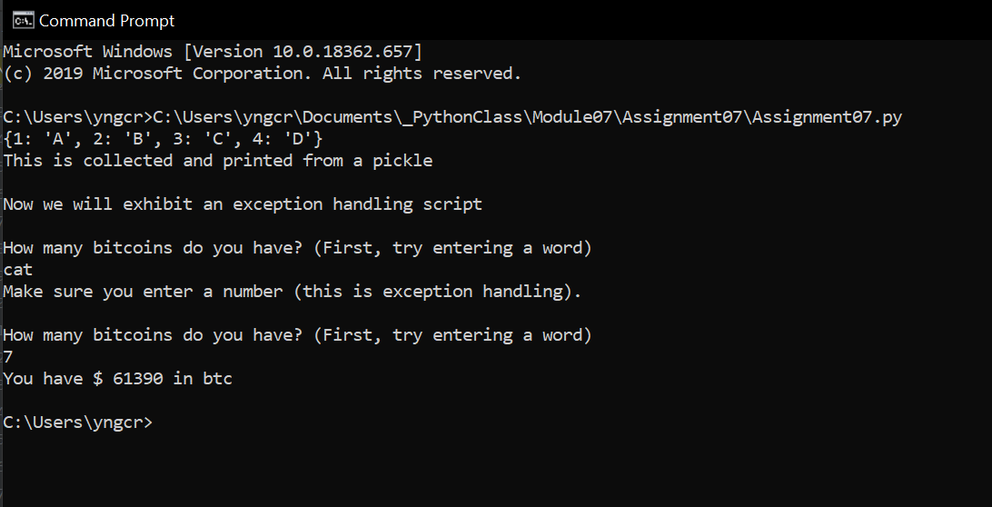

***Image7. Running the script in the command shell.***

Summary

Pickling the data and returning that data was the harder of the two tasks in this assignment since I was unable to integrate the two. And the exception handling was fairly simple. All in all, this was not my best work, but it is complete and I have to be happy with that.