East Maui Irrigation Model Report

Trutta Environmental Solutions, LLC

## Methods

**Add text here to explain methods**

### Habitat calculations

**Explanatory text about hab calcs**

### Water diversion calculations

**Explanatory text about water calcs**

## Output

### Grouping Variable = Watersheds

#### Habitat results

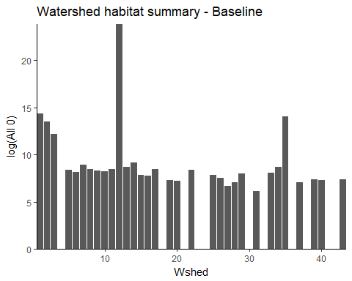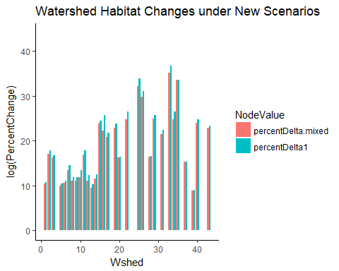

Summary of Habitat Changes by Watershed

|  |  |  |  |  |  |
| --- | --- | --- | --- | --- | --- |
| Wshed | Total Habitat 0 | Total Habitat Mixed | Total Habitat 1 | Percent Change Mixed | Percent Change 1 |
| 1 | 1705385 | 5.468363e+08 | 8.512690e+08 | 3196526.85% | 4981653.11% |
| 2 | 741240 | 1.810092e+11 | 4.031849e+11 | 2441967926.86% | 5439320626.69% |
| 3 | 194717 | 2.338218e+10 | 3.720343e+10 | 1200818778.64% | 1910631035.81% |
| 4 | 0 | 0.000000e+00 | 0.000000e+00 | 0.00% | 0.00% |
| 5 | 4270 | 9.134587e+05 | 1.356604e+06 | 2129247.54% | 3167058.55% |
| 6 | 3469 | 1.301354e+06 | 2.126727e+06 | 3741380.51% | 6120663.02% |
| 7 | 7381 | 4.650065e+07 | 1.449721e+08 | 62990475.52% | 196402591.79% |
| 8 | 4754 | 3.272485e+06 | 6.772196e+06 | 6873645.35% | 14235258.73% |
| 9 | 4202 | 2.645841e+06 | 6.028998e+06 | 6286622.56% | 14337924.80% |
| 10 | 3831 | 5.309353e+06 | 2.426009e+07 | 13848922.21% | 63315726.96% |
| 11 | 4767 | 1.048638e+09 | 2.584609e+09 | 2199775684.71% | 5421867799.45% |
| 12 | 22523886671 | 1.361141e+13 | 4.845765e+13 | 6033098.32% | 21503893.33% |
| 13 | 5988 | 8.052601e+05 | 1.753080e+06 | 1334789.75% | 2917655.31% |
| 14 | 9371 | 9.623314e+06 | 2.339097e+07 | 10259250.13% | 24951012.70% |
| 15 | 2546 | 5.983563e+11 | 1.025329e+12 | 2350181917739.72% | 4027215652930.09% |
| 16 | 2332 | 1.113018e+11 | 3.385673e+12 | 477280605905.32% | 14518322836252.14% |
| 17 | 4626 | 4.981022e+10 | 1.353510e+11 | 107674492464.40% | 292587550464.76% |
| 18 | 0 | 0.000000e+00 | 0.000000e+00 | 0.00% | 0.00% |
| 19 | 1474 | 1.271443e+11 | 3.324593e+11 | 862579775827.30% | 2255490309538.67% |
| 20 | 1351 | 1.582817e+08 | 1.742231e+08 | 1171579368.62% | 1289576143.60% |
| 21 | 0 | 0.000000e+00 | 0.000000e+00 | 0.00% | 0.00% |
| 22 | 4341 | 2.622037e+12 | 1.460611e+13 | 6040169270065.13% | 33646879274922.83% |
| 23 | 0 | 8.280617e+10 | 2.196088e+11 | 0.00% | 0.00% |
| 24 | 0 | 0.000000e+00 | 0.000000e+00 | 0.00% | 0.00% |
| 25 | 2469 | 2.321348e+15 | 1.248952e+16 | 9401975250242916.00% | 50585347970098072.00% |
| 26 | 1827 | 1.588351e+14 | 5.346108e+14 | 869376709788039.75% | 2926167623949699.00% |
| 27 | 810 | 8.100000e+02 | 8.100000e+02 | 0.00% | 0.00% |
| 28 | 1155 | 1.584261e+08 | 1.853648e+08 | 1371644801.73% | 1604879774.89% |
| 29 | 3002 | 2.089940e+12 | 4.466143e+12 | 6961826892827.97% | 14877223890486.34% |
| 30 | 0 | 0.000000e+00 | 0.000000e+00 | 0.00% | 0.00% |
| 31 | 458 | 8.963955e+09 | 2.535267e+10 | 195719531639.74% | 553551783668.12% |
| 32 | 0 | 0.000000e+00 | 0.000000e+00 | 0.00% | 0.00% |
| 33 | 3197 | 5.535098e+16 | 2.758763e+17 | 173134117378606464.00% | 862922320137197184.00% |
| 34 | 5928 | 3.406319e+12 | 1.840725e+13 | 5746151667636.21% | 31051359585254.72% |
| 35 | 1296943 | 4.596531e+18 | 4.720658e+18 | 35441287152078156.00% | 36398359402706760.00% |
| 36 | 0 | 0.000000e+00 | 0.000000e+00 | 0.00% | 0.00% |
| 37 | 1225 | 5.201900e+07 | 5.830384e+07 | 424634903.67% | 475939730.61% |
| 38 | 0 | 0.000000e+00 | 0.000000e+00 | 0.00% | 0.00% |
| 39 | 1599 | 1.199198e+05 | 1.364460e+05 | 739967.48% | 843320.83% |
| 40 | 1541 | 4.210883e+11 | 8.412827e+11 | 2732565042965.20% | 5459329573199.22% |
| 41 | 0 | 0.000000e+00 | 0.000000e+00 | 0.00% | 0.00% |
| 42 | 0 | 0.000000e+00 | 0.000000e+00 | 0.00% | 0.00% |
| 43 | 1613 | 1.443934e+11 | 2.320592e+11 | 895185126624.92% | 1438680558946.06% |

**Space for interpretation of preceding plots and table**.

#### Water Diversion results

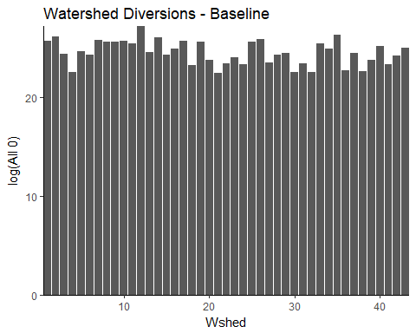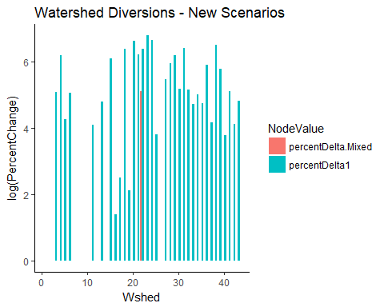

Summary of Water Diversions by Watershed

|  |  |  |  |  |  |
| --- | --- | --- | --- | --- | --- |
| Wshed | Total Diverted - All 0 | Total Diverted - Mixed | Total Diverted - All 1 | Percent Change - Mixed | Percent Change - All 1 |
| 1 | 145060379000 | 87125446000 | 68655252060 | -3993.85% | -5267.13% |
| 2 | 214252471600 | 181408851600 | 102982878090 | -1532.94% | -5193.39% |
| 3 | 39254158800 | 23261303850 | 102982878090 | -4074.18% | 16234.90% |
| 4 | 5843135100 | 686817300 | 34327626030 | -8824.57% | 48748.64% |
| 5 | 49933123800 | 23572675300 | 85819065075 | -5279.15% | 7186.80% |
| 6 | 33502535900 | 13477300350 | 85819065075 | -5977.23% | 15615.69% |
| 7 | 156283635105 | 88293498553 | 102982878090 | -4350.43% | -3410.51% |
| 8 | 133561238500 | 70577061000 | 34327626030 | -4715.75% | -7429.82% |
| 9 | 131372253500 | 69717327000 | 34327626030 | -4693.15% | -7387.00% |
| 10 | 141782089550 | 62475117860 | 102982878090 | -5593.58% | -2736.54% |
| 11 | 106809517700 | 78944546900 | 171638130150 | -2608.85% | 6069.55% |
| 12 | 650428561300 | 504624372700 | 171638130150 | -2241.66% | -7361.15% |
| 13 | 46923355130 | 4870969865 | 102982878090 | -8961.93% | 11947.04% |
| 14 | 204101190150 | 100614295175 | 137310504120 | -5070.37% | -3272.43% |
| 15 | 34987159695 | 28764461245 | 188801943165 | -1778.57% | 43963.21% |
| 16 | 65989281500 | 62721252250 | 68655252060 | -495.24% | 404.00% |
| 17 | 137725125950 | 125945330550 | 154474317135 | -855.31% | 1216.13% |
| 18 | 12342205640 | 1817823180 | 85819065075 | -8527.15% | 59533.01% |
| 19 | 126815756020 | 121226441920 | 137310504120 | -440.74% | 827.56% |
| 20 | 20305470160 | 14996210720 | 171638130150 | -2614.69% | 74528.03% |
| 21 | 5753742650 | 2291690700 | 34327626030 | -6017.04% | 49661.39% |
| 22 | 14856706465 | 39477178155 | 102982878090 | 16571.96% | 59317.43% |
| 23 | 27518391980 | 23856815679 | 274621008240 | -1330.59% | 89795.44% |
| 24 | 13681897400 | 6139812260 | 120146691105 | -5512.46% | 77814.35% |
| 25 | 129726517725 | 124471969185 | 188801943165 | -405.05% | 4553.84% |
| 26 | 169991233940 | 121087724504 | 102982878090 | -2876.83% | -3941.87% |
| 27 | 15389754050 | 6725070050 | 51491439045 | -5630.16% | 23458.26% |
| 28 | 35495104865 | 31342176446 | 171638130150 | -1170.00% | 38355.44% |
| 29 | 40629654510 | 33665787150 | 240293382210 | -1713.99% | 49142.36% |
| 30 | 6142273000 | 0 | 17163813015 | -10000.00% | 17943.75% |
| 31 | 14589690555 | 11237154345 | 102982878090 | -2297.88% | 60586.06% |
| 32 | 6275863000 | 0 | 17163813015 | -10000.00% | 17348.93% |
| 33 | 113209307385 | 105685078470 | 240293382210 | -664.63% | 11225.59% |
| 34 | 62156957720 | 48500580280 | 154474317135 | -2197.08% | 14852.30% |
| 35 | 255372214140 | 254231845370 | 549242016480 | -44.66% | 11507.51% |
| 36 | 7320094550 | 1395193830 | 34327626030 | -8094.02% | 36895.06% |
| 37 | 41693408500 | 32207008750 | 68655252060 | -2275.28% | 6466.69% |
| 38 | 6773217350 | 1470564210 | 51491439045 | -7828.85% | 66022.13% |
| 39 | 20116113350 | 5160034225 | 85819065075 | -7434.88% | 32661.85% |
| 40 | 83741800400 | 77469597400 | 120146691105 | -748.99% | 4347.28% |
| 41 | 12870298500 | 0 | 34327626030 | -10000.00% | 16671.97% |
| 42 | 31747023000 | 31747023000 | 51491439045 | 0.00% | 6219.30% |
| 43 | 68689477000 | 67761526700 | 154474317135 | -135.09% | 12488.79% |

**Space for interpretation of preceding plots and table**.

#### Habitat results by species, grouped by Watershed

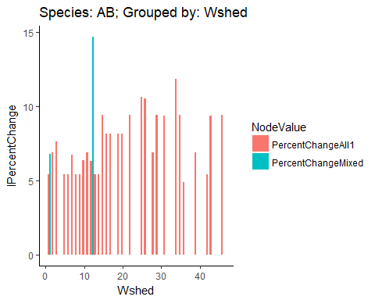

|  |  |  |  |  |  |
| --- | --- | --- | --- | --- | --- |
| Wshed | All 0 | Mixed | All 1 | PercentChangeMixed | PercentChangeAll1 |
| 1 | 362607.0 | 3.598150e+04 | 1.199381e+05 | 90776.03% | 23333.30% |
| 2 | 137813.0 | 1.595127e+07 | 1.771667e+08 | -9913.60% | 101067.46% |
| 3 | 25298.0 | 2.576825e+06 | 5.717756e+07 | -9901.82% | 211891.52% |
| 4 | 0.0 | 0.000000e+00 | 0.000000e+00 | 0.00% | 0.00% |
| 5 | 750.0 | 2.533500e+04 | 8.441240e+04 | -9703.97% | 23318.54% |
| 6 | 706.0 | 5.013450e+04 | 1.670363e+05 | -9859.18% | 23317.62% |
| 7 | 1919.0 | 5.867648e+05 | 5.718157e+06 | -9967.30% | 87452.27% |
| 8 | 1072.0 | 1.399739e+05 | 4.664347e+05 | -9923.41% | 23322.98% |
| 9 | 1371.0 | 1.057928e+05 | 3.525570e+05 | -9870.41% | 23325.24% |
| 10 | 1243.0 | 2.556714e+05 | 1.780266e+06 | -9951.38% | 59630.99% |
| 11 | 1005.0 | 1.513108e+07 | 1.679640e+08 | -9999.34% | 101006.00% |
| 12 | 3883654040.1 | 1.584293e+05 | 1.055591e+06 | 245124783.80% | 56628.50% |
| 13 | 1613.0 | 2.519080e+04 | 8.395200e+04 | -9359.69% | 23326.45% |
| 14 | 2450.0 | 2.408834e+05 | 8.028276e+05 | -9898.29% | 23328.47% |
| 15 | 416.0 | 8.400493e+08 | 1.034777e+11 | -10000.00% | 1221805.59% |
| 16 | 1199.0 | 7.582424e+09 | 2.806743e+11 | -10000.00% | 360164.29% |
| 17 | 707.0 | 3.358376e+08 | 1.243496e+10 | -9999.98% | 360267.01% |
| 18 | 0.0 | 0.000000e+00 | 0.000000e+00 | 0.00% | 0.00% |
| 19 | 332.0 | 1.717560e+09 | 6.355943e+10 | -10000.00% | 360056.52% |
| 20 | 297.0 | 1.499428e+05 | 5.517357e+06 | -9980.19% | 357964.21% |
| 21 | 0.0 | 0.000000e+00 | 0.000000e+00 | 0.00% | 0.00% |
| 22 | 1045.0 | 9.372498e+09 | 1.156174e+12 | -10000.00% | 1223581.18% |
| 23 | 0.0 | 0.000000e+00 | 0.000000e+00 | 0.00% | 0.00% |
| 24 | 0.0 | 0.000000e+00 | 0.000000e+00 | 0.00% | 0.00% |
| 25 | 717.0 | 3.455252e+12 | 1.421611e+15 | -10000.00% | 4104347.66% |
| 26 | 575.0 | 1.752372e+11 | 6.552753e+13 | -10000.00% | 3729361.29% |
| 27 | 103.0 | 0.000000e+00 | 0.000000e+00 | Inf% | 0.00% |
| 28 | 130.0 | 2.054996e+06 | 2.277688e+07 | -9999.37% | 100836.66% |
| 29 | 553.0 | 3.536239e+09 | 4.332292e+11 | -10000.00% | 1215112.82% |
| 30 | 0.0 | 0.000000e+00 | 0.000000e+00 | 0.00% | 0.00% |
| 31 | 151.0 | 9.027358e+07 | 1.094373e+10 | -9999.98% | 1202284.71% |
| 33 | 0.0 | 0.000000e+00 | 0.000000e+00 | 0.00% | 0.00% |
| 34 | 427.0 | 3.770758e+13 | 5.168297e+16 | -10000.00% | 13696255.02% |
| 35 | 896.0 | 1.368978e+10 | 1.687900e+12 | -10000.00% | 1222963.77% |
| 36 | 322.2 | 4.908900e+03 | 1.165730e+04 | -9343.65% | 13747.08% |
| 38 | 0.0 | 0.000000e+00 | 0.000000e+00 | 0.00% | 0.00% |
| 39 | 143.0 | 4.362017e+05 | 4.830604e+06 | -9996.72% | 100742.45% |
| 40 | 0.0 | 0.000000e+00 | 0.000000e+00 | 0.00% | 0.00% |
| 42 | 225.0 | 3.138500e+03 | 1.044620e+04 | -9283.09% | 23284.24% |
| 43 | 152.0 | 2.284029e+09 | 2.787277e+11 | -10000.00% | 1210333.69% |
| 44 | 0.0 | 0.000000e+00 | 0.000000e+00 | 0.00% | 0.00% |
| 45 | 0.0 | 0.000000e+00 | 0.000000e+00 | 0.00% | 0.00% |
| 46 | 295.0 | 2.447330e+08 | 2.996196e+10 | -9999.99% | 1214271.48% |

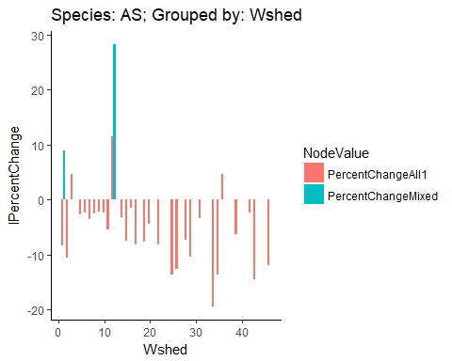

|  |  |  |  |  |  |
| --- | --- | --- | --- | --- | --- |
| Wshed | All 0 | Mixed | All 1 | PercentChangeMixed | PercentChangeAll1 |
| 1 | 213901 | 2.688300e+03 | 2.688300e+03 | 785664.86% | 0.02% |
| 2 | 75627 | 4.034643e+05 | 4.034644e+05 | -8125.56% | 0.00% |
| 3 | 6659 | 9.825910e+04 | 1.966176e+05 | -9322.30% | 10010.12% |
| 4 | 0 | 0.000000e+00 | 0.000000e+00 | 0.00% | 0.00% |
| 5 | 708 | 6.104300e+03 | 6.108600e+03 | -8840.16% | 7.06% |
| 6 | 536 | 4.304000e+03 | 4.308000e+03 | -8754.65% | 9.32% |
| 7 | 924 | 1.280350e+04 | 1.280710e+04 | -9278.32% | 2.84% |
| 8 | 671 | 3.802800e+03 | 3.805700e+03 | -8235.53% | 7.45% |
| 9 | 468 | 2.302500e+03 | 2.304900e+03 | -7967.39% | 10.67% |
| 10 | 623 | 3.202100e+03 | 3.205100e+03 | -8054.39% | 9.52% |
| 11 | 702 | 3.230147e+05 | 3.230293e+05 | -9978.27% | 0.45% |
| 12 | 1913904926 | 1.000000e-01 | 1.001000e+02 | 198540905983740.03% | 10373571.43% |
| 13 | 1060 | 0.000000e+00 | 0.000000e+00 | Inf% | 0.00% |
| 14 | 1667 | 1.800300e+03 | 1.801100e+03 | -740.56% | 4.20% |
| 15 | 454 | 2.904517e+06 | 2.904534e+06 | -9998.44% | 0.06% |
| 16 | 80 | 1.022200e+04 | 1.024500e+04 | -9921.74% | 22.50% |
| 17 | 774 | 9.977794e+06 | 9.977820e+06 | -9999.22% | 0.03% |
| 18 | 0 | 0.000000e+00 | 0.000000e+00 | 0.00% | 0.00% |
| 19 | 161 | 1.950839e+07 | 1.950847e+07 | -9999.92% | 0.04% |
| 20 | 163 | 3.418420e+05 | 3.418840e+05 | -9995.23% | 1.23% |
| 21 | 0 | 0.000000e+00 | 0.000000e+00 | 0.00% | 0.00% |
| 22 | 725 | 6.900904e+06 | 6.900925e+06 | -9998.95% | 0.03% |
| 23 | 0 | 0.000000e+00 | 0.000000e+00 | 0.00% | 0.00% |
| 24 | 0 | 0.000000e+00 | 0.000000e+00 | 0.00% | 0.00% |
| 25 | 329 | 5.542149e+09 | 5.542149e+09 | -10000.00% | 0.00% |
| 26 | 227 | 2.386720e+09 | 2.386720e+09 | -10000.00% | 0.00% |
| 27 | 164 | 0.000000e+00 | 0.000000e+00 | Inf% | 0.00% |
| 28 | 250 | 3.300024e+06 | 3.300048e+06 | -9999.24% | 0.07% |
| 29 | 525 | 2.572859e+08 | 2.572860e+08 | -9999.98% | 0.00% |
| 30 | 0 | 0.000000e+00 | 0.000000e+00 | 0.00% | 0.00% |
| 31 | 49 | 3.911398e+05 | 3.912796e+05 | -9998.75% | 3.57% |
| 33 | 0 | 0.000000e+00 | 0.000000e+00 | 0.00% | 0.00% |
| 34 | 750 | 2.810316e+12 | 2.810316e+12 | -10000.00% | 0.00% |
| 35 | 1669 | 1.790228e+09 | 1.790228e+09 | -9999.99% | 0.00% |
| 36 | 368222 | 3.301103e+13 | 6.602206e+13 | -10000.00% | 10000.00% |
| 38 | 0 | 0.000000e+00 | 0.000000e+00 | 0.00% | 0.00% |
| 39 | 341 | 5.678505e+06 | 5.678609e+06 | -9999.40% | 0.18% |
| 40 | 0 | 0.000000e+00 | 0.000000e+00 | 0.00% | 0.00% |
| 42 | 496 | 1.041050e+04 | 1.042100e+04 | -9523.56% | 10.07% |
| 43 | 535 | 1.860826e+10 | 1.860826e+10 | -10000.00% | 0.00% |
| 44 | 0 | 0.000000e+00 | 0.000000e+00 | 0.00% | 0.00% |
| 45 | 0 | 0.000000e+00 | 0.000000e+00 | 0.00% | 0.00% |
| 46 | 463 | 1.085384e+09 | 1.085384e+09 | -10000.00% | 0.00% |

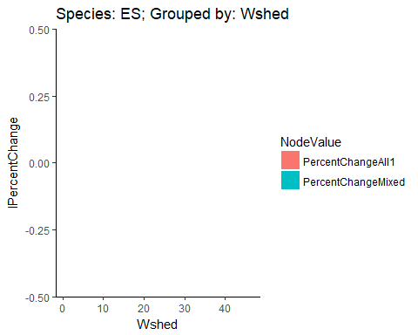

|  |  |  |  |  |  |
| --- | --- | --- | --- | --- | --- |
| Wshed | All 0 | Mixed | All 1 | PercentChangeMixed | PercentChangeAll1 |
| 1 | 16.0 | 0 | 0.0 | Inf% | 0.00% |
| 2 | 10.0 | 0 | 0.0 | Inf% | 0.00% |
| 3 | 0.5 | 0 | 100.0 | Inf% | Inf% |
| 4 | 0.0 | 0 | 0.0 | 0.00% | 0.00% |
| 5 | 12.0 | 0 | 0.0 | Inf% | 0.00% |
| 6 | 21.0 | 0 | 0.0 | Inf% | 0.00% |
| 7 | 36.0 | 0 | 0.0 | Inf% | 0.00% |
| 8 | 29.0 | 0 | 0.0 | Inf% | 0.00% |
| 9 | 21.0 | 0 | 0.0 | Inf% | 0.00% |
| 10 | 58.0 | 0 | 0.0 | Inf% | 0.00% |
| 11 | 1.0 | 0 | 0.0 | Inf% | 0.00% |
| 12 | 921.5 | 0 | 86.8 | Inf% | Inf% |
| 13 | 72.0 | 0 | 0.0 | Inf% | 0.00% |
| 14 | 189.0 | 0 | 0.0 | Inf% | 0.00% |
| 15 | 53.0 | 0 | 0.0 | Inf% | 0.00% |
| 16 | 0.0 | 0 | 0.0 | 0.00% | 0.00% |
| 17 | 26.0 | 0 | 0.0 | Inf% | 0.00% |
| 18 | 0.0 | 0 | 0.0 | 0.00% | 0.00% |
| 19 | 0.0 | 0 | 0.0 | 0.00% | 0.00% |
| 20 | 0.0 | 0 | 0.0 | 0.00% | 0.00% |
| 21 | 0.0 | 0 | 0.0 | 0.00% | 0.00% |
| 22 | 46.0 | 0 | 0.0 | Inf% | 0.00% |
| 23 | 0.0 | 0 | 0.0 | 0.00% | 0.00% |
| 24 | 0.0 | 0 | 0.0 | 0.00% | 0.00% |
| 25 | 0.0 | 0 | 0.0 | 0.00% | 0.00% |
| 26 | 0.0 | 0 | 0.0 | 0.00% | 0.00% |
| 27 | 3.0 | 0 | 0.0 | Inf% | 0.00% |
| 28 | 20.0 | 0 | 0.0 | Inf% | 0.00% |
| 29 | 22.0 | 0 | 0.0 | Inf% | 0.00% |
| 30 | 0.0 | 0 | 0.0 | 0.00% | 0.00% |
| 31 | 0.0 | 0 | 0.0 | 0.00% | 0.00% |
| 33 | 0.0 | 0 | 0.0 | 0.00% | 0.00% |
| 34 | 28.0 | 0 | 0.0 | Inf% | 0.00% |
| 35 | 55.0 | 0 | 0.0 | Inf% | 0.00% |
| 36 | 960.0 | 0 | 93.6 | Inf% | Inf% |
| 38 | 0.0 | 0 | 0.0 | 0.00% | 0.00% |
| 39 | 2.0 | 0 | 0.0 | Inf% | 0.00% |
| 40 | 0.0 | 0 | 0.0 | 0.00% | 0.00% |
| 42 | 5.0 | 0 | 0.0 | Inf% | 0.00% |
| 43 | 14.0 | 0 | 0.0 | Inf% | 0.00% |
| 44 | 0.0 | 0 | 0.0 | 0.00% | 0.00% |
| 45 | 0.0 | 0 | 0.0 | 0.00% | 0.00% |
| 46 | 30.0 | 0 | 0.0 | Inf% | 0.00% |

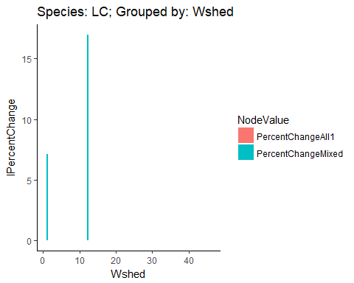

|  |  |  |  |  |  |
| --- | --- | --- | --- | --- | --- |
| Wshed | All 0 | Mixed | All 1 | PercentChangeMixed | PercentChangeAll1 |
| 1 | 744087 | 5.386330e+04 | 5.386330e+04 | 128143.48% | 0.00% |
| 2 | 406099 | 3.902317e+07 | 3.902317e+07 | -9895.93% | 0.00% |
| 3 | 155583 | 1.460402e+07 | 1.460402e+07 | -9893.47% | 0.00% |
| 4 | 0 | 0.000000e+00 | 0.000000e+00 | 0.00% | 0.00% |
| 5 | 1236 | 4.964010e+04 | 4.964010e+04 | -9751.01% | 0.00% |
| 6 | 1050 | 8.458050e+04 | 8.458050e+04 | -9875.86% | 0.00% |
| 7 | 2369 | 1.476163e+06 | 1.476163e+06 | -9983.95% | 0.00% |
| 8 | 1370 | 1.221891e+05 | 1.221891e+05 | -9887.88% | 0.00% |
| 9 | 1449 | 8.095580e+04 | 8.095580e+04 | -9821.01% | 0.00% |
| 10 | 947 | 2.218165e+05 | 2.218165e+05 | -9957.31% | 0.00% |
| 11 | 1447 | 6.161841e+07 | 6.161841e+07 | -9999.77% | 0.00% |
| 12 | 13395956215 | 5.548490e+04 | 5.548490e+04 | 2414331921.40% | 0.00% |
| 13 | 1445 | 2.671850e+04 | 2.671850e+04 | -9459.18% | 0.00% |
| 14 | 2337 | 1.568671e+05 | 1.568671e+05 | -9851.02% | 0.00% |
| 15 | 898 | 6.624086e+10 | 6.624086e+10 | -10000.00% | 0.00% |
| 16 | 746 | 2.732995e+09 | 2.732995e+09 | -10000.00% | 0.00% |
| 17 | 1462 | 3.235825e+09 | 3.235825e+09 | -10000.00% | 0.00% |
| 18 | 0 | 0.000000e+00 | 0.000000e+00 | 0.00% | 0.00% |
| 19 | 555 | 2.186655e+10 | 2.186655e+10 | -10000.00% | 0.00% |
| 20 | 524 | 2.995292e+07 | 2.995292e+07 | -9999.83% | 0.00% |
| 21 | 0 | 0.000000e+00 | 0.000000e+00 | 0.00% | 0.00% |
| 22 | 1400 | 1.802887e+11 | 1.802887e+11 | -10000.00% | 0.00% |
| 23 | 0 | 0.000000e+00 | 0.000000e+00 | 0.00% | 0.00% |
| 24 | 0 | 0.000000e+00 | 0.000000e+00 | 0.00% | 0.00% |
| 25 | 926 | 2.480080e+14 | 2.480080e+14 | -10000.00% | 0.00% |
| 26 | 670 | 2.355533e+13 | 2.355533e+13 | -10000.00% | 0.00% |
| 27 | 206 | 0.000000e+00 | 0.000000e+00 | Inf% | 0.00% |
| 28 | 184 | 7.411748e+07 | 7.411748e+07 | -9999.98% | 0.00% |
| 29 | 850 | 2.432885e+11 | 2.432885e+11 | -10000.00% | 0.00% |
| 30 | 0 | 0.000000e+00 | 0.000000e+00 | 0.00% | 0.00% |
| 31 | 189 | 4.670563e+09 | 4.670563e+09 | -10000.00% | 0.00% |
| 33 | 0 | 0.000000e+00 | 0.000000e+00 | 0.00% | 0.00% |
| 34 | 469 | 1.176132e+16 | 1.176132e+16 | -10000.00% | 0.00% |
| 35 | 1058 | 3.073225e+11 | 3.073225e+11 | -10000.00% | 0.00% |
| 36 | 34577 | 1.276935e+16 | 1.276935e+16 | -10000.00% | 0.00% |
| 38 | 0 | 0.000000e+00 | 0.000000e+00 | 0.00% | 0.00% |
| 39 | 230 | 1.168172e+07 | 1.168172e+07 | -9999.80% | 0.00% |
| 40 | 0 | 0.000000e+00 | 0.000000e+00 | 0.00% | 0.00% |
| 42 | 296 | 1.344530e+04 | 1.344530e+04 | -9779.85% | 0.00% |
| 43 | 189 | 1.669029e+11 | 1.669029e+11 | -10000.00% | 0.00% |
| 44 | 0 | 0.000000e+00 | 0.000000e+00 | 0.00% | 0.00% |
| 45 | 0 | 0.000000e+00 | 0.000000e+00 | 0.00% | 0.00% |
| 46 | 344 | 4.029345e+10 | 4.029345e+10 | -10000.00% | 0.00% |

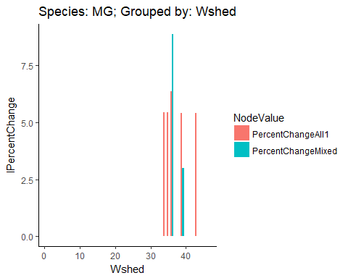

|  |  |  |  |  |  |
| --- | --- | --- | --- | --- | --- |
| Wshed | All 0 | Mixed | All 1 | PercentChangeMixed | PercentChangeAll1 |
| 1 | 90.0 | 0.0 | 0.0 | Inf% | 0.00% |
| 2 | 76.0 | 0.0 | 0.0 | Inf% | 0.00% |
| 3 | 0.5 | 0.0 | 100.0 | Inf% | Inf% |
| 4 | 0.0 | 0.0 | 0.0 | 0.00% | 0.00% |
| 5 | 156.0 | 0.0 | 0.0 | Inf% | 0.00% |
| 6 | 71.0 | 0.0 | 0.0 | Inf% | 0.00% |
| 7 | 115.0 | 0.0 | 0.0 | Inf% | 0.00% |
| 8 | 99.0 | 0.0 | 0.0 | Inf% | 0.00% |
| 9 | 65.0 | 0.0 | 0.0 | Inf% | 0.00% |
| 10 | 121.0 | 0.0 | 0.0 | Inf% | 0.00% |
| 11 | 113.0 | 0.0 | 0.0 | Inf% | 0.00% |
| 12 | 279438.0 | 0.0 | 99.4 | Inf% | Inf% |
| 13 | 131.0 | 0.0 | 0.0 | Inf% | 0.00% |
| 14 | 445.0 | 0.0 | 0.0 | Inf% | 0.00% |
| 15 | 64.0 | 0.0 | 0.0 | Inf% | 0.00% |
| 16 | 0.0 | 0.0 | 0.0 | 0.00% | 0.00% |
| 17 | 114.0 | 0.0 | 0.0 | Inf% | 0.00% |
| 18 | 0.0 | 0.0 | 0.0 | 0.00% | 0.00% |
| 19 | 0.0 | 0.0 | 0.0 | 0.00% | 0.00% |
| 20 | 0.0 | 0.0 | 0.0 | 0.00% | 0.00% |
| 21 | 0.0 | 0.0 | 0.0 | 0.00% | 0.00% |
| 22 | 96.0 | 0.0 | 0.0 | Inf% | 0.00% |
| 23 | 0.0 | 0.0 | 0.0 | 0.00% | 0.00% |
| 24 | 0.0 | 0.0 | 0.0 | 0.00% | 0.00% |
| 25 | 2.0 | 0.0 | 0.0 | Inf% | 0.00% |
| 26 | 3.0 | 0.0 | 0.0 | Inf% | 0.00% |
| 27 | 27.0 | 0.0 | 0.0 | Inf% | 0.00% |
| 28 | 45.0 | 0.0 | 0.0 | Inf% | 0.00% |
| 29 | 72.0 | 0.0 | 0.0 | Inf% | 0.00% |
| 30 | 0.0 | 0.0 | 0.0 | 0.00% | 0.00% |
| 31 | 0.0 | 0.0 | 0.0 | 0.00% | 0.00% |
| 33 | 0.0 | 0.0 | 0.0 | 0.00% | 0.00% |
| 34 | 230.0 | 395.7 | 1305.7 | -4186.81% | 23000.00% |
| 35 | 308.0 | 333.6 | 1103.6 | -766.60% | 23083.51% |
| 36 | 97468.0 | 1321.2 | 8906.4 | 727696.71% | 57409.09% |
| 38 | 0.0 | 0.0 | 0.0 | 0.00% | 0.00% |
| 39 | 111.0 | 92.7 | 302.7 | 1973.76% | 22653.06% |
| 40 | 0.0 | 0.0 | 0.0 | 0.00% | 0.00% |
| 42 | 90.0 | 0.0 | 0.0 | Inf% | 0.00% |
| 43 | 123.0 | 801.1 | 2621.1 | -8464.68% | 22717.68% |
| 44 | 0.0 | 0.0 | 0.0 | 0.00% | 0.00% |
| 45 | 0.0 | 0.0 | 0.0 | 0.00% | 0.00% |
| 46 | 93.0 | 0.0 | 0.0 | Inf% | 0.00% |

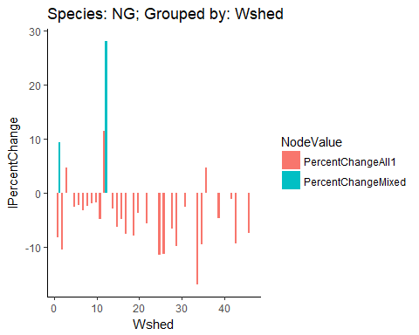

|  |  |  |  |  |  |
| --- | --- | --- | --- | --- | --- |
| Wshed | All 0 | Mixed | All 1 | PercentChangeMixed | PercentChangeAll1 |
| 1 | 231450.0 | 2.190700e+03 | 2.190700e+03 | 1046507.94% | 0.03% |
| 2 | 84327.0 | 2.278481e+05 | 2.278481e+05 | -6298.98% | 0.00% |
| 3 | 4762.0 | 3.786850e+04 | 7.583560e+04 | -8742.49% | 10026.07% |
| 4 | 0.0 | 0.000000e+00 | 0.000000e+00 | 0.00% | 0.00% |
| 5 | 790.0 | 4.002000e+03 | 4.005100e+03 | -8026.00% | 7.59% |
| 6 | 587.0 | 3.302200e+03 | 3.305600e+03 | -8222.42% | 10.21% |
| 7 | 1059.0 | 7.201900e+03 | 7.204800e+03 | -8529.56% | 3.99% |
| 8 | 751.0 | 3.501900e+03 | 3.504700e+03 | -7855.43% | 7.99% |
| 9 | 410.0 | 1.301300e+03 | 1.303200e+03 | -6849.23% | 14.62% |
| 10 | 325.0 | 1.401900e+03 | 1.404300e+03 | -7681.73% | 17.12% |
| 11 | 928.0 | 2.223110e+05 | 2.223275e+05 | -9958.26% | 0.74% |
| 12 | 1679375774.2 | 1.000000e-01 | 1.001000e+02 | 163287574733506.78% | 9723080.89% |
| 13 | 796.0 | 0.000000e+00 | 0.000000e+00 | Inf% | 0.00% |
| 14 | 940.0 | 1.100600e+03 | 1.101200e+03 | -1459.09% | 5.32% |
| 15 | 344.0 | 1.128913e+06 | 1.128933e+06 | -9996.95% | 0.18% |
| 16 | 228.0 | 1.845104e+05 | 1.845250e+05 | -9987.64% | 0.79% |
| 17 | 919.0 | 4.583185e+06 | 4.583207e+06 | -9997.99% | 0.05% |
| 18 | 0.0 | 0.000000e+00 | 0.000000e+00 | 0.00% | 0.00% |
| 19 | 306.0 | 1.484173e+07 | 1.484178e+07 | -9999.79% | 0.03% |
| 20 | 250.0 | 1.081163e+05 | 1.081408e+05 | -9976.88% | 2.26% |
| 21 | 0.0 | 0.000000e+00 | 0.000000e+00 | 0.00% | 0.00% |
| 22 | 528.0 | 4.406138e+05 | 4.406294e+05 | -9988.02% | 0.35% |
| 23 | 0.0 | 0.000000e+00 | 0.000000e+00 | 0.00% | 0.00% |
| 24 | 0.0 | 0.000000e+00 | 0.000000e+00 | 0.00% | 0.00% |
| 25 | 331.0 | 4.683030e+08 | 4.683031e+08 | -9999.99% | 0.00% |
| 26 | 226.0 | 5.964036e+08 | 5.964037e+08 | -10000.00% | 0.00% |
| 27 | 144.0 | 0.000000e+00 | 0.000000e+00 | Inf% | 0.00% |
| 28 | 232.0 | 4.044633e+06 | 4.044682e+06 | -9999.43% | 0.12% |
| 29 | 532.0 | 1.854130e+08 | 1.854131e+08 | -9999.97% | 0.00% |
| 30 | 0.0 | 0.000000e+00 | 0.000000e+00 | 0.00% | 0.00% |
| 31 | 41.0 | 1.640810e+05 | 1.642024e+05 | -9997.50% | 7.40% |
| 33 | 0.0 | 0.000000e+00 | 0.000000e+00 | 0.00% | 0.00% |
| 34 | 577.0 | 3.104231e+11 | 3.104231e+11 | -10000.00% | 0.00% |
| 35 | 871.0 | 3.198582e+07 | 3.198584e+07 | -9999.73% | 0.01% |
| 36 | 127732.8 | 2.014284e+12 | 4.028569e+12 | -10000.00% | 10000.00% |
| 38 | 0.0 | 0.000000e+00 | 0.000000e+00 | 0.00% | 0.00% |
| 39 | 173.0 | 1.345074e+06 | 1.345184e+06 | -9998.71% | 0.82% |
| 40 | 0.0 | 0.000000e+00 | 0.000000e+00 | 0.00% | 0.00% |
| 42 | 212.0 | 3.907400e+03 | 3.918400e+03 | -9457.43% | 28.25% |
| 43 | 180.0 | 1.032955e+08 | 1.032955e+08 | -9999.98% | 0.01% |
| 44 | 0.0 | 0.000000e+00 | 0.000000e+00 | 0.00% | 0.00% |
| 45 | 0.0 | 0.000000e+00 | 0.000000e+00 | 0.00% | 0.00% |
| 46 | 169.0 | 1.201085e+07 | 1.201092e+07 | -9999.86% | 0.06% |

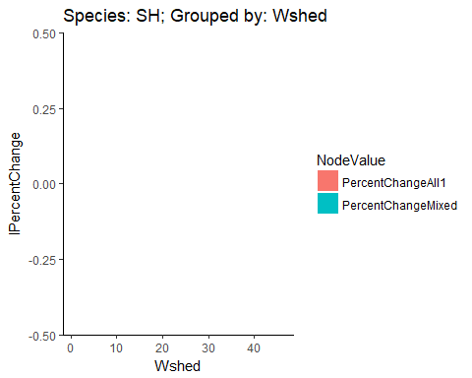

|  |  |  |  |  |  |
| --- | --- | --- | --- | --- | --- |
| Wshed | All 0 | Mixed | All 1 | PercentChangeMixed | PercentChangeAll1 |
| 1 | 3.0 | 0 | 0.0 | Inf% | 0.00% |
| 2 | 1.0 | 0 | 0.0 | Inf% | 0.00% |
| 3 | 0.0 | 0 | 0.0 | 0.00% | 0.00% |
| 4 | 0.0 | 0 | 0.0 | 0.00% | 0.00% |
| 5 | 3.0 | 0 | 0.0 | Inf% | 0.00% |
| 6 | 3.0 | 0 | 0.0 | Inf% | 0.00% |
| 7 | 10.0 | 0 | 0.0 | Inf% | 0.00% |
| 8 | 10.0 | 0 | 0.0 | Inf% | 0.00% |
| 9 | 7.0 | 0 | 0.0 | Inf% | 0.00% |
| 10 | 31.0 | 0 | 0.0 | Inf% | 0.00% |
| 11 | 0.0 | 0 | 0.0 | 0.00% | 0.00% |
| 12 | 713.0 | 0 | 83.3 | Inf% | Inf% |
| 13 | 14.0 | 0 | 0.0 | Inf% | 0.00% |
| 14 | 152.0 | 0 | 0.0 | Inf% | 0.00% |
| 15 | 16.0 | 0 | 0.0 | Inf% | 0.00% |
| 16 | 0.0 | 0 | 0.0 | 0.00% | 0.00% |
| 17 | 6.0 | 0 | 0.0 | Inf% | 0.00% |
| 18 | 0.0 | 0 | 0.0 | 0.00% | 0.00% |
| 19 | 0.0 | 0 | 0.0 | 0.00% | 0.00% |
| 20 | 0.0 | 0 | 0.0 | 0.00% | 0.00% |
| 21 | 0.0 | 0 | 0.0 | 0.00% | 0.00% |
| 22 | 13.0 | 0 | 0.0 | Inf% | 0.00% |
| 23 | 0.0 | 0 | 0.0 | 0.00% | 0.00% |
| 24 | 0.0 | 0 | 0.0 | 0.00% | 0.00% |
| 25 | 0.0 | 0 | 0.0 | 0.00% | 0.00% |
| 26 | 0.0 | 0 | 0.0 | 0.00% | 0.00% |
| 27 | 0.0 | 0 | 0.0 | 0.00% | 0.00% |
| 28 | 3.0 | 0 | 0.0 | Inf% | 0.00% |
| 29 | 8.0 | 0 | 0.0 | Inf% | 0.00% |
| 30 | 0.0 | 0 | 0.0 | 0.00% | 0.00% |
| 31 | 0.0 | 0 | 0.0 | 0.00% | 0.00% |
| 33 | 0.0 | 0 | 0.0 | 0.00% | 0.00% |
| 34 | 11.0 | 0 | 0.0 | Inf% | 0.00% |
| 35 | 15.0 | 0 | 0.0 | Inf% | 0.00% |
| 36 | 1235.5 | 0 | 92.2 | Inf% | Inf% |
| 38 | 0.0 | 0 | 0.0 | 0.00% | 0.00% |
| 39 | 0.0 | 0 | 0.0 | 0.00% | 0.00% |
| 40 | 0.0 | 0 | 0.0 | 0.00% | 0.00% |
| 42 | 1.0 | 0 | 0.0 | Inf% | 0.00% |
| 43 | 3.0 | 0 | 0.0 | Inf% | 0.00% |
| 44 | 0.0 | 0 | 0.0 | 0.00% | 0.00% |
| 45 | 0.0 | 0 | 0.0 | 0.00% | 0.00% |
| 46 | 20.0 | 0 | 0.0 | Inf% | 0.00% |

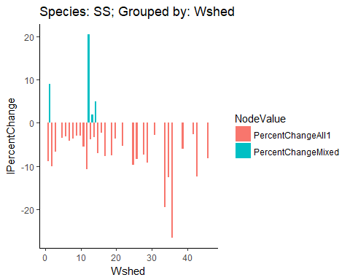

|  |  |  |  |  |  |
| --- | --- | --- | --- | --- | --- |
| Wshed | All 0 | Mixed | All 1 | PercentChangeMixed | PercentChangeAll1 |
| 1 | 153231 | 1.989600e+03 | 1.989600e+03 | 760171.95% | 0.01% |
| 2 | 37287 | 1.489739e+05 | 1.489740e+05 | -7497.08% | 0.00% |
| 3 | 2414 | 1.568270e+04 | 1.568290e+04 | -8460.72% | 0.13% |
| 4 | 0 | 0.000000e+00 | 0.000000e+00 | 0.00% | 0.00% |
| 5 | 615 | 5.006500e+03 | 5.008100e+03 | -8771.60% | 3.25% |
| 6 | 495 | 2.704400e+03 | 2.705500e+03 | -8169.62% | 4.03% |
| 7 | 949 | 7.204400e+03 | 7.205600e+03 | -8682.75% | 1.61% |
| 8 | 752 | 5.505900e+03 | 5.507300e+03 | -8634.18% | 2.66% |
| 9 | 411 | 5.010000e+02 | 5.012000e+02 | -1795.97% | 4.86% |
| 10 | 483 | 5.008000e+02 | 5.010000e+02 | -355.18% | 4.96% |
| 11 | 571 | 1.080164e+05 | 1.080205e+05 | -9947.14% | 0.38% |
| 12 | 1650714643 | 1.997000e+02 | 1.997000e+02 | 82664989401.44% | 0.00% |
| 13 | 857 | 8.007000e+02 | 8.009000e+02 | 702.51% | 2.33% |
| 14 | 1191 | 5.003000e+02 | 5.004000e+02 | 13808.01% | 3.36% |
| 15 | 301 | 5.809185e+05 | 5.809233e+05 | -9994.82% | 0.08% |
| 16 | 79 | 7.526800e+03 | 7.534200e+03 | -9895.04% | 9.75% |
| 17 | 618 | 1.414722e+06 | 1.414728e+06 | -9995.63% | 0.04% |
| 18 | 0 | 0.000000e+00 | 0.000000e+00 | 0.00% | 0.00% |
| 19 | 120 | 4.836503e+06 | 4.836528e+06 | -9999.75% | 0.05% |
| 20 | 117 | 4.634990e+04 | 4.636240e+04 | -9974.76% | 2.69% |
| 21 | 0 | 0.000000e+00 | 0.000000e+00 | 0.00% | 0.00% |
| 22 | 488 | 9.429760e+04 | 9.430200e+04 | -9948.25% | 0.47% |
| 23 | 0 | 0.000000e+00 | 0.000000e+00 | 0.00% | 0.00% |
| 24 | 0 | 0.000000e+00 | 0.000000e+00 | 0.00% | 0.00% |
| 25 | 164 | 3.035647e+07 | 3.035649e+07 | -9999.95% | 0.01% |
| 26 | 126 | 8.243079e+06 | 8.243099e+06 | -9999.85% | 0.02% |
| 27 | 163 | 0.000000e+00 | 0.000000e+00 | Inf% | 0.00% |
| 28 | 291 | 5.992154e+05 | 5.992192e+05 | -9995.14% | 0.06% |
| 29 | 440 | 2.181277e+07 | 2.181279e+07 | -9999.80% | 0.01% |
| 30 | 0 | 0.000000e+00 | 0.000000e+00 | 0.00% | 0.00% |
| 31 | 28 | 6.415140e+04 | 6.418930e+04 | -9995.64% | 5.90% |
| 33 | 0 | 0.000000e+00 | 0.000000e+00 | 0.00% | 0.00% |
| 34 | 705 | 9.237335e+11 | 9.237335e+11 | -10000.00% | 0.00% |
| 35 | 1056 | 1.921308e+08 | 1.921308e+08 | -9999.95% | 0.00% |
| 36 | 666425 | 8.574979e+12 | 8.574979e+12 | -10000.00% | 0.00% |
| 38 | 0 | 0.000000e+00 | 0.000000e+00 | 0.00% | 0.00% |
| 39 | 225 | 1.260115e+06 | 1.260144e+06 | -9998.21% | 0.23% |
| 40 | 0 | 0.000000e+00 | 0.000000e+00 | 0.00% | 0.00% |
| 42 | 274 | 4.212300e+03 | 4.215300e+03 | -9349.52% | 7.28% |
| 43 | 345 | 7.043282e+08 | 7.043282e+08 | -10000.00% | 0.00% |
| 44 | 0 | 0.000000e+00 | 0.000000e+00 | 0.00% | 0.00% |
| 45 | 0 | 0.000000e+00 | 0.000000e+00 | 0.00% | 0.00% |
| 46 | 199 | 8.185674e+06 | 8.185695e+06 | -9999.76% | 0.03% |

**Space for interpretation of preceding plots and tables**.