CHAPTER ONE: INTRODUCTION

1.0 Introduction
Digital marketplaces have become essential platforms in modern economies, transforming the way buyers and sellers interact by providing greater efficiency, transparency, and trust in commercial transactions. In sectors that depend heavily on reliable and timely access to goods—such as construction—these platforms are particularly important. The construction industry is resource-intensive, with materials often accounting for more than half of total project costs. This makes procurement a critical determinant of both cost efficiency and overall project success. The adoption of digital marketplaces tailored to construction has therefore become a priority globally, regionally, and locally, albeit at varying levels of maturity and sophistication.

1.1 Background of the Study

Implementation in Developed Countries
In Germany, Schüttflix has emerged as a leading digital marketplace that specializes in bulk construction materials such as sand, gravel, and aggregates. The platform connects producers, haulers, and contractors while offering real-time pricing, same-day delivery options, and route optimization. By improving transparency and reducing inefficiencies in procurement and logistics, Schüttflix has redefined construction material distribution in Europe (Schüttflix, n.d.; Alston, 2023).
In North America, BuildDirect operates as a large-scale digital marketplace that provides homeowners, contractors, and suppliers access to a wide range of construction and home improvement materials. The platform integrates supplier directories, manufacturer-direct pricing, and logistics support, while also offering digital tools that improve decision-making for buyers. By reducing reliance on physical showrooms and connecting suppliers directly to consumers, BuildDirect has enhanced accessibility and reduced costs in procurement (BuildDirect, n.d.; MarketScreener, n.d.).
In the United Kingdom, marketplaces such as the Builders Merchant Federation Online have supported the digitization of procurement for both small and large contractors. These platforms focus on supplier verification, standardized quality assurance, and logistics integration, which collectively improve accountability and supply chain reliability for the construction sector (Builders, n.d.).

Implementation in African Countries
In Nigeria, TradeDepot has transformed B2B commerce by providing a digital distribution platform that connects small retailers with manufacturers and wholesalers. While its core focus is on fast-moving consumer goods, TradeDepot’s model demonstrates the relevance of digital platforms to procurement in emerging markets. Its use of predictive analytics, inventory optimization, and digitized logistics illustrates how similar systems can enhance efficiency in construction procurement, where supply chains are equally fragmented (TradeDepot, n.d.; Finnfund, 2023).
In South Africa, Builders Warehouse has integrated e-commerce capabilities into its retail operations, offering customers the ability to browse, order, and schedule deliveries of construction materials online. Although these platforms have improved price transparency and accessibility in urban areas, they still face challenges with logistics beyond metropolitan centers and lack advanced features such as AI-driven counterfeit detection (Builders, n.d.; ITWeb, 2025).

Implementation in Kenya
In Kenya, the growth of e-commerce has been led by platforms such as Jumia and Kilimall, which provide consumers with a wide variety of goods, including basic construction and hardware materials. However, these generic platforms are not tailored to the specific requirements of construction procurement. They typically lack critical functionalities such as bulk-order workflows, supplier verification, counterfeit detection, and predictive price analytics. This means that small and medium-sized construction material suppliers remain largely confined to local markets, while buyers struggle with fluctuating prices, counterfeit products, and unreliable delivery systems (Jumia Kenya, n.d.; Kilimall, n.d.; Mwencha, Thuo, & Muathe, 2019; Makokha, Asenahabi, & Makokha, 2021).
Several studies on Kenya’s e-commerce ecosystem highlight that while online shopping adoption has grown rapidly, specialized procurement platforms for industrial sectors like construction remain underdeveloped. This creates inefficiencies in the supply chain that increase project costs, delay timelines, and undermine trust between buyers and suppliers. Moreover, government trade reports emphasize that Kenya’s Vision 2030 economic pillar depends on improving competitiveness in industries such as construction, where better supply chain management and technological innovation are urgently needed (U.S. International Trade Administration, 2024).
1.2 Problem Statement
Despite being a vital sector in Kenya’s economy, the construction industry faces persistent procurement challenges:
- Limited visibility of suppliers and fluctuating prices – Buyers lack reliable platforms to compare suppliers and track price trends.
- Prevalence of counterfeit or substandard products – Counterfeit materials not only inflate costs but also compromise safety.
- Logistical inefficiencies in sourcing and delivery – Delays and high transport costs make procurement unreliable.
- Limited market access for SMEs – Sellers’ struggle to reach customers outside their immediate locality, stifling competitiveness.
Existing e-commerce platforms are too generic and fail to address the unique requirements of construction procurement, such as bulk ordering, material verification, and logistics coordination. Constructify will bridge this gap by leveraging AI to enhance transparency, trust, and efficiency in the Kenyan construction supply chain.

1.3 Project Objectives

Overall Goal
The overall goal of this project is to design and develop Constructify: A Smart Digital Marketplace for Construction Materials that addresses inefficiencies in procurement while promoting transparency, trust, and scalability.
System Design and Development Objectives
- To analyze the limitations and challenges of existing procurement systems in Kenya’s construction sector.
- To develop a robust, user-friendly platform with features such as bulk ordering, supplier verification, logistics support, and secure payments.
- To integrate AI-driven features including price prediction, fraud detection, smart search, and personalized recommendations.
- To evaluate the performance, usability, and effectiveness of Constructify compared to traditional procurement systems.

1.4 Project Questions
1. What are the traditional challenges with existing procurement systems in Kenya’s construction sector?
Kenya’s construction industry has long relied on manual and fragmented procurement processes, which create inefficiencies across the supply chain. Buyers face limited visibility of suppliers, making it difficult to compare options or monitor price fluctuations. The prevalence of counterfeit and substandard materials not only drives up costs but also jeopardizes project safety. Logistical bottlenecks—such as unreliable delivery networks and high transport costs—often cause delays that undermine project timelines. Moreover, small and medium-sized enterprises (SMEs) face barriers to market access since they lack digital tools to reach buyers beyond their locality. These traditional challenges contribute to inflated costs, inefficiency, and distrust in the procurement process.
2. How will Constructify address these challenges through specialized features and AI integration?
Constructify will directly tackle procurement inefficiencies by introducing tailored features for the construction industry. Bulk ordering and transparent supplier directories will give buyers more control over procurement, while supplier verification mechanisms will help minimize counterfeit risks. Logistics integration and delivery tracking will streamline material distribution, reducing delays and costs. The use of AI will add a layer of intelligence: price prediction models will guide buyers on when and where to source materials, fraud detection systems will flag suspicious activity, and smart search functions will make it easier for users to find exactly what they need. Together, these specialized features will create a trusted, efficient, and scalable procurement ecosystem.
3. How effective is Constructify compared to traditional procurement systems in terms of usability, performance, and scalability?
Constructify’s effectiveness will be evaluated by comparing its usability, performance, and scalability to traditional procurement systems. Usability will be measured through user experience testing to assess how easily buyers and suppliers can navigate the platform, complete transactions, and access relevant information. Performance will be evaluated by examining factors such as speed of order processing, accuracy of pricing predictions, and reliability of logistics support. Scalability will focus on the platform’s ability to support growth—from pilot implementation in Nairobi to potential expansion across Kenya—while maintaining efficiency and trust. The expectation is that Constructify will outperform traditional procurement systems by providing a more seamless, data-driven, and reliable marketplace for construction materials.
1.5 Scope of the Project
Constructify will provide a two-sided digital marketplace tailored to the construction industry.
- Buyer Functions: Search, filter, compare, and purchase materials with transparent pricing. Bulk ordering and delivery tracking will be supported.
- Seller Functions: Product listing, inventory management, pricing tools, and access to analytics.
- AI Features: Personalized recommendations, smart natural-language search, price forecasting, and counterfeit detection.
- Payments and Logistics: Integration with M-Pesa, card payments, and third-party delivery providers.
Stakeholders include construction firms, contractors, SMEs (suppliers), logistics partners, and financial institutions. The pilot implementation will target the Nairobi metropolitan area, with potential for nationwide scalability.
1.6 Limitations of the Study
The study and system development face several potential challenges:
- Time constraints – Completing design, development, and testing within 14 weeks may limit the scope of advanced AI features.
- Resource constraints – Limited funding and computing resources may restrict large-scale AI model training.
- Data access issues – Access to reliable datasets on construction material pricing and suppliers may be difficult.
- User adoption challenges – Convincing traditional suppliers and buyers to shift from manual systems may take time.
To overcome these challenges, the project will adopt an MVP (minimum viable product) approach, use publicly available datasets, leverage cloud computing services for scalability, and include sensitization workshops for early adopters.
1.7 Significance of the Study
This project contributes to both national development priorities and global SDGs.
- SDG 9 (Industry, Innovation, and Infrastructure) – Enhances infrastructure development by improving supply chain efficiency.
- SDG 8 (Decent Work and Economic Growth) – Promotes SME competitiveness, creating opportunities in trade and employment.
- SDG 4 (Quality Education) – Aligns with the goal of enhancing digital and vocational skills by training youth in emerging technologies such as AI and digital marketplaces.
Within the Kenyan context, Constructify will modernize construction procurement, lower costs, improve trust in material quality, and contribute to the economic pillar of Vision 2030 by enhancing industry competitiveness and inclusivity.
1.8 Chapter Summary
This chapter introduced the Constructify project by outlining the context of digital marketplaces globally, regionally, and locally. It identified persistent procurement challenges in Kenya’s construction sector, provided the problem statement, and outlined objectives, project questions, scope, limitations, and significance. The chapter established Constructify’s relevance to Kenya’s construction industry, its alignment with SDGs, and its potential to transform procurement processes.

CHAPTER TWO: LITERATURE REVIEW

2.0 Introduction
A literature review is an essential part of any research project as it provides a foundation for understanding existing knowledge, identifies research gaps, and establishes the relevance of the current study. By examining previous studies, existing systems, and theoretical perspectives, researchers can critically analyze achievements, limitations, and areas for improvement. This chapter reviews selected digital marketplace systems relevant to construction procurement, compares their performance, and highlights their strengths and weaknesses. It also connects these insights to the objectives of this study, thereby justifying the need for a specialized digital marketplace for Kenya’s construction industry.

2.1 Analysis, Comparison, and Criticism of Existing Projects
2.1.1 Schüttflix (Germany)
Schüttflix is a German-based digital marketplace for bulk construction materials such as gravel, sand, and asphalt (Schüttflix, 2023). The platform connects construction companies directly to material suppliers and logistics providers through a mobile app. It offers real-time pricing, digital order management, and optimized delivery scheduling. One of its major achievements is the reduction of procurement inefficiencies by integrating logistics with digital sourcing, enabling faster and more transparent material delivery across Germany.
However, Schüttflix is heavily reliant on advanced infrastructure such as efficient road networks and GPS-enabled logistics, which limits its applicability in less developed regions. While it demonstrates the potential of digitization in construction supply chains, its dependence on Europe’s strong infrastructure makes it less suitable for emerging economies like Kenya.
Strengths: Real-time transparency, efficient logistics integration, wide supplier network.
Weaknesses: Infrastructure dependency, limited applicability in developing economies.
2.1.2 TradeDepot (Nigeria)
TradeDepot is a Nigerian e-commerce platform that digitizes fragmented supply chains by linking small retailers directly with manufacturers and distributors (TechCrunch, 2021). The system allows retailers to order goods via mobile applications and offers inventory forecasting powered by data analytics. Its key achievement is increasing accessibility for informal retailers, reducing procurement costs, and enhancing supply chain visibility.
Nevertheless, TradeDepot’s primary focus is on fast-moving consumer goods (FMCGs), making it less specialized for construction procurement. It also faces logistical challenges in rural areas, where poor road networks hinder reliable deliveries. Although the platform showcases the benefits of digitization in Africa’s supply chains, its narrow scope limits its relevance to the construction sector.
Strengths: Predictive analytics, improved access for SMEs, mobile-first accessibility.
Weaknesses: Limited to retail/FMCGs, rural logistics inefficiencies, lack of construction specialization.
2.1.3 Jumia (Kenya)
Jumia is Kenya’s largest e-commerce marketplace, offering a wide variety of consumer products, including some construction materials (Mwencha, Thuo, & Muathe, 2019). It has played a significant role in popularizing online shopping in Kenya, with features such as mobile money integration (M-Pesa), delivery tracking, and discount-driven marketing campaigns. Jumia’s achievement lies in its wide adoption across Kenya, introducing digital procurement culture to the mass market.
However, Jumia’s lack of specialization in construction procurement limits its ability to serve the sector effectively. Issues such as counterfeit goods, weak supplier verification, and inconsistent delivery reliability have undermined its credibility for bulk and sensitive procurement like construction.
Strengths: Large customer base, diverse product offering, secure mobile payments.
Weaknesses: Counterfeit risks, weak supplier verification, unreliable logistics for bulky goods.
2.1.4 Summary of Comparison of the Systems

Table 1
Feature | Schüttflix (Germany) | TradeDepot (Nigeria) | Jumia (Kenya)
Cost Efficiency | High savings | Moderate | Inconsistent
Usability | User-friendly | Mobile optimized | General UI
Installation Needs | Web/Mobile App | Mobile-first | Web/Mobile App
Database Efficiency | Real-time updates | Inventory-focused | Limited for construction
Security | Regular audits | Secure payments | Secure payments
Vulnerability Checks | Frequent | Limited | Limited

The comparison shows that while these platforms offer varying strengths in cost, usability, and security, none directly addresses Kenya’s construction procurement needs. Their limitations highlight the gap for a specialized, AI-driven platform like Constructify.

2.2 Literature Review Based on Research Objectives
2.2.1 Challenges of Old Systems
The analysis of existing systems reveals several persistent challenges:
- Poor scalability – Platforms such as Jumia and TradeDepot face logistical limitations in rural areas, hindering expansion (Mushayavanhu & Simuka, 2020).
- Weak supplier verification and quality control – Counterfeit products and unverified suppliers undermine trust (Mwencha et al., 2019).
- High implementation costs – Advanced systems like Schüttflix require robust infrastructure, which is expensive to replicate in developing countries (Mojaki, Tuyikeze, & Ndlovu, 2024).
- Lack of specialization – General platforms fail to provide features tailored for bulk construction procurement, such as real-time price prediction, verified suppliers, or bulk order optimization (Mulwa, Kimitei, & Mohammed, 2024).
2.2.2 Benefits of the New System (Constructify)
The proposed system seeks to address these limitations by introducing:
- Enhanced security and supplier verification – AI-driven fraud detection will ensure authentic and trusted construction materials.
- Cost efficiency – Predictive analytics and demand forecasting will minimize procurement expenses through real-time price optimization.
- Scalability – Designed for both urban and rural users, Constructify integrates mobile-first features suitable for Kenya’s diverse infrastructure.
- Ease of use and integration – With seamless links to M-Pesa and other payment systems, the platform will provide user-friendly procurement accessible to SMEs and contractors alike.

2.3 Chapter Summary
This chapter reviewed existing digital marketplace systems including Schüttflix in Germany, TradeDepot in Nigeria, and Jumia in Kenya. While these systems demonstrate significant advancements in supply chain digitization, they fall short of addressing Kenya’s specific construction procurement challenges. Key issues include weak supplier verification, lack of specialization, and scalability barriers. The proposed Constructify system bridges this gap by offering a secure, scalable, and AI-powered platform tailored for the Kenyan construction industry.

CHAPTER THREE: RESEARCH DESIGN AND METHODOLOGY

3.0 Introduction
This chapter outlines the research design and methodology adopted for the project. The approach is systems-oriented, focusing on the design, development, and testing of the proposed solution through the Software Development Life Cycle (SDLC). The methodology ensures that the system developed is functional, secure, scalable, and reliable.

3.1 Locality of the Project and Beneficiaries
The project is situated within the Kenyan fintech and construction ecosystem, where secure and transparent procurement systems are essential. Kenya’s established mobile money infrastructure, particularly M-Pesa, provides an enabling environment for digital payment integration.
Beneficiaries of the project include:
- Construction companies and contractors who require reliable procurement systems.
- Suppliers and vendors who benefit from direct access to verified buyers.
- Financial service providers who rely on secure digital transactions.
- IT administrators and regulators responsible for maintaining compliance, monitoring, and security.

3.2 Research Design Approach – Descriptive and Applied
Two complementary research design approaches were employed:
- Descriptive design was used to analyze challenges in existing systems and to understand user requirements. This provided insights into the limitations of current procurement platforms and e-commerce systems.
- Applied design was adopted to develop, test, and implement the proposed system. This ensured that theoretical findings were transformed into practical solutions for real-world application.
By combining descriptive and applied designs, the project bridged theoretical analysis with practical system development.

3.3 Software Development Life Cycle (SDLC) Approach
The project followed the SDLC framework, which offers a structured and iterative process for system development. The phases included:
- Planning – Defined project goals, scope, resources, and timelines.
- Analysis – Identified gaps and weaknesses in existing procurement systems.
- Design – Created the system architecture, database schema, and security protocols.
- Implementation – Carried out coding, integration of M-Pesa payments, and feature development.
- Testing – Conducted functional, performance, usability, and security testing.
- Deployment – Rolled out a pilot version of the system for evaluation.
- Maintenance – Established monitoring and upgrade mechanisms to address bugs, improve features, and ensure system sustainability.

3.4 System Testing Plan
Testing was a critical part of system validation. The following types of testing were conducted:
- Functional testing – Verified that core features such as registration, order processing, and payment integration performed as expected.
- Performance testing – Measured response times, load capacity, and transaction efficiency under stress.
- Usability testing – Assessed user experience, navigation ease, and accessibility across devices.
- Compatibility testing – Ensured system reliability across multiple operating systems, browsers, and devices.

3.5 Security Testing
Security was prioritized due to the sensitive nature of fintech transactions. Measures included:
- Authentication and authorization checks to validate user access rights.
- Vulnerability scanning using automated tools to detect common risks.
- Penetration testing to simulate possible cyberattacks.
- Encryption testing to ensure confidentiality and integrity of stored and transmitted data.
- Compliance checks against international standards such as PCI-DSS and ISO/IEC 27001.

3.6 Data Handling and Analysis
System test results were used as the primary source of data instead of questionnaires or surveys. Metrics analyzed included:
- Error logs and system exceptions.
- Security alerts and breach attempts.
- Response times during peak usage.
- Resource utilization under different workloads.
The results were analyzed both quantitatively (e.g., load times, error rates) and qualitatively (e.g., usability feedback) to refine and optimize the system.

3.7 Ethical Considerations
Ethical guidelines were followed throughout the project to ensure responsible system development. These included:
- Confidentiality of test data and user-related information.
- Ensuring no harm during penetration testing by restricting it to controlled environments.
- Acknowledging open-source tools and frameworks used during development.
- Compliance with organizational, financial, and legal regulations, including data protection policies in Kenya.

3.8 Chapter Summary
This chapter presented the research design and methodology guiding the project. The combination of descriptive and applied designs provided both theoretical grounding and practical implementation. The SDLC framework structured the development process, while testing and security measures ensured system functionality, performance, and resilience. Data handling focused on system metrics rather than human surveys, reflecting an engineering-driven evaluation. Ethical considerations were observed throughout development and testing. This methodology provides a robust foundation for building and validating the proposed solution.

CHAPTER FOUR: SYSTEM ANALYSIS AND SYSTEM DESIGN

4.0 Introduction
This chapter presents the system analysis and design of the Constructify Marketplace System. System analysis identifies user requirements and transforms them into structured system specifications, while system design defines how these specifications are implemented through architecture, data, and interaction models (Sommerville, 2016).
The proposed system enables users to buy, sell, or rent construction equipment and services through an interactive online platform. The chapter discusses system requirements, stakeholder roles, and key system models such as the architecture, UML diagrams, and database schema representation.

4.1 System Requirements
System requirements describe what the system should do (functional) and how it should perform (non-functional). They are derived from the research and user needs outlined in Chapter Three.
4.1.1 Functional Requirements
Functional requirements define the main operations of the Constructify system (Dennis, Wixom, & Tegarden, 2020).
ID | Functional Requirement | Description
FR1 | User Registration & Login | The system shall allow users to create accounts, log in, and manage profiles securely.
FR2 | Seller Verification | The system shall allow sellers to register businesses and await admin approval.
FR3 | Product Listing Management | Sellers shall be able to create, update, and delete listings with images, location, price, and stock.
FR4 | Search & Filtering | Buyers shall be able to search listings by category, location, and keywords.
FR5 | Messaging | The system shall allow users to send and receive chat messages regarding listings.
FR6 | Reviews & Ratings | Buyers shall be able to leave reviews and ratings for sellers.
FR7 | Activity Tracking | The system shall log user interactions such as views, favorites, and inquiries.
FR8 | Price History Tracking | The system shall record and display changes in listing prices over time.
FR9 | Admin Dashboard | Admins shall be able to manage users, sellers, and listings, and generate system reports.

4.1.2 Non-Functional Requirements
Non-functional requirements define the system’s quality attributes and operational constraints (Pressman & Maxim, 2020).
Table 2
ID | Non-Functional Requirement | Description
NFR1 | Usability | The interface shall be intuitive and responsive across web and mobile devices.
NFR2 | Security | All user data shall be encrypted using AES-256 encryption, and passwords hashed with bcrypt.
NFR3 | Performance | The system shall handle at least 200 concurrent users without performance degradation.
NFR4 | Scalability | The architecture shall support modular growth and cloud deployment.
NFR5 | Reliability | The system shall maintain 99.5% uptime annually.
NFR6 | Maintainability | The system code shall follow modular design principles for ease of updates.

4.2 Stakeholders
Stakeholders are individuals or entities with an interest in the development, operation, or outcome of the system (Avison & Fitzgerald, 2006).
Table 3
Stakeholder | Role | Interest in System
Buyer | Purchases or rents equipment | Access reliable listings and communicate with sellers easily
Seller | Posts listings for products/services | Manage sales, update listings, and track performance
Admin | Manages users, sellers, and listings | Maintain data integrity and platform compliance
System Developer | Designs and maintains the system | Ensure scalability and performance
Reviewer | Leaves feedback on transactions | Ensure trust and platform reputation

4.3 System Models
System models visually represent how Constructify operates. They illustrate the architecture, workflows, data structures, and interactions between system components (Satzinger, Jackson, & Burd, 2016).

4.3.1 System Architecture Diagram
The Constructify system follows a three-tier architecture for scalability and maintainability (Bass, Clements, & Kazman, 2012).
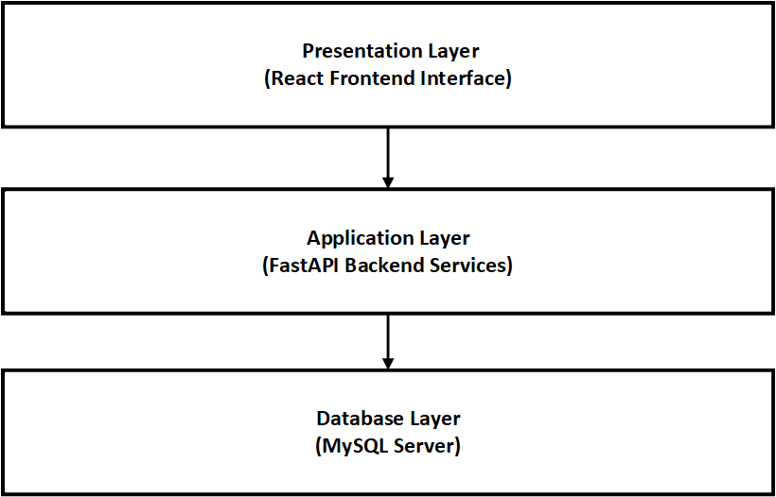
Figure 1

4.3.2 Use Case Diagram
The use case diagram illustrates key user interactions with the system (Booch, Rumbaugh, & Jacobson, 2005).
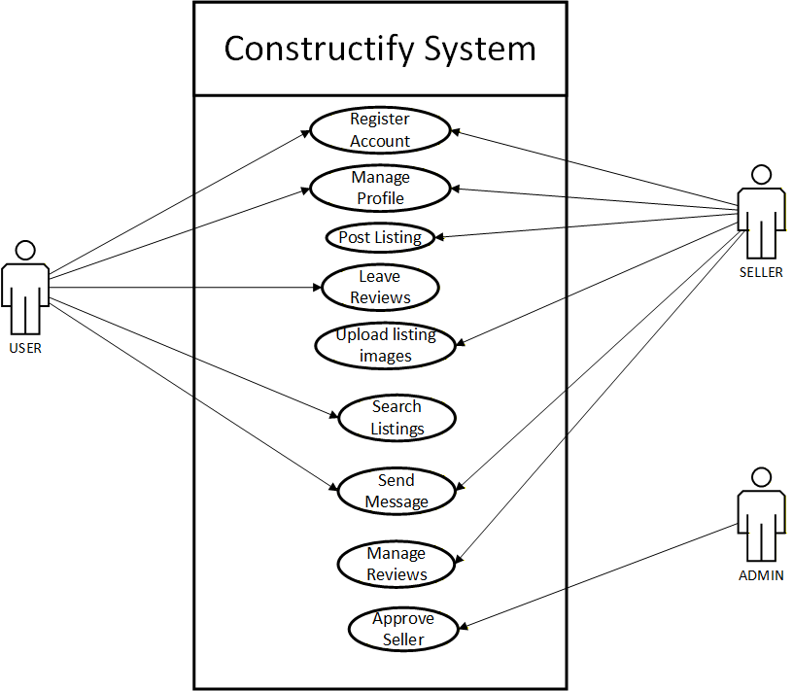
Figure 2

4.3.3 Flowchart
The flowchart below shows the process of a buyer searching for and messaging a seller.
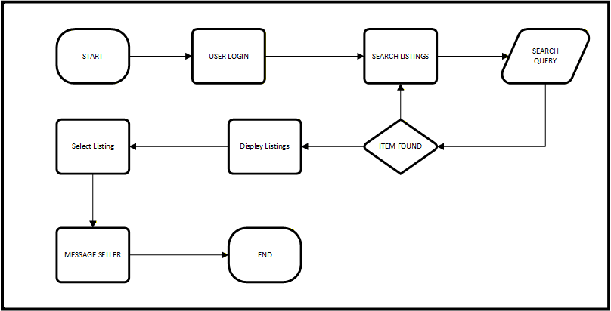
Figure 3

4.3.4 Class Diagram
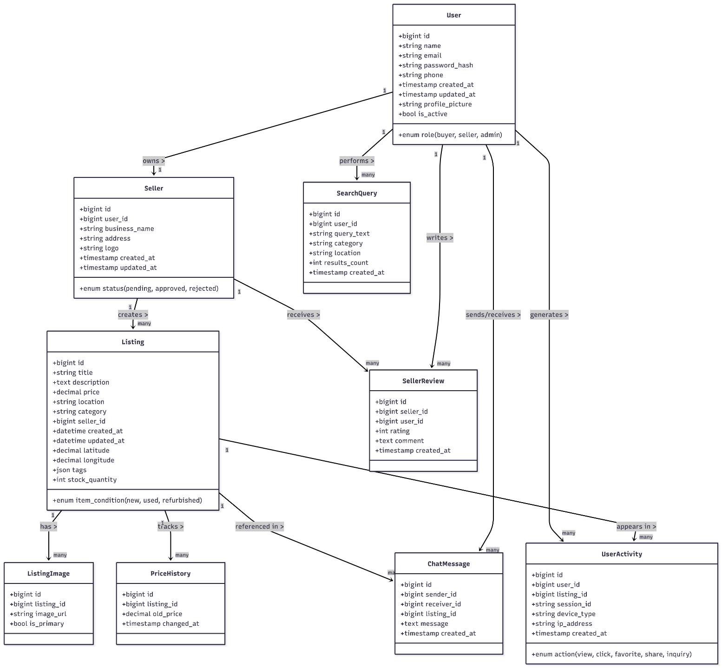
The class diagram represents the main classes, their attributes, and relationships (Fowler, 2004).
Figure 4

4.3.5 Data Flow Diagram (DFD)

Context Diagram (Level 0)
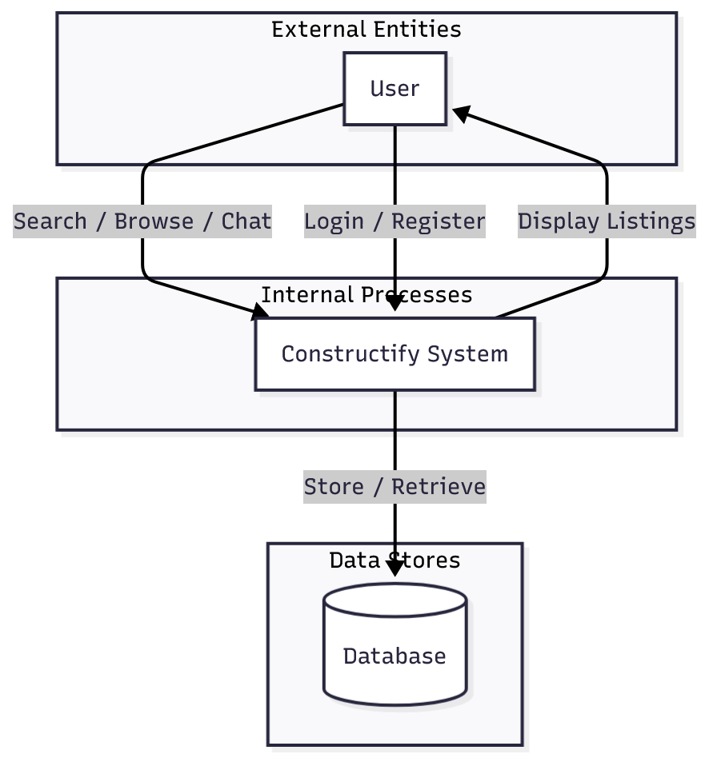
Figure 5
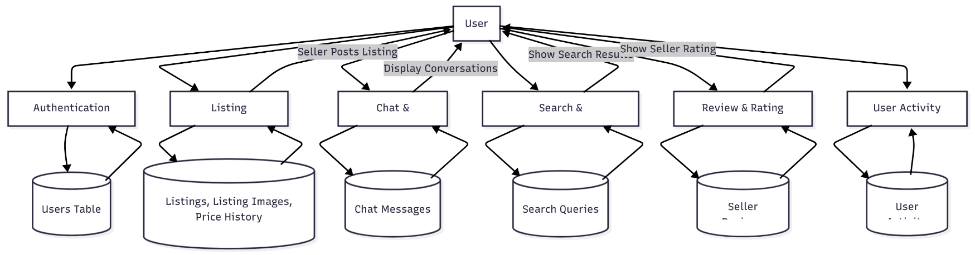
Context Diagram (Level 1)
Figure 6

References
- Abuya, J. O., & Panya, K. O. (2022). Influence of digital payment systems in curbing procurement fraud in state corporations in Kenya. Strategic Journal of Business & Change Management, 9(2), 137–149. Retrieved from https://erepository.kibu.ac.ke/handle/123456789/9537
- Alston, F. (2023, August 23). Schüttflix’s €45M raise fuels construction industry efficiency. Tech.eu. https://tech.eu/2023/08/23/schuttflix-s-45m-construction-industry-efficiency/
- Builders. (n.d.). Interactive catalogue / DIY specials. Builders. https://www.builders.co.za/Interactive-Catalogue
- BuildDirect. (n.d.). BuildDirect. https://www.builddirect.com/
- Finnfund. (2023). TradeDepot Inc. Finnfund. https://www.finnfund.fi/en/hankkeet/tradedepot-inc/
- ITWeb. (2025, July 23). Builders Warehouse streamlines yard operations with service systems. ITWeb. https://www.itweb.co.za/article/builders-warehouse-streamlines-yard-operations-with-service-systems/JN1gP7OAOVnqjL6m
- Kilimall. (n.d.). Kilimall Kenya. https://www.kilimall.co.ke/
- Makokha, P. W., Asenahabi, B. M., & Makokha, J. O. (2021). E-commerce adoption and business performance of SMEs in Kenya. International Journal of Business Management, Entrepreneurship and Innovation, 3(2), 49–61. https://doi.org/10.35942/jbmed.v3i2.219
- MarketScreener. (n.d.). BuildDirect.com Technologies Inc. – Company profile. MarketScreener. https://www.marketscreener.com/quote/stock/BUILDDIRECT-COM-TECHNOLOG-114383845/company/
- Mojaki, L. M., Tuyikeze, T., & Ndlovu, N. K. (2024). A digital procurement framework for South African public sector: A content analysis approach. South African Journal of Information Management, 26(1), Article 1871. https://doi.org/10.4102/sajim.v26i1.1871
- Mulwa, L., Kimitei, E., & Mohammed, Z. (2024). Effect of supply chain digitization on firm performance in government state corporations in Kenya. American Journal of Economics and Business Innovation, 4(1), 45–62. https://doi.org/10.54536/ajebi.v4i1.3780
- Mushayavanhu, T. P., & Simuka, J. (2020). A qualitative study on barriers to e-commerce technologies uptake by informal manufacturing micro and small enterprises in Harare. International Journal of Business Strategy and Social Sciences, 5(1), 15–25. https://doi.org/10.18488/171.v5i1.2986
- Mwencha, P. M., Thuo, J. K., & Muathe, S. M. (2019). An assessment of the state of e-commerce in Kenya. Eastern Africa Journal of Contemporary Research, 1(1), 58–69. Retrieved from https://ir-library.ku.ac.ke/items/af66272a-c73c-4930-ad67-1699654da31e
- Schüttflix. (n.d.). About us. Schüttflix. https://www.schuettflix.com/global/en/about-us/
- TechCrunch. (2021, December 9). TradeDepot raises $110m to digitize Africa’s informal retail sector. TechCrunch. https://techcrunch.com/2021/12/06/tradedepot-raises-110m-from-ifc-novastar-to-extend-bnpl-service-to-merchants-across-africa/
- TradeDepot. (n.d.). Home. TradeDepot. https://www.tradedepot.co/
- U.S. International Trade Administration. (2024, July 5). Kenya — eCommerce. https://www.trade.gov/country-commercial-guides/kenya-ecommerce

