**INFO 3490- Citizen Security Programme's M&E Capacity Strengthening Project**

812003224 | 812003142 | 812002736 | 812001150 | 809002496

Requirements documents

**Table of Contents**

**User Requirements:** 2

**System Requirements:** 2

**Data Flow Diagram** 3

**Use Cases** 2

**User Interface Screenshots** 15

## **User Requirements:**

1. The users shall be able to add new projects to the system.
2. The users shall be able to add persons to a specific project
3. The users shall be able to assign specific roles to persons of a project
4. The users shall be able to view projects that are in progress and also completed.
5. The users shall be able to assign specific pay rates to persons assigned to a project.
6. The users shall be able to create tasks for a project.
7. The users shall be able to assign resources to a task.

## **System Requirements:**

1. System should be able to grant users access to login
2. System should have mechanisms in place for the users to view their projects
3. System should have mechanisms in place for users to change project information in terms of change of start or end date.
4. System should be able to allow users to update project details and progress.
5. System should be able to allow users to calculate wages for persons assigned to a project(s).
6. System should have procedures in place for customers to be able to print their statements.
7. System should be able to allow users to import and export persons into and from other projects.
8. System should have mechanisms in place for users to state the time required for specific tasks.
9. System should be able to grant users the ability to view and search inputted data from it.

## **Data Flow Diagram**

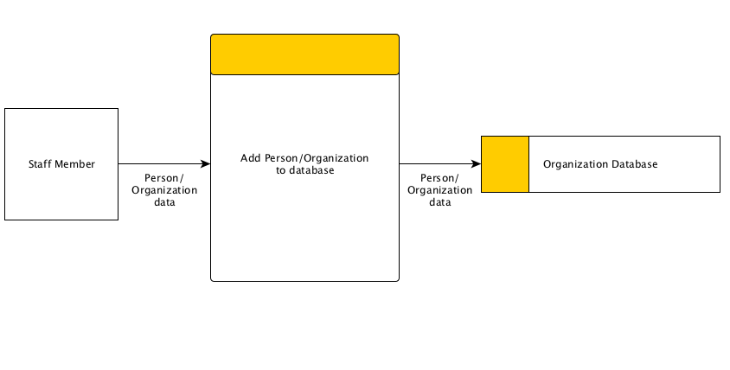

Figure : Adding a person to an organization

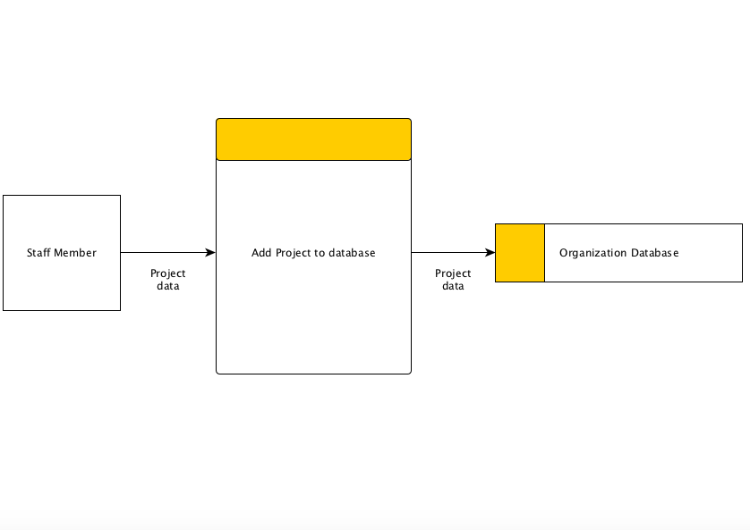

Figure : Adding a Project to the System

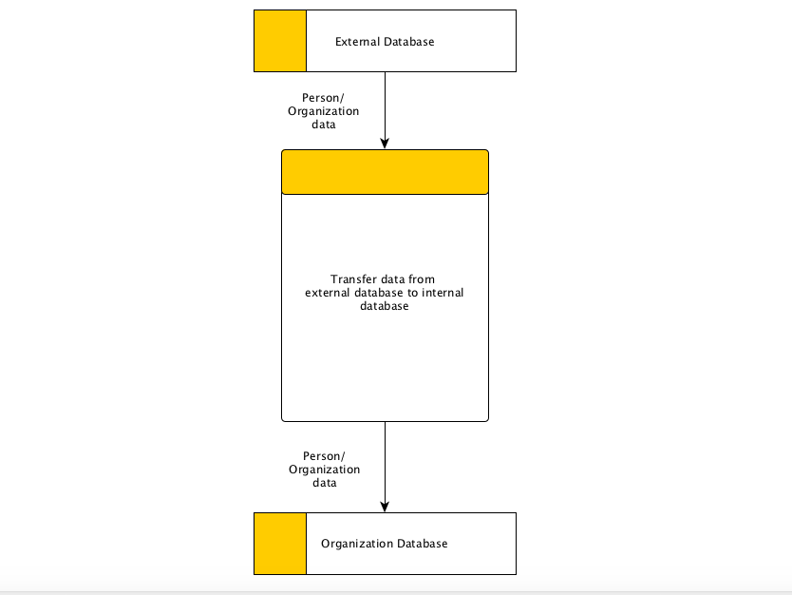

Figure : Transferring of Data (IN)

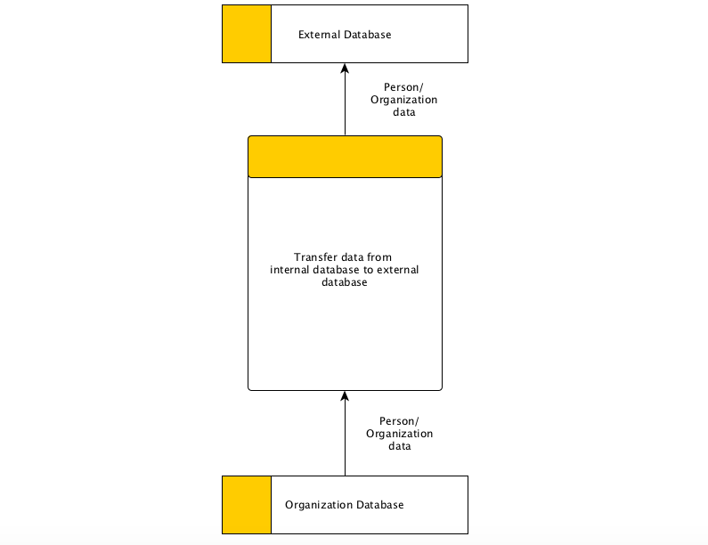

Figure : Transferring of Data (Out)

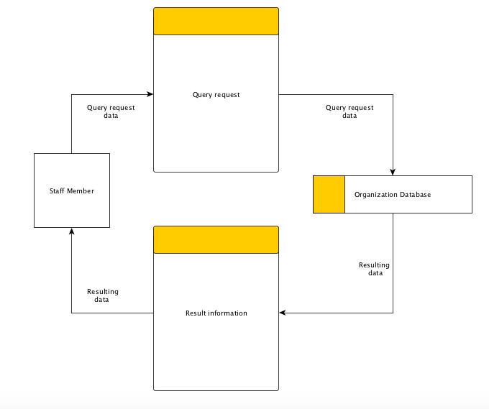

Figure : Querying Information

## **Use Cases**

|  |  |
| --- | --- |
| Use Case Number:- | 1 |
| Use Case Name | User First Time Login |
| Related Requirements | Must be a recognized NGO staff member and be added to the system.  Must receive temporary username and password for first time login. |
| Goal | Having an online user account |
| Pre-Conditions | * Must be added by an administrator or manager to the system * Must be a staff member of the NGO |
| Successful | User successful in setting up their account |
| Fail End Condition | User being unsuccessful in setting their account |
| Primary Actor | User |
| Secondary Actor | Administrator or Manager |
| Main Flow | 1. User receives login credentials for account from an administrator. 2. User goes to the website and types in the temporary username and password. 3. Clicks Login. 4. User selects “Enter a new password” on prompt. 5. Users enters their new password. 6. User clicks on next. 7. User enters their organization’s name. 8. User click finish. 9. User is then directed to the main menu. |

|  |  |
| --- | --- |
| Use Case Number:- | 2 |
| Use Case Name | Regular Login |
| Related Requirements | Must be a recognized NGO staff member and be added to the system.  Must have username and password |
| Goal | Able to login to account |
| Pre-Conditions | * Must have a permanent username and password * Must be a staff member of the NGO |
| Successful | User is successful in logging into their account |
| Fail End Condition | User is unsuccessful in logging into their account |
| Primary Actor | User |
| Secondary Actor | Administrator or Manager |
| Main Flow | 1. User enters login credentials. 2. User clicks on login 3. User is directed to the home page |

|  |  |
| --- | --- |
| Use Case Number | 3 |
| Use Case Name | Add a new project |
| Related Requirements | Online account to interface with the system |
| Goal In Context | Successfully create a new project |
| Pre-Condition | The user be logged in with a predetermined account |
| Successful End Condition | The user creates a new project |
| Fail End Condition | The user was unable to add a new project |
| Primary Actors | Project Manager |
| Secondary Actors | None |
| Trigger | None |
| Main Flow | 1. Select the “Project” tab 2. Click “Add a new project” 3. Enter Project Detail information (Name, Description, Location, Start/End Date, Team Leader, Total Budget & Funder) 4. Click next 5. Enter Beneficiaries information (Beneficiary Type, Sex, Age Group) 6. Click next 7. Enter Objectives & Activates information respectively. 8. Click next 9. Enter Input & Output information respectively. 10. Click next 11. Add persons to project 12. Click Finish |

|  |  |
| --- | --- |
| Use Case Number:- | 4 |
| Use Case Name | Modify Project |
| Related Requirements |  |
| Goal | Ability to modify existing project |
| Pre-Conditions | * Must be an administrator or Project Leader * Project must exist |
| Successful | User successful in modifying project |
| Fail End Condition | User being unsuccessful in modifying project |
| Primary Actor | Administrator or Project Leader |
| Secondary Actor | None |
| Main Flow | 1. Select project from Home Screen 2. Opens to a summary of Project information 3. Click modify |

|  |  |
| --- | --- |
| Use Case Number | 5 |
| Use Case Name | Add a Person/Member |
| Related Requirements | Online account to interface with the system |
| Goal In Context | Successfully add person/member to system |
| Pre-Condition | The user be logged in with a predetermined account |
| Successful End Condition | The user adds new person/member |
| Fail End Condition | The user was unable to add new person/member |
| Primary Actors | Project Manager/System Administrator |
| Secondary Actors | None |
| Trigger | None |
| Main Flow | 1. Select the “Members” tab 2. Click “Add a new member” 3. Enter Personal Detail (First Name, Last Name, Age, Sex, Address, Role & Organization) 4. Click finish |

|  |  |
| --- | --- |
| Use Case Number | 6 |
| Use Case Name | Modify a Person/Member information |
| Related Requirements | Online account to interface with the system |
| Goal In Context | Successfully modify person/member information to system |
| Pre-Condition | The user be logged in with a predetermined account |
| Successful End Condition | The user modifies person/member’s information |
| Fail End Condition | The user was unable to modify person/member’s information |
| Primary Actors | Project Manager/System Administrator |
| Secondary Actors | None |
| Trigger | None |
| Main Flow | 1. Select the “Members” tab 2. Click “View Members” 3. Select member to modify 4. Opens to a summary of member information 5. Click edit 6. Modify information 7. Click Save |

|  |  |
| --- | --- |
| Use Case Number | 7 |
| Use Case Name | Add a new Organization |
| Related Requirements | Online account to interface with the system |
| Goal In Context | Successfully add new organization |
| Pre-Condition | The user be logged in with a predetermined account |
| Successful End Condition | The user adds a new organization |
| Fail End Condition | The user was unable to add a new organization |
| Primary Actors | Project Manager/System Administrator |
| Secondary Actors | None |
| Trigger | None |
| Main Flow | 1. Select the “Organization” tab 2. Click “Add a new Organization” 3. Enter Organization Detail information (Name, Address, Type) 4. Click finish |

|  |  |
| --- | --- |
| Use Case Number | 8 |
| Use Case Name | Modify a Organization Information |
| Related Requirements | Online account to interface with the system |
| Goal In Context | Successfully modify a organization’s information |
| Pre-Condition | The user be logged in with a predetermined account |
| Successful End Condition | The user modifies organization information |
| Fail End Condition | The user was unable to modify organization’s information |
| Primary Actors | Project Manager/System Administrator |
| Secondary Actors | None |
| Trigger | None |
| Main Flow | 1. Select the “Organization” tab 2. Click “View Organizations” 3. Select Organization to edit 4. Opens to a summary of Organization information 5. Click edit 6. Edit Organization information 7. Click save |

|  |  |
| --- | --- |
| Use Case Number | 9 |
| Use Case Name | Export Person/Member Information to PDF |
| Related Requirements | Online account to interface with the system |
| Goal In Context | Successfully export person/member information from system to a downloadable PDF document |
| Pre-Condition | The user be logged in with a predetermined account |
| Successful End Condition | The user gets a PDF document containing the person/member information |
| Fail End Condition | The user was unable to get a the PDF document containing the person/member’s information |
| Primary Actors | Project Manager/System Administrator |
| Secondary Actors | None |
| Trigger | None |
| Main Flow | 1. Select the “Members” tab 2. Click “View Members” 3. Select member. 4. Opens to a summary of member information 5. Click Export to PDF 6. Click Download |

|  |  |
| --- | --- |
| Use Case Number | 10 |
| Use Case Name | Export Organization Information to PDF |
| Related Requirements | Online account to interface with the system |
| Goal In Context | Successfully export Organization information from system to a downloadable PDF document |
| Pre-Condition | The user be logged in with a predetermined account |
| Successful End Condition | The user gets a PDF document containing the organization information |
| Fail End Condition | The user was unable to get a the PDF document containing the organization’s information |
| Primary Actors | Project Manager/System Administrator |
| Secondary Actors | None |
| Trigger | None |
| Main Flow | 1. Select the “Members” tab 2. Click “View Organization” 3. Select organization. 4. Opens to a summary of organization information 5. Click Export to PDF 6. Click Download |

|  |  |
| --- | --- |
| Use Case Number | 11 |
| Use Case Name | Export Person/Member Information to PDF |
| Related Requirements | Online account to interface with the system |
| Goal In Context | Successfully export person/member information from system to a downloadable PDF document |
| Pre-Condition | The user be logged in with a predetermined account |
| Successful End Condition | The user gets a PDF document containing the person/member information |
| Fail End Condition | The user was unable to get a the PDF document containing the person/member’s information |
| Primary Actors | Project Manager/System Administrator |
| Secondary Actors | None |
| Trigger | None |
| Main Flow | 1. Select the “Members” tab 2. Click “View Members” 3. Select member. 4. Opens to a summary of member information 5. Click Export to PDF 6. Click Download |

|  |  |
| --- | --- |
| Use Case Number | 12 |
| Use Case Name | Export Project Information to PDF |
| Related Requirements | Online account to interface with the system |
| Goal In Context | Successfully export project information from system to a downloadable PDF document |
| Pre-Condition | The user be logged in with a predetermined account |
| Successful End Condition | The user gets a PDF document containing the project information |
| Fail End Condition | The user was unable to get a the PDF document containing the project information |
| Primary Actors | Project Manager/System Administrator |
| Secondary Actors | None |
| Trigger | None |
| Main Flow | 1. Select project from Home screen 2. Opens a summary of Project information 3. Click Export to PDF 4. Click Download |

|  |  |
| --- | --- |
| Use Case Number | 13 |
| Use Case Name | Query information. |
| Related Requirements | Online account to interface with the system |
| Goal In Context | Successfully find a given member, project or organization with the search words used. |
| Pre-Condition | The user be logged in with a predetermined account |
| Successful End Condition | The user gets results based on keywords entered |
| Fail End Condition | The user was unable to get results |
| Primary Actors | Project Manager/System Administrator |
| Secondary Actors | None |
| Trigger | None |
| Main Flow | 1. Enter keywords to search for 2. Click Query 3. All relating information is returned. |

|  |  |
| --- | --- |
| Use Case Number:- | 14 |
| Use Case Name | Login Out |
| Related Requirements | Must have an account |
| Goal | User able to log out |
| Pre-Conditions | User must be currently logged in |
| Successful | User is successful in logging out of their account |
| Fail End Condition | User is unsuccessful in logging into their account |
| Primary Actor | User |
| Secondary Actor | Administrator or Manager |
| Main Flow | 1. User clicks on logout 2. System goes to log in screen and |

## **User Interface Screenshots**

Login Page

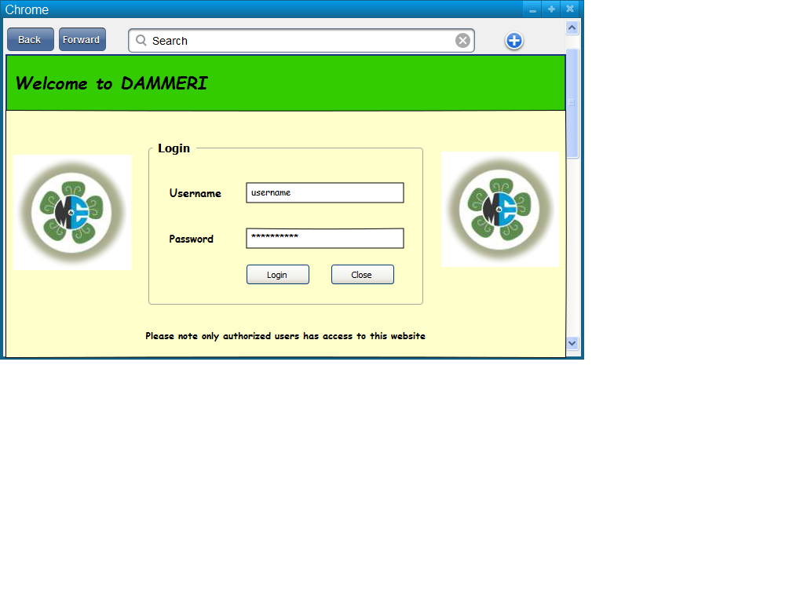

Initial Configuration Stages

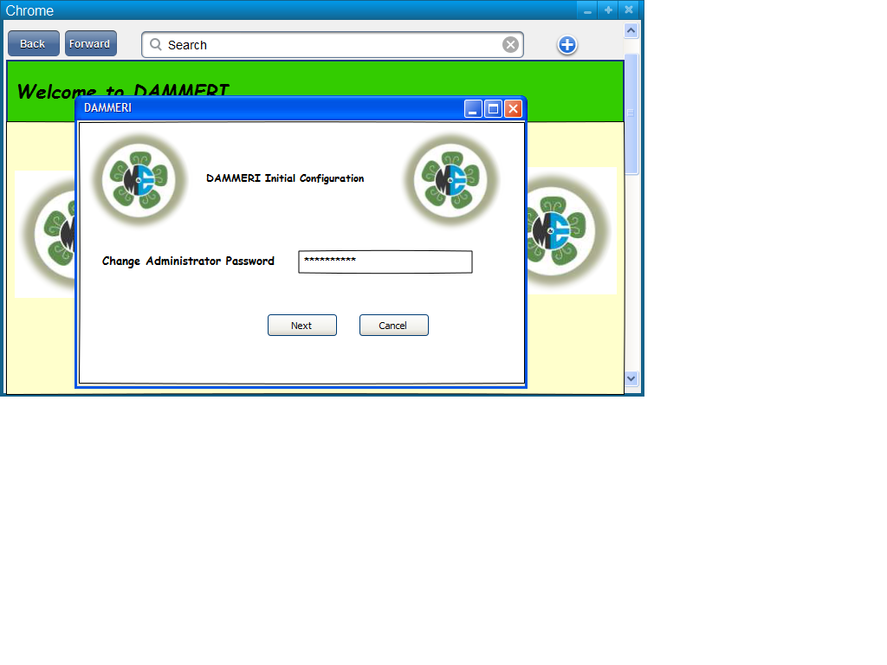

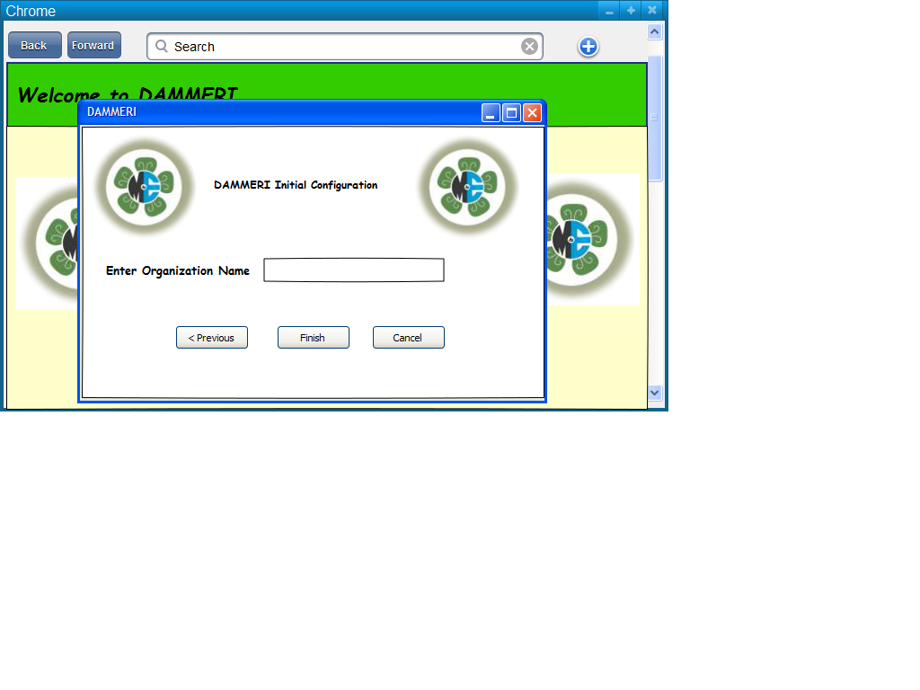

Project Tab

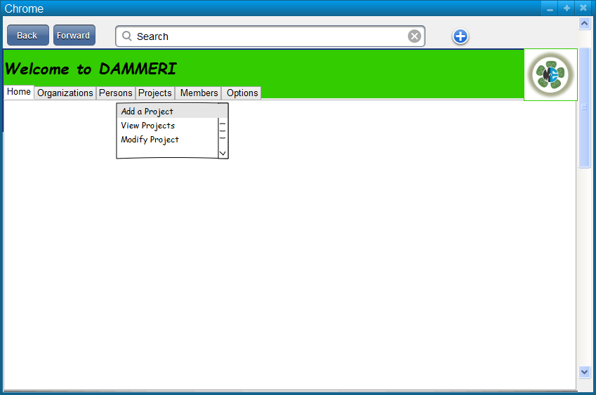

Adding a Project from the Projects Tab

