Dayuan Wang

HW7

Part A:

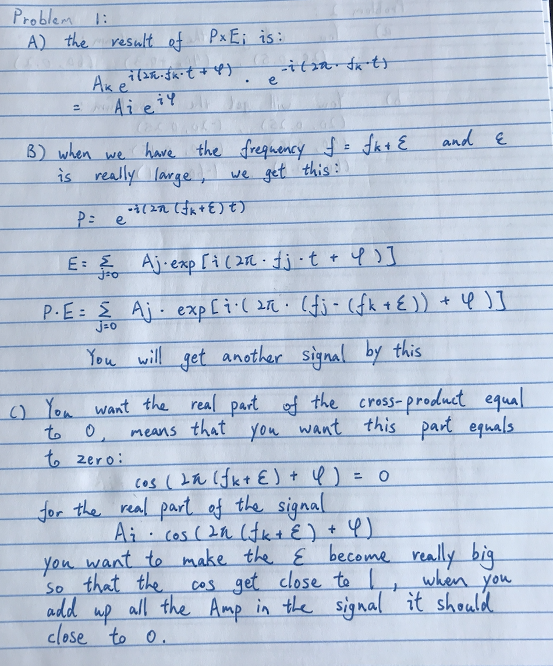

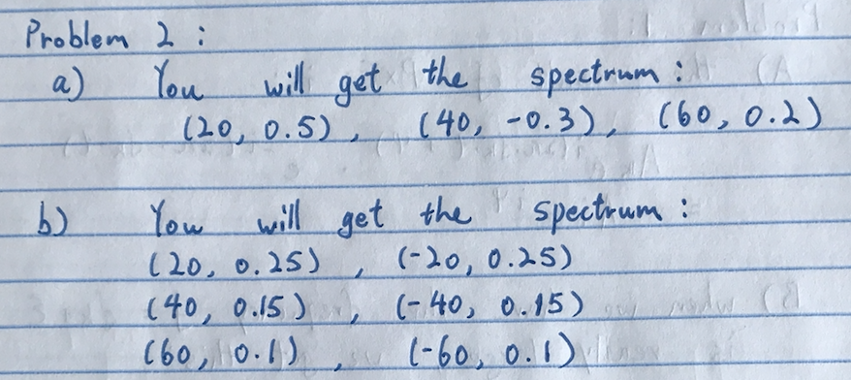

Part B:

Problem 1:

a)

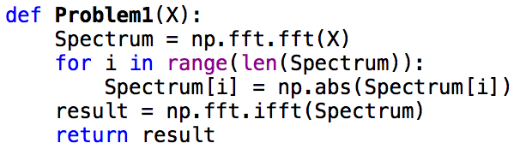

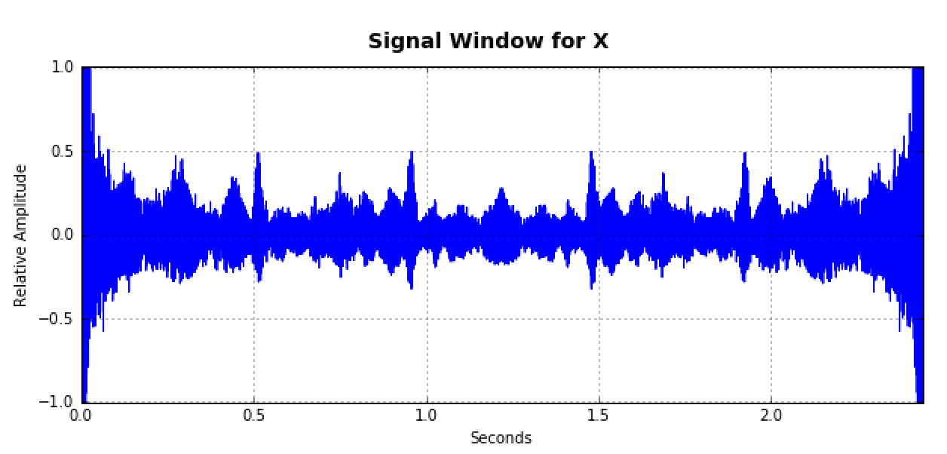

The phase matters for the signal. When all the phase are 0, you will get a even sine wave.

b)

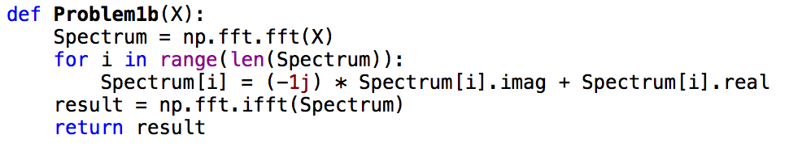

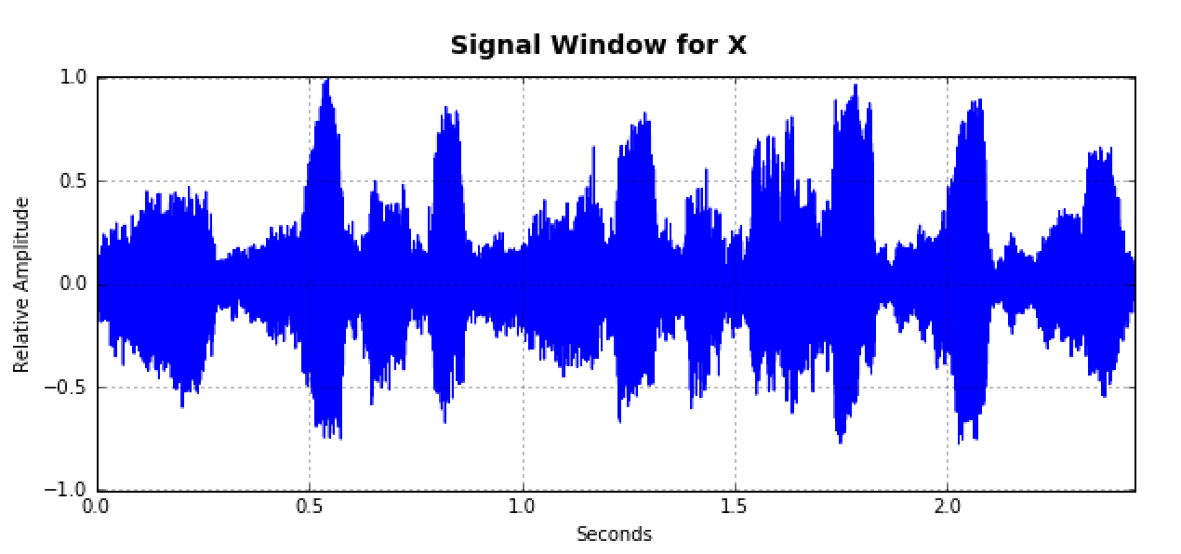

The signal get reversed. Here we are just change all the complex number to its complex conjugate. So the phase matters.

The original signal for the next two problem is:

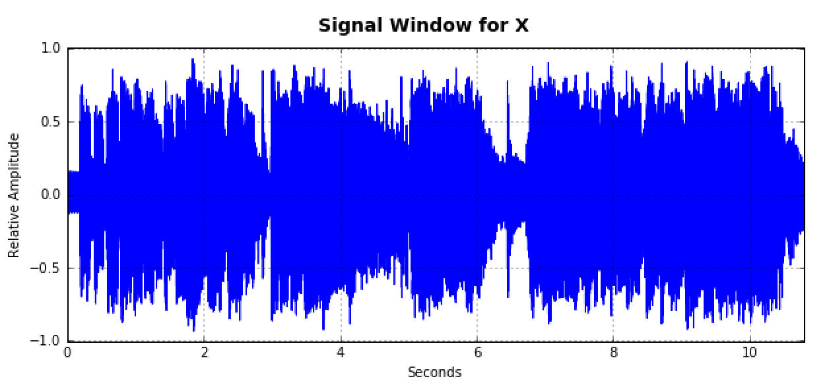

Problem 2

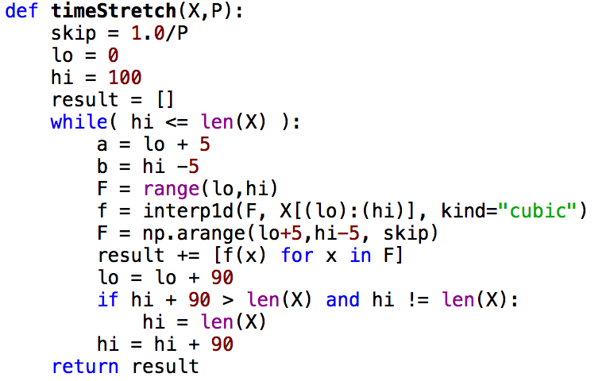

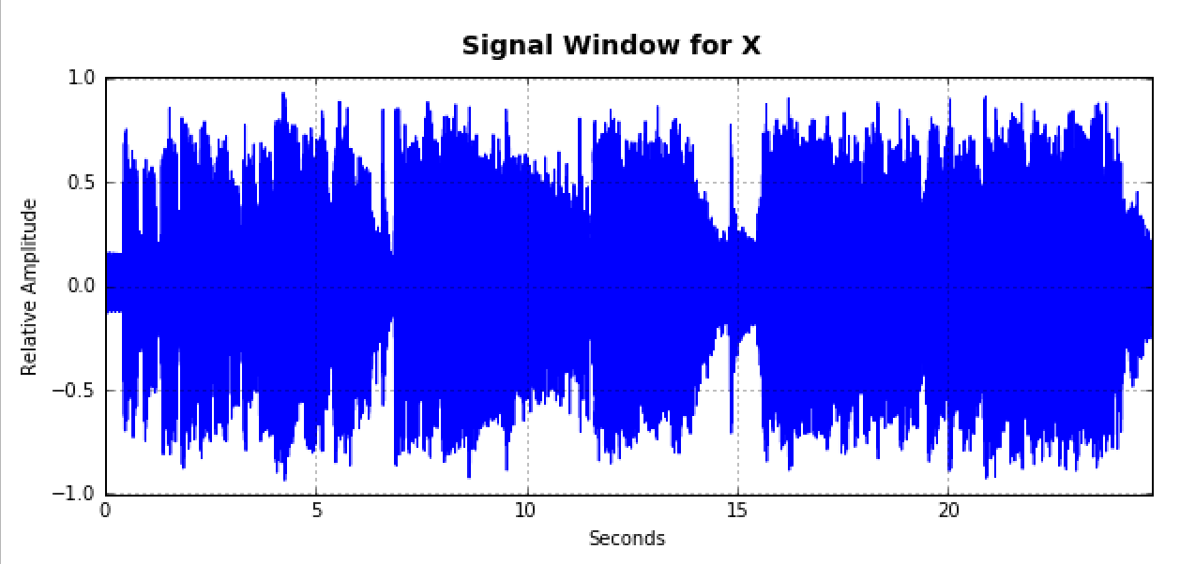

Problem 3

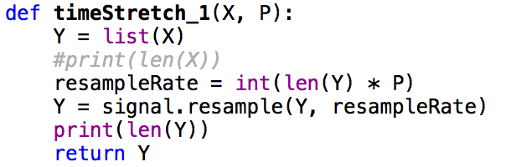

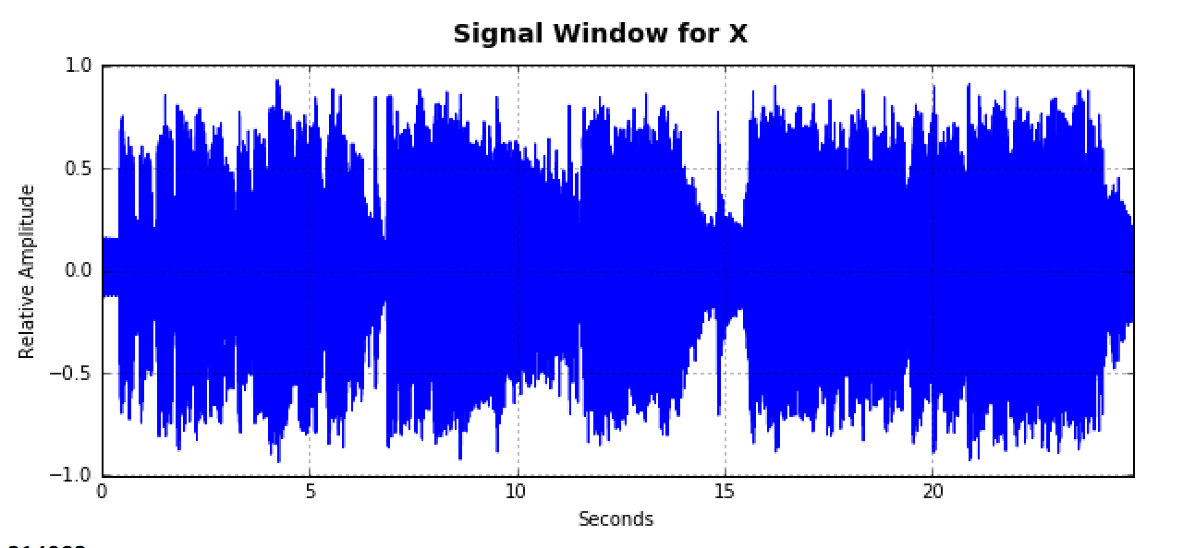

Problem 4

1. The larger the stretch factor will make your signal slower, but the pitch is the same
2. The higher window size, the less noice of the signal
3. N/i, when “i” gets higher, it has higher pitch, if we only have N the sound is broke
4. We want to keep the N = 2048, H = N//4

Problem 5:

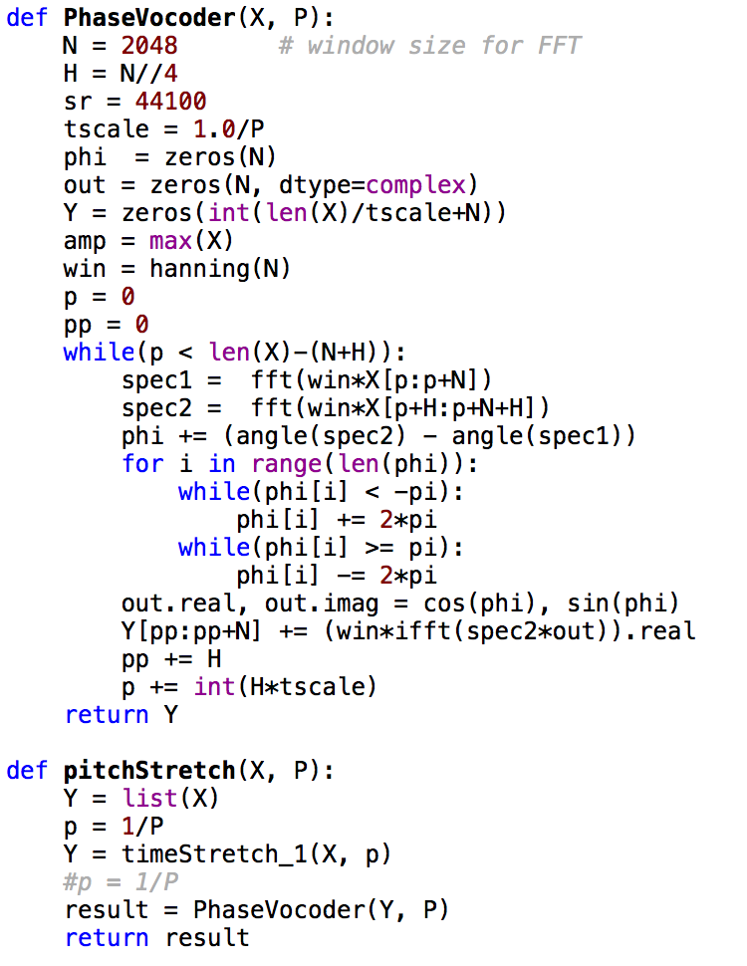

The Code below is to show the signal **lower by the perfect four**. When P = 1/(2**(17/12))

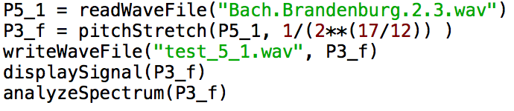

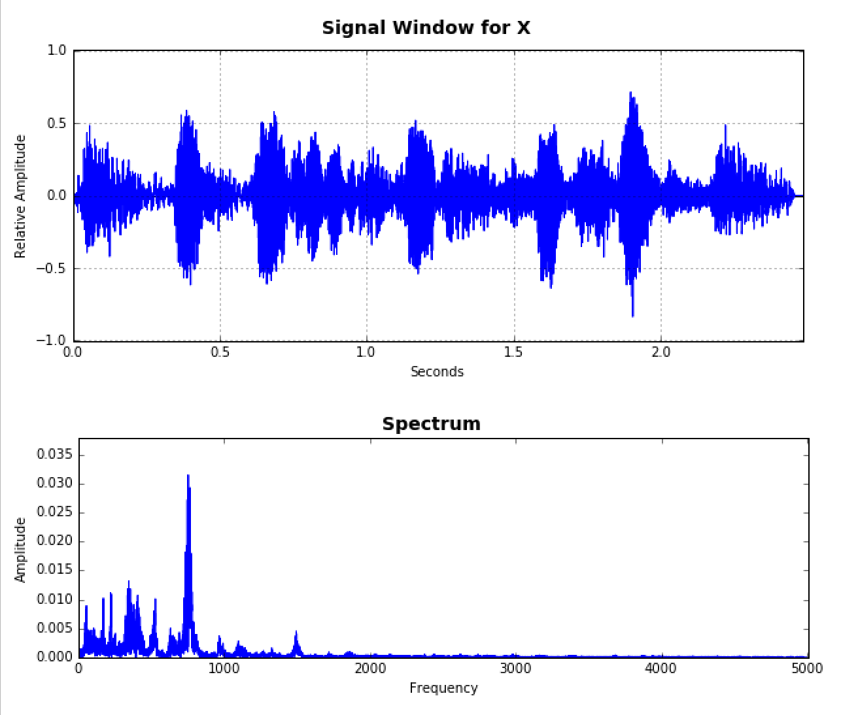

The code below is to show the music signal **lower by Octave**. P = ½

