## **Description:**

College Library (CL) is currently cooperating as a client for our group. **Pamela** and **Kelli**, staff at CL, will be our main clients. They requested us to develop a new button-making system to replace their current implementation. Some features that they are looking for is accepting button-maker reservations, approving exceptions, adding reservations, and notifying patrons about reservation confirmations. The theme for this project development is **stream-lining**. Current reservations (Google Calendar) are handled manually via Kelli/Pamela.

## **Trello Board**

<https://trello.com/invite/b/679949217e98518d834ae43e/ATTI196c81b27621c8c607ec3b08046bd397EEEC33A7/is-424>

## **User Stories**

Story 1: As a user, I want a clear header so I can navigate easily.

Story 2: As CL staff/administrator, I want a clean and understandable homepage that is easy to use so users don’t get lost and leave the site.

Story 3: As an administrator, I want to see and I want users to see what days are open to reserve a button maker.

## **Breaking Down User Stories and Burndown Chart (5 points)**

| Task | Corresponding Story Number | Duration | Priority | Complexity | Lead Person |
| --- | --- | --- | --- | --- | --- |
| Create the header | 1 | 1 hour | 3 | Low | Victor |
| Create a understandable homepage | 2 | 2 hours | 1 | Medium | Gabe |
| Create calendar page | 3 | 3 hours | 2 | Medium | Dara |

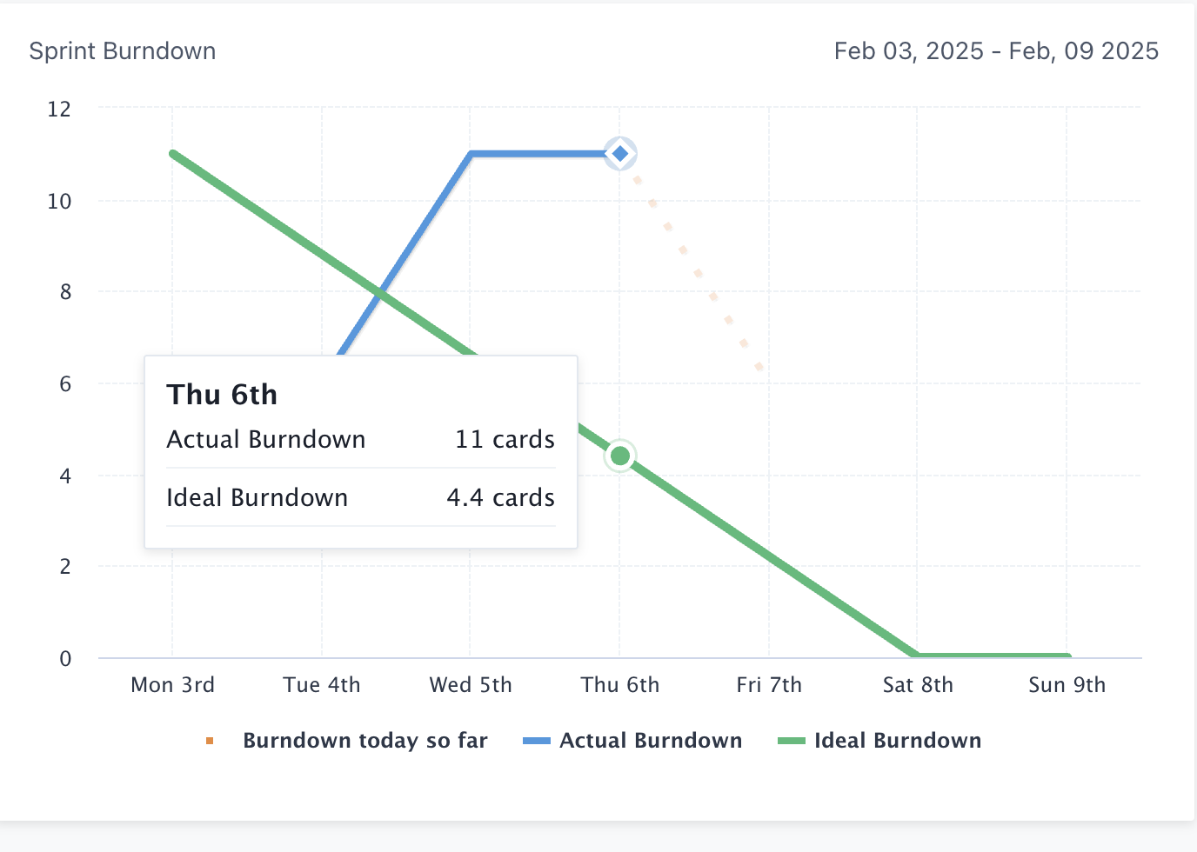

## **Repo URL on Github (3 points)**

Include your GitHub public repo URL in your README only if the topic was covered by the due date.

## **Prototype Link**

<https://cloud.justinmind.com/usernote/prototype/9ed62d84c9ae3ed54940f05a476be04be2d71841edc1c879c89b580f2f4ede12>

## **Daily Scrum (5 points)**

You are assumed that you have done at least 15 minutes of daily meetings throughout the sprint. Show evidence of 3 “stand-up” Scrum meetings in your README. In your evidence, show each team member’s responses to the following questions:

1. 2/3/25
   1. Dara:
      1. n/a
      2. Today, we are planning to begin work on this document, check our trello board, and write up the user stories.
      3. Right now, we are a bit confused on breaking down the user stories and how to complete that section of the sprint.
   2. Benjamin:
      1. n/a
      2. We are planning on continuing to have ideas and think about user stories and the breakdowns.
      3. We are confused on what must be down for the project and also have to make a more comprehensive analysis of the project.
   3. Gabriel:
      1. n/a
      2. We are planning on adding the user stories and connecting trello to the breakdown chart.
      3. So far, we have some questions regarding the breakdown charts, and some general questions regarding the project timeline.
   4. Daniel:
      1. Created end user documentation where technical/abstract details will be
      2. We reviewed tasks for sprint 1, came up with priority tasks, as well as questions to be clarified
      3. We currently have very little idea of deadlines, priorities, and tasks that are assigned points within the description
   5. Victor
      1. n/a
      2. Began work on this document and figuring out what we know/still need to ask
      3. Still need to figure out our priorities for the rest of the project, identify what needs to happen and we have some questions
2. 2/4/2025
   1. Dara
      1. We added user stories and added more tabs to our trello board
      2. We are planning to revise user stories to make them more simple and establish which tasks are our priority
      3. We have to pivot due to the old powerup not working and need to learn to use the new one.
   2. Benjamin
      1. Yesterday we organized our trello board and made a better schedule.
      2. Looking to make the stories more detailed and understandable. Also going to start having more ideas on how to improve the site and assign tasks.
      3. Wording for the stories and burndown problems
   3. Gabriel
      1. Yesterday, we added some more tasks to our trello board
      2. Today, I plan to look over the project guidelines and see about justinmind
      3. Besides the burndown chart not working, nothing else.
   4. Daniel
      1. Reviewed tasks and goals
      2. Will look over project specification and trello assignment allocation
      3. Some nuances in calendar assignment and functions
   5. Victor
      1. Yesterday we updated the trello board and met to go over what needed to be done
      2. Today, I will look over the guidelines further and start getting accustomed to justinmind
      3. No individual issues besides burndown chart
3. 2/7/2025
   1. Dara
      1. Yesterday, we went over the sprint document and did some edits to the trello board. I also worked on the styling of the html page for the reserve/calendar tab.
      2. Today I am planning to continue working on the reserve/calendar tab.
      3. Right now, my html is not working as intended and I am working on making it functional.
   2. Benjamin
      1. Yesterday we went over the scheduling on gantt and added more trello tasks.
      2. Today I’m working on the calendar page prototype in justinmind and have ideas with each other on how we should make it.
      3. Thinking about how to make the calendar a booking function in one.
   3. Gabriel
      1. Yesterday, me and Victor did some paired programming and started creating the HTML and styling for the home page
      2. Today, I plan to improve the HTML for the home page and add the calendar portion to it
      3. Me and Victor had some issues making the format
   4. Daniel
      1. Reviewed code and logic sent from cohort
      2. Will look to combine html pages with some navigation functionality
      3. Calendar and reservation interaction is beginning to become complex
   5. Victor
      1. Yesterday after class I worked with Gabe to create the HTML and CSS for the homepage of the site
      2. Today I plan to go over the site and smooth out any errors and consider integrating it with the calendar page
      3. Still having some issues making the HTML how I want it to be, a few fixes away from having the formatting how I want it to be.

## **Sprint Review (4 points)**

1. What did you learn from doing our first sprint?
   1. We learned that there is a lot of planning involved. There is a lot of things that came up that we weren’t able to think of at the time we were planning which resulted in some improvised planning. We also learned that communication is truly key when it comes to these projects.
2. What did go well? Why?
   1. Our cohort was very collaborative. Each member was very involved and creative with ideas. This flexibility and speed allowed us to expedite the sprint with minimal issues.
3. What didn’t go well? Why not?
   1. For much of the beginning of the project we were all confused and not on the same page. We had some trouble getting the project started, understanding where to start and what to do at some of our meetings slowed us down for some time.
4. How can you make things better next time?
   1. One thing we can do to make things better next time would be to have more firmly set tasks before we begin. At the start of our sprint, we had a few tasks but we added onto them in the middle of it, causing the burndown to be thrown off a bit. Another aspect that will be improved is our communication between each other. It was already at a high level and we did a good job communicating our schedules and thoughts, but as we become more familiar with each other and move along the project we can get our work done more smoothly.
5. Are you satisfied with what you already completed?
   1. Yes, we are satisfied with what we have already completed because we went above and beyond the work for the sprint and started working on the functionality of the pages. We are very happy with our prototypes and decided to move on to the next step, which was actually making the website. We also scheduled a standing meeting on Fridays at the same time so we can ensure that we will have ample time to complete the assignment.
6. Which group was invited? What are your observations/notes? Everybody was present?

## **Submission:**

1. Your README file.

2. Your prototyping file.

3. Your files (HTML, CSS, and JS if any) and images.

4. Put all resources in one folder. Zip your folder. Upload one zipped file per group.

5. Due to the nature of this assignment, no late submissions will be accepted.