Develop an application Using Typescript

EX NO: 5(B) NAME : R.B. Dwaraka Dharshini
DATE: ROLL NO:25MCA003

Aim
To create a web-based Pet Care Hub system using TypeScript, HTML, and CSS. The goal is to demonstrate core TypeScript concepts like Union Types, Intersection Types, Tuples, and Array Slicing to manage and display pets data (name, weight, and status) dynamically.

Procedure
- Project Setup: Create an HTML file for the structure, a CSS section for styling, and a TypeScript file for the logic.
- UI Creation: Design a user-friendly card using HTML <input> tags for fruit details and a <select> tag for stock status.
- Type Definition: In TypeScript, define a Union Type (Status) to strictly allow only "Available" or "Out of Stock" values.
- Intersection Type: Create two interfaces for Name and Price, then combine them using an Intersection Type (FullFruit) to form a complete object.
- Event Handling: Create a displayAll() function and link it to the "Add to List" button using the onclick attribute.
- Data Extraction: Use Type Assertions (like as HTMLInputElement) to read values from the text boxes and dropdown.
- Tuple Conversion: Split the input string and store the name and price into Tuples (fixed-length arrays).
- Array Slicing: Use the .slice() method on the tuples to extract only the fruit names for separate display.
- Execution: Compile the TypeScript file into JavaScript and open the HTML file in a browser to test the functionality.

index.html :

<!DOCTYPE html>
<html lang="en">
<head>
<meta charset="UTF-8">
<meta name="viewport" content="width=device-width, initial-scale=1.0">
<title>Pet Care Hub | Health Records</title>
<style>
/* 1. MODERN PET-FRIENDLY STYLES */
body {
font-family: 'Segoe UI', Roboto, Helvetica, Arial, sans-serif;
display: flex;
justify-content: center;
align-items: center;
min-height: 100vh;
/* Minty Fresh Gradient */
background: linear-gradient(135deg, #a8e6cf 0%, #dcedc1 100%);
margin: 0;
}

.card {
background: #ffffff;
padding: 40px;
border-radius: 30px;
width: 400px;
box-shadow: 0 20px 40px rgba(0,0,0,0.1);
border-bottom: 8px solid #3498db;
transition: transform 0.3s ease;
}

.card:hover {
transform: translateY(-5px);
}

h3 {
color: #2c3e50;
text-align: center;
margin-bottom: 30px;
font-size: 26px;
font-weight: 700;
border-bottom: 2px solid #f1f2f6;
padding-bottom: 15px;
}

label {
display: block;
font-weight: 600;
margin-bottom: 8px;
color: #576574;
font-size: 13px;
text-transform: uppercase;
}

input, select {
width: 100%;
padding: 14px;
margin-bottom: 20px;
border-radius: 12px;
border: 2px solid #f1f2f6;
background: #f8f9fa;
box-sizing: border-box;
transition: all 0.3s ease;
outline: none;
}

input:focus, select:focus {
border-color: #3498db;
background: #fff;
box-shadow: 0 0 10px rgba(52, 152, 219, 0.2);
}

button {
background: #3498db;
color: white;
border: none;
padding: 16px;
font-weight: bold;
cursor: pointer;
width: 100%;
border-radius: 12px;
font-size: 16px;
text-transform: uppercase;
transition: all 0.3s ease;
box-shadow: 0 6px 15px rgba(52, 152, 219, 0.3);
}

button:hover {
background: #2980b9;
transform: scale(1.02);
}

.result-box {
margin-top: 30px;
padding: 25px;
border: 2px dashed #bdc3c7;
background: #fffdf9;
border-radius: 15px;
position: relative;
color: #2c3e50;
line-height: 1.8;
font-size: 14px;
animation: fadeIn 0.5s ease-in;
}

@keyframes fadeIn {
from { opacity: 0; } to { opacity: 1; }
}

.box-title {
position: absolute;
top: -12px;
left: 20px;
background: #3498db;
color: white;
padding: 2px 12px;
font-weight: bold;
font-size: 11px;
border-radius: 20px;
}

.highlight { color: #e67e22; font-weight: bold; }
.success { color: #27ae60; font-weight: bold; }
</style>
</head>
<body>

<div class="card">
<h3>🐾 Pet Care Hub</h3>

<label>Pet 1 (Name Weight):</label>
<input type="text" id="in1" placeholder="e.g. Buddy 25">

<label>Pet 2 (Name Weight):</label>
<input type="text" id="in2" placeholder="e.g. Luna 12">

<label>Pet 3 (Name Weight):</label>
<input type="text" id="in3" placeholder="e.g. Alford 12">

<label>Vaccination Status (Union):</label>
<select id="uStat">
<option value="Vaccinated">Vaccinated</option>
<option value="Pending">Pending</option>
</select>

<button onclick="displayAll()">Update Records</button>

<div class="result-box" id="outBox" style="display:none;">
<span class="box-title">HEALTH CERTIFICATE</span>
<div id="outContent"></div>
</div>
</div>
<script src="script.js"></script>
</body>
</html>

Script.js :

// 1. Union Type (Simple Choice)
type Status = "Vaccinated" | "Pending";

// 2. Intersection (Combining two simple parts)
interface NamePart { pName: string; }
interface WeightPart { pWeight: number; }
type PetRecord = NamePart & WeightPart;

function displayAll(): void {
// Get values simply
const input1 = (document.getElementById("in1") as any).value.split(" ");
const input2 = (document.getElementById("in2") as any).value.split(" ");
const input3 = (document.getElementById("in3") as any).value.split(" ");

const uStatus = (document.getElementById("uStat") as any).value;

// --- 3. TUPLES (Pairs in Brackets) ---
// Rule: [String, Number]
const tuple1: [string, number] = [input1[0], parseInt(input1[1])];
const tuple2: [string, number] = [input2[0], parseInt(input2[1])];
const tuple3: [string, number] = [input3[0], parseInt(input3[1])];

// --- 4. SLICE (Take only the Name) ---
const sliceName = tuple1.slice(0, 1);

// --- 5. INTERSECTION OBJECT (Merge) ---
const myPet: PetRecord = {
pName: tuple1[0],
pWeight: tuple1[1]
};

// Output Logic
const box = document.getElementById("outBox")!;
const content = document.getElementById("outContent")!;

box.style.display = "block";
content.innerHTML = `
<b>Tuples:</b> (${tuple1[0]}, ${tuple1[1]}) & (${tuple2[0]}, ${tuple2[1]}) & (${tuple3[0]}, ${tuple3[1]}) <br>
<b>Slice Name:</b> ${sliceName} <br>
<b>Object:</b> { name: "${myPet.pName}", weight: ${myPet.pWeight} } <br>
<b>Status:</b> ${uStatus}
`;
}

Output:

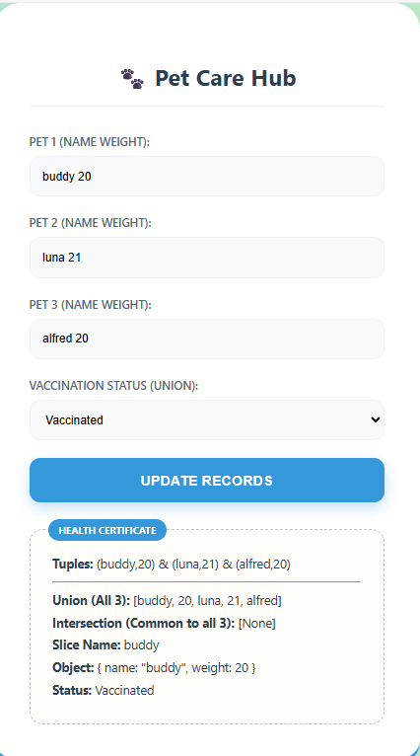

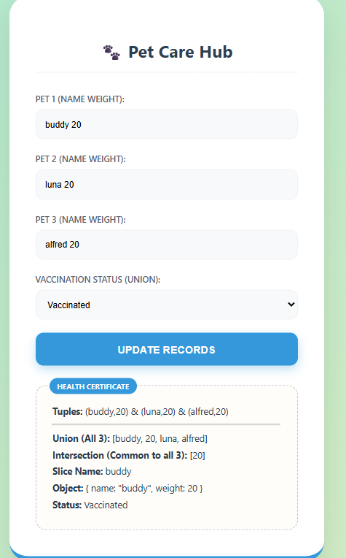

Result
The program successfully implements Branching (Switch) and Looping (for, while, do-while) to display user input. demonstrates Tuples, Object Types, and Unions to ensure strict data safety and structured output within the HTML DOM.

