PREPARE BIODATA/RESUME USING HTML TAGS
EX.NO: 1(A) NAME : R.B. Dwaraka Dharshini
DATE: ROLL NO: 25MCA003

Aim:
Write a program to develop a resume or Bio data using various html tags and also develop a registration form using various html tags in notepad or visual studio.
Procedure:
1. Page Initialization (<body>, <center>, <table>)
- Set the document background color using the bgcolor attribute in the <body> tag.
- Use the <center> tag to align the entire resume to the middle of the screen.
- Create the main structure with a <table> tag, setting width="60%" and border="1" to form a professional border around your content.
2. Identity & Visuals (<h1>, <hr>, <img>)
- Define your name as the primary heading using the <h1> tag for high visibility.
- Insert horizontal dividers using the <hr> tag to separate the header from the body.
- Embed a profile photo using the <img> tag, specifying width and height to ensure the image fits the layout.
3. Academic Data Structuring (<tr>, <th>, <td>)
- Organize educational qualifications into a sub-table using <tr> for each row.
- Use the <th> tag for the top row to automatically bold and center the headings (Course, CGPA, Year).
- Fill in details using the <td> tag to keep the institution names and scores perfectly aligned in columns.
4. Skill & Project Listing (<ul>, <li>, <b>)
- Present Technical Skills and Projects in a clean list format using the <ul> (Unordered List) tag.
- Wrap every individual item in an <li> tag to generate professional bullet points.
- Apply the <b> tag to specific keywords or project titles to make them stand out to the reader.
5. Sectioning & Spacing (<h3>, <p>, <br>)
- Create clear section headers (like "STRENGTHS") using the <h3> tag for consistent font sizing.
- Use the <p> tag to wrap the Career Objective and Declaration text for proper paragraph spacing.
- Insert <br> tags in the Personal Details and Signature sections to force text onto new lines where needed.

Source Code:
<!DOCTYPE html>
<html>
<head>
<title>Resume - Dwaraka Dharshini R.B</title>
</head>
<body bgcolor="#EAEAEA">
<center>
<table width="60%" border="1" cellpadding="20" cellspacing="0" bordercolor="black" bgcolor="white">
<tr>
<td>
<!-- HEADER -->
<center>
<h1>DWARAKA DHARSHINI R.B</h1>
<p>
📧 dwaraka@gmail.com | 📞 9345678654 | 📍 Tamil Nadu, India
</p>
<hr color="black">
</center>
<!-- CAREER OBJECTIVE AND PROFILE IMAGE -->
<table width="100%">
<tr>
<td valign="top">
<h3>CAREER OBJECTIVE</h3>
<p>
To obtain a responsible position where I can apply my technical skills and contribute to organizational success.<br>
To enhance my technical knowledge by learning new technologies and adapting to industry standards.<br>
To contribute positively to the organization through dedication, teamwork, and continuous improvement.<br>
To build a successful career while delivering quality work and professional growth.
</p>
</td>
<td width="30%" valign="top" align="center">
<img src="img.jpeg" width="120" height="150" alt="Profile Photo" margin-top:"3">
</td>
</tr>
</table>
<!-- EDUCATIONAL QUALIFICATION -->
<h3>EDUCATIONAL QUALIFICATION</h3>
<table width="100%" border="1" cellpadding="6" cellspacing="0" bordercolor="black">
<tr>
<th>Course</th>
<th>Institution</th>
<th>CGPA</th>
<th>Year</th>
</tr>
<tr>
<td>MCA</td>
<td>Mepco Schlenk Engineering College</td>
<td>Pursuing</td>
<td>2025–2027</td>
</tr>
<tr>
<td>UG</td>
<td>Lady Doak College</td>
<td>6.8</td>
<td>2022–2025</td>
</tr>
<tr>
<td>SSLC</td>
<td>SEV Matriculation.Hr.Sec School</td>
<td>7.7</td>
<td>2021</td>
</tr>
<tr>
<td>HSC</td>
<td>SEV Matriculation.Hr.Sec School</td>
<td>7.8</td>
<td>2019</td>
</tr>
</table>
<!-- TECHNICAL SKILLS -->
<hr>
<h3>TECHNICAL SKILLS</h3>
<ul>
<li>Python</li>
<li>MySQL</li>
<li>C</li>
<li>Java</li>
</ul>
<!-- ACADEMIC PROJECTS -->
<hr>
<h3>ACADEMIC PROJECTS</h3>
<ul>
<li><b>Musical Instrument Store</b> – Python & MySQL</li>
<li><b>Quiz Application</b> – Android Studio</li>
<li><b>Shopzee Application</b> - Android Studio(Java)</li>
<li><b>Baggit</b> - Html with css,Javascript</li>
<li><b>Netflix Dashboard</b> - Power Bi</li>
<li><b>Arudra Hospic Website</b> - Web Developement</li>
</ul>
<!-- CERTIFICATIONS -->
<hr>
<h3>CERTIFICATIONS</h3>
<ul>
<li>Python Programming – Online Certification</li>
<li>Introduction to AI – Free Online Course</li>
<li>Java Developement</li>
<li>C Developement</li>
</ul>
<!-- INTERNSHIP / TRAINING -->
<hr>
<h3>INTERNSHIP / TRAINING</h3>
<p>
Web Development Intern – Kevel Korp, Madurai<br>
Worked on HTML and CSS for women’s fashion website.
</p>
<!-- AREA OF INTEREST -->
<hr>
<h3>AREA OF INTEREST</h3>
<ul>
<li>Python Development</li>
<li>Web Development</li>
<li>Database Management</li>
<li>App Developement</li>
<li>Data Analysis(Power BI)</li>
</ul>
<!-- STRENGTHS -->
<hr>
<h3>STRENGTHS</h3>
<ul>
<li>Quick learner</li>
<li>Self-motivated</li>
<li>Good communication skills</li>
<li>Presentation Skills</li>
<li>Quick Adapter</li>
</ul>
<!-- PERSONAL DETAILS -->
<hr>
<h3>PERSONAL DETAILS</h3>
<p>
Name : Dwaraka Dharshini R.B <br>
Date of Birth : 17/03/2005 <br>
Languages Known : English, Tamil <br>
Nationality : Indian
</p>
<!-- DECLARATION -->
<hr>
<h3>DECLARATION</h3>
<p>
I hereby declare that the above information is true and correct
to the best of my knowledge.
</p>

<br>
<p>
<b>Place:</b> Tamil Nadu <br>
<b>Date:</b> 21/01/2026
</p>
<p align="right">
<b>Signature</b><br>
Dwaraka Dharshini R.B
</p>
</td>
</tr>
</table>
</center>
</body>
</html>

OUTPUT:
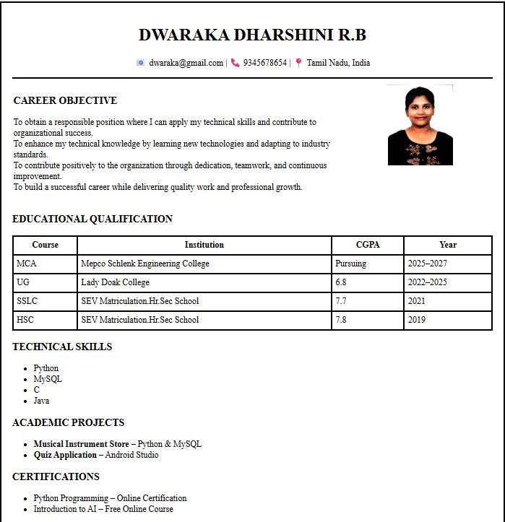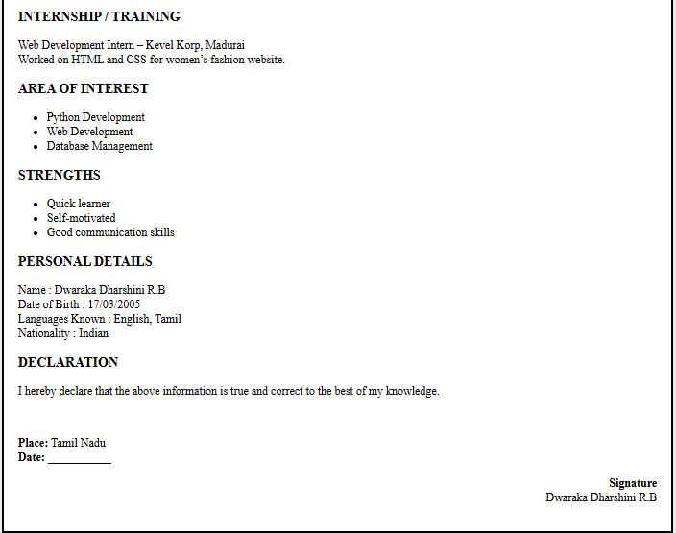

REGISTRATION FROM USING VARIOUS HTML TAGS
EX.NO: 1(B) NAME : R.B. Dwaraka Dharshini
DATE: ROLL NO: 25MCA003

Aim :
To Write a code to develop a passport Registration form using various html tags with different controls .
Procedure :
1. Page Setup & Header (<body>, <h2>)
- Initialize the page using the <body> tag with bgcolor and text attributes to establish the color scheme.
- Create a prominent page title using the <h2> tag, centered with an align="center" attribute.
- Apply inline styling (style) to the header to add a background color and padding for a professional appearance.
2. Form & Table Layout (<form>, <table>, <tr>)
- Wrap the entire input area in a <form> tag to enable data collection and submission.
- Use a <table> with border="1" and cellpadding="8" to align labels and input fields perfectly.
- Apply alternating bgcolor attributes to the <tr> (Table Rows) to create a "zebra-stripe" effect for better readability.
3. Basic Input Fields (<input type="text/date/tel/email">)
- Use specific <input> types like text, date, tel, and email to ensure user data is captured in the correct format.
- Include the required attribute in these tags to prevent the form from being submitted with empty fields.
- Collect the residential address using the <textarea> tag, which allows for multi-line text input.
4. Selection & Options (<input type="radio">, <select>, <option>)
- Implement gender selection using <input type="radio">, allowing the user to pick only one choice from a group.
- Create a dropdown menu for Passport Type using the <select> tag.
- Define each choice within the dropdown using <option> tags to keep the form compact and organized.
5. File Upload & Actions (<input type="file/submit/reset">)
- Allow users to attach a photograph using <input type="file"> with the accept="image/*" attribute to restrict file types.
- Add a row for buttons using <td colspan="2"> to center them across both columns.
- Include type="submit" to process the registration and type="reset" to clear all entries instantly.
10 Form Validations & Descriptions
- required (Mandatory): Forces the user to fill in a field before the form can be submitted (e.g., Full Name).
- type="date" (Calendar): Restricts input to a valid date format and provides a calendar picker for the Date of Birth.
- type="radio" (Exclusive Choice): Ensures only one option can be selected from a group (e.g., Gender).
- rows & cols (Sizing): Limits the visual size of the Address area to keep the layout neat and readable.
- type="tel" (Phone Format): Optimizes the input for numeric phone data and triggers number pads on mobile devices.
- type="email" (Email Structure): Checks if the input follows the "name@example.com" format automatically.
- type="file" (Attachment): Restricts the input to file browsing, allowing the user to Upload a photo.
- accept="image/*" (Media Filter): Limits the file picker to only show image files, preventing incorrect document uploads.
- pattern="[0-9]{10}" (Digit Lock): Validates that exactly 10 numerical digits are entered for the Phone Number.
- maxlength="10" (Character Cap): Physically stops the user from typing more than 10 characters in the phone field
Source Code :
<!DOCTYPE html>
<html>
<head>
<title>Passport Registration Form</title>
</head>
<body bgcolor="#f0f8ff" text="#000000">
<h2 align="center" style="background-color:#4682b4; color:white; padding:10px;">Passport Registration Form</h2>
<form>
<table border="1" cellpadding="8" cellspacing="0" align="center" bgcolor="#ffffff">
<!-- Full Name -->
<tr bgcolor="#e6f2ff">
<td>Full Name:</td>
<td><input type="text" name="fullname" required></td>
</tr>

<!-- Date of Birth -->
<tr bgcolor="#f9f9f9">
<td>Date of Birth:</td>
<td><input type="date" name="dob" required></td>
</tr>

<!-- Gender -->
<tr bgcolor="#e6f2ff">
<td>Gender:</td>
<td>
<input type="radio" name="gender" value="Male"> Male
<input type="radio" name="gender" value="Female"> Female
<input type="radio" name="gender" value="Other"> Other
</td>
</tr>

<!-- Nationality -->
<tr bgcolor="#f9f9f9">
<td>Nationality:</td>
<td><input type="text" name="nationality" required></td>
</tr>

<!-- Address -->
<tr bgcolor="#e6f2ff">
<td>Residential Address:</td>
<td><textarea name="address" rows="4" cols="30" required></textarea></td>
</tr>

<!-- Phone -->
<tr bgcolor="#f9f9f9">
<td>Phone Number:</td>
<td><input type="tel" name="phone" required></td>
</tr>

<!-- Email -->
<tr bgcolor="#e6f2ff">
<td>Email ID:</td>
<td><input type="email" name="email" required></td>
</tr>

<!-- Passport Type -->
<tr bgcolor="#f9f9f9">
<td>Passport Type:</td>
<td>
<select name="passportType" required>
<option value="">--Select--</option>
<option value="ordinary">Ordinary Passport</option>
<option value="official">Official Passport</option>
<option value="diplomatic">Diplomatic Passport</option>
</select>
</td>
</tr>

<!-- Upload Photo -->
<tr bgcolor="#e6f2ff">
<td>Upload Passport Size Photo:</td>
<td><input type="file" name="photo" accept="image/*"></td>
</tr>

<!-- Emergency Contact -->
<tr bgcolor="#f9f9f9">
<td>Emergency Contact:</td>
<td>
Name: <input type="text" name="emergencyName"><br>
Phone: <input type="tel" name="emergencyPhone"><br>
Relation: <input type="text" name="emergencyRelation">
</td>
</tr>
<!-- Buttons -->
<tr bgcolor="#dbe9f4">
<td colspan="2" align="center">
<input type="submit" value="Register">
<input type="reset" value="Clear">
</td>
</tr>
</table>
</form>
</body>
</html>

OUTPUT :
Validation :
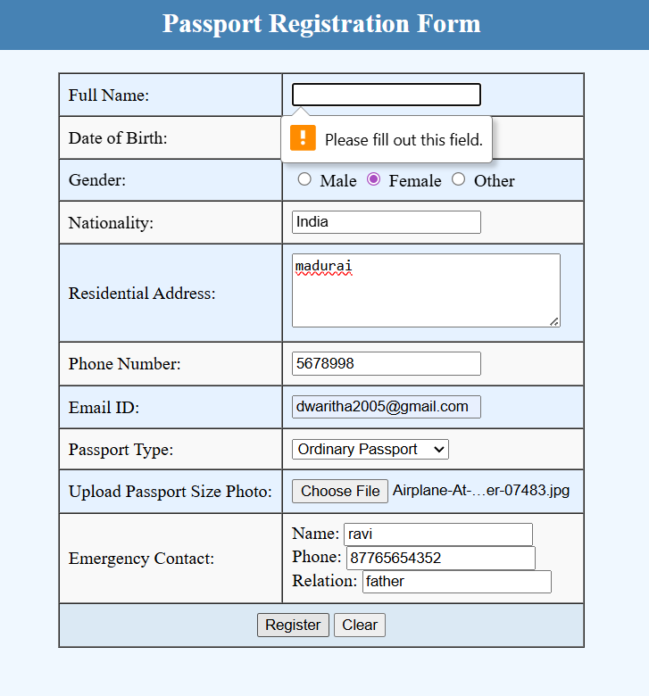
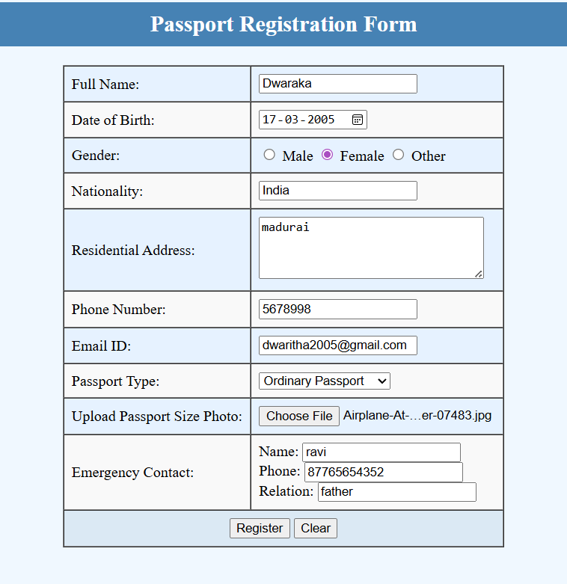

Result :
Thus, The passport Registration Form and resume are created using basic html tags and displayed in separate web pages . Therefore, This output was verified successfully.

