Develop an application Using Typescript

EX NO: 5(A) NAME : R.B. Dwaraka Dharshini
DATE: ROLL NO:25MCA003

5 A) Create an application for implementing Banching statements and looping statements using typesctipt.

Aim
To design and implement a web application using TypeScript to demonstrate the use of Control Flow Statements, including Branching (Switch-Case) and Looping (For, While, and Do-While) for mathematical computations.

Procedure
- Get Elements: It grabs three items from your HTML: an input box (num), a dropdown menu (choice), and a display area (result).
- Read Values: It converts the text from the input box and the dropdown into numbers.
- Check the Choice: It looks at which option you picked in the dropdown:
  - Choice 1 (Even Numbers): It loops from 2 up to your number, adding every second number to a list.
  - Choice 2 (Fibonacci): It calculates a sequence where each number is the sum of the two before it (0, 1, 1, 2, 3...) until it reaches your count.
  - Choice 3 (Strong Number): It checks if the sum of the factorials of your number's digits equals the number itself

- Display: It takes the final text it created and injects it into the result area on your screen.
To make this work in your browser, you just need an HTML file with an <input id="num">, a <select id="choice">, and a <div id="result">.

index.html

<!DOCTYPE html>
<html lang="en">
<head>
<meta charset="UTF-8">
<meta name="viewport" content="width=device-width, initial-scale=1.0">
<title>TypeScript Looping Demo</title>
<style>
/* Base Styling */
body {
font-family: 'Segoe UI', Tahoma, Geneva, Verdana, sans-serif;
background: linear-gradient(135deg, #667eea 0%, #764ba2 100%);
height: 100vh;
display: flex;
justify-content: center;
align-items: center;
margin: 0;
color: #333;
}

/* Glassmorphism Card Container */
.container {
background: rgba(255, 255, 255, 0.9);
padding: 2rem;
border-radius: 15px;
box-shadow: 0 8px 32px rgba(0, 0, 0, 0.1);
width: 350px;
text-align: center;
}

h2 {
margin-bottom: 1.5rem;
color: #4a4a4a;
font-size: 1.5rem;
}

/* Form Elements Styling */
.form-group {
margin-bottom: 1rem;
text-align: left;
}

label {
display: block;
margin-bottom: 5px;
font-weight: 600;
font-size: 0.9rem;
}

input, select {
width: 100%;
padding: 10px;
border: 1px solid #ddd;
border-radius: 8px;
box-sizing: border-box; /* Ensures padding doesn't affect width */
font-size: 1rem;
}

/* Submit Button Styling */
button {
width: 100%;
padding: 12px;
background-color: #764ba2;
color: white;
border: none;
border-radius: 8px;
cursor: pointer;
font-size: 1rem;
font-weight: bold;
transition: background 0.3s ease;
margin-top: 10px;
}

button:hover {
background-color: #5a3a7d;
}

/* Result Display Area */
#result {
margin-top: 20px;
padding: 15px;
min-height: 20px;
background: #f8f9fa;
border-radius: 8px;
word-wrap: break-word;
color: #2d3436;
font-size: 1.1rem;
}
</style>
</head>
<body>

<div class="container">
<h2>Looping Demo</h2>

<div class="form-group">
<label for="num">Enter Number:</label>
<input type="number" id="num" placeholder="e.g., 10">
</div>

<div class="form-group">
<label for="choice">Select Logic:</label>
<select id="choice">
<option value="1">Even Series (For)</option>
<option value="2">Fibonacci (While)</option>
<option value="3">Strong Number (Do-While)</option>
</select>
</div>

<button onclick="process()">Calculate Result</button>

<h3 id="result"></h3>
</div>

<script src="app.js" defer></script>
</body>
</html>

app.ts

function process(): void {
const numElement = document.getElementById("num") as HTMLInputElement;
const choiceElement = document.getElementById("choice") as HTMLSelectElement;
const resultElement = document.getElementById("result");

if (!numElement || !choiceElement || !resultElement) return;

let n: number = Number(numElement.value);
let choice: number = Number(choiceElement.value);
let result: string = "";

switch (choice) {
case 1: { // Added curly braces for block scope
for (let i = 2; i <= n; i += 2) {
result += i + " ";
}
break;
}

case 2: {
let a: number = 0;
let b: number = 1;
let i: number = 0;
while (i < n) {
result += a + " ";
let temp = a + b;
a = b;
b = temp;
i++;
}
break;
}

case 3: {
let tempNum: number = n; // Changed name to avoid conflict
let sum: number = 0;
do {
let r: number = tempNum % 10;
let fact: number = 1;
for (let i = 1; i <= r; i++) {
fact *= i;
}
sum += fact;
tempNum = Math.floor(tempNum / 10);
} while (tempNum > 0);

result = (sum === n) ? "Strong Number" : "Not a Strong Number";
break;
}

default:
result = "Select a valid choice";
}

resultElement.innerHTML = result;
}

Output:

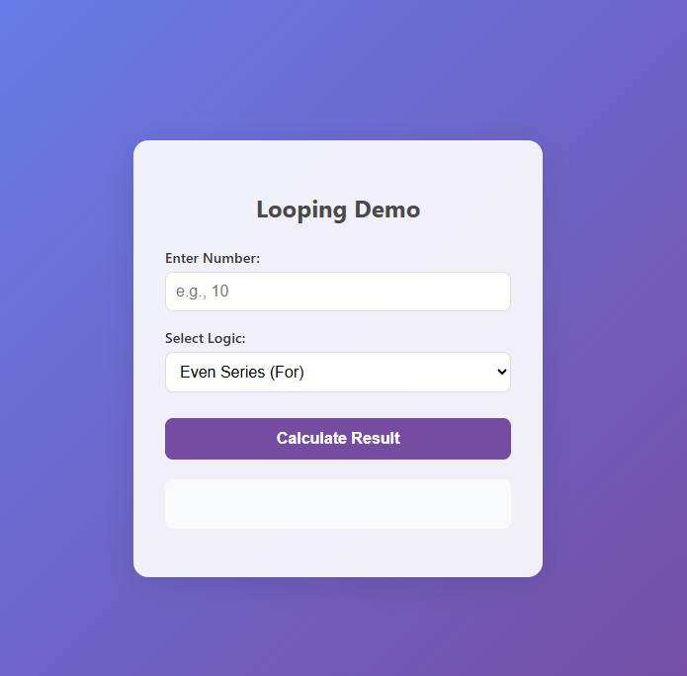

Even series:

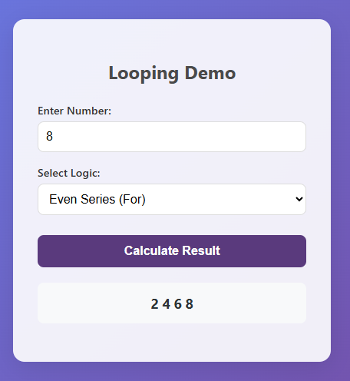

Fibonacci series:

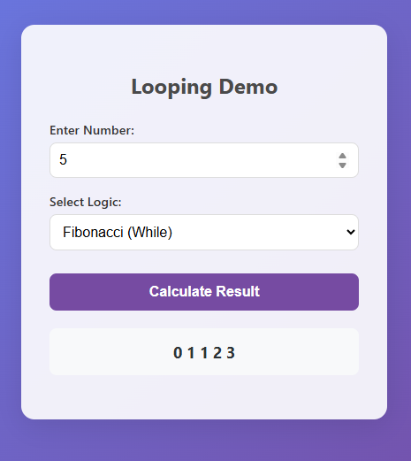

Strong number:

