Develop an Application Using Components in React JS

EX NO: 7 NAME : R.B. Dwaraka Dharshini
DATE: ROLL NO:25MCA003

7 A) Create function and class components to display your name with CSS

Aim
To demonstrate and compare the implementation of Functional Components and Class Components in React, showcasing how both can achieve the same UI result using internal styling.

Procedure :

- Open your Project: Open VS Code and go to File > Open Folder, then select your my-dwaraka-app folder.

- Locate App.js: In the left-side file explorer, open the src folder and click on the file named App.js.

- Clear the File: Delete all the existing code inside App.js so you have a blank screen.

- Paste the New Code: Copy and paste the beginner-friendly code I provided (the one with the Function and Class components) into the file

- Save your Work: Press Ctrl + S on your keyboard to save the changes.

- Open Terminal: If not already open, go to the top menu in VS Code and select Terminal > New Terminal.

- Run the App: Type the command npm start and press Enter.

- View Results: Wait for your web browser to open http://localhost:3000. You will see the Blue box (Function) and the Green box (Class) both saying "Hi, I am Dwaraka."

Commands to run :

C:\Users\mca1290>npx create-react-app my-dwaraka-app

C:\Users\mca1290>cd my-dwaraka-app

C:\Users\mca1290\my-dwaraka-app>npm start
You can now view my-dwaraka-app in the browser.

Local: http://localhost:3000
On Your Network: http://172.16.25.133:3000

Note that the development build is not optimized.
To create a production build, use npm run build.

webpack compiled successfully

Code:

import React from "react";
// 1. THE FUNCTION COMPONENT (The Modern Way)
function MyFunctionComponent() {
const boxStyle = {
border: "2px solid blue",
margin: "10px auto",
padding: "10px",
width: "200px",
borderRadius: "10px"
};
return (
<div style={boxStyle}>
<h3>Function Component</h3>
<p>Hi, I am Dwaraka</p>
</div>
);
}
// 2. THE CLASS COMPONENT (The Traditional Way)
class MyClassComponent extends React.Component {
render() {
const boxStyle = {
border: "2px solid green",
margin: "10px auto",
padding: "10px",
width: "200px",
borderRadius: "10px"
}
return (
<div style={boxStyle}>
<h3>Class Component</h3>
<p>Hi, I am Dwaraka</p>
</div>
);
}
}
// 3. THE MAIN APP (Where both show up)
function App() {
return (
<div style={{ textAlign: "center", marginTop: "40px", fontFamily: "sans-serif" }}>
<h1>Dwaraka's React Page</h1>
<MyFunctionComponent />
<MyClassComponent />
</div>
);
}
export default App;

Output:

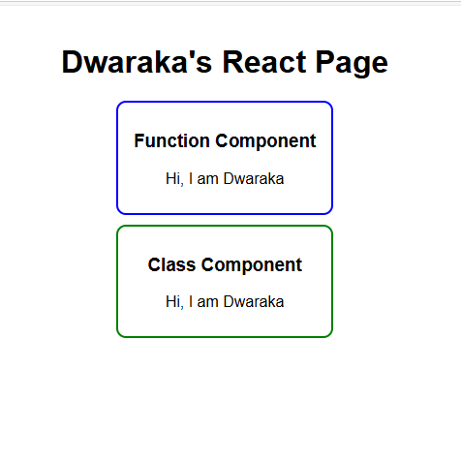

Develop an Application Using Components in React JS

EX NO: 7 NAME : R.B. Dwaraka Dharshini
DATE: ROLL NO:25MCA003

7B) Create a simple calculator Application using React JS . Use props and function/class components.

Aim:
To design and implement a Simple Calculator Application using React.js that demonstrates the integration of Functional Components, Class Components, State Management, and Event Handling within a single interactive UI.

Procedure:

- Open the Project in your Code Editor: Open Visual Studio Code (recommended) and select the folder you created (e.g., my-calculator).
- Replace the Code in src/App.jsx:
  - Find the file src/App.jsx in the file explorer on the left.
  - Delete everything currently in that file.
  - Paste the simplified beginner code I provided (the one where every button is a component).
  - Save the file (Ctrl + S or Cmd + S).
- Clean up Default Styles (Optional): If the layout looks strange, go to src/App.css and src/index.css, delete all the code inside them, and save. This removes the default Vite styling.
- View the App in your Browser:
  - Go back to the terminal where you see VITE v8.0.10 ready.
  - Follow the Local link: http://localhost:5173/.
  - Your calculator should now appear instantly on that page.
- Stop or Restart:
  - To stop the server, press Ctrl + C in the terminal.
  - To start it again later, just type npm run dev in that same project folder.

Code:

import React, { useState } from "react";

// 1. THE TEMPLATE (Every button uses this)
const BaseButton = ({ text, color, action }) => (
<button
onClick={action}
style={{ ...styles.btn, backgroundColor: color }}
>
{text}
</button>
);

// 2. THE INDIVIDUAL COMPONENTS (Every button has its own component name)
const AddBtn = (props) => <BaseButton {...props} text="Add (+)" color="#4CAF50" />;
const SubBtn = (props) => <BaseButton {...props} text="Sub (-)" color="#2196F3" />;
const MulBtn = (props) => <BaseButton {...props} text="Mul (*)" color="#FF9800" />;
const DivBtn = (props) => <BaseButton {...props} text="Div (/)" color="#9C27B0" />;
const ModBtn = (props) => <BaseButton {...props} text="Mod (%)" color="#795548" />;
const ClearBtn = (props) => <BaseButton {...props} text="Clear" color="#f44336" />;

export default function App() {
const [num1, setNum1] = useState("");
const [num2, setNum2] = useState("");
const [result, setResult] = useState(0);

// Simple math functions
const add = () => setResult(Number(num1) + Number(num2));
const sub = () => setResult(Number(num1) - Number(num2));
const mul = () => setResult(Number(num1) * Number(num2));
const div = () => setResult(Number(num1) / Number(num2));
const mod = () => setResult(Number(num1) % Number(num2));
const clear = () => { setNum1(""); setNum2(""); setResult(0); };

return (
<div style={styles.page}>
<div style={styles.card}>
<h2>Simple Calculator</h2>

<input
type="number" placeholder="Number 1"
value={num1} onChange={(e) => setNum1(e.target.value)}
style={styles.input}
/>
<input
type="number" placeholder="Number 2"
value={num2} onChange={(e) => setNum2(e.target.value)}
style={styles.input}
/>

<div style={styles.box}>
<AddBtn action={add} />
<SubBtn action={sub} />
<MulBtn action={mul} />
<DivBtn action={div} />
<ModBtn action={mod} />
<ClearBtn action={clear} />
</div>

<h3 style={styles.res}>Result: {result}</h3>
</div>
</div>
);
}

const styles = {
page: { display: "flex", justifyContent: "center", marginTop: "40px", fontFamily: "Arial" },
card: { border: "1px solid #ccc", padding: "20px", borderRadius: "10px", textAlign: "center", width: "300px" },
input: { width: "90%", padding: "10px", marginBottom: "10px", borderRadius: "5px", border: "1px solid #ddd" },
box: { display: "flex", flexWrap: "wrap", gap: "10px", justifyContent: "center" },
btn: { padding: "10px", color: "white", border: "none", borderRadius: "5px", cursor: "pointer", fontWeight: "bold" },
res: { marginTop: "20px", color: "#333" }
};

Output:

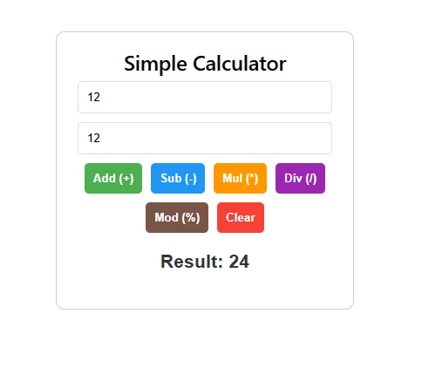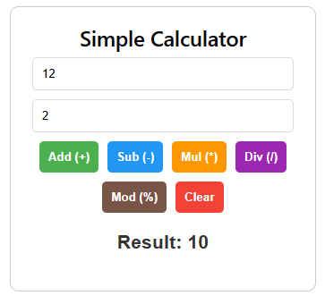

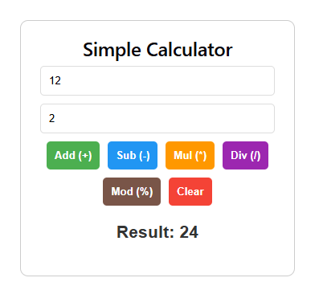

Result:
Thus the above application using functional and class components in React JS was created and displayed successfully.

