WEBPAGE USING INTERNAL AND EXTERNAL CSS
EX.NO: 2 NAME : R.B. Dwaraka Dharshini
DATE: ROLL NO: 25MCA003

Aim :
To design a simple Homemade ceramics webpage using html and css and apply styles using Inline and External cascading style.

Procedure :
1. Document Structure & Metadata (index.html)
- Initialization: Use the <!DOCTYPE html> declaration and <html> root tag to define the document as HTML5.
- Head Section: Include the <title> tag for the browser tab name and use the <link> tag with href="css/calc.css" to connect your external stylesheet.
- Script Integration: Place the <script> tag at the end of the <body> to ensure all HTML elements (DOM) are fully loaded before the JavaScript logic executes.
2. Interface & Display Layout (<div class="calculator">)
- Main Container: Wrap the interface in a <div> with class="calculator" to serve as a centered, styled box for all components.
- Heading: Use an <h2> tag to clearly label the application as a "Simple Calculator."
- Result Display: Implement an <input type="text"> with id="display". The disabled attribute is essential to prevent users from typing directly into the box, ensuring it only shows output from the buttons.
3. Button Grid & Event Handling (grid-template-columns)
- CSS Grid Layout: Use display: grid with grid-template-columns: repeat(4, 70px) in the CSS to arrange buttons into a standard 4-column calculator keypad.
- Interactive Events: Each <button> uses the onclick attribute to trigger specific JavaScript functions:
  - Numbers: append('7') adds the character to the string.
  - Operators: append('+') adds the mathematical operator.
  - Actions: clearDisplay() resets the screen, and calculate() solves the equation.
4. Visual Styling & Themes (calc.css)
- Background Alignment: Use display: flex and height: 100vh on the body tag to perfectly center the calculator on the screen.
- Zebra Styling: Apply specific background colors to different button classes (e.g., orange for .operator, red for .clear, and green for .equal) to make the interface user-friendly and intuitive.
- Rounded Aesthetics: Use border-radius: 15px on the container and 10px on buttons for a modern, professional appearance.
5. Mathematical Logic & Processing (cc.js)
- Input Management: The append function uses string concatenation (display.value + value) to build the mathematical expression bit by bit.
- Evaluation Engine: The calculate function uses the eval() function to process the string as a real math problem and return the final answer to the display.
- Reset Logic: The clearDisplay function sets the value back to an empty string "" to allow for new calculations.
Source code :
Internal css :
<!DOCTYPE html>
<html>
<head>
<title>Simple Landing Page</title>
</head>

<body style="margin:0; font-family: Arial;">

<!-- Navbar -->
<div style="background-color:white; padding:15px; display:flex; justify-content:space-between;">
<b style="font-size:22px;">MINA</b>
<div>
<a href="#" style="margin:10px; text-decoration:none; color:black;">Shop</a>
<a href="#" style="margin:10px; text-decoration:none; color:black;">About</a>
<a href="#" style="margin:10px; text-decoration:none; color:black;">Contact</a>
</div>
</div>

<!-- Offer bar -->
<div style="background-color:#D07A4A; color:white; text-align:center; padding:10px;">
Free shipping on orders over $50
</div>

<!-- Hero Section with Background Image -->
<div style="
background-image: url('bg.jpg');
background-size: cover;
background-position: center;
height: 400px;
text-align: center;
padding-top: 100px;
">

<h1 style="color:white; font-size:50px;">Handmade Ceramics</h1>

<p style="color:white; font-size:18px;">
Painted clay ceramics made with love.
</p>

<button style="padding:10px 20px; border:none; background-color:white; font-size:16px;">
Shop Now
</button>
</div>
</body>
</html>

External Css :
external. html
<!DOCTYPE html>
<html lang="en">
<head>
<meta charset="UTF-8">
<meta name="viewport" content="width=device-width, initial-scale=1.0">
<title>Simple Landing Page</title>
<link rel="stylesheet" href="external_css.css">
</head>
<body>

<!-- Header & Navigation -->
<header>
<div class="navbar">
<b class="logo">MINA</b>
<nav>
<a href="#shop">Shop</a>
<a href="ab.html">About</a>
<a href="#contact">Contact</a>
</nav>
</div>
<div class="offer">
<mark>Free shipping</mark> on orders over $50
</div>
</header>

<main>
<!-- Hero Section -->
<section class="hero">
<h1>Handmade Ceramics</h1>
<p>Painted clay ceramics made with <strong>love</strong>.</p>
<button type="button">Shop Now</button>
</section>

<!-- Product Gallery -->
<section class="shop">
<div class="collection">Our Collections</div>

<div class="product-grid">
<!-- Individual Card 1 -->
<div class="card">
<img src="pot1.jpg" alt="Vase">
<div class="card-info">
<h3>Midnight Vase</h3>
<p>Durable stoneware, dishwasher safe.</p>
<span class="price">$45.00</span>
</div>
</div>

<!-- Individual Card 2 -->
<div class="card">
<img src="pot2.jpg" alt="Bowl">
<div class="card-info">
<h3>Earth Bowl</h3>
<p>Unique hand-painted designs.</p>
<span class="price">$32.00</span>
</div>
</div>
<div class="card">
<img src="pot3.jpg" alt="Bowl">
<div class="card-info">
<h3>Earthenware</h3>
<p>Unique hand-made Mud Ceramics.</p>
<span class="price">$45.00</span>
</div>
</div>

<div class="card">
<img src="pot4.jpg" alt="Bowl">
<div class="card-info">
<h3>Earth Bowl</h3>
<p>Decorative hand-painted designs.</p>
<span class="price">$32.00</span>
</div>
</div>
</div>
</section>

<!-- FAQ Section -->

</main>
<!-- Footer -->
<footer>
<address>
Contact us: <a href="mailto:hello@mina.com">hello@mina.com</a>
</address>
<p>&copy; <time datetime="2024">2024</time> MINA Ceramics</p>
</footer>

</body>
</html>
external_css . css :

/* 1. Basic Page Setup */
body {
margin: 0;
font-family: sans-serif;
line-height: 1.5;
background-color: #4B3621;
}
/* 2. Navigation Bar */
.navbar {
display: flex;
justify-content: space-between;
align-items: center;
padding: 20px;
color:white;
}
.navbar a {
text-decoration: none;
color: white;
margin-left: 15px;
}
/* 3. Orange Offer Bar */
.offer {
background-color: #D07A4A;
color: white;
text-align: center;
padding: 10px;
}

/* 4. Hero Section (Big Image Area) */
.hero {
/* Simple way to dim an image: use a dark background color + image */
background-color: #444;
background-image: url('bg.jpg');
background-size: cover;
background-position: center;
/* Center the text vertically and horizontally */
height: 400px;
display: flex;
flex-direction: column;
justify-content: center;
align-items: center;
color: white;
}
.collection {
text-align: center;
font-size: 28px;
font-weight: bold;
margin: 30px 0;
color :white;
font-family: 'Gill Sans', 'Gill Sans MT', Calibri, 'Trebuchet MS', sans-serif;
}
/* 1. Make the container a Grid */
.product-grid {
display: flex;
justify-content: center;
gap: 80px; /* Space between cards */
flex-wrap: wrap; /* Makes them move to the next line on mobile */
padding: 20px;
}
/* 2. Style the individual card */
.card {
background-color: #FFFFF0;
border: 1px solid rgb(10, 10, 10);
border-radius: 41px;
width: 300px;
overflow: hidden;
box-shadow: 0 4px 8px rgba(0, 0, 0, 0.1);
transition: 0.3s;
}
/* 3. Hover effect to make it feel interactive */
.card:hover {
transform: translateY(-10px); /* Lifts up slightly */
}
/* 4. Ensure the image fits the card */
.card img {
width: 100%;
height: 200px;
object-fit: cover; /* Crops image to fit perfectly */
}
/* 5. Padding for text inside the card */
.card-info {
padding: 15px;
text-align: left;
}
.price {
color: #8B4513; /* Brown for price */
font-weight: bold;
}
/* 5. Button Styling */
button {
background-color: white;
padding: 10px 25px;
border: none;
cursor: pointer;
font-weight: bold;
}
/* 6. Footer (Bottom of Page) */
footer {
background-color: #ebbfbf;
color: rgb(10, 10, 10);
text-align: center;
padding: 30px;
margin-top: 50px;
}
/* 7. Image Gallery */
img {
max-width: 100%; /* Prevents image from being too big */
height: auto;
display: block;
margin: 0 auto;
}
Output :
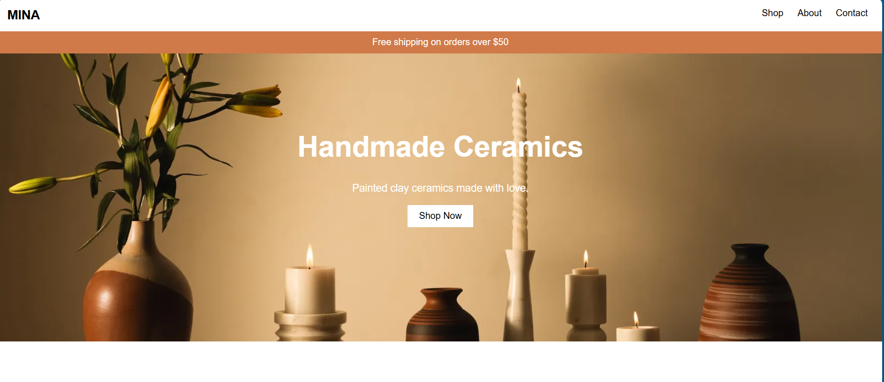
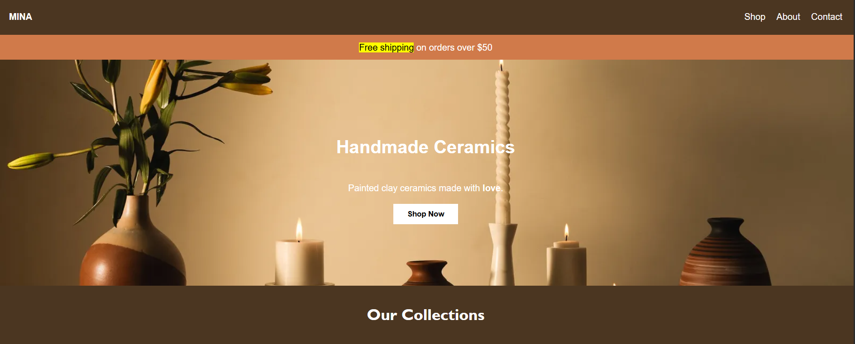
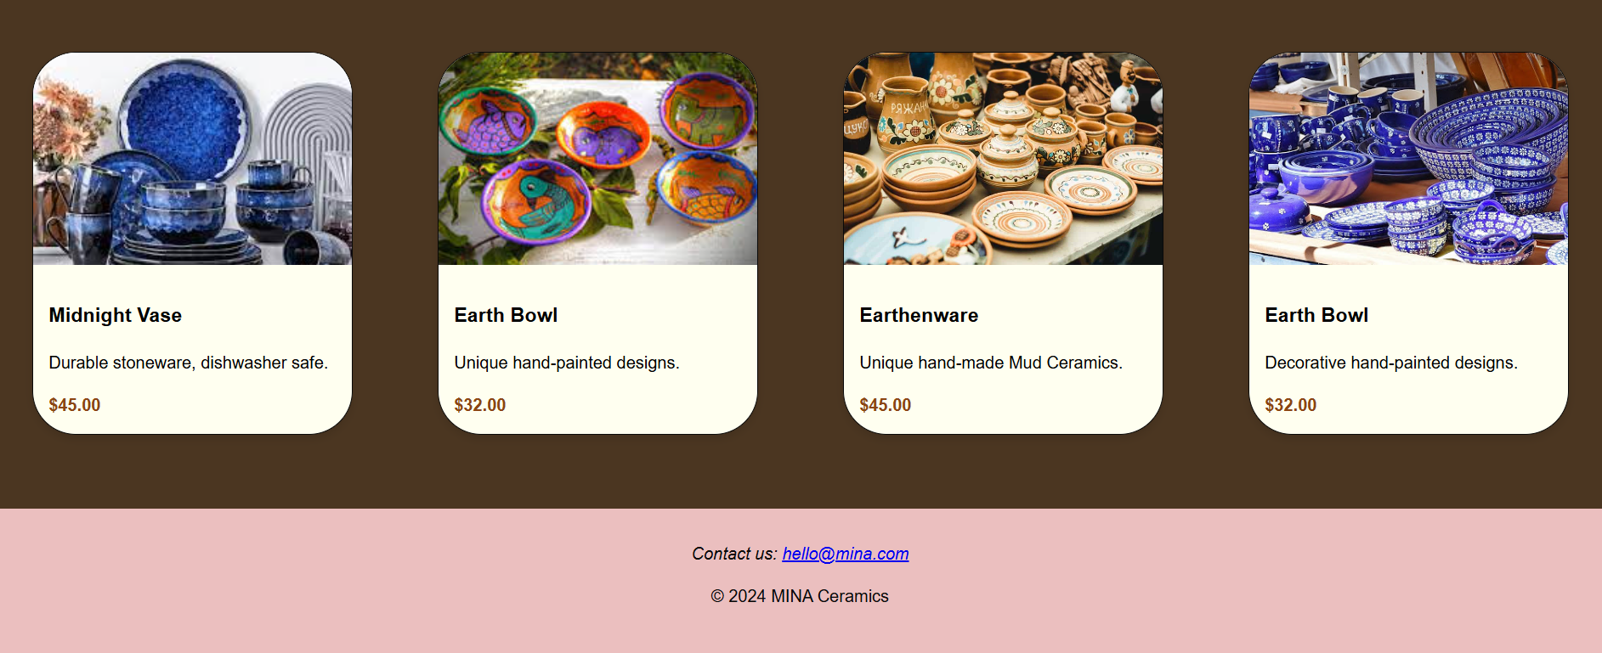
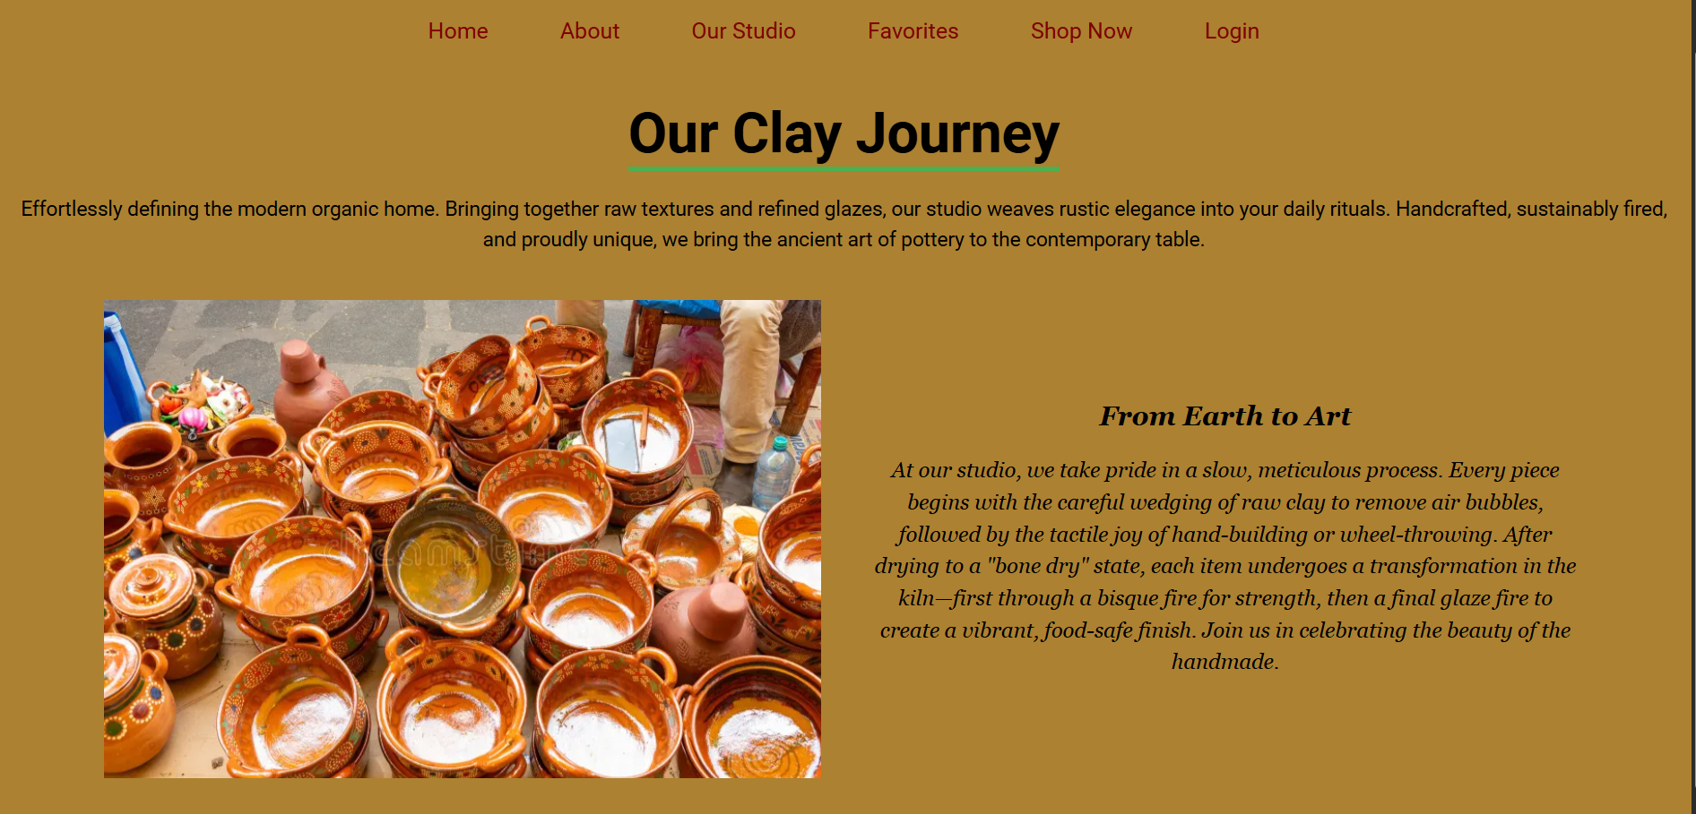

Result :
Thus, To design a simple Homemade ceramics webpage using html and css and apply styles using Inline and External cascading style. Therefore , The output was verified successfully.

