SIMPLE CALCULATOR USING HTML , CSS AND JAVA SCRIPT
EX.NO: 3(A) NAME : R.B. Dwaraka Dharshini
Date : Roll N.o : 25MCA003
Aim :
To create a simple attractive web page of simple calculator using html , css and java script .
Procedure:
1. Page Initialization (<html>, <head>, <body>)
• Create the basic HTML structure using <html>, <head>, and <body> tags.
• Define the title of the webpage using the <title> tag as Calculator.
• Link the external CSS file using the <link> tag inside the <head> section.
2. Calculator Container (<div>, <h2>)
• Create a main container using the <div> tag with class calculator.
• Add a heading using the <h2> tag to display Simple Calculator.
• This container holds all the calculator elements together.
3. Display Screen (<input>)
• Create an input field using the <input> tag with id display.
• Set the type as text to display numbers and results.
• Use the disabled attribute to prevent manual typing.
4. Button Layout (<div class="buttons">)
• Create another <div> container called buttons.
• This container organizes all calculator buttons.
• Use CSS grid layout to arrange buttons in rows and columns.
5. Number Buttons (<button>)
• Create buttons for digits 0–9 using the <button> tag.
• Assign the class number for styling purposes.
• Use the onclick event to call the append() function.
6. Operator Buttons (+ - * /)
• Create operator buttons for addition, subtraction, multiplication, and division.
• Assign the class operator to style them differently.
• Use onclick="append()" to add the operator to the display.
7. Clear Button (clearDisplay())• Create a Clear (C) button to remove the values from the display.
• Assign the class clear for styling.
• Call the clearDisplay() JavaScript function when the button is clicked.
8. Equal Button (calculate())
• Create an Equal (=) button to evaluate the mathematical expression.
• Assign the class equal for a unique color.
• Call the calculate() function when the button is pressed.
9. Styling Using CSS (calc.css)
• Use CSS Flexbox to center the calculator on the webpage.
• Apply background colors, padding, and border radius for design.
• Style buttons with different colors for numbers, operators, clear, and equal buttons.
10. JavaScript Functionality (cc.js)
• Create functions like append(), clearDisplay(), and calculate().
• The append() function adds numbers or operators to the display.
• The calculate() function evaluates the expression using eval() and displays the result.

Source Code :
Calculator .html :
<!DOCTYPE html>
<html>
<head>
<title>Calculator</title>
<link rel="stylesheet" href="css/calc.css">
</head>

<body>
<div class="calculator">
<h2>Simple Calculator</h2>

<input type="text" id="display" disabled>

<div class="buttons">
<button class="clear" onclick="clearDisplay()">C</button>
<button class="operator" onclick="append('/')">/</button>
<button class="operator" onclick="append('*')">*</button>
<button class="operator" onclick="append('-')">-</button>

<button class="number" onclick="append('7')">7</button>
<button class="number" onclick="append('8')">8</button>
<button class="number" onclick="append('9')">9</button>
<button class="operator" onclick="append('+')">+</button>

<button class="number" onclick="append('4')">4</button>
<button class="number" onclick="append('5')">5</button>
<button class="number" onclick="append('6')">6</button>
<button class="equal" onclick="calculate()">=</button>

<button class="number" onclick="append('1')">1</button>
<button class="number" onclick="append('2')">2</button>
<button class="number" onclick="append('3')">3</button>
<button class="number" onclick="append('0')">0</button>
</div>
</div>
<script src="JS/cc.js"></script>
</body>
</html>

Calc.css :
body{
display:flex;
justify-content:center;
align-items:center;
height:100vh;
background:#625151;
}

.calculator{
background:hsl(0, 100%, 1%);
padding:37px;
border-radius:15px;
}
.calculator h2{
color:white;
text-align:center;
margin-bottom:10px;
}

#display{
width: 93%;
height:50px;
font-size:22px;
text-align:right;
margin-bottom:10px;
padding:10px;
border:none;
border-radius:8px;
color: #f2f2f2;
}

.buttons{
display:grid;
grid-template-columns:repeat(4,70px);
gap:10px;
}

button{
height:60px;
font-size:20px;
border:none;
border-radius:10px;
cursor:pointer;
}

.operator{ background:#ff9500; color:white; }
.number{ background:#333; color:white; }
.clear{ background:red; color:white; }
.equal{ background:green; color:white; }

cc.js :
let display = document.getElementById("display");

function append(value) {
display.value = display.value + value;
}

function clearDisplay() {
display.value = "";
}

function calculate() {
display.value = eval(display.value);
}

OUTPUT :

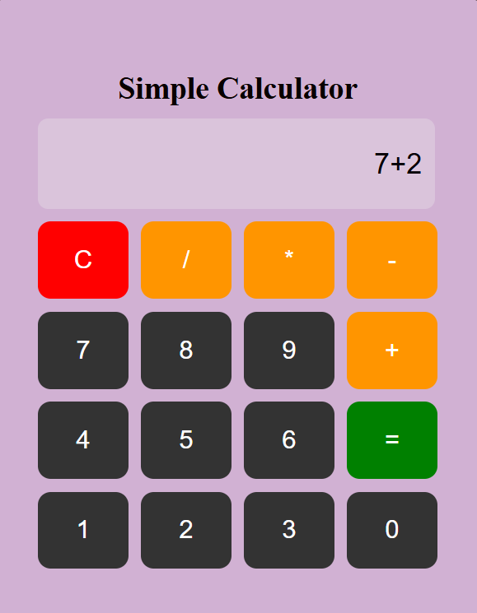
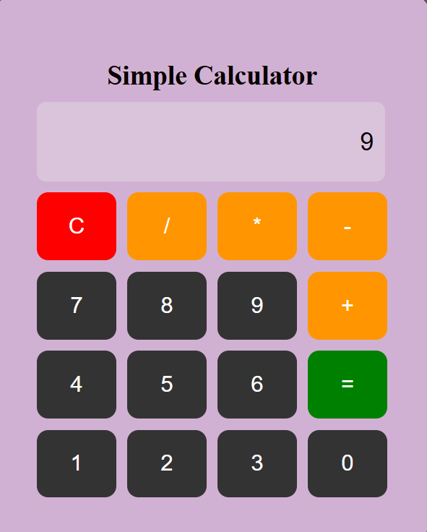

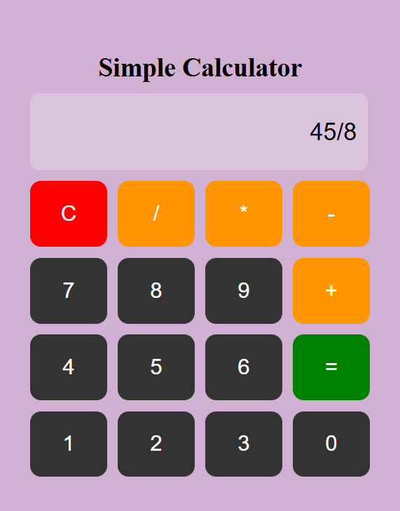
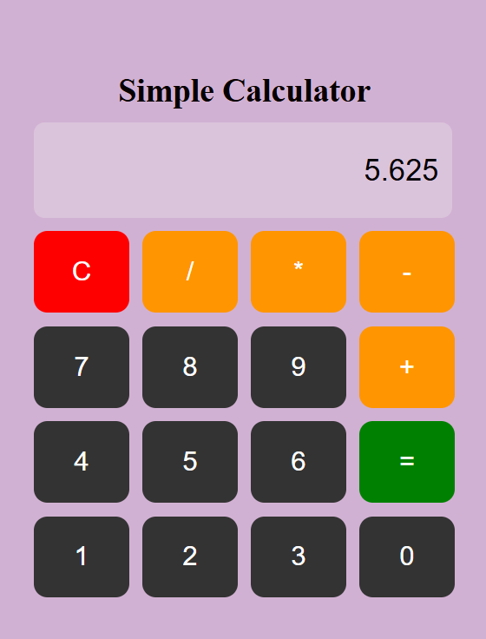

BUILD APPLICATION USING JAVASCRIPT METHOD (DATASTRUCTURE)
EX.NO: 3(B) NAME : R.B. Dwaraka Dharshini
Date : Roll N.o : 25MCA003
Aim :
To create a music playlist application using singly linked list and perform operatios such as adding , deleting , searching songs using javascript .
Procedure :
• Start the program and create an HTML file to design the structure of the Music Playlist application.
• Add a heading, input box, buttons, and an unordered list (<ul>) to display the playlist.
• Link the CSS file to style the webpage using colors, layout, and button effects.
• Design the interface using CSS by adding background gradient, card layout, button styles, and list formatting.
• Create a JavaScript file and declare an array named playlist to store song names.
• Create a function called operate(choice) to perform different playlist operations based on the button clicked.
• Implement Add at Beginning using playlist.unshift(song) to insert the song at the start of the list.
• Implement Add at Middle and Add at End using splice() and push() to insert songs in the middle or at the end.
• Implement Delete and Search operations using indexOf() and splice() to remove or locate songs in the playlist.
• Create the showPlaylist() function to display all songs dynamically in the HTML list using DOM manipulation.
Source Code :
music.html
<!DOCTYPE html>
<html>
<head>
<title>Music Playlist</title>
<link rel="stylesheet" href="css/mp.css">
</head>
<body>

<div class="app">
<h1>🎧 Music Playlist</h1>

<input type="text" id="song" placeholder="Enter song name">

<div class="buttons">
<button onclick="operate('af')">🎤Add Begginning</button>
<button onclick="operate('delete')">🗑️Delete Song</button>
<button onclick="operate('search')">🕵️‍♂️Search Song</button>
<button onclick="operate('middle')">↔️Add Middle</button>
<button onclick="operate('end')">📥Add End</button>
<button onclick="showSLL()">📘 About Singly Linked List</button>

</div>
<div id="sllCard" class="card" style="display:none;">
<h3>🌟 About Singly Linked List</h3>
<p>
A Singly Linked List is like a chain 🔗
where each part is connected to the next one.
<br><br>
Each node has:
<br>📦 Data
<br>➡️ Link to the next node
<br><br>
We can:
<br>✨ Add at beginning
<br>✨ Add in middle
<br>✨ Add at end
<br>✨ Delete
<br>✨ Search
<br><br>
It moves only in one direction ➡️
</p>
</div>

<h3>🎶 Playlist</h3>
<ul id="playlist"></ul>

<p id="message"></p>
</div>
<script src="JS/muds.js"></script>
</body>
</html>
mp.css :
body{
background:linear-gradient(to right, #ff512f, #dd2476);
font-family: Arial;
}
.app{
width:380px;
margin:60px auto;
background:#f1a1d0;
padding:25px;
border-radius:20px;
box-shadow:0 10px 20px rgba(0,0,0,0.3);
text-align:center;
}
h1{
color:#9d0190;
}
input{
width:90%;
padding:10px;
margin:10px 0;
border-radius:8px;
border:1px solid #ccc;
}
.buttons button{
margin:5px;
padding:10px 15px;
border:none;
border-radius:20px;
background:#ff512f;
color:white;
cursor:pointer;
}
.buttons button:hover{
background:#dd2476;
}
ul{
list-style:none;
padding:0;
}
ul li{
background:#ffe3ec;
margin:6px;
padding:10px;
border-radius:12px;
text-align:left;
font-weight:bold;
}
#message{
margin-top:10px;
color:#333;
font-weight:bold;
}
Muds.js :
let playlist = []; // acts like our linked list

function operate(choice){
let song = document.getElementById("song").value;

switch(choice){
case "af":
if(song == ""){
alert("Enter song name");
return;
}
playlist.unshift(song); // This adds to the START (Index 0)
document.getElementById("message").innerHTML = "Added to top: " + song;
break;
case "delete":
let delIndex = playlist.indexOf(song);
if(delIndex == -1){
document.getElementById("message").innerHTML = "Song not found";
} else {
playlist.splice(delIndex, 1);
document.getElementById("message").innerHTML = "Song deleted: " + song;
}
break;
case "middle":
if(song == ""){
alert("Enter song name");
return;
}
// Math.floor ensures we get a whole number (e.g., 5 / 2 = 2)
let midIndex = Math.floor(playlist.length / 2);

// .splice(index, itemsToDelete, newItem)
playlist.splice(midIndex, 0, song);

document.getElementById("message").innerHTML = "Song added to middle (Position " + (midIndex + 1) + "): " + song;
break;
case "search":
let searchIndex = playlist.indexOf(song);
if(searchIndex == -1){
document.getElementById("message").innerHTML = "Song not found";
} else {
document.getElementById("message").innerHTML =
"Song found at position: " + (searchIndex + 1);
}
break;
case "end":
if(song === ""){
alert("Enter song name");
return;
}
playlist.push(song);
document.getElementById("message").innerHTML = "✅ Song added to the end: " + song;
break;
}

showPlaylist();
}
function showSLL() {
var card = document.getElementById("sllCard");

if (card.style.display == "none") {
card.style.display = "block";
} else {
card.style.display = "none";
}
}
function showPlaylist(){
let list = document.getElementById("playlist");
list.innerHTML = "";
for(let i = 0; i < playlist.length; i++){
let li = document.createElement("li");
li.textContent = "🎵 " + playlist[i];
list.appendChild(li);
}
}

OUTPUT :
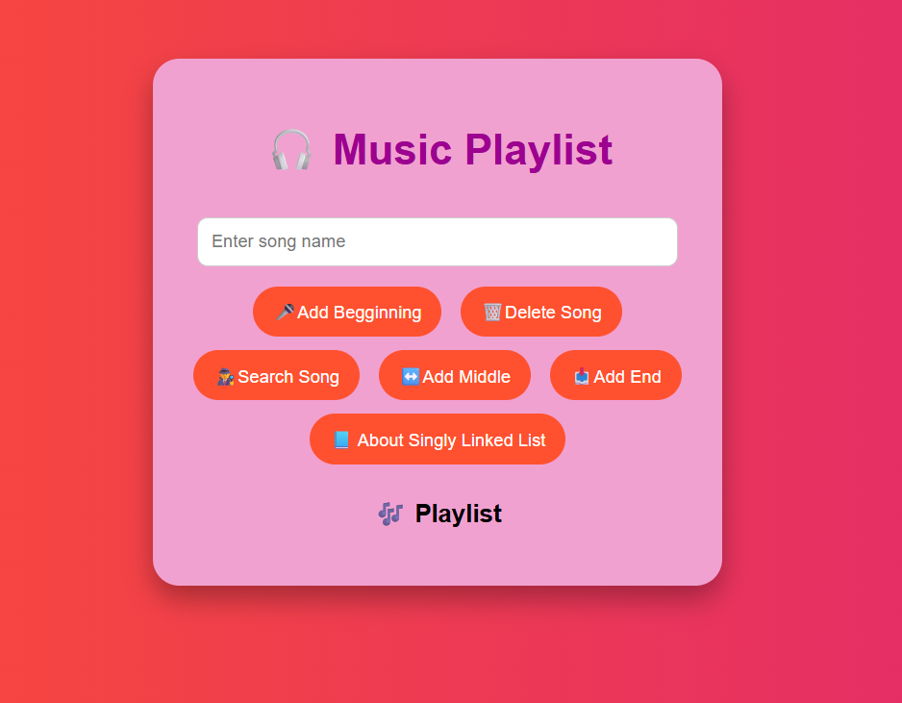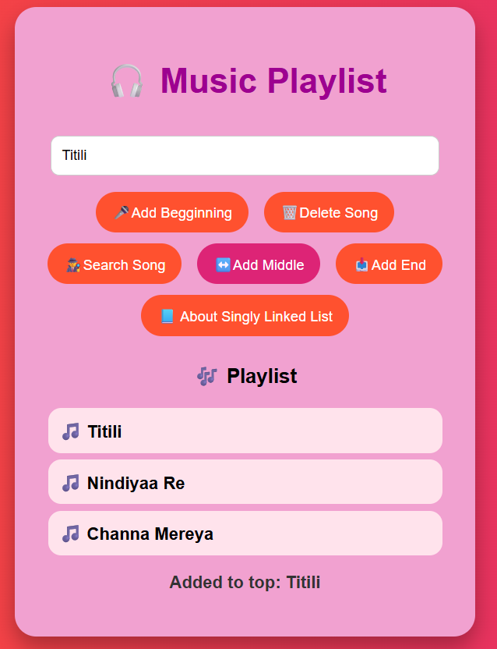
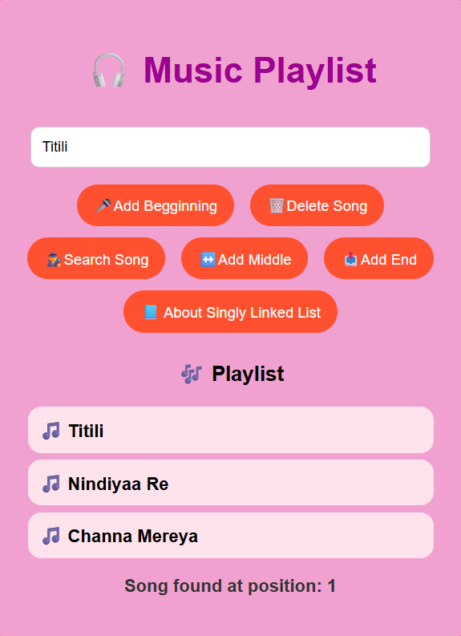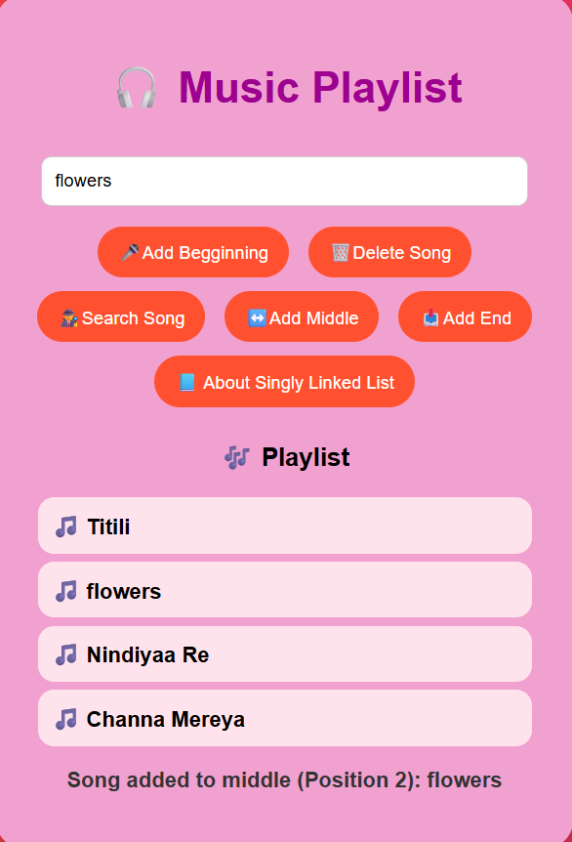

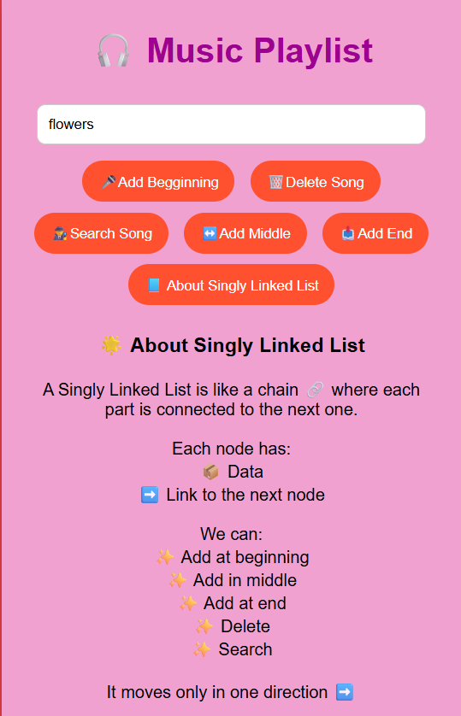

Result :
To create a simple attractive web page of simple calculator using html , css and java script and To create a music playlist application using singly linked list and perform operations such as adding , deleting , searching songs using javascript was executed successfully .

