**CSE 664 Introduction to System-on-Chip Design**

**Final Project – 8-Bit Microcontroller**



Revision: 1.0

Date Prepared: June 2023

Prepared by: Austin Benedetti, Daniel Ems, Nicholas Lyons, Mike Pena, Trent Reeves, Mimansa Verma, Derrick Ward, Jiawen Zhen

Prepared for: CSE 664 Introduction to System-on-Chip Design, Spring 2023, section M401, Professor Mohammed Abdallah

Contents

1 Design Documentation 4

1.1 Entity: acc_simple 4

1.1.1 Diagram 4

1.1.2 Description 4

1.1.3 Ports 4

1.1.4 Signals 5

1.1.5 Processes 5

1.2 Entity: ALU_8bit 6

1.2.1 Diagram 6

1.2.2 Description 6

1.2.3 Ports 6

1.2.4 Processes 6

2 Entity: controller_fsm 8

2.1 Diagram 8

2.2 Description 8

2.3 Ports 8

2.4 Processes 9

3 Entity: nbit_two_one_mux 10

3.1 Diagram 10

3.2 Description 10

3.3 Ports 10

4 Simulations 11

4.1 Modelsim - accumulator.v 11

4.2 Modelsim – ALU_8bit.v 11

4.3 Modelsim – controller_fsm.v 12

4.4 Modelsim – nbit_two_one_mux.v 12

5 References 13

APPENDIX A: 8-Bit Microcontroller Code Base 13

THIS PAGE INTENTIONALLY LEFT BLANK

# Design Documentation

## Entity: acc_simple

* **File**: accumulator.v

### Diagram

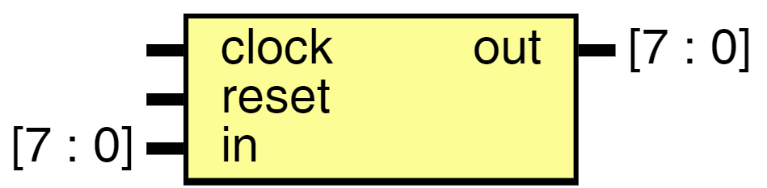

### Description

A register in which intermediate arithmetic logic unit results are stored. This simple 8-bit accumulator's output will continuously grow by increments of the input until reset.

Note - Overflow is not handled

### Ports

| **Port name** | **Direction** | **Type** | **Description** |
| --- | --- | --- | --- |
| clock | input |  | Clock. Output is posedge triggered |
| reset | input |  | Clears register value (1 = clear, 0 = hold) |
| in | input | [7 : 0] | Input from ALU |
| out | output | [7 : 0] | Output return to ALU |

### Signals

| **Name** | **Type** | **Description** |
| --- | --- | --- |
| accumulator | reg [7 : 0] | Temporary storage for accumulator output |

### Processes

* unnamed: ( @(posedge clock or posedge reset) )

**Type:** always

**Description**  
Increments output by input at rising edge of clock.  
If reset is high then clear output.

## Entity: ALU_8bit

* **File**: ALU_8bit.v

### Diagram

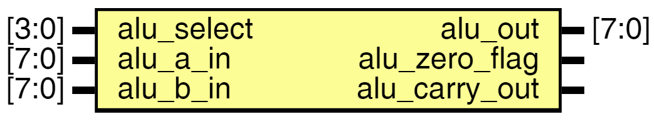

### Description

A combinational digital circuit that performs arithmetic and bitwise operations on integer binary numbers.

### Ports

| **Port name** | **Direction** | **Type** | **Description** |
| --- | --- | --- | --- |
| alu_out | output | [7:0] | 8 bit result (connected to mux that is connected to ACC) |
| alu_zero_flag | output |  | Set if result is zero (connected to controller) |
| alu_carry_out | output |  | Set if carry bit is needed (connected to controller) |
| alu_select | input | [3:0] | Select ALU operation (received from controller) |
| alu_a_in | input | [7:0] | ACC ALU input |
| alu_b_in | input | [7:0] | REG ALU input |

### Processes

* unnamed: ( @(alu_a_in or alu_b_in or alu_select) )

**Type:** always

**Description**  
The ALU outputs change anytime the inputs change (combinational logic).

# Entity: controller_fsm

* **File**: controller_fsm.v

## Diagram

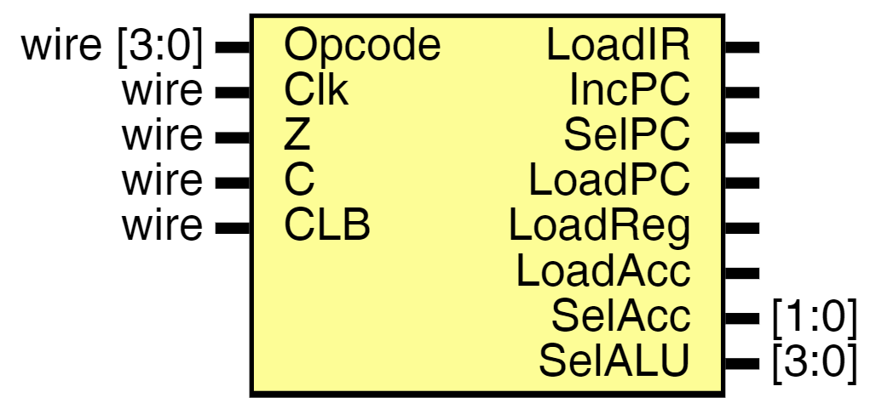

## Description

Model that uses a known set of inputs to define several combinations of outputs and states.

## Ports

| **Port name** | **Direction** | **Type** | **Description** |
| --- | --- | --- | --- |
| LoadIR | output |  | Load instruction register with next instruction - (Should be checked before update) |
| IncPC | output |  | Program counter which is incremented only to next instruction |
| SelPC | output |  | Used to increment PC by immediate or val in reg |
| LoadPC | output |  | Signal to update PC value - (Should be checked before JUMP ONLY) |
| LoadReg | output |  | Signal to update register - (Should be checked before update) |
| LoadAcc | output |  | Signal to update accumulator - (Should be checked before update) |
| SelAcc | output | [1:0] | Select signal for ACC muxes - (SelAcc[1] = SelAcc1, SelAcc[0] = SelAcc0) |
| SelALU | output | [3:0] | Select signal for ALU operation (opcode) |
| Opcode | input | wire [3:0] | Opcode from instruction register |
| Clk | input | wire | Clock signal |
| Z | input | wire | Zero bit |
| C | input | wire | Carry bit |
| CLB | input | wire | TODO: WHAT IS THIS? |

## Processes

* unnamed: ( @(Clk) )

**Type:** always

**Description**  
Case statement for setting control signals

# Entity: nbit_two_one_mux

* **File**: nbit_two_one_mux.v

## Diagram

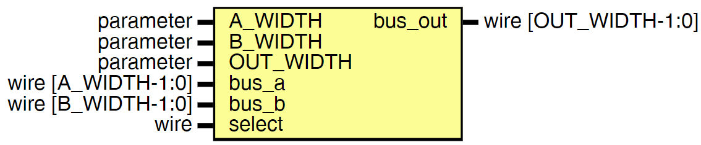

## Description

A data selector device that selects between several analog or digital input signals and forwards the selected input to a single output line.

## Ports

| **Port name** | **Direction** | **Type** | **Description** |
| --- | --- | --- | --- |
| A_WIDTH | input | parameter |  |
| B_WIDTH | input | parameter | Width of INPUT BUS A |
| OUT_WIDTH | input | parameter | Width of INPUT BUS B |
| bus_out | output | wire [OUT_WIDTH-1:0] | Output bus |
| bus_a | input | wire [A_WIDTH-1:0] | Input bus A |
| bus_b | input | wire [B_WIDTH-1:0] | Input bus B |
| select | input | wire | Select Signal |

# Simulations

## Modelsim - accumulator.v

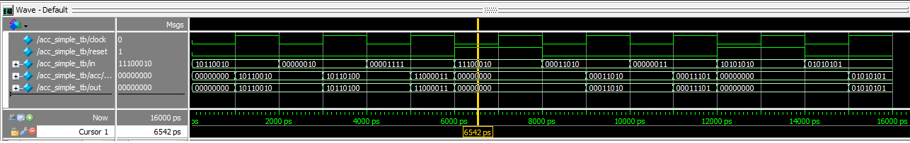

## Modelsim – ALU_8bit.v

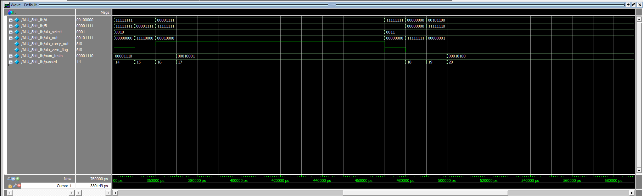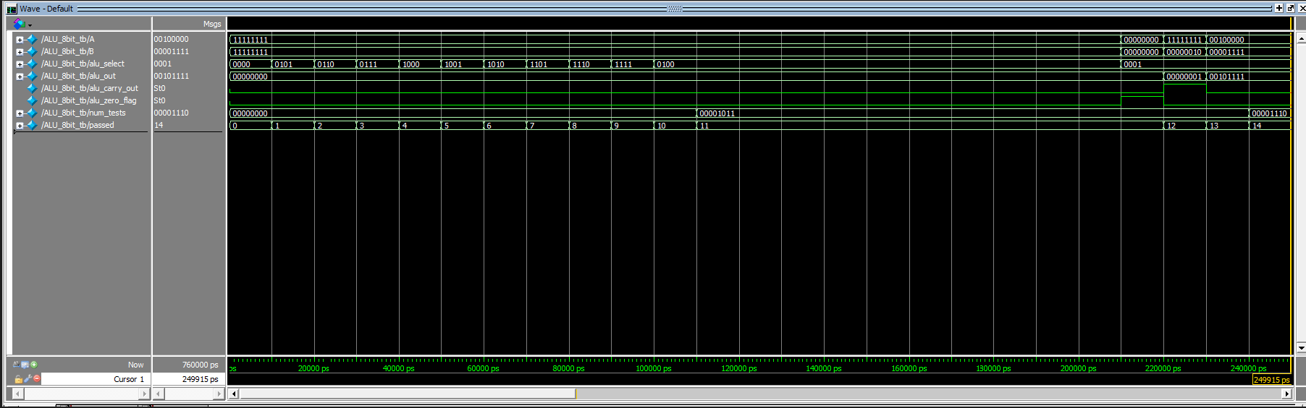

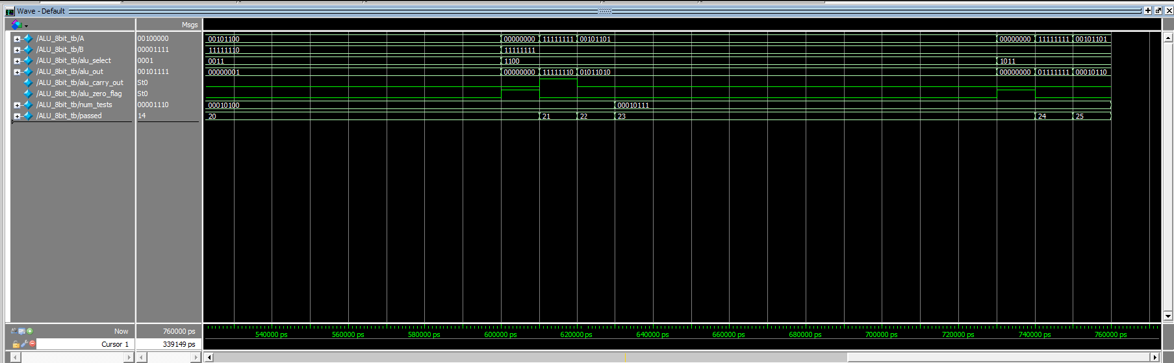

## Modelsim – controller_fsm.v

## Modelsim – nbit_two_one_mux.v

# References

## APPENDIX A: 8-Bit Microcontroller Code Base



Prepared by:

Austin Benedetti, Daniel Ems, Nicholas Lyons, Mike Pena, Trent Reeves, Mimansa Verma, Derrick Ward, Jiawen Zhen