# Preparation for the Accounts functionality

Created by Dexter Watson (daw35)

Contents

Preparation for the Accounts functionality 1

Use Case Diagram 3

Scenarios 4

User Story: As a user I want to sign up for the trading simulation website 4

Sign Up 4

User Story: As a user I want to login to the trading simulation website 5

Login 5

User Story: As a user I want to logout of the trading simulation website 7

Logout 7

## Use Case Diagram

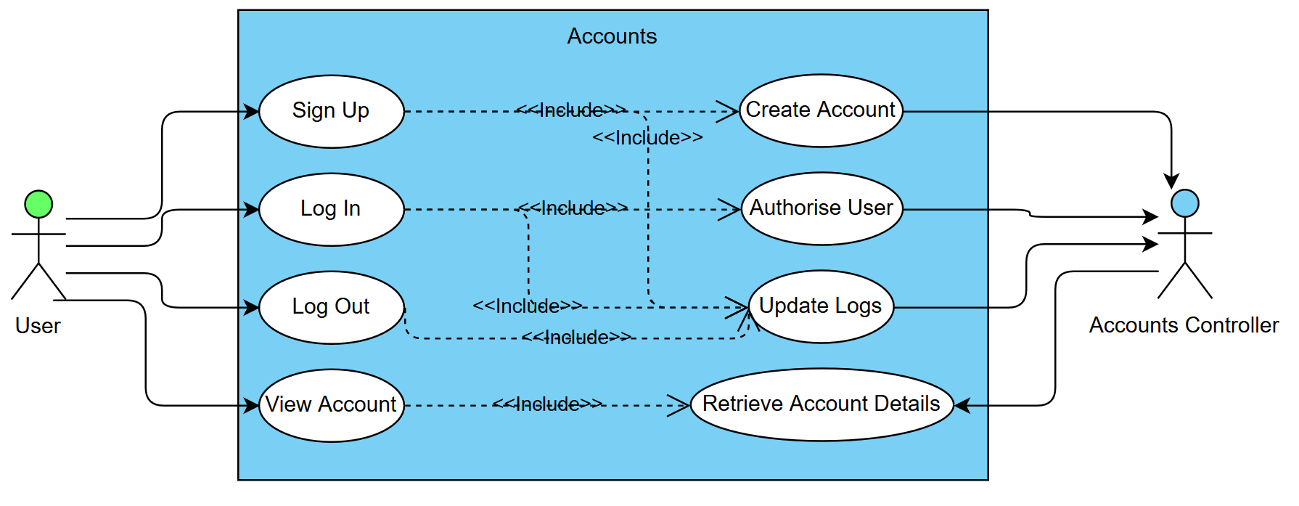

# Scenarios

## User Story: As a user I want to sign up for the trading simulation website

|  |  |
| --- | --- |
| *Use case name* | Sign Up |
| *Participating actors* | User, Accounts server |
| *Flow of events:  Normal flow* | 1. I open the website and I am greeted with a sign up or login page 2. I click sign up and I am redirected to a signup page where I am asked to enter a username and a password 3. I enter a username and a password and click sign up 4. I am now redirected to the home page and can see that my account has automatically been logged in |
| *Flow of events:  Alternative flow* | The username already exists  4. Username taken error message is displayed  The password does not meet the requirements  4. Password does not meet requirements error message is displayed |
| *Pre-condition* | User is not logged in |
| *Post-condition* | The server records the signup event.  The new account is created |
| *Notes* |  |

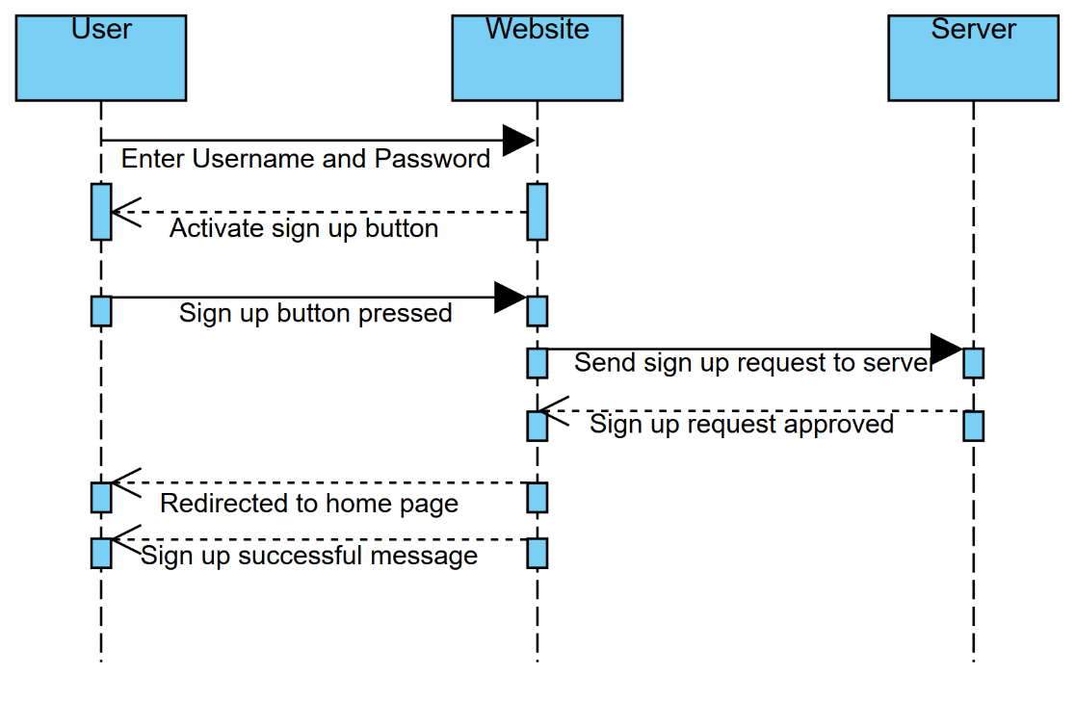Successful sign up:

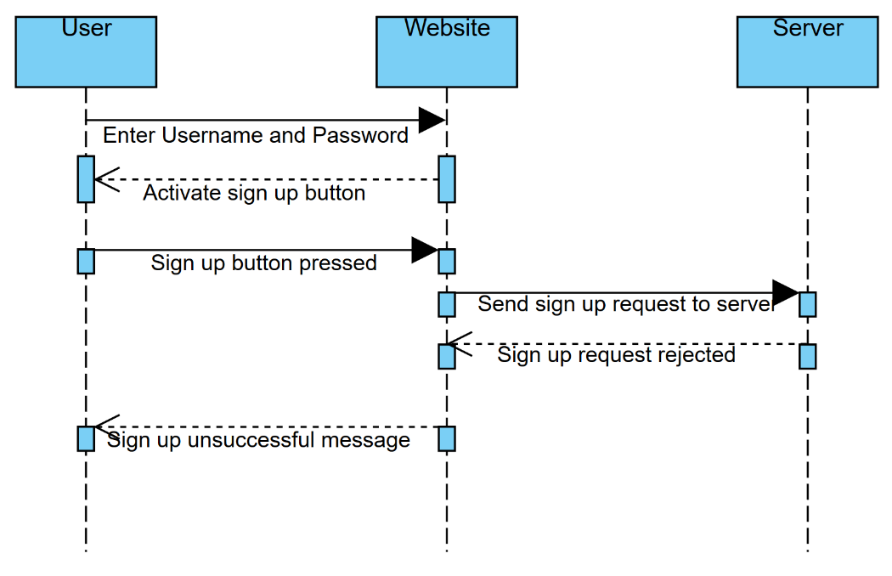Failed sign up:

## User Story: As a user I want to login to the trading simulation website

|  |  |
| --- | --- |
| *Use case name* | Login |
| *Participating actors* | User, Accounts server |
| *Flow of events:  Normal flow* | 1. I open the website and I am greeted with a sign up or login page 2. I click login and I am redirected to a login page where I am asked to enter my username and password 3. I enter my username and password and click login 4. I am now redirected to the home page and I can see that my account has been logged in |
| *Flow of events:  Alternative flow* | The username does not exist  5. Username does not exist message is displayed  The password is incorrect  5. Password does not match error message is displayed |
| *Pre-condition* | User is not logged in |
| *Post-condition* | The server records the login event.  The user is redirected to the home page. |
| *Notes* |  |

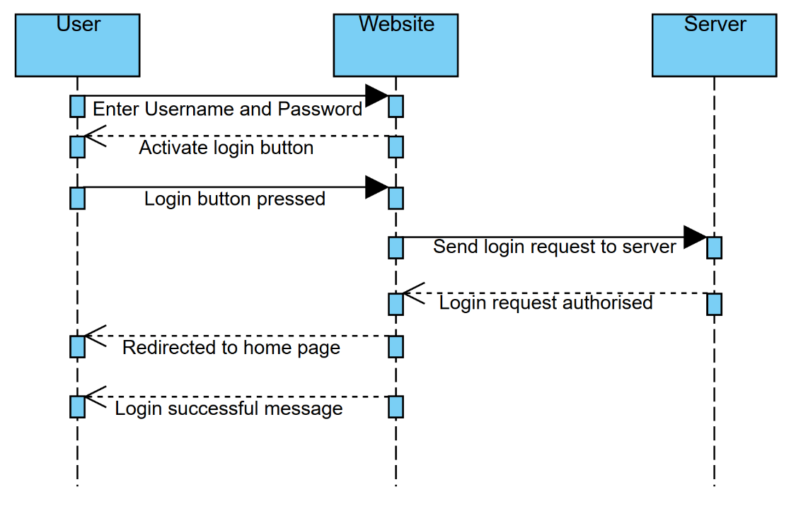

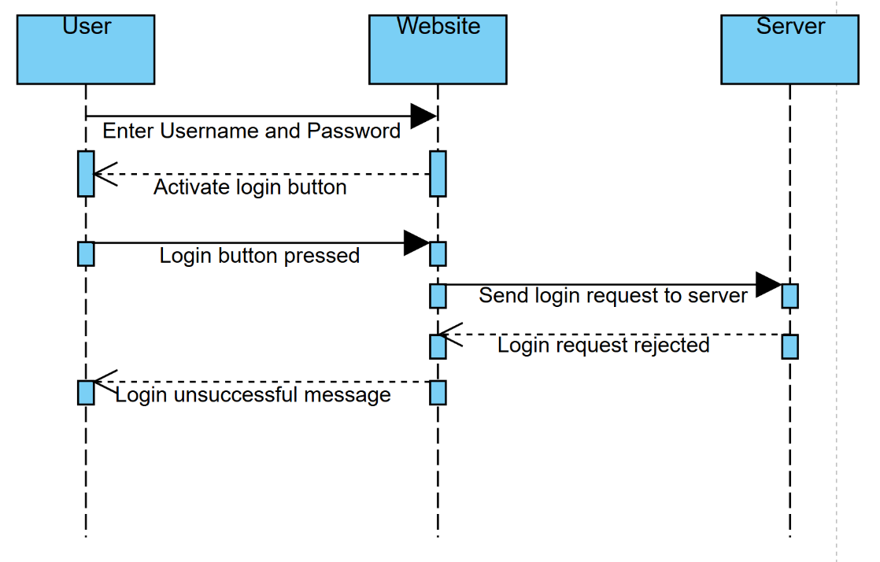

## User Story: As a user I want to logout of the trading simulation website

|  |  |
| --- | --- |
| *Use case name* | Logout |
| *Participating actors* | User, Accounts server |
| *Flow of events:  Normal flow* | 1. I am on the home screen of the website; I can see that I am logged in 2. I click on the logout button at the top of the page and I am redirected to the sign up/login page |
| *Flow of events:  Alternative flow* |  |
| *Pre-condition* | User is logged in |
| *Post-condition* | The server records the logout event.  The user is redirected to the login/sign up page. |
| *Notes* |  |

