# Preparation for the Price Prediction functionality

Created by Dexter Watson (daw35)

Contents

Preparation for the Price Prediction functionality 1

Use Case Diagram 3

Scenarios 3

User Story: As a user I want to view my existing portfolios 3

Existing portfolios 3

User Story: As a user I want to select a different portfolio 4

Selecting a portfolio 4

User Story: As a user I want to view the performance for a selected portfolio 5

Portfolio Performance chart 5

User Story: As a user I want to delete a portfolio 6

Delete portfolio 6

## Use Case Diagram

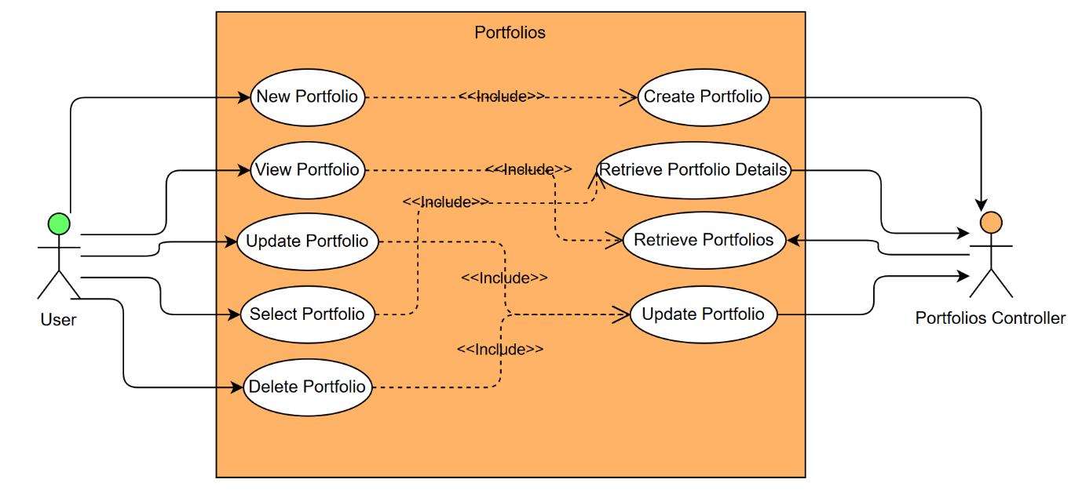

# Scenarios

## User Story: As a user I want to view my existing portfolios

|  |  |
| --- | --- |
| *Use case name* | Existing portfolios |
| *Participating actors* | User, portfolio controller |
| *Flow of events:  Normal flow* | 1. User logs into the website 2. User navigates to the account page 3. User can view their existing portfolios |
| *Flow of events:  Alternative flow* |  |
| *Pre-condition* | User must be logged in. |
| *Post-condition* |  |
| *Notes* |  |

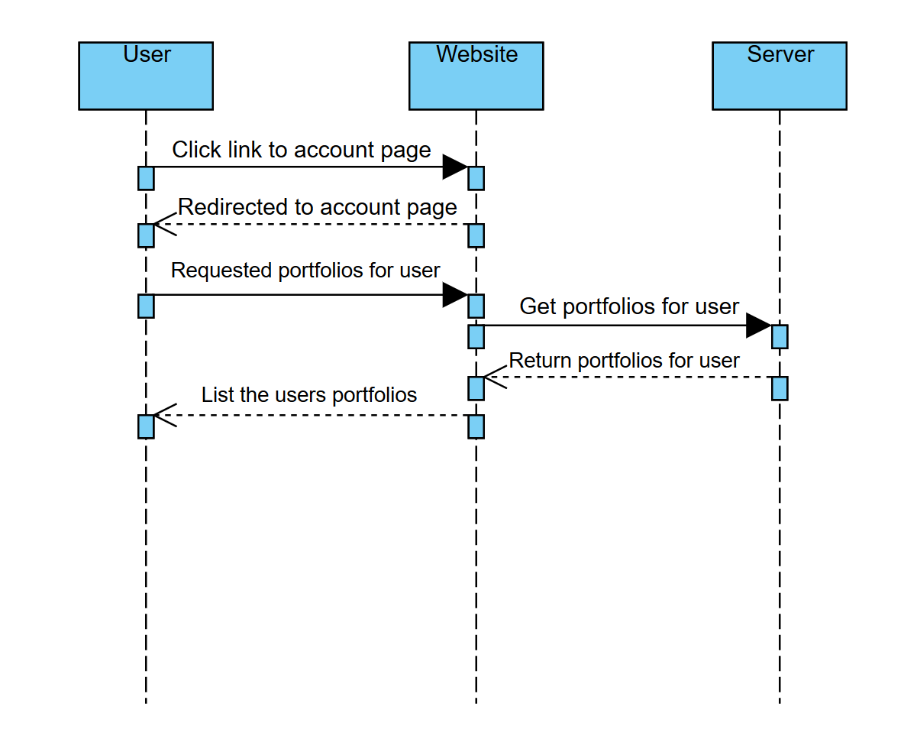

## User Story: As a user I want to select a different portfolio

|  |  |
| --- | --- |
| *Use case name* | Selecting a portfolio |
| *Participating actors* | User, portfolio controller, accounts controller |
| *Flow of events:  Normal flow* | 1. User logs into the website 2. User navigates to the portfolio page 3. User clicks on a portfolio and the selected portfolio at the top of the page changes |
| *Flow of events:  Alternative flow* |  |
| *Pre-condition* | User must be logged in. |
| *Post-condition* | The selected portfolio for the account changes in the database.  All transactions will now apply to the selected portfolio. |
| *Notes* |  |

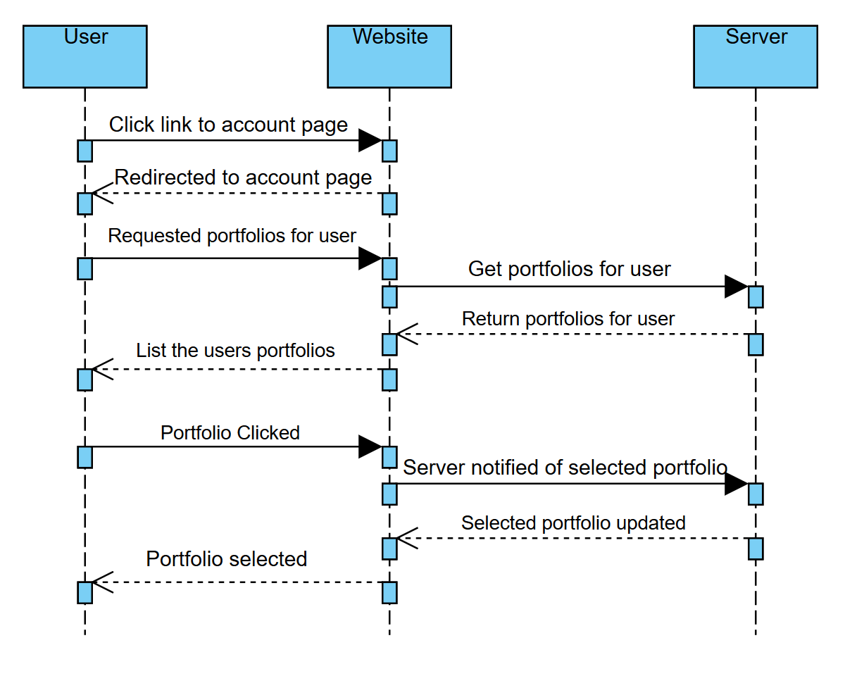

## User Story: As a user I want to view the performance for a selected portfolio

|  |  |
| --- | --- |
| *Use case name* | Portfolio Performance chart |
| *Participating actors* | User, CryptoData controller, positions controller |
| *Flow of events:  Normal flow* | 1. User logs into the website 2. User navigates to the portfolio page 3. User selects a portfolio 4. The transactions associated with that portfolio are listed and a line graph is loaded with a history of their portfolios value |
| *Flow of events:  Alternative flow* | Not enough data to populate the graph  4. Transactions associated with that portfolio are listed and no graph is displayed |
| *Pre-condition* | User must be logged in. |
| *Post-condition* |  |
| *Notes* |  |

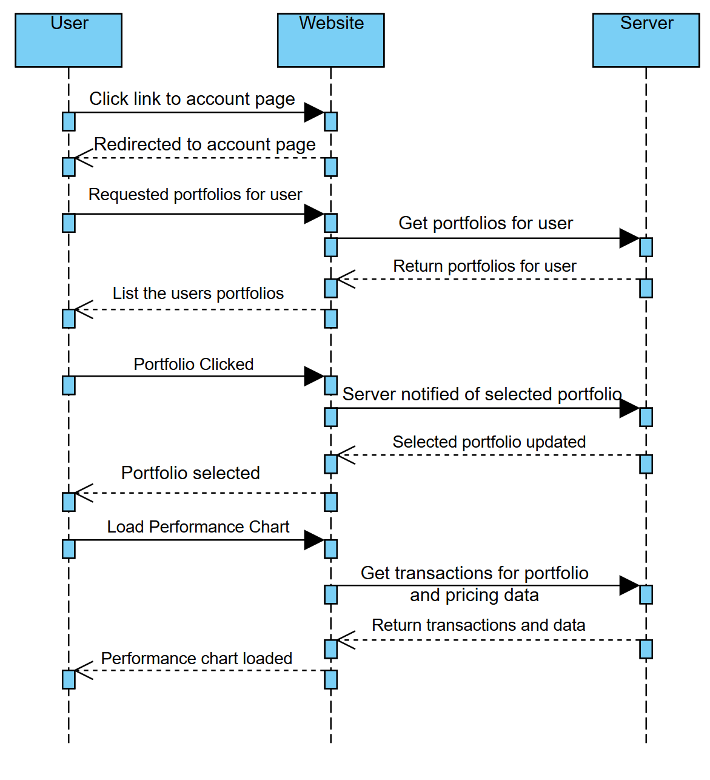

## User Story: As a user I want to delete a portfolio

|  |  |
| --- | --- |
| *Use case name* | Delete portfolio |
| *Participating actors* | User, portfolio controller |
| *Flow of events:  Normal flow* | 1. User logs into the website 2. User navigates to the portfolio page 3. User click the delete icon next to a portfolio 4. The portfolio is removed |
| *Flow of events:  Alternative flow* |  |
| *Pre-condition* | User must be logged in. |
| *Post-condition* | The deleted portfolio now has a deleted flag next to it in the database but is **not** permanently removed. |
| *Notes* |  |

