5/8/2017

Devin Brite

Quinsigamond community college

Race Manager Application

User Guide

Race Manager User Guide: Table of Contents

Introduction 2

How to use the Race Manager Application: 3

1.) Open the Race Manager Application 3

2.) Open Form 1000: Team Management 4

a.) Loading teams from a text file 5

b.) Adding teams 6

c.) Deleting Teams 10

d.) Returning to Form 0000 11

3.) Open Form 2000: Runner Management 12

a.) Loading runners from a text file 13

b.) Adding runners 14

c.) Deleting Runners 18

d.) Returning to Form 0000 19

4.) Open Form 3000: Race Management 20

a.) Loading time entries from a text file 21

b.) Entering Bib Numbers 22

c.) Syncing Bib Numbers to Times 25

d.) Returning to Form 0000 26

5.) Open Form 4000: Results Manager 27

a.) Calculating Results 28

b.) Archiving the Results 29

# Introduction

The race manager application is used to manage races in an organized fashion. The race manager makes managing teams, racers, and times easy. With included features for scanners and archives, the software is feature complete and guaranteed to do what you need it to. This guide will show you, step by step, how to use the software. To get started, please turn to the next page.

# How to use the Race Manager Application:

## Open the Race Manager Application

You’ll be greeted with a splash screen, followed shortly by the main form (Form 0000). In form 1000 you can click the “1-Team Mgr” button to go to Form 1000, or the “2-Runner Mgr” to go to Form 2000. Once Form 1000 and Form 2000 have been properly filled out, Form 3000 becomes available by clicking the “3-Race Mgr” button. After Form 3000 is properly filled out, Form 4000 becomes available by clicking the “4-Results Mgr” button. Once the user is finished with all forms, or at any point during the process, the user can click the “eXit” button to exit the application.

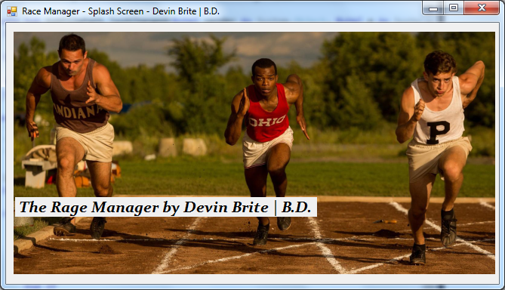

Pictured: Splash Screen

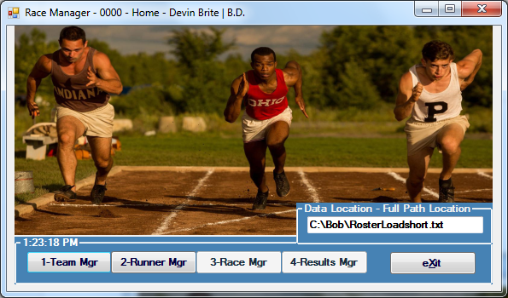

Pictured: Form 0000

## Open Form 1000: Team Management

Form 1000 is used to load teams from a file, add new teams, and delete teams from the roster. First, the user enters a file location in the “Data Location” text box to a “RosterLoad” text file. Then the user clicks the “Load Teams” button. After that, the user can click “Add Team” to enter data for, and add a new team. The user also has the option of deleting teams (if there are any on the roster). This can be done by selecting a team in the list, then clicking the “Delete Team” button. Once the user is done modifying the team roster, they can click the “Return” button to return to the main screen.

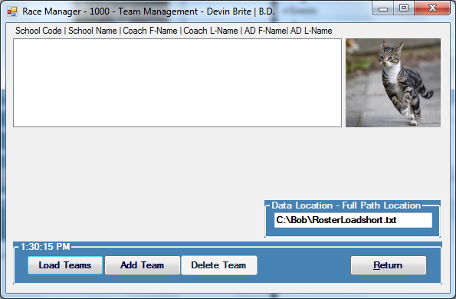

Pictured: Form 1000

### Loading teams from a text file

Enter the location of the desired roster file into the “Data Location” text box. Then click the “Load Teams” button.

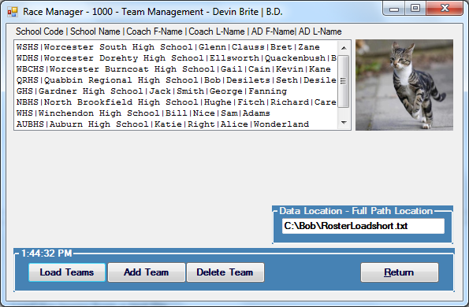

Pictured: Form 1000 after loading teams

### Adding teams

Click the “Add Team” button and enter the data into the form. Then click “Save” to add the new team to the list. If you’ve made a mistake while entering data, you can click the “reFresh” button to reset the form. Once the user has finished entering teams, they can press the “Cancel” button to close the “Add Team Information” section, and continue using the application.

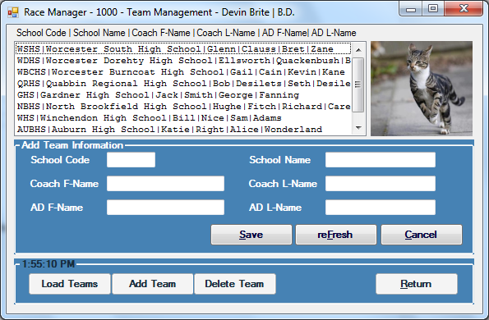

Pictured: Form 1000 after clicking the “Add Team” button

#### Enter team information

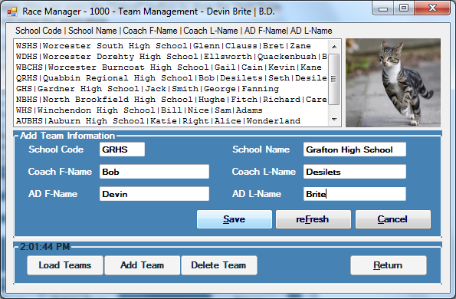

Pictured: Form 1000 after entering data for a new team

#### Click the “Save” button

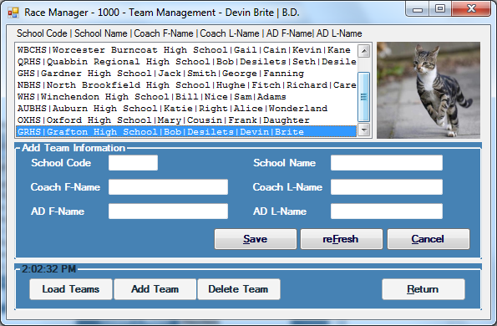

Pictured: Form 1000 after a new team has been added

#### (Optionally) Click the “reFresh” button to clear the form

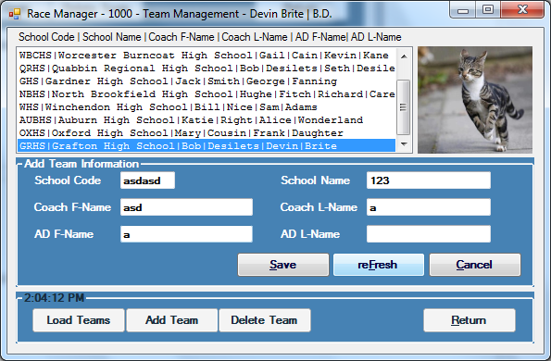

Pictured: Form 1000 after entering wrong information

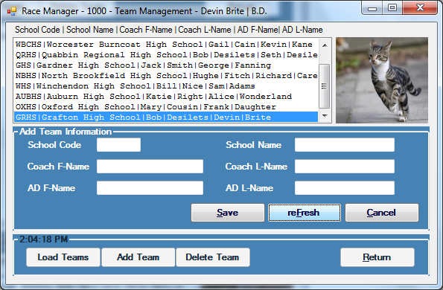Pictured: Form 1000 after the “reFresh” button has been clicked

#### Click the “Cancel” button to return to the standard form 1000

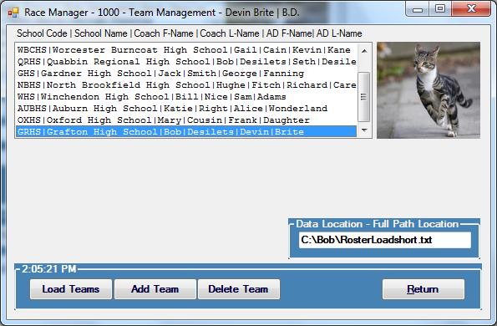

Pictured: Form 1000 after the “Cancel” button (inside the “Add Team Information” group) has been clicked

### Deleting Teams

Select a team from the team roster list, then click the “Delete Team” button.

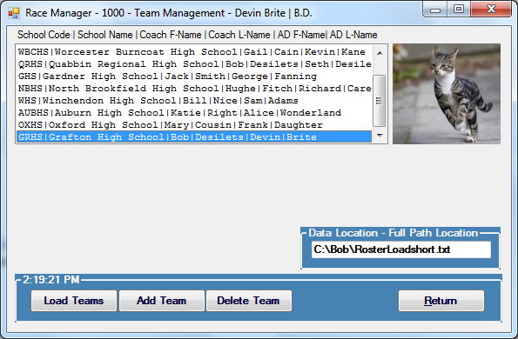

Pictured: Form 1000 a team has been selected for deletion.

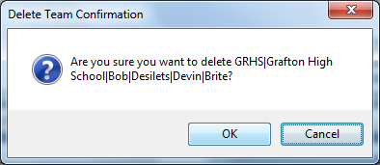

Pictured: A prompt asking “Are you sure?”

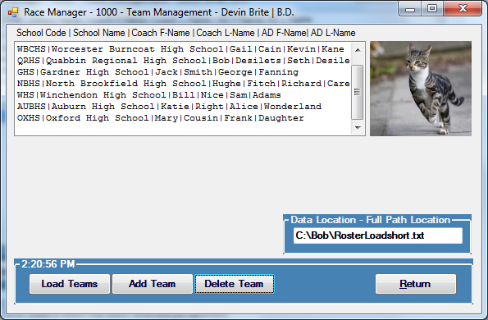

Pictured: Form 1000 after a team has been deleted

### Returning to Form 0000

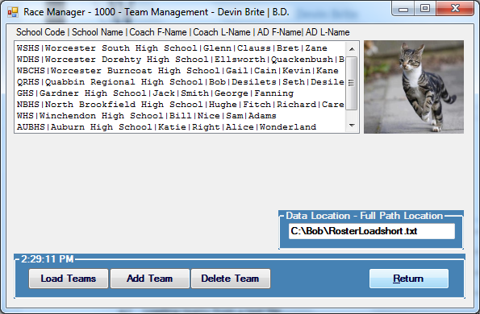

Pictured: Form 1000 with the “Return” button highlighted

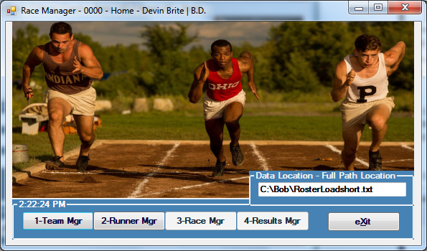

Pictured: Form 0000 after Form 1000 has been completed

## Open Form 2000: Runner Management

Form 2000 is used to load runners from a file, add new runners, and delete runners from the roster. First, the user enters a file location in the “Data Location” text box to a “RosterLoad” text file. Then the user clicks the “Load Runners” button. After that, the user can click “Add Runners” to enter data for, and add a new runner. The user also has the option of deleting runners (if there are any on the roster). This can be done by selecting a runner in the list, then clicking the “Del. Runners” button. Once the user is done modifying the runner list, they can click the “Return” button to return to the main screen.

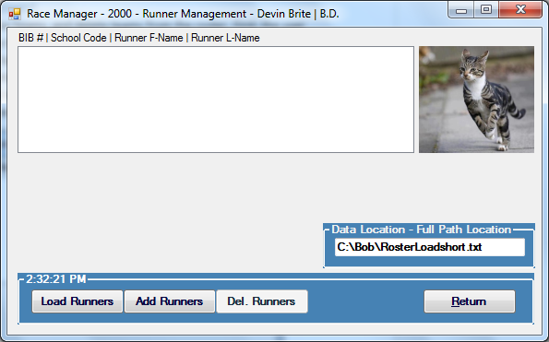

Pictured: Form 2000 upon first load

### Loading runners from a text file

Enter the location of the desired roster file into the “Data Location” text box. Then click the “Load Runners” button.

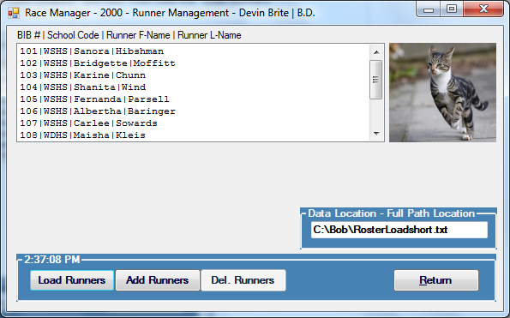

Pictured: Form 2000 after loading runners

### Adding runners

Click the “Add Runners” button and enter the data into the form. Then click “Save” to add the new runner to the list. If you’ve made a mistake while entering data, you can click the “reFresh” button to reset the form. Once the user has finished entering runners, they can press the “Cancel” button to close the “Add Runner Information” section, and continue using the application.

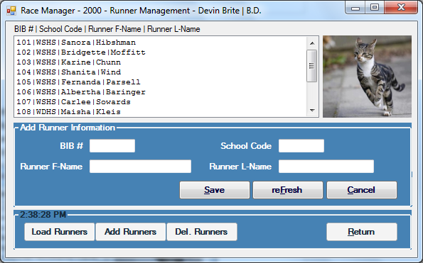

Pictured: Form 2000 after clicking the “Add Runner” button

#### Enter runner information

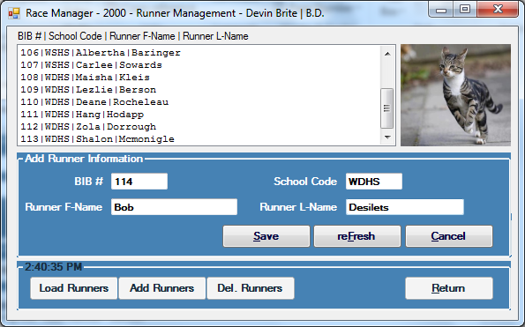

Pictured: Form 2000 after entering data for a new runner

#### Click the “Save” button

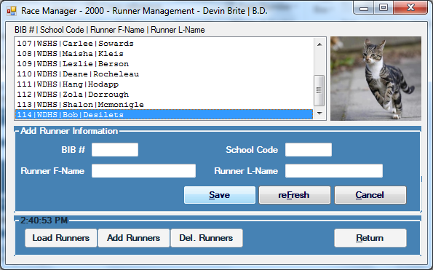

Pictured: Form 2000 after a new runner has been added

#### (Optionally) Click the “reFresh” button to clear the form

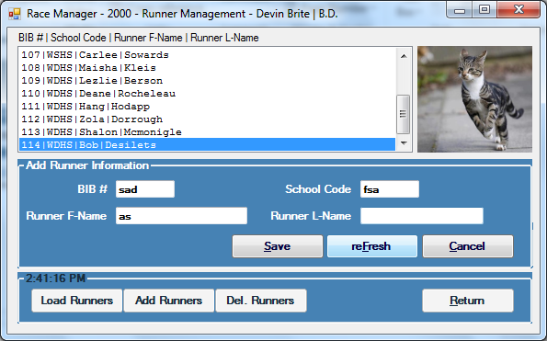

Pictured: Form 2000 after entering wrong information

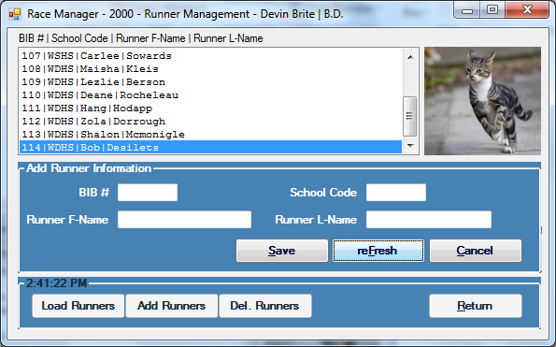

Pictured: Form 2000 after the “reFresh” button has been clicked

#### Click the “Cancel” button to return to the standard form 2000

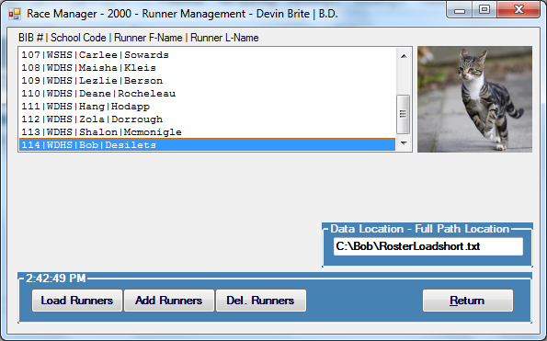

Pictured: Form 2000 after the “Cancel” button (inside the “Add Runner Information” group) has been clicked

### Deleting Runners

Select a runner from the runner list, then click the “Del. Runners” button.

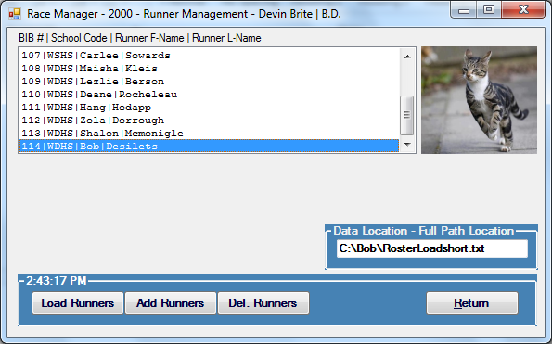

Pictured: Form 1000 a team has been selected for deletion.

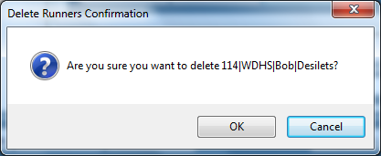

Pictured: A prompt asking “Are you sure?”

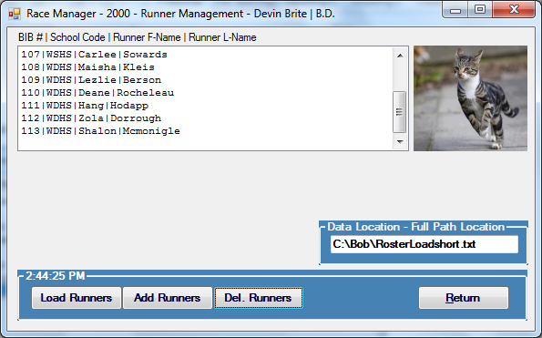

Pictured: Form 1000 after a team has been deleted

### Returning to Form 0000

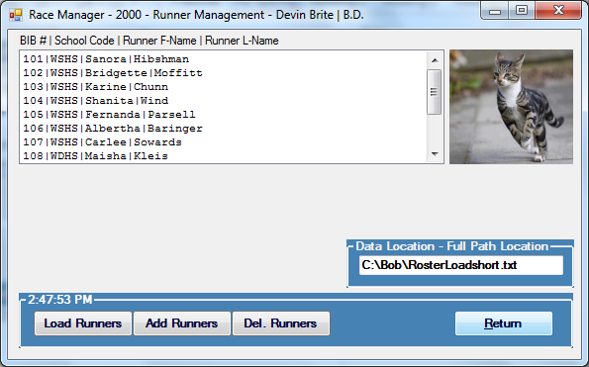

Pictured: Form 2000 with the “Return” button highlighted

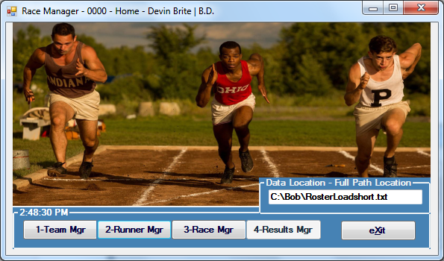

Pictured: Form 0000 after Form 1000 and Form 2000 have been completed

## Open Form 3000: Race Management

Form 3000 is used to load race times from a file and enter and sync the corresponding bib numbers. First, the user enters a file location in the “Data Location” text box to a “TimeFile” text file. Then the user clicks the “Load Times” button. Once the user is done syncing bib numbers, they can click the “Return” button to return to the main screen.

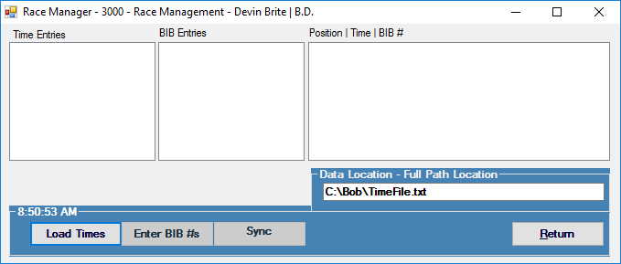

Pictured: Form 3000 upon first opening.

### Loading time entries from a text file

Enter the location of the desired time file into the “Data Location” text box. Then click the “Load Times” button.

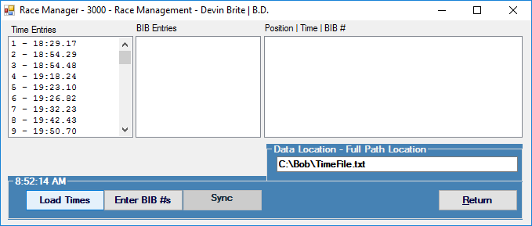

Pictured: Form 3000 after loading the times.

### Entering Bib Numbers

There are two ways to enter bib numbers. The first is through a “scanner”, which reads inputs from a text file. The second is by manually entering each number. To start, the user presses the “Enter Bib #s” button. A prompt asks whether or not to scan from a file. If the user clicks “Yes”, they are then prompted to enter a file location. If they click “No”, the program does not automatically enter the next number. After that, the application will prompt for each bib number in order. Clicking “Ok” will perform checks on the bib number and advance to the next bib number to enter. If the user chooses to use the scanner, they only need to press the “Ok” button for each bib number.

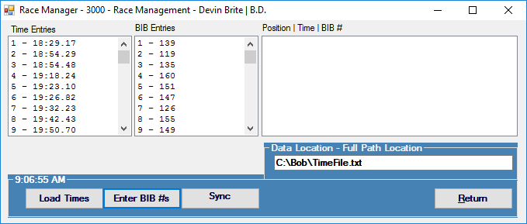

Pictured: Form 3000 after bib numbers have been entered.

#### Using a scanner

##### First, the user clicks the “Enter Bib #s” button. The user is prompted with a choice: “Yes” to read from a scanner, or “No”. In this case, we’ll click “Yes”.

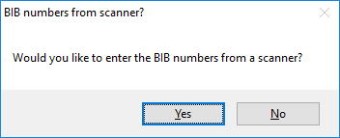

Pictured: A prompt asking if the user would like to use a scanner

##### Then the user enters a file location and clicks “OK”

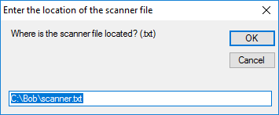

Pictured: A prompt asking for the location of the scanner file

##### The user is prompted to enter a number, but the value has been automatically entered. Press “OK” to continue. Repeat this step until all data has been entered.

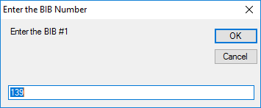

Pictured: A prompt asking the user to enter a bib number.

Here we can see that a bib number is already entered.

#### Entering bib numbers manually

##### The user clicks the “Enter Bib #s” button. The user is prompted with a choice: “Yes” to read from a scanner, or “No”. In this case, we’ll click “No”.

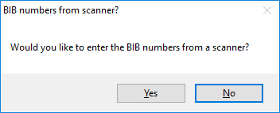

Pictured: A prompt asking if the user would like to use a scanner

##### The user is prompted to enter a number. Enter a number, then click the “OK” button.

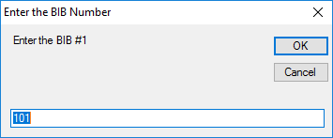

Pictured: A prompt asking the user to enter a bib number.

### Syncing Bib Numbers to Times

Once all the bib numbers have been entered, the user simply needs to click the “Sync” button.

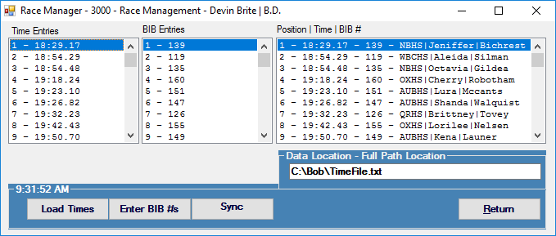

Pictured: Form 3000 after the times have been synced to bib numbers.

### Returning to Form 0000

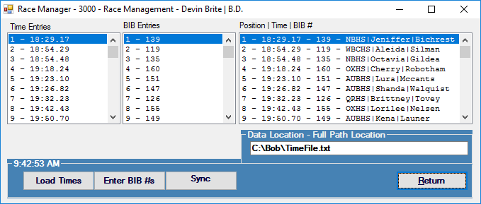Pictured: Form 3000 with the “Return” button highlighted

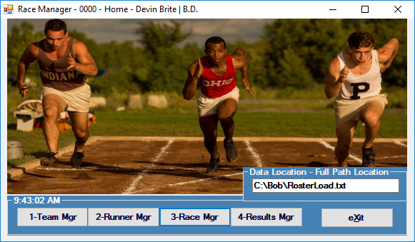

Pictured: Form 0000 after Form 3000 has been completed

## Open Form 4000: Results Manager

Form 4000 is used to calculate, display, and save the race information to a file. The user clicks the “Calculate Res.” Button (Calculate Results) to calculate and display the race information such as the Team Results, and Individual Results. After the race results have been calculated, the user can save the results to C:\Bob\result.txt by clicking the “Archive Files” button. A notification pops up to alert the user about the location of the file.

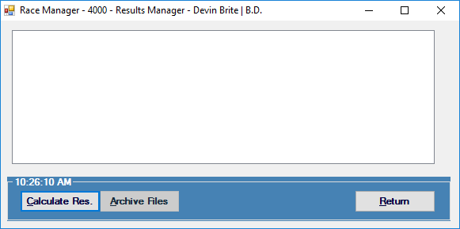

Pictured: Form 4000 upon first load

### Calculating Results

Simply click the “Calculate Res.” Button to calculate and display the race results.

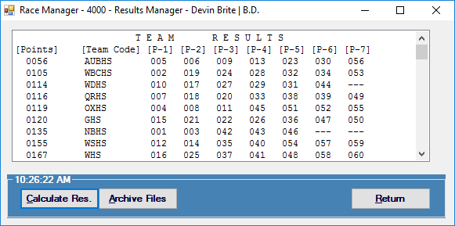

Pictured: Form 4000 after clicking “Calculate Res.”

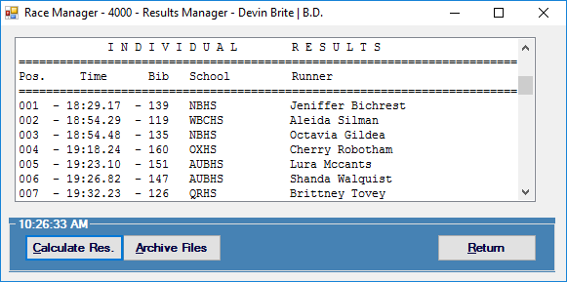

Pictured: Form 4000 after clicking “Calculate Res.” (Scrolled down to show some individual results)

### Archiving the Results

Clicking the “Archive Files” button saves the results to “C:\Bob\result.txt”. A notification pops up to alert the user to the location of the newly archived file.

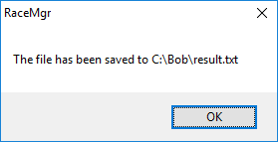

Pictured: The notification alerting the user to the location of the results

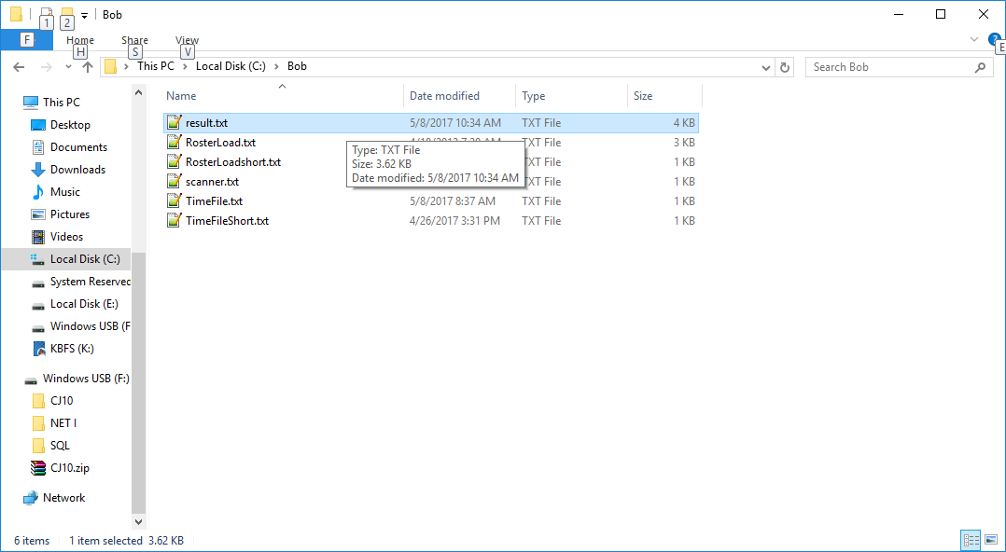

Pictured: The result.txt file viewed in the Windows Explorer

Race Manager Application: User Guide

by Devin Brite