**CS 340 Project Step 1 Final | Group 73**

**Team Members:** Adam Leatherman, Darren Choate

**Project Title:** Maine Wildlife Database

**Feedback By the Peer Reviewers:**

**From Aiden Murphy:**

Hi Darren and Adam!

[edit to fit the review rubric:]

Does the overview describe what problem is to be solved by a website with DB back end?

Yes, I like your proposal overview, I think you're not just completing an assignment but pointing your efforts to something that will benefit the Earth! I think that the Organization entities don't quite match the use described in the overview, but I understand needing to make a full-fledged database. Overall I think the overview is very strong.

Does the overview list specific facts?

Yes, the overview mentions reputable facts about the need for data collection in this field. It also mentions real-life issues like climate crisis and the change of our biodiversity.

Are at least four entities described, and does each one represent a single idea to be stored as a list?

Yes, there are an appropriate amount of entities, with each one representing a single idea. As mentioned above, I think that the use of the Organization and Observer Organization entities is a bit off-topic, and I think the data attributes could be arranged in a way where conservation and animal protection are prioritized.

Does the outline of entity details describe the purpose of each, list attribute datatypes and constraints, and describe relationships between entities?

Yes, the attributes make sense and the attribute restraints are all clear. Each entity has a list of relationships included with real-world context explaining the connection.

Are 1:M relationships correctly formulated? Is there at least one M:M relationship? Does the ERD present a logical view of the database?

Yes, all 1:M relationships look correct to me. There is an M:N relationship, and this is probably where the 'necessity' of the Organizations entity comes from. The Observers have an M:N relationship with the Organizations entity, which is appropriately displayed as an intersection table on their ERD

Is there consistency in a) naming between overview and entity/attributes b) entities plural, attributes singular c) use of capitalization for naming?

Yeah! Almost all of the attributes and entities follow the styling included with the project. Technically Observation Organization should be Observation Organizations, or as written in this overview, ObserverOrgs.

Conclusion:

I think this draft is really strong, but also has room to grow conceptually. I think the Organizations entity is the weakest point, as I try to think about its utility on the front end of things. Regardless, I think your first draft would certainly be applicable if your website dedicated significant amounts of attention to the networking of Observers' organizations. All in all, great first draft!

Happy coding!

**Action Based on Feedback:** Based on Aiden’s review, we decided to remove the Organizations table. We agree that it would have detracted from the overall theme of wildlife observation and was slightly off-topic. Our original intent was to convey that an observer could have been part of many organizations and an organization could have consisted of many observers.

Instead, to more closely align with a database that strictly captures animal sightings, we decided to implement a M:N relationship between Animals and Observers. To implement this, we added an ObserverAnimals table, which details the expertise level an observer may have with a specific animal and the time-of-day preference that an observer may have in observing a specific animal.

Details of the newly implemented table can be found in the Database Outline and ERD.

**From Jenny Zhong:**

The idea of a crowdsourced database for wildlife sightings is really cool. The only suggestion I would give is to narrow down to maybe a certain species? I think just the general database of sightings for all animals is a bit broad. Perhaps it could be narrow down to migratory birds or birds-of-prey in the area to monitor their numbers and area where they are still sighted? Again, this is just a suggestion.

**Action Based on Feedback:** None. While we agree that a database of sightings for animals is broad, it was never our intention to be extremely specific. The data collected will consist of recorded wildlife sightings in Maine, and we believe our database can facilitate this without constraining on a certain species.

**From Christopher McLean:**

Does the overview describe what problem is to be solved by a website with DB back end?

This is a really cool idea! The team did a great job explaining what the problem the Maine Wildlife Database (MWD) will solve. It’s demonstrated that the MWD will allow nature observers to log details about the sightings of various animal species. This will allow scientists, hobbyists, and other interested parties to utilize that information. Additionally, a future implementation will let users track all of their own sightings.

Does the overview list specific facts?

The overview does list specific facts. I found it helpful to know how many U.S. residents watch wildlife annually! I think it could have been additionally beneficial to have a few more numerical facts. For example, knowing how many annual users were anticipated to use the MWD in the first year would be valuable.

Are at least four entities described and does each one represent a single idea to be stored as a list?

The MWD has five entities: Animals, Locations, Observers, Sightings, and Organizations, as well as ObserverOrg as an intersection table. Each entity does represent a single idea.

Does the outline of entity details describe the purpose of each, list attribute data types and constraints and describe relationships between entities?

The outline does describe the Animals and Location entities, and Sightings and Observers are pretty intuitive to understand. It would have been helpful for me personally to have a description of the Organizations entity, I’m assuming it’s describing something like a local bird watching club, or the Audubon Society. The outline does list attribute data types and constraints. It also describes all the relationships between entities.

Are 1:M relationships correctly formulated? Is there at least one M:M relationship? Does the ERD present a logical view of the database?

All 1:M relationships appear to be correctly formulated. There is a M:N relationship between Observers and Organizations, with ObserverOrg as the intersection table between the two. The ERD presents a very clear logical view of the database.

Is there consistency in a) naming between overview and entity/attributes b) entities plural, attributes singular c) use of capitalization for naming?

There is a very consistent approach with the naming conventions within the database. Entities are all plural and use Pascal case (however, the intersection table is singular as ObserverOrg). Attributes are all singular except for the details attribute in the Sightings entity, though that may make sense in this instance. Each attribute is in camel case.

This was really well done, good luck on your project!

**Action Based on Feedback:** Christopher correctly pointed to the fact that our initial intersection, ObserverOrganization, was singular when all other tables were plural. We corrected this in our new intersection table, ObserverAnimals (as described in above action). Additionally, we ensured that our new table had a clear description, which may have been lacking in our draft.

**From Masseeh Safi:**

· Does the overview describe what problem is to be solved by a website with DB back end?

The overview very clearly describes the problem and how the DB backend implementation will help address it.

· Does the overview list specific facts?

The initial paragraph sets clear context with a concise summary of the environment being addressed. Then the following paragraph gives examples of how the data types and relationships will provide insightful information.

·Are at least four entities described and does each one represent a single idea to be stored a s a list?

Yes, there are 5 entities and a 6th table to address a M:N relationship.

· Does the outline of entity details describe the purpose of each, list attribute datatypes and constraints and describe relationships between entities?

I do not entirely understand the Organizations table being tied to the Observers.

I gather that Observers are the main users who will be contributing the bulk of the sighting data, and theoretically this could be hundreds of thousands of users. And I understand Organizations to be the users of the data to address the problems described in the problem statement. Maybe in the next iteration, a description could be helpful to signal who the Observers and Organizations are and how they are related.

· Are 1:M relationships correctly formulated? Is there at least one M:M relationship? Does the ERD present a logical view of the database?

The 1:M relations are correctly formulated as I can tell. And there’s an M:N relationship that is addressed with an intersection table.

The ERD is very well organized. I’m taking notes!

· Is there consistency in a) naming between overview and entity/attributes b) entities plural, attributes singular c) use of capitalization for naming?

The consistency looks great! The only nitpick would be that ObserverOrg could also be plural to match the rest of the tables.

Great job!

**Action Based on Feedback:** Like other commentors, Masseeh had confusion around the Organizations table. As previously stated, we removed this table in favor of a new M:N relationship, Animals-to-Observers. To reiterate, this table will capture each observer’s expertise in dealing with certain animals and will record their time-of-day preference in observing said animals. We also ensured a plural name for the intersection table like Masseeh and others suggested.

**Overview:**

Birders, wildlife photographers, and other nature enthusiasts need a crowdsourced repository of wildlife sightings in order to increase the chances of finding a targeted species. In addition, climate change is putting increased pressure on some animals, while opening up new areas to others. Global trade, exotic pets and random events can introduce new species to an area; the results can be devastating or simply interesting. Scientists and hobbyists alike could benefit from crowdsourced wildlife sightings, and this data could point to increased or decreased prevalence of species in different locations. Research suggests that the opportunity for data collection not only exists but is extensive; for example, a 2022 National Survey of Fishing, Hunting, and Wildlife-Associated Recreation by the U.S. Fish and Wildlife Service and the Association of Fish and Wildlife Agencies found that 148 million U.S. residents watched wildlife in 2022.

Users will submit sightings, noting the animal and location, along with details including time and date of the sighting. The administrators of the database will enter these sightings into the database. It will be possible to get reports on the number of sightings of an animal in a given year or location, or to view all of the locations an animal has been sighted, or the animals found in a given location. Observers will be stored so that observers can be reached to provide further details if needed, and for future implementation of a user facing app that will allow individuals to view their own sightings.

**Database Outline:**

* **Animals**: information about animal species
  + **animalID:** int, auto_increment, not NULL, PK
  + **species:** varchar, not NULL
  + **class:** varchar, not NULL
  + **federallyListed:** bool, not NULL
  + **expected:** bool, not NULL
  + **Relationship:** a 1:M relationship between Animals and Sightings is implemented with animalID as a FK inside Sightings
  + **Relationship:** a M:N relationship between Animals and Observers is implemented with ObserverAnimals intersection table, creating a 1:M relationship
* **Locations:** town, county, and/or park information
  + **locationID**: int, auto_increment, not NULL, PK
  + **parkName:** varchar
  + **Relationship**: a 1:M relationship between Locations and Sightings is implemented with locationID as a FK inside of Sightings.
* **Sightings:** stores information about wildlife sightings, including time, date, details, and references to associated animal, location, and observer
  + **sightingID:** int, auto_increment, not NULL, PK
  + **locationID:** int, not NULL, FK
  + **observerID:** int, FK
  + **animalID:** int, not NULL, FK
  + **sightingTime**: TIME, not NULL
  + **sightingDate:** DATE, not NULL
  + **weather:** varchar, not NULL
  + **Relationship:** a M:1 relationship between Sightings and Animals is implemented with animalID as a foreign key inside of Sightings.
  + **Relationship:** a M:1 relationship between Sightings and Locations is implemented with locationID as a foreign key inside of Sightings.
  + **Relationship:** a M:1 relationship between Sightings and Observers is implemented with personID as a foreign key inside of Sightings.
* **Observers:** contains details about individuals who observe wildlife, such as name, phone number, and email address
  + **observerID:** int, auto_increment, not NULL, PK
  + **name:** varchar, not NULL
  + **phoneNumber:** varchar, not NULL
  + **emailAddress:** varchar, not NULL
  + **Relationship:** a 1:M relationship between Observers and Sightings is implemented with observerID as a foreign key inside of Sightings.
  + **Relationship:** a M:N relationship between Observers and Animals is implemented with ObserverAnimals intersection table, creating a 1:M relationship
* **ObserverAnimals: r**epresents the expertise level of observers in observing specific animals, establishing a many-to-many relationship between observers and animals
  + **observerAnimalID: :** int, (observerID, animalID), not NULL, PK
  + **observerID:** int, not NULL, FK
  + **animalID:** int, not NULL, FK
  + **expertiseLevel:** varchar, not NULL
  + **timeOfDayPreference:** varchar, not NULL
  + **Relationship:** a M:1 relationship between ObserverAnimals and Observers is implemented with observerID as a foreign key inside of ObserverAnimals.
  + **Relationship:** a M:1 relationship between ObserverAnimals and Animals is implemented with animalID as a foreign key inside of ObserverAnimals.

**Entity-Relationship Diagram:**

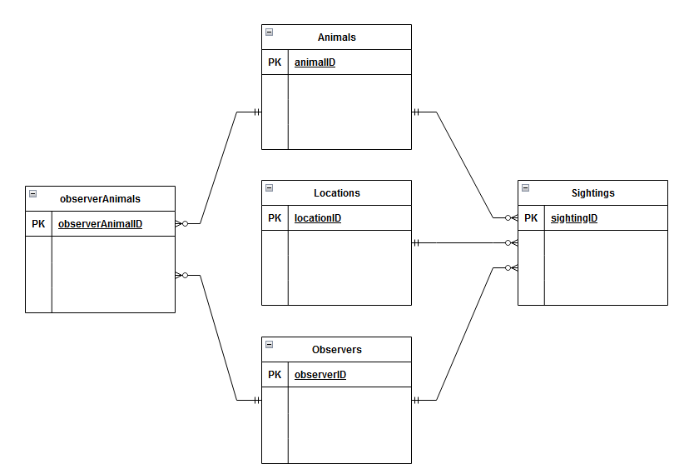

**Schema:**

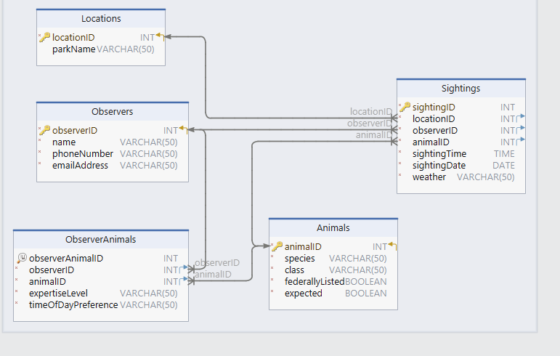

**Sample Data:**

**Animals**

|  |  |  |  |  |
| --- | --- | --- | --- | --- |
| **animalID** | **species** | **class** | **federallyListed** | **expected** |
| 1 | Canada lynx | mammal | FALSE | TRUE |
| 2 | American marten | mammal | FALSE | TRUE |
| 3 | gray fox | mammal | FALSE | TRUE |

**Observers**

|  |  |  |  |
| --- | --- | --- | --- |
| **observerID** | **name** | **phoneNumber** | **emailAddress** |
| 1 | Ethan Thompson | 555-789-1234 | user1@example.net |
| 2 | Olivia Rodriguez | 123-456-7890 | user2@example.net |
| 3 | Mason Cooper | 987-654-3210 | user3@example.net |

**ObserverAnimals**

|  |  |  |  |  |
| --- | --- | --- | --- | --- |
| **observerAnimalID** | **observerID** | **animalID** | **expertiseLevel** | **timeOfDayPreference** |
| 1 | 1 | 20 | intermediate | morning |
| 2 | 8 | 19 | expert | night |
| 3 | 15 | 8 | intermediate | night |

**Locations**

|  |  |
| --- | --- |
| **locationID** | **parkName** |
| 1 | Acadia National Park |
| 2 | Camden Hills State Park |
| 3 | Wolfe's Neck Woods State Park |

**Sightings**

|  |  |  |  |  |  |  |
| --- | --- | --- | --- | --- | --- | --- |
| **sightingID** | **locationID** | **observerID** | **animalID** | **time** | **date** | **weather** |
| 1 | 20 | 14 | 16 | 8:45 AM | 17-Feb-23 | rain |
| 2 | 17 | 3 | 15 | 2:30 PM | 5-Apr-23 | snow |
| 3 | 2 | 16 | 6 | 11:15 AM | 21-Jun-23 | clear |