GENERIC SENSOR FORMAT
SPECIFICATION

29 December 2004

Prepared For:
Naval Oceanographic Office
Stennis Space Center, MS 39522

Prepared By:
Science Applications International Corporation
221 Third Street
Newport, RI 02840
Table of Contents
1. INTRODUCTION 1-1
1.1 Purpose 1-1
1.2 Background 1-1
1.3 DoDBL overview 1-2
1.3.1 Usage of GSF outside of DoDBL 1-2
1.4 Goals 1-2
1.4.1 Portability 1-3
1.4.2 Extensibility 1-3
1.4.3 Efficiency 1-3
1.4.4 Acceptance 1-3
1.4.5 Consistency 1-3
2. APPLICABLE DOCUMENTS 2-1
2.1 Government documents 2-1
2.1.1 Specifications, standards, and handbooks 2-1
2.1.2 Other Government documents, drawings, and publications 2-1
2.2 Non-Government publications 2-1
2.3 Order of precedence 2-2
3. CONVENTIONS 3-1
3.1 Accuracy 3-1
3.2 Datums 3-1
3.3 Swath-related nomenclature 3-1
3.4 Ship-based coordinate system 3-2
3.5 Units of measure 3-3
3.6 Data element formats 3-3
3.6.1 Text 3-3
3.6.2 Binary integers 3-3
3.6.3 Geographic coordinates 3-4
3.6.3.1 Text form 3-4
3.6.3.2 Binary form 3-4
3.6.4 Depths 3-4
3.6.5 Dates 3-4
3.6.6 Times 3-5
3.6.7 Angular measures 3-5
3.6.7.1 Heading and course 3-5
3.6.7.2 Yaw 3-5
3.6.7.3 Roll 3-5
3.6.7.4 Pitch 3-6
3.7 Record Description 3-6
4. DATA STRUCTURE 4-1
4.1 Transmittal Header File 4-2
4.2 Metadata File 4-3
4.3 GSF Data File 4-3
4.3.1 GSF Record Structure 4-3
4.3.1.1 Checksum flag 4-4
4.3.1.2 Record identification field 4-4
4.3.1.3 Checksum 4-5
4.3.1.4 Data record 4-5
4.3.2 GSF Record Types 4-5
4.3.3 Header Record 4-6
4.3.4 Swath Bathymetry Ping Record 4-6
4.3.4.1 Ping header 4-6
4.3.4.2 Scale-factor subrecord 4-8
4.3.4.3 Array subrecords 4-12
4.3.4.4 Depth Array Subrecord 4-13
4.3.4.5 Nominal Depth Array Subrecord 4-13
4.3.4.6 Acrosstrack Array Subrecord 4-13
4.3.4.7 Alongtrack Array Subrecord 4-13
4.3.4.8 Travel-time Array Subrecord 4-13
4.3.4.9 Beam-angle Array Subrecord 4-13
4.3.4.10 Mean Calibrated Amplitude Array Subrecord 4-14
4.3.4.11 Mean Relative Amplitude Array Subrecord 4-14
4.3.4.12 Echo Width Array Subrecord 4-14
4.3.4.13 Quality factor Array Subrecord 4-14
4.3.4.14 Receive Heave Array Subrecord 4-14
4.3.4.15 Beam Flags Array Subrecord 4-14
4.3.4.16 Packed 2-bit Array Subrecord 4-14
4.3.4.17 Signal to Noise Array Subrecord 4-14
4.3.4.18 Beam Angle Forward Array Subrecord 4-15
4.3.4.19 Vertical Error Array Subrecord 4-15
4.3.4.20 Horizontal Error Array Subrecord 4-15
4.3.4.21 Sensor-specific Subrecords 4-15
4.3.5 Single-beam Sounding Record 4-16
4.3.6 Summary Record 4-17
4.3.7 Sound Velocity Profile Record 4-17
4.3.8 Processing Parameter record 4-18
4.3.9 Sensor Parameter record 4-24
4.3.10 Comment record 4-25
4.3.11 History record 4-25
4.3.12 Navigation error record * obsolete, as of GSF v1.07* 4-26
4.3.13 HV Navigation error record 4-27
4.3.14 Attitude record 4-27

Appendix A.1 Record Identifiers
Appendix A.2 Swath Bathymetric Ping Subrecord Identifiers
Appendix A.3 Single-beam Sounding Sensor Specific Records
Appendix B.1 Swath Bathymetric Ping Sensor Specific Records
Appendix B.2 Single-beam Sounding Sensor Specific Records
Appendix B.3 Bathymetric Receive Beam Imagery Sensor Specific Subrecords
Appendix C.1 Standard Ping Flag Definitions
Appendix C.2 Standard Beam Flag Definitions

TABLES
Table 4-1 Transmittal Header File 4-2
Table 4-2 Header Record Definition 4-6
Table 4-3 Swath Bathymetry Ping Record Definition 4-8
Table 4-4 Single beam Sounding Record Definition 4-16
Table 4-5 Summary Record Definition 4-17
Table 4-6 Sound Velocity Profile Record Definition 4-17
Table 4-7 Processing Parameter Record Definition 4-18
Table 4-8 Defined Processing Parameter Text Strings 4-18
Table 4-9 Sensor Parameter Record Definition 4-25
Table 4-10 Comment Record Definition 4-25
Table 4-11 History Record Definition 4-25
Table 4-12 Navigation Error Record Definition 4-26
Table 4-13 HV Navigation Error Record Definition 4-27

FIGURES
Figure 3-1 Coordinate systems for beam location
Figure 3-2 Ship-based coordinate system
Figure 3-3 GSF definition conventions
Figure 4-1 Data Set Organization
Figure 4-2 GSF Data File Structure
Figure 4-3 Ping record schematic
Figure 4-4 Ping Scale Factor Subrecord Schematic

Generic Sensor Format Specification

REVISIONS
Rev | Date | Pages Affected | Remarks
0 | 30 SEP 93 | All | Initial Draft Version.
A | 31 MAR 94 | All | Final Draft Version.
B | 30 JAN 95 | All | Released as Draft MIL-STD-2415
C | 29 JUL 96 | All | Sequential encapsulation updated to reflect changes due to implementation of software version GSF-v1.02.
D | 04 SEP 98 | All | No longer designated as Draft. Changes as follows:  - Updated specification to reflect changes due to implementations through GSF-v1.06.  - Removed the direct access encapsulation (GSF/DA) from the specification, leaving only the sequential encapsulation.  - Restricted all time fields in a data file to use precise time. All data currently conforms to this restriction. This change in effect codifies a restriction imposed by the use of the library as part of the standard.  - Reformatted the document into Word 6.0(95) format. Updated all figures into Windows metafile format (WMF).  - Limited editing resulting in spelling, grammatical and a few technical changes.  - Changed the header numbering sequence from 1.1.1.a (1) to 1.1.1.1.1.  - Split table 2 (GSF/S Record Definitions) into a separate table for each record.  Added references for POSIX 1003.1 and GSF Library documentation.
E | 12 NOV 98 | All | Changes as follows:  - Updated specification to reflect changes due to implementations through GSF-v1.07.  - Modified the gsfPrintError function to call the gsfStringError function.  - Defined a new GSF navigation error record that replaces the currently defined navigation error record.  - Defined a new horizontal navigation error record that contains a text field describing the positioning system type.  - Modified gsf_enc.c to encode the existing error array subrecords (depth_error, across_track_error and along_track_error) as two byte quantities.  - Added two new array subrecords, horizontal error and vertical error, to the GSF swath bathymetry ping data structure,
F | 07 OCT 99 | All | Changes as follows:  - Updated specifications to reflect changes due to implementations through GSF-v1.08.  - Updated the description of the beam angle forward array and the beam angle array subrecords.  - Updated Appendix A.2 Swath Bathymetry Ping Subrecord Identifier Definition to reflect additions of EM3000_SPECIFIC, EM1002_SPECIFIC, EM300_SPECIFIC and CMP_SASS_SPECIFIC subrecord identifiers  - Added Swath Bathymetry Ping Sensor-specific Subrecord Definitions for the SIMRAD EM3000 series sonar, Compressed SASS data, and TypeIII SASS data
G | 12 OCT 99 | All | Changes as follows:  - Updated specifications to reflect changes due to implementations through GSF-v1.09.  - Modified Swath Bathymetry Ping Sensor-specific Subrecord Definition for the Compressed SASS data format.
H | 20 OCT 00 | All | Changes as follows:  - Updated specifications to reflect changes due to implementations through GSF-v1.10.
I | 16 JAN 01 | All | Changes as follows:  - Updated specifications to reflect changes due to implementations through GSF-v1.11.
J | 03 APR 02 | A-3 | Changes as follows:  - Updated specifications to reflect changes due to implementations through GSF-v2.0. Reserved sensor specific subrecord IDs for Reson 81P series 8101, 8111, 8125, 8150, and 8160 sonar systems. Added sensor specific subrecord ID and subrecord definition for Simrad EM120
K | 08 JUL 02 | All | Changes as follows:  Updated specifications to reflect changes due to implementations through GSF-v2.01.
L | 20 JUN 03 | All | Changes as follows:  - Updated specifications to reflect changes due to implementations through GSF-v2.02, including updates for multibeam imagery per bathymetric receive beam
M | 29 DEC 04 | All | Changes as follows:  - Updated specifications to reflect changes due to implementations through GSF-v2.03.

INTRODUCTION

Purpose
This report documents a Generic Sensor Format (GSF) for use as an exchange format in the Department of Defense Bathymetric Library (DoDBL), one of three DoDBL processing formats. Similar formats are under development for the interchange of vector data, such as hydrographic soundings and features; and raster data, such as gridded bathymetry and processed acoustic imagery.

This standard focuses on the encoding of multibeam data, the highest priority for the DoDBL. It is also designed to be expandable to encode unprocessed acoustic imagery as those Defense Hydrographic Initiative (DHI) requirements become clearer. It is intended for coordination among the DoDBL nodes - the Defense Mapping Agency (DMA), the Naval Oceanographic Office (NAVOCEANO), the National Ocean Service (NOS), and the National Geophysical Data Center (NGDC), as well as academia and industry to collect data and design systems that use GSF.

Background
GSF is designed to efficiently store and exchange information produced by geophysical measurement systems before it has been processed into either vector or raster form. A sensor data set contains all the information needed to compute the depth or other values at a specific geographic position, but that calculation has not yet been made. This structure is particularly useful for data sets created by systems such as multibeam sounders that collect a large quantity of data from a single location and initially express geographic positions in relative terms. GSF not only saves storage space and reduces data transfer volumes, it also provides the receiver with critical information that may be lost when processing the oversampled data to either raster or vector form.

The current use of GSF is to define data from bathymetric surveying systems; however, this is only one of a class of sensors that GSF can support. Acoustic imagery, seismic reflection profiles, swept-frequency (chirp) sub-bottom imagery are other classes of data that may be incorporated into the DoDBL but cannot be efficiently stored in either vector or raster form.

This draft standard implementation was based on earlier work at the University of Rhode Island supported by DHI and other work at the Naval Research Laboratory (NRL). This paper does not present the rationale for this implementation. The rationale is based on two earlier papers, which describe the overall rationale and approach (Ferguson and Chayes, 1992 and 1995) and on extensive discussions with Mssrs. deMoustier and Charters at Scripps Institute of Oceanography.

DoDBL overview
The DoDBL is a distributed library of bathymetric and hydrographic data (note: the Hydrographic Source Assessment System (HYSAS) documentation uses these terms interchangeably). The data, which are acquired and archived by organizations in the Department of Defense (DoD) and the Department of Commerce National Oceanic and Atmospheric Administration (NOAA), may be stored in many different structures and formats. The intent of this specification is to ease data exchange among the nodes by standardizing the format for sensor data files, including unprocessed bathymetry and acoustic imagery. The two other general types of data in the DoDBL: vector (which includes single-beam soundings) and raster (which includes gridded bathymetry and rectified acoustic imagery) use similar specifications. GSF is also intended for data transfer between collection platforms and their respective DoDBL node.

There are many sources for DoDBL data sets. The GSF deals primarily with multibeam (swath) and acoustic imagery data sets that are collected by both DoD and non-DoD survey ships.

Usage of GSF outside of DoDBL
This specification describes the form of data being exchanged within the DoDBL. The format described in this specification is intended, however, to be of use outside the DoDBL. Using this format will increase the efficiency of data transfer between the agency's internal archive and the DoDBL and, perhaps, between agencies without direct access to the DoDBL. For use of this specification outside the DoDBL, Transmittal files and Metadata files are optional, although their use is encouraged. Many of the elements of the Metadata file may be most accurately described immediately after the data have been collected. From the moment the data are collected, adoption of the Metadata file as a method of maintaining important descriptive information can significantly enhance the data's long-term usability.

Goals
GSF is designed to be modular and adaptable to meet the unique requirements of a variety of sensors. The goals of the Generic Sensor Format are:

- Portability among all major computing platforms.
- Extensibility so that new types of data and measurements can be easily incorporated.
- Efficiency in terms of storage volume and data access.
- Endorsement by the major groups of users outside the DoDBL.
- Consistency with other DoDBL formats.

Portability
Portability among the various computing platforms that will collect, process, and store data in GSF is critical. Adequate data description and the exclusive use of industry, national and international standards for data encoding ensure portability in this standard. Where practical, GSF is consistent with industry standards for network exchange. This will reduce the time for some systems once the DoDBL nodes are fully networked.

Extensibility
Because of the rapid state of development in sensor systems, it is very important to provide a mechanism for planned growth and evolution. Increasing sophistication of the sensor systems and signal processing techniques have increased the information extracted from a single ping. It is essential that GSF allow for expansion to prevent early obsolescence of the format. GSF achieves extensibility through modular structure and self-description.

New data elements can be specified for new data records and these records can be introduced into a data stream without forcing all programs that may read them to be modified. These features taken together allow different network implementations to coexist on the same data path and are partly responsible for the popularity and success of the Ethernet transport protocol. By adopting a similar approach, GSF has been equipped with a mechanism for gradual change that should help ensure its long-term usefulness.

Efficiency
To enhance storage efficiency, GSF makes extensive use of binary encoding. Most data elements within GSF are numeric, and it is estimated that the use of standard binary 2- and 4-byte big endian (most significant byte first) integers reduces storage volume by 40-50%. The self-defining header schema and time-tagged records allow efficient data access.

Acceptance
The development of this specification incorporated inputs from many different segments of the swath mapping community. Representatives of commercial, academic and federal agencies all provided valuable feedback during the definition of this specification.

Consistency
This draft standard is consistent with the other standards to be used in the DoDBL. It has a common Transmittal Header File to allow rapid identification by the receiver, and common Metadata elements to provide the standard DHI ancillary information about the data set. It also uses big endian binary like the proposed Raster Data Exchange Standard (RDES) to obviate the need to develop unique utilities.

APPLICABLE DOCUMENTS

Government documents

Specifications, standards, and handbooks
The following specifications, standards, and handbooks form a part of this document to the extent listed below. Unless otherwise specified, the issues of these documents are those listed in the current Department of Defense Index of Specifications and Standards (DODISS) and the supplement thereto.

MILITARY STANDARDS

MIL-STD-490A | Specification Practices
MIL-STD-600001 | Mapping Charting & Geodesy Accuracy Standard, 26 February 1990
MIL-STD-600003 | MC&G Product Generation Rules

(Unless otherwise indicated, copies of federal and military specifications, standards, and handbooks are available from the Standardization Documents Order Desk, Bldg. 4D, 700 Robbins Avenue, Philadelphia, PA 19111-5094.)

Other Government documents, drawings, and publications
The following Government documents, drawings, and publications form a part of this document to the extent specified. Unless otherwise listed, the document versions are those cited in the solicitation.

DMA TM 8358.1 | Datums, Ellipsoids, Grids, and Grid Reference Systems. First Edition. September 1990
DIAM 65-18 | Defense Intelligence Agency Manual - Geopolitical Data Elements and Related Features. March 1984

(These publications are available from DMA by writing to: Director, Defense Mapping Agency, ATTN: PR, 8613 Lee Highway, Fairfax, VA 22031-2137.)

Non-Government publications
The following publications form a part of this document to the extent specified. Unless otherwise noted, the issues of the documents that are DoD adopted are those listed in the issue of the DODISS cited in the solicitation. The issues of documents not listed in the DODISS are the issues of the documents cited in the solicitation.

ANSI/IEEE 754-1985. IEEE Standard for Binary Floating Point Arithmetic. August 12, 1985. (Application for copies should be addressed to the publisher: IEEE, Inc., 345 East 47th St., NY, 10017)
ANSI/IEEE Std 1003.1b-1993. IEEE Standard for Information Technology – Portable Operating System Interface (POSIX) – Part 1: System Application Program Interface (API) – Amendment 1: Realtime Extension [C Language]. (Application for copies should be addressed to the publisher: IEEE, Inc., 345 East 47th St., NY, 10017)
ANSI x3.4-1977. Code for Information Interchange (ASCII) Adopted in FIPSPUB 1-1, 24 December 1980.
ISO 8601. International Organization for Standardization, Data Elements and Interchange Formats - Information Interchange - Representation of Dates and Times, 1988 (Application for copies should be addressed to the American National Standards Institute, 1430 Broadway, New York, NY 10018).
Bureau of the Budget, United States National Map Accuracy Standards, Government Printing Office, 1947. (This standard is printed in its entirety in Thompson, Morris M., 1988, Maps for America, U.S. Geological Survey, 3rd ed., p. 104).
Chayes, D.A., Nishimura, C.E., Czarneki, M.F., Pitcher, D. 1991. A Paradigm for Processing Sidescan and Bathymetry: The Next Generation. Proceedings of the Maritime Technical Society.
Ferguson, J.S. and Chayes, D.A. 1992. A Generic Swath-Mapping Data Format. Marine Geodesy vol. 15, pp 129-140
Ferguson, J.S. and Chayes, D.A. 1995. Use of a Generic Sensor Format to Store Multibeam Data. Marine Geodesy vol. 18, pp 299-315
GSFlib, the Generic Sensor Format Library, 16 January 2001.

Non-government standards and other publications are normally available from the organizations that prepare or distribute the documents. These documents also may be available in or through libraries or other information services.

Order of precedence
If there is a conflict between the text of this document and the references cited herein (except for related associated detail specifications, specification sheets, or MS standards), the text of this document takes precedence. Nothing in this document, however, supersedes applicable laws and regulations unless a specific exemption has been obtained.

CONVENTIONS

Accuracy
Data files exchanged using the GSF may be of any accuracy. However, the horizontal and vertical accuracy must be determined by standard method and cited in the Metadata File or supporting documentation.

Datums
The preferred horizontal datum is the World Geodetic System 1984 (WGS-84) ellipsoid. However, data files exchanged using the GSF may be referenced to any datum as long as the datum is cited in the Metadata File or supporting documentation

The preferred vertical (sounding) datum is the WGS-84 geoid. However, data files exchanged using the GSF may be referenced to any datum as long as the datum is cited in the Metadata File or supporting documentation. All depths shall be referenced as positive displacements below datum; e.g., a depth of 100 meters below datum would be represented as 100.

Swath-related nomenclature
Two methods of determining beam location relative to a vessel are allowed by GSF, as illustrated by Figure 3-1. Most multibeam sonars provide data in a mixture of both systems. The first is a polar coordinate system with the vessel at the center of a sphere. Individual soundings are located by measuring the range from the vessel to the bottom and the beam angle. The pitch angle is also required and is usually constant for a given ping.
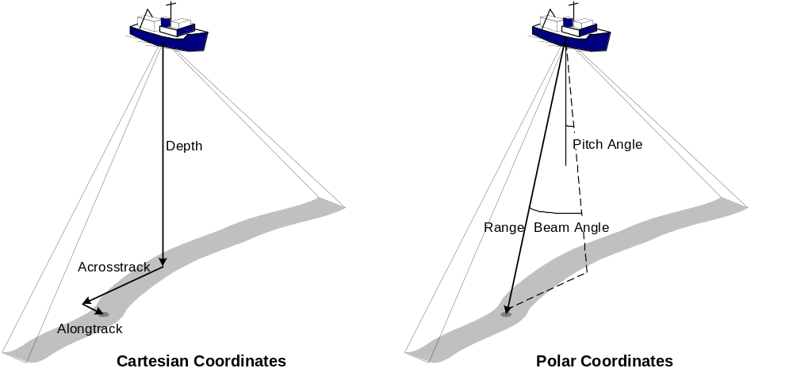
Figure 3-1 Coordinate systems for beam location

GSF also supports a Cartesian system in which individual soundings are located by describing their depth, acrosstrack and alongtrack offsets. Alongtrack offsets may be expressed for each ping or each beam, as appropriate to the specific system, and may be encoded as a distance or a pitch angle.

Ship-based coordinate system
Figure 3-2 shows the ship-based coordinate system used to refer to both onboard locations of sensors and their ship-based measurements. The vessel's direction of travel is along the x-axis. The z-axis is positive down to be consistent with the convention that depths are expressed as positive numbers. The y-axis is defined to point to starboard in order to form a right-handed coordinate system and is consistent with the usual convention that beam offsets increase in the positive direction. The origin of the coordinate system is arbitrarily located on the vessel, either at the center of the sonar's transducer array or at the vessel's center of motion, as appropriate.

Depths are positive and increase as one moves below the ocean's surface, acrosstrack offsets are positive to the vessel's starboard and negative to port, and alongtrack offsets are positive forward of the vessel's reference position and negative astern of it. Heave is positive if the vessel moves below the mean or reference surface.
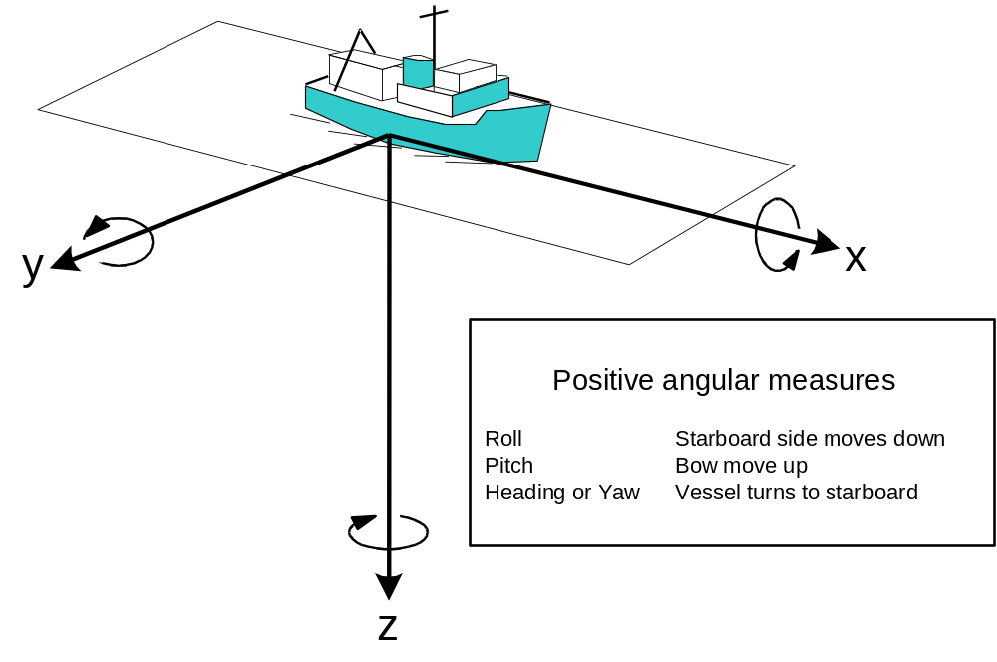
Figure 3-2 Ship-based coordinate system

Units of measure
Units of measurement in this specification are metric and are the preferred units of measurement for GSF files. However, data from systems that use English units may be recorded as such, so long as these units are properly documented.

Data element formats

Text
Text shall be standard ASCII characters as defined by ANSI x3.4-1977. Text fields shall normally be fixed-length, but Comments fields are variable-length. Text fields are left justified and are signified in this specification by a "T”.

Binary integers
To reduce storage volume, GSF makes extensive use of binary integers. All integers shall be big endian (most significant byte first), and may be either 1-byte unsigned, 2-byte signed or unsigned, or 4-byte signed, as required and as specified in the file header. An “I” shall identify signed binary integers in this specification; a “U” shall identify unsigned integers.

GSF may make use of binary integer arrays. When specifying the length of the array, the format is <integer length>*<number of integers>. For example, a field type of "I” and a count of "2*3” indicate a 2-byte integer array with three elements. GSF often encodes several integers within one 32-bit word. The structure of these packed words is fully defined in this specification.

Geographic coordinates
Horizontal position coordinates may be encoded either as a special case of the text field or binary integer field.

Text form
Position in text form shall normally be used high-level GSF files such as the Metadata file and shall be specified in the format:

±DDDMMmmmm±DDMMmmmm,

where D=degrees, M=minutes and m=.0001 minutes, the first set of values specifies the longitude (+ is East), and the second set of values specifies the latitude (+ is North)

For example, -075300000+45160020 would be 45°16.002'N 75°30'W.

Binary form
To maintain consistency with the rest of the file and reduce storage volume, the GSF data files use position in binary form. Latitude and longitude are encoded using two 4-byte signed integer fields representing ten-millionths of degrees. Latitude is positive in the Northern Hemisphere and longitude is positive in the Eastern Hemisphere.

For example, latitude = 325000000 longitude = -0702550000,
would be 32.5°N (32°30'N) 70.255°W (70°15'18”W).

Depths
Normally, depth measurements shall be in meters or decimeters. Some multibeam systems consistently calculate depths according to the English measurement system, recording them in fathoms. These units are acceptable if properly documented. In all cases, it is imperative to explicitly state the assumptions used to derive these values. For example, depths reported in meters may assume a constant sound velocity of 1500 meters/second to derive the depths. This fact must be properly recorded in the SOUND_VELOCITY field of the metadata file.

Dates
Date fields shall conform to ISO 8601, paragraph 5.2.1.1 (Basic Format), and shall be of the form CCYYMMDD (e.g., 19920831 for August 31, 1992). A “D” shall identify date fields in this specification. Such fields are usually limited to transmittal and metadata files.

Times
The representation of time within the GSF is an important design element. Because time appears in many places within a GSF data set, it can have a significant impact on data volume. In transmittal and metadata files, ISO 8601 defines standards for representation of dates. In the data files, ISO 8601 is not appropriate because the standard only allows character representations. It would expand data volume by an unacceptable amount.

The POSIX System Application Program Interface standard controls representation of Time in GSF data files. This includes real-time extensions and uses a combination of three values: a reference time, the number of seconds that have elapsed since the reference point, and the number of nanoseconds that have elapsed since the beginning of the current second. The reference time may be any absolute time. Quite often, midnight of 01 January 1970 is used because many computers use this time in their time of day clocks. Alternatively, the beginning of the start date of the survey (as stated in the Metadata File or supporting documentation) may be used, especially if the data were collected prior to 1970. A 4–byte integer field specifies the number of elapsed seconds since the reference time. A second 4-byte integer field specifies the number of elapsed nanoseconds since the beginning of the current second.

Angular measures
Angular measures such as heading, course, yaw, roll and pitch are represented in hundredths of degrees and are stored as 2-byte signed or unsigned integers.

Heading and course
Heading refers to the direction of the vessel's bow and course refers to the direction of its motion through the water. Heading and course are measured from true North, and describe the vessel's rotation about the z-axis. They increase in value as the vessel turns to starboard in accordance with standard compass angular measures and have a range of 0.00 to 360.00 using a 2-byte unsigned integer.

Yaw
The vessel's short-term rotation about the z-axis is the Yaw. It is measured from the bow of the ship and increases toward the starboard side of the vessel. Yaw normally describes short-term oscillation or pointing errors due to gyrocompass or transducer array misalignment. Yaw has a valid range of –180.00 to +180.00 using a 2-byte signed integer.

Roll
Roll describes the vessel's rotation about the x-axis. Roll is measured from references established when the vertical reference sensor system is calibrated and should be near zero when the ship is evenly trimmed. Roll increases in value as the ship's starboard side moves downward and has a valid range of -180.00 to +180.00 using a 2–byte signed integer.

Pitch
Pitch describes a ship's rotation about the y-axis. Like roll, pitch is measured from references established when the vertical reference sensor system is calibrated and should be near zero when the ship is evenly trimmed. Pitch increases as the sensor platform moves upward and has a valid range of -180.00 to +180.00 using a 2-byte signed integer.

Record Description
Each record is composed of a set of fields that contain the data elements that are defined in subsequent tables. Fields may be big-endian binary (most significant byte first) or ASCII and may be fixed- or variable-length. This specification presents GSF records in tabular form. Figure 3-3 describes the conventions used in these tables.
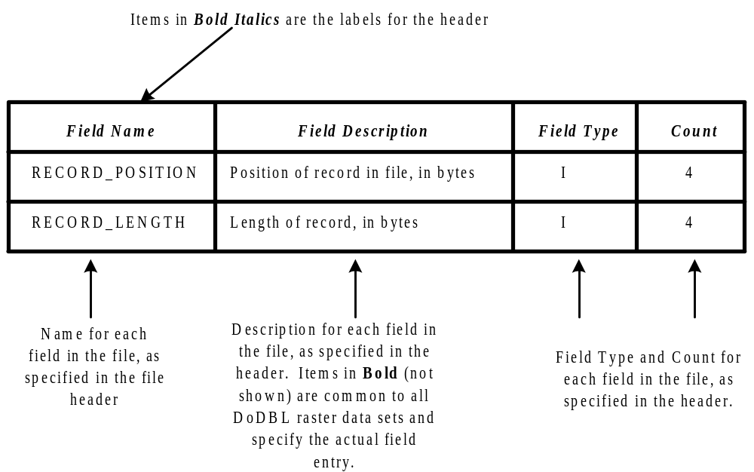
Figure 3-3 GSF definition conventions

DATA STRUCTURE
Data stored in Generic Sensor form are contained in several files, each with a specific use. A complete GSF data set contains all these files, related as shown in Figure 4-1. These files are:
- Transmittal files that describe what data are being transmitted in a given transaction and how they may be handled,
- Metadata Files that describe the contents and nature of a given collection of data, and
- Files containing the data themselves.

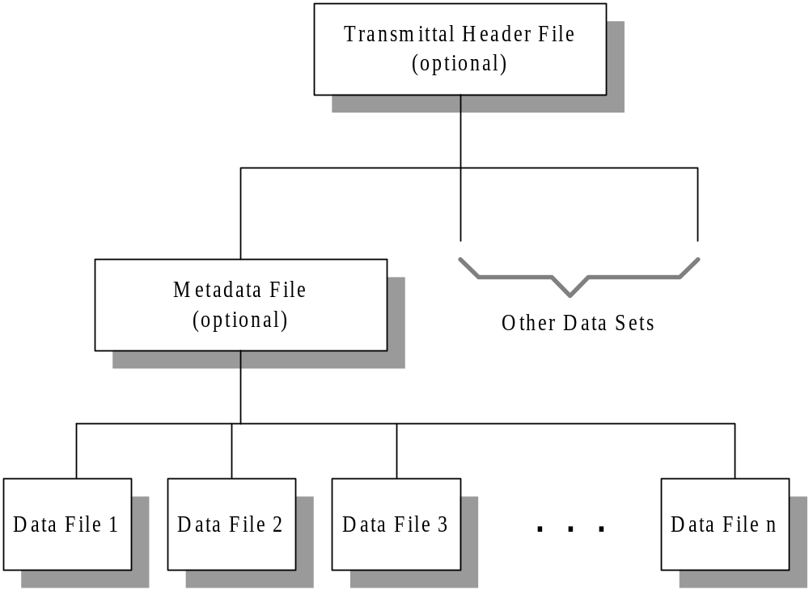
Figure 4-1 Data Set Organization
Transmittal files are developed to describe a particular transaction. Transmittal files are not a permanent record that describes the data, but record the transfer of data, document the prescribed handling, the format of the media and the specifications that describe the data's form.

Metadata files describe the data themselves, including their temporal and areal extent, and the overall condition of a GSF data set.

GSF data files are organized by time; data collected over a given time period shall be stored in a single file. All the data collected from a given sensor over a period of time is recorded in a single file. The amount of data recorded in a given sequential file may be fixed (e.g., data may be segregated by date of collection) or may be based on operational requirements such as survey layout. A GSF data set may be composed of one or more GSF data files. Data sets will generally be segregated based on operational or logistical factors such as survey area or cruise duration. A single metadata file describes the contents of the entire data set.

Transmittal Header File
This file, common to all DoDBL exchange sets, provides information on the type of data to be exchanged, the number of data sets in the exchange, the highest security classification, and the standards and specifications used for this transmittal. It can be printed and provided in hardcopy when the transmittal is by physical (not network) exchange. If the transmittal spans more than one volume, then each volume shall have a Transmittal Header File. The use of the Transmittal Header File is mandatory for exchanges within the DoDBL but is optional for data exchanged outside of the DoDBL. Table 4-1 specifies the contents of the Transmittal Header File.
Table 4-1 Transmittal Header File
Field Name | Field Description | Field Type | Count
VERSION | Version Number (reserved) | T | 10
DATA_NAME | DoDBL Sensor | T | 12
DATA_DESCRIPTION | General description of data | T | 100
MEDIA_STD | Media standard used on this volume. E.g., ISO 9660 | T | 20
ORIGINATOR | Sender, e.g., DMAHTC | T | 50
ADDRESSEE | Receiver with address | T | 120
MEDIA_VOLUMES | Number of volumes in this transmittal | T | 2
SEQ_NUMBER | Sequential order of this volume | T | 2
NUM_DATA_SETS | Number of data sets in this transmittal | T | 2
SECURITY_CLASS | Highest classification on this volume (See HRD) | T | 1
DOWNGRADING | Originating Activity Determination Required (OADR)? YES or NO | T | 3
DOWNGRADE_DATE | Date of downgrading, blank if OADR | D | 1
RELEASABILITY | Releasability restrictions | T | 20
OTHER_STD_NAME | Generic Sensor Format | T | 50
OTHER_STD_DATE | Publication date of GSF | D | 1
OTHER_STD_VER | Version of GSF | T | 10
TRANSMITTAL_ID | Unique ID for this transmittal | T | 12
EDITION_NUMBER | Edition number for this database | T | 10
EDITION_DATE | Date of creation for this database | D | 1

Metadata File
This file, also contained within all DoDBL exchange sets, provides information on the computed quality, the parameters used to compute quality, the areal extent, and the security classification of each individual data set. There is one Metadata File for each data set in the transmittal. It is permissible to forward a hardcopy listing of the information contained in the Metadata File as long as the information is complete and accurate. The use of the Metadata File is mandatory for exchanges within the DoDBL; it is optional for exchanges that do not occur within the DoDBL mechanism. Its use is strongly encouraged; however, to assure uniform maintenance of important descriptive data. The HYSAS Requirements Document (HRD) specifies the contents of the Metadata File.

GSF Data File
GSF data files are composed of a series of records arranged sequentially in time. A header record is the first record in the file; otherwise, there is no prescribed ordering. Note, however, that specific processing implementations may require the presence of other records in order to function, especially summary and processing parameter records.

GSF Record Structure
The first word of each record contains one 32-bit unsigned integer that defines the size of the data portion of the record. The second word is an identifier field consisting of a checksum flag, a reserved field and a record identification field. Figure 4-2 illustrates this structure.

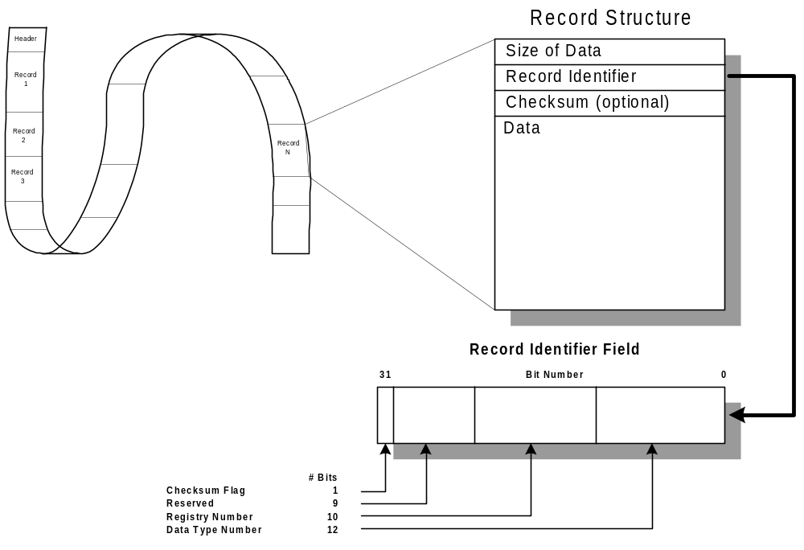
Figure 4-2 GSF Data File Structure

Checksum flag
The checksum flag is the first bit in the word; when set to one, a checksum immediately follows the record identifier.

Record identification field
The record identifier contains a number that can be related uniquely to the structure defining the data field. It is divided into registry and data type subfields to allow a distributed method of assigning these fields.

Registry
The registry portion of the record identifier is a ten-bit unsigned integer identifying the registrar responsible for assigning data type subfield numbers. It allows more than one group to be responsible for the assignment process by assigning registry numbers to each group. Those records, defined in Appendix A.1 of this document, have a registry number of zero. Other registry numbers are assigned to individual agencies, institutions or corporations, allowing them to define "private" data type identifiers that will not conflict with the standard ones. The group's registry number is a prefix for these private data records. Other groups need not know what types of data are contained within a private data record; they may simply ignore the record and skip to the next one. If some privately defined data types become commonly used, then reassigning them a new number with a registry number of zero and defining the data type within the standard incorporates them into the standard.

Data type
The data type portion of the record identifier field is a 12-bit unsigned integer that defines a specific data structure. The registrar identified in the registry portion is responsible for assigning data type numbers.

Checksum
If the checksum flag has been set, a record checksum is contained in the 32-bit word that follows the identifier field, otherwise this word is absent. If present, this word contains an integer number that is the sum of all the bytes between the checksum and the end of the record in modulo–32 form. Specifying the checksum allows GSF data to be reliably transmitted across a noisy communication path. Normally, checksums would not be used for data stored on disk.

Data record
A data structure that has been related to the data identifier by the appropriate registrar identifies the data record. The only restriction on a data record is that it must be an integral multiple of four bytes long; therefore, between zero and three empty bytes may be appended to the end of a data record.

GSF Record Types
As should be clear from the previous section, there are no restrictions on the type of data that can be encapsulated into Generic Sensor Format. At present, however, only bathymetry data are stored in this format. The format supports both single-beam and multibeam bathymetry data. The records currently defined include:
- a header record,
- a swath bathymetry ping record to contain multibeam bathymetry data,
- a single-beam sounding record to contain single-beam data,
- a summary record to record the temporal and spatial extremes of the data
- a sound velocity profile record,
- a navigation error record to allow the positional error estimate associated with a given data point to be described,
- an attitude record to record full time series attitude data
- a processing parameter record to define the state of the data recorded in the file,
- a sensor parameter record to record the state of the sensor when the data were produced,
- a comment record for annotating the data, and
- history records that provide an audit trail of processing that has been applied to the data.

Not all record types must be present to describe the data; for instance, a file may only consist of ping records if only those data are available or desirable. All records contain a time field consisting of precise time and will normally, but not necessarily, be in chronological order. The format of each GSF data record is defined in the following sections.

Header Record
The header record contains a single text field recording the version number of the GSF data file format as described in Table 4-2.
Table 4-2 Header Record Definition
Field Name | Description | Field Type | Count
VERSION | Version of GSF | T | 12
Header Record Size: |  |  | 12

Swath Bathymetry Ping Record
A ping record consists of a mandatory ping header and one or more optional subrecords. Figure 4-3 shows the swath bathymetric ping record in schematic form. The normal configuration for a ping record consists of a ping header, a pair of array subrecords containing depth and acrosstrack values and other optional subrecords that may not appear in every ping. Table 4-3 defines the record’s data elements including the ping header and all subrecords. Appendix A.2 defines swath bathymetric ping record identifiers.

In some cases, a subrecord may contain a set of values that applies to a series of pings. This subrecord is placed in the first record to which it applies. These values will then be considered to apply until a new instance of the subrecord appears. Subrecords which may be used in this manner include scale factor subrecords and the error array subrecords containing estimates of measurement errors, including the HORIZONTAL_ERROR_ARRAY, and VERTICAL_ERROR_ARRAY.

Ping header
A ping header consists of time, vessel's position, attitude, heading, course and speed, all of which are stored in standard form. The header also contains the number of beams in the ping's array records (defined as N for array subrecord definitions), the index, or column, number of the beam located nearest the vessel's keel, a ping flag, and both tide and depth offsets for the ping. Any tide and depth offsets present have already been added to the depth values in the ping's array records.

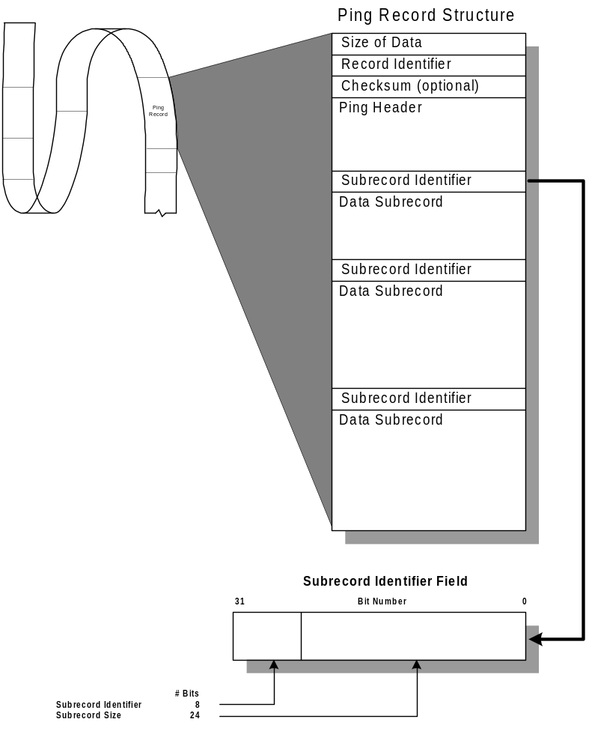
Figure 4-3 Ping record schematic
Two sets of flags are available in the ping record to provide for data to be flagged to indicate whether it is usable or not. Each ping header has a ping flag that is a 16-bit word that defines the usability of the ping's data. If the low-order bit (bit 0) of the ping flag is clear, the ping can be used for processing or display. If this bit is set, the ping data can not be used. The remaining fifteen bits are not defined within this specification; they allow users to define implementation-specific reasons for flagging the ping. Each ping may also contain a "BEAM_FLAGS_ARRAY” that indicates whether individual beams are usable. Section 4.3.4.15 further describes beam flags.

Scale-factor subrecord
Scale factors change the range and resolution of the values in array subrecords. This allows all ocean depths to be expressed in meters with sufficient resolution within a 2-byte signed integer and acoustical measurements to be expressed in decibels within a 1-byte unsigned integer.
Table 4-3 Swath Bathymetry Ping Record Definition
Field Name | Description | Field Type | Count
Ping Header Subrecord |  |  | 42
TIME | Time of ping transmission | I | 2*4
LONGITUDE | Longitude of ship in ten-millionths of degrees | I | 4
LATITUDE | Latitude of ship in ten-millionths of degrees | I | 4
NUM_BEAMS | Number of beams in ping (N) | I | 2
CENTER_BEAM | Location of center beam. The first beam is the outermost port beam. | I | 2
PING_FLAGS | Flags that indicate the usability of the ping data. See section 4.3.4.1 |  | 2
RESERVED |  |  | 2
TIDE_CORRECTOR | Tidal offset in centimeters. This value has been added to all depth values in the ping whether they are flagged as usable or not. | I | 2
DEPTH_CORRECTOR | Dynamic draft (or vessel depth for submersible vessels) in centimeters. This value has been added to all depth values in the ping. | I | 4
HEADING | Ship's heading in hundredths of degrees including any offsets that have been applied to the data as documented in the processing parameter record | U | 2
PITCH | Ship's pitch in hundredths of degrees including any offsets that have been applied to the data as documented in the processing parameter record | I | 2
ROLL | Ship's roll in hundredths of degrees including any offsets that have been applied to the data as documented in the processing parameter record | I | 2
HEAVE | Ship's heave in centimeters | I | 2
COURSE | Ship's direction of motion through water in hundredths of degrees | U | 2
SPEED | Ship's speed in hundredths of knots | U | 2
Scale Factor Subrecord |  |  | 4+12M
NUM_FACTORS | Number of scale factors (M) | I | 4
SCALE_FACTOR_ARRAY | ID, compression flag, scale factor and offset values for each array subrecord in the ping, see section 4.3.4.2 |  | 12*M
Beam Array Subrecords.
Some of the following arrays are used to record data from each beam.
DEPTH_ARRAY | Depth (z) values for each beam in meters, corrected for measured sound velocity. Scale factors applied before storage. | U | 2*N
NOMINAL_DEPTH_ARRAY | Depth (z) values for each beam in meters, using an average sound speed of 1500 m/s. Scale factors applied before storage. | U | 2*N
ACROSS_TRACK_ARRAY | Acrosstrack (y) values in meters. Scale factors applied before storage. | I | 2*N
ALONG_TRACK_ARRAY | Alongtrack (x) values in meters. Scale factors applied before storage. | I | 2*N
TRAVEL_TIME_ARRAY | Travel time in seconds. Scale factors applied before storage. | U | 2*N
BEAM_ANGLE_ARRAY | Incoming beam angle at transducer face in degrees. Scale factors applied before storage. | I | 2*N
MEAN_CAL_AMPLITUDE_ARRAY | Mean amplitude in decibels (referenced to 1 micropascal at 1 meter). Scale factors applied before storage. | I | 1*N
MEAN_REL_AMPLITUDE_ARRAY | Mean amplitude in decibels relative to an arbitrary intensity. Scale factors applied before storage. | U | 1*N
ECHO_WIDTH _ARRAY | Measured width of bottom echo in seconds. Scale factors applied before storage. | U | 1*N
QUALITY_FACTOR_ARRAY | Measures of beam quality in arbitrary units. Meaning of each field is dependent on the sensor in use. | U | 1*N
RECEIVE_HEAVE_ARRAY | Ship's heave at receive time in meters. Scale factors applied before storage. | I | 1*N
DEPTH_ERROR_ARRAY | Estimated depth measurement error in meters. Scale factors applied before storage.  (OBSOLETE: replaced with horizontal_error_array and vertical_error_array. New applications should use horizontal_error_array and vertical_error_array ) | U | 2*N
ACROSS_TRACK_ERROR_ARRAY | Estimated across track measurement error in meters. Scale factors applied before storage.  (OBSOLETE: replaced with horizontal_error_array and vertical_error_array. New applications should use horizontal_error_array and vertical_error_array ) | U | 2*N
ALONG_TRACK_ERROR_ARRAY | Estimated along track measurement error in meters. Scale factors applied before storage.  (OBSOLETE: replaced with horizontal_error_array and vertical_error_array. New applications should use horizontal_error_array and vertical_error_array ) | U | 2*N
BEAM_FLAGS_ARRAY | Flags that indicate whether individual beam data are usable. See section 4.3.4.15 |  | 1*N
PACKED_2BIT_ARRAY | Array of bit flags, each two bits wide. Meaning of bit flags is dependent on the sensor in use. |  | N/4
SIGNAL_TO_NOISE_ARRAY | Signal to noise ratio of each beam. | I | 1*N
BEAM_ANGLE_FORWARD_ARRAY | Beam angle in the fore-aft direction in degrees. Scale factors applied before storage. | I | 2*N
VERTICAL_ERROR_ARRAY | Array of estimated vertical error (meters, at 95% confidence) | U | 2*N
HORIZONTAL_ERROR_ARRAY | Array of estimated horizontal error (meters, at 95% confidence) | U | 2*N
Sensor Specific Subrecord. See Appendix B.1 for definitions.
BRB_INTENSITY, Structure containing bathymetric receive beam time series intensities, and associated per-ping information.
BITS_PER_SAMPLE | Number of bits per intensity sample. | I | 1
APPLIED_CORRECTIONS | Flags to describe corrections applied to intensity values. | I | 4
SPARE | Reserved for future use. | I | 16
SENSOR_IMAGERY | Sensor specific imagery information. See Appendix B.3 for definitions.
TIME_SERIES_INTENSITY, Array of structures containing the per-beam time series intensity information. |  |  | Size*N
SAMPLE_COUNT | Number (Ns) of intensity samples for this beam. | I | 2
DETECT_SAMPLE | Index of bottom detection sample for this beam. | I | 2
SPARE | Reserved for future use. | I | 8
SAMPLES_ARRAY | Array of Ns intensity samples, in dB. | I | 4*Ns
Swath Bathymetry Ping Record Size: |  |  | variable

Figure 4-4 describes scale factor subrecords schematically. After the subrecord identifier is a count that defines the number of scale factors listed within the subrecord. Following the count are arrays of scale factors, one for each array subrecord used within the GSF data file and an array of scale factors for each beam array. Each scale factor array consists of subrecord ID of the array subrecord being scaled, a compression flag describing the type of compression applied to the array subrecord and two scale factors, a multiplier and an offset. In order to transform the values in the array subrecord into the engineering units defined Table 4-3, each element in the array must be divided by the multiplier and the offset subtracted from the result.
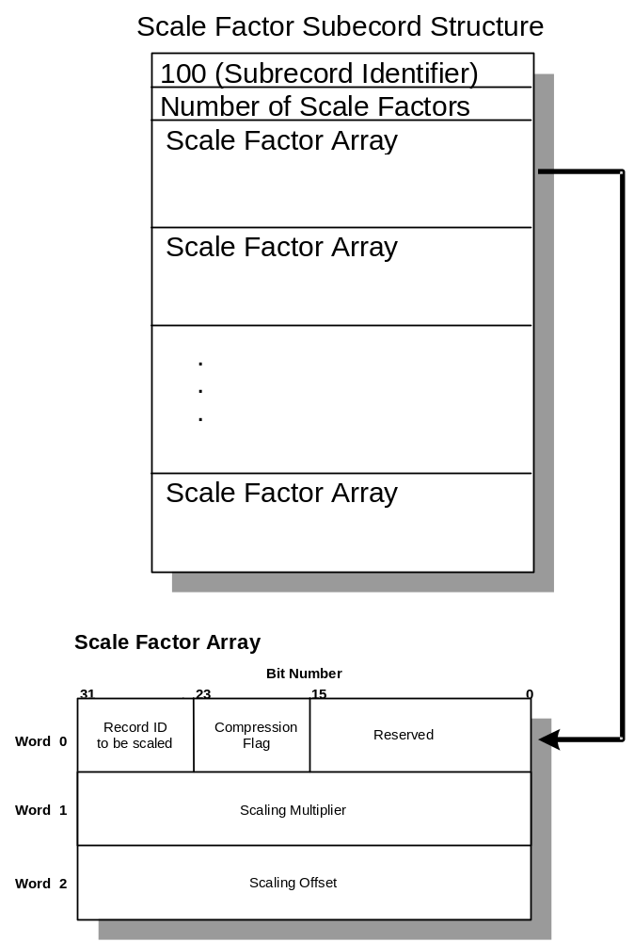
Figure 4-4 Ping Scale Factor Subrecord Schematic

Array subrecords
The major portion of a ping record consists of several array subrecords, each containing one kind of measurement derived for each beam. These arrays contain the data that are associated with each beam of the ping being described; examples of these data include the geometric location of the bathymetric point, parameters that describe the acoustic nature of the return or parameters that describe the statistical nature of the depth measurement. Table 4-3 defines valid array subrecords; subsequent sections describe these array subrecords in more detail. Some array subrecords are composed of either 8-bit or 16-bit integers that may represent either signed or unsigned quantities depending upon the kind of data they contain. For each array subrecord, the first beam is the outermost port beam.

Depth Array Subrecord
This field contains an array of depth values, one for each beam in the ping. Each depth value is encoded as a 2-byte integer. The processing parameter record describes the calculation of the depths in the depth array. The units are meters before being scaled as defined in the scaling factor subrecord.

Nominal Depth Array Subrecord
This field contains an array of nominal depth values, one for each beam in the ping. Nominal depths are scaled from the sonar’s travel times using an average sound speed of 1500 m/s instead of using a measured sound velocity. This field is provided for sonars that are capable of producing two depth values, one calculated using a measured sound velocity profile and another calculated using a fixed sound speed of 1500 m/s. Note that if only one depth value is available it is written into the depth array no matter how the depths have been calculated. Each nominal depth value is encoded as a 2-byte integer. The units are meters before being scaled as defined in the scaling factor subrecord.

Acrosstrack Array Subrecord
This field contains an array of acrosstrack distances, one for each beam in the ping. Each distance value is encoded as a 2-byte integer. The units are meters before being scaled as defined in the scaling factor subrecord.

Alongtrack Array Subrecord
This field contains an array of alongtrack distances for each beam in the ping. Each distance is encoded as a 2-byte integer. The units are meters before being scaled as defined in the scaling factor subrecord.

Travel-time Array Subrecord
This field contains an array of travel times for each beam in the ping. Each time is encoded as a 2-byte integer. The units are seconds before being scaled as defined in the scaling factor subrecord.

Beam-angle Array Subrecord
This field contains an array of beam angles for each beam in the ping. Each angle is encoded as a 2-byte integer. The units are degrees before being scaled as defined in the scaling factor subrecord. Each beam angle represents the rotation from vertical of the beam, so that beams pointed straight down have a “vertical” angle of zero. The range of vertical angle values is 0-180 degrees (downward looking sonars have a practical range of 0-90 degrees, with 90 degrees being horizontal).

Mean Calibrated Amplitude Array Subrecord
This field contains an array of average calibrated amplitude values for each beam. Each amplitude value is encoded as a 1-byte integer. The units are in decibels (re 1 micropascal at 1 meter) before being scaled as defined in the scaling factor subrecord.

Mean Relative Amplitude Array Subrecord
This field contains an array of average relative (uncalibrated) amplitude values for each beam in the ping. Each amplitude value is encoded as a 1-byte integer. The units are in decibels (re 1 micropascal at 1 meter) before being scaled as defined in the scaling factor subrecord.

Echo Width Array Subrecord
This field contains an array of width of the bottom echoes for each beam. Each time is encoded as a 1-byte integer. The units are seconds before being scaled as defined in the scaling factor subrecord.

Quality factor Array Subrecord
This field contains measures of beam quality in arbitrary sensor-dependent units, one for each beam in the ping.

In the case of Reson sonars, the quality factor for each beam will be a value from 0 to 15, which represents the 4-bit quality value from the Reson R-Theta message. (Note: Some implementations of GSF include Reson brightness and co-linearity flags in the packed 2-bit array subrecord referenced below. That subrecord should no longer be used, and this quality factor array should be used in its place.)

For Simrad EM series sonars, the quality factor for each beam will be a value from 0 to 254, which represents the 8-bit quality factor contained in the Simrad Depth datagram.

For the ELAC 1180 MKII, the quality factor will be a value from 1 to 8, where 1 is best quality and 8 is worst quality,

The quality factor for Seabeam 2112 sonars is will be a value from 0 to 3, where the lowest order bit will be set if the beam was flagged by the sonar as poor quality. The second lowest order bit is set if the data source is Weighted Mean Time (WMT). The data source is Bearing Direction Indicator (BDI) if the second bit is not set.

Receive Heave Array Subrecord
This field contains the platform's heave at receive time for each beam. Each heave is encoded as a 1-byte integer. The units are meters before being scaled as defined in the scaling factor subrecord.

Beam Flags Array Subrecord
This field contains flags that indicate the usability of the data in each beam in the ping. Each beam is represented by a 1-byte (8-bit) set of flags that indicate whether individual beams within a ping are usable or not. If the low-order bit (bit 0) of a given beam flag is clear the corresponding beam data are usable; if the bit is set that beam's data are not to be used for processing or display. The meaning of the remaining seven bits are not defined within this specification.

Packed 2-bit Array Subrecord
This field contains integers that consist of four 2-bit arrays. Each 2-bit array indicates information about the data in each beam in the ping. The meaning of the bit flags is dependent on the sensor in use.

Signal to Noise Array Subrecord
This field contains the signal to noise ratio (SNR) for each beam. SNR is encoded as a 1-byte integer. The values have no units and are scaled as defined in the scaling factor subrecord.

Beam Angle Forward Array Subrecord
This field contains an array of beam angles for each beam in the ping. Each angle is encoded as a 2-byte integer. The units are degrees before being scaled as defined in the scaling factor subrecord. The beam angle forward is the azimuth of the beam measured counterclockwise from directly to starboard. The range of the azimuthal angle is 0 - 360 degrees.

Vertical Error Array Subrecord
This field contains an array of vertical distances for each beam in a ping. Each distance is encoded as a 2-byte integer. The units are meters before being scaled as defined in the scaling factor subrecord. This subrecord is provided with the intent that when used in conjunction with the Horizontal Error Subrecord will functionally replace the currently defined error subrecords (DEPTH_ERROR_ARRAY, ACROSS_TRACK_ERROR_ARRAY, ALONG_TRACK_ERROR_ARRAY).

Horizontal Error Array Subrecord
This field contains an array of horizontal distances for each beam in a ping. Each distance is encoded as a 2-byte integer. The units are meters before being scaled as defined in the scaling factor subrecord. This subrecord is provided with the intent that when used in conjunction with the Vertical Error Subrecord will functionally replace the currently defined error subrecords (DEPTH_ERROR_ARRAY, ACROSS_TRACK_ERROR_ARRAY, ALONG_TRACK_ERROR_ARRAY).

Sensor-specific Subrecords
These subrecords are designed to contain data that are not beam-oriented and that vary from ping to ping, but do not fit into the ping header. An example of this type of data might be the power amplifier gain settings for a particular ping. These data are, by nature, specific to a particular sonar system or manufacturer and are defined to ensure that all the data available in a particular ping record can be recorded. Because of the specificity of these data, these subrecords are usually located at the end of the ping record and may be ignored by the majority of processing and display software. Appendix B.1 defines the sensor-specific subrecords. It is important to note the presence of the sensor specific subrecord may identify the sensor that produced the data. Therefore, it may be desirable to define two different subrecords with identical data elements because the different sensor-specific subrecord identifiers identify the sensor.

Bathymetric Receive Beam Time Series Intensity Subrecord
This subrecord is designed to contain imagery data for each of the bathymetric receive beams. This record contains the number of bits per sample encoded as a 1-byte integer and a bitmasked set of flags describing the corrections that have been applied to the intensity values, encoded as a 4-byte integer. This record also contains 16 spare header bytes per ping and sensor specific data that is per-ping and relative to imagery. This record also contains an array of Intensity Time Series structures containing information for each beam in a ping. Each element in this array is a set of values that define the per-beam time series intensity information. These values are: the number of samples for the beam encoded as a 2-byte integer, the index of the sample that represents the bottom detection point for the beam encoded as a 2-byte integer, 8 spare bytes, and an array of samples for the beam encoded as a 1-byte integer. The samples in the array represent logarithmic intensity referenced to unity, in half dB steps, and are ordered increasing in range.

Single-beam Sounding Record
(This record should no longer be used, as of GSF v2.03. While this record is still supported, single-beam data should now be stored in the Swath Bathymetry Ping Record, with number of beams set to one.)

Table 4-4 defines the single beam sounding record. The basis for the single beam sounding record is the swath bathymetry ping record, but the single beam sounding record is much simpler.
Table 4-4 Single-beam Sounding Record Definition
Field Name | Description | Field Type | Count
TIME | Time of sounding | I | 2*4
LONGITUDE | Longitude of ship in ten-millionths of degrees | I | 4
LATITUDE | Latitude of ship in ten-millionths of degrees | I | 4
TIDE_CORRECTOR | Tidal offset in centimeters. | I | 2
DEPTH_CORRECTOR | Dynamic draft (or vessel depth for submersible vessels) in centimeters. | I | 4
HEADING | Ship's heading in .01 degrees including any offsets that have been applied to the data as documented in the processing parameter record | U | 2
PITCH | Ship's pitch in .01 degrees including any offsets that have been applied to the data as documented in the processing parameter record | I | 2
ROLL | Ship's roll in .01 degrees including any offsets that have been applied to the data as documented in the processing parameter record | I | 2
HEAVE | Ship's heave in centimeters | I | 2
DEPTH | Sounding depth in centimeters | I | 4
SOUND_SPEED_ CORRECTION | Sound speed correction in meters | I | 2
POSITIONING_ SYSTEM_TYPE | ID for type of positioning system. |  | 2
Sensor Specific Subrecord. See Appendix B.2 for definitions
Single-beam Sounding Record Size |  |  | 34 + sensor specific

Summary Record
The summary record contains a temporal and spatial synopsis of the data stored in the file. These records allow application programs to rapidly determine whether the data in the file are of interest. Table 4-5 defines the format of a summary record.
Table 4-5 Summary Record Definition
Field Name | Description | Field Type | Count
BEGIN_TIME | Time of earliest record in file | I | 2*4
END_TIME | Time of latest record in file | I | 2*4
MIN_LATITUDE | Southernmost extent of data records | I | 4
MIN_LONGITUDE | Westernmost extent of data records | I | 4
MAX_LATITUDE | Northernmost extent of data records | I | 4
MAX_LONGITUDE | Easternmost extent of data records | I | 4
MIN_DEPTH | Least depth in data records | I | 4
MAX_DEPTH | Greatest depth in data records | I | 4
Summary Record Size |  |  | 40

Sound Velocity Profile Record
The sound velocity profile record contains values of sound velocity used in estimating individual sounding locations. It consists of; the time the profile was observed, the time it was introduced into the sounding location procedure, the position of the observation, the number of points in the profile, and the individual points, expressed as depth and sound velocity pairs. Table 4-6 defines the format of a sound velocity profile record.
Table 4-6 Sound Velocity Profile Record Definition
Field Name | Description | Field Type | Count
OBS_TIME | Time SVP was observed. | I | 2*4
APP_TIME | Time SVP was applied to sonar data. | I | 2*4
LONGITUDE | Longitude of SVP observation in ten-millionths of degrees. | I | 4
LATITUDE | Latitude of SVP observation in ten-millionths of degrees. | I | 4
NUM_POINTS | Number of points in SVP observation (S). | I | 4
SVP_ARRAY | Depth and sound velocity pair for each observation point, in centimeters and hundredths of meters/second, respectively. | I | 4*2*S
SVP Record Size |  |  | 28+8*S

Processing Parameter record
Processing parameter records contain important scalar or vector values that describe overall survey conditions or operational values. Typical parameters include items such as the navigation sensor's antenna location or the reference ellipsoid for the geographic position. Table 4-7 defines the format of a processing parameter record. Each processing parameter record contains a time, a count of the parameters defined within the record, and a text string for each parameter definition. The string's length begins each parameter text string.
Table 4-7 Processing Parameter Record Definition
Field Name | Description | Field Type | Count
TIME | Time of processing parameter validity. | I | 2*4
NUM_PARAMS | Number of processing parameters in record (P). | I | 2
PARAM_SIZE(1) | Size of first processing parameter (P1). | I | 2
PARAM_TEXT(1) | Text containing first processing parameter, see section 4.3.8. | T | P1
. . . | . . .
. . . | . . .
PARAM_SIZE(P) | Size of first processing parameter (PN). | I | 2
PARAM_TEXT(P) | Text containing Pth processing parameter, see section 4.3.8. | T | PN
Processing Parameter Record Size: |  |  | Variable

The parameter text string consists of a parameter keyword followed by an equals sign ("=”) and then the value of the parameter, e.g., “KEYWORD=VALUE”. Corrections or offsets that refer to the ship are in absolute ship-based coordinates as defined in section 3.4. These values are in meters relative to the origin of the coordinate system. Each such correction has both "APPLIED” and "TO_APPLY” values. This allows for the storage of corrections that are known when the data are recorded but have not been applied to the data. Table 4-8 defines the necessary processing parameter records. The first column defines acceptable keywords, the second defines a description of the values.
Table 4-8 Defined Processing Parameter Text Strings
Keyword | Description
"REFERENCE TIME" | String description of the beginning of the time epoch. Two choices for the beginning time are allowed. For recently collected data, the beginning of the epoch is often defined to be 1 January 1970 because many computers use this convention. An alternative beginning, especially for data collected prior to this date, is midnight of the beginning date of the survey. In any case, the format for the reference time consists of the full four-digit year, the ordinal day of year and the time expressed as hour, minute and second.  Format: CCYY/DDD HH:MM:SS  Example: "1970/001 00:00:00”
"ROLL_COMPENSATED" | Indicates whether the sounding data have been roll compensated.  Format: "YES” or "NO”
"PITCH_COMPENSATED" | Indicates whether the sounding data have been pitch compensated.  Format: "YES” or "NO”
"HEAVE_COMPENSATED" | Indicates whether the sounding data have been heave compensated.  Format: "YES” or "NO”
"TIDE_COMPENSATED" | Indicates whether the sounding data have been tide compensated.  Format: "YES”, "NO”, "PREDICTED” or "OBSERVED”
"DEPTH_CALCULATION" | Indicates whether the sounding data have been computed by integrating travel time through the water column; this is a "corrected” computation of depth. An alternative method for computing depth is to assume a constant sound speed, usually of 1500 meters/second. Note that this does not refer to the data contained in the NOMINAL_DEPTH_ARRAY subrecord of the ping record.  Format: "CORRECTED” or "RELATIVE_TO_1500_MS”
"RAY_TRACING" | Indicates whether the angle/travel-time pairs have been corrected for ray tracing.  Format: "YES” or "NO”
"DRAFT_TO_APPLY" | Value of a draft offset that is known, but has not yet been applied. More than one offset may be described to allow for sensors with more than one transducer. If more than one value is provided, the first value applies to the port transducer and the second applies to the starboard transducer.  Format: +DD.DD or +DD.DD,+DD.DD  Example: "+02.84,+02.73”" "
“PITCH_TO_APPLY” | Value of a pitch offset that is known, but has not yet been applied. More than one offset may be described to allow for sensors with more than one transducer. If more than one value is provided, the first value applies to the port transducer and the second applies to the starboard transducer.  Format: +DD.DD or +DD.DD,+DD.DD  Example: "+00.68,-01.03”
"ROLL_TO_APPLY" | Value of a roll offset that is known, but has not yet been applied. More than one offset may be described to allow for sensors with more than one transducer. If more than one value is provided, the first value applies to the port transducer and the second applies to the starboard transducer.  Format: +DD.DD or +DD.DD,+DD.DD  Example: "-00.13”
"GYRO_TO_APPLY" | Value of a heading offset that is known, but has not yet been applied. More than one offset may be described to allow for sensors with more than one transducer. If more than one value is provided, the first value applies to the port transducer and the second applies to the starboard transducer.  Format: +DD.DD or +DD.DD,+DD.DD  Example: "-00.50”
"POSITION_OFFSET_TO_APPLY" | Location of the ship's position reference (e.g., the navigation antenna) that is known but has not yet been applied.  Format: +XX.XX,+YY.YY,+ZZ.ZZ  Example: "+05.30,-01.20,+03.62”
"TRANSDUCER_OFFSET_TO_APPLY" | Location of the ship's sensor transducer that is known but have not yet been applied. More than one location may be described to allow for sensors with more than one transducer. If six values are provided, the first three apply to the port transducer and the last three apply to the starboard transducer.  Format: +XX.XX,+YY.YY,+ZZ.ZZ or +XX.XX,+YY.YY,+ZZ.ZZ,+XX.XX,+YY.YY,+ZZ.ZZ  Example: "+05.30,-01.20,+03.62,+05.28,+01.76,+03.68”
“MRU_PITCH_TO_APPLY” | Value of a pitch offset for the motion sensor that is known, but has not yet been applied.  Format: +XX.XX  Example: “+00.13”
“MRU_ROLL_TO_APPLY” | Value of a roll offset for the motion sensor that is known, but has not yet been applied.  Format: +XX.XX  Example: “+00.13”
“MRU_HEADING_TO_APPLY” | Value of a heading offset for the motion sensor that is known, but has not yet been applied.  Format: +XX.XX  Example: “-01.48”
“MRU_OFFSET_TO_APPLY” | Location of the ship's motion sensor that is known but has not yet been applied.  Format: +XX.XX,+YY.YY,+ZZ.ZZ  Example: "+02.15,-01.88,+02.91”
“CENTER_OF_ROTATION_OFFSET_TO_APPLY” | Location of the ship's center of rotation that is known but has not yet been applied.  Format: +XX.XX,+YY.YY,+ZZ.ZZ  Example: "+02.15,-01.88,+02.91”
"APPLIED_DRAFT" | Value of the draft offset that has been applied to the sounding data. More than one offset may be described to allow for sensors with more than one transducer. If the correction is not known, then the applied draft correction is identified as "UNKNWN”. If more than one value is provided, the first value applies to the port transducer and the second applies to the starboard transducer.  Format: +DD.DD or +DD.DD,+DD.DD  Example: "+02.84,+02.73” or "UNKNWN,UNKNWN”
"APPLIED_PITCH_BIAS" | Value of the pitch offset that has been applied to the sounding data. More than one offset may be described to allow for sensors with more than one transducer. If the correction is not known, then the applied pitch correction is identified as "UNKNWN”. If more than one value is provided, the first value applies to the port transducer and the second applies to the starboard transducer.  Format: +DD.DD or +DD.DD,+DD.DD  Example: "-01.34,+00.31” or "UNKNWN”
"APPLIED_ROLL_BIAS" | Value of the roll offset that has been applied to the sounding data. More than one offset may be described to allow for sensors with more than one transducer. If the correction is not known, then the applied roll correction is identified as "UNKNWN”. If more than one value is provided, the first value applies to the port transducer and the second applies to the starboard transducer.  Format: +DD.DD or +DD.DD,+DD.DD  Example: "-01.06,” or "UNKNWN,UNKNWN
"APPLIED_GYRO_BIAS" | Value of the heading offset that has been applied to the sounding data. More than one offset may be described to allow for sensors with more than one transducer. If the correction is not known, then the applied heading correction is identified as "UNKNWN”. If more than one value is provided, the first value applies to the port transducer and the second applies to the starboard transducer.  Format: +DD.DD or +DD.DD,+DD.DD  Example: "+01.30,+01.00” or "UNKNWN,UNKNWN”
"APPLIED_POSITION_OFFSET" | Location of the ship's position reference (e.g., the navigation antenna) that has been applied to the sounding data. If the position offset is not known, then the applied offset is identified as "UNKNWN”.  Format: +XX.XX,+YY.YY,+ZZ.ZZ  Example: "+05.30,-01.20,+03.62” or "UNKNWN,UNKNWN,UNKNWN”
"APPLIED_TRANSDUCER_OFFSET" | Location of the ship's sensor transducer that has been applied to the data. More than one location may be described to allow for sensors with more than one transducer. If the transducer offset is not known, then the applied offset is identified as "UNKNWN”. If six values are provided, the first three apply to the port transducer and the last three apply to the starboard transducer.  Format: +XX.XX,+YY.YY,+ZZ.ZZ or  +XX.XX,+YY.YY,+ZZ.ZZ,+XX.XX,+YY.YY,+ZZ.ZZ  Example: "+05.30,-01.20,+03.62,+05.28,+01.76,+03.68” or "UNKNWN,UNKNWN,UNKNWN,UNKNWN,UNKNWN,UNKNWN”
“APPLIED_MRU_PITCH” | Value of a pitch offset for the motion sensor that has been applied to the data.  Format: +XX.XX  Example: “+00.13”
“APPLIED_MRU_ROLL” | Value of a roll offset for the motion sensor that has been applied to the data.  Format: +XX.XX  Example: “+00.13”
“APPLIED_MRU_HEADING” | Value of a heading offset for the motion sensor that has been applied to the data.  Format: +XX.XX  Example: “-01.48”
“APPLIED_MRU_OFFSET” | Location of the ship's motion sensor that has been applied to the data.  Format: +XX.XX,+YY.YY,+ZZ.ZZ  Example: "+02.15,-01.88,+02.91”
“APPLIED_CENTER_OF_ROTATION_OFFSET” | Location of the ship's center of rotation that has been applied to the data.  Format: +XX.XX,+YY.YY,+ZZ.ZZ  Example: "+02.15,-01.88,+02.91”
"GEOID" | Definition of the horizontal datum in text form. Text is for informational purposes only, but should be descriptive enough to uniquely identify the datum. If the horizontal datum is not known, the value is identified as "UNKNOWN”.  For example, "WGS-84”.
"TIDAL_DATUM" | Definition of the reference vertical datum in text form. If the tidal datum is not known, the value is identified as "UNKNOWN”.  For example, "MLW” or "ALAT”.

Sensor Parameter record
Sensor parameter records contain parameters that are transmitted by the sonar at times such as startup, shutdown or when the sensor's mode of operation changes. Typical parameters include the sensor's mode, sensor offset locations, and draft compensation values. Table 4-9 defines the format of a processing parameter record. Each sensor parameter record contains a time, a count of the parameters defined within the record, and a text string for each parameter definition. Each text string is prefixed by string length. The text string consists of a parameter keyword followed by an equals sign (“=”) and then the value of the parameter. Sensor parameter records are by nature sensor-specific, therefore there are no standard keywords defined for these parameters. Important values such as draft correctors or sensor locations are reproduced in the processing parameter record.
Table 4-9 Sensor Parameter Record Definition
Field Name | Description | Field Type | Count
TIME | Time of sensor parameter validity. | I | 2*4
NUM_PARAMS | Number of sensor parameters in record (Q). | I | 2
PARAM_SIZE(1) | Size of first sensor parameter (Q1). | I | 2
PARAM_TEXT(1) | Text containing first sensor parameter, see section 4.3.9. | T | Q1
. . . | . . .
. . . | . . .
PARAM_SIZE(Q) | Size of first sensor parameter (QN). | I | 2
PARAM_TEXT(Q) | Text containing Qth sensor parameter, see section 4.3.9. | T | QN
Sensor Parameter Record Size: |  |  | Variable

Comment record
The comment record maintains information that is not otherwise accommodated by the other records. It consists of a time, a text string and the length of the string. One use might be to include entry of watch personnel comments during a survey. Table 4-10 defines the format of a comment record.
Table 4-10 Comment Record Definition
Field Name | Description | Field Type | Count
TIME | Time of comment. | I | 2*4
TEXT_LENGTH | Number of characters in text (R). | I | 4
COMMENT_TEXT | Text containing comment. | T | R
Comment Record Size: |  |  | 12+R

History record
The history record is intended to support automatic documentation of processing which has been applied to the data. It includes: the time the processing step occurred; the name of the operator; the name of the computer doing the processing; the program being used, along with any command line arguments or pertinent parameters; and a comment field is available for a summary of the processing that occurred when the program was run. Table 4-11 defines the format of a history record.

Table 4-11 History Record Definition
Field Name | Description | Field Type | Count
TIME | Time of processing action. | I | 2*4
NAME_SIZE | Number of characters in computer's name (U). | I | 2
MACHINE_TEXT | Name of computer on which processing occurs. | T | U
OPERATOR_SIZE | Number of characters in operator's name (V). | I | 2
OPERATOR_TEXT | Name of operator performing the processing. | T | V
COMMAND_SIZE | Number of characters in command line (W). | I | 2
COMMAND_TEXT | Command line used to run processing action. | T | W
COMMENT_SIZE | Number of characters in comment (X). | I | 2
COMMENT_TEXT | Summary of processing action. | T | X
History Record Size: |  |  | 16+U+ V+W+X

Navigation error record * obsolete, as of GSF v1.07*
(This record is obsolete, as of GSF v1.07. The HV Navigation error record supercedes this record and should be used in its place.)

This record contains estimates of the horizontal position error inherent in the latitude and longitude values in a given data record, along with the first time that the error estimates are valid. The record ID containing the position whose error is being estimated is also included so that a file containing different types of records, each of which contain position, may attribute error estimates for each record. Table 4-12 defines the format of a navigation error record.
Table 4-12 Navigation Error Record Definition
Field Name | Description | Field Type | Count
TIME | Time of error estimate validity. | I | 2*4
RECORD_ID | Record ID to which the estimates applies | I | 4
LONGITUDE_ERROR | Estimated error in decimeters, 95% CE. | I | 4
LATITUDE_ERROR | Estimated error in decimeters, 95% CE. | I | 4
Navigation Error Record Size: |  |  | 20

HV Navigation error record
This record supercedes that specified by the Navigation Error Record. This record contains estimates of the horizontal and vertical position error inherent in a given data record, along with the time that the error estimates are valid. The record ID containing the position whose error is being estimated is also included so that a file containing different types of records, each of which contain position, may attribute error estimates for each record. A variable length field specifies the positioning system that provides the error estimates. Refer to the GSFlib documentation – Supporting Data Structures and Definitions -- for a list of the available four character positioning system codes. Additionally, a field of four characters has been reserved for future use. Table 4-13 defines the format of a HV Navigation error record.
Table 4-13 HV Navigation Error Record Definition
Field Name | Description | Field Type | Count
TIME | Time of error estimate validity. | I | 2*4
RECORD_ID | Record ID to which the estimates applies | I | 4
HORIZONTAL_ERROR | RMS Errors in meters | I | 4
VERTICAL_ERROR | RMS Errors in meters | I | 4
SPARE | Reserved space, for future used | T | 4
POSITION_TYPE | Character String Code specifying type of positioning system | T | v
Navigation Error Record Size: |  |  | 24 + v

Attitude record
This record contains an array of measurements as reported by the vessel attitude sensor. This allows for the storage of every attitude measurement reported by the motion sensor. The attitude record consists of an integer value defining the number of measurements in the record, followed by arrays of time, pitch, roll, heave, and heading for each measurements. The number of measurements is variable and user-definable, but any single attitude record should contain no more than sixty seconds worth of measurements. Table 4-14 defines the format of an Attitude record.
Table 4-14 Attitude Record Definition
Field Name | Description | Field Type | Count
NUM_MEASUREMENTS | Number of attitude measurements in this record. | I | 2
ATTITUDE_TIME | Array of attitude measurement times | I | N*2*4
PITCH | Array of pitch measurements | I | N*4
ROLL | Array of roll measurements | I | N*4
HEAVE | Array of heave measurements | T | N*4
HEADING | Array of heading measurements | T | N*4
Attitude Record Size: |  |  | Variable

Appendix A.1 Record Identifier Definition

The record identifiers specified in this section define data records encoded in GSF. Record identifiers are recorded as decimal quantities.

Note that GSF data files may have records that have identifiers not described below; you may ignore records with undefined identifiers. This condition can occur because records with non-zero registry numbers are not defined within the formal specification. See section 4.3.1.2 for more information.

As of GSF v1.07 the NAVIGATION_ERROR record is obsolete. This record will remain as part of the GSF specification and the software library for the next few releases of GSF, allowing users of this record ample time to make the necessary software updates to migrate to the new record. New software releases should use the HV_NAVIGATION_ERROR record instead of the NAVIGATION_ERROR record.

Record Description Record Identifier
HEADER 1
SWATH_BATHYMETRY_PING 2
SOUND_VELOCITY_PROFILE 3
PROCESSING_PARAMETERS 4
SENSOR_PARAMETERS 5
COMMENT 6
HISTORY 7
NAVIGATION_ERROR (obsolete) 8
SWATH_BATHY_SUMMARY 9
SINGLE_BEAM_SOUNDING 10
HV_NAVIGATION_ERROR 11
ATTITUDE 12

Appendix A.2 Swath Bathymetry Ping Subrecord Identifier Definition

The subrecord identifiers specified in this section define data elements within the Swath Bathymetry Ping Records. Subrecord identifiers are recorded as decimal quantities.

Subrecord Description Subrecord Identifier
DEPTH_ARRAY 1
ACROSS_TRACK_ARRAY 2
ALONG_TRACK_ARRAY 3
TRAVEL_TIME_ARRAY 4
BEAM_ANGLE_ARRAY 5
MEAN_CAL_AMPLITUDE_ARRAY 6
MEAN_REL_AMPLITUDE_ARRAY 7
ECHO_WIDTH_ARRAY 8
QUALITY_FACTOR_ARRAY 9
RECEIVE_HEAVE_ARRAY 10
DEPTH_ERROR_ARRAY (obsolete) 11
ACROSS_TRACK_ERROR_ARRAY (obsolete) 12
ALONG_TRACK_ERROR_ARRAY (obsolete) 13
NOMINAL_DEPTH_ARRAY 14
QUALITY_FLAGS_ARRAY 15
BEAM_FLAGS_ARRAY 16
SIGNAL_TO_NOISE_ARRAY 17
BEAM_ANGLE_FORWARD_ARRAY 18
VERTICAL_ERROR_ARRAY 19
HORIZONTAL_ERROR_ARRAY 20
SCALE_FACTORS 100
SEABEAM_SPECIFIC 102
EM12_SPECIFIC 103
EM100_SPECIFIC 104
EM950_SPECIFIC 105
EM121A_SPECIFIC 106
EM121_SPECIFIC 107
SASS_SPECIFIC (To Be Replaced By CMP_SASS) 108
SEAMAP_SPECIFIC 109
SEABAT_SPECIFIC 110
EM1000_SPECIFIC 111
TYPEIII_SEABEAM_SPECIFIC (To Be Replaced By CMP_SASS ) 112
SB_AMP_SPECIFIC 113
SEABAT_II_SPECIFIC 114
SEABAT_8101_SPECIFIC (obsolete) 115
SEABEAM_2112_SPECIFIC 116
ELAC_MKII_SPECIFIC 117
EM3000_SPECIFIC 118
EM1002_SPECIFIC 119
EM300_SPECIFIC 120
CMP_SASS_SPECIFIC (To replace SASS and TYPEIII_SEABEAM) 121
RESON_8101_SPECIFIC 122
RESON_8111_SPECIFIC 123
RESON_8124_SPECIFIC 124
RESON_8125_SPECIFIC 125
RESON_8150_SPECIFIC 126
RESON_8160_SPECIFIC 127
EM120_SPECIFIC 128
EM3002_SPECIFIC 129
EM3000D_SPECIFIC 130
EM3002D_SPECIFIC 131
SB_ECHOTRAC_SPECIFIC 206
SB_BATHY2000_SPECIFIC 207
SB_MGD77_SPECIFIC 208
SB_BDB_SPECIFIC 209
SB_NOSHDB_SPECIFIC 210
SB_PDD_SPECIFIC 211
SB_NAVISOUND_SPECIFIC 212
Appendix A.3 Single-beam Sounding Subrecord Identifier Definition

The subrecord identifiers specified in this section define data elements within the Swath Bathymetry Ping Records. Subrecord identifiers are recorded as decimal quantities.

Subrecord Description Subrecord Identifier
ECHOTRAC_SPECIFIC 201
BATHY2000_SPECIFIC 202
MGD77_SPECIFIC 203
BDB_SPECIFIC 204
NOSHDB_SPECIFIC 205
Appendix B.1 Swath Bathymetry Ping Sensor-specific Subrecord Definitions

The sensor-specific subrecords are defined for use within the Swath Bathymetry Ping Records in Table B-1. Appendix A.2 defines subrecord identifiers for each subrecord. This specification does not provide detailed information about the data items within these subrecords. Use of these data requires a detailed knowledge of the sensor being used.
Table B-1 Swath Bathymetry Ping Sensor-specific Subrecord Definitions
Field Name | Description | Field Type | Count
SEABEAM  Subrecord containing fields peculiar to SEABEAM sonar. |  |  | 2
ECLIPSE_TIME | Eclipse computer clock at time of ping. | U | 2
SIMRAD EM100  Subrecord containing fields peculiar to Simrad EM100 sonar. |  |  | 11
SHIP_PITCH | Pitch of ship at ping time in 0.01 degree. | I | 2
TRANSDUCER_PITCH | Angle of mechanical pitch stabilizer at ping time in 0.01 degree. | I | 2
MODE | Description of sonar's mode. | I | 1
POWER | Description of transmitter's power level. | I | 1
ATTENUATION | Description of receiver's attenuation level. | I | 1
TVG | Description of receiver's time-varying gain curve. | I | 1
PULSE_LENGTH | Description of transmitted pulse length. | I | 1
COUNTER | Ping counter from Simrad amplitude datagram | I | 2
SIMRAD EM950  Subrecord containing fields peculiar to Simrad EM950 sonar. |  |  | 10
PING_NUMBER | Number assigned to ping by sonar. | I | 2
MODE | Description of sonar's mode. | I | 1
QUALITY | Description of ping quality. | I | 1
SHIP_PITCH | Pitch of ship at ping time in hundredths of degrees. | I | 2
TRANSDUCER_PITCH | Angle of mechanical pitch stabilizer at ping time in hundredths of degrees. | I | 2
SURFACE_SOUND_VELOCITY | Surface sound velocity used to calculate beam angle in tenths of meters/seconds. | I | 2
SIMRAD EM1000  Subrecord containing fields peculiar to Simrad EM1000 sonar. |  |  | 10
PING_NUMBER | Number assigned to ping by sonar. | I | 2
MODE | Description of sonar's mode. | I | 1
QUALITY | Description of ping quality. | I | 1
SHIP_PITCH | Pitch of ship at ping time in hundredths of degrees. | I | 2
TRANSDUCER_PITCH | Angle of mechanical pitch stabilizer at ping time in hundredths of degrees. | I | 2
SURFACE_SOUND_VELOCITY | Surface sound velocity used to calculate beam angle in tenths of meters/seconds. | I | 2
SIMRAD EM121  Subrecord containing fields peculiar to Simrad EM121 sonar. |  |  | 11
PING_NUMBER | Number assigned to ping by sonar. | I | 2
MODE | Description of sonar's mode. | I | 1
VALID_BEAMS | Number of valid beams in ping. | I | 1
PULSE_LENGTH | Description of transmitted pulse length. | I | 1
BEAM_WIDTH | Description of receive beam width. | I | 1
TRANSMIT_POWER | Description of transmitter's power level. | I | 1
TRANSMIT_STATUS | Number of transmit channels not working. | I | 1
RECEIVE_STATUS | Number of receive channels not working. | I | 1
SURFACE_SOUND_VELOCITY | Surface sound velocity used to calculate beam angle in tenths of meters/seconds. | I | 2
SIMRAD EM121A  Subrecord containing fields peculiar to Simrad EM121A sonar. |  |  | 11
PING_NUMBER | Number assigned to ping by sonar. | I | 2
MODE | Description of sonar's mode. | I | 1
VALID_BEAMS | Number of valid beams in ping. | I | 1
PULSE_LENGTH | Description of transmitted pulse length. | I | 1
BEAM_WIDTH | Description of receive beam width. | I | 1
TRANSMIT_POWER | Description of transmitter's power level. | I | 1
TRANSMIT_STATUS | Number of transmit channels not working. | I | 1
RECEIVE_STATUS | Number of receive channels not working. | I | 1
SURFACE_SOUND_VELOCITY | Surface sound velocity used to calculate beam angle in tenths of meters/seconds. | I | 2
SIMRAD EM120, EM300, EM1002, EM3000, and EM3002  Subrecord containing fields peculiar to Simrad EM120, EM300, EM1002, EM3000, and EM3002 series sonars. |  |  | 21+47*L
MODEL_NUMBER | Model number of Simrad sensor acquiring ping data. | I | 2
PING_NUMBER | Number assigned to ping by sonar. | I | 2
SERIAL_NUMBER | Serial number of multibeam sonar. | I | 2
SURFACE_VELOCITY | Surface sound velocity used to calculate beam angle in tenths of meters/seconds. | I | 2
TRANSDUCER_DEPTH | Depth of transducer (transmit depth) in centimeters. | I | 2
VALID_BEAMS | Number of valid beams in ping. | I | 2
SAMPLE_RATE | Sampling rate (f) in Hz. | I | 2
DEPTH_DIFFERENCE | Depth difference between sonar heads of the EM3000D in centimeters. | I | 2
OFFSET_MULTIPLIER | Transducer depth offset multiplier | I | 1
RUN_TIME_ID | Indicates existence and number of EM3000 series specific run-time parameter arrays (L) in subrecord. Bit 0 set (value of 1) indicates only one set of run-time parameters are included in the subrecord -- used for single headed sonar system. Bit 1 set (value of 2) indicates two sets of run-time parameters complete the subrecord -- used for the EM3000D series sonar (dual headed) systems. If bit 1 is set, the first element of the array represents the port transducer head while the second array element represents the starboard transducer head. | I | 4
RUN_TIME_MODEL_NUMBER(1) | Model number for sonar head | I | 2
RUN_TIME_SECONDS(1) | Time at start of data record, in whole seconds since 00:00:00 Coordinated Universal Time, January 1, 1970. | I | 4
RUN_TIME_NANOSECONDS(1) | Time at start of data record, an additional fractional portion of whole seconds expressed in nanoseconds, since 00:00:00 Coordinated Universal Time, January 1, 1970. | I | 4
RUN_TIME_PING_NUMBER(1) | Number assigned to ping by sonar | I | 2
RUN_TIME_SERIAL_NUMBER(1) | Serial number assigned to sonar head | I | 2
RUN_TIME_SYSTEM_STATUS(1) | Identifier describing system status | I | 2
RUN_TIME_MODE(1) | Identifier describing sonar mode | I | 1
RUN_TIME_FILTER_ID(1) | Identifier describing sonar filter | I | 1
RUN_TIME_MIN_DEPTH(1) | Minimum depth setting in meters | I | 2
RUN_TIME_MAX_DEPTH(1) | Maximum depth setting in meters | I | 2
RUN_TIME_ABSORPTION(1) | Absorption coefficient in hundredths of dB/km | I | 2
RUN_TIME_PULSE_LENGTH(1) | Transmit pulse length in microseconds | I | 2
RUN_TIME_TRANSMIT_BEAM_WIDTH(1) | Transmit beam width in tenths of degrees | I | 2
RUN_TIME_POWER_REDUCTION(1) | Transmit power reduction in dB | I | 1
RUN_TIME_RECEIVE_BEAM_WIDTH(1) | Receive beamwidth in tenths of degrees | I | 1
RUN_TIME_RECEIVE_BANDWIDTH(1) | Receive bandwidth in fifty Hz resolution | I | 1
RUN_TIME_RECEIVE_GAIN(1) | Receiver fixed gain setting in dB | I | 1
RUN_TIME_CROSS_OVER_ANGLE(1) | TVG law crossover angle in degrees | I | 1
RUN_TIME_SSV_SOURCE(1) | Source of sound speed at transducer | I | 1
RUN_TIME_PORT_SWATH_WIDTH(1) | Maximum port swath width in meters | I | 2
RUN_TIME_BEAM_SPACING(1) | Beam Spacing | I | 1
RUN_TIME_PORT_COVERAGE_SECTOR(1) | Port coverage sector in degrees | I | 1
RUN_TIME_STABILIZATION(1) | Yaw and pitch stabilization mode | I | 1
RUN_TIME_STBD_COVERAGE_SECTOR(1) | Starboard coverage sector in degrees | I | 1
RUN_TIME_STBD_SWATH_WIDTH(1) | Maximum starboard swath width in meters | I | 2
RUN_TIME_HILO_FREQ_ABSORP_RATIO(1) | HiLo frequency absorption coefficient ratio | I | 1
RUN_TIME_SPARE(1) | Reserved for future use. | I | 4
RUN_TIME_MODEL_NUMBER(2) | Model number for sonar head | I | 2
RUN_TIME_SECONDS(2) | Time at start of data record, in whole seconds since 00:00:00 Coordinated Universal Time, January 1, 1970. | I | 4
RUN_TIME_NANOSECONDS(2) | Time at start of data record, an additional fractional portion of whole seconds expressed in nanoseconds, since 00:00:00 Coordinated Universal Time, January 1, 1970. | I | 4
RUN_TIME_PING_NUMBER(2) | Number assigned to ping by sonar | I | 2
RUN_TIME_SERIAL_NUMBER(2) | Serial number assigned to sonar head | I | 2
RUN_TIME_SYSTEM_STATUS(2) | Identifier describing system status | I | 2
RUN_TIME_MODE(2) | Identifier describing sonar mode | I | 1
RUN_TIME_FILTER_ID(2) | Identifier describing sonar filter | I | 1
RUN_TIME_MIN_DEPTH(2) | Minimum depth setting in meters | I | 2
RUN_TIME_MAX_DEPTH(2) | Maximum depth setting in meters | I | 2
RUN_TIME_ABSORPTION(2) | Absorption coefficient in hundredths of dB/km | I | 2
RUN_TIME_PULSE_LENGTH(2) | Transmit pulse length in microseconds | I | 2
RUN_TIME_TRANSMIT_BEAM_WIDTH(2) | Transmit beam width in tenths of degrees | I | 2
RUN_TIME_POWER_REDUCTION(2) | Transmit power reduction in dB | I | 1
RUN_TIME_RECEIVE_BEAM_WIDTH(2) | Receive beamwidth in tenths of degrees | I | 1
RUN_TIME_RECEIVE_BANDWIDTH(2) | Receive bandwidth in fifty Hz resolution | I | 1
RUN_TIME_RECEIVE_GAIN(2) | Receiver fixed gain setting in dB | I | 1
RUN_TIME_CROSS_OVER_ANGLE(2) | TVG law crossover angle in degrees | I | 1
RUN_TIME_SSV_SOURCE(2) | Source of sound speed at transducer | I | 1
RUN_TIME_PORT_SWATH_WIDTH(2) | Maximum port swath width in meters | I | 2
RUN_TIME_BEAM_SPACING(2) | Beam Spacing | I | 1
RUN_TIME_PORT_COVERAGE_SECTOR(2) | Port coverage sector in degrees | I | 1
RUN_TIME_STABILIZATION(2) | Yaw and pitch stabilization mode | I | 1
RUN_TIME_STBD_COVERAGE_SECTOR(2) | Starboard coverage sector in degrees | I | 1
RUN_TIME_STBD_SWATH_WIDTH(2) | Maximum starboard swath width in meters | I | 2
RUN_TIME_HILO_FREQ_ABSORP_RATIO(2) | HiLo frequency absorption coefficient ratio | I | 1
RUN_TIME_SPARE(2) | Reserved for future use. | I | 4
SEAMAP  Subrecord containing fields peculiar to Seamap sonar. |  |  | 22
PORT_TRANSMIT_1 | Level of first port transmitter. | I | 2
PORT_TRANSMIT_2 | Level of second port transmitter. | I | 2
STBD_TRANSMIT_1 | Level of first starboard transmitter. | I | 2
STBD_TRANSMIT_2 | Level of second starboard transmitter. | I | 2
PORT_GAIN | Gain of port receive channel, in tenths of decibels. | I | 2
STBD_GAIN | Gain of starboard receive channel, in tenths of decibels. | I | 2
PORT_PULSE_LENGTH | Length of port transmission, in tenths of seconds. | I | 2
STBD_PULSE_LENGTH | Length of starboard transmission, in tenths of seconds. | I | 2
PRESSURE_DEPTH | Depth measured by pressure sensor, in tenths of meters. | I | 2
ALTITUDE | Distance of towbody from seafloor, in tenths of meters. | I | 2
TEMPERATURE | Temperature at towbody location, in tenths of degrees Centigrade. | I | 2
SEABAT 9000  Subrecord containing fields peculiar to RESON SeaBat 9000 Series sonars.  Obsolete; see SEABAT 9000 II Subrecord. |  |  | 8
PING_NUMBER | Number assigned to ping by sonar. | I | 2
SURFACE_SOUND_VELOCITY | Surface sound velocity used to calculate beam angle in tenths of meters/seconds. | I | 2
MODE | Description of sonar mode setting. | I | 1
RANGE | Description of sonar range setting. | I | 1
TRANSMIT_POWER | Description of transmitter's power level. | I | 1
RECEIVE_GAIN | Description of receiver's gain setting. | I | 1
SEABEAM with Amplitude  Subrecord containing fields peculiar to SEABEAM sonar with amplitude beam values. |  |  | 2
HOUR | Hour of Eclipse computer clock at time of ping. | I | 1
MINUTE | Minute of Eclipse computer clock at time of ping | I | 1
SECOND | Seconds of Eclipse computer clock at time of ping | I | 1
HUNDREDTHS | Hundredths of seconds of Eclipse computer clock at time of ping | I | 1
BLOCK_NUMBER | Block number | I | 4
AVG_GATE_DEPTH | Average Depth of Bottom Gate | I | 2
SEABAT 9000 II  Subrecord containing fields peculiar to RESON SeaBat 9000 Series sonars. First SEABAT 9000 Subrecord is obsolete. |  |  | 14
PING_NUMBER | Number assigned to ping by sonar. | I | 2
SURFACE_SOUND_VELOCITY | Surface sound velocity used to calculate beam angle in tenths of meters/seconds. | I | 2
MODE | Description of sonar mode setting. | I | 1
RANGE | Description of sonar range setting. | I | 1
TRANSMIT_POWER | Description of transmitter's power level. | I | 1
RECEIVE_GAIN | Description of receiver's gain setting. | I | 1
TRANSMIT_BEAMWIDTH | Transmit beamwidth, in tenths of degrees. | I | 1
RECEIVE_BEAMWIDTH | Receive array beamwidth, in tenths of degrees. | I | 1
RESERVED | Reserved for future use | I | 4
SEABAT 8101  Subrecord containing fields peculiar to RESON SeaBat 8101 Series sonars.  Obsolete. See Reson 8100 subrecord. |  |  | 31
PING_NUMBER | Number assigned to ping by sonar. | I | 2
SURFACE_SOUND_VELOCITY | Surface sound velocity used to calculate beam angle in tenths of meters/seconds. | I | 2
MODE | Description of sonar mode setting. | I | 2
RANGE | Description of sonar range setting. | I | 2
TRANSMIT_POWER | Description of transmitter's power level. | I | 2
RECEIVE_GAIN | Description of receiver's gain setting. | I | 2
PULSE_WIDTH | Transmit pulse width | I | 2
TVG_SPREADING | TVG spreading coefficient | I | 1
TVG_ABSORPTION | TVG absorption coefficient | I | 1
TRANSMIT_BEAMWIDTH | Transmit beamwidth, in tenths of degrees. | I | 1
RECEIVE_BEAMWIDTH | Receive array beamwidth, in tenths of degrees. | I | 1
RANGE_FILTER_MINIMUM | Range filter minimum value in meters. | I | 2
RANGE_FILTER_MAXIMUM | Range filter maximum value in meters. | I | 2
DEPTH_FILTER_MINIMUM | Depth filter minimum value in meters. | I | 2
DEPTH_FILTER_MAXIMUM | Depth filter maximum value in meters. | I | 2
PROJECTOR_TYPE | Type of projector used for transmission | I | 1
RESERVED | Reserved for future use | I | 4
SEABEAM 2112  Subrecord containing fields peculiar to SEABEAM 2112 sonars. |  |  | 16
MODE | Sonar mode of operation | I | 1
SURFACE_SOUND_VELOCITY | Surface sound velocity in hundredths of meters/second | I | 2
SSSV_SOURCE | Source of surface sound velocity | I | 1
PING_GAIN | Ping gain | I | 1
PULSE_WIDTH | Ping pulse width | I | 1
TRANSMITTER_ATTENUATION | Transmitter attenuation | I | 1
NUMBER_ALGORITHMS | Number of algorithms in use. | I | 1
ALGORITHM_ORDER | Order of algorithm use. | I | 4
RESERVED | Reserved | I | 4
ELAC MKII  Subrecord containing fields peculiar to ELAC BottomChart MkII sonar. |  |  | 11
MODE | Sonar mode of operation | I | 1
COUNTER | Ping counter | I | 2
SURFACE_SOUND_VELOCITY | Surface sound velocity in meters/sec. | I | 2
PULSE_LENGTH | Transmit pulse length in hundredth of seconds. | I | 2
RECEIVER_GAIN_STBD | Starboard transceiver receive gain in decibels | I | 1
RECEIVER_GAIN_PORT | Port transceiver receive gain in decibels | I | 1
RESERVED | Reserved | I | 2
TYPEIII SASS  Subrecord containing fields peculiar to SASS TypeIII data. This subrecord will be replaced by the COMPRESSED SASS subrecord. Future releases should use the COMPRESSED SASS subrecord. |  |  | 10
LEFTMOST_BEAM | Leftmost beam of sonar ping | I | 2
RIGHTMOST_BEAM | Rightmost beam of sonar ping | I | 2
TOTAL_NUMBER_OF_BEAMS | Number of beams in ping | I | 2
NAVIGATION_MODE | Description of sonar’s navigation mode | I | 2
PING_NUMBER | Number assigned to ping by sonar | I | 2
MISSION_NUMBER | Mission number assigned to ping | I | 2
COMPRESSED SASS (BOSDATA)  Subrecord containing fields peculiar to the SASS*YERG Compressed Data Format. This format may contain SASS, SASS IV, SASS V, NAVO Seabeam, BTOSS or Simrad Sonar Data. |  |  | 4
LFREQ | Sea surface sound velocity in tenths of feet/second, from BOSDAT (lfreq) | I | 2
LNTENS | Since 1992, used to record heave value for ping in tenths of meters; prior to 1992, the content of this field is undocumented. | I | 2
RESON 8100  Subrecord containing fields peculiar to RESON SeaBat 8100 Series sonars. This format may contain data from an 8101, 8111, 8125, 8150 or 8160 sonar. |  |  | 31
LATENCY | Time from ping to output (milliseconds). | I | 2
PING_NUMBER | Number assigned to ping by sonar. | I | 4
SONAR_ID | Least significant 4 bytes of Ethernet address. | I | 4
SONAR_MODEL | Model number of sonar (8101, 8125, etc.). | I | 2
FREQUENCY | Sonar frequency in KHz. | I | 2
SURFACE_SOUND_VELOCITY | Surface sound velocity used to calculate beam angle in tenths of meters/seconds. | I | 2
SAMPLE_RATE | A/D samples per second. | I | 2
PING_RATE | Pings per second. | I | 2
MODE | Description of sonar mode setting. | I | 2
RANGE | Description of sonar range setting. | I | 2
TRANSMIT_POWER | Description of transmitter's power level. | I | 2
RECEIVE_GAIN | Description of receiver's gain setting. | I | 2
PULSE_WIDTH | Transmit pulse width | I | 2
TVG_SPREADING | TVG spreading coefficient | I | 1
TVG_ABSORPTION | TVG absorption coefficient | I | 1
TRANSMIT_BEAMWIDTH | Transmit beamwidth, in tenths of degrees. | I | 1
RECEIVE_BEAMWIDTH | Receive array beamwidth, in tenths of degrees. | I | 1
PROJECTOR_TYPE | Description of sonar projector type. | I | 1
PROJECTOR_ANGLE | Projector pitch steering angle. | I | 2
RANGE_FILTER_MINIMUM | Range filter minimum value in meters. | I | 2
RANGE_FILTER_MAXIMUM | Range filter maximum value in meters. | I | 2
DEPTH_FILTER_MINIMUM | Depth filter minimum value in meters. | I | 2
DEPTH_FILTER_MAXIMUM | Depth filter maximum value in meters. | I | 2
FILTERS_ACTIVE | Describes if range filter and/or depth filters are active. | I | 1
TEMPERATURE | Temperature at sonar head. | I | 2
BEAM_SPACING | Across-track angular beam spacing in degrees. | I | 2
RESERVED | Reserved for future use | I | 2
SB_ECHOTRAC  Subrecord containing fields peculiar to ODOM Echotrac and PDD single-beam sonars, as well as ODEC Bathy 2000 single-beam sonars. |  |  | 10
NAV_ERROR | Navigation error. | I | 2
MPP_SOURCE | Flag to determine source of navigation. | I | 1
TIDE_SOURCE | Source of tide correctors, this information should also be stored in the ping flags. | I | 1
DYNAMIC_DRAFT | Speed induced draft in meters | I | 2
SPARE | Reserved for future use. | I | 4
SB_MGD77  Subrecord containing fields peculiar to MGD77 single-beam archival data. |  |  | 18
TIME_ZONE_CORR | Time zone corrector | I | 2
POSITION_TYPE_CODE | Position type code. | I | 2
CORRECTION_CODE | Manner in which sound velocity correction was made. | I | 2
BATHY_TYPE_CODE | Manner in which bathymetry was obtained | I | 2
QUALITY_CODE | Navigation quality code. | I | 2
TRAVEL_TIME | Two way travel time in 0.0001 seconds | I | 4
SPARE | Reserved for future use. | I | 4
SB_BDB  Subrecord containing fields peculiar to BDB single-beam archival data.. |  |  | 14
DOC_NO | Doc. No. | I | 4
EVAL | Evaluation flag. | I | 1
CLASSIFICATION | Classification flag. | I | 1
TRACK_ADJ_FLAG | Track adjustment flag. | I | 1
SOURCE_FLAG | Source flag. | I | 1
PT_OR_TRACK_LN | Discrete point of track line flag. | I | 1
DATUM_FLAG | Datum flag | I | 1
SPARE | Reserved for future use. | I | 4
SB_NOSHDB  Subrecord containing fields peculiar to NOS HDB single-beam archival data.. |  |  | 8
TYPE_CODE | Depth type code | I | 2
CARTO_CODE | Cartographic code | I | 2
SPARE | Reserved for future use. | I | 4
SB_NAVISOUND  Subrecord containing fields peculiar to Navisound single-beam data. |  |  | 10
PULSE_LENGTH | Pulse length in meters. | I | 2
SPARE | Reserved for future use. | I | 8
Appendix B.2 Single-beam Sounding Sensor-specific Subrecord Definitions

The sensor-specific subrecords are defined for use within Single-beam Sounding Ping Records. Subrecord identifiers for each subrecord are defined in Appendix A.3. This specification does not provide detailed information about the data items within these subrecords. Usage of these data requires a detailed knowledge of the sensor being used.
Table B-2 Single-beam Sounding Sensor-specific Subrecord Definitions
Field Name | Description | Field Type | Count
ECHOTRAC  Subrecord containing fields peculiar to ODOM Echotrac sonar. |  |  | 4
NAV_ERROR | Navigation error | I | 2
NAV_SOURCE | Source of navigation | I | 1
TIDE_SOURCE | Source of tide correctors. | I | 1
BATHY2000  Subrecord containing fields peculiar to ODEC Bathy 2000 sonar. |  |  | 4
NAV_ERROR | Navigation error | I | 2
NAV_SOURCE | Source of navigation | I | 1
TIDE_SOURCE | Source of tide correctors. | I | 1
MGD77  Subrecord containing fields peculiar to MGD77 archival data. |  |  | 14
TIME_ZONE_CORR | Time zone corrector | I | 2
POSITION_TYPE_CODE | Position type code. | I | 2
CORRECTION_CODE | Manner in which sound velocity correction was made. | I | 2
BATHY_TYPE_CODE | Manner in which bathymetry was obtained | I | 2
QUALITY_CODE | Navigation quality code. | I | 2
TRAVEL_TIME | Two way travel time in 0.0001 seconds | I | 4
BDB  Subrecord containing fields peculiar to BDB archival data.. |  |  | 10
DOC_NO | Doc. No. | I | 4
EVAL | Evaluation flag. | I | 1
CLASS | Classification flag. | I | 1
TRACK_ADJ_FLAG | Track adjustment flag. | I | 1
SOURCE_FLAG | Source flag. | I | 1
PT_OR_TRACK_LN | Discrete point of track line flag. | I | 1
DATUM_FLAG | Datum flag | I | 1
NOSHDB  Subrecord containing fields peculiar to NOS HDB archival data.. |  |  | 4
TYPE_CODE | Depth type code | I | 2
CARTO_CODE | Cartographic code | I | 2
Appendix B.3 Bathymetric Receive Beam Imagery Sensor-specific Subrecord Definitions

The sensor-specific subrecords are defined for use within Bathymetric Receive Beam Intensity Ping subecords, and Wide Receive Beam Intensity subrecords. This specification does not provide detailed information about the data items within these subrecords. Usage of these data requires a detailed knowledge of the sensor being used.
Table B-3 Imagery Sensor-specific Subrecord Definitions
Field Name | Description | Field Type | Count
SIMRAD EM120, EM300, EM1002, EM3000, and EM3002  Subrecord containing fields peculiar to Simrad EM120, EM300, EM1002,EM3000, and EM3002 series sonars. |  |  | 18
RANGE_NORM | Range to normal incidence used to correct sample amplitudes (in samples) | I | 2
START_TVG_RAMP | Start range sample of TVG ramp if not enough dynamic range (0 else) | I | 2
STOP_TVG_RAMP | Stop range sample of TVG ramp if not enough dynamic range (0 else) | I | 2
BSN | Normal incidence BS in dB | I | 1
BSO | Oblique BS in dB | I | 1
MEAN_ABSORPTION | Mean absorption coefficient in dB/km, resolution of 0.01 dB/km. | I | 2
SPARE | For future use. | I | 8
RESON 8100  Subrecord containing fields peculiar to RESON SeaBat 8100 Series sonars. This format may contain data from an 8101, 8111, 8125, 8150 or 8160 sonar. |  |  | 8
SPARE | For future use. | I | 8

Appendix C.1 Standard Ping Flag Definitions

The following definitions represent commonly used definitions for the GSF ping bit flags. If GSF_IGNORE_PING is set and nothing else is set then the whole ping had no bottom detections made, otherwise bits 1 through 11 specify the reason(s) why the ping was flagged.

IGNORE_PING GSF_IGNORE_PING
OFF_LINE_PING GSF_PING_USER_FLAG_01
BAD_TIME GSF_PING_USER_FLAG_02
BAD_POSITION GSF_PING_USER_FLAG_03
BAD_HEADING GSF_PING_USER_FLAG_04
BAD_ROLL GSF_PING_USER_FLAG_05
BAD_PITCH GSF_PING_USER_FLAG_06
BAD_HEAVE GSF_PING_USER_FLAG_07
BAD_DEPTH_CORRECTOR GSF_PING_USER_FLAG_08
BAD_TIDE_CORRECTOR GSF_PING_USER_FLAG_09
BAD_SVP GSF_PING_USER_FLAG_10 NO_POSITION GSF_PING_USER_FLAG_11

The bit GSF_PING_USER_FLAG_12 is used to indicate that a delayed heave correction has been applied.
DELAYED_HEAVE_APPLIED GSF_PING_USER_FLAG_12

The bits GSF_PING_USER_FLAG_14 and GSF_PING_USER_FLAG_15 are used to describe the source of the tide correctors applied to a ping, as described in Table C-1.

Table C-1 Ping Flag Tide Source Descriptions
Source of tide corrector. | Bit 15 | Bit 14
Unkown | 0 | 0
Predicted | 0 | 1
Observed, preliminary | 1 | 0
Observed, verified | 1 | 1

Appendix C.2 Standard Beam Flag Definitions

The lower order two bits of the eight bit beam flag value are used to categorize the flag as either informational, a beam to ignore, or a selected beam. When the first two bits designate that a beam is flagged as ignore, the remaining bits specify the reason the beam is to be ignored. When the fist two bits designate that a beam is selected, the remaining six bits specify the reason why the beam is selected. The only informational bit defined is that a beam exceeds “class 1” criteria.

Category 00 (INFORMATIONAL)
xxx1xx00 => This beam exceeds class 1 criteria.

Category 01 (IGNORE)
00000001 => This beam is to be ignored, no detection was made by the sonar.
xxxxx101 => This beam is to be ignored, it has been manually edited.
xxxx1x01 => This beam is to be ignored, it has been filter edited.
xx1xxx01 => This beam is to be ignored, since it exceeds “class 2” criteria.
x1xxxx01 => This beam is to be ignored, since it exceeds the maximum footprint.
1xxxxx00 => Spare bit field.

Category 10 (SELECTED)
00000010 => Selected sounding, no reason specified.
xxxxx110 => Selected sounding, it is a least depth.
xxxx1x10 => Selected sounding, it is a maximum depth.

xx1xxx10 => Selected sounding, it has been identified as a feature
x1xxxx10 => Selected sounding, spare.
1xxxxx10 => Selected sounding, spare.

