# 1、自定义3个关于x的函数y1、y2、y3，用plot绘制[-2，2]上的曲线

1）曲线1，2，3为红实线、绿实线、黑虚线（图1）

2）将在x轴范围重新限定在[-3，3]上，同时y轴范围限定在[-1.5，1.5]上（图2）；

3）将图2上开网格（图3）

4）对曲线1，2，3进行标注（图4）。

**代码：**

close all; clear; clc;

x = -2:0.01:2;

y1 = (sin(x)).^2;

y2 = (sin(x)).^2 + cos(x);

y3 = (sin(x)).^3 + (cos(x)).^3;

figure % 绘图

plot(x,y1,'r-',x,y2,'g-',x,y3,'k--')

title('图一')

% 函数axis()，该函数的作用是控制坐标轴的刻度范围及显示形式,教材P89，例3-29，PPT37

figure % 绘图

plot(x,y1,'r-',x,y2,'g-',x,y3,'k--')

axis([-3, 3, -1.5, 1.5])

title('图二')

figure % 绘图

plot(x,y1,'r-',x,y2,'g-',x,y3,'k--')

axis([-3, 3, -1.5, 1.5])

grid on % 加网格线

title('图三')

figure % 绘图

plot(x,y1,'r-',x,y2,'g-',x,y3,'k--')

axis([-3, 3, -1.5, 1.5])

title('图四')

xlabel('x')

ylabel('y')

legend('y = (sin(x))^2','y = (sin(x))^2 + cos(x)','y = (sin(x))^3 + (cos(x))^3')

% gteat 鼠标放置文本，不方便

% gtext('y = (sin(x))^2')

% gtext('y = (sin(x))^2 + cos(x)')

% gtext('y = (sin(x))^3 + (cos(x))^3')

**结果：**

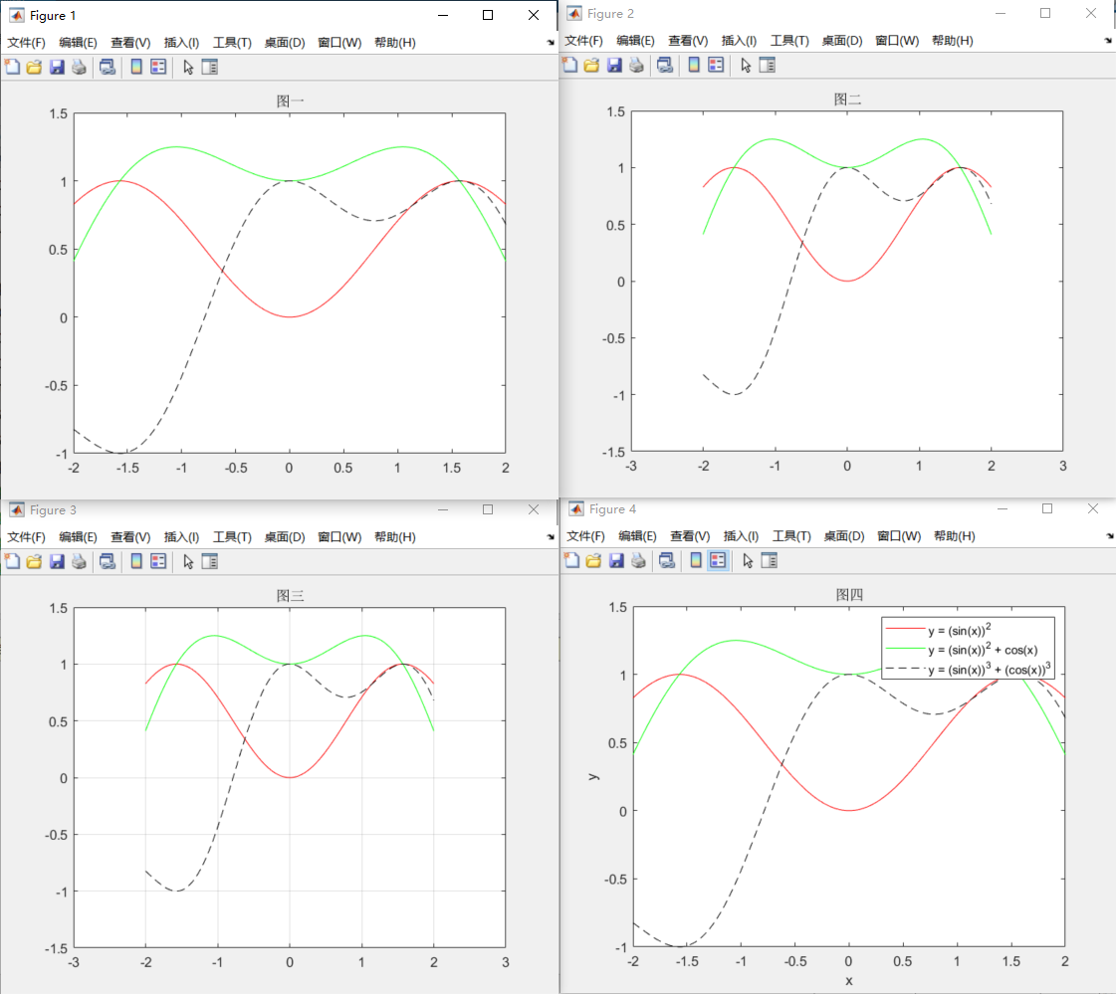

# 2、自定义2个关于x1，x2的函数yl，y2，用plot绘制[-2，2]上的曲线

1）曲线1，2为黄实线、绿虚线，数据点为菱形【自定义sn】（图1）

2）曲线1，2的s自定义，数据点为圆形其中sn自定义（图2）；

3）对图2曲线进行标注（图3）

**代码：**

close all; clear; clc;

x1 = -2:0.1:2;

x2 = -2:0.1:2;

y1 = (x1 + sqrt(x2.^2+1)).^4;

y2 = (exp(x1)-exp(-x2)).^3;

figure

plot(x1,y1,'y-d',x2,y2,'g--d','LineWidth',3,'Markersize',2)

title('图一')

figure

plot(x1,y1,'r-.o',x2,y2,'b-','LineWidth',4,'MarkerFaceColor','g','MarkerEdgeColor','y')

title('图二')

figure

plot(x1,y1,'r-.o',x2,y2,'b-','LineWidth',4,'MarkerFaceColor','g','MarkerEdgeColor','y')

title('图三')

legend('(x1 + sqrt(x2^2+1))^4','(exp(x1)-exp(-x2))^3')

**结果：（下一页）**

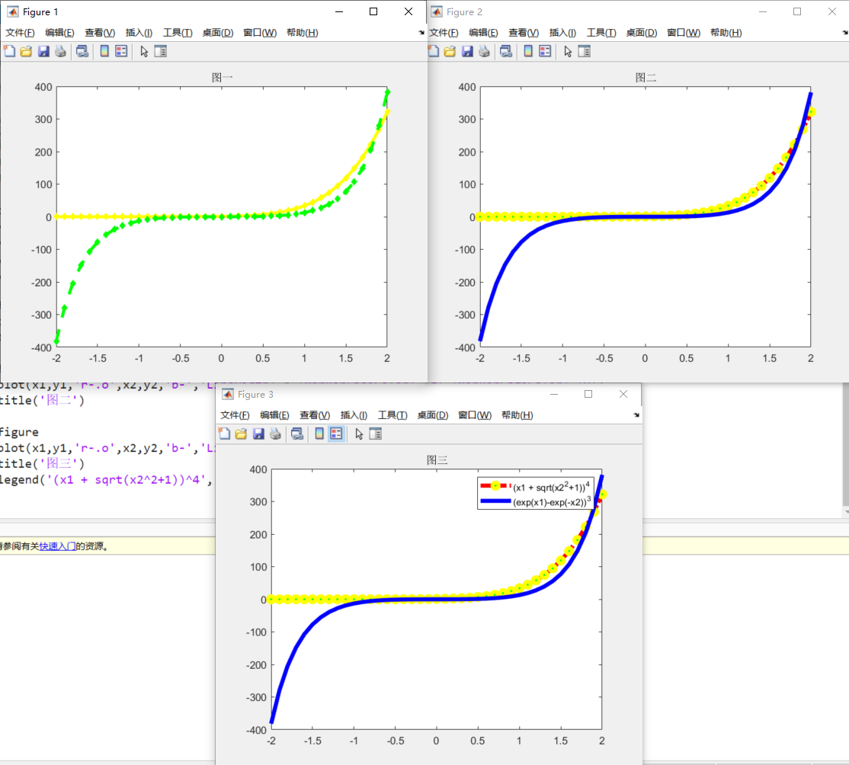

# 作业3附加题

绘制飞机航迹图，数据自拟，方位自拟

**代码：**

%% 初始化参数

close all; clear; clc;

m = 30;n = 30;

Spoint = [3, 10]; %起始点坐标

Epoint = [29, 22]; %目标点坐标

%% 构建地图

for i = 1:m+2

if i == 1

for j = 1:n+2

Matrix(i,j) = -inf;

end

elseif i == m+2

for j = 1:n+2

Matrix(i,j) = -inf;

end

else

for j = 1:n+2

if ((j == 1)|(j == n+2))

Matrix(i,j) = -inf;

else

Matrix(i,j) = inf;

end

end

end

end

%%障碍

for j=2:30

Matrix(5,j)=-inf;

for j=2:6

Matrix(24,j)=-inf;

for j=9:31

Matrix(10,j)=-inf;

for j=20:25

Matrix(15,j)=-inf;

for j=5:20

Matrix(20,j)=-inf;

for j=18:20

Matrix(28,j)=-inf;

for i=4:6

Matrix(i,18)=-inf;

for i=17:20

Matrix(i,5)=-inf;

for i=23:25

Matrix(i,20)=-inf;

for i=13:17

Matrix(i,13)=-inf;

end

end

end

end

end

end

end

end

end

end

% 显示地图

%subplot(2,2,1);

h1 = plot(Spoint(1),Spoint(2),'gO');

hold on

h2 = plot(Epoint(1),Epoint(2),'rO');

%% 寻路

Matrix(Spoint(1),Spoint(2))=0;

Matrix(Epoint(1),Epoint(2))=inf;

G=Matrix;

F=Matrix;

openlist=Matrix;

closelist=Matrix;

parentx=Matrix;

parenty=Matrix;

openlist(Spoint(1),Spoint(2)) =0;

for i = 1:n+2

for j = 1:m+2

k = Matrix(i,j);

if(k == -inf)

h3 = plot(i,j,'k.');

end

hold on

end

end

axis([0 m+3 0 n+3]);

plot(Epoint(1),Epoint(2),'b+');

plot(Spoint(1),Spoint(2),'b+');

while(1)

num=inf;

for p=1:m+2

for q=1:n+2

if(openlist(p,q)==0&&closelist(p,q)~=1)

Outpoint=[p,q];

if(F(p,q)>=0&&num>F(p,q))

num=F(p,q);

Nextpoint=[p,q];

end

end

end

end

closelist(Nextpoint(1),Nextpoint(2))=1;

for i = 1:3

for j = 1:3

k = G(Nextpoint(1)-2+i,Nextpoint(2)-2+j);

if(i==2&&j==2|closelist(Nextpoint(1)-2+i,Nextpoint(2)-2+j)==1)

continue;

elseif (k == -inf)

G(Nextpoint(1)-2+i,Nextpoint(2)-2+j) = G(Nextpoint(1)-2+i,Nextpoint(2)-2+j);

closelist(Nextpoint(1)-2+i,Nextpoint(2)-2+j)=1;

elseif (k == inf)

distance=((i-2)^2+(j-2)^2)^0.5;

G(Nextpoint(1)-2+i,Nextpoint(2)-2+j)=G(Nextpoint(1),Nextpoint(2))+distance;

openlist(Nextpoint(1)-2+i,Nextpoint(2)-2+j)=0;

% H=((Nextpoint(1)-2+i-Epoint(1))^2+(Nextpoint(2)-2+j-Epoint(2))^2)^0.5;%欧几里德距离启发函数

H_diagonal=min(abs(Nextpoint(1)-2+i-Epoint(1)),abs(Nextpoint(2)-2+j-Epoint(2)));%比较复杂的对角线启发函数

H_straight=abs(Nextpoint(1)-2+i-Epoint(1))+abs(Nextpoint(2)-2+j-Epoint(2));

H=sqrt(2)*H_diagonal+(H_straight-2*H_diagonal);

% H=max(abs(Nextpoint(1)-2+i-Epoint(1)),abs(Nextpoint(2)-2+j-Epoint(2)));%比较简单的对角线函数

F(Nextpoint(1)-2+i,Nextpoint(2)-2+j)=G(Nextpoint(1)-2+i,Nextpoint(2)-2+j)+H;

parentx(Nextpoint(1)-2+i,Nextpoint(2)-2+j)=Nextpoint(1);

parenty(Nextpoint(1)-2+i,Nextpoint(2)-2+j)=Nextpoint(2);

else distance=((i-2)^2+(j-2)^2)^0.5;

if(k>(distance+G(Nextpoint(1),Nextpoint(2))))

k=distance+G(Nextpoint(1),Nextpoint(2));

% H=((Nextpoint(1)-2+i-Epoint(1))^2+(Nextpoint(2)-2+j-Epoint(2))^2)^0.5; %欧几里德距离启发函数

H_diagonal=min(abs(Nextpoint(1)-2+i-Epoint(1)),abs(Nextpoint(2)-2+j-Epoint(2)));%比较复杂的对角线启发函数

H_straight=abs(Nextpoint(1)-2+i-Epoint(1))+abs(Nextpoint(2)-2+j-Epoint(2));

H=sqrt(2)*10*H_diagonal+10*(H_straight-2*H_diagonal);

% H=max(abs(Nextpoint(1)-2+i-Epoint(1)),abs(Nextpoint(2)-2+j-Epoint(2)));%比较简单的对角线函数

F(Nextpoint(1)-2+i,Nextpoint(2)-2+j)=k+H;

parentx(Nextpoint(1)-2+i,Nextpoint(2)-2+j)=Nextpoint(1);

parenty(Nextpoint(1)-2+i,Nextpoint(2)-2+j)=Nextpoint(2);

end

end

if(((Nextpoint(1)-2+i)==Epoint(1)&&(Nextpoint(2)-2+j)==Epoint(2))|num==inf)

parentx(Epoint(1),Epoint(2))=Nextpoint(1);

parenty(Epoint(1),Epoint(2))=Nextpoint(2);

break;

end

end

if(((Nextpoint(1)-2+i)==Epoint(1)&&(Nextpoint(2)-2+j)==Epoint(2))|num==inf)

parentx(Epoint(1),Epoint(2))=Nextpoint(1);

parenty(Epoint(1),Epoint(2))=Nextpoint(2);

break;

end

end

if(((Nextpoint(1)-2+i)==Epoint(1)&&(Nextpoint(2)-2+j)==Epoint(2))|num==inf)

parentx(Epoint(1),Epoint(2))=Nextpoint(1);

parenty(Epoint(1),Epoint(2))=Nextpoint(2);

break;

end

end

P=[];

s=1;

while(1)

if(num==inf)

break;

end

h4 = plot(Epoint(1),Epoint(2),'b+');

P(s,:)=Epoint;

s=s+1;

% pause(1);

xx=Epoint(1);

Epoint(1)=parentx(Epoint(1),Epoint(2));

Epoint(2)=parenty(xx,Epoint(2));

if(parentx(Epoint(1),Epoint(2))==Spoint(1)&&parenty(Epoint(1),Epoint(2))==Spoint(2))

plot(Epoint(1),Epoint(2),'b+');

P(s,:)=Epoint;

break;

end

end

P(s+1,:)=Spoint;

legend([h1,h2,h3,h4],'起始点','目标点','障碍物','航迹点');

count=0;

for i=2:12

for j=2:12

if(G(i,j)~=inf&&G(i,j)~=-inf)

count=count+1;

end

end

end

count

% 将得到的折现曲线拟合成光滑的曲线

P=P';

a=[];

b=[];

a=P(1,:);

b=P(2,:);

figure

plot(a,b);

axis([0,n+3,0,n+3]);

values = spcrv([[a(1) a a(end)];[b(1) b b(end)]],3);

figure

plot(values(1,:),values(2,:),'r--','LineWidth',2);

title('飞机平滑航迹图')

axis([0,m+3,0,m+3]);

**结果：**

