# 小测三 郭永峥

# x范围自拟,y=sin2x+2xcosx,用plot(x,y,s,sn)绘图,

要求:红色实线,线宽3,正五边形点[大小8,边绿色,内部黄色]

并标注:标题、xy轴.

语句：

close all; clear; clc;

x = 0:0.5:50;

y = sin(2*x) + 2*x.*cos(x)

plot(x,y,'r-p','LineWidth',3,'MarkerSize',8,'MarkerEdgeColor','g','MarkerFaceColor','r')

title('y=sin2x+2xcos 的曲线')

xlabel('x')

ylabel('sin2x+2xcosx')

结果：xc3gyz11.m

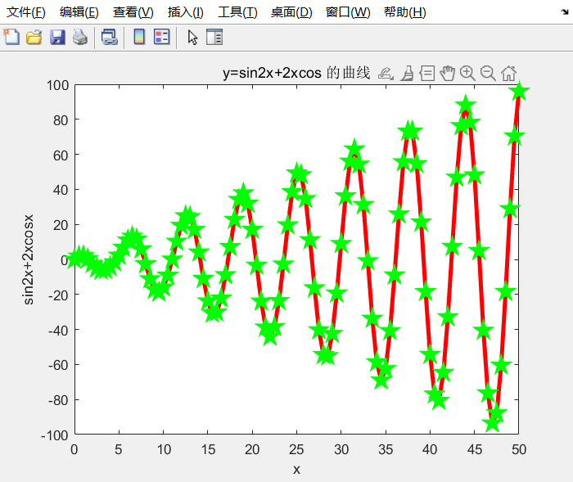

# 自定义x1,yl,x2,y2在同一图中用plot(x1,yl,s1,x2,y2,s2,sn(1))绘图,

# 要求(x1,y1)

蓝色虚线圆点,(x2,y2)绿色点划线右三角,线宽4.

并标注:标题、图例、xy轴.

将[题目+语句+结果]统一到word并2个m文件,发课代表[14:00之前完成,晚交扣分]

语句：

close all; clear; clc;

x1 = 0:0.2:15;

x2 = 5:0.2:20;

y1 = (sin(x1)).^2;

y2 = (cos(x2)).^3;

plot(x1,y1,'--ob',x2,y2,'g-.>','LineWidth',4)

title('(sin(x))^2和(cos(x))^3图形曲线')

xlabel('x')

ylabel('y')

legend('(sin(x))^2','(cos(x))^3')

结果：xc3gyz12.m

