Abstract
Background:
Multiple sequence alignments (MSAs) are often used for gathering information about evolutionary relationships between organisms, but these methods are slow, computationally intensive, and often unreliable for diverse data sets produced by metagenomics methods.
Results:
GECKOV (GEnome Clustering using K-mer frequencies or Vectors) is a stand-alone software application for clustering genomes and fragments of genomes without using MSA. Several algorithms for creating distance matrices are provided through a user-friendly graphical user interface. The algorithms are based on genome composition using the frequencies of different sized k-mers of nucleotides. GECKOV also includes clustering methods based on vectors created from graphical representations of genome sequences.
Conclusion:
GECKOV is a simple software program for rapid clustering of diverse genomes and unclassified sequences.
Introduction
Multiple sequence alignments are a common method for building phylogenetic trees from complete genome sequences or amino acid sequences from coding regions. However, identifying coding regions for related proteins can be time consuming. Current gene identification algorithms are optimized to identify open reading frames (ORFs) in bacterial or eukaryotic genomes. It is difficult to identify ORFs in viral metagenomic libraries because of sequencing errors and short sequence reads. If the sequence lengths are vastly different or the sequences are only slightly similar, the MSA will be of low quality, giving unreliable trees. Approximately 65% of viral metagenomic sequences in the non-redundant databases have no homologues.¹ Moreover, it is computationally expensive to perform a MSA on a large number of sequences, often to the point that performing the MSA is essentially impossible to do in practice.
Studies have shown that dinucleotide composition is similar in related organisms and different in unrelated organisms.^{2,3} This composition is consistent over the entire genome, including both coding and non-coding regions. Therefore it is possible to make a phylogenetic tree using genomic signatures created using the sequence composition.⁴ Genomic signatures are stored as vectors containing the k-mers of nucleotides of length k. Friberg et al. reported that trinucleotides contain more information than dinucleotides and may be more useful for phylogenetic analysis.⁵
We present GECKOV, an open source software application for genome clustering and phylogenetic tree construction without multiple sequence alignment. GECKOV allows users to quickly and easily compare genome sequences using a variety of algorithms based on sequence composition.

Implementation
GECKOV is written in Python (http://www.python.org) using wxPython for the GUI implementation. The program is packaged as a standalone application using Py2App for use on Mac OS X. GECKOV prepares distance matrices using the format for the PHYLIP distance matrix programs Neighbor, Fitch, and Kitsch, which are used to construct the phylogenetic trees (http://evolution.genetics.washington.edu/phylip.html).⁶ The trees are visualized using Archaeopteryx part of the FORESTER libraries (http://www.phylosoft.org/archaeopteryx).⁷ The open source PHYLIP and Archaeopteryx programs are packaged as a part of the GECKOV application. Typical options provided by the PHYLIP distance matrix programs for optimizing the tree construction are provided to the user as part of the easy to use GUI eliminating the need to learn to use multiple programs to visualize evolutionary relationships between genomes.
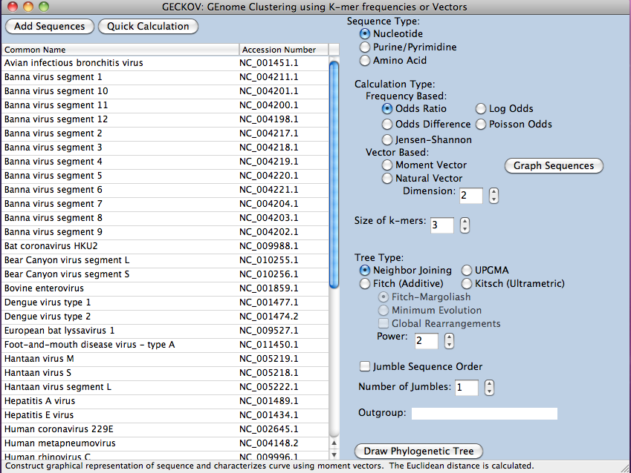
Figure 1. Interface of GECKOV. List on left shows sequences added to database. Panel on right shows possible clustering calculations and tree types available.
Results
Input and manipulation of sequences
New sequences are added to a database by importing them in FASTA format. GECKOV will calculate distances between organisms using several different algorithms and k-mer lengths and store those values in the database. For a large number of sequences this initial calculation can take up to a couple hours, but is generally faster than computing an MSA for a set of diverse sequences. Moreover, if the user wants to add or delete sequences, it is not necessary to recompute the MSA. Alternatively, if the user has a small number of sequences and knows the distance matrix algorithm and tree-type they want, GECKOV provides an option for doing one specific computation, but will not save the results (although the resulting tree can be exported as a PDF).
Algorithms used
GECKOV does not introduce any novel algorithms for genome clustering. Instead, a number of algorithms described in the literature for classifying sequences based on sequence content are implemented rather than using multiple sequence alignment or other sequence similarity methods. Many of these algorithms were not distributed as part of any open-source software by the original authors. A variety of programs such as Phylopythia, TACOA, and TETRA using K-mer frequency distributions or vector composition methods, however many of these programs are configured for classifying cellular organisms and are not well adapted to viruses.^{8,9,10}
K-mer Frequency
The Jensen-Shannon (JS) divergence can be calculated using the Kullback-Leibler (KL) divergence (relative entropy) to measure the similarity between two probability distributions. The JS divergence is symmetric, unlike the KL divergence, and is bounded between 0 and 1.¹¹ While the JS divergence is not a metric because it does not always satisfy the triangle inequality, the square root of the JS divergence is a metric.^{12,13,14}
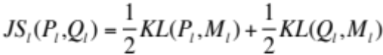
where 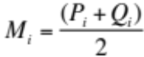 and KL is the Kullback-Leibler divergence:
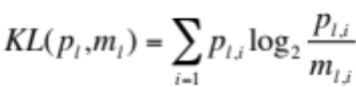
GECKOV calculates the JS divergence between the probability distributions of each genome for features of size k. Probability distributions are generated by running a sliding window of length k through the genome from position 1 to n - k + 1, where n is the length of the genome. The counts for all possible k-mers are stored in a vector C_{k} .
C_{k} = <c_{k,1},...,c_{k,M}>
where M, the number of all possible features, is 4^{k} and 4 is the alphabet size. The frequency counts for each k-mer are normalized to form a probability distribution,
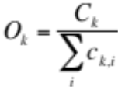
giving the relative abundance of each observed k-mer. The normalization reduces the effect of genome length differences in the comparison. For sequences that are three times or more different in length, the longer sequence is fragmented into segments the length of the shorter sequence and the average distance of the fragments is taken.
A number of other methods exist to create distance measures directly from raw frequency counts for k-mers. The expected frequency of a k-mer is the product of its component nucleotide frequencies. A bias vector can be created which measures the bias between the observed and expected k-mer frequencies as an odds ratio:^{3,15,16}
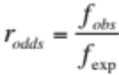
Computing the norm of the distance between the two bias vectors with p = 2
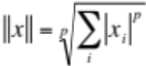
gives the Euclidean distance between organisms.
The odds ratio can also be evaluated as a logarithm:¹⁷
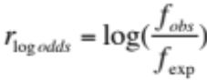
The bias can also be calculated as the normalized deviation from a Poisson distribution:⁵
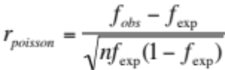
A fourth measure is the odds difference, which is similar to the Poisson deviation but does not contain a normalization factor:⁴
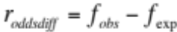
Vector Composition
Yau et al. described a two-dimensional graphical representation of gene sequences in two quadrants of the Cartesian coordinate system which has no circuit or degeneracy, giving a one-to-one correspondence between the gene sequence and its mathematical graph.¹⁸ An alternative system using just one quadrant of the Cartesian coordinate system was proposed by Wang et al.¹⁹ For nucleotide sequences the ordering of the four nucleotides in the coordinate system is based on the GC content of genomes. For protein sequences, the ordering of the amino acids is related to the hydrophobicity of the amino acids.²⁰ The graph of a gene sequence can be represented as a sequence of points (1, y₁), (2,y₂),...,(n, y_{n}). To this end, GECKOV evaluates moments which have the following form:
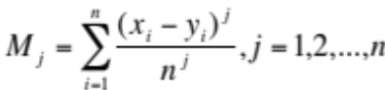
where n is the number of nucleotides in a DNA sequence, and (x_{i},y_{i}) is the position of the i-th nucleotide in the graphical curve. As each gene sequence has a one-to-one correspondence between the sequence and its graphical curve, each gene sequence also has an n-dimensional moment vector (M₁,M₂,...,M_{n}) associated with it by definition.²¹ The moment vector allows the construction of a genome space as a subspace in Euclidean space. The evolutionary distance between two genomes can be calculated by taking the Euclidean distance between two genomes which are represented as distinct points in the genome space.
The natural vector method uses normalized centralized moments to extend the amount of information conveyed by the moment vector. Normalized central moments have the following form:
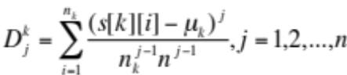
where k = A, C, G, T. By including information about the distribution of nucleotides in the DNA sequence, it is possible to discriminate between two sequences that may have the same nucleotide contents and the same length provided that the distribution of nucleotides is different.²² Again, a genome space can be constructed and the evolutionary distance between two organisms calculated. GECKOV is capable of producing natural vectors for k-mers of length greater than 1, however, further study would be needed to confirm the accuracy of these results.
Conclusions
GECKOV allows diverse genomes to be clustered based on the composition of the genome without using multiple sequence alignments. The simple interface allows users to rapidly visualize evolutionary relationships among species (including viruses). Users have control over a variety of parameters including the distance matrix algorithm and the options available in the Phylip distance matrix programs via the interface. Using patterns detected in the composition of genomes, GECKOV can be used to cluster genomes as well as unclassified sequences.
References
1. Edwards RA, Rohwer, F: Viral metagenomics. Nat. Rev. Microbiol. 2005, 3:504-510.
2. Nussinov, R: Strong doublet preferences in nucleotide sequences and dna geometry. J Mol. Evol. 1984, 20:111-119.
3. Karlin S, Burge C: Dinucleotide relative abundance extremes: a genomic signature. Trends Genet. 1995, 11:283-290.
4. Nakashima H, Ota M, Nishikawa K, Ooi T: Genes from nine genomes are separated into their organisms in the dinucleotide composition space. DNA Res. 1998, 5:251-259.
5. Friberg M: Virus classification using k-nucleotide frequencies. [http://cbrg.inf.ethz.ch/bio-recipes/VirusClassification/code.html]
6. Felsentein J: PHYLIP (Phylogeny Inference Package) version 3.6. [http://evolution.genetics.washington.edu/phylip.html]
7. Han MV, Zmasek CM: phyloXML: XML for evolutionary biology and comparative genomics. BMC Bioinformatics 2009, 10:356.
8. McHardy AC, Martín HG, Tsirigos A, Hugenholtz P, Rigoutsos, I: Accurate phylogenetic classification of variable-length DNA fragments. Nat. Methods 2007, 4:63-72.
9. Diaz NN, Krause L, Goesmann A, Niehaus K, Nattkemper TW: TACOA - Taxonomic classification of environmental genomic fragments using a kernelized nearest neighbor approach. BMC Bioinformatics 2009, 10:56.
10. Takahashi M, Kryukov K, Saitou N: Estimation of bacterial species phylogeny through oligonucleotide frequency distances. Genomics 2009, 93:525-533.
11. Sims GE, Jun S, Wu G, Kim S: Alignment-free genome comparison with feature frequency profiles (FFP) and optimal resolutions. Proc. Natl. Acad. Sci. U. S. A. 2009, 106:2677-2682.
12. Lin J: Divergence measures based on the Shannon entropy. IEEE Trans. Inf. Theory 1991, 37:145-151.
13. Endres DM, Schindelin JE: A new metric for probability distributions. IEEE Trans. Inf. Theory 2003, 49:1858-1860.
14. Ôsterreicher F, Vajda I: A new class of metric divergences on probability spaces and its statistical applications. Ann. Inst. Statist. Math. 2003, 55:639-653.
15. Campbell A, Mrazek J, Karlin S: Genomic signature comparisons among prokaryote, plasmid, and mitochondrial dna. Proc. Natl. Acad. Sci. U. S. A. 1999, 96:9184-9189.
16. Gentles AJ, Karlin S: Genome-scale compositional comparisons in eukaryotes. Genome. Res., 2001, 11:540-546.
17. Nakashima H, Nishikawa K, Ooi T: H. Differences in dinucleotide frequencies of human, yeast, and escherichia coli genes. DNA Res. 1997, 4:185-192.
18. Yau SS, Wang J, Niknejad A, Lu C, Jin N, Ho, Y: DNA sequence representation without degeneracy. Nucleic Acids Res. 2003, 31:3078-80.
19. Wang J, Wang W: New 2-D graphical representation of DNA sequences. Biophys. Rev. Lett. 2006, 1:133-140.
20. Yau SS, Yu C, He R: A protein map and its application. DNA Cell Bio. 2008, 27:241-250.
21. Yu C, Liang Q, Yin C, He RL, Yau SS: A novel construction of genome space with biological geometry. DNA Res. 2010, 17:155-168.
22. Deng M, Yu C, Liang Q, He RL, Yau SS: A novel method of characterizing genetic sequences: genome space with biological distance and applications. PLoS ONE 2011, 6:e17293.

