## Business Use Case

Many airline these days offer broadcast TV, on-demand movies and internet connectivity on board their aircraft. An airline may want to understand what relationships exist between customer purchases of in-flight entertainment and/or connectivity within and across flights for marketing and other reasons. Being able to identify common purchases and their relationship to cities and/or routes would help the airline understand customer behavior, preferences, etc.

## Data Model

### Nodes

Purchaser (Name, CardType, Last4digitsCC)

Product (id)

Flight (Number, Takeoff)

Aircraft (id)

Airport (id)

### Relationships

Purchase (TV, Connectivity): between Purchaser and product nodes

ProductAvailable: between Product and Flight nodes

Departed: between Flight and Airport nodes

Arrived: between Flight and Airport nodes

Flew: between Aircraft and Flight

## Data Import Queries

### Import Aircraft

|  |
| --- |
| LOAD CSV WITH HEADERS FROM  "file:C:\\Code\\R\\DataAcqMgmt\\Neo4j\\DataModel\\Aircraft.csv" AS csv  MERGE (ac:Aircraft {id: csv.TailNumber }) |

### Import Airports

|  |
| --- |
| LOAD CSV WITH HEADERS FROM  "file:C:\\Code\\R\\DataAcqMgmt\\Neo4j\\DataModel\\Airports.csv" AS csv  MERGE (ap:Airport {id: csv.ICAO }) |

### Import Products

|  |
| --- |
| LOAD CSV WITH HEADERS FROM  "file:C:\\Code\\R\\DataAcqMgmt\\Neo4j\\DataModel\\Products.csv" AS csv  MERGE (ap:Product {id: csv.Name }) |

### Import Flights

|  |
| --- |
| LOAD CSV WITH HEADERS FROM  "file:C:\\Code\\R\\DataAcqMgmt\\Neo4j\\DataModel\\Flights.csv" AS csv  MATCH (ac:Aircraft {id: csv.Aircraft})  MATCH (o:Airport {id:csv.Origin})  MATCH (d:Airport {id:csv.Destination})  MERGE (fl:Flight {number: csv.Number, Takeoff: csv.TakeoffDateTime })  MERGE (ac)-[:Flew]->(fl)  MERGE (fl)-[:Departed]->(o)  MERGE (fl)-[:Arrived]->(d) |

### Import In-Flight Entertainment & Connectivity Purchases

The following query merges purchaser information and creates relationships with property counters for each product purchased on a given flight. It also merges a relationship between purchaser and product to quickly indicate those who have ever used a given product.

|  |
| --- |
| LOAD CSV WITH HEADERS FROM  "file:C:\\Code\\R\\DataAcqMgmt\\Neo4j\\DataModel\\Purchases.csv" AS csv  MATCH (pr:Product {id: csv.Product})  MATCH (fl:Flight {number: csv.FlightNum})  MERGE (pc:Purchaser {name: csv.CardholderName, cardType: csv.CardType, last4digitsCC: csv.Last4digitsCC })  MERGE (pr)-[:ProductAvailable]->(fl)  MERGE (pc)-[p:Purchase]->(fl)  ON CREATE  SET p.TV = CASE WHEN pr.id = "TV"  THEN 1  ELSE 0  END,  p.Connectivity = CASE WHEN pr.id = "Connectivity"  THEN 1  ELSE 0  END  ON MATCH  SET p.TV = CASE WHEN pr.id = "TV"  THEN p.TV + 1  ELSE p.TV  END,  p.Connectivity = CASE WHEN pr.id = "Connectivity"  THEN p.Connectivity + 1  ELSE p.Connectivity  END  MERGE (pc)-[:User_Of]->(pr) |

## Graph Illustration

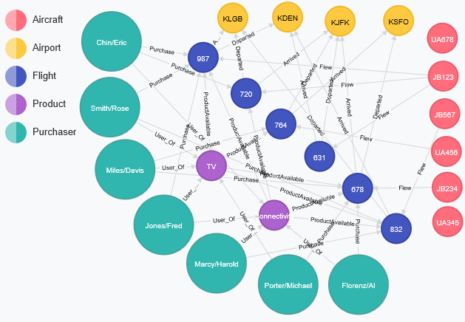

## Data Access Queries

### Who are the Connectivity Users?

|  |
| --- |
| MATCH (pr:Product {id: "Connectivity"})-[ruo:User_Of]-(u) RETURN u,pr |

### 

### Who are the TV Users?

|  |
| --- |
| MATCH (pr:Product {id: "TV"})-[ruo:User_Of]-(u) RETURN u,pr |

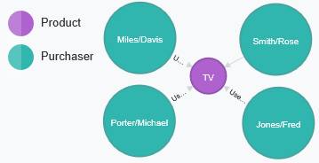

### Who are the Connectivity Users who have also used TV?

|  |
| --- |
| MATCH (pr:Product {id: "Connectivity"})-[ruoC:User_Of]-(u)-[rouT:User_Of]-(prTV:Product {id: "TV"}) RETURN u,pr,prTV |

### Who are the users who have purchased Connectivity and TV on the same Flight?

|  |
| --- |
| MATCH (pr:Product {id: "Connectivity"})-[ruoC:User_Of]-(u)-[rouT:User_Of]-(prTV:Product {id: "TV"})  MATCH (u)-[p:Purchase]-(fl:Flight)  WHERE p.Connectivity > 0 AND p.TV > 0  RETURN u,pr,fl,prTV |

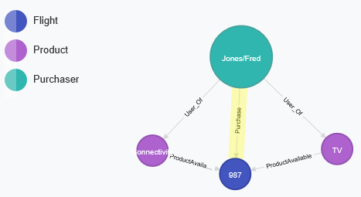

### What flights and airports have purchases of both connectivity and TV on the same Flight?

|  |
| --- |
| MATCH (pr:Product {id: "Connectivity"})-[ruoC:User_Of]-(u)-[rouT:User_Of]-(prTV:Product {id: "TV"})  MATCH (u)-[p:Purchase]-(fl:Flight)-[d:Departed]-(o:Airport)  WHERE p.Connectivity > 0 AND p.TV > 0  MATCH (u)-[p]-(fl)-[a:Arrived]-(ar:Airport)  WHERE p.Connectivity > 0 AND p.TV > 0  RETURN fl,o,ar |

